Systems Engineering – Design & Manufacture Case Study
Introduction
The QFD (Quality Function Deployment) design process is a methodology for coherently converting customer requirements for a product into derived engineering specifications, by working step-by-step to assess the relative significances and importances of system functions, means of achieving functions, creating concept designs, creating sub-systems and components, and analysing these to produce tolerances for manufacturing processes. The process was developed in the 1960’s in Japan, and following its perceived success at major companies such as Mitsubishi, it has become widely used and been adapted by many large corporations to improve their design process through ‘left-shifting’. Its success has both shortened the time and significantly reduced costs for moving from the customer requirements and design concept to producing a finished article [1].
In this case a selected portion of the QFD process and associated tools has been applied to the design process for a new, improved bird/animal scarer cartridge fired form a 12-gauge shotgun.
Gathering Requirements
Customer requirements were gathered through in-depth meetings with the customer. Requirements derived from the meetings were grouped by stakeholder/user. 9 key customer requirements were selected for analysis.
Rationalising Requirements
Requirements were rationalised by using a pairwise comparison matrix to determine the more and less important requirements. The horizontal and vertical axes of the matrix were populated with the customer requirements, which were then ranked in preference against each other. Importance scores were created for each requirements by using the sum-product principle and normalising the derived values.
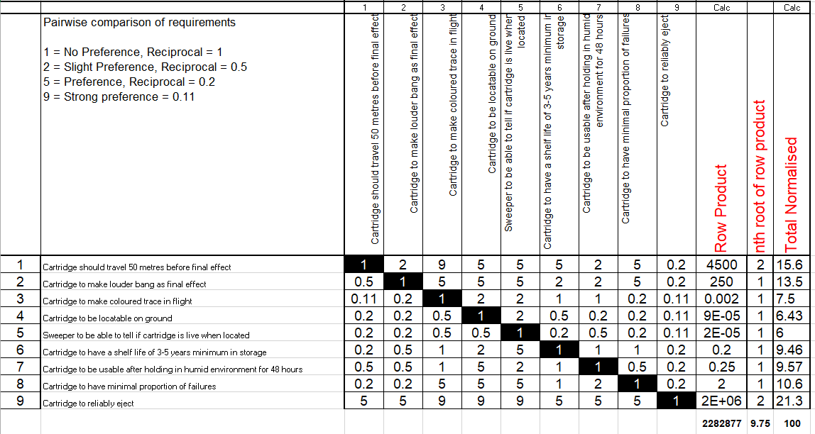

Design Concept
From the customer requirements, a design concept was created and a list of the key design features or ‘hows’ for meeting the requirements was derived.
Design QFD1
The QFD1 matrix was used to rank the relative significance of design features or ‘hows’ in fulfilling each requirement. Customer requirements and their relative importances were used to populate the horizontal axis, whilst the design features populated the vertical axis. The relative significances were ranked as either 9 (very significant), 3 (significant), 1 (some significance), or as 0 (unrelated), such that importance scores could be determined for the design features by using the sum-product principle. Beneath the matrix target values were listed for the design features in terms of percentage of successful functions; for example, the percentage of cartridges where the propelling charge ignites and burns.
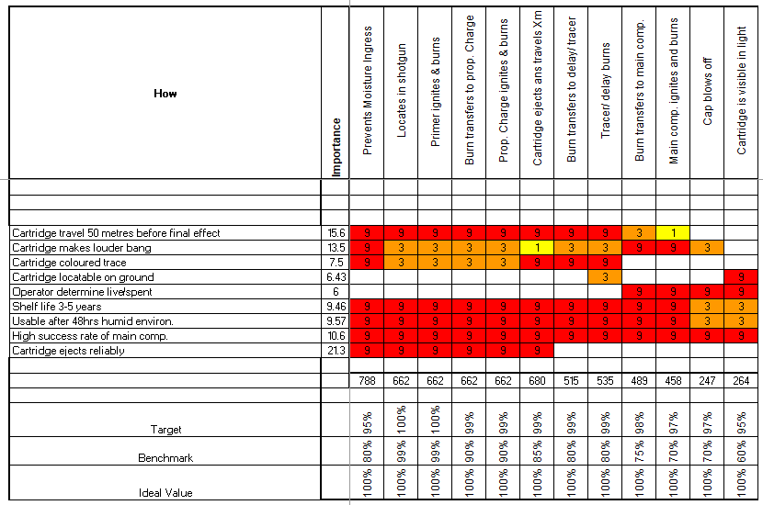

Functional Means Analysis
Means for achieving the design features from the design concept were listed based on the designer’s knowledge of the subject area and on some basic research. This included both the means of achieving the design features in the current design and potential alternative means for the concept design.
The listed means for each design concept were then analysed to determine whether they would be appropriate given the other design features required. In this case 4 means were discounted, 3 because they would render success of other design features impossible or highly unlikely (highlighted in red), and 1 based on the fact it would be unlikely to be achieved based on development cost and time (highlighted in purple). For example the LED strip and hermetic sealing of exterior of the unit were discounted as they would change the dimensions of the cartridge and likely prevent the design function of the cartridge ejecting reliably and travelling the 50m distance. In house manufacturing of the primer was discounted due to the relative difficulty, time and cost in manufacturing compared to the off-the-shelf primer.
Once each means had been selected as either possible or discounted, the columns containing the listed means were re-shuffled to outline two design concepts using only possible means. ‘Concept 2’ utilised an alternate means to the current design for all but one design feature, whereas ‘Concept 1’ utilised a combination of current means and alternate means.
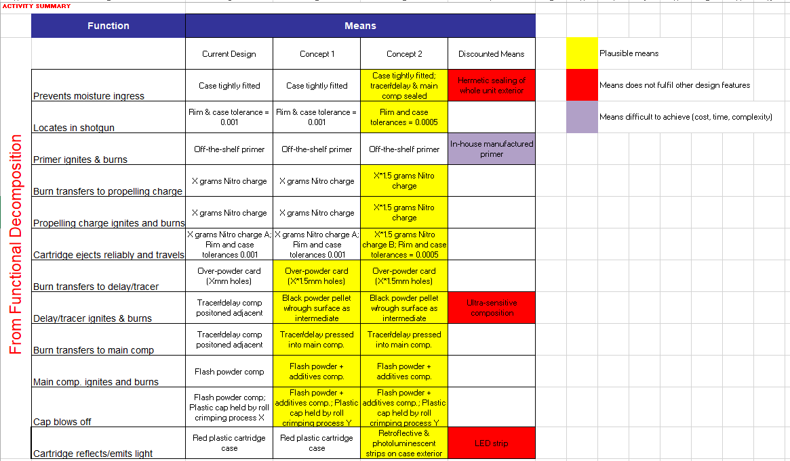

Functional Metrics
Test method and a metrics for testing the success of the design features were analysed and listed, based on the designers’ knowledge and basic research. The significance of each test method for determining the success of each design feature was ranked using a ‘functional metrics matrix’, in order to produce importance scores for each test method.

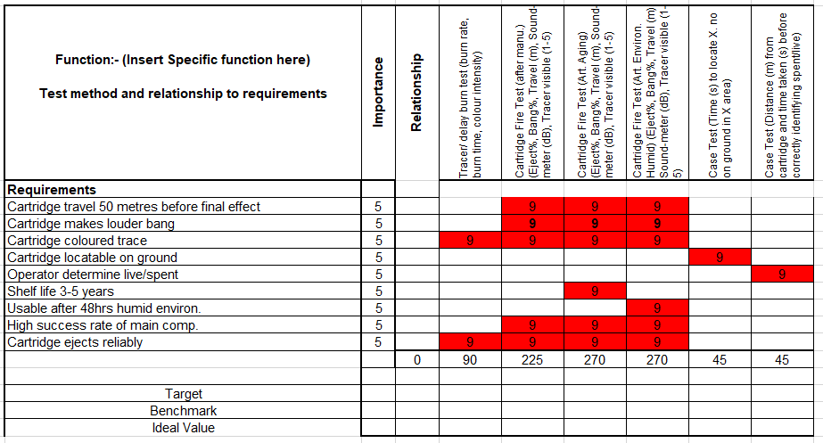
System Pugh
A ‘system Pugh matrix’ was created to provide a comparison of the current and concept designs outlined in the functional means analysis. The current and concept designs constituted the vertical axis. Whilst, the horizontal axis of the matrix was populated with the customer requirements, and their weighted relative importance as derived from the rationalisation in the pairwise comparison. Each customer requirement was ranked against each design concept to assess whether the design features pertaining to it (as in the functional means analysis) ‘much better fulfilled (2)’, ‘better fulfilled (1)’, ‘didn’t improve or worsen (0), ‘worsened (-1) or ‘significantly worsened’ (-2) the ability to fulfil the requirement.
An additional 4 generic design and manufacturing requirements, were included on the horizontal/requirements access, with these pertaining to the needs of the manufacturer to meet all the customer requirements in terms of viability of cost and time. These were ‘development cost’, ‘manufacturing time’, ‘off-the-shelf compositions and components cost’, ‘off-the-shelf compositions and components lead time’. All of these additional requirements were given a relative weighted importance of 15 (higher than all but the most important customer requirement.
Using the sum-product principle applied to the rankings and to both the ‘relative weighted importance’ and ‘equal importance’ of the customer requirements, an overall ranking for each design was derived.
This determined that Concepts 1 & 2 were both advantageous in comparison to the current design, with Concept 2 scoring highest. Whilst Concept 2 was ranked the lowest in terms of the additional requirements of the manufacturer, this was more than offset by the higher rankings than Concept 1 for the customer requirements.
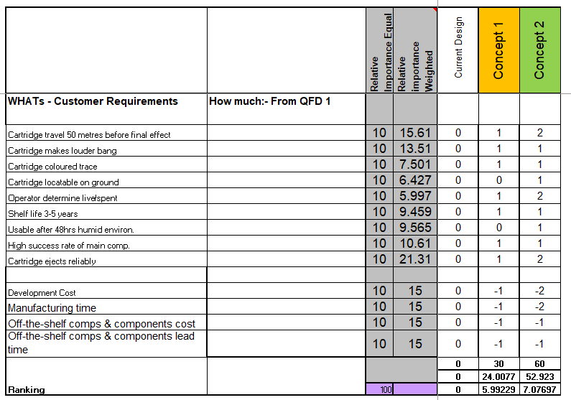

Design QFD2
Through analysis of the means listed in the functional means analysis, a list of required subsystems and components was created.
The QFD2 matrix was utilised, with the subsystems and components populating the vertical axis, and the system functions (from the design concept) populating the horizontal axis. The significance of each component in achieving the system function was ranked as either 9 (very significant), 3 (significant), 1 (some significance), or as 0 (unrelated), so that overall importance scores for each component could be derived whilst accounting for the relative importance of each system function using the sum-product principle.
The ‘rim and primer unit’ and use of a compatible gun were identified as the two most important components.
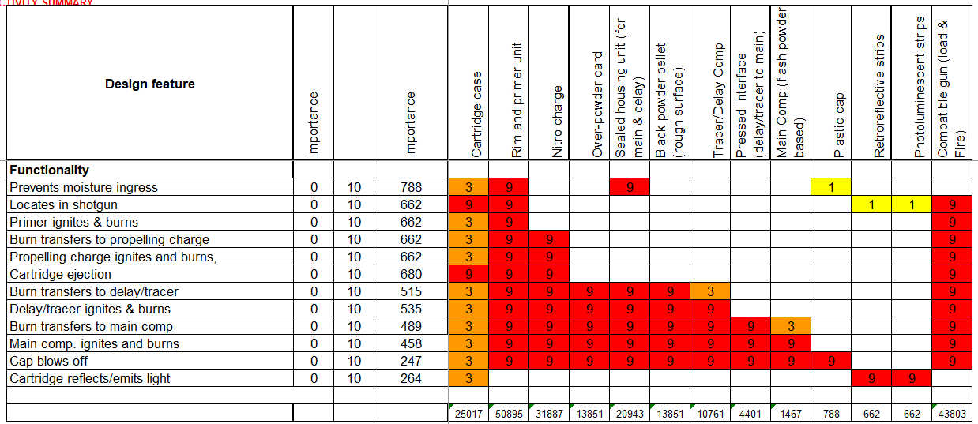
Noises & P-Diagram
A P-diagram was used to list the ‘noises’ in the system which could affect the system outputs derived from the system inputs, based on the use of the subsystems and components analysed in QFD2. Noise types were categorised as ‘external’, ‘unit-to-unit’, and ‘deterioration’. Design control factors and parameters for the above identified noises were then identified and listed, so as to provide an input for a merged QFD3/QFD4.
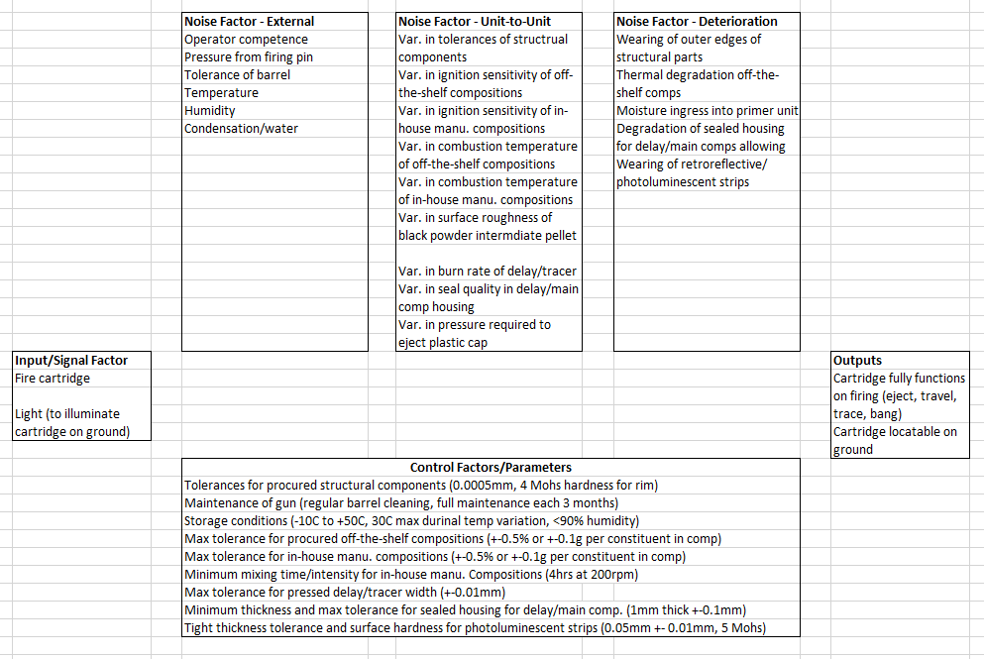
QFD3 and QFD4
The merged QFD3/QFD4 matrix was used to determine the relative importance of each design control factor and its parameter against each of the noise factors identified. The control parameters were given a relative importance weighting based on a combination of the importance scores for each component derived in QFD2 and the severity of the scaled impact of noise/variability on the success or failure of each component. This was ranked as either 0,1,3,9.
As in QFD2 matrix, each combination was ranked as either 9 (very significant), 3 (significant), 1 (some significance), or as 0 (unrelated), allowing derivation of a relative importance score for each noise factor.
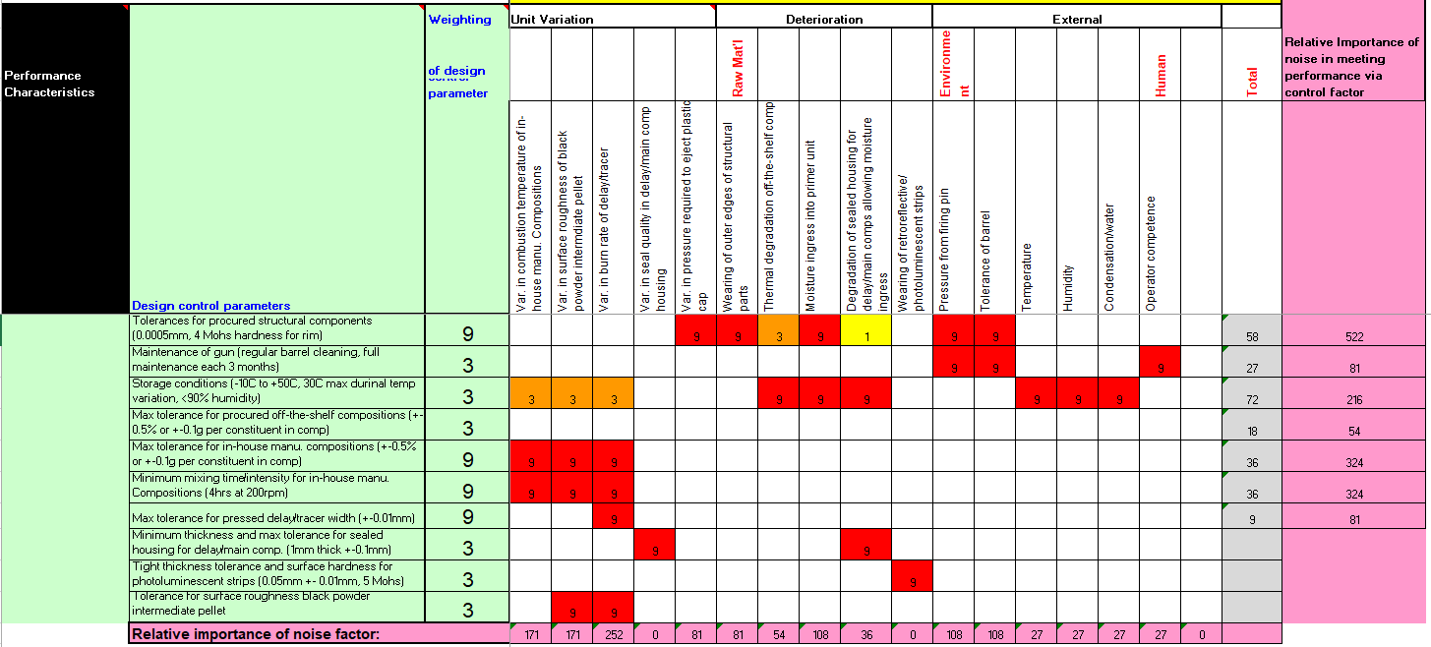
Conclusion
The use of the QFD process in aiding in the design of the new, improved bird scarer cartridge has been demonstrated up to point of manufacturing process and tolerances. This has been achieved through step by step conversion of customer requirements to technical design requirements, via:
- rationalisation of customer requirements
- creation of design features in a design concept
- scoring importance of design features/functions against requirements
- selecting concept designs using the design features through functional means analysis
- comparing concept designs through a Pugh matrix
- detailing subsystems and components
- scoring the importance of components against system functions
- detailing noises and variabilities
- detailing control parameters within specific manufacturing processes
- scoring the importance of control parameters and tolerances relative to noises
The use of this process has identified where the most important requirements, functions, components and finally tolerances/specifications lie within the design and manufacturing process.

