

LEVEL/ LEFEL 5
MODULE CODE: ACCC5001
DATABASE MANAGEMENT SYSTEMS by

Aleksandar Nedelchev
BCs Cloud Computing

Table of Contents
1. Introduction 3
2. Proposed strategy 4
3. Advantages 5
3.1 Shareability and local autonomy 5
3.2 Availability 6
3.3 Reliability 6
3.4 Performance 6
3.5 Economics 6
3.6 Modular growth 6
4. Disadvantages 6
References 8

Introduction

In this report I will focus to document the strategies that can be employed by Pet Care with a DBMS server at defined regional locations based on the Task 1 of the assignment and the tables created.
A Distributed Database Management System (DDBMS) is a single logical database separated into many pieces. All the fragments are stored on one or more computers managed by a separate DBMS, with a communication network (private lines or Internet connection) connecting the computers to it. Every site is has the ability of processing user requests that require access to local data (every site will have some degree of local autonomy or not) independently and is also capable of processing data stored on other network servers. Users can access the DDBMS through applications categorised as not needing data from other sources (local applications) and those having data from other sources (global applications). (CONNOLLY & BEGG, 2005)
Locations in the system does not need to have its own local database, as demonstrated by the DDBMS topology shown in Figure 1
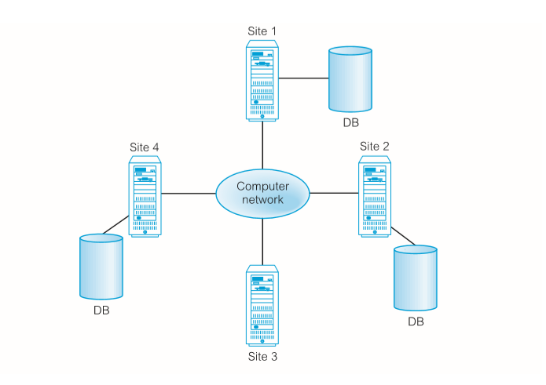
Figure 1: Distributed database management system.
(Source: (CONNOLLY & BEGG, 2005))

Proposed strategy

For the task that we have - Pet Care with a DBMS server my proposal is to go with locations based distributed DBMS solution split by regions Figure 2 & 3.
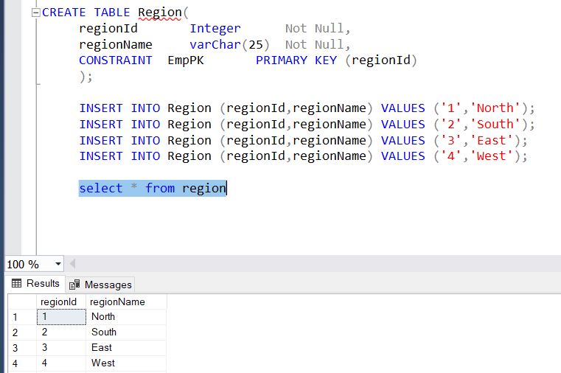
Figure 2: Regions
(Source: Created by the author)

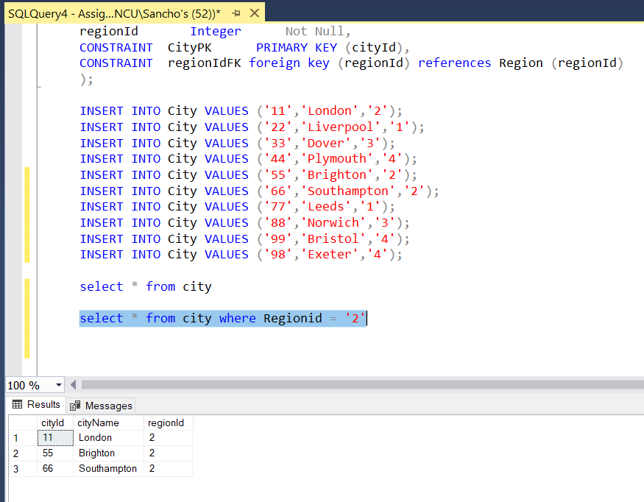
Figure 3: Cities from Region 2 = South
(Source: Created by the author)

The distributed DBMS technology will help Pet Care to store database on more than one separate computer systems regionally based instead of a single, centralized server. The computer servers may be located at every local clinic: London, Liverpool, Dover, and Plymouth. Internet connection will link the computers and will enable the staff of all the clinics to communicate, and a DDBMS will allow them to access data stored at another clinic server. Thus, a staff member will access the local or the nearest server, when they are saving or fetching data from database. A DDBMS will be useful to split some parts of database into a different location but still will be visible for the staff like one logical database and will make the local data more widely and quickly available. Also, this can bring a lot of other advantages that I will discuss next.

Advantages

Shareability and local autonomy

We should save data at the site where people usually use the data. For instance, all data records for Liverpool patients will be stored in the Liverpool clinic server. In this way, users have local data control and can therefore define and implement local data use policies. Once it's saved, there's no need to travel to London or wait to be downloaded once needed. (CONNOLLY & BEGG, 2005)

Availability
In a centralised DBMS, DBMS operations are terminated by a single PC or device failure. A failure at one DDBMS site, however, or a failure of a communication link that makes certain sites unavailable, does not make the entire network non-operational. Even with some of these failures, the DDBMSs are designed to continue to operate. When one single server fails, the device will be able to redirect requests from the failed server to another. (CONNOLLY & BEGG, 2005)

Reliability
As long as the data may be replicated to be stored at more than one location, failure of a server or communication connexion does not automatically make the data unavailable. (CONNOLLY & BEGG, 2005)

Performance
Since the data is stored near the customer location, and with the inherent parallelism of distributed DBMSs, the speed of access to the database can be greater than a remote centralised database can be achieved. (CONNOLLY & BEGG, 2005)

Economics
Computing capacity was measured in the 1960s according to the square of the equipment's costs: three times the cost would have nine times the capacity. This was named Grosch's Law. Nevertheless, it is now widely agreed that building a computer from smaller computers with the same capacity of a single large computer costs considerably less. It makes it more price-effective to have separate machines for the business branches and departments. Adding workstations to a network is often significantly more cost-effective than upgrading a mainframe programme. The second possible cost cutting exists where databases are geographically distant and access to distributed data is needed by applications. For these cases, it could be much more feasible to segment the application and execute the processing locally at each location because of the comparative expense of data being transmitted through the network as compared to the cost of local access. (CONNOLLY & BEGG, 2005)

Modular growth
In a distributed world the management of expansion is much simpler. You can connect new sites to the network without impacting the activity of other sites. Such versatility makes it relatively easy for an company to grow. In our case this is essential. The Pet care is planning to expand to new cities and regions. (CONNOLLY & BEGG, 2005)

Disadvantages

For order to execute an application, if we must choose between a distributed architecture and a centralised architecture, the system architect must balance the benefits against the drawbacks of data distribution. We've seen the advantages of using the distributed systems already. The key drawback of distributed database systems is the additional sophistication required to ensure proper communication between sites. The increased difficulty takes various forms:
• Price of Software Creation. A centralised database system is more complex to manage, so it is more costly.
• The potential of bugs is bigger. Because the sites that make up the distributed system work in parallel, it is more difficult to ensure the correctness of the algorithms, particularly operation during system part failures, and recovery from failures. (Silberschatz, Korth, & Sudarshan, 2011)

According to CONNOLLY & BEGG, 2005 the other disadvantages can be:
- Size Cost of DBMSs
- Additional hardware costs
- Cost of conversion
- Performance
- Higher impact of a failure

References

CONNOLLY, T. M., & BEGG, C. E. (2005). Database Systems. Harlow: Pearson Education Limited.
Hernandez, M. J. (2003). Database Design for Mere Mortals. Boston: Pearson Education, Inc.
Silberschatz, A., Korth, H. F., & Sudarshan, S. (2011). DATABASE SYSTEM CONCEPTS. New York: McGraw-Hill.

