

Report for Strategic Management

Name: Ahmed Alrubaye
Student Number: 1704619

Abstract

Strategic management is the most important part of business management. The executives of an organization are responsible for this task in order to achieve strategic objectives and mission. Market data and response comes from the lower management that is then used by senior management to set up strategies. The report is about strategic management at Lidl Stiftung & Co. KG. It was identified that Lidl is using cot leadership strategy since its incorporation and it is still successful while following the same strategy. However, this may not work in future. The retail sector is expanding very fastly. Big competitors like Tesco have big market shares. Lidl must change its strategies if it wishes to reach the level of Aldi or Tesco. It is recommended that changing to the differentiation strategy Lidl would be able to increase its worth and market share by a big percentage.

Table of Contents
1 Introduction 4
2 Background of Lidl 4
3 Competitive Strategy of Lidl 5
3.1 Success of Lidl by means of Using Cost Leadership Strategy 6
3.2 Benefits of cost leadership 8
3.3 Problems of cost leadership 8
4 Conclusion 9
5 Recommendations 10
6 References 12

Introduction
The report is being prepared for the identification and evaluation of competitive and development strategies of business. In our Case we have taken Lidl Stiftung & Co. KG as a sample which is a Germany grocery store operating in the supermarket industry effectively and efficiently and maintains itself as a fearful competitor for big chains like Aldi and Tesco.

Background of Lidl
Lidl was started in 1930 as a grocery wholesaler store in Germany and is considered as a largest grocery retailer in Europe today with more than 10000 stores all over Europe and 600 stores in UK. Lidl is headquartered in Germany (Bloomberg.com, 2019). It remained in Germany until 1999 after which it expanded outside Germany as well. After its expansion towards UK, it feared its competitors by obtaining a growing market share in the supermarket industry. It does not have more than 3.5%market share in UK but is considered one of the fastest growing grocery retailers in the supermarket industry. It has about 300000 employees (Marketbusinessnews.com, 2014). It offers items that are available at TESCO and ALDI (Lidl.co.uk, 2019). The stores of Lidl have a list of more than 800 items that are mainly sold upon its own name. It is now making its expansion to Hungary, Denmark and Slovenia. It provides high quality items. In 2013, Lidl invested about EUR 120 million for its expansion by renovating its old stores and opening new stores (Theguardian.com, 2014). The goal of this investment was to gain a market share in Spain. A portion of the budget was also allocated for a new logistics Platform in Murica (Fis.com, 2018). Success of Lidl is based upon its market and competitive strategies.

Competitive Strategy of Lidl
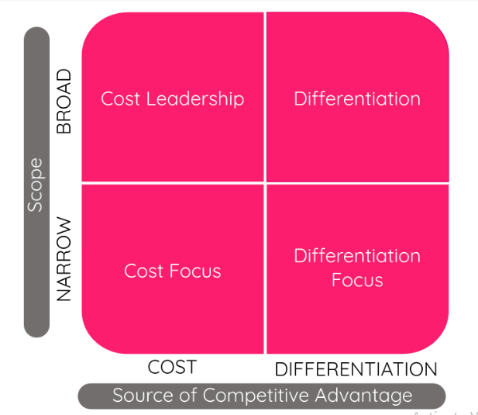
In a highly competitive industry such as supermarket, business seek to win over customers as well as markets to achieve high profits and more market share. As per porter, four fundamental strategies can be used by businesses to achieve its growth objectives i.e. cost leadership, differentiation and cost focus and differentiation focus. The basic economic concept that porter followed is that cost and prices of the business must be established based upon comparisons with its major competitors. Porter’s generic strategies can be identified by means of a matrix that shows competitive advantage on x-axis and target scope on y-axis. Cost leadership has a broad scope and competitive advantage is cost based. Differentiation is a distinctive product with broad scope. Cost focus has a narrow target scope and low cost while differentiation also has narrow scope but offers distinctive product.
In the case of Lidl, it can be identified that it is using cost leadership strategy out of the four strategies porter has set. The primary goal of Lidl is to gain more sale volume by proving low cost products. However, this is not compromised by giving low quality of products. The quality of products of Lidl is being maintained dramatically along with low cost. This not only gains consumer attention but also loyalty to the brand which makes one-time customer a repetitive customer.
Low cost is nit also compromised by disturbing the consumers due to bad store outlay. The customers can choose their products with ease and quickly. Since Lidl offers low cost products, no more incentive schemes are needed and offered for its products displayed in stores or website. Each store has continuous promotions so further discounts are not needed and cannot be afforded as well. The strategy is based upon selling more goods with lease labor cost and least time, it usually opens stores near to its distribution centers to save costs for moving goods.
We can say that Lidl follows a clever pricing strategy which retains its customers by provision of high quality products but on low cost. Sometimes, new consumers may believe that they Lidl do not offer good quality because the products appear to be very cheap compared to that of competitors such as Aldi. However, the negative perception of the consumers goes away once they use the product offered by Lidl in their stores under their own brand name.
The cost leadership strategy is being used by Lidl with incredible effectiveness because it is constantly growing its market share not only in Germany but also in other countries. To achieve this growth with high quality products, Lidl has focused upon low manufacturing costs and sale of products so that margins remain high. With lowest production costs and high sales volume, it achieves sufficient profits being a cost leader in supermarket industry. However, to maintain its current statistics, Lidl needs to move away from current competitive strategies so that they may stay innovative and competitive for many years further.

Success of Lidl by means of Using Cost Leadership Strategy
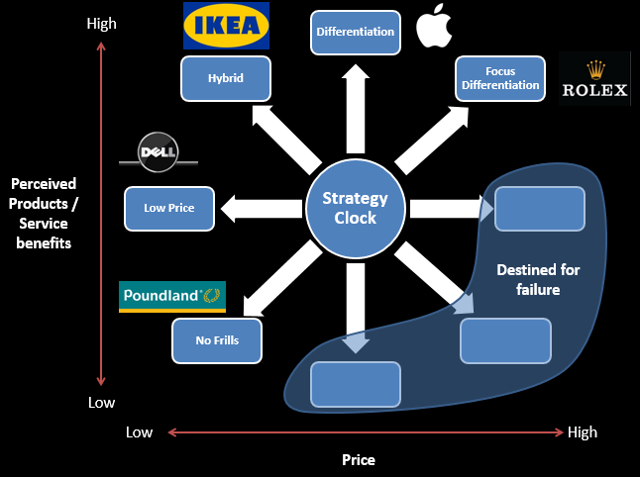
As we have identified that Lidl is being using cost leadership strategy out of the four strategies set up by porter. We will now further evaluate how this strategy helped Lidl to become incredibly successful and how it feared it competitors. Cost leadership means producing at a lower cost than the competitor and then selling at a lower price as compared to the competitors. Lidl kept on minimizing its cost of sales and manufacturing and maintained quality of products so that list of loyal customers can be increased. However, today’s customer is becoming intelligent enough and is not satisfied on a low-cost product but wants differentiation and innovation speedily. They are willing to pay but want value for money for the products they have purchased (realestate-lidl.co.uk, 2019). Hence, the changing scenarios of the market can further be understood by the strategy clock. Being a cost leader, Lidl stand at the position in between Low price and Differentiation on the strategy clock that is Hybrid. Hybrid tends to provide high quality products but the price is low. Hybrid strategy has the same aim as the cost leader that is achievement of differentiation but at low prices as compared to competitors. This good as an entry strategy such as Lidl used it when it started its expansion outside Germany and became successful and is today a well-known housing brand name across Europe and UK. The key to this strategy is a balance between quality and price which is being smartly managed by the management of Lidl. Moreover, one the entry has been done successfully; the cost leader may have to change its strategy to gain further market share. In case of Lidl we did not see that. Over the last 20 years after expanding into European markets, it has not changed its strategy but maintained its quality at low price which helped them achieve greater sales volume which offsets their loss of highly priced products which are aimed at gaining high margins. Margins is based upon two factors i.e. price and volume. Raise in either of the factors would raise margin so Lidl focuses upon raising Volumes not prices. However, it is now being perceived in the market that Lidl might be giving low quality products as it never increases its prices as much as competitors do. This perception needs to be removed from the market so that Lidl does not lose its market share that it has obtained over several years.

Benefits of cost leadership
The companies operating in supermarket industry follow other marketing strategies such as differentiation and differentiation focus but cost leadership strategy is also used by many including Lidl. It is a general rule that consumers normally opt for low priced product but at the same time want value for money. This wish of the consumer can only be achieved by the cost leadership strategy of the porter’s four generic strategies (Ruddick, May 2015). This is the biggest benefit of cost leadership strategy that a high customer base is attracted which is the case in Lidl. The cost leader can dominate the market if it executes the set strategy wisely such as Lidl.
The cost leader also attains economies of scale as it is focused upon selling as much quantity of its products as it can in the shortest time. Low production cost along with this aim would ultimately achieve economies of scale for the business when helps them retain their status in the market for long (Ft.com, 2019).

Problems of cost leadership
On one side cost leadership strategy provides several benefits but on the other hand it has a few limitations as well. Above all limitations we can say that the strategy is best suited for net entrants. Maintaining the same strategy for long would achieve its maximum effect at a point in time where a new strategy would then be needed immediately (Ft.com, 2019). Hence it is important that a shift to appropriate strategy is made on right time without incurring any losses such as loss of market share or loss of consumers.
Moreover, there is a possibility that competitors may shift to the same strategy to gain competitive advantage by means of offering a different product than Lidl on a lower cost. This would encourage a price war which would ultimately result in losses being incurred by one business (Sean Poulter, Nov 2014). Hence, it is not a sustainable strategy for long term.
Another drawback of the cost leadership strategy is that it keeps it focus upon cost due to which changing consumer tastes and preferences are constantly being ignore. So, there comes a time that a loyal consumer shifts to a competitor because Lidl never focused upon the changing preferences of them due to which it had to lose sales volume. Decreasing sales volume and high turnover of loyal customers would not only cause damage to market share but also to profit margins. The company may end up having loses and at such a time of crisis it becomes difficult to plan further strategies and business end up striving and then ultimately fails. Hence Lidl needs to focus upon innovation so that it may bring up new product in the market at a low cost before competitors do.
Lastly, another limitation of the cost leadership strategy is that it may lose its loyal customers who stick to the brand since long due to its current strategy. New strategies may help the business achieve more market share but it could be at the cost of losing old customers who were happy with low cost and high-quality products. If this is the case, they may switch to other brands such as Carrefour which has bigger name in the supermarket industry.

Conclusion
It can be observed from the above report that Lidl has used it competitive strategy so well that it is achieving growth and success over the same strategy since many years. With the achievement of low production and manufacturing costs a high quality was being maintained since long. It is apparent that the strategy was executed to its maximum effect. Now it needs to increase the effect by changing its strategy. Success is defined as profit for the business and satisfaction for the consumer. This cannot only be achieved by cost leadership strategy but differentiation strategy can attain the same. The past strategies may not be useful in future years so it’s time that Lidl give thoughts to new strategies.

Recommendations
In order to remain competitive in the UK and European Grocery market and continue building up market shares, Lidl need to use more of aforementioned strategies. This may result in following an approach that is a combination of different generic strategies. With an introduction of a best quality upper-class range of products, it can be said that Lidl has changed its competitive strategy from cost leader to differentiation but this would not be the case inside. The cost leadership strategy being in place for older products, the Differentiation strategy would be used with the new products only. This would take the business to new heights of success and further create brand awareness and customer loyalty. Without disturbing the current business structure, we can assume that Lidl would achieve further market shares. However, the new strategy must be wisely adopted without disturbing its current routine and consumers which might result in loss of market share.
It is also recommended that the company must focus upon research and development so that it may come up with new and innovative products at the same strategy of cost leadership so that it becomes difficult for the competitor to do the same.
Furthermore, it is suggested that Lidl should open new grocery stores in UK as there is high opportunity of consumer growth. This would not only expand their presence and accessibility but also provide growth in market share and sales volume.
It is also recommended that use of the company website must be encouraged by means of increased e-commerce marketing so that its presence can reaches a wide consumer base not only in UK and Europe but outside areas as well. Once this is done, it is further recommended that Lidl should also step into other countries except from the ones it is operating currently.
With one or more of the recommendations given above, it can be assumed that Lidl would reach new heights of success not only in Europe and UK but outside these areas as well.

References
Bloomberg.com, 2019. www.bloomberg.com. [Online]
Available at: https://www.bloomberg.com/profile/company/7535212Z:GR
[Accessed on: 12 Nov 2019].
Fis.com, 2018. www.fis.com. [Online]
Available at: https://www.fis.com/fis/techno/newtechno.asp?l=e&id=59182&ndb=1
Ft.com, 2019. www.ft.com. [Online]
Available at: https://www.ft.com/content/72accf64-39ce-11e9-b72b-2c7f526ca5d0
[Accessed on: 12 Nov 2019].
Ft.com, 2019. www.ft.com. [Online]
Available at: https://www.ft.com/content/c1ba03bc-8e7d-11e8-bb8f-a6a2f7bca546
[Accessed on: 12 Nov 2019].
Lidl.co.uk, 2019. www.lidl.co.uk. [Online]
Available at: https://www.lidl.co.uk/en/our-products
[Accessed on: 12 Nov 2019].
Marketbusinessnews.com, 2014. www.marketbusinessnews.com. [Online]
Available at: https://marketbusinessnews.com/lidl-stiftung-co-kg-company-information/16240/
[Accessed on: 12 Nov 2019].
realestate-lidl.co.uk, 2019. www.realestate-lidl.co.uk. [Online]
Available at: https://www.realestate-lidl.co.uk/
[Accessed on: 12 Nov 2019].
Ruddick, G., May 2015. Supermarkets could increase prices to pay for living wage, s.l.: s.n.
Sean Poulter, Nov 2014. www.dailymail.co.uk, s.l.: s.n.
Theguardian.com, 2014. www.theguardian.com. [Online]
Available at: https://www.theguardian.com/business/2014/jun/27/lidl-launches-store-expansion-programme
[Accessed on: 12 Nov 2019].

