BA (Hons) Leadership and Management Skills for the workplace
Leading and implementing workplace change
BMSW6103
Daniela Cioranu 1914830

Table of Contents
Introduction 3
Discussion of the changing nature of the workplace critically using examples from relevant literature and organizations 3
Evolve the changes in the organization through automation 9
Discussion of the type of organizational structure that affects the change management process in light of Toyota Company. 18
Reference List 22

Introduction
Globalization brings positive changes in the workplace, and it increases the significance of automation. To implement effective changes in the workplace, the development of a change management model is highly important for the company. Automation-focused organizations require change management strategies that are just as comprehensive as their automation strategies. This entails the corporation forging all-encompassing alliances. An organization's success is based on how quickly high-quality products are delivered, which indicates that it is essential to embrace test automation solutions that help in reaching this goal. A sound test automation plan actually gives businesses the ability to reduce time to market, boost ROI by streamlining testing procedures, reduce human error, and accelerate iterative release cycles. This study is going to portray how automation changes the workplace and working culture of an organization as well as the role of change management in the organization. This study also showcases the contribution of the change management model in Toyota Company.

Discussion of the changing nature of the workplace critically using examples from relevant literature and organizations
The creation of chatbots and other process automation tools like food delivery robots over the years has allowed customers and businesses to save money and time and has resulted in the modern workplace known today. Most workplace automation nowadays is powered by software. APIs, AI, big data, and machine learning, have paved the way for new analytics advancements, promoting even more efficient automation and workflow optimization, in addition to the move toward cloud-based tools and apps. It has been identified that 69% of jobs can be decreased because of the increasing rate of automation (ndtv.com, 2022). Supporting this statement, it can be highlighted that cashier, lift operator, warehouse, and factory worker jobs have been replaced by automation, and that is a crucial example that showcases the rate of jobs decreasing globally. Tesco has opened the most unique frictionless store in the UK, and the development of this automation technology in their company has helped them to increase their customer satisfaction rate. According to Singh (2019), frictionless stores create a positive connection between the company's sellers and buyers of the company, most importantly provide the crucial ability for the customer to find out the exact product that they need in the store. it automatically enhances customer satisfaction rate and develops comparative advantages in the market. On the other hand, the negative effect of frictionless stores has also been identified. It can be stated that developing these effective stores decreases the requirements of store employees in Tesco which can increase the unemployment rate in the country in the foreseeable future. Those people who have the least knowledge about technology can face major future challenges in developing countries (Leal Filho et al. 2019). In the case of India, it can be stated that the most popular company, Tata Power, develops EZ Home automation solutions, and these effective technologies help to manage any kind of home appliance through the help of smart devices and phones. The development of this type of technology in India decreases the demand for electrical switches, which affects the businesses that manufacture electrical switches in the country. It can also be stated that in the near future, the use of electrical switches can decrease by 48%, and that could affect the income rate of those people who are engaged with electrical switch manufacturing companies or businesses. As per the view of Karim et al. (2019), it has been stated that technical skills are the most significant part of business and all employees should be skilled to enhance the demand for employees in the market. By 2040, automation will decrease the job rate in Japan, India, Australia, China, and Korea. At that time, the lack of technical skills among employees could decrease their demand in the market. That clearly showcases the significance of skillful employees in the market. The market for smart homes is always evolving. India's metropolitan households are gradually embracing the idea of smart homes (Nagarkar, 2022). Home automation is anticipated to become a typical feature in the future due to the development of DINKs, DISKs, and very high-income homes across the nation. Home automation is now a reality and economically viable across the nation because of technological advancements and accessibility. The market for smart homes is expanding at a 30% YOY rate. According to estimates, if the market rises as expected, its revenue will double every three years, resulting in rapid expansion.

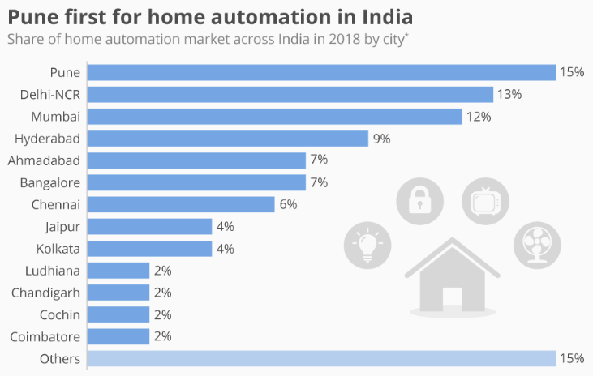
Figure 1: Increasing rate of home automation among the cities of India
(Source: Statista.com, 2018)

The above figure has shown that, with a 15% share of the overall market, Pune is now India's largest market for home automation. The rise of HNWIs and IT centers is responsible for the expanding market share of smart houses in India (Statista.com, 2018) . HNWIs are mainly found in Gujarat, the National Capital Region, and Punjab, while Coimbatore, Bangalore, Pune, Noida, and Hyderabad are home to the majority of IT hubs. This area of the study has revealed the increasing rate of home automation in India. This clearly indicates how future difficulties can arise for the jobs those home automation replaces such as those companies who manufacture door locks for customers they start to manufacture automatic door locks which replace the work of people who develop door locks.

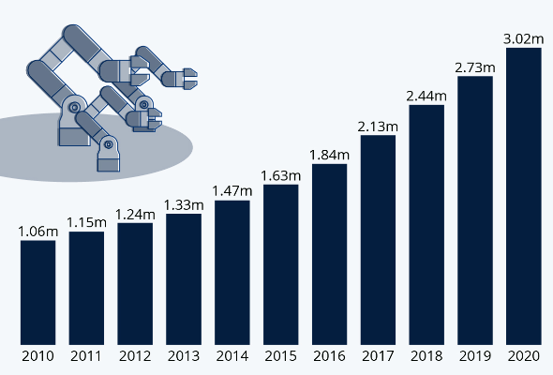
Figure 2: Increasing rate of robots in the operational industry
(Source: statitsta.com, 2021)

Even while more people are appreciating how convenient it is to have a robot clean their home or cut their lawn, industrial applications have seen the most improvement in robotics (Statista.com, 2021). Whether it's critical handling, assembly, or welding—the three jobs that industrial robots will be used for most frequently in new installations in 2020—modern manufacturing processes can't function without them shouldering a portion of the load.
The above statistic, which is based on data from the International Robotics Federation, shows that over the past 10 years, the number of operational industrial robots has tripled. By the end of 2020, more than three million robots will be in use across a range of industries (Statista.com, 2021). It has already been identified that Tata increases the rate of robotics in their company, which can replace 60,000 jobs in the future. On the other hand, while implementing automation in an organization, the development of a significant change management model helps the company in the long run. As per the view of Pellinen (2022), Lewin's change model helps to bring long-lasting positive changes in the organization, and most importantly, it helps to eliminate challenges and threats while bringing positive changes. Upskilling needs to be prioritized for the future of employment, not just in India but also internationally. Most importantly, as more companies turn to automation to increase efficiency and optimize industrial processes, improving workers' management skills will be beneficial to major organizations' financial health. It has been identified that a 2018 Capgemini Research Institute report found that by upskilling its workers, a 50,000-person organization could save $278 million over the course of three years. Increasing the rate of new jobs help to enhance the economic condition of the countries and most importantly it opens new job opportunity for the people. Investing in robot’s boosts output and quality, and the reduced costs frequently lead to more prospects for employment for their human counterparts (Dixon et al. 2021). While some companies may reduce their workforce after integrating robots, generally speaking, the surge in automation leads to additional hiring, therefore robots aren't really displacing workers at all. This is due to the fact that as these companies become more productive, they must expand their workforce to meet the demand. In order to boost production and foster competition, businesses perform at their best when they actively integrate emerging technologies, such as AI and robotics. Hence, it seems to benefit both the employees and the business as a whole. Actually, any employment-related problems are more likely to surface in companies that underinvest and stagnate. As per the view of Moldoveanu and Narayandas (2019), it has been identified that many organizations around the entire world start to develop training courses for their employees which help them to learn about new skills and technology. Most significantly, it showcases the employee value of the organization, and that helps to develop employee loyalty in the organization. In the case of Hindustan Unilever company, they have started a training program for their employees to improve their technical skills, and most importantly this move by the company helps to create the company's reputation in the competitive market.
The e-commerce industry gradually increases nowadays because of the platform. The concept of automation and the application of task-based models to examine it result in some overarching principles that seem to govern interactions between machines and humans. These make it possible to visualize the entire impact of automation on income and employment. The following areas of the study showcase how the nature of work in the world is changing gradually:
- Labor is replaced by automation. The basic goal of office technology is to achieve this. Whether technology can complete a task that is currently done by a human, it will accomplish it more rapidly, accurately, and affordably (Nissim and Simon, 2021). However, substitution has its limits because of the constraints of technology (machines will never be able to do everything) and price fluctuations.
- The addition of money and people helps innovation. As machines take over time-consuming, routine chores, human potential is liberated to create new jobs and products. In spite of the fact that ATMs made simple transactions unnecessary, consider how the proliferation of new consumer banking services aided in the expansion of local branch offices, increasing both the number of bank tellers employed and the required skill set for those positions. Notably, the US economy experienced a 50% rise in employment during the IT era between 1980 and 2007 in occupations with new job titles.
- Automation assists to increase demand and create more jobs. Machines take the place of workers, increasing quality and output while decreasing the cost of goods and services. This may be the result of boosting labor in these particular locations, though not usually and permanently (Agarbal et al. 2019). This is so that the enhanced demand for these commodities and operations carried on by the quality and cost experiences and support about by automation may offset any possible employment losses from automation. Automation's increased productivity and wages may also provide workers with more disposable income, which may stimulate consumption and lead to the creation of jobs in different sectors of the economy.
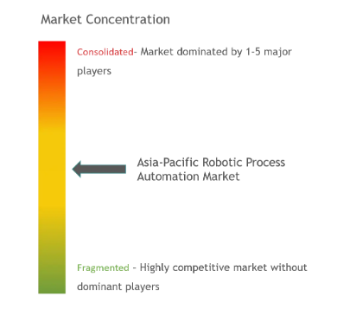
Figure 3: Market concentration in Asia-pacific
(Source: Zhou, 2020)
Asia-robotic Pacific's process automation market is competitive despite having few players. These companies are increasing their profitability and market share through clever joint ventures. AntWorks Pte Ltd, Automation Anywhere Inc., and Blue Prism Group PLC are a few additional notable participants (Zhou, 2020). In April 2020, as part of business growth, global RPA vendor Automation Anywhere announced that it would open several regional offices in the Greater China Region (GCR). In order to acquire an automated fare collection agreement for Metro Routes "2A, 2B, and 7", Datamatics and Mumbai Metro collaborated in February 2019. The consortium, which is led by AEP Ticketing solutions SRL, DGSL, and AEP, has issued the letter of acceptance (LOA) for deploying the AFC system at 52 stations in the popular city of Mumbai.
Manufacturing, a sector of the Chinese economy that is undergoing rapid change, is one of its main pillars. The country has advanced to a position of leadership in the manufacturing industry thanks to this substantial shift. Chinese investment mostly in high-tech services and manufacturing sectors grew in the first eight months of 2019, according to the NDRC. From January 2019 to August 2019, the investment climbed by 12% year over year, which represents an expansion of 0.9% basis points from the January-July timeframe (Toan and Chien, 2021). The use of robots in the production of electronic and electrical products is another factor boosting the industry in the area. Thanks to programs like "Make in India," businesses like Samsung Electronics have built the world's largest smartphone factory on earth in Noida, that located in India, with the capacity to produce 120 million phones yearly. The region's automotive industry is also predicted to be a major driver of demand for robotic process automation because China is the largest automobile market.
This area of the study has clearly showcased the major growth of Asia-pacific in automation and that changes the work culture of this area effectively. It has been found that the rate of employment is going to increase within 10 years in this area and that is only because of the crucial contribution of the automation industry. On the other hand, it can also be stated that the demand for skillful employees in this area is going to increase significantly.

Evolve the changes in the organization through automation
In this modern world, automation is used in businesses to operate processes, systems, and other methods automatically. Businesses and multinational corporations are using automation to make multiple advantages such as reduction in cost, effort, time, manual errors, and many more. According to the study of Jayatilleke and Lai, (2018), automation is generally used by companies while making changes that are significant for the company's outcome. After detecting the challenges that are affecting the growth and development of the organization automation can be used. Automation has a unique strength to improve retention, productivity, and workflow which is reflected in the quality of the outcome. According to the view of Cameron and Green, (2019), companies that deal with customers directly also get a huge benefit regarding customer service and delivery. In the case of Toyota Company, it has been identified that automation also increases transparency which helps in making business decisions and organizational cultural improvement.
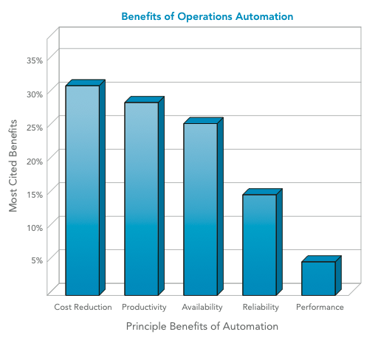
Figure 4: Benefits of automation
(Source: Jayatilleke and Lai, 2018)
The above figure portrays the benefits of automation which are experienced by companies in different ways. According to the study of Jayatilleke and Lai, (2018), cost reduction is also a huge benefit that is experienced by detecting errors and providing guidance to the employees of the organization regarding profitable decision-making. There are multiple ways of changing an Toyota's processes and in this generation, most of them are done by automation, industry 4.0, and many more. According to the research of Dzwigol et al. (2019), an overview of the performance of the employees, managers, and leaders for organizations is also monitored through automation which is also a huge advantage to making changes from a broader perspective.
Many countries have been working on improving their manufacturing hub and that can be done by implementing automation. The company Toyota is expanding its business in different countries with the help of automation as they have started manufacturing its products in various places effectively. Based on the above statement, Doppelt, (2017) has opined that major companies in the automobile sector are upgrading the skills of the employees to manage automation which can help in enhancing streamlined production methods and efficiency.
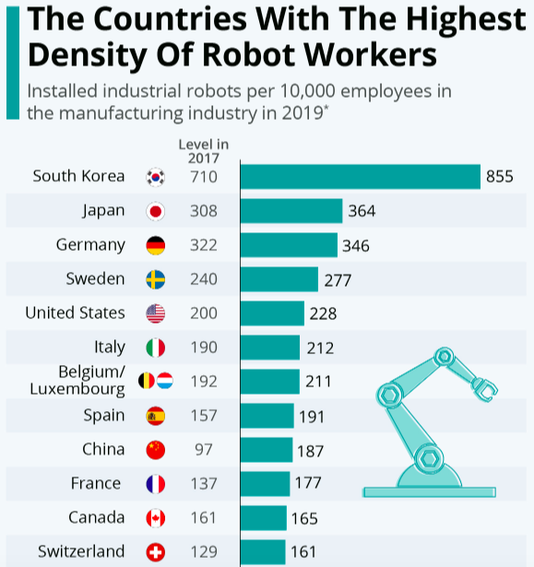
Figure 5: Statistics of using Automation
(Source: Doppelt, 2017)
The above figure is illustrating the list of countries that are using most automation and robotic workers in organizations for multiple uses. Countries such as India, China, Australia, and Japan are facing challenges in this situation regarding job losses and unskilled labor and that is affecting the economy heavily. On the other hand, countries in North America and Europe are facing fewer obstacles compared to the above-mentioned countries concerning these aspects. According to the research of Dzwigol et al. (2019), there are five components in this process that can help in making an effective change that is needed to fulfill the objectives of the organization and those are Inputs, Activities, Outputs, Outcomes, and Impact. The presence of automation in these components can be effective to detect the required factors which can drive the organization to its desired goal and objectives. According to the research of Domingues et al. (2017), automation can help the organization by solving primary issues such as improving the skills and knowledge of the employees by providing training that is effective for growth. The organizational growth and outcome also depend on the performances of the employees and that is why improvement in skills, knowledge, techniques, and experience would be effective for the future.
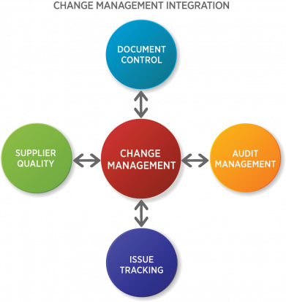
Figure 6: Integration of Change management
(Source: Domingues et al. 2017)
The Integration of Change management is shown in the above figure which can be easily done with the help of automation. Organizations in India, South Korea, China, Australia, and Japan need some changes in the structure and culture and that can be done by applying automation which is very effective as per the reports. According to the research of Dzwigol et al. (2019), the implementation of the Change management process is to evolve quality and compliance. The elements of Change management integration such as audit management, supplier quality, and issue tracking are one of the significant factors to focus on during the Change management process. Since the pandemic hits the Global market 74% of companies are implementing automation in their business processes as it is helping them to understand the challenges and focus on digital transformation for a better outcome. According to the research of Domingues et al. (2017), aligning the Change management process with automation can be effective in aligning the departments in the organization during digital transformation as it changes many processes, methods, and operations. According to a survey, the most common organizational issues are productivity, process management, innovation, teamwork, customer satisfaction, customer relationship management, and many more. According to the research of Yatskiv et al. (2019), these challenges can be determined specifically with the help of automation. The mitigation of these issues can be done with the implementation of the Lewin Change management model. This management model was developed by Kurt Lewin in 1940 after understanding the requirement of changing organizational structure and others.
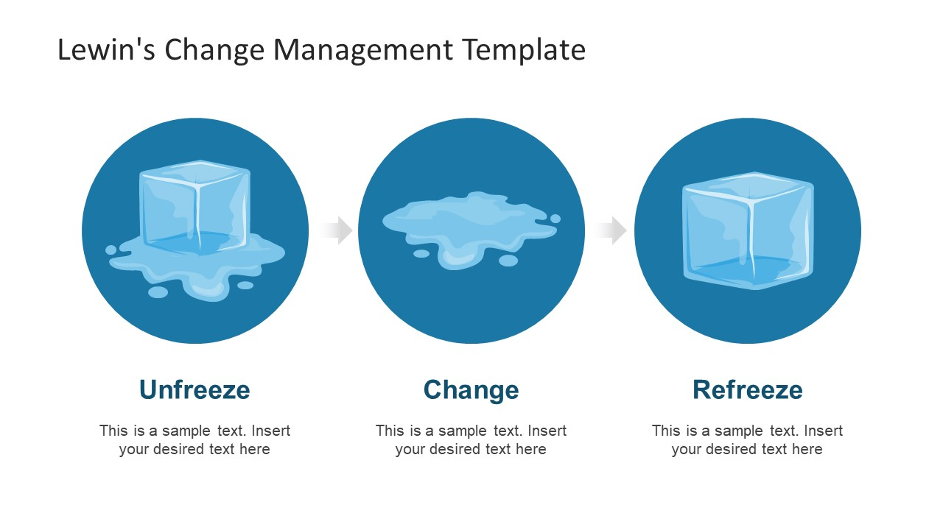
Figure 7: Lewin Change management model
(Source: Created by the author)
This Lewis change management model is applied in three stages in Toyota Company. The description and function of the stages are mentioned in the below section.
Stage 1: Unfreeze
The first stage of the change process involves the preparation that the Toyota needs to do for accepting the changes that are necessary. These changes should be done to meet the business objectives and goals within a limited time frame. In this stage, organizations focus on the functions that are needed to be changed immediately for the betterment of the performance and outcome. As per the surveys, the first stage of the process is always stressful and difficult for the employees of the organisation.
Stage 2: Change
The second stage is focused on the change based on which the implementation is done. The change can be done after identifying the issues that are affecting certain factors of the Toyota. Along with that, the change should impress the employees in a new direction that can specifically drive them to meet the objectives and goals prominently. The analysis of the change that is going to be implemented by the organization can be measured by applying it to the Change Curve.
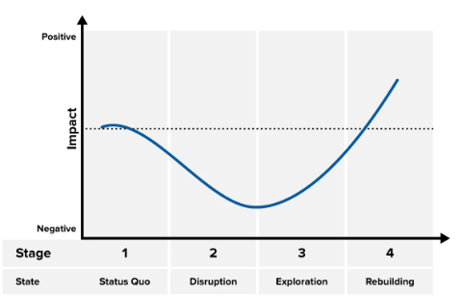
Figure 8: Change Curve
(Source: Created by the author)
The Change Curve that is illustrated in the above figure is used to analyze and monitor the changes done in the organization. There would be four stages in this curve section that is focused on special factors that can change the environment of the organization. Every popular brand such as Apple, Microsoft, Adidas, and other companies has been constantly changing their processes to adopt new technology and systems for improving their performance and outcome to gain more customers. Monitoring the improvement on a regular basis is important for the vision of the Toyota and that can be done by implementing this stage. The changes should be analyzed multiple times by the employees of the Toyota and that can be effective to determine the challenges which can affect the organization after implementation. Along with that, the vision of the organization should be clear and based on that the strategy would be implemented and the reason behind the change in the organization should be clear to all the employees as well to maximize their efforts while the changes are experienced by the organization. After this stage, the organization needs to proceed to the last stage which is Refreeze.
Stage 3: Refreeze
This stage is focused on adopting and experiencing the new changes in the Toyota and making them stable for improving the organizational outcome and other required aspects. The employees in the organization should focus on the improvement in stability, confidence, and comfort as that can help in enhancing performance, productivity, efficiency, and quality of the organization. The adoption of changes in the leadership, reward system, feedback system, organizational structure, organizational culture, and communication system is very significant for further processes. Along with that, the employees should focus on improving and stabilizing these aspects which can help the Toyota to meet its objectives and achieve the goals effectively. Organizations that are using automation in their business to grow are getting an advantage by driving exponential growth which increases the reach of the company in different markets and has the full potential to convert people into customers efficiently. Hiring standard employees for the organization who have the potential to change the organization's weaknesses into strengths and threats into opportunities needed in the situation can be done by implementing automated processes and Systems.
This area of the study has clearly portrait that in the Toyota company significantly the employees are effected by the Lewis change management model. Moreover, it helps them to improve their performance in the organisation and that enhance the customer satisfaction rate affectively.
Organizations such as Tesla, Airbnb, Canva, and many more are using the technologies of automation which include “better lead scoring, improved segmentation, reduced churn, probability-based customer mapping, and more impactful campaigns”. According to the top analyst, the organization suspends huge amounts of hours in an excel sheet whereas they are missing the gaps in the performance of the employees and that can be fulfilled by applying automatic systems in the required places. There are multiple types of automation tools that can effectively help in different organization segments.
Selenium
This tool helps in improving the operations of marketing and improving the network.
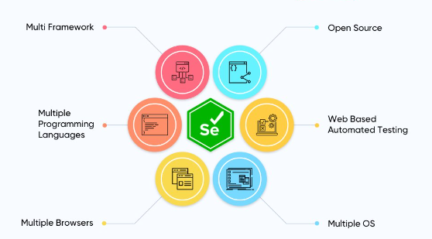
Figure 9: Selenium tool
(Source: Anwer et al. 2019)
The Selenium tool ranks number 1 due to its potential and performance for organizations. According to the research of Anwer et al. (2019), the automation tool has the ability to create advanced automation scripts to increase reach in the domestic and international markets. It also has the ability to support parallel test execution which is very much important while making changes in the organization. Toyota has implemented this effective tool in their company and that assist to improve their operation and business performance in the company.
Appium
This particular tool can help the brands to connect with mobile phones which are immensely required in the stage to acquire a large customer base.
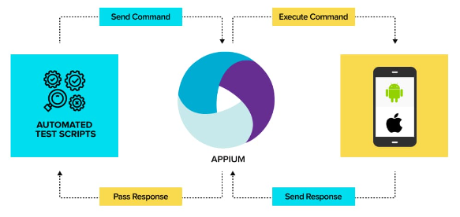
Figure 10: Appium tool
(Source: Siderska, 2021)
The Appium tool is used to connect the entire technology to mobile applications. As the customer sir mostly on the social media platform this tool can help them to make the connection strong for the organization effectively. According to the research of Siderska, (2021), the benefits of using this application are gaining popularity among consumers in the market with immense stability which is highly required for the organization to improve the Network and other factors. Implementation of these effective tool in the Toyota company help to improve the brand reputation in the comparative market. mode over it has also identified that this advanced technology in hands the customer satisfaction rate and that influence the customer engagement rate in the company. According to the research of Anwer et al. (2019), this tool is precisely considered the best for mobile applications as it helps to connect with consumers who have IOS, Android, and Windows applications. Connection to the mobile application has another benefit which is language and that can be used in every market on the international platform.
There are many similar kinds of tools that can be used as automation for the organization to improve the required aspects. According to the research of Delsing, (2017), tools such as Catalon studio, Cucumber, Worksoft, HPE Unified Functional Testing (UFT), and many more. Companies such as Yokogawa Electric, Mitsubishi Electric, and many more automation companies in South Asia have adopted automation after facing challenges. According to the research of Pang et al. (2018), these companies have been inspired by Schneider Electric, Honeywell process solutions, Rockwell Automation, and many more as they have been using automation tools and Technology for many years and improving their organization outcome on the Global stage.
As organizations are facing job loss due to the utilization of automation similarly automation is also helping multiple businesses to grow and that requires a workforce and unemployment is decreasing massively. On the other hand, Siderska, (2021) has stated that the government should focus on increasing business and organizations' growth and which can drive the employment rate efficiently. The mentioned automation tools have the ability to grow the businesses as per their potential and that is needed immensely during such challenges. According to the research of O’Connor et al. (2019), Job loss continued in the market due to unskilled and unprofessional people involved in the organization which is affecting the business aspect in the domestic and global markets. This can be improved by automation and the unskilled and unprofessional people also become professional and skilled as required by businesses and organizations (Anwer et al. 2019). According to a survey of organizations in Japan, South Korea, China, India, and Australia, the implementation of automation has been increasing massively and that can affect the employment rate. According to the research of Bindra and Mantooth, (2019), this can be increased by starting new businesses and companies which need a workforce massively. These strategies are applied by North American and European companies as per the latest report of Forrester. Adoption of automation in the mentioned five countries can be effective as it is improving the economy and standard of the product and services provided to the customers and in the international stages. According to the research of Moriwaki (2017), this is helping organizations to raise the skills and employability rate in the country with the quality outcome that is needed. There are multiple companies in North America and Europe that have been developing Smart home ecosystems and hubs which involves Amazon Alexa, Apple HomeKit and Siri, Google Home and Google Assistant, and many more and that is driving consumers majorly in every continent (Domingues et al. 2017). Automation helps the organization to acquire a huge range of customers and that has been proven by European and North American countries.

Discussion of the type of organizational structure that affects the change management process in light of Toyota Company.

Toyota is one of the most popular Japanese companies and this company follows a divisional organizational structure. This company started to implement automation technology to improve its operation process. In this scenario, the development of a change management model is highly important for the company. According to Burton and Obel (2018), it has been stated that divisional organizational structure helps in the gradual changes of the company and that supports the employee value, and most importantly, assists to enhance the sales rate of the company. In my opinion, this effective organizational structure helps the management team to implement the changes in the company with proper efficacy and knowledge. On the other side, there are a few significant benefits that have been identified that develop because of this organizational structure. This effective organizational help the manager to improve their managerial skill and that improve the service and production of Toyota effectively. In this structure divisional head is crucially responsible for all types of losses and profits for Toyota. This statement clearly indicates that this structure helped in the entire change management of Tesco company. As per the view of Nielsen et al. (2019), it has been identified that a divisional organizational structure enhances flexibility and initiative among managers, which helps in implementing changes inside the organization. I think that this is one of the most effective features of this organizational structure because this crucial feature helps to create a significant impact on the change management model of the company and that increases the value of a customer as well as employees of the company. At the time of taking any crucial decision, this effective organizational structure plays an effective role.
According to Martela (2019), it has been found that in a divisional organizational structure, any crucial decision is taken very rapidly and that helps to resolve any challenging situation in the company. In my opinion, I can state that taking a fast decision in a critical time, help Toyota to handle any situation after implementing new automation technology in their company and enhance the safety and security of employees. Many times, it has been found that because of the lack of technical skills among employees, there are major challenges in handling new automation technology in the company. In the case of divisional organizational structure, it helps to improve the managerial operation, which assists in improving the training facilities of employees in Toyota, and that decreases the chances of this type of issue from the organization (Martela., 2019) However, on the other hand, sometimes this effective structure can bring major challenges for change management. It has been identified that at the time of implementing any change management model in the organization, proper communication and positive relationships between employees and managers are needed. In this situation, the divisional organizational structure creates a major communication gap and increases the conflict rate in the organization, which affects the entire change management procedure of the company. In my opinion, I can have stated that this type of issue can decrease the productivity rate of the company and also negatively affect the project investment, which creates a major loss for the company. Hence, the management team should be more aware of the time needed to handle this type of situation.
Hence the company Toyota has a Divisional organization structure that means operations in the business are centered around Geographic groups, products, and markets. According to my opinion, the methods used in Toyota are based on traditional Japanese business hierarchy and the senior executive has the power to make decisions. Any kind of changes in the management or system is driven by the Senior executive and that is due to the structure and the culture (Pang et al. 2018). The Change management process in an organization is done after identifying the obstacles and issues that affect the company in certain aspects. The company Toyota needs to grow in the global market and has become limited in this situation. On the other hand, Aini et al. (2020) stated that, Change Management principles that are going to be adopted by any company should follow principles that understand the change, planning the change, implementing the change, and communicating regarding the changes. Toyota and its organizational structure have the potential to influence The Change management process with the help of automation and that can effectively improve the networking issue that is affecting the growth of the company in several countries. According to the research of Morgan JM, (2020), the company is primarily facing challenges regarding weak management that reflect on workforce management and weak performances. According to the survey the company is willing to save manpower and production with maintaining the quality of the outcome and that can be done by focusing on Change management procedures. According to my perspective, the Change management processes can be done using automation tools and technology which is done by Global competitors such as Tesla, Rolls-Royce, and many more. The company should use automation as the number of manual errors or human errors is increasing during production and that is unavoidable while it is selling to the customers (Barron et al. 2017). This is causing customer loss which affects the company's revenue more than low production and Manufacturing of the vehicles. According to some reports, Toyota is using “Symbio's AI-based software” which is providing real-time control to industrial robots and enhances flexibility and production without errors. Due to the presence of the Toyota Production System (TPS), the company has applied Lean manufacturing and waste elimination processes which is producing the overhead and manufacturing costs efficiently (Iwao S, 2017). The company is currently using major concepts such as Jidoka and just-in-time which is helping them to increase the production of vehicles with a variety of domains such as automobile, machinery, and textile.
Recommendation
Recommendation 1: Including Automation in day-to-day life
European and North American companies have been implementing automation in everyday life which is helping consumers to gain an advantage regarding cost reduction time reduction and other factors. Automation can be used in telephonic switchboards, electronic navigations, and so on in different places which are helping consumers to make the effortless in that daily life hence they are needed in this situation. The company Toyota needs to implement these automated systems in different places to gain market advantage as needed.
Recommendation 2: Adopting Automation to increase productivity and quality
European and North American companies are using automation in every required place to increase the quality and productivity of the work. The implementation of Robotic Gas Pumps, Garage Opener Apps, Appliance-Controlling Adapters, Automated School Buses, Automated Texting Apps, and many more can help to bring an effective change that is needed to improve productivity and quality of the outcome.
Conclusion
The above discussion on the Change management process and automation can help the research to conclude precisely. The impact of jobless and similar challenges due to automation is discussed in this research. The North American and European companies excelled in their performance with the help of automation which is described in the study. The use of the Lewis change management model is also done in the study with a proper analysis of South Asian countries and their risks regarding automation adoption. A vast reflection on the organizational structure of Toyota and its influence on the Change management process is also done in the study. Based on this a proper recommendation is provided which helps to summarize the research as needed.

Reference List
Agrawal, A., Gans, J.S. and Goldfarb, A., 2019. Artificial intelligence: the ambiguous labor market impact of automating prediction. Journal of Economic Perspectives, 33(2), pp.31-50.
Aini, S., Lubis, M., Witjaksono, R.W. and Azizah, A.H., 2020, June. Analysis of Critical Success Factors on ERP Implementation in PT. Toyota Astra Motor Using Extended Information System Success Model. In 2020 3rd International Conference on Mechanical, Electronics, Computer, and Industrial Technology (MECnIT) (pp. 370-375). IEEE.
Anwer, S., Wen, L. and Wang, Z., 2019. A systematic approach for identifying requirement change management challenges: Preliminary results. Proceedings of the Evaluation and Assessment on Software Engineering, pp.230-235.
Barron, A., Pereda, A. and Stacey, S., 2017. Exploring the performance of government affairs subsidiaries: A study of organisation design and the social capital of European government affairs managers at Toyota Motor Europe and Hyundai Motor Company in Brussels. Journal of World Business, 52(2), pp.184-196.
Bindra, A. and Mantooth, A., 2019. Modern tool limitations in design automation: Advancing automation in design tools is gathering momentum. IEEE Power Electronics Magazine, 6(1), pp.28-33.
Burton, R.M. and Obel, B., 2018. The science of organizational design: fit between structure and coordination. Journal of Organization Design, 7(1), pp.1-13.
Cameron, E. and Green, M., 2019. Making sense of change management: A complete guide to the models, tools and techniques of organizational change. Kogan Page Publishers.
Delsing, J., 2017. Local cloud internet of things automation: Technology and business model features of distributed internet of things automation solutions. IEEE Industrial Electronics Magazine, 11(4), pp.8-21.
Dixon, J., Hong, B. and Wu, L., 2021. The robot revolution: Managerial and employment consequences for firms. Management Science, 67(9), pp.5586-5605.
Domingues, A.R., Lozano, R., Ceulemans, K. and Ramos, T.B., 2017. Sustainability reporting in public sector organisations: Exploring the relation between the reporting process and organisational change management for sustainability. Journal of environmental management, 192, pp.292-301.
Doppelt, B., 2017. Leading change toward sustainability: A change-management guide for business, government and civil society. Routledge.
Dzwigol, H., Shcherbak, S., Semikina, M., Vinichenko, O. and Vasiuta, V., 2019. Formation of strategic change management system at an enterprise. Academy of Strategic Management Journal, 18, pp.1-8.
Iwao S. Revisiting the existing notion of continuous improvement (Kaizen): literature review and field research of Toyota from a perspective of innovation. Evolutionary and Institutional Economics Review. 2017 Jun;14(1):29-59.
Jayatilleke, S. and Lai, R., 2018. A systematic review of requirements change management. Information and Software Technology, 93, pp.163-185.
Karim, M.M., Choudhury, M.M. and Latif, W.B., 2019. The impact of training and development on employees’ performance: An analysis of quantitative data. Noble International Journal of Business and Management Research, 3(2), pp.25-33.
Leal Filho, W., Tripathi, S.K., Andrade Guerra, J.B.S.O.D., Giné-Garriga, R., Orlovic Lovren, V. and Willats, J., 2019. Using the sustainable development goals towards a better understanding of sustainability challenges. International Journal of Sustainable Development & World Ecology, 26(2), pp.179-190.
Martela, F., 2019. What makes self-managing organizations novel? Comparing how Weberian bureaucracy, Mintzberg’s adhocracy, and self-organizing solve six fundamental problems of organizing. Journal of Organization Design, 8(1), pp.1-23.
Moldoveanu, M. and Narayandas, D., 2019. The future of leadership development. Harvard business review, 97(2), pp.40-48.
Morgan JM, Liker JK. The Toyota product development system: integrating people, process, and technology. Productivity press; 2020 Oct 28.
Moriwaki, T., 2017. Ten years of International Journal of Automation Technology. International Journal of Automation Technology, 11(3), pp.339-339.
Nagarkar, S.V., 2022. Dynamic privacy and security assessment in a smart home environment using big data analytics.
Nielsen, J.E., Babić, V., Stojanović-Aleksić, V. and Nikolić, J., 2019. Driving forces of employees’ entrepreneurial intentions-leadership style and organizational structure. Management: Journal of Sustainable Business and Management Solutions in Emerging Economies, 24(3), pp.59-71.
Nissim, G. and Simon, T., 2021. The future of labor unions in the age of automation and at the dawn of AI. Technology in Society, 67, p.101732.
O’Connor, A.M., Tsafnat, G., Thomas, J., Glasziou, P., Gilbert, S.B. and Hutton, B., 2019. A question of trust: can we build an evidence base to gain trust in systematic review automation technologies?. Systematic reviews, 8(1), pp.1-8.
Pang, Z., Yang, G., Khedri, R. and Zhang, Y.T., 2018. Introduction to the special section: convergence of automation technology, biomedical engineering, and health informatics toward the healthcare 4.0. IEEE Reviews in Biomedical Engineering, 11, pp.249-259.
Pellinen, S., 2022. Implementing organizational structure change in supply chain management team.
Siderska, J., 2021. The adoption of robotic process automation technology to ensure business processes during the COVID-19 pandemic. Sustainability, 13(14), p.8020.
Singh, R., 2019. Why do online grocery shoppers switch or stay? An exploratory analysis of consumers’ response to online grocery shopping experience. International Journal of Retail & Distribution Management.
Statista.com (2018), Pune first for home automation in India, Available at: https://www.statista.com/chart/14229/pune-first-for-home-automation-in-india/ [Accessed on: 20/10/2022]
Statista.com (2021), Rise of the Robots, Available at: https://www.statista.com/chart/26210/operational-stock-of-industrial-robots/ [Accessed on: 20/10/2022]
Toan, N.D. and Chien, T.D., FOREIGN DIRECT INVESTMENT SITUATION AND TREND OF SOME ASIA COUNTRIES: OPPORTUNITIES FOR VIETNAM. Bank competition, ownership and stability interrelationship in transition economies: A case study of Vietnam, p.1102.
Yatskiv, S., Voytyuk, I., Yatskiv, N., Kushnir, O., Trufanova, Y. and Panasyuk, V., 2019, June. Improved method of software automation testing based on the robotic process automation technology. In 2019 9th International Conference on Advanced Computer Information Technologies (ACIT) (pp. 293-296). IEEE.
Zhou, Y., 2020. AUTOMATION, THE FUTURE OF WORK AND INCOME INEQUALITY IN THE ASIA–PACIFIC REGION1. Achieving Inclusive Growth in the Asia Pacific, p.103.

