Database Design (The Book Store)

Student Name: Lloyd Johnson
Student Number: 1802820
Module Code: ACCB4013
Module: Information Engineering

Contents
Introduction 3
Relationship Diagram 4
Reports 4
Forms 6
Evidence of SQL 10
User Guide 11

Introduction
This documentation will contain an Entity Relationship Diagram showing all the how all the tables created in the database relate to each other such as one to many relationships within the database.
The documentation will state the user requirements of the system and then explain what has been done to hit those requirement targets in the database.
The documentation will also show evidence that correct forms, reports and tables have been used in the database and relate to the book store database. There will also be evidence that SQL was used to create the database tables and queries.
The documentation will include a User Guide. This user guide will talk through all the steps that a user will need in order to fully understand what each button in the database does. The user guide will also discuss how to add or delete any information from the table using the design view or SQL. The user guide will discuss what each table means and what information it holds. Next the guide will show the user how to query the system using Access or SQL. Then finally the user guide will show how to create forms and reports using Microsoft Access.

Relationship Diagram
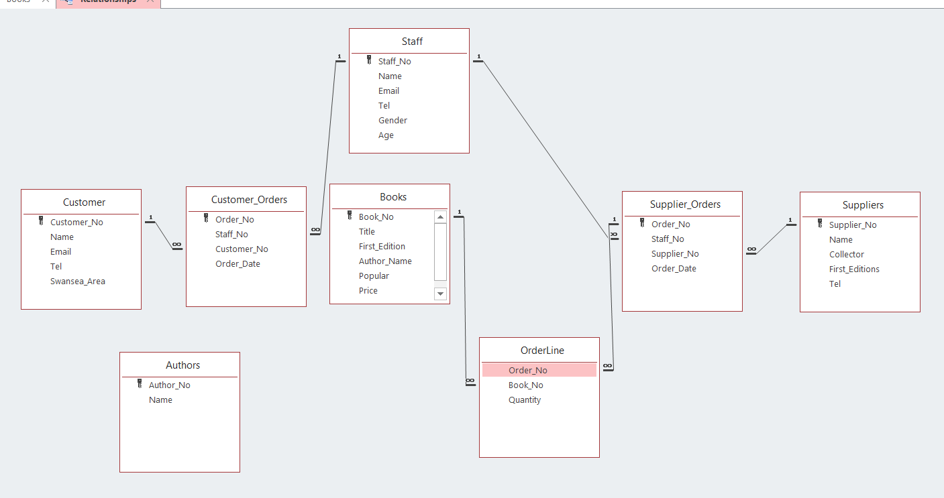

Reports
The Reports were made from the queries that were calculated in the database.
The first report created was a report on all the books that were less than £5 that were in stock.
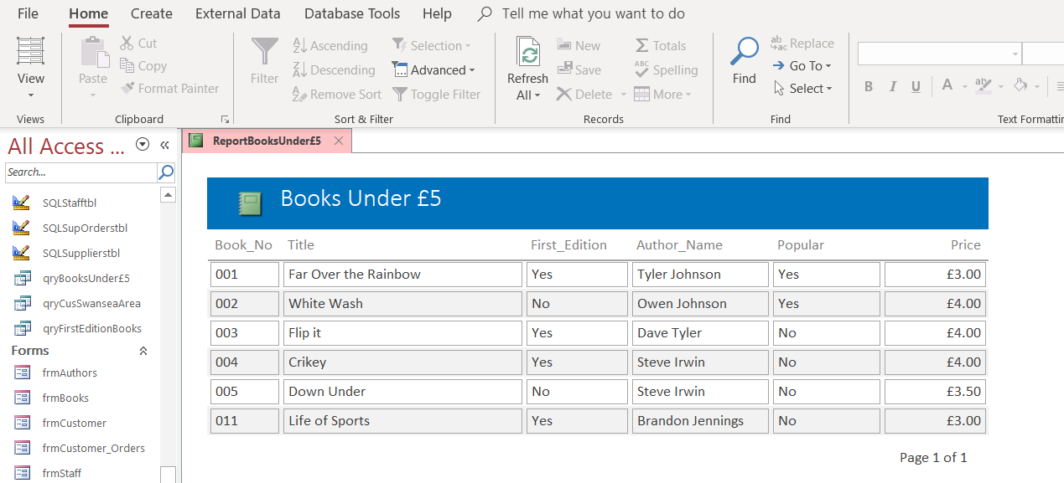

The next report shows all the first edition books housed in store.
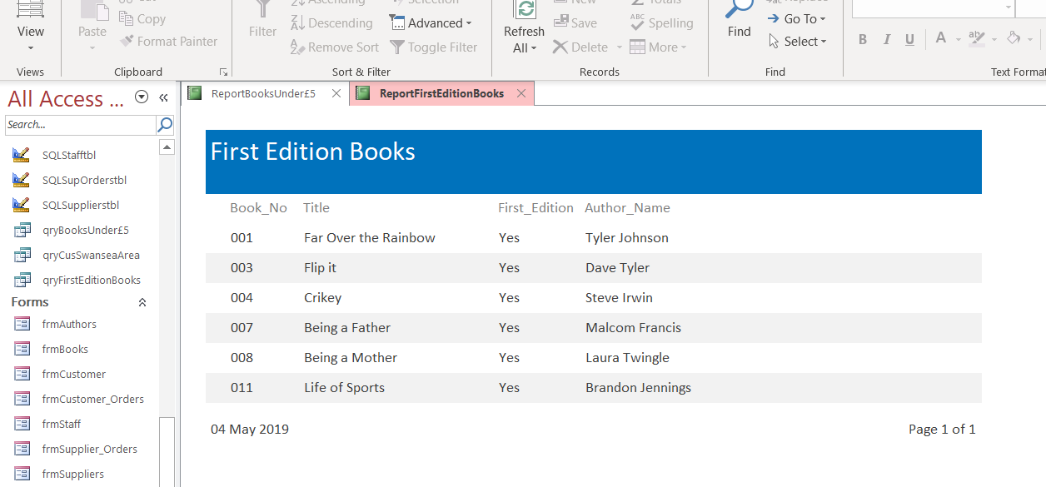
The final report showed all the customers contact information if they were based in the Swansea area.
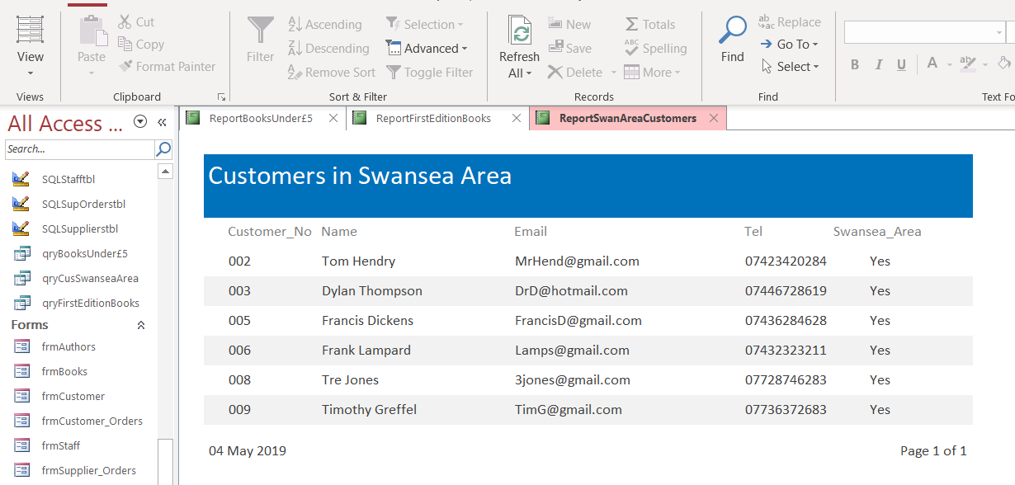

Forms
Authors Table form
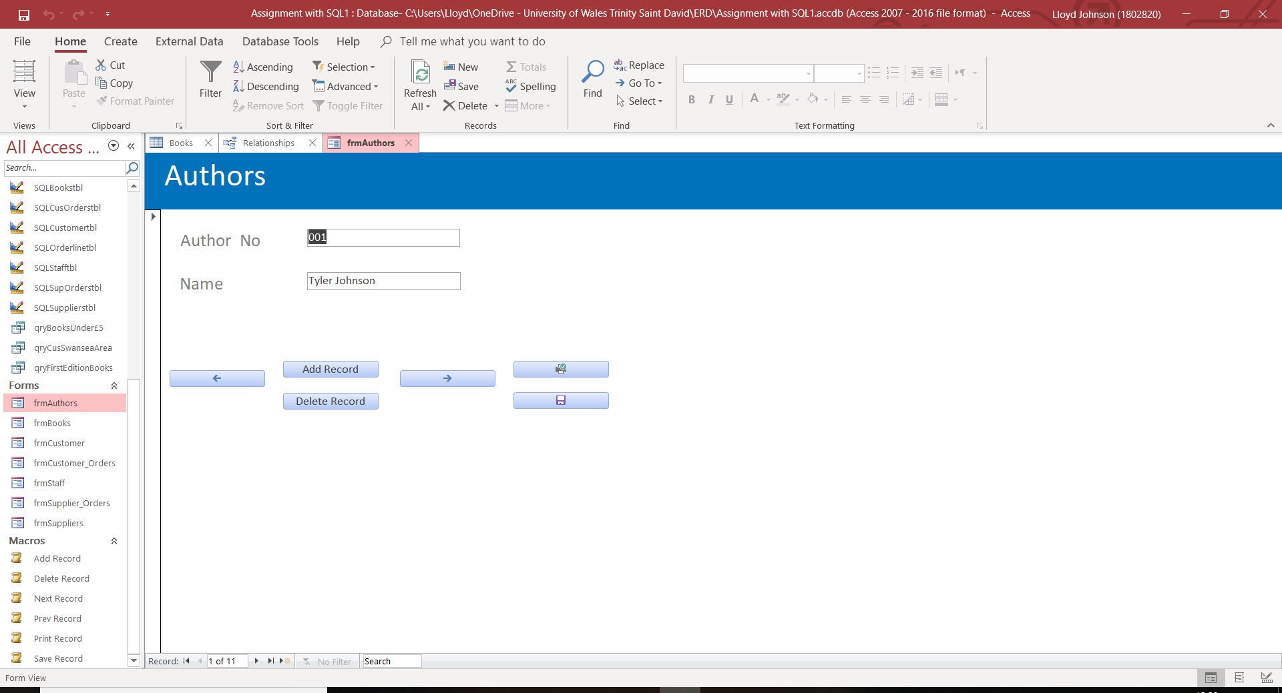
Books Table form
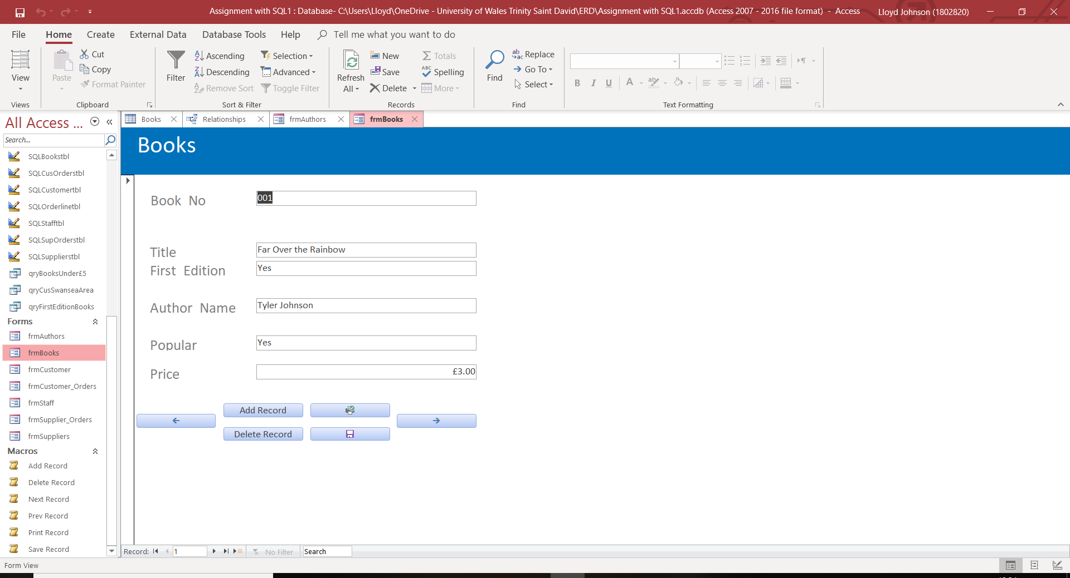

Customer Table form
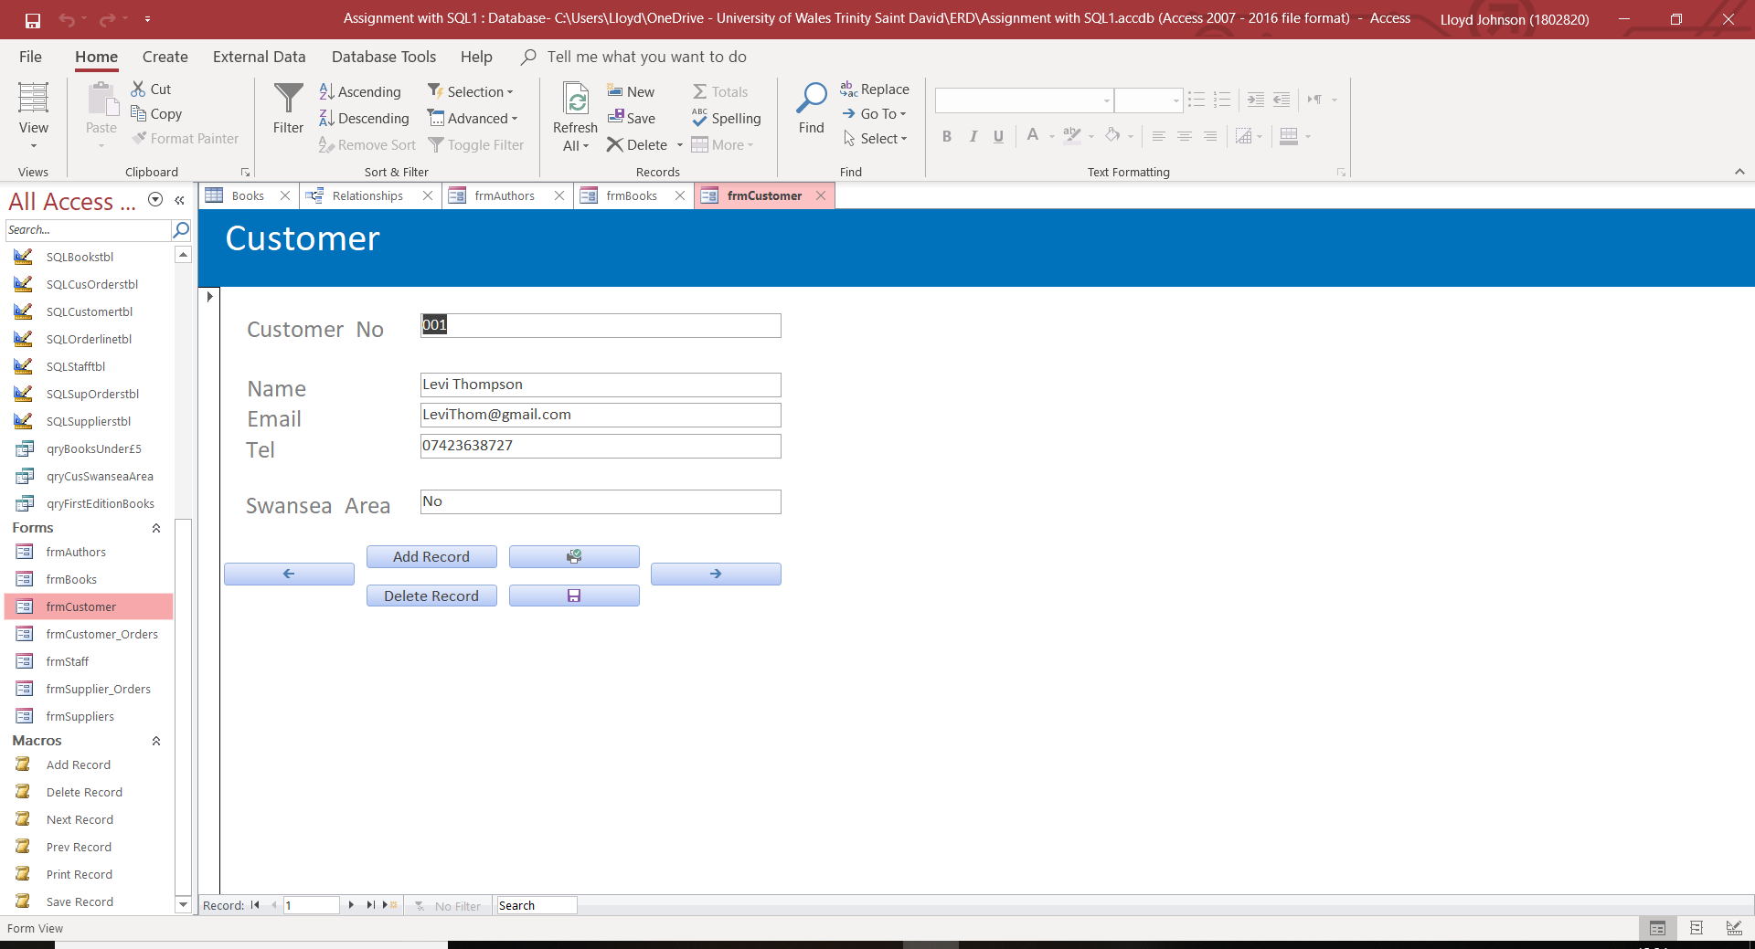
Customer Orders Table form
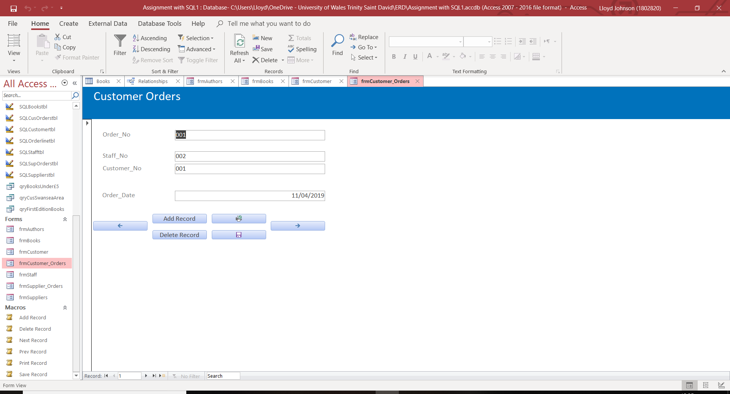

Staff Table form
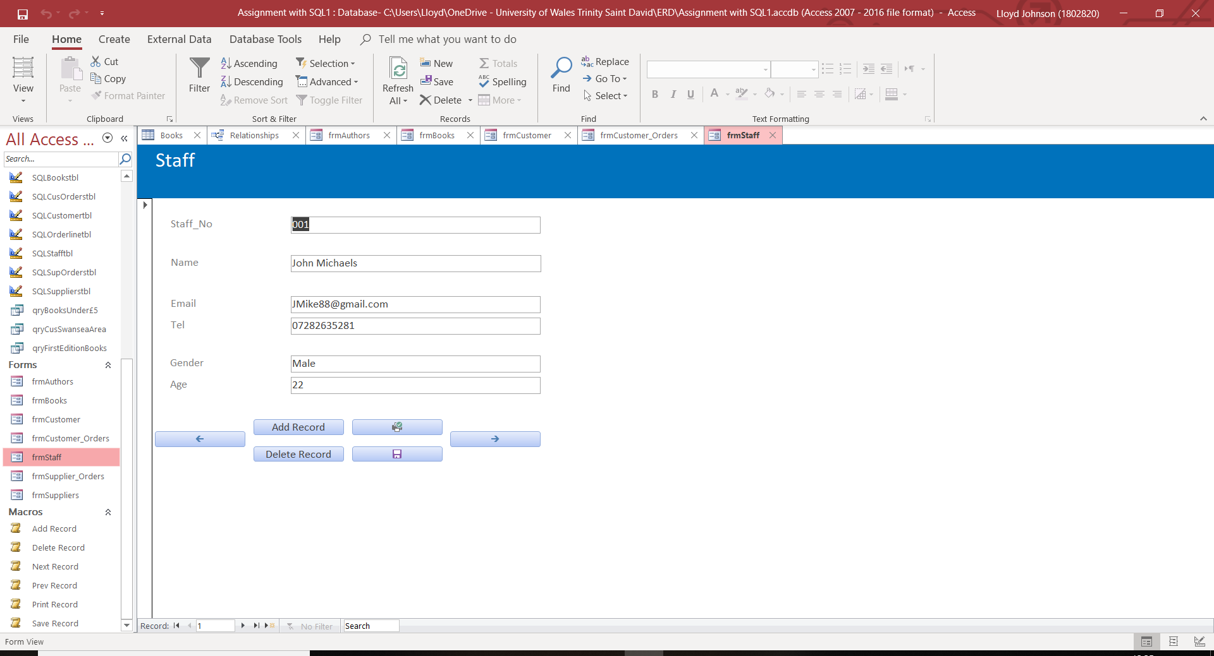
Suppliers Orders Table form
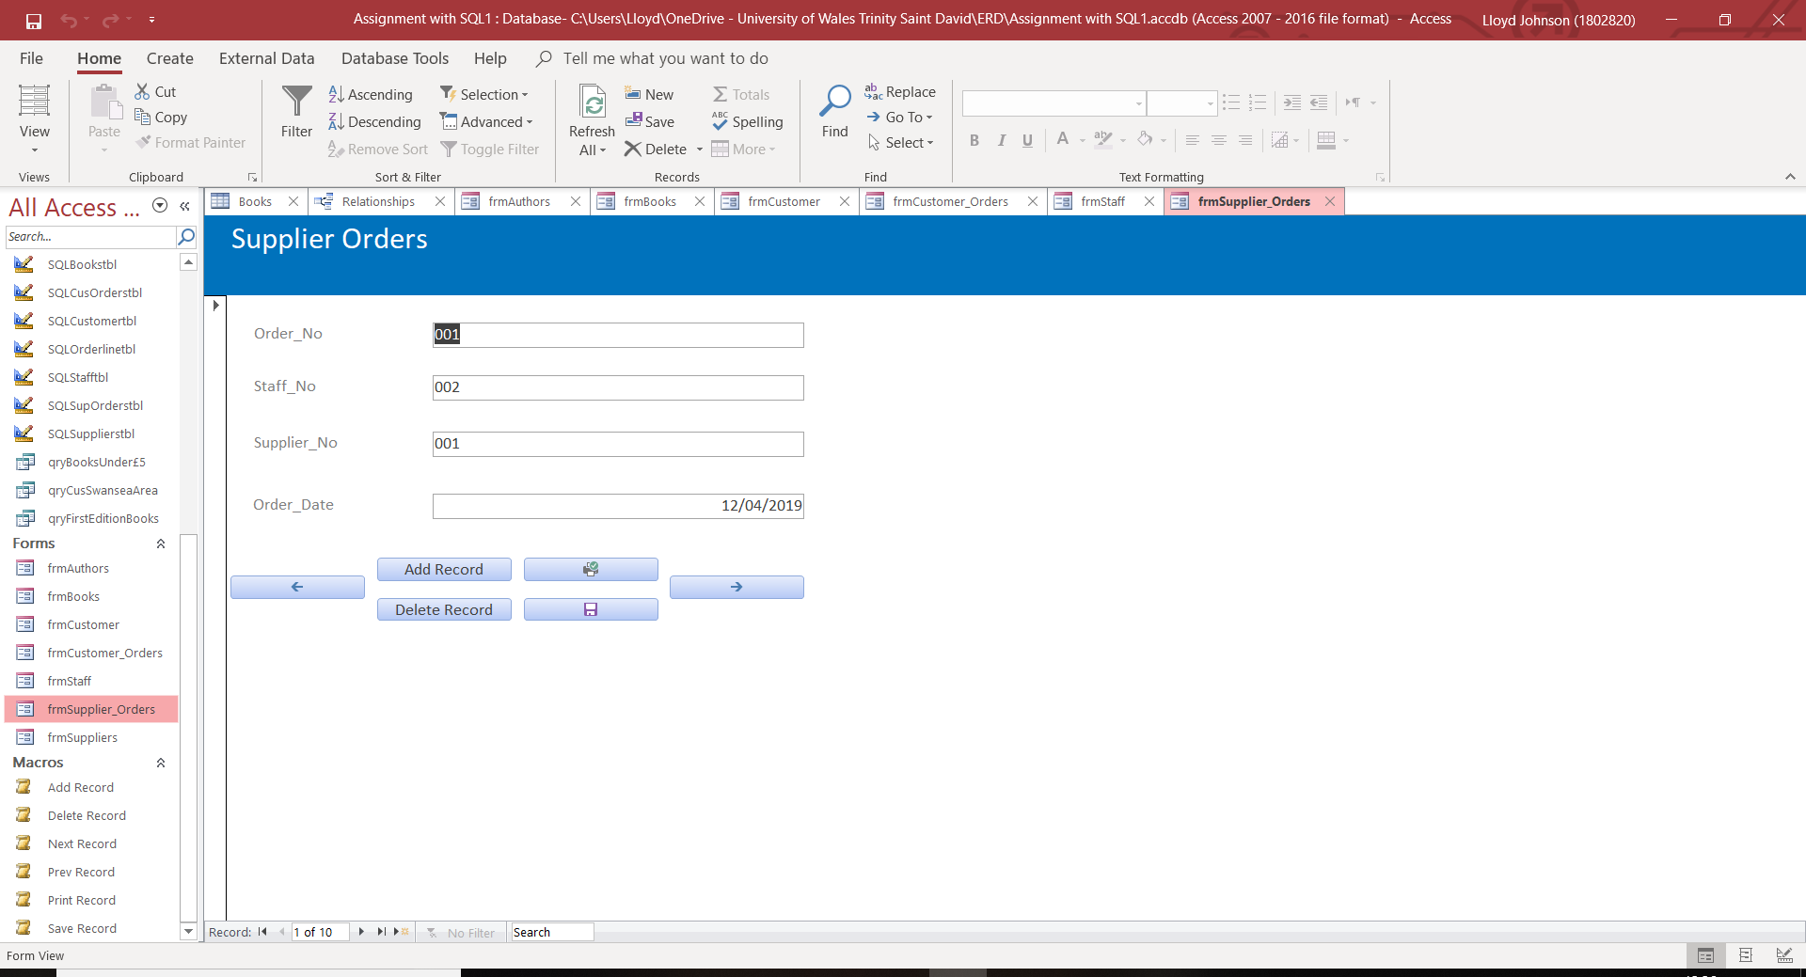

Suppliers Table form
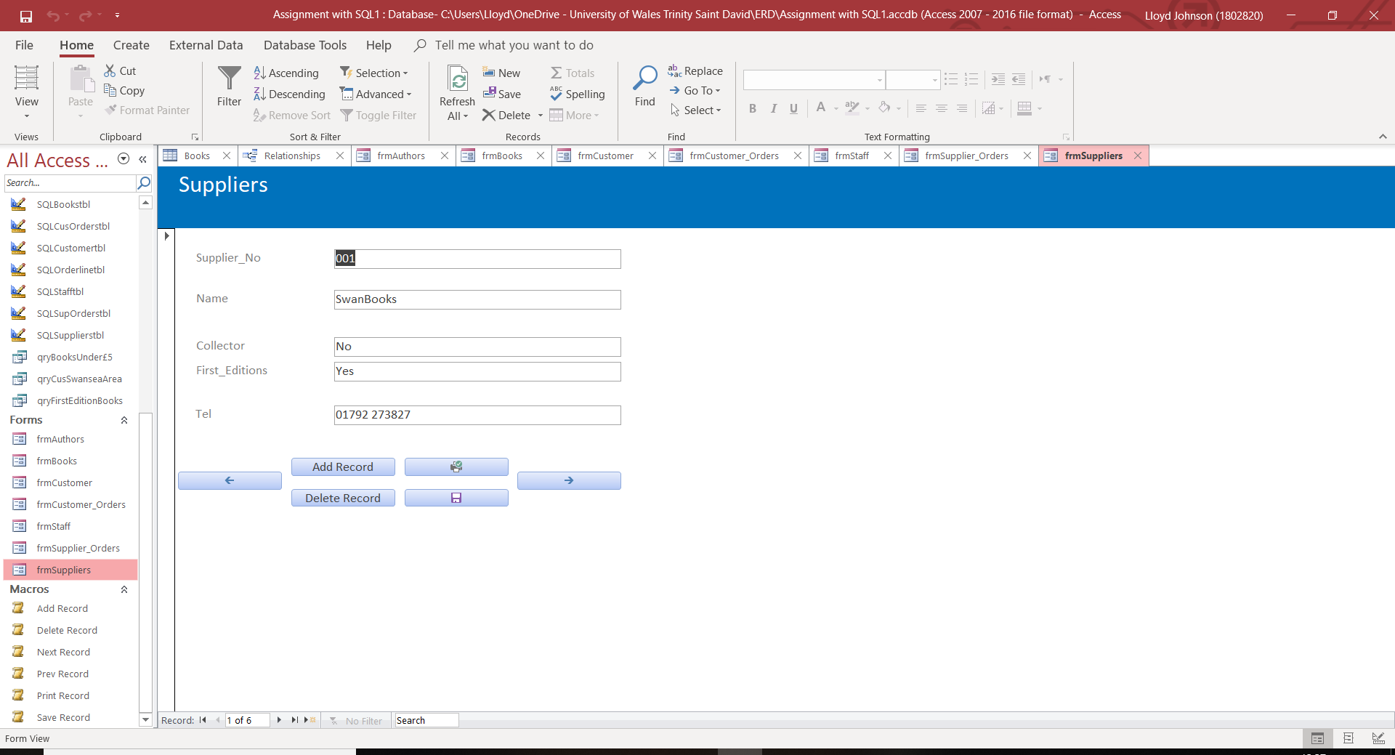
Order line Table form
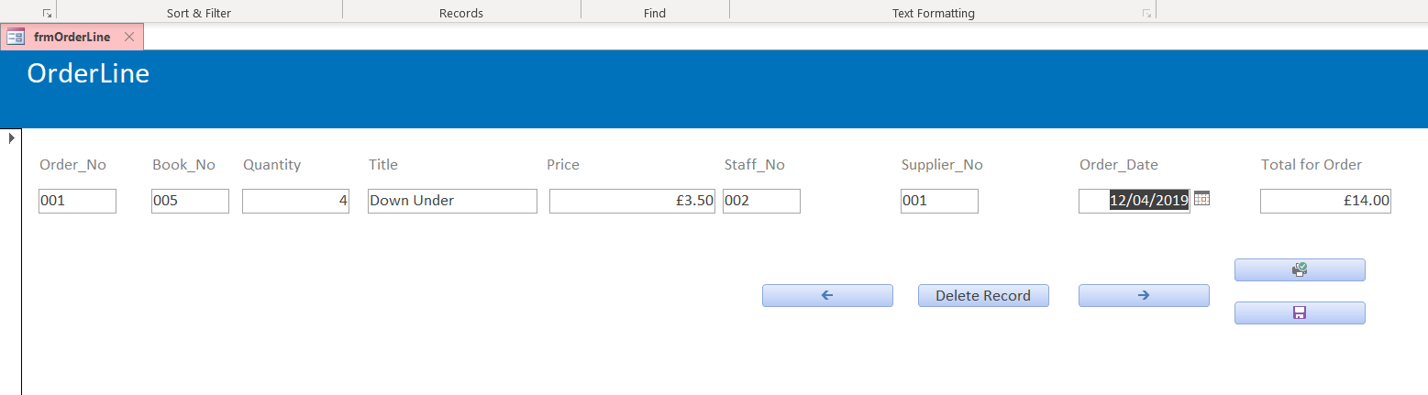

Evidence of SQL
The first place where SQL statements were used in the database was to create tables.
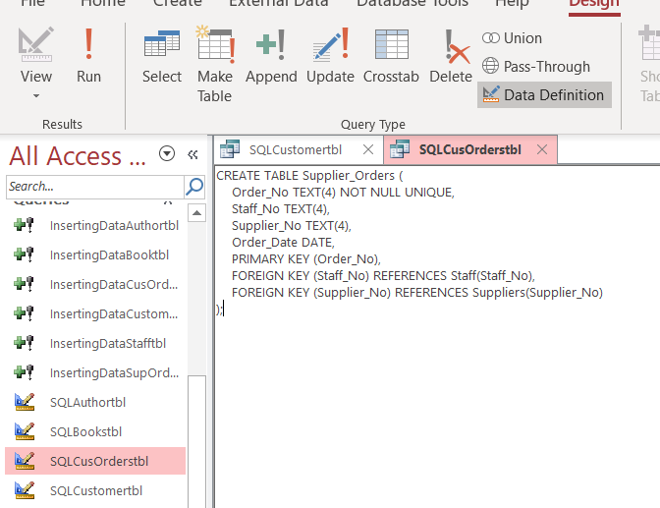
As the screen shot shows the relationships were created when the table was created. This was done by setting certain fields on the table as foreign keys and then referencing other tables fields. The Primary keys were also set when writing the SQL for the table.
Another area that SQL was used in the database is populating the tables within the database.
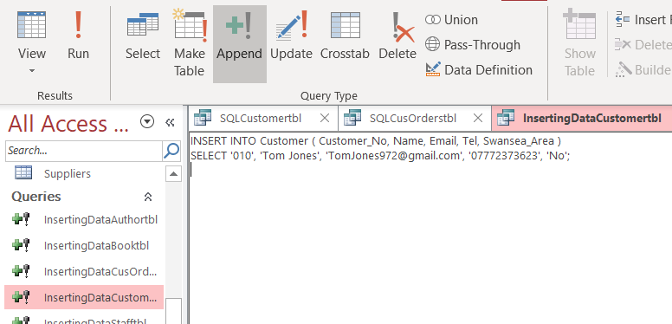
All the tables in the database were populated using SQL.

SQL was also used to create queries from the tables.
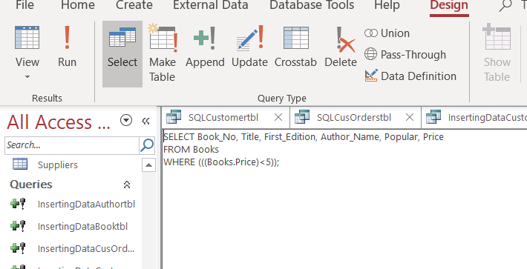

User Guide
This guide will teach the user how to correctly navigate through the database. The guide will also show the user how they will be able to edit, add and delete all the data within the database.
To navigate through the database, there is a menu that will appear when the database is first opened.
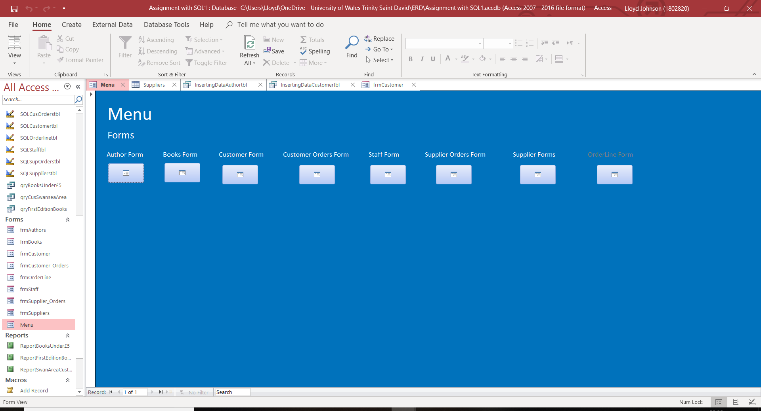
To be taken to the form of the user’s choice simply select the button below the users form.
  - Using the forms
There are buttons on the forms that allow the user to edit the tables.
The two left and right arrow buttons will allow the user to navigate through the record in each of the corresponding table names.
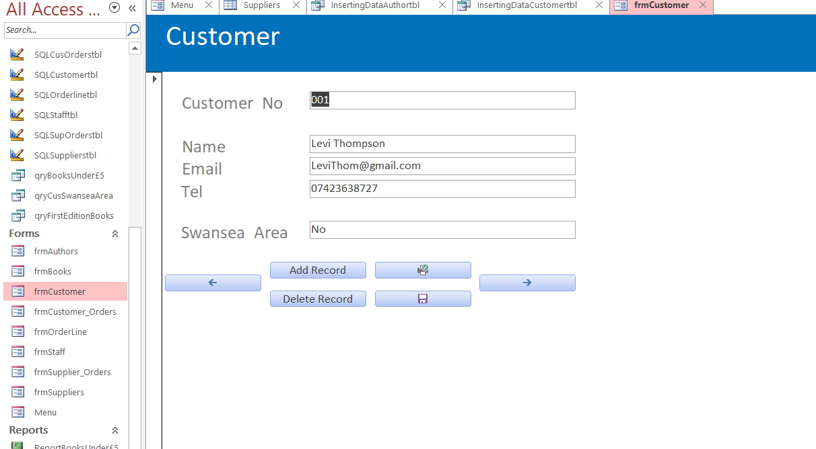
The left arrow will take the user to the previous record, while the right arrow will take the user to the next record.
The add button will take the user to another record form and allow the user to add new records to the tables. The delete record button will delete a record from the table when clicked. The floppy disc button will allow the user to save any changes to the records that have been made or save a new record that was created.
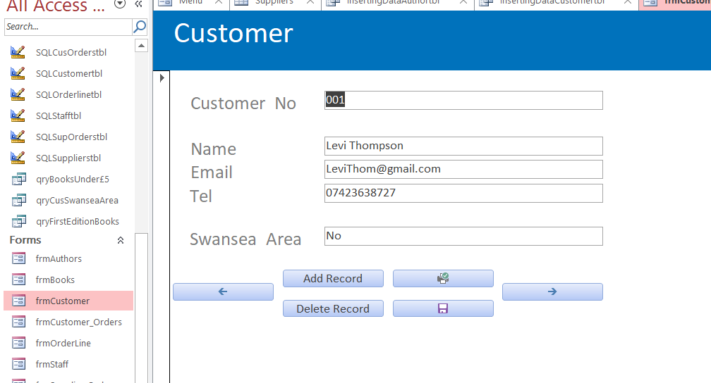

The printer button above that will print out the form page.

  - Using SQL
To add data to the tables without using the forms and using the SQL statements that are in the database select the queries with “Insertingdata” at the beginning. When adding record this way copies the code above, then simply change the information in the second line.
INSERT INTO Customer ( Customer_No, Name, Email, Tel, Swansea_Area )
SELECT '010', 'Tom Jones', 'TomJones972@gmail.com', '07772373623', 'No';
Change the code like this.
INSERT INTO Customer ( Customer_No, Name, Email, Tel, Swansea_Area )
SELECT '011', 'Tim Burton', 'TimB@gmail.com', '07772323243', 'Yes';
After the code has been changed delete the copied code.

To create tables using SQL select the “SQLNAMEtbl” queries. Again copy the code from these queries. Such as this.
CREATE TABLE Customer(Customer_No TEXT(4) CONSTRAINT customer_no_pk PRIMARY KEY,
Name TEXT(25),
Email TEXT(30),
Tel TEXT(12),
Swansea_Area TEXT(3));
- The Yellow highlight will change the name of the table
- The Red highlights will change the field names
- The blue highlights will change the size of the fields such as text length
- The green highlights will change the type of field it is such as currency or number.
Changing the field types
- Integer is for Numbers
- Currency is for currency
- Date/Time is for the date and the time.
To add a primary key to the table type this after the field you want selected.
CONSTRAINT “FIELDNAME”_pk PRIMARY KEY
Then finally to add a foreign key to the table which will set up relationships type this at the end of the code.
FOREIGN KEY (Staff_No) REFERENCES Staff(Staff_No),
- The green highlight is the name of the field the user wants to be the foreign key and it should have the same name as the field name in the table that the user is referencing.
- The red highlight is the name of the table that the foreign key is being referenced from.

