

Assessment 1 – Reading Task Template
PART 1: Upload your photo of your A3 in-class notes here:
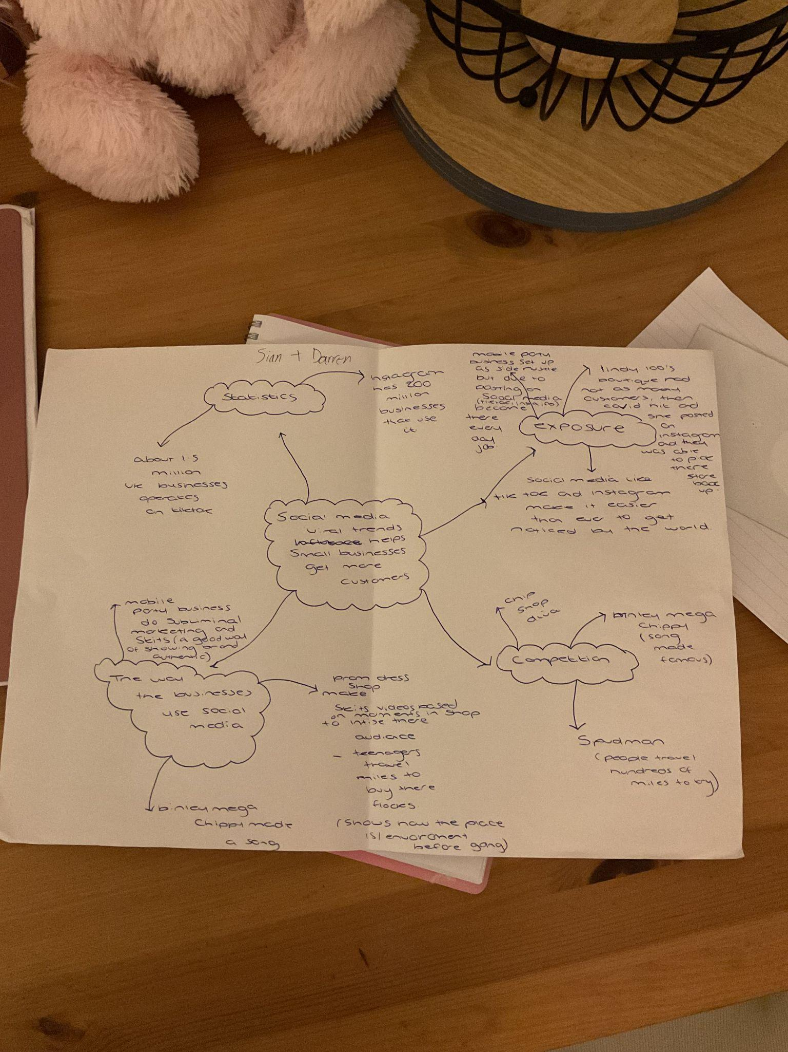

PART 2:
- Answer every question below in 1-3 full sentences.
- Use your own words. Do not use generative AI to answer these questions.
- Include a specific detail from the text when asked.
REMINDER
- The main idea is the overall message of the whole text.
- A key point helps to explain the main idea.
- A specific detail or example from the text shows that the key point is true.

- What is the main idea of the whole text?

The main idea of the article is about small businesses and people who use social media to turn likes, followers and views into a way of earning a living and making money.

It explains how posting content online can help businesses:
- Attract new customers - interesting videos, photos and offers can encourage people to visit the business and make purchases.
- Increase brand awareness - posting regularly helps more people discover the business and learn what products or service it offers.
- Build customer relationships - social media allows businesses to communicate directly with customers, answer questions and respond to comments.
- Reaches a wider audience - online posts can be seen by people all around the world, helping businesses reach more potential customers.
- Builds reputation and trust - regular posts can make small businesses look reliable and show customers what a business looks like from a wider prospective.
- Increases sales - good online content can encourage customers to buy products , turning views and likes into actual sales.

- What is one key point that supports the main idea, and which specific example from the text shows this?
A key point from the text supporting the main idea (posting content online can help a small business attract customers and increase sales) is “turning likes into livelihoods” this supports the main idea because it shows that a business can turn attention and likes on social media into a real income and business success.

- What is a different key point that supports the main idea, and which specific example from the text shows this?

Another specific key point is the article says “the sandwich shop does post its own videos on tiktok, but it is the content posted by its customers that has boosted its bottom line.”
This shows that customers sharing content online can increase the shops popularity and help it make mire money.

- Which part of the text do you think is most important, and why?
I think the most important part of the text is when linda hunter - better known as lindy loo, shows how a small business can use online platforms to reach customers all over the world. It shows that moving the business online helped the owner continue selling clothes and grow her customer base.

Reflection:
- What did you find difficult in this task (including in-class components), and why was it difficult?
I found that some of the information in the task was difficult to read at first. I found it challenging to identify the main points of the article and decide which information was most important. I also had difficulty understanding some of the business terms and explaining how social media could help a small business. An in-class component I found difficult was finding key information as there was a lot of information in the article, so picking out relevant details was challenging.

- What helped you with this difficulty, and how did it help you?
One thing that helped me with this difficulty was highlighting the key information I found in the article. This helped me with focusing on the most important key points and helped me understand on what i thought was the main idea.

