
Hotel standards, reputation management and service culture

Augusta-Roxana Toth (2226559)
BMIH4003 Hospitality & Guest Services
Module Lead: Charlotte Joyne
Word count:1771

Executive Summary 1
Introduction 2
Hotel Standards 2
Euro Standards for Hotels 3
Reputation Management 3
Key Highlights: 4
Corporate reputation management strategy 5
Service Culture 5
Service Culture best practices 6
Element of Service Culture 6
Conclusion 7
Recommendations 7
References 9

Executive Summary
The purpose of this report is the hospitality industry is composed of various models that are focused on providing services to guests. High-touch customer service is a key component of this industry. Because of the sector's competitive nature, firms must be constantly updated to stay ahead of the curve. This can help them deliver the best possible customer experience.
The study sought to identify the cultural elements that influence the establishment and implementation of a hotel's service culture. It was also conducted to determine the impact of this on the hotel's human capital performance. I will investigate the standards for a hotel's brand and how to manage its reputation. In addition, I will analyse how clients feel about the industry when they write negative or positive comments about it and how a service culture is particularly important for a company as it can help improve its efficiency and quality.
Contents
Executive Summary 1
Introduction 2
Hotel Standards 2
Euro Standards for Hotels 3
Aims of the Standard 3
Eligibility 4
Reputation Management 4
Key Highlights: 4
1. Send automated feedback surveys 5
2. Respond to reviews – even the positive ones 5
3. Simplify your work with templates 6
4. Maintain a consistent tone 6
5. Schedule time to respond regularly 6
6. Let technology run your hotel reputation management 6
7. Get in touch with guests pre-stay 6
Service Culture 6
Service Culture best practices 7
Element of Service Culture 7
Conclusion 7
Recommendations 8
References 9

Introduction
A hotel rating is a process used by hotel owners and operators to describe the quality of their establishments. It was initially focused on providing travellers with information about the basic facilities of a hotel, but it has since evolved to a more comprehensive approach to the experience of staying at a hotel (Boley, 2020).
The concept of reputation management refers to the practice of influencing the way people perceive and talk about a company or its brands. This process involves monitoring the interactions between stakeholders and responding to any threats to reputation (Sheldon, 2022).
A service culture is a framework that emphasizes providing the best possible customer service. It involves training employees on how to deliver exceptional service and provide the best possible value to their customers. This approach can help a company stand out from the crowd and improve its productivity.
They establish a culture of customer-centricity by assigning each employee responsibilities that are designed to deliver exceptional customer service and value (Indeed, 2023).

Hotel Standards
The purpose of brand consistency standards is consistent brand identity can help businesses achieve their goals in the long run. This is especially true when it comes to public relations and competitiveness.
A company's brand consistency is defined as its ability to maintain its positioning and communication in line with its values and identity (Dickson, 2016).
Standards for hotels will vary depending on their class, type, and value proposition. Chain hotels, for instance, are heavily involved in standardization. Standardization is an important aspect of any hotel's operations, as it sets the standard for the type and class of hotel it operates (DePino, 2023).
The brand standards of Aloft Hotels are constantly updated to reflect the changes in consumer behaviour. For instance, when it came to developing a new guestroom for the future generation of music lovers, the design team collaborated with the ownership group to ensure that the hotel would meet their needs. Today, Sheraton Hotels is reimagining the way people experience their encounters with the brand. Through a combination of technology and behavioural insights, they can provide our guests with the best possible experience (Edmundson, 2022).

Euro Standards for Hotels
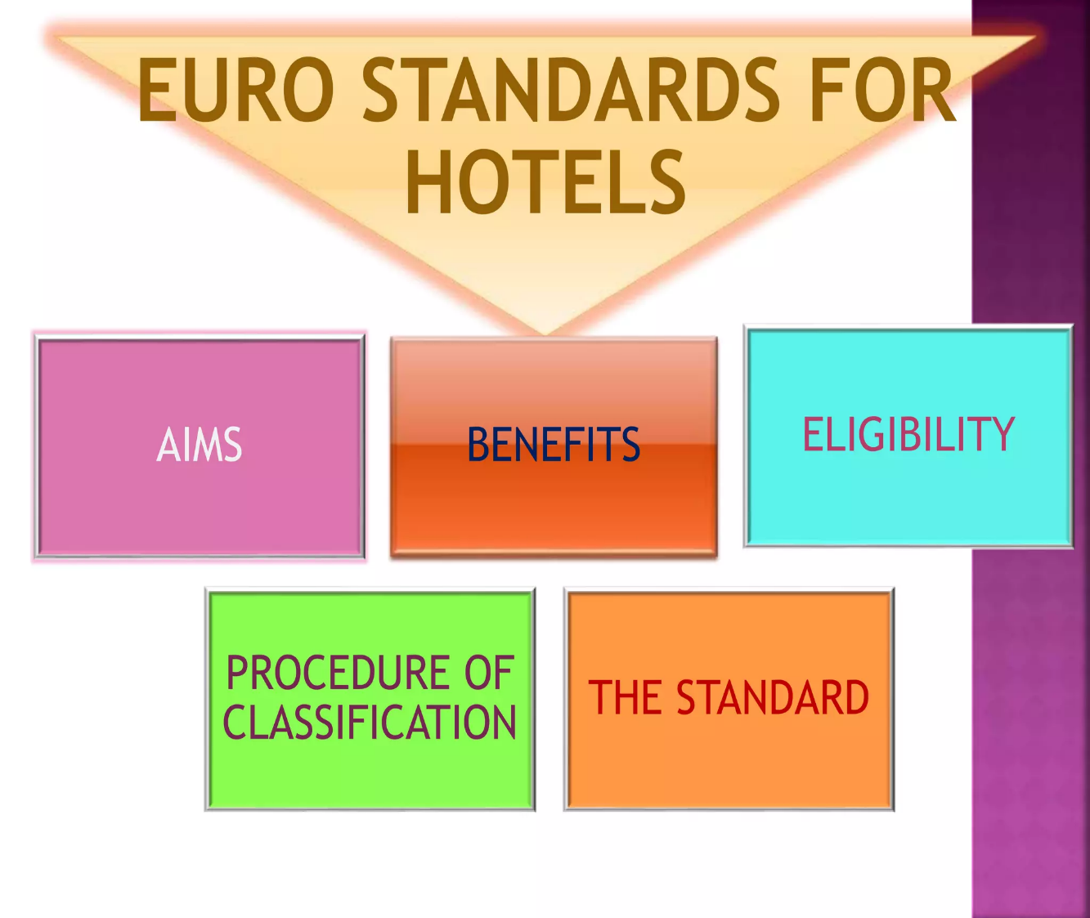
(Chadha, 2015).

Aims of the Standard
- To encourage establishments and hotels to hire accommodation that is in line with the European Union's standards.
- To promote confidence in hotels, we want to encourage our clients to feel that they are receiving the best possible service.
- To ensure that all the necessary legal requirements for the preparation and serving of food are respected and considered.

Eligibility
The requirements to be certified by the EEIG are as follows:
- Meet the 2012 definition of a HOTEL establishment or enterprise.
- have a formal constitution.
- be registered at the national level.
- They must also meet various environmental, planning, safety, and legal requirements.
- be committed to improving the service for their users. (EEIG, 2012).

Reputation Management
Online reputation management is a process utilized to improve the customer experience by working with various social media platforms, media outlets, and SEO. This can be done in the offline world as well (Shelton, 2022). The rise of digital communication and the spread of opinions about a property's reputation has made it more important than ever to maintain a strong online reputation. This is why it is important that you regularly monitor and improve the quality of your reputation. (Huynh,2020). Due to the rise of online reservation platforms, hotels are now heavily dependent on them. When it comes to maintaining a positive reputation, a hotel's content should be of the highest quality.
User-generated content can influence the demand for bookings and can also affect a hotel's overall position (Martin-Rios, 2018 A)

Key Highlights:
- Due to the increasing importance of reviews, guests are becoming more aware of how powerful these statements can be.
- The pressure on managers increases as they are evaluated and placed in positions of increasing importance.
- Online platforms are not always responsible for the actions taken to improve a reputation.
- The extent of manipulation varies depending on the country and business (Martin-Rios, 2018 B)
Online reputation management is becoming more important for hotels as more guests become aware of how their actions can affect the reputation of a hotel.
While it is important for hotels to offset the negative content posted on their platforms, it is also important that they take the necessary steps to prevent these types of posts from happening in the first place. Some of the techniques that can help distinguish authentic and manipulated reviews include linguistic cues. However, it is not always possible for a hotel to control the actions of other individuals who post content. There are usually opportunities for legal action when it comes to issues related to negative online reviews. A hotel can take legal action if it believes that the comments posted on its website are defamatory (Martin-Rios, 2018 C).
A study conducted by TripAdvisor revealed that 79% of users would choose a higher-rated property if there are two options available. Also, it showed that over 80% of travellers read or always check out reviews before making a reservation. These findings show that your hotel's reputation is strong enough to give it a competitive edge. A study conducted by TrustYou revealed that positive feedback can win over m According to the study, travellers are more inclined to book a hotel if it has a higher rating.
The results of this study are encouraging for independent hotels, as it shows that their property can still compete against major chains. It also shows that they can compete head-to-head with other hotels by delivering a great guest experience and having a consistent review system with more guests than a hotel's brand.
In this report, we will talk about ten strategies that will help you manage your hotel's reputation online (Darios, 2022 A).
- Send automated feedback surveys: One of the most effective ways to increase the number of reviews a hotel can receive is by directly asking its guests to provide feedback. This method is remarkably simple: Just send them a survey that asks them to provide their feedback.
- Respond to reviews – even the positive ones: Not only is it important to collect reviews, but it’s also important to respond to them in a way that makes them feel valued and included in the decision-making process. According to a study conducted by TripAdvisor, 65% of users prefer to book a hotel that responds positively to reviews, and 85% of users said that their perception of the establishment rises when they read a good review. A well-written response can help turn a negative situation into an opportunity.
- Simplify your work with templates: To avoid getting overwhelmed by emotions, build a bank of responses that will cater to both negative and positive reviews.
- Maintain a consistent tone: A successful hotel management strategy depends on having a consistent tone. This is because, when people respond to a certain tone, it can appear in reviews. To ensure consistency, we recommend creating a tone-based guide.
- Schedule time to respond regularly.
- Let technology run your hotel reputation management.
- Contact guests pre-stay. (Darios, 2022 B).

Service Culture
A service culture is a mindset where employees are focused on providing the best possible customer experience. This approach can make an organization stand out from the crowd and is very beneficial for business. A company's service culture can help boost sales and improve customer service. Besides just what employees experience, a good service culture also goes beyond that (Louveau, 2021 A).
A positive experience for the brand can help people connect with it and provide them with a reason to return. They'll also want to share their positive feedback to help boost the company's marketing efforts.
Some of the companies that embody this concept include Nordstrom, Ritz-Carlton, and Zappos.
Zappos places a premium on customer service, and it gives its employees the choice of joining its "Zapponian" culture or being paid to voluntarily resign from their positions. Similarly, at Ritz-Carlton, its workers are referred to as "Ladies and Gentlemen," and they are given discretionary spending allowances that enable them to make informed decisions regarding their customers. Nordstrom also values the contributions of its employees, and it encourages them to strive for excellence (Louveau, 2021 B).

Service Culture best practices
- Provide Service Culture training.
- Communicate with customers.
- Include all parts of the company.
- Seek out the right hires.
- Encourage a customer focus. (Louveau, 2021 C)

Element of Service Culture
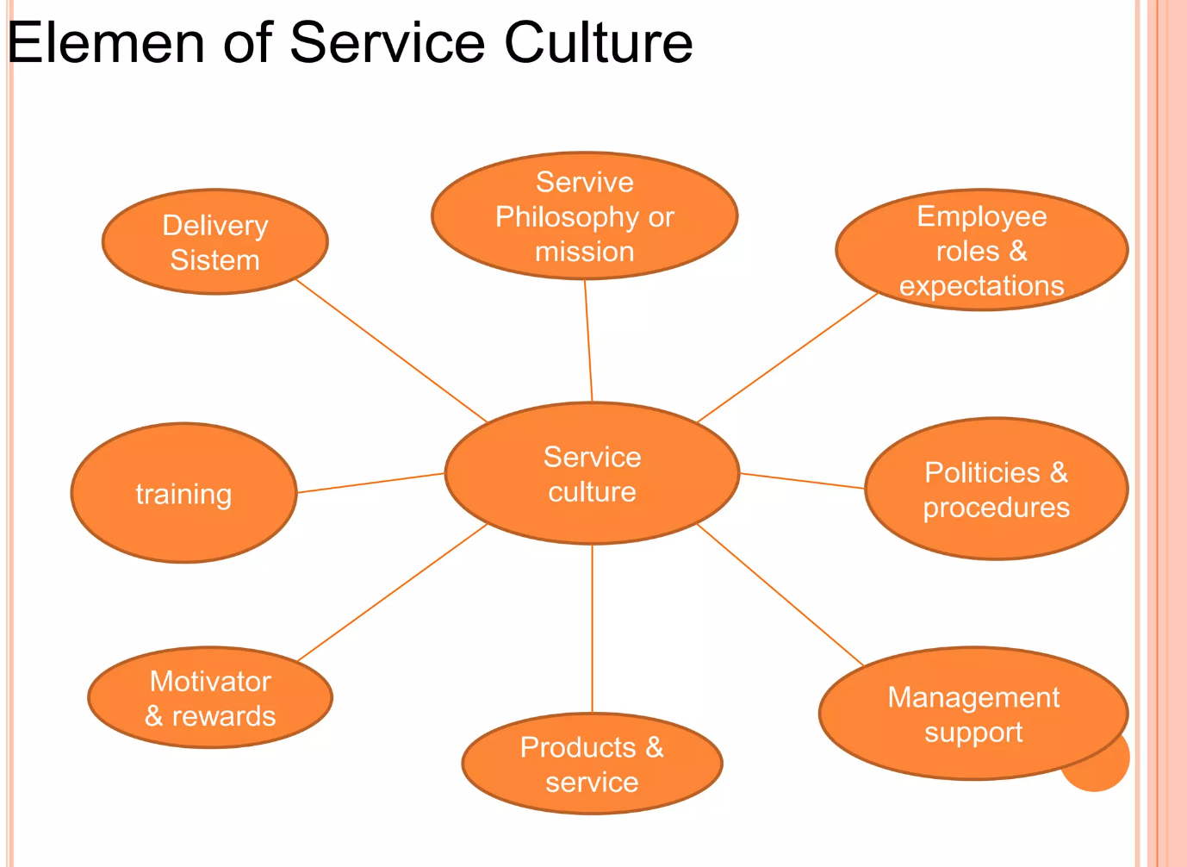(Daily, 2014).

Conclusion
This study was conducted through a qualitative descriptive research method. I used the three elements of the social situation to analyse the various activities and factors that affect the development and implementation of an organization's service culture. These include the place, actors, and activities. I also investigated the human capital performance of the hotel industry.
The results of the study revealed that core values, unique knowledge, and meaningful contributions are the characteristics that make a company's service culture unique.
Due to the increasing number of service organizations in the market, they are faced with the challenges of delivering quality and satisfactory services to their customers. The culture of the organization can help them overcome these challenges and improve their profitability. When it comes to enhancing the service level, employees must consider the continuous optimization of the company's operations.
The job satisfaction of the employees is a vital factor that can affect the quality of service that an organization provides. This issue needs to be thoroughly investigated to find out the numerous factors that influence this (Dikmen, Bozdaglar 2017).

Recommendations
One of the most effective ways to attract high-quality employees is by having them serve as brand ambassadors. They can recommend their employers to their friends and relatives. Another great way to retain employees is by making sure that the leaders are getting to know each team member personally. They'll be more willing to commit longer to the organization if they have a good relationship with their managers.
The goal of a hotel's technology is to provide better services and increase the productivity of its employees. One of the most important factors that a property should consider is the implementation of a new property management system. This system will allow the front desk to communicate with the housekeeping staff and generate reports.
Large hotels can use software that handles housekeeping tasks and allows the staff to monitor the progress of their work throughout the day. The devices used by the housekeepers allow them to mark the rooms as clean once they have been completed, which can be displayed in the PMS (Burton, 2021).

References
- Boley, M. (2020). Hotel Reputation Management Tips and Examples Hoteliers Need to Know. Available at: https://www.cvent.com/en/blog/hospitality/hotel-reputation-management/ (Accessed 17 May 2023).
- Burton, E.(2021). Five tips for improvement if you are in the hotel industry. Available at: https://blog.typsy.com/5-tips-for-improvement-if-youre-in-the-hotel-industry/ (Accessed 31 May 2023).
- Chadha, A. (2015). Euro standards for hotels. Oxo. Available at: https://www.slideshare.net/arushichadha73/euro-standards-for-hotelsoxo/ (Accessed 17 May 2023).
- Darios, I. (2022). 10 Tactics for successful hotel reputation management. Available at: https://www.cloudbeds.com/articles/10-tactics-for-successful-hotel-reputation-management/ (Accessed 06 June 2023).
- Dikmen, F. Bozdaglar H. (2017). The Role of Service Culture in Hospitality Industry. International Journal of Business and Social Science Vol 8, No 5. Available at: http://ijbssnet.com/journals/Vol_8_No_5_May_2017/12.pdf/ (Accessed 17 May 2023).
- Dainy, W. (2014). Element of service culture. Available at: https://www.slideshare.net/withadainy/service-cultureppt-tugas-1/ (Accessed 17 May 2023).
- Dickson, G. (2016). The importance of brand standards. Available at: https://insights.ehotelier.com/author/graemedickson/ (Accessed 16 May 2023).
- DePino, F. (2023). Hospitality Branding – Stand Above the Rest. Available at: https://mediaboom.com/news/hospitality-branding/ (Accessed 16 May 2023).
- EHotelier, (2021). A closer look at service culture. Available at: https://insights.ehotelier.com/insights/2021/08/31/a-closer-look-at-service-culture/ (Accessed 18 May 2023).
- Edmundson, T. (2022). The intersection of guests, owners, brands, and staff. Available at: https://www.todayshotelier.com/2020/02/03/brand-standards/ (Accessed 16 May 2023).
- Huynh, T. (2020). 5 Tips for Hotels’ Effective Reputation Management. Available at: https://www.hotellinksolutions.com/5-tips-for-hotels-reputation-management/ (Accessed 17 May 2023).
- Indeed, Editorial Team (2023). Service culture: definition, importance and how to build it. Available at: https://uk.indeed.com/career-advice/career-development/service-culture/ (Accessed 17 May 2023).
- Lacalle, E. (2021). The importance of hotel branding and how to build an effective strategy. Available at: https://www.mews.com/en/blog/hotel-branding/ (Accessed 16 May 2023).
- Louveau, F. (2021). What is Service Culture? Available at: https://hospitalityinsights.ehl.edu/service-culture-definition/ (Accessed 17 May 2023).
- Martin-Rios, C. (2018). 4 Reputation Management Challenges Every Hotel Manager Faces. Available at: https://www.hospitalitynet.org/opinion/4088619.html/ (Accessed 17 May 2023).
- Reputation X, (2022). Corporate reputation management strategy. Available at: https://blog.reputationx.com/corporate-reputation-strategy/ (Accessed 17 May 2023).
- Shelton, R. (2022). What is Reputation Management? Available at: https://www.igniyte.co.uk/blog/what-is-reputation-management/ (Accessed 17 May 2023).

