Component 2: Task 2 - Written Report
Student Name: Radu Acris
Student Number: 2239621
Lecturer Name: Masud Ibrahim
BA (Hons) Business Management
Entrepreneurship
LCBB5001

Contents
1.Introduction. 3
2.The history of my favourite entrepreneur… 4
3. Donald John Trump (born June 14, 1946). 5
3.1. Achievements. 6
3.1.1. Real Estate: 6
3.1.2. Brand Expansion and Licensing: 8
4. Trump’s motives as a businessman: 9
5. Entrepreneurial traits… 10
6.Conclusion: 10
Bibliography 11

1.Introduction.

Entrepreneurship is about more than just building a business, it's a journey of innovation, resilience, and pushing beyond comfort zones. Entrepreneurs often begin with a vision that drives them to take risks, navigate uncertainty, and create something impactful from scratch. This journey brings challenges like financial risk and intense competition. As Donald Trump particularly detailed:
“If you’re going to be thinking anyway, you might as well think big” (Trump & Schwartz, 1987).
Donald Trump’s story illustrates these characteristics, combining ambition, branding, and risk-taking. As a prominent figure in real estate, media, and politics, Trump leveraged these entrepreneurial qualities to build an enduring legacy. His career offers a compelling example of the opportunities and challenges of entrepreneurship, explaining how adaptability, self-discovery, and strategic thinking can boost someone toward significant influence across various industries.

2.The history of my favourite entrepreneur…

‘’I like thinking big. I always have. To me it’s very simple: if you’re going to be thinking anyway, you might as well think big. Most people think small, because most people are afraid of success, afraid of making decisions, afraid of winning. And that gives people like me a great advantage (Trump & Schwartz, 1987)’’.

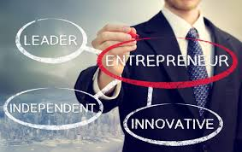
Being an entrepreneur is starting something from scratch, frequently motivated by a desire to innovate, solve a problem, or change the world. In order to achieve a vision, it entails accepting the unknown, taking chances, and moving outside of comfort zones (SANDRA L. FISHER, 2008).
Being an entrepreneur involves more than just
Fig.1
business; it also involves self-discovery, perseverance, and flexibility. Every setback teaches perseverance, every victory feeds the desire to achieve greater things, and every difficulty offers a chance to learn and develop. One of the most fulfilling career pathways for people who are prepared to put in the work is entrepreneurship, which may have a significant influence on sectors and communities in addition to providing personal fulfilment.

3. Donald John Trump (born June 14, 1946).

Donald Trump, an American entrepreneur, real estate developer, and former U.S. president, has built a significant legacy in business, media, and branding. Born in 1946 in Queens, New York, he joined his family's real estate firm, the Trump Organization, in the early 1970s. Utilizing his skills in negotiation and strategic branding, Trump expanded the family business beyond residential properties to high-profile commercial projects, such as office buildings, hotels, and casinos in New York City and other prominent locations (Mollan & Geesin, 2019).
His brand, often featuring his surname, became widely recognized as a marker of luxury and exclusivity.
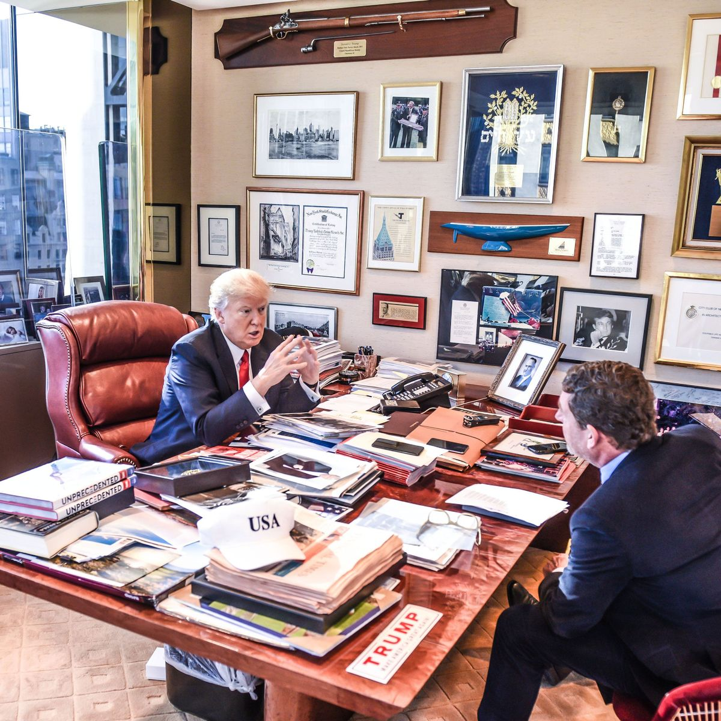

Fig.2
Trump's ventures extended beyond real estate, significantly shaping his public persona. He hosted The Apprentice, a television show that combined business challenges with entertainment, reinforcing his image as a decisive, results-oriented business leader. This media exposure further amplified his personal brand, making him a household name in the U.S. and internationally.
Despite facing multiple business bankruptcies, Trump demonstrated resilience and a willingness to adapt, which allowed him to sustain his public and professional presence. His entry into politics, culminating in his presidency from 2017 to 2021, was marked by his application of entrepreneurial tactics—such as strong brand positioning, direct engagement with the public, and a focus on decisive messaging (Mollan & Geesin, 2019).

3.1. Achievements.

3.1.1. Real Estate:
Donald Trump’s real estate development career has been marked by high-profile projects, ambitious branding, and a focus on luxury properties. His work in real estate began in the early 1970s, when he joined the Trump Organization, a company founded by his father, Fred Trump, which initially focused on residential properties in New York City’s outer boroughs. Donald Trump shifted the company's direction by focusing on larger, high-profile developments in Manhattan and other prestigious locations, emphasizing luxury and exclusivity (Wooten, 2009).
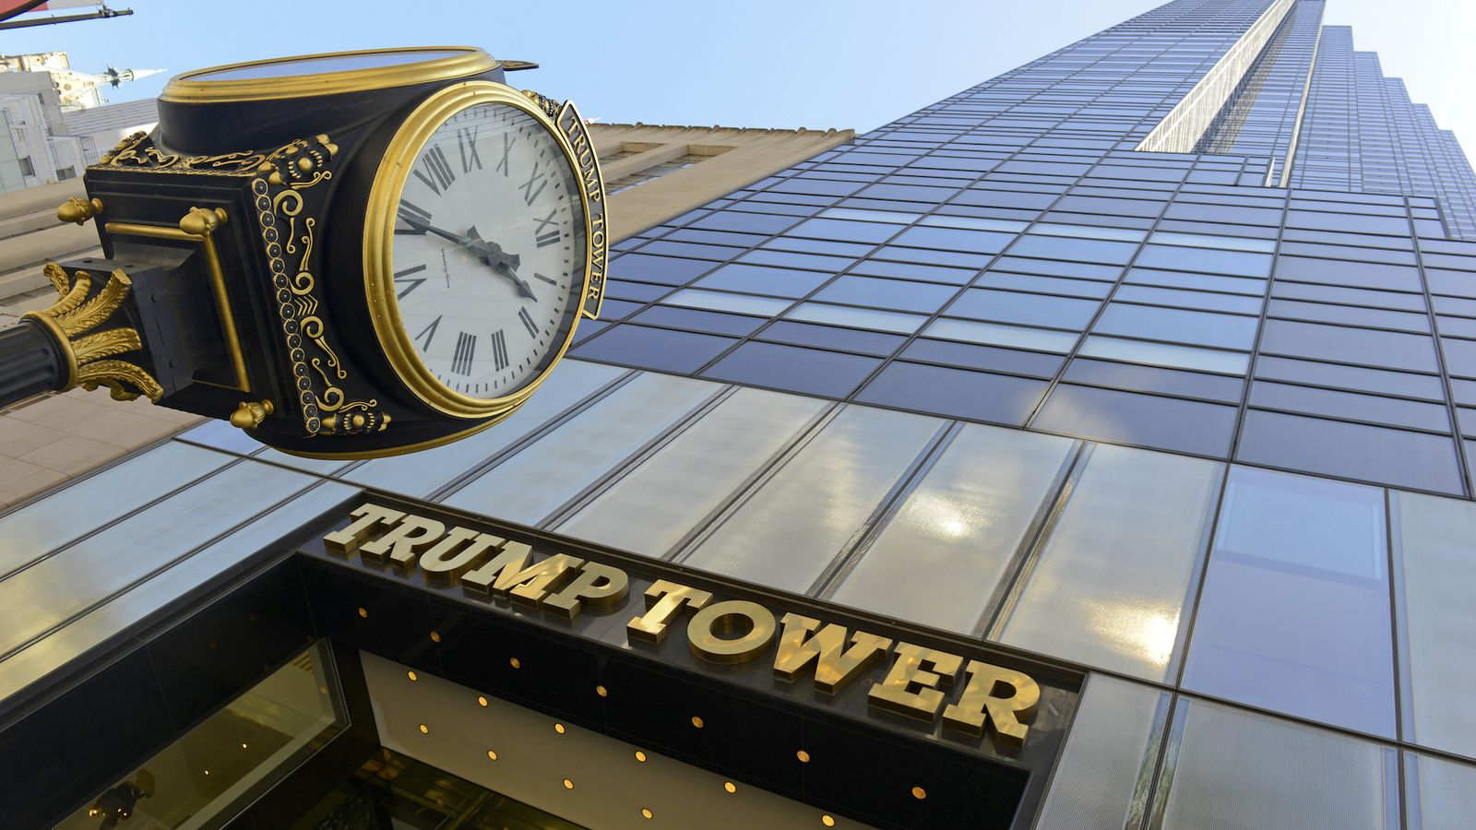
Key projects in Trump’s real estate development portfolio include:
Trump Tower: Completed in 1983 on Fifth Avenue in Manhattan, Trump Tower is a 58-story skyscraper that includes residential units, retail spaces, and Trump’s corporate headquarters. Its luxury interiors, prominent location, and striking architectural design made it a symbol of Trump’s brand and an icon of New York real estate. Fig.3

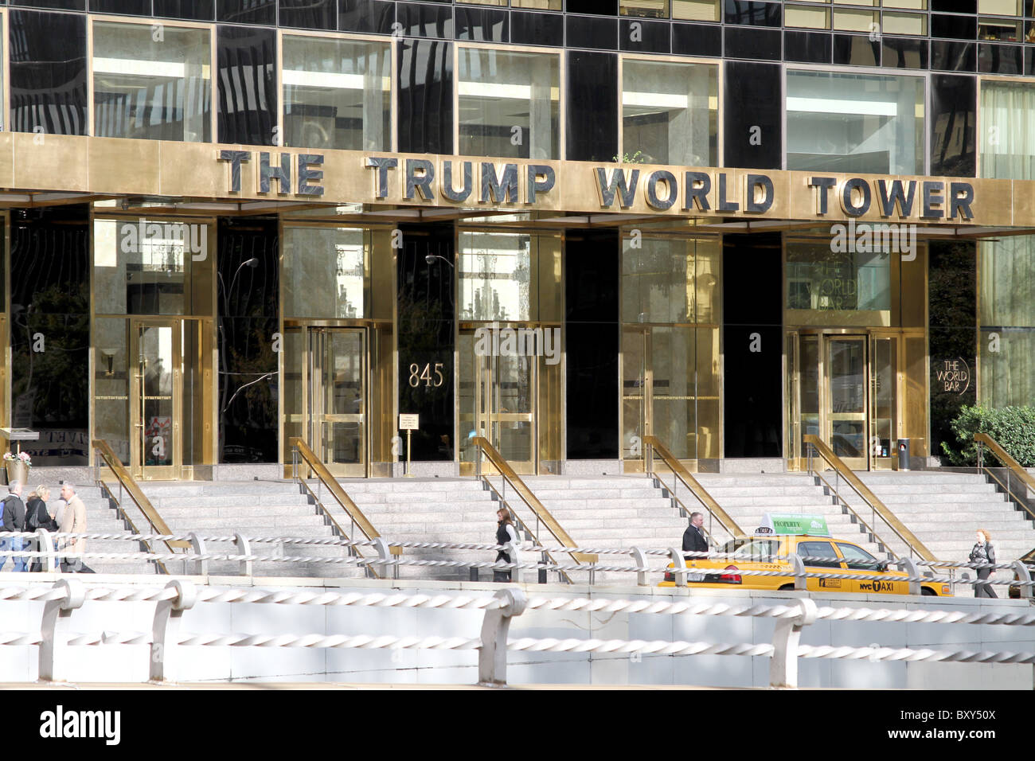
Trump Plaza and Trump World Tower: Trump Plaza, a luxury condominium on Manhattan’s East Side, and Trump World Tower, a residential skyscraper near the United Nations headquarters, further cemented his brand's reputation for exclusive, high-end properties. Trump World Tower, in particular, was one of the tallest
Fig.4
residential buildings globally at the time of its completion in 2001.
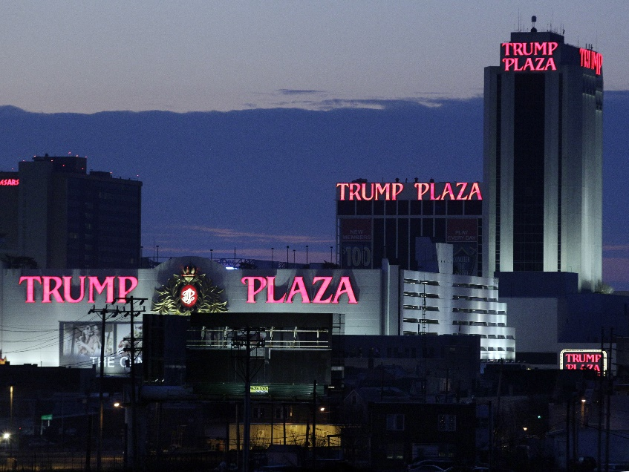
Casino and Resort Ventures: Trump expanded his real estate portfolio into Atlantic City, New Jersey, where he developed and operated several casino properties, including the Trump Taj Mahal, Trump Plaza, and Trump Marina. While these ventures initially generated substantial revenue, they also involved significant financial challenges and multiple bankruptcies (Wooten, 2009). Fig.5
International Expansion and Licensing: In the 2000s, Trump began to license his name to real estate projects worldwide, including developments in Canada, the Philippines, and the Middle East. Licensing agreements allowed Trump to generate revenue from his brand without assuming the financial risk of direct ownership, capitalizing on the prestige associated with the Trump name.

3.1.2. Brand Expansion and Licensing:

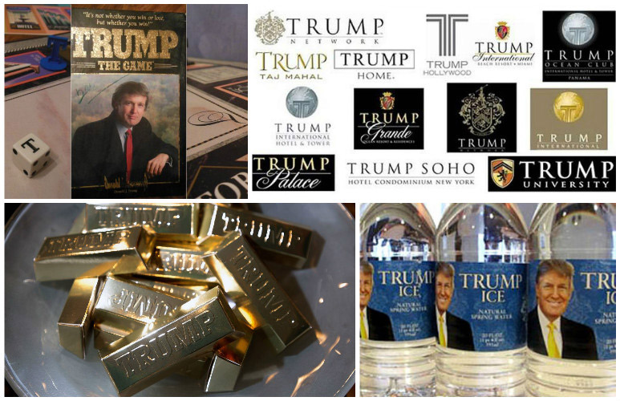
The "Trump" name became a global brand that extended beyond real estate to include a variety of products and services, from Trump-branded merchandise to licensing deals in hospitality. His brand's reach demonstrated how effective personal branding could create added value across diverse industries.
Fig.7
Consumer Products: Trump licensed his name for a wide array of consumer products, creating an extensive portfolio that included items such as Trump-branded colognes, bottled water (Trump Ice), home furnishings, mattresses, and even steaks (Trump Steaks). These products were often marketed as premium or luxury items, reflecting Trump’s brand image and appealing to consumers looking to connect with his lifestyle of wealth and success.
Hospitality and Lifestyle: Trump branded and licensed his name to upscale hotels, resorts, and golf courses around the world, including Trump International Hotels, Trump National Golf Club properties, and Trump World properties. This expansion into hospitality provided affluent customers with an immersive experience of the Trump brand’s luxurious promise. By associating his name with high-end amenities, premium locations, and elegant designs, Trump created environments that aligned with his brand image and enhanced his visibility in the lifestyle and travel markets.
Education and Training: Trump launched Trump University in 2005, a for-profit business education company focused on real estate and wealth-building courses. While Trump University faced significant controversy and legal challenges, it demonstrated his willingness to use his name in education and self-improvement sectors, capitalizing on his reputation as a successful entrepreneur and marketer.

4. Trump’s motives as a businessman:
Donald Trump’s motives as a businessman, public figure, and politician have been shaped by a complex blend of ambition, brand-building, influence, and personal legacy.
- Personal and Family Empowerment: Trump has also shown a strong motivation to empower and involve his family in his ventures, particularly his children, who play significant roles in the Trump Organization. This demonstrates a motivation to build a family legacy and to cultivate a dynasty that shares his values, vision, and influence in business and politics.
- Innovation and Market Opportunity: Trump has pursued opportunities to leverage his brand in emerging markets or untapped industries. Whether licensing his name internationally or expanding into media and education, Trump has been motivated by the potential for growth and influence in new markets, showing an interest in diversification and maximizing his brand’s value (Brands, 2017).
- Pursuit of Success and Wealth: Trump has often been motivated by a desire to achieve financial success and accumulate wealth, seeing business as a competition where winning is paramount. From his early real estate ventures to licensing his name, Trump’s decisions have frequently focused on ventures that promised significant financial return and high-profile status.
- Personal Branding and Public Recognition: Trump has consistently prioritized building and maintaining his public image. He often pursued ventures that reinforced his brand identity as a successful, powerful businessman. His presence in high-profile projects, media appearances, and the luxury image associated with his properties reflect a deep motivation to craft and protect his public image (Brands, 2017).
Overall, Trump’s motivations have been shaped by a combination of personal ambition, a competitive spirit, a focus on legacy, and a desire for influence. These motives have helped him create an expansive and high-profile career that spans real estate, media, and politics, driven by a distinct, brand-centric approach that emphasizes visibility, success, and resilience.

5. Entrepreneurial traits…

- Brand-Building and Personal Marketing: Trump’s skill in branding helped him turn his name into a symbol of luxury and success. Building a recognizable personal or business brand that reflects the values and strengths can be a powerful asset in almost any field.
- Negotiation Skills: Trump’s success in securing major real estate deals reflected strong negotiation skills. Developing confidence and proficiency in negotiation can be invaluable, whether in securing investments, partnerships, or client agreements.
- Resilience in Facing Setbacks: Trump faced multiple bankruptcies and public challenges but was able to bounce back and reestablish his brand. Cultivating resilience and a solution-oriented mindset in the face of setbacks is essential for long-term entrepreneurial success.
- Risk-Taking: Trump demonstrated a willingness to take calculated risks, even in challenging industries like casinos and media. Developing comfort with risk, especially when it aligns with a well-researched strategy, can help drive growth and uncover new opportunities.

6.Conclusion:

Donald Trump’s entrepreneurial pathway highlights the importance of ambition, calculated risk-taking, resilience, and strategic branding for success across varied industries. Through famous ventures in real estate, brand licensing, and media, Trump transformed his name into a mark of luxury, illustrating the power of personal branding to extend beyond individual sectors (Sexton, 2009). Aspiring entrepreneurs can draw inspiration from Trump’s branding method, his motivation to take strategic risks and his ability to recover from setbacks. Like Trump, the entrepreneurial journey involves navigating obstacles, identifying market opportunities, and continually striving for growth. By fostering a clear vision of success and building a resilient, impactful brand, entrepreneurs can create lasting legacies and contribute significantly to their industries and groups.

Bibliography
Brands, H., 2017. The Unexceptional Superpower: American Grand Strategy in the Age of Trump. In: s.l.:s.n., p. 33.
Mollan, S. & Geesin, B., 2019. Donald Trump and Trumpism: Leadership, ideology and narrative of the business executive turned politician. Sage Journals.
SANDRA L. FISHER, M. E. G. M. C., 2008. Entrepreneurial Learning. s.l.:Routledge.
Sexton, D., 2009. Trump University Branding 101: How to Build the Most Valuable Asset of Any Business. s.l.:John Wiley and Sons, 2009.
Trump, D. J. & Schwartz, T., 1987. Trump: The Art of the Deal. United States: Random House.
Wooten, S. M., 2009. Donald Trump: From Real Estate to Reality TV. s.l.:Enslow Publishing.

