University of Wales
Trinity Saint David

BA Marketing Management

Dissertation

An analysis of the usage of digital marketing in the
construction and manufacturing industry

2020

Jack Steele (1700866)


DECLARATION

This work has not previously been accepted in substance for any degree and is not being concurrently submitted in candidature for any degree.

Signed……………………………………………
Date………4/6/20………………………………………

STATEMENT 1

This dissertation is being submitted in partial fulfilment of the requirements for the degree of BA.

Signed…………………………………………….
Date………4/6/20………………………………………

STATEMENT 2

This dissertation is the result of my own independent work/investigation, except where otherwise stated. Other sources are acknowledged by footnotes giving explicit references. A bibliography is appended.

Signed……………………………………………
Date…………4/6/20……………………………………

STATEMENT 3

I hereby give consent for my dissertation, if accepted, to be available for photocopying and for interlibrary loan, and for the title and summary to be made available to outside organisations.

Signed……………………………………………… Date…………4/6/20………………………………………

STATEMENT 4

I hereby give consent for my dissertation, if accepted, to be available on the university’s IT system to those who have consent to use the system.

Signed……………………………………………… Date…………4/6/20………………………………………

Acknowledgment

I would like to thank my whole family, my father, mother, brother and sister for providing the support I needed to guide me through my experience at university and giving the confidence I needed to complete something I considered very challenging. I would also like to thank my partner Morgan for giving the motivation and confidence to complete my work at the best of my ability.

I would like to show gratitude to all my university lecturers who supported me through my experience, in particular Gareth Hughes and Caroline Jawad, who were able to help me manage a seemingly impossible workload and also giving me confidence. The support of all the friends I have gained through university also had a significant impact on my learning and were able to make the experience enjoyable.

I also would like to show appreciation to all of the participants who had taken part of the research to collect primary data, as the dissertation would not have been able to be completed.

Abstract

The overall aim of this dissertation is to analyse the usage of digital marketing in the construction and manufacturing industry. Chapter one is an introduction outlining the background and rationale of the research and provides the aims and objectives for the dissertation, as well as the structure. The completion of a literature review will be in the following chapter which critically analyses peer reviewed work and previous research in order to develop a foundation of knowledge on digital marketing and the construction and manufacturing industries and also identify any gaps in the literature. Chapter three details the three methods of data collection that will be used in this dissertation. Using strictly qualitative data, semi-structured interviews, a content analysis and e-mail interviews were the methods that have been used. The reason there were three methods of collection was due to the low number of interviewees because of a reluctance of participation and the COVID-19 pandemic. The analysis of the results follows in chapter four, finding three main themes that could be linked to all three phases of data collection. The main themes that affected the usage of digital marketing in the industry were money, time and knowledge and understanding. If a company has access to the themes that have listed, their usage of digital marketing is significantly higher compared to a company that does not have access to these themes. The conclusion includes a discussion of the findings and also provides recommendations from the researcher based from the results, examines the limitations of the dissertation and ideas for further research.

COVID-19 Statement

After the UK implemented a 24-hour curfew in March 2020, UWTSD took steps to support the research student and research during the curfew and University building closures. Formal supervision meetings continued as much as possible and arranged via suitable meeting software and documents shared electronically.

Some research was at greater risk to delays, for example projects requiring physical presence to undertake interviews, fieldwork or data collection. Supervisors and research students urgently reviewed their research plans. UWTSD understands that some students’ projects and dissertations were planned to require in-person research and data collection that is not possible in this period of remote learning. Digital research activities that advance the studies, were prioritised. If it was no longer possible to continue with the existing plan then consideration to changes to the project plan should be considered to offset, wherever possible, undue future delays to the project/dissertation submission. All fieldwork conducted by students occurred remotely using electronic means wherever possible. Students, with the help of their supervisors, are urged to document the extent of the disruption to their research.

COVID-19 had drastically affected the completion of the dissertation. The collection of data was challenging and led to many participants cancelling planned interviews and new participants were reluctant to take part. The result of this caused the researcher a great deal of stress due to the approaching deadline and other methods of collection had to be completed. The lack of university resources and books forced the researcher to use digital resources only to complete the dissertation. Unable to visit the library, the research was completed in a busy and loud environment and this affected the researcher’s mental health and motivation.

Table of Contents
1. Introduction 1
1.1. Background 1
1.2. Rationale 2
1.3. Aims and Objectives 2
1.3.1. Research Aims 2
1.3.2. Objectives 3
1.4. Structure of Dissertation 3
1.5. Conclusion 3
2. Literature Review 4
2.1. Introduction 4
2.2. Marketing 4
2.2.1. Traditional Marketing 5
2.2.2. Digital Marketing 5
2.3. Digital Marketing Strategy 6
2.4. The UK and Welsh Construction Industry 8
2.5. The use of digital marketing in B2B industrial market 9
2.5.1. Social Media Use 11
2.6. Literature Review Conclusion 11
3. Methodology 13
3.1. The definition of Methodology 13
3.2. Research Onion 13
3.3. Epistemology 14
3.4. Philosophical Stance 14
3.5. Approach 15
3.6. Strategy 15
3.7. Research Overview 16
3.8. Semi-Structured Interviews 16
3.9. An Introduction to Content Analysis 17
3.10. E-mail Interviews 19
3.11. Reliability, Validity and Ethical Risk 19
3.12. Methodology Conclusion 20
4. Analysis of Results 21
4.1. Data Analysis 21
4.2. Methods 21
4.3. Main Findings 22
4.3.1. Interviews 22
4.3.1.1. Money 22
4.3.1.2. Time 23
4.3.1.3. Knowledge and Understanding 24
4.3.2. Content Analysis 24
4.3.2.1. Website Tools 25
4.3.2.2. Social Media Use 28
4.3.2.3. Mobile Applications 31
4.3.3. E-mail Interviews 31
4.4. Analysis of Results Conclusion 34
5. Conclusions and Recommendations 35
5.1. Introduction 35
5.2. Achievement of Objectives 35
5.3. Main Findings 35
5.4. Recommendations 36
5.5. Further Research 37
5.6. Limitations 37
5.7. Final Summary 38
Self-reflection 39
References 40
Appendices 44

List of Figures

Figure 3.1 - Research Onion (Saunders, et al., 2007) 14
Figure 3.2 - Inductive and Deductive Approach (Trochim & Donnelly, 2006) 15
Figure 3-3 Email response from Balfour Beatty showing reluctance to participate in research. 17
Figure 3.4 - Company information available from their websites. 18
Figure 4.1 - Word tree of money 23
Figure 4.2 - Word tree giving context for when participants said understanding 24
Figure 4.3 - Screenshot of The Crosby Groups homepage 26
Figure 4.4 – Screenshot of the homepage of Caddick Construction 26
Figure 4.5 - Screenshot of the message from Facebook when clicked the link from their website 28
Figure 4.6 - Facebook page of Vinci displaying a live chat function 29
Figure 4.7 - The Crosby Group's YouTube page 31
Figure 4-8 - Word tree of understanding from the e-mail interviews 32

List of Tables

Table 4.1 - Content Analysis of five large construction and manufacturing companies 25
Table 4.2 - Content Analysis of the companies that there interviewed 25
Table 4.3 - Colour codes to understand the content analysis grid 25
Table 4.4 - Matrix Analysis of the e-mail interviews 33

Introduction

The purpose of this dissertation is to understand the usage of digital marketing within the construction and manufacturing industry. Research in this area is scarce and this has been noted within the dissertation. This chapter will give a brief background on the topic of the paper to give reason to why the researcher believes it is an important topic. It will provide a rationale and also address the aims and objectives of this dissertation.

Background

Digital marketing has been revolutionary to companies in the last two decades by giving them a new platform for them to market their brand, products and reputation (Ismail, 2019). Many sectors have taken advantage of the emergence of digital marketing, improving their knowledge on their customers and creating relationships. The entertainment, fitness, healthcare and retailer sectors in particular have seen success when using it (Nwazor, 2018). These sectors primary target customers and are considered business-to-customer (B2C) companies and these types of companies usually see more success, likely due a shorter decision-making process by the customers (Cohn, 2015). Business-to-business (B2B) companies are not as known for their digital marketing engagement. Miller (2012) has written about the way that B2B business use digital marketing, expressing concerns that all the companies have been slower to adapt to the new media compared to those who operate in a B2C environment. Funnelling down to look at sectors that are B2B, construction and manufacturing are interesting as they are industries that have a lot of history. Yet in the modern day of technology and with the tools that are available, these industries have not been able to adapt as quickly as the other sectors such as retail, for example. The workforce of the construction industry makes up 7% of the UK’s population, which is 2.4 million (Rhodes, 2019). The industry is a driver of the UK economy, yet other key drivers of the economy such as banking and insurance services have seen great success when using digital marketing. The businesses in the contracting construction sector consists of mostly SMEs, which makes up 99.9% of the sector (Department for Business Innovation and Skill , 2013). The report continues to explain that SMEs are also more likely to experience monetary difficulties due to having fewer financial options compared to the larger companies. The majority of the companies do appear to have their own website, but the researcher has observed that not all companies use the digital platform the same way. Any research about understanding how businesses that operate in the construction and manufacturing industry use digital marketing is something that the researcher was not able to discover. The industries are seeing growth (Jackson, 2017) it appears to be the best time to observe how the usage of digital marketing will affect their business, especially during pandemic if COVID-19. This will allow businesses in this sector to take advantage of the digital marketing platform and understanding the uses will give the researcher knowledge that will aid them in the pursuit of their career pathway.

Rationale

The rationale has stemmed from the researcher’s personal interest on the topic. The researcher has been undertaking a marketing degree, and a research project is essential in the final year of study. Another reason the researcher has personal interest in the study due to working in the construction and manufacturing industry. After completing an internship module with the company in the sector, they had offered a part-time job upon completion of the internship. Additionally, the researcher hopes to continue to work in the industry and gaining in-depth knowledge on the topic will be beneficial to them to fulfil that.

There is a paucity of research in this area, as shown by Google Scholar when searching for certain phrases (Appendix 1). With only 7,650 search results with the phrase ‘B2B Digital Marketing Construction’, it shows that there is a lack of interest and research to digital marketing in the construction and manufacturing sectors. A timeline of the history of marketing from Ehlers (2017) has been adapted by the researcher to provide a visual representation of which direction marketing is heading (Appendix 2). It is shown in the most recent years of the timeline that there has been a fast growth for online advertising and social media platform. This is an indicator that the future of marketing is transitioning to focus on the use of digital tools rather than traditional methods.

Aims and Objectives

Research Aims

The aim of this research is to critically evaluate and understand the usage of digital marketing within the construction and manufacturing industry.
In order to be able to fully complete this main aim the following objectives will need to be met:

Objectives

- To evaluate previous research on digital strategy in the construction and manufacturing sectors and develop greater understanding by critically analysing peer reviewed journals and credible publications on the subject.

- To collect primary data and identify and analyse digital marketing use in the construction and manufacturing industry.

- To present recommendations to the construction and manufacturing industry to recognise and learn about the importance of the use of digital marketing.

Structure of Dissertation

In order to complete the objectives of the dissertation, chapter two will analyse academic literature around marketing digital marketing, the construction and manufacturing industry and the digital marketing uses.

Chapter three will identify the methods of primary data collection that will aid the researcher to fill in gaps that are visible in chapter two.

The fourth chapter will be used to analyse the data that has been collected via three phases of collection. Analysis will be sequential, following the order the data was collected.

The fifth and final chapter will provide a summary of main findings and discuss anything that has been discovered. This chapter will also include recommendations from the researcher, limitations in the dissertation and thought on further research.

Conclusion

This chapter has outlined the aim and objectives of this dissertation which has stemmed from the contents of the background and the rationale. The following chapter will be providing an in-depth analysis of academic literature, which aims to complete the following objective: -

- To evaluate previous research on digital strategy in the construction and manufacturing sectors and develop greater understanding by critically analysing peer reviewed journals and credible publications on the subject.

Literature Review

Introduction

The purpose of writing a literature review is to provide the foundation of the previous research on the topic, to describe related research in the field and show how the research extends or challenges this, or addresses a gap in the work in the field, and also includes a discussion of relevant theories (Ridley, 2012). Ridley (2012) also states that literature reviews provide an overview of the current context in which the research is situated by referring to contemporary debates, issues and questions in the field. A literature review also introduces the definitions of relevant key terms and important variables used for a study or manuscript development (Baker, 2016).

The construction and manufacturing industries have been around for many years, yet it seems many of the companies have not adapted to including digital marketing strategy in their plans. There has been research on the topic of the lack of digital marketing in different business-to-business (B2B) companies, with research from Smart Insights (Chaffey & Chappell, 2020).

Marketing

Kotler, et al (2008) discusses multiple definitions of marketing in the book ‘Principles of Marketing’. The simplest definition according to the authors is that “marketing is managing profitable customer relationships” (Kotler, et al., 2008, p. 4). Although this is not a pertinent definition of marketing for this dissertation because the researcher will be discussing another definition that they see more fit further on in the literature review.

However, Kotler, et al (2008) have defined the meaning of marketing themselves, by examining earlier definitions and terms in order to agree. Their definition has been summarized to fulfilling customer needs whist completing objectives set by the business.

Jobber (2010) has explained that the concept of marketing is to ensure that corporate goals have been reached, whilst fulfilling and surpassing customers’ needs better than their competitors, which has the same elements as the previously discussed definitions. He discusses further by stating that successful companies are focused on encouraging the customer to return to the brand, with the goal being long term satisfaction, not short term.

Kotler, et al (2008) additionally discusses that marketing can come in the forms of traditional and digital marketing. Traditional is a form of marketing that is widely used and utilises channels such as TV and radio adverts, billboards, newspapers and magazines. In recent years, the introduction of digital marketing has challenged the ideas of traditional marketing. Digital marketing uses channels such as the internet, websites and social media.

Traditional Marketing

Blythe (2016) discusses that traditional marketing focuses on the exchange between business and the customer, with the business focusing on a single sale. This means that when a company uses a traditional marketing channel, they are more focused on completing a single sale rather than building a relationship with the customer. Widjaya (2017) explains that this type of marketing offers great reach to a local audience, using radio stations, newspaper adverts and company details on the side of a van. Schmitt (2011) suggests that the centre point of traditional marketing is the product, the features it has and the benefits. Traditional marketing has little focus on customer service, which results in low customer loyalty to the company.

Blythe (2016) expresses concern with traditional marketing, because when a customer completes a transaction, they can be anonymous, and therefore the customer has reduced from a person with wants and needs to being part of a demographic.

The cost of traditional market can be quite extensive. For example, Hughes (2005) discusses the involvements of attending trade shows for companies, with the costs varying for floor layouts and space. The more floor a business wants will make the costs rise. Hughes (2005) also discusses the importance of staff training in regard to trade shows, to retain knowledge on the brand and the products that they are selling but also have the ability to build a relationship with the visitor at the same time. Thought attending trade shows presents good opportunities to engage potential customers, the cost of attending trade shows over the course of a year will be high.

Digital Marketing

The term internet marketing was originally used before the term digital marketing (Jobber, 2010), and this changed due to the inclusion of a wide range of communication technologies that have emerged, such as the smart phone. The definition of what digital marketing means has been provided simply by Chaffey (2012) as applying digital media and technologies to achieve marketing objectives. This will be the meaning for the purpose of this dissertation. The definition that Jobber (2010) provides can be summarized to essentially the same meaning, with the addition of exceeding customer needs better than their competitors.

Chaffey (2012) explains the advantages that the internet has provided for businesses, with a new medium for advertisements and PR, a new distribution channel for products and options to expand into new markets. Digital marketing can be used to develop higher levels of customer service through the collection of data and reading the website or social media analytics. By doing this companies are able to understand what their customers’ needs and wants are and take a different approach to improve their service.

Digital Marketing has many benefits for users, such as accountability through web analytics, micro-targeting for delivering messages to different audiences and also an element of cost control if paid advertisements are being used (Kotler, et al., 2008). Although digital marketing can be cost efficient, it can be expensive. The cumulative costs of developing an effective website and managing it with knowledgeable staff can be dear. Baltes (2017) explains that marketing hardware and software changes rapidly and is constantly improving, which can lead to rising costs for a company and require experts not only in marketing but also digital technology in order to take advantage of the platform. Research from Chaffey & Patron (2012) looked at the barriers of effective use of website analytics, and it is suggested by the respondents answers that major barriers were a lack time due to being too busy with other work, showing that businesses tend to consider web analytics to be less important than other jobs in the work place.

Digital Marketing Strategy

Digital marketing strategy as stated by Chaffey (2012) is the approach of utilising digital technology platforms that will contribute to both marketing and business objectives. Baltes (2016) explains that the whole marketing strategy is directed to informing the customers and increasing their interest in the companies and the products and services they provide, to steer them to purchase from the company and make them into loyal customers to the brand. This is important for SMEs as they may rely on their repeat business.

Bakhtieva (2017) believes that digital marketing exceeds traditional marketing when penetrating most business activities and thus making it more strategic. Due to this, companies require a framework that that has full understanding of digital marketing and considers every aspect. This backs up the importance of having a framework or a strategy to follow in digital marketing. In a report by Smart Insights (Chaffey & Chappell, 2020), they recommend creating a digital plan as it will provide a company with focus and direction for the future.

There are many forms of digital marketing available for B2B companies to make use of, such as content marketing and inbound marketing. Baltes (2015) uses the Content Marketing Institute (2012) definition of content marketing, which is: -

“Content marketing is the marketing and Business Process for creating and distributing relevant and valuable content to attract, acquire, and engage a clearly defined and understood target audience - with the objective of driving profitable customer action”.

Content marketing has grown its importance in digital marketing, with Baltes (2015) pointing out that 70% of B2B companies are creating more content than they were a year before, which shows that many companies are deciding to put more faith in digital marketing activities. (Baltes, 2015) then concludes by stating that without implementing quality content, a digital marketing strategy is unable to be successful. Taiminen and Karjaluoto (2015) explains that SME marketing is usually reactive, spontaneous and informal. Their main goals are to raise awareness of their brand and products, and they describe the marketing of majority of SMEs as unplanned and disorganised. Those who do follow a marketing planning activity have found that it increases the success of marketing in SMEs.

Baltes (2016) has also analysed Inbound Marketing, claiming it was the most important digital marketing strategy. She defines the meaning of inbound marketing as a form of marketing that is in need of precision targeting of the audience and communicate with them through the use of high-quality content. Continuing to explain the different forms of inbound marketing, such as blogs, social media accounts, e-mail campaigns, search engine optimization (SEO), podcasts, video content and webinars. Video content on a company’s website will increase their chances of being shown of the first page off Google by 53% (Patel, 2018). There are other digital marketing strategy elements, as Carter (2019) suggests that having a well-designed website with high quality images, fast loading times and displaying cookies are all components of a successful digital marketing strategy. Gregg and Walczak (2010) explains that an increase in website quality will increase the trust between the user and the brand. Opreana & Vinerean (2015) proposes that the definition of inbound marketing should be that digital inbound marketing is the process of being able to reach and covert consumers by generating organic tactics online. They then proceed to showcase the main features of inbound marketing, which includes being organic, aiming to create long lasting relationships with consumers and the different forms. This supports the literature by Baltes (2016) as the forms that are included are very similar.

Search engine optimization (SEO) is effective and is one of the main strategies used by marketeers (Ortiz‐Cordova & Jansen, 2012). Chaffey (2012) explains that SEO is a structed approach used to improve the websites visibility on organic search engine results. This can be done by making sure selected phrases or key words are included in the website. Another well used strategy in digital marketing is pay per click marketing (PPC). PPC is a paid text advertisement where a company will be charged for each click that the advert receives. The position of the adverts may show on the top of the page of the search engine results page (SERPS). Chaffey (2012) claims that only a quarter or a third of all clicks are on the payed listings, with search preferring to click on organic listings and continues to explain that PPC adverts also create a good opportunity to raise awareness.

The UK and Welsh Construction Industry

In a document by Rhodes (2019) he explains that in the UK, the construction industry contributed £117 billion towards the UK economy, which was made up of 343,000 construction businesses around the country. Making up 6% of the UKs economy, the industry is valuable to the nation. In a document provided by the Department for Business Innovation and Skills (2013), the definition of the construction sector has been divided in to three sub-sectors which are Contracting, Services and Products. Each sub-sector plays a vital role in the industry, with Contracting accounting for nearly 70% of the value generated in the construction industry in addition to providing jobs for 70% of the sectors jobs. The industry has an ageing workforce with the highest proportion of workers are ages 40 to 44 years old, which has a direct impact on the availability of skills within the business (Bahra, 2017).

The construction sector had been heavily affected by the recession the UK had experienced in 2008. The sector in 2007 accounted for 8.9% of the UKs gross value added (GVA), and by the year 2011, the percentage of GVA had fallen to 6.7%. The document from the Department for Business Innovation and Skills (2013), also states that the recession is likely to last twice as long for the construction contracting due to a number of key factors, such as the issue with accessing finance. This gives an insight to the reasons that the construction industry has not been keeping up with other sectors in regard to adopting digital marketing techniques, as they may not had the financial capability to invest in advancing technologies that are needed. Due to the outbreak of COVID-19, 87% of companies have stated that it has affected their business and 38% believe they will face financial difficulties as a result (Constructionline, 2020). This may result in companies within this sector having fewer finances to be able to invest in digital marketing.

The construction industry in Wales has been seeing significant growth, claimed in an article from the BBC (2019), and the industry is now a main driver of GPD for Wales. Although, industries GDP contribution can fluctuate, as seen in the latest Welsh GDP report provided by Ryall (2019), the construction industry can be seen to fall after years of growth. The growth of Wales’ construction and manufacturing industry has been helped by the funding from the welsh government, with construction projects around Wales to improve the infrastructure of the country (Pearson, 2019).

Companies in the construction or similar industries are usually traditional, from their marketing to their processes. Many companies will attend trade shows alongside businesses who are in a similar industry or even perhaps provide an identical service.

The use of digital marketing in B2B industrial market

It is widely known that digital marketing in the sectors of architecture, engineering and construction (AEC) are moving as a snail’s pace in comparison to other types of sectors, as discussed by Vijayeta (2019). Although, he does continue to explain that over the decade there has been some progress for AEC industries with the emergence of various tools available for companies to take advantage of. Digital Marketing can be used to build brands and spread awareness, yet research by Jarvinen, et al. (2012) states that B2B industrial companies prefer to use one directional communication, such as emails. Their research concluded that one of the likely barriers of digital marketing adoption is the lack of human resources and expertise, with research provided from Avlonitis & Panagopoulos (2005), Frambach & Schillewaert (2002), Mehrtens, Cragg & Mills (2001) and Schillewaert, Ahearne, Frambach, & Moenaert (2005) that states that a significant barrier is the lack of general technical knowledge from employees. Although, their research was published between 2001 – 2005, and with technology rapidly improving, it can be concluded that this research is outdated. Gilmore, et al. (2007) states that due to the generalist nature of managers and employees in SMEs, there is limited knowledge on the many tools that are instrumental to an e-marketing strategy, which gives the research more validity and is more recent.

Stankovska, et al., (2016) discusses that the technology that is needed has become easily accessible, cheap and user-friendly, arguing that these changes in technology has reduced the barriers for SMEs in the adoption of digital marketing. The barriers that have been discussed include the lack of financial resources and employees with knowledge and skill. In their research they discovered that SMES are starting to benefit with the new technologies that are available.

After an analysis of the results from the research by Jarvinen, et al. (2012), it shows that a large number of the participants agreed that lack of money, unclear ROI and challenges in content creation are strong factors in the barriers of digital marketing. The results may have an impact on this research and may provide foundation for the answers that may be received. The methodology that Jarvinen, at al. (2012) used was the collection of quantitative data from a sample size of 145 B2B companies in Finland.

A notable factor in this research is that they have used a quantitative research method. Trying to research how digital marketing in being applied in this industry using this method will not give the bigger picture of the true reasons of why and how these companies make use of these tools as Rahman (2017) states that it fails to discover what the deeper fundamental meanings and explanations are. The researcher of this dissertation will not be using any quantitative data, as the qualitative data will being used to gain further understanding and knowledge on the usage of digital marking. Due to the topic of the research, numbers will only be able to reveal so much information.

Research by Kelly (2016) discusses that the construction industries late arrival to digital marketing, it has led to a lack of faith in the different approaches which are able to drive sale and deliver profit. This supports the research that claimed that the lack of general technical knowledge is a significant barrier. Kelly’s (2016) research was a focus on the Irish Construction sector, and with research from Finland sharing similar data, they provide the researcher with further understanding on the topic that can influence the research. Additional findings from Kelly (2016) research include that 20% of the companies that took part do not implement digital marketing. This is a large figure for any industry and in a world surrounded by various digital communications it is hard to ignore that many companies are not interested in taking advantage of the tools available to them. Eight respondents from the questionnaire that was sent out stated that they felt that digital marketing activities served not much importance or any importance at all to their business. Out of the 80% of the companies that use digital marketing, only around 60% have their own marketing department. This give the author the impression that some companies do not want to invest money in their marketing. Another point that is worth discussing is that a quarter of the companies who engage with digital marketing, do not have their own marketing department. This leads to questions along the line of who is orchestrating the marketing for the company, whether it may be an employee or an external agency, and if they are an employee, do they have the relevant education and could be a topic that can be implemented into the authors research.

Social Media Use

In a discussion about social media, Perera, et al. (2015) talks about various advantages to business when they use them. The platforms allow companies to increase their brand awareness, receive fast feedback, improved communications and give them the capability of reaching a global audience. Ovadia (2009) also expresses value in using social media to collect feedback. Only 20% of construction companies having implemented social media within their business, compared to 77% of business in the sector of information and communications (Perera, et al., 2015) which is a massive gap. Azhar and Abeln (2014) also discuss the usage of social media in the construction industry by pointing out that 72% of businesses know how important social media can be to the company but are unsure of how to create a strategy that will engage their audience. Although a large number of construction companies have not implemented a social media strategy, the usage if evident in both large and SME organisation (Perera, et al., 2015). Rynne (2019) claims that 82% of B2B marketers who use social media believe that LinkedIn is the best website to reach content marketing objectives, followed by Twitter with 67% and Facebook with 48%. Despite observations of the usefulness of social media, Azhar and Abeln (2014) observed that it is yet to become a mainstream communication tool within the industry. Continuing to explain the results from their research, it had shown that three factors had been attributing to the lack of usage. These were privacy issues, security issues and the lack of understanding.

Literature Review Conclusion

To conclude the literature review, there has been a considerable amount of research and literature surrounding marketing and digital marketing. There have been various marketing tools and techniques that have been discussed to build knowledge for the research project. With digital marketing in the industry of construction moving at a ‘snail’s pace’, there has been evidence that the digital aspect of marketing has ignored throughout the industry. Even though the sector is contributing billions to the economy and growing, there is still a large gap between the usage of traditional methods of marketing and digital. Though there is evidence of the slow progress of the implementation of digital marketing in the construction and manufacturing industries, there is a severe lack of literature and research surrounding the main reasons companies in this sector are not adapting at fast as other types of businesses. This chapter has been able to complete the following objective that was set by the researcher:

- To evaluate previous research on digital strategy in the construction and manufacturing sectors and develop greater understanding by critically analysing peer reviewed journals and credible publications on the subject.

The next chapter will be used to seek the most appropriate methodology to gather primary research data to address the gaps that have discussed in the literature review (Bevan, 2019).

Methodology

The purpose of this section will be to provide a discussion that will go through which methods of research will be used to collect the primary research. This section will also provide reasoning on why the research methods have been chosen and will include why the methods was chosen over other options.

Choosing the best method will depend on the objectives that have been set and what the aim of the research is. The aim for this research is to understand what the barriers to adopting a digital marketing strategy in South Wales, in the industry of construction and manufacturing. The following objectives will need to be completed to achieve the goal of the research:

- To collect primary data and identify and analyse digital marketing use in the construction and manufacturing industry.

The definition of Methodology

Kothari (2008) has defined that the purpose of research as the application of procedures to discover the answers to questions and that the main aim is to discover the truth of what has not yet been found out.

The objectives of undertaking research can include the discovery of new facts, to verify and test facts, and to find solutions and to overcome problems (Rajasekar, et al., 2013). Motivations in completing a research task can consist of the desire to complete a degree, to be of service to society and the aspirations of becoming respected (Kothari, 2008)

Research Onion

The research onion is an infographic created by Saunders, et al (2007) and it is used to show the different methods that are available for researchers to use when conducting primary research. Starting from the outside layer moving towards the centre, a research methodology can be created, and this can be used when following the research procedure.

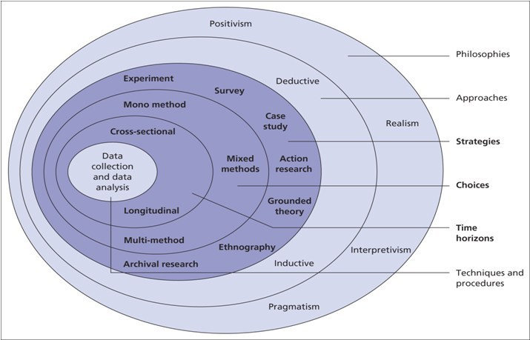
Figure 3.1 - Research Onion (Saunders, et al., 2007)

Epistemology

The research onion has been adapted over a number of editions, and it doesn’t cover everything that is important for researching. It fails to cover ontology, axiology and epistemology, and these would be shown on the outside of the onion. Rubel (2006, P.109) explained that “one widely accepted branch of modern epistemological theory holds that knowledge results from the building of simplified mental models of reality in order to solve problems”, and this is about ‘how’ we know. The meaning that this dissertation is epistemology, and that knowledge helps us problem solve (Jawad, 2018).

Philosophical Stance

The philosophical stance that will be followed throughout this research will be an interpretivism stance. Ryan (2018) states that interpretivism argues that truth and knowledge are subjective, and they depend of a single person understanding and experiences with them. When the research questions rely of a person perception it is subjective and this is when interpretivism will be used (Corbin & Strauss, 2015). Ryan (2018) continues to express that researchers cannot entirely separate themselves from their own values and beliefs, and this will impact the researcher’s interpretations and analysis of the data.

Approach

This research will follow an inductive approach. An inductive approach is used to generate untested conclusions, generalises the specific to the general and us used for the building and generation of theory (Saunders, et al., 2019). Using an inductive approach for this research is the most suitable as it allows theory to be evolve based on findings (Carpenter, 2017).

The alternative to the inductive approach is deductive. The process of this approach is when the starting point is with a theory, and the researcher then designs a strategy to put the theory to the test (Saunders, et al., 2019). As this research is not starting with theory, but with an observation, using an inductive approach is the most practical.

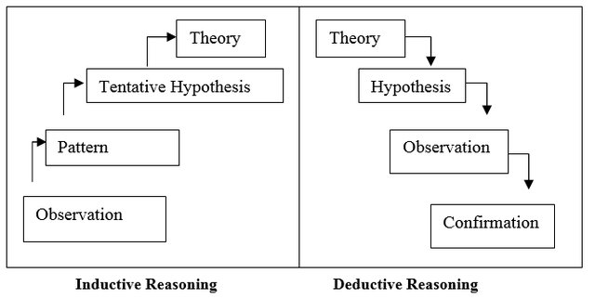
Figure 3.2 - Inductive and Deductive Approach (Trochim & Donnelly, 2006)

Strategy

Three strategies have been selected as the best options for the collection of data. Using solely a survey method for the collection of data was the original strategy. Interviews are a widely used data collection tool for qualitative research, as conducting interviews are a valuable methods of gaining insight into people’s perception, understandings and experiences (Frances, et al., 2009). Due to the recent impact of COVID-19, there was a reluctance to take part in an interview by potential candidates, face-to-face and using technological applications, which resulted in the need of additional methods of data collection.

This necessitated the change from using a mono method data collection to a multi-method. Multi-method research is an attempt to combine research methods to address a certain problem and it can be used strategically or used over the course of a research project (McKendrick, 1999). The additional methods of data collection are a content analysis and more interviews with senior members of staff of the university via email, who are experts in their field.

A cross-sectional timeframe has been chosen as the nature of this research is understanding what the representatives of companies in this industry currently think of digital marketing. Opinions and understanding on the subject may change over a period of time when using a longitudinal timeframe, and due to the changing technologies and tools it is important to understand current opinions of the subject in the industry (Carpenter, 2017).

Research Overview

Semi-Structured Interviews

Phase one of the collection of data with participants followed a semi-structured interview. The reasons this type of interview was conducted is due to the suitability to explore the participants opinions and perceptions. It is designed to ascertain subjective responses from the participant regarding a particular situation or what they have experienced and the participants are free to respond to the open ended questions how they wish (McIntosh & Morse, 2015). The interviewees were first be asked to answer a few identical questions to ensure validity, and when theoretical saturation is close the interview will then need to adapted to understand the develop theory (Carpenter, 2017). The ability to substitute words but not the meaning acknowledges that not every participant has the same vocabulary and the meanings of words may differ from each respondent (Barriball, 1994).

The sample size was originally planned to include a minimum of twelve participants, but due to COVID-19, as discussed, caused a reluctance for potential interviewees to take part. This was not the sole reason for reluctance, other reasons will be discussed in Chapter 5. The reasons the sample aim was twelve is because a higher sample size would have resulted in less depth of analysis for each participant and is the suggested number of interviews to conduct by Baker and Edwards (2012) as this will give the researcher the experience of planning and structuring an interview.

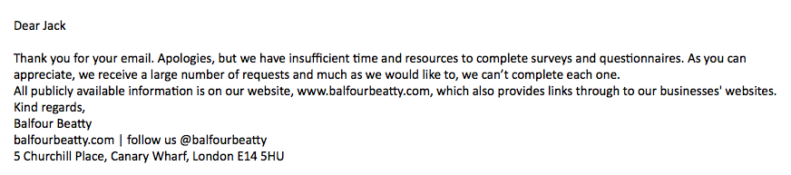
Figure 3-3 Email response from Balfour Beatty showing reluctance to participate in research.
The sample of participants chosen was based on their job title and industry they worked in. There was no need to use demographics when choosing the participants as their gender, age, etc. did not apply to the research objectives. The process of the interviews started by declaring the participants confidentiality and the audio of interview was recorded to be able to transcript the interview accurately instead of transcribing through the interview.

An Introduction to Content Analysis

Phase two of the collection of data will be using a content analysis. The context analysis methodology has been continually developing since the early 1920’s (Stepchenkova, et al., 2008) Context analysis examines textual data for patterns and structures, focusing on key features that the researcher wants to pay attention to, developing categories and forming them into noticeable constructs to understand the meaning behind the text (Gray & Densten, 1998).

Krippendorff (2013) defined a content analysis as a research technique, making replicable and valid inferences from text to context of their use. When using this method, it allows the researcher to access valuable information. This is because the presence of the researcher will not be felt by the participant (Pothecary, 2016).

This research is aiming to understand how digital marketing is used in the construction and manufacturing sector. The content analysis will be applied to analysing a company’s website, and the companies that have been selected are: -

- Balfour Beatty
- Kier Group
- Vinci
- The Crosby Group
- Caddick Construction

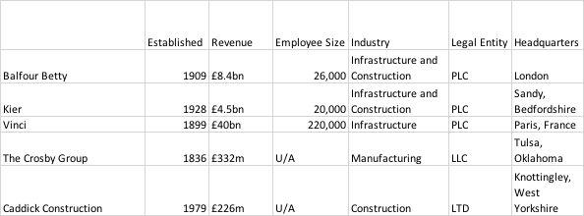
Figure 3.4 - Company information available from their websites.

The rationale for the choice of these companies have been based on the company’s success, in the UK or on an international level, and two less known, but well-respected organisations in the industry. The researcher has chosen various digital marketing tools, which are: -

- A Company Website
- SEO
- Video content on the website
- Blogs
- Social Media Accounts
- Podcasts
- Newsletters
- HQ Site Images
- YouTube and/or Vimeo
- Mobile Applications
- Site Load Speed

These marketing tools are relevant and measurable and can be identified when analysing the company’s website and are well-known digital marketing tactics (Chaffey, 2012). The analysis has used the researcher’s knowledge to identify the tools that have been used and included a colour coding system to determine how well a company has been performing based on their websites. The colour codes range from red, amber and green. Red symbolising a bad performance, amber indicating that there is room for improvement and green signalling good practise by the company. The researcher also used a tool available on the internet to test the site speed of each company. This tool was: -

- https://tools.pingdom.com/

The researcher then conducted the same content analysis on the companies that were interviewed, comparing the usage of digital marketing tools of large companies in the sector with smaller sized companies. This was done to see how the size of the company effects the way they utilise digital marketing.

E-mail Interviews

As a final attempt to collect data due to the paucity of time and nearness of submission, phase three had senior members of different universities were contacted and asked to answer a set of four questions via e-mail. The researchers reasoning behind this decision was to have an opinion from experts in the marketing field. The advantages of using this method that the participant does not need to meet face to face and there is no need for sophisticated hardware or technological skill. (Jawad, 2020) The researcher was wary of taking too much of the participants time, which was the reason there was only four questions. With the timing of the pandemic, it was a perfect opportunity to approach the senior staff members as it most likely would have resulted in a decline if the situation was normal.

Reliability, Validity and Ethical Risk

For this dissertation, the research needs to make sure that all the data that has been collected is valid and reliable. Gheyle and Jacobs (2017, P.10) explains that validity “is the extent to which a measuring procedure represents the intended and only the intended concept”. The reliability of research means that the research techniques should result in the findings being replicable (Krippendorff, 2013). The researcher has considered the reliability and validity by carefully selecting the samples. Only those who are working in the industries of construction and manufacturing have been chosen to participate in the interviews.

To make sure all the data collected is valid, an in-depth literature review was written prior to designing the methodology chapter. The literature review was able to give the researcher a foundation of knowledge on the subject. It has been suggested by Collis and Hussey (2009) that using more than one method of data collection will result in more validity. This will apply to the research due to the interviews being much harder to conduct due to the COVID-19 outbreak, and a content analysis has been included to be able to gather additional data.

There is an element of ethical risk in the research. Due to the subject of this dissertation and who the sample includes, people may consider the information that is being asked at sensitive information. The participants of the interview were told what the research is about and if they were happy to continue with the interview, to which they all agreed. The content analysis is only using data on their website that is available for the public to view, thus no ethical considerations needed to be made. A completed ethics form was submitted alongside the research proposal which had been accepted prior to the collection of data.

Methodology Conclusion

This chapter has identified the methods of data collection that have been used. Following the research onion, the researcher has distinguished which philosophy, approach, strategies and other elements that this research will be using. Using semi-structured interviews, conducting a content analysis on various company’s websites and further interviews with field experts will reveal information to the researcher that they will be available to use in order to complete set objectives. This chapter was able to complete the second objective, and the following chapter will use the methods discussed to gather, analyse and put forward findings.

Analysis of Results

The previous chapter looked over and discussed the methods for primary research. This chapter will provide a critical data analysis on the data that has been gathered on digital marketing in the construction and manufacturing industry.

The researcher has made sure that the data collection was sequential, and due to this, the analysis that this chapter will consist of shall be sequential as well. An analysis of phase one of interviews will be first, followed by phase two, the content analysis and finishing with phase three (e-mail interviews). The researcher had planned to conduct twelve interviews, but due to the COVID-19 pandemic, only four were completed. The content analysis of the websites of the companies that were mentioned in the previous chapter was conducted from the 14/5/20 to 19/5/20. The content analysis comprised of objectively reviewing the company’s websites and identifying commonalities and differences between each of the five companies (Jawad, 2006).

Data Analysis

Marshall & Rossman (1999) has described data analysis as the process of bringing order, structuring and meaning to collected data. Once the data is categorised, it enables it to become more manageable and themes will naturally arise (Collis & Hussey, 2009).

Methods

There were three methods of data collection conducted in this dissertation, the first of which were the interviews. These interviews explored the use of digital marketing by construction and manufacturing companies and also included questions on why the company the interviewee was representing was not participating in any digital marketing activities.

The interviews followed a survey strategy and followed an interpretivist approach, and these interviews were set out to be semi-structured. This allows the participant to answer how they wish to an open-ended question (McIntosh & Morse, 2015). These interviews were originally supposed to take place face-to-face, but the researcher had to adapt and used Zoom to contact and talk to the respondents. All the data from the interviews were organised and analysed using the NVivo software. It is a limitation of this dissertation that there were a much smaller number of interviews conducted than anticipated. It is highly likely that the reasons behind this are connected to the COVID-19 pandemic.

Main Findings

Interviews

The topic of each interview was a discussion on the use of digital marketing, and the companies that were interviewed were small manufacturing and construction companies. The researcher had discovered that many smaller companies operating in the industries were not taking part in many digital marketing activities. The researcher directed the interview towards the reasons why these companies were not actively using digital marketing tools (Appendix 3). Although the interviews were only conducted to four participants, during the analysis of the interviews using NVivo, three themes had been revealed. The themes that were revealed were the lack of time, money and understanding. Further analysis into each theme will follow.

Money

The first theme that had appeared whilst analysing the interviews data was the high costs of investment when trying to implement any digital marketing plans. All of the participants had expressed concern with the costs of implementing digital marketing within their company. One of the participants had explained that they were unsure on whether investing in digital marketing would bring any benefit, and another participant responded by saying that: -

“I think the money is too much to employ somebody to do just solely marketing
without knowing if it’s going to bring in any money or not.” (P4)

The researcher believes that this shows that smaller companies are not prepared to implement a digital marketing strategy due to the risk of not making a return of investment (Jarvinen, et al., 2012). The researcher had used Nvivo to run a word query. The word tree below has two points that have been focused on, showing that the companies have explained that they either do not have enough money or that the amount of money is too much to invest in.

Figure 4.1 - Word tree of money
One participant revealed that they use an external agency to manage their social media accounts (P1), showing that they do in fact consider digital marking important enough to spend money on it (Kelly, 2016).

Time

Another theme that had emerged from phase one is the lack of time that the employees had due to other areas of the business being considered more important. One participant who said time was an issue explained that they would do the digital marketing if business was slow. If business was busy, they would need to help out to make sure that the business is running smoothly (Chaffey & Patron, 2012).

When asked about the reasons they used an external agency, SME 1 had answered with: -

“We just didn’t have the time to do it” (P1)

In regard to this participant, it seems that their main problem when implementing digital marketing was the lack of time. The company knew that it is important for them to use this type of marketing, as they resorted to spending money for an agency to manage it for them (Kelly, 2016).

Knowledge and Understanding

The third theme, understanding, gave some insight to what was holding them back when using digital marketing. Two participants had expressed that a lack of understanding and knowledge was the reason that they have not been using digital marketing tools for the company (Azhar & Abeln, 2014).

One of the participants had said that there was a lack of understanding from the older employees of the companies, showing that there may be demographic challenges within the industry (Bahra, 2017). This will be returned to on page 32.

Figure 4.2 - Word tree giving context for when participants said understanding

Content Analysis

The content analysis uses the archival research strategy, and this consisted of identifying five company websites and critically evaluating the uses of digital marketing, to understand the way it has been used in the construction and manufacturing industry. A grid has been formed that include various digital marketing tools that have been discussed in Chapter 2. A tick has been placed to indicate whether the company use the digital marketing tools that have been selected, whist there is a colour code indicating how well they are utilising the particular tool. Every effort was maintained to keep independent, as all of the content analysis was based on the researcher’s interpretation. This was checked twice to avoid human error and enhance the reliability and validity of the data collection.

The content analysis was conducted by the researcher, covering five companies that can be considered market leaders. This content analysis had used 19 marketing tools to understand the usage of digital marketing in this sector (Chaffey, 2012), although not all of the tools will be covered due to the amount of data collected. The companies that were interviewed had been promised anonymity by the researcher and the names have been replaced with ‘SME’.

Table 4.1 - Content Analysis of five large construction and manufacturing companies
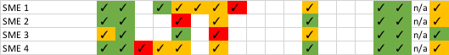
Table 4.2 - Content Analysis of the companies that there interviewed
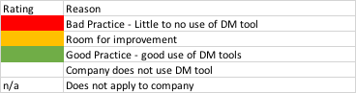
Table 4.3 - Colour codes to understand the content analysis grid

Website Tools

All of the companies who had been chosen for this content analysis had a website online for people to visit when they please. Of the nine, two companies had been given an amber rating due to the visual appearance of the website. The Crosby Groups website was very outdated compared to the other websites in its table. SME 3’s website was also outdated in the terms of visuals. Three of the SME’s websites were rated a Green due to the modern and clean appearance. The researcher is able assume that three of the SMEs have an understanding that a good, high quality website will be able to increase trust from the website visitors (Gregg & Walczak, 2010). As The Crosby Group have a low quality website, it seems as though they do not recognise the link between high quality and trust. Homepages of Caddick and Crosby’s homepage will be shown below to show comparison between the quality of the website.


Figure 4.3 - Screenshot of The Crosby Groups homepage
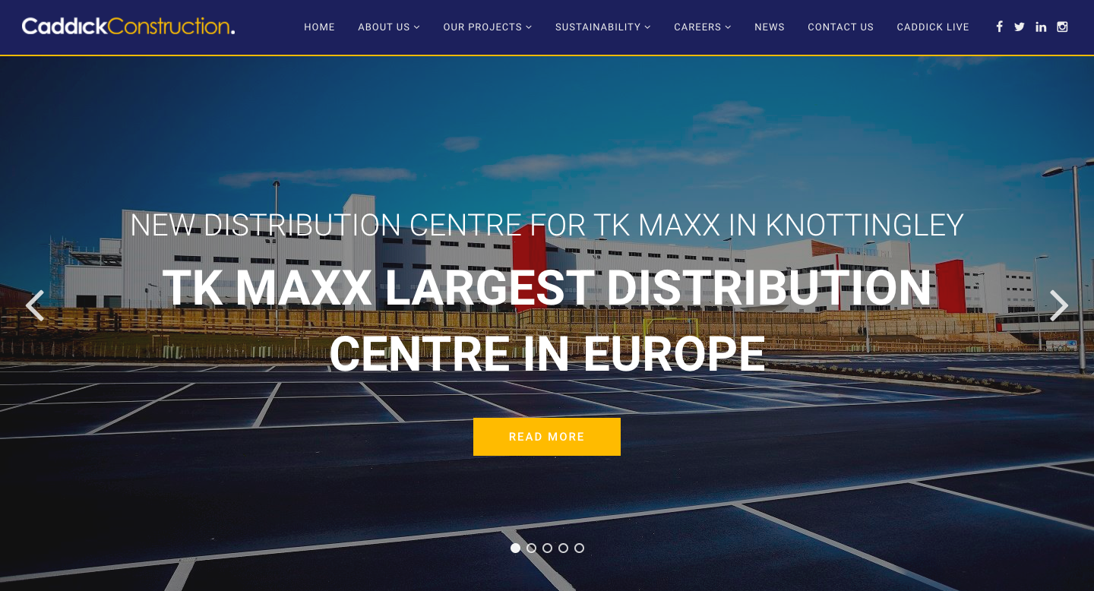
Figure 4.4 – Screenshot of the homepage of Caddick Construction

All websites have a green rating for their SEO, as all of the companies placed first in the search results for the name of the company, showing that all companies understand the importance of being shown on top of the search results (Ortiz‐Cordova & Jansen, 2012).

The third website tool on the grid was video content. This was strictly video content that was available to watch on the company’s website. All but one of the five larger companies use video content of the company’s website. All those who used this tool used it well, as the researcher has given them a green rating. Each company took a different approach when making the video content, Balfour Beatty had focused on high quality, short videos (up to 3 minutes) on different subjects, whilst The Crosby Groups video content is also high quality, relatively short but has been directed to resemble a television show. With video content being able to chance of being shown at the top of google by 53% (Patel, 2018), it is a very useful tool to use of a website. Only one of the SMEs have video content on their website, but this was given a red rating because the video content was not created by the company themselves, but rather by a company the SME was selling a product for.

The next website tool that was included on the content analysis was the use of blogs. (Baltes, 2015) All of the larger companies had a blog page on their website providing news and updates on the company’s recent projects and company culture. Those who are a PLC all share reports to give information to their shareholders. Caddick Constructions blog posts were varied from long to short, and the researcher had felt there was a lack of structure. Two of the SME’s have a blog page, the first of which had been well written and provided good information. Although the second SME did have a blog page, the content of the blog was lacklustre. It gave short and direct news and the researcher feels it would be more appropriate for a social media platform such as Twitter.

All but one of the larger companies provide an e-mail newsletter that people can subscribe to. The content of the newsletter was unknown to the researcher, but all of the options were clearly visible to the user when looking at the news section of the website. None of the SME’s had any option of a subscription to e-mail newsletter, which indicates to the researcher that the company’s do not run any e-mail marketing campaigns, and this could be caused by a lack of knowledge (Gilmore, et al., 2007).

All of the PLC’s display their share prices on the top of their homepage, ensuring that visitors of the website know the price if they are interested in investing. This is a good use of digital marketing for the websites as it will remind the visitor of the option of purchasing shares. The site load time was analysed using the website tool that was discussed in Chapter 3. Only two of the larger companies had been rated highly, and the other three were not due to the slower load times. One surprising result was The Crosby Groups website, which the researcher had rated amber, also had a slow loading time even though the researcher perceived it as simple and outdated (Chaffey, 2012), (Carter, 2019). The one SME that had been rated amber seen the best load time out of the four companies, and this is highly likely due to how simple the website is.

Social Media Use

All of the companies that have been a part of this content analysis have made use of at least two of the five social media platforms that are going to be discussed. These two being Facebook and Twitter, which is surprising due to LinkedIn being the most popular B2B platform to distribute content, with 82% of B2B marketeers saying it is the best platform for marketing objectives. (Rynne, 2019). Kier Group and Caddick Construction had been given a red rating, this is due to the poor use of the platform. Kier Group had one post on the page and Caddick Constructions page was not reachable via their website, displaying a message “sorry, this content isn’t available at the moment” (Figure 4-5).

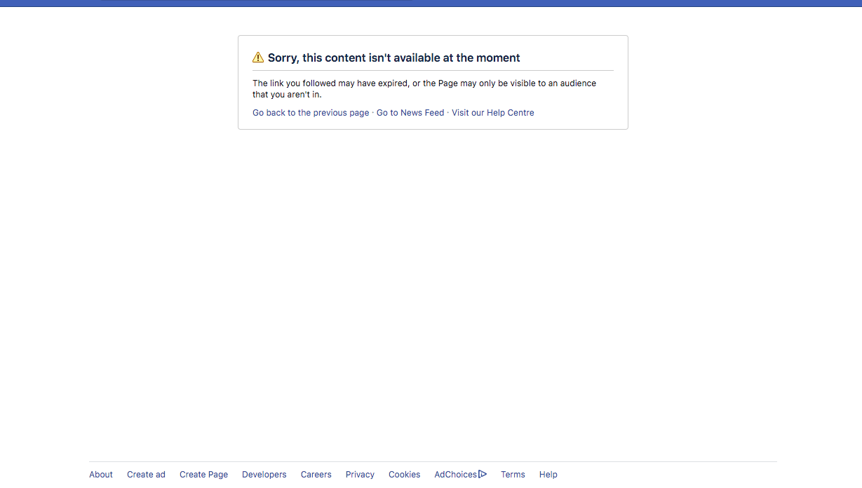
Figure 4.5 - Screenshot of the message from Facebook when clicked the link from their website
The researcher had tried to find a Facebook page for Caddick Construction and failed to locate one. The reason they have gained a tick in the content analysis table is due to them providing a link to a page on their website which does not exist, which shows that they may not be updating their website thoroughly. Vinci is the only company in their table that had been given a green rating, and this is due to a high level of professionalism on their pages. They provided a live chat function on the page to enable visitors to ask questions or find out information. As they are a large company with various companies within their group, and each have their own Facebook page and personalised content. The researcher believes that Vinci can be considered market best practise for the use of this social media platform (Perera, et al., 2015).

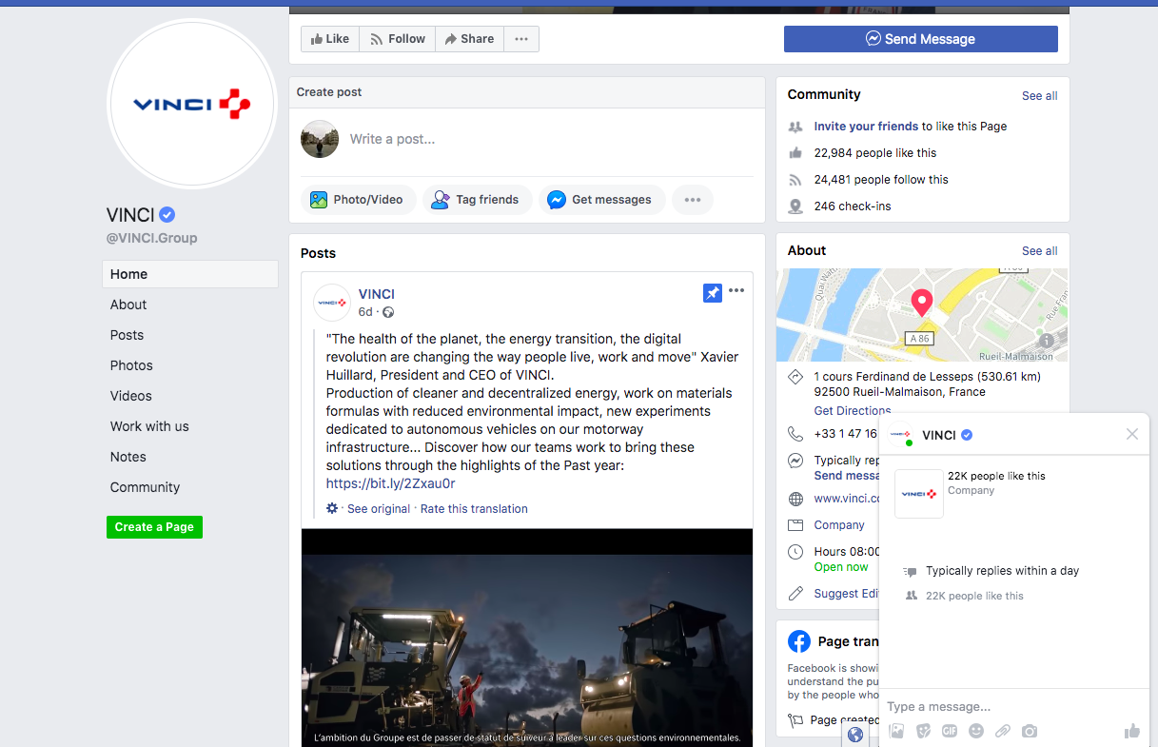
Figure 4.6 - Facebook page of Vinci displaying a live chat function
Each of the SMEs have their own pages, and one showing good use of the website. Providing offers through Facebook, engaging visitors of the page and posting at a consistent rate, they have been able to receive a good following. SME 2 had been rated red due to the inactivity of the company, posting once per year since 2017. The other two SMEs had posted around 3 times a month and engaged with visitors, but the content was very basic. Three of the four SMEs were not able to produce quality content and there was a lack of consistency between post, indicating there was no implementation of a content plan by the companies and their posts were usually reactive (Taiminen & Karjaluoto, 2015).

Another commonality between all the companies analysed was the use of a twitter page. Balfour Beatty and Caddick Construction both use the platform to update followers on their projects and document their community engagement activities. Whilst Balfour Beatty have a significantly higher amount of following compared to Caddick, they do not engage with their followers apart from liking tweets that have mentioned their account. Caddick Construction use their twitter account to not only to provide updates on their work, but to actively engage with their followers and reply to messages they receive. The researcher believes that Balfour Beatty use their twitter account as a platform to inform followers of their business as a news source, and Caddick Construction use it as a platform for their followers to communicate with the company and collect feedback (Ovadia, 2009).

None of the SMEs had been given a green rating for their use of their Twitter account. SME 1’s use of twitter was posting daily tweets which lacked valuable information. The researcher thinks that they chose quantity over quality when deciding what to post. Only one of the remaining SMEs had made a post this year, showing that the other two participants do not consider twitter a priority, likely due to them not having enough time due to other work needing to be done (Chaffey & Patron, 2012).

A noticeable gap within the two tables is the SMEs lack of social media planforms in comparison to the larger companies. With only SME 1 using LinkedIn and Instagram, there is a clear difference of the usage of social media between the two sets of company. When the researcher asked SME 2 why they did not use LinkedIn, they responded by saying: -

“it’s just whether we have the time or the resources to get into it” (P2)

This shows further evidence to the researcher that one of the reasons the gap in the table is so apparent is due to the SMEs lack of free time to participate in more digital marketing activities (Chaffey & Patron, 2012).

All but one of the larger companies have a YouTube channel, with only The Crosby Group receiving a green rating. They produce a TV inspired show delivering information on products and safe use. The company have also produced a podcast in a video format which now seem to be the direction the company is moving forward with YouTube. None of the SMEs had created a YouTube channel or created any video content for their website and this may be due to the lack of technical knowledge and generalist nature of employees in SMEs as said by Gilmore, et al. (2007). Another video website that is used by two of the companies is Vimeo, and both use it as a hosting platform to be able to display video content on their website.

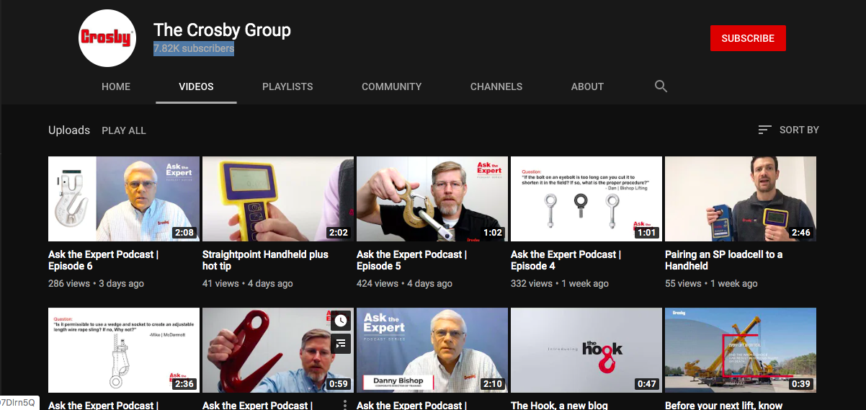
Figure 4.7 - The Crosby Group's YouTube page

Mobile Applications

Only three of the larger companies had created a mobile application. Vinci have created multiple applications, mainly focused on being a news outlet to their shareholders or customers. These were all available from various application stores on mobile devices. The other two companies had been rated red due to their applications being web-based and this give the indication that they do not get updated. The two applications are also no available through mobile stores, but rather through their websites and some phones do not allow the download of external applications due to security risk. This point shows that security risks need to be considered when creating an application, as discussed in the literature review by Azhar and Abeln (2014).

E-mail Interviews

The final method that was used was a structured interview via e-mail that was sent to various members of staff at different universities, from which three responded. The e-mail consisted of four questions based on the results of the analysis from phase one. The researcher had done this to gain opinions on the results from a person who is an expert in their field. The participants responded with rich information that was useful to the objective of this dissertation.

The e-mail interviews had consisted of 4 questions (Appendix 4), as the researcher was wary of taking too much of the participants time. All three of the participants were academics within universities and can be considered experts in their field. The researcher has used a matrix analysis to identify themes from the participants answers. One theme from each question had been identified and they were education, evolution, dominance and opportunity. The first question asked them for their opinion of the results from phase one of the interviews and a theme that stemmed from their answers was education. This links with the researcher’s previous analysis results of knowledge and understanding. The theme from the second set of answers was evolve, and this also can be linked to knowledge and understanding. This can mean that companies will need to evolve their knowledge and understanding to full utilise digital marketing in their business. The fourth theme, opportunity, also links due to need of knowledge and understanding to realise what opportunities digital marketing can offer.

The researcher had linked the theme of dominance to money and time. If a company has the money to pay for resources and expertise, it would not be a barrier to digital marketing (Jarvinen, et al., 2012). When companies hire employees, they gain more time to prioritise the different tasks, allowing digital marketing to be focused without the worry of completing another job. If a company has neither money nor time, they will be unable to assert dominance.

P2 of the e-mail interviews had touched upon the lack of understanding could be due to the older demographic of the workers in the industry, which links back to the literature review with Bahra (2017) expressing that the ageing demographic has a direct impact of the skills that are available.
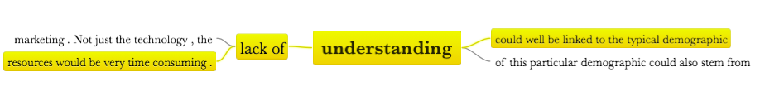
Figure 4-8 - Word tree of understanding from the e-mail interviews

It has also been discussed that “money will often be used as a justification for lack of marketing” (P2), explaining further that it is an oddity that it is used as an excuse due to the relative low costs of digital marketing. This is backed by (Stankovska, et al., 2016), as they explained that due to the advances in technology, barriers to adoption have been lowered with digital marketing being user friendly, cheap and accessible.

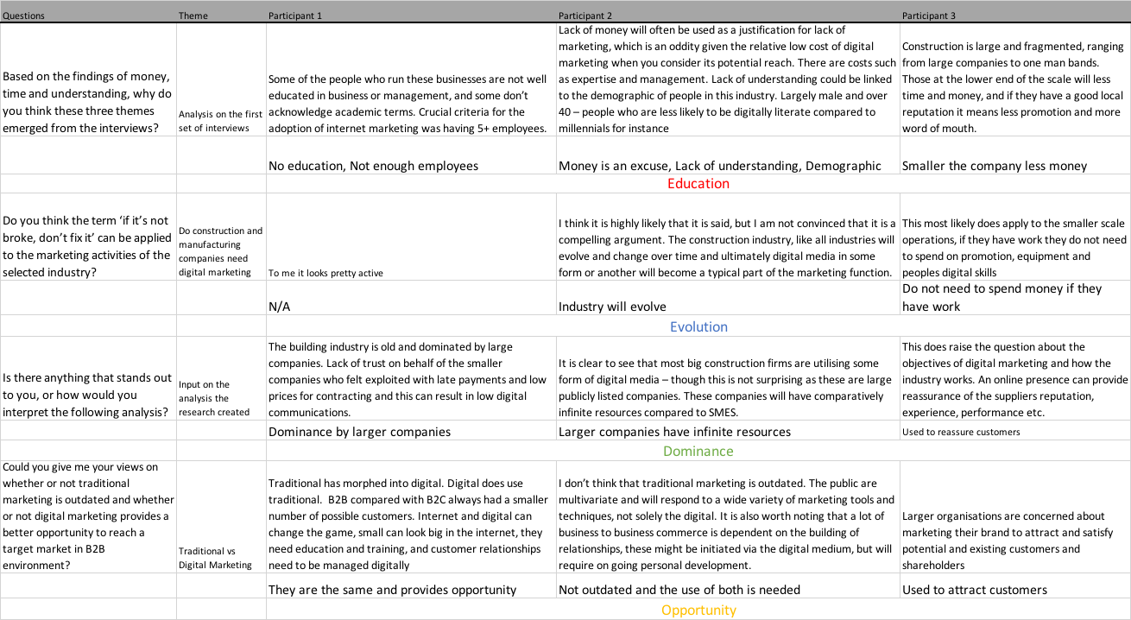
Table 4.4 - Matrix Analysis of the e-mail interviews

Analysis of Results Conclusion

This chapter has been able to complete its objective set by analysing the data that has been collected via three different methods. The researcher was able to extract three themes from all of the methods and had been able to link them together. The next chapter will be aiming to complete the last objective which is: -

- To present recommendations to the construction and manufacturing industry to recognise and learn about the importance of the use of digital marketing.

Conclusions and Recommendations

Introduction

This chapter will be used to discuss that analysis of the data collection. The discussion will be sequential in the order the analysis followed, starting with the interviews with the four SMEs, continuing with the content analysis and finishing with the interviews with the three university academics. When the discussion has been completed, the data will be able to outline the industries use of digital marketing. This chapter will achieve the following objective: -

- To present recommendations to the construction and manufacturing industry to recognise and learn about the importance of the use of digital marketing.

Achievement of Objectives

- To evaluate previous research on digital strategy in the construction and manufacturing sectors and develop greater understanding by critically analysing peer reviewed journals and credible publications on the subject.

Evaluation of previous research had been completed during Chapter 2.

- To collect primary data and identify and analyse digital marketing use in the construction and manufacturing industry.

Analysis of collected data on the usage of digital marketing had been completed throughout Chapter 4.

- To present recommendations to the construction and manufacturing industry to recognise and learn about the importance of the use of digital marketing.

Recommendations will be made further on in the current chapter, allowing this objective to become complete.

Main Findings

The main findings of this research support much of what was discussed during the literature review. The researcher had concluded that the main finding of this dissertation is that the use of digital marketing in a construction/manufacturing company will largely depend on the knowledge and understanding of those who are employed by or who runs the business. If persons in the company do not have the knowledge and understanding of how to use and implement digital marketing, they would not be able to utilise it successfully.

Other findings show that resources such as money and time are also factors that determine that usage of digital marketing in the construction and manufacturing industry. The content analysis was able to visualise how money and time can have great impact on the increased usage of digital marketing. The more money, a company is able to supply the best resources to aid the implementation and also pay for employees with expertise in the area. If a company has more time, they are able to focus on completing digital marketing objectives and tasks without worrying about other duties in the business.

Recommendations

The following recommendations are being made to increase the usage of digital marketing in these sectors. Recommendations will be made to the government, SMEs

The first recommendation is for the government and/or Welsh assembly to create a web page that will allow SMEs of all industries to reach out for help with digital marketing and provide information for those who do not understand it. There is a clear lack of knowledge and understanding of digital tools in the construction and manufacturing industry and the government should be able to provide free resources and advice to those who need help.

The second recommendation will be to encourage companies to make use of free course websites such as Google Digital Garage and Alison.com to allow their employees to gain knowledge on digital marketing and other subjects. This can be a great aid to SMEs in the industry, as limited financial resources were one of the findings from the interviews. These can also be used as a top up course if employees have had previous education and need refreshment.

The third recommendation will be to continue to use traditional marketing strategies as part of their overall company strategy. Marketing is important and is has not changed, but rather the communication channel that is used has changed. Traditional strategies are very important especially in the industry, and it is important to use both types when planning. Traditional tactics offer great local reach.

The fourth recommendation is for the SMEs who do not have an online presence. The researcher believes that an online presence is essential for a business and recommends creating one, even if it is only a social media page. Social media accounts are free of cost when setting up, and the platform allows the business to provide updates and information to potential customers.

Further Research

The only type of data that this dissertation had collected was qualitative data. Further research conducted may be able to collect quantitative data or use a mixed method approach to collect an additional form of data.

The number of interviews that were conducted were inadequate, and further research should ensure the number of participants should be increased to collect more reliable results. The researcher would recommend steering the focus on the SMEs on the industry, as results from this dissertation has shown that there are multiple barriers for adoption for smaller business compared to the larger ones.

Location based research may provide quality data. Comparing the use of digital marketing of companies by region may be able to reveal patterns in successful usage of the tools and geographical locations. For example, the use of digital marketing in London may prove to be more successful than another city such as Manchester. Cultural differences may be revealed if the research includes participants from different countries, which may be able to show how other countries make use of digital marketing and how they value it compared to the UK.

Limitations

Whilst completing this dissertation, there have limitations. Gathering data had been proven to be difficult because of the reluctance of potential participants. One cause of reluctance may be due to the companies and/or employees not wanting to reveal trade secrets. A company’s marketing strategy can make them successful and they may have felt that if they agreed to partake, their plans may be made public and competitors may be able to take advantage.

The researcher also thinks that upon completion of the analysis of results, there may have been a reluctance to participate due to the lack of knowledge and understanding of the subject. This stems from the possibility of them not knowing enough has pushed them away from partaking in a research interview.

The COVID-19 pandemic has also caused limitation when completing the dissertation, being the main factor in the reluctance of participants. Causing face to face interviews to become impossible with government restriction and forcing the researcher to depend on digital technologies to complete the collection of data. As discussed, the demographic of the industry may have also caused reluctance as they may not be familiar with the applications that the researcher needed to use to collect and record data.

Final Summary

As a final summary to conclude this dissertation, the researcher was able to complete the research aim that had been set, which was to evaluate and understand the usage of digital marketing in the construction and manufacturing industries. Following the completion of the research aim, the researcher believes that they have accumulated a vast array of knowledge of the topic, not only from the review of literature but from conducting the research. The researcher feels that this knowledge will definitely help them along their chosen career path, assisting them to be able to understand how to use digital marketing when pursuing a job in construction and manufacturing.

The dissertation was able to highlight three main themes that will affect each company’s use of digital marketing, these themes being Money, Time and Knowledge and Understanding. There is a big difference between the SMEs usage and the larger company’s usage, and this is because the larger companies have an excess of the three themes that have been identified.

Employees in these types’ companies need to be educated if they are offered a marketing role within the organisation and not left to work with no understanding of what they need to do. With the clear gap between large companies, who are dominant in the industry, and SMEs, there’s need to be information provided in order to aid them in their digital marketing strategies.

Self-reflection

During the course of this dissertation, the researcher wanted to increase their knowledge and understanding of the use of digital marketing in the construction and manufacturing sector. This was because they were undertaking a marketing degree and they experienced first-hand the lack of use when taking a part-time job with a manufacturing company.

This dissertation had proven to be more difficult that the researcher anticipated, although they have developed knowledge and gained experience of software such as NVivo. The researcher has been able to expand their understanding of research, its methods and have been able to apply it to real-world problems.

Difficulties arose during the process of this dissertation upon the interference of the COVID-19 pandemic, as it made it significantly more challenging to conduct and perform planned data collection methods, such as the interviews. The researcher was able to respond to these difficulties by learning how to adapt their methods under pressure to be able to complete the research.

References
Avlonitis, G. J. &. P. N. G., 2005. Antecedents and consequences of CRM technology acceptance in the sales force. Industrial Marketing Management, 34(4), pp. 355-268.
Azhar, S. & Abeln, J. M., 2014. Investigating social media applications for the construction industry. Alabama, Elsevier Ltd.
Bahra, A., 2017. The underlying challenges of the construction industry. [Online]
Available at: https://www.constructionproducts.org.uk/news-media-events/blog/2017/september/the-underlying-challenges-of-the-construction-industry/
[Accessed 25 May 2020].
Baker, J. D., 2016. The Purpose, Process, and Methods of Writing a Literature Review. AORN Journal, 103(3), pp. 265-269.
Baker, S. E. & Edwards, R., 2012. How many qualitative interviews is enough?, London: National Centre for Research Methods Review Paper .
Bakhtieva, E., 2017. B2B digital marketing strategy: a framework for assessing digital touchpoints and increasing customer loyalty based on Austrian companies from heating, ventilation and air conditioning industry. Oeconomia Copernicana, 8(3), p. 463–478.
Baltes, L., 2015. Content marketing - the fundamental tool of digital marketing. Bulletin of the Transilvania University of Braşov Series V: Economic Sciences, 8(2).
Baltes, L. P., 2017. Marketing technology (Martech) – the most important dimension of online marketing. Transilvania University of Braşov Series V: Economic Sciences, 10(59), pp. 43-48.
Barriball, K. L., 1994. Collecting data using a semi-structured interview: a discussion paper. Journal of Advanced Nursing, 19(2), pp. 328-335.
BBC, 2019. GDP: Wales economic growth boosted by construction. [Online]
Available at: https://www.bbc.co.uk/news/uk-wales-49580680
[Accessed 13 April 2020].
Bevan, K., 2019. A critical evaluation on the effectiveness of self-regulatory codes in the accounting profession, Swansea: UWTSD.
Blythe, J., 2016. Essentials of Marketing. 6th Edition ed. Harlow: Pearson.
Carpenter, B., 2017. Critical Evaluation of the Effectivness of the Measures Implemented by the French Government in Growing the British-French Tourism Industry following recent Islamic Attacks, Swansea: UWTSD.
Carter, E., 2019. 7 Components of a Successful Digital Marketing Strategy. [Online]
Available at: https://www.webfx.com/blog/marketing/digital-marketing-components-5-elements-of-a-successful-digital-marketing-strategy/
[Accessed 17 May 2020].
Chaffey, D., 2012. Digital Marketing. 5th Edition ed. Harlow: Pearson.
Chaffey, D. & Chappell, M., 2020. Managing digital marketing in 2020, London: Smart Insights.
Chaffey, D. & Patron, M., 2012. From web analyti cs to digital marketi ng opti mizati on: Increasing the commercial value of digital analyti cs. Journal of Direct, Data and Digital Marketing Practice, 14(1), pp. 30-45.
Cohn, C., 2015. Differences In Selling B2B Vs. B2C. [Online]
Available at: https://www.forbes.com/sites/chuckcohn/2015/06/16/differences-in-selling-b2b-vs-b2c/#611852b14fb2
[Accessed 24 May 2020].
Collis, J. & Hussey, R., 2009. Business Research. 3rd Edition ed. Basingstoke, Hampshire: Palgrave Macmillan.
Constructionline, 2020. The impact of COVID-19 across the Construction Industry [Infographic]. [Online]
Available at: https://www.constructionline.co.uk/insights/news/covid-19-infographic/
[Accessed 25 May 2020].
Content Marketing Institute, 2012. What Is Content Marketing?. [Online]
Available at: https://contentmarketinginstitute.com/what-is-content-marketing/#:~:text=Enter%20content%20marketing.,to%20drive%20profitable%20customer%20action.
[Accessed 29 May 2020].
Corbin, J. & Strauss, A., 2015. Basics of Qualitative Research. 4th Edition ed. Thousand Oaks, CA: SAGE Publications.
Department for Business Innovation and Skill , 2013. UK construction: economic analysis. [Online]
Available at: https://www.gov.uk/government/publications/uk-construction-economic-analysis
[Accessed 2 April 2020].
Ehlers, J., 2017. History of Marketing Timeline. [Online]
Available at: https://www.jennovativemarketing.com/2017/08/history-marketing-timeline/
[Accessed 19 May 2020].
Frambach, R. T. &. S. N., 2002. Organizational innovation adoption: A multi- level framework of determinants and opportunities for future research. Journal of Business Research, 55(2), pp. 163-176.
Frances, R., Coughlan, M. & Cronin, P., 2009. Interviewing in qualitative research. International Journal of Therapy and Rehabilitation, 16(6), pp. 309-314 .
Gheyle, N. & Jacobs, T., 2017. Content Analysis: a short overview, Ghent: Centre for EU Studies.
Gilmore, A., Gallagher, D. & Henry, S., 2007. E-marketing and SMEs: operational lessons for the future. European Business Review, 19(3), pp. 234-247.
Gray, J. H. & Densten, I. L., 1998. Integrating Quantitative and Qualitative Analysis Using Latent and Manifest Variables. Quality and Quantity, 32(4), p. 419–431.
Gregg, D. G. & Walczak, S., 2010. The relationship between website quality, trust and price premiums at online auctions. Electronic Commerce Research, 10(1), pp. 1-25.
Hughes, M., 2005. Tradeshows 2.0. Tradeshow Week, 35(47), p. 84.
Ismail, N., 2019. Digital marketing transformation: a revolution of strategy and execution. [Online]
Available at: https://www.information-age.com/digital-marketing-transformation-a-revolution-of-strategy-and-execution-123478009/
[Accessed 25 May 2020].
Jackson, G., 2017. UK construction sector returns to growth. [Online]
Available at: https://www.ft.com/content/da44e368-bfaf-11e7-b8a3-38a6e068f464
[Accessed 25 May 2020].
Jarvinen, J., Tollinen, A., Karjaluoto, H. & Jayawardhena, C., 2012. DIGITAL AND SOCIAL MEDIA MARKETING USAGE IN B2B INDUSTRIAL SECTION. Marketing Management Journal, 22(2), pp. 102-117.
Jawad, C., 2006. An Analysis of Responsible Internet Gambling Websites, Swansea: University of Wales.
Jawad, C., 2018. The dissertation: Research methods, Swansea: UWTSD.
Jawad, C., 2020. Interviews and Focus Groups, Swansea: UWTSD.
Jobber, D., 2010. Principles and Practice of Marketing. 6th Edition ed. Berkshire: McGraw-Hill .
Kelly, M., 2016. Digital Marketing in the Irish Construction Industry, Dulbin: s.n.
Kothari, C. R., 2008. Research Methodology: Methods and Techniques. 4th Edition ed. New Delhi: New Age International.
Kotler, P., Armstrong, G., Wong, V. & Saunders, J., 2008. Principles of Marketing. 5th Edition ed. Harlow: Pearson.
Krippendorff, K., 2013. Content Analysis: An Introduction to Its Methodology. 3rd Edition ed. Thousand Oaks, CA: SAGE.
Marshall, C. & Rossman, G. B., 1999. Designing qualitative research. 3rd Edition ed. London: Sage Publications.
McIntosh, M. J. & Morse, J. M., 2015. Situating and Constructing Diversity in Semi-Structured Interviews. Global Qualitative Nursing Research, Volume 2, pp. 1-12.
McKendrick, J., 1999. Multi-Method Research: An Introduction to Its Application in Population Geography. The Professional Geographer, 51(1), pp. 40-50.
Mehrtens, J. & Cragg, P. B. &. M. A. M., 2001. A model of Internet adoption by SMEs. Information & Management, 39(3), pp. 165-176.
Miller, M., 2012. B2B Digital Marketing: Using the Web to Market Directly to Businesses. 1st Edition ed. Indiana: Pearson, Inc.
Nwazor, T., 2018. 5 Industries Getting The Most ROI From Digital Marketing. [Online]
Available at: https://www.bigdropinc.com/blog/5-industries-getting-roi-digital-marketing/
[Accessed 20 May 2020].
Opreana, A. & Vinerean, S., 2015. A New Development in Online Marketing: Introducing Digital Inbound Marketing. Expert Journal of Marketing, 3(1), pp. 29-34.
Ortiz‐Cordova, A. & Jansen, J., 2012. Classifying Web Search Queries to Identify High Revenue Generating Customers. Journal of the American Society for Information Science and Technology, 63(7).
Ovadia, S., 2009. Exploring the Potential of Twitter as a Research Tool. Behavioral & Social Sciences Librarian, 28(4), pp. 202-205.
Patel, N., 2018. Is it Time to Add Video Marketing to Your Content Marketing?. [Online]
Available at: https://neilpatel.com/blog/is-it-time-to-add-video-marketing-to-your-content-marketing/
[Accessed 6 May 2020].
Patrutiu-Baltes, L., 2016. Inbound Marketing - the most important digital marketing strategy. Transilvania University of Braşov Series V: Economic Sciences, 9(2), pp. 61-68.
Pearson, S., 2019. Funding Wales’ much-needed infrastructure projects. [Online]
Available at: https://www.capital-law.co.uk/news/2019/11/04/funding-wales-much-needed-infrastructure-projects/
[Accessed 10 April 2020].
Perera, S., Victoria, M. & Brand, S., 2015. USE OF SOCIAL MEDIA IN CONSTRUCTION INDUSTRY: A CASE STUDY. London, London South Bank University.
Pothecary, B., 2016. CSR within the social gaming industry, Swansea: UWTSD.
Rahman, S., 2017. The Advantages and Disadvantages of Using Qualitative and Quantitative Approaches and Methods in Language “Testing and Assessment” Research: A Literature Review. Journal of Education and Learning, 6(1), pp. 102-112.
Rajasekar, S., Philominathan, P. & Chinnathambi, V., 2013. RESEARCH METHODOLOGY. [Online]
Available at: https://arxiv.org/pdf/physics/0601009.pdf
[Accessed 14 May 2020].
Rhodes, C., 2019. Construction industry: statistics and policy, London: House of Commons Library.
Ridley, D., 2012. The literature review: A step-by-step guide for students. 2nd Edition ed. London: SAGE.
Rubel, R. C., 2006. THE EPISTEMOLOGY OF WAR GAMING. Naval War College Review, 59(2), pp. 108-128.
Ryall, E., 2019. GDP, Wales: April to June 2019, Cardiff: Office for National Statistics.
Ryan, G., 2018. Introduction to positivism, interpretivism and critical theory. Nurse Researcher, 25(4), pp. 41-49.
Rynne, A., 2019. The Sophisticated Marketer's Guide to LinkedIn: The 5 Year Anniversary. [Online]
Available at: https://business.linkedin.com/content/dam/me/business/en-us/marketing-solutions/cx/2020/pdfs/Sophisticated-Marketers-Guide-5Yrs-eBook-2020.pdf
[Accessed 25 May 2020].
Saunders, M., Lewis, P. & Thornhill, A., 2007. Research Methods for Business Students. 4th Edition ed. London: Pearson Education.
Saunders, M., Lewis, P. & Thornhill, A., 2019. ESEARCH METHODS EIGHTH EDITION RESEARCH METHODS EIGHTH EDITION FOR BUSINESS STUDENTS. 8th Edition ed. Harlow: Pearson Education Limited.
Schillewaert, N. A. M. J. F. R. T. &. M. R. K., 2005. The adoption of information technology in the sales force.. Industrial Marketing Management, 34(4), pp. 323-336.
Schmitt, B., 2011. Experience Marketing: Concepts, Frameworks and Consumer Insights. 5(2), pp. 55-112.
Stankovska, I., Josimovski, S. & Edwards, C., 2016. Digital channels diminish SME barriers: The case of the UK. Ekonomska Istraživanja / Economic Research, 29(1), pp. 217-232.
Stepchenkova, S., Kirilenko, A. P. & Morrison, A. M., 2008. Facilitating Content Analysis in Tourism Research. Journal of Travel Research, 47(4), pp. 454-469.
Taiminen, H. & Karjaluoto, H., 2015. The usage of digital marketing channels in SMEs. Journal of Small Business and Enterprise Development, 22(4), pp. 633-651.
Trochim, W. & Donnelly, J., 2006. The Research Methods Knowledge Base. 3rd Edition ed. Cincinnati, OH: Atomic Dog.
Vijayeta, M., 2019. "BIM( Building Information Modeling) Uptake"- A digital marketing tool in Construction Industry. Bangalore, NIMHANS Convention Centre.
Widjaya, V., 2017. 5 ADVANTAGES OF TRADITIONAL MARKETING OVER DIGITAL MARKETING. [Online]
Available at: http://www.smbceo.com/2017/04/19/5-advantages-of-traditional-marketing-over-digital-marketing/
[Accessed 25 May 2020].

Appendices

Appendix 1

Appendix 2

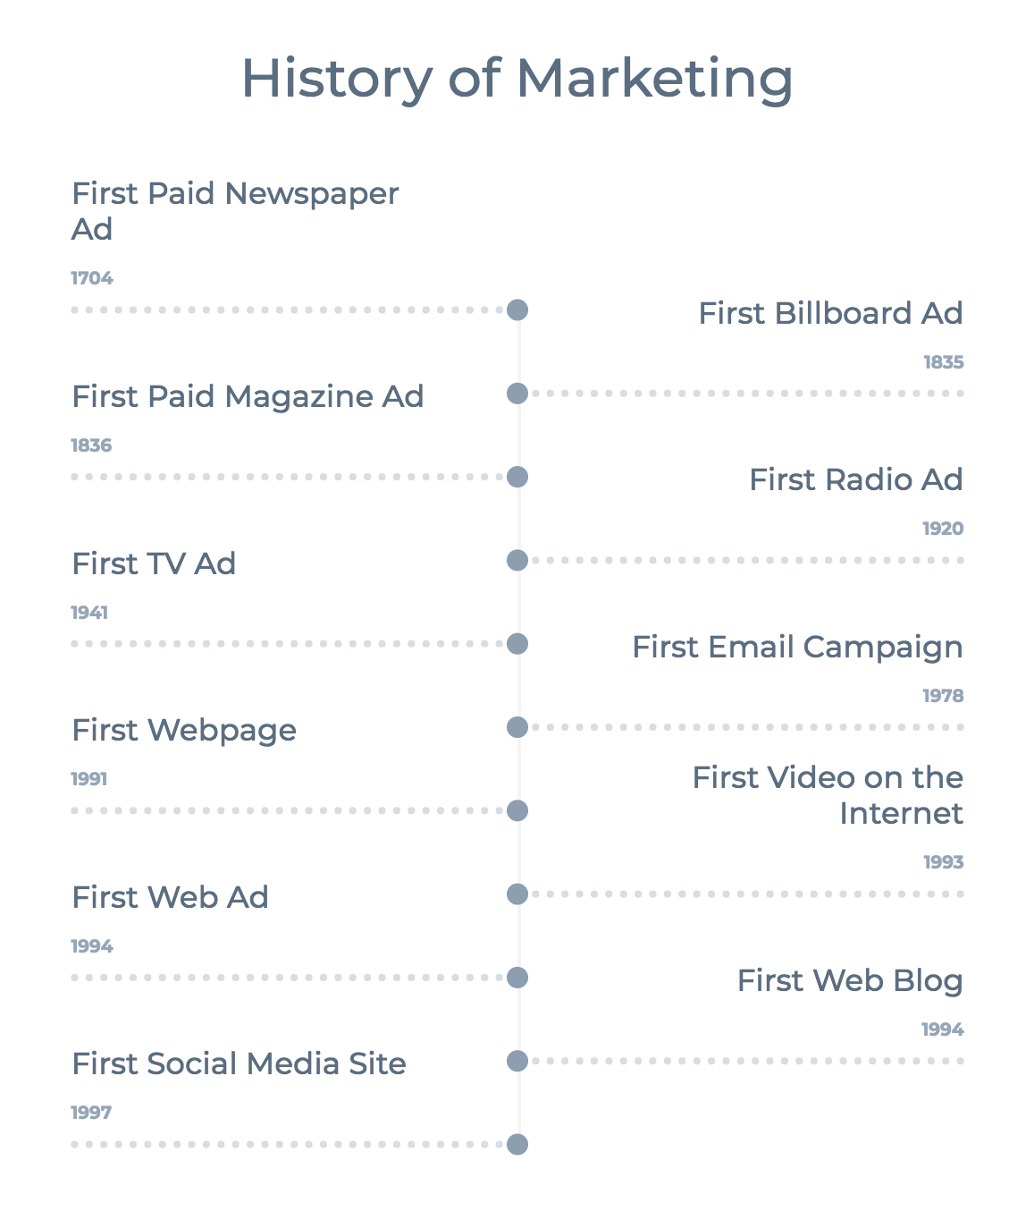
Appendix 3

P1: 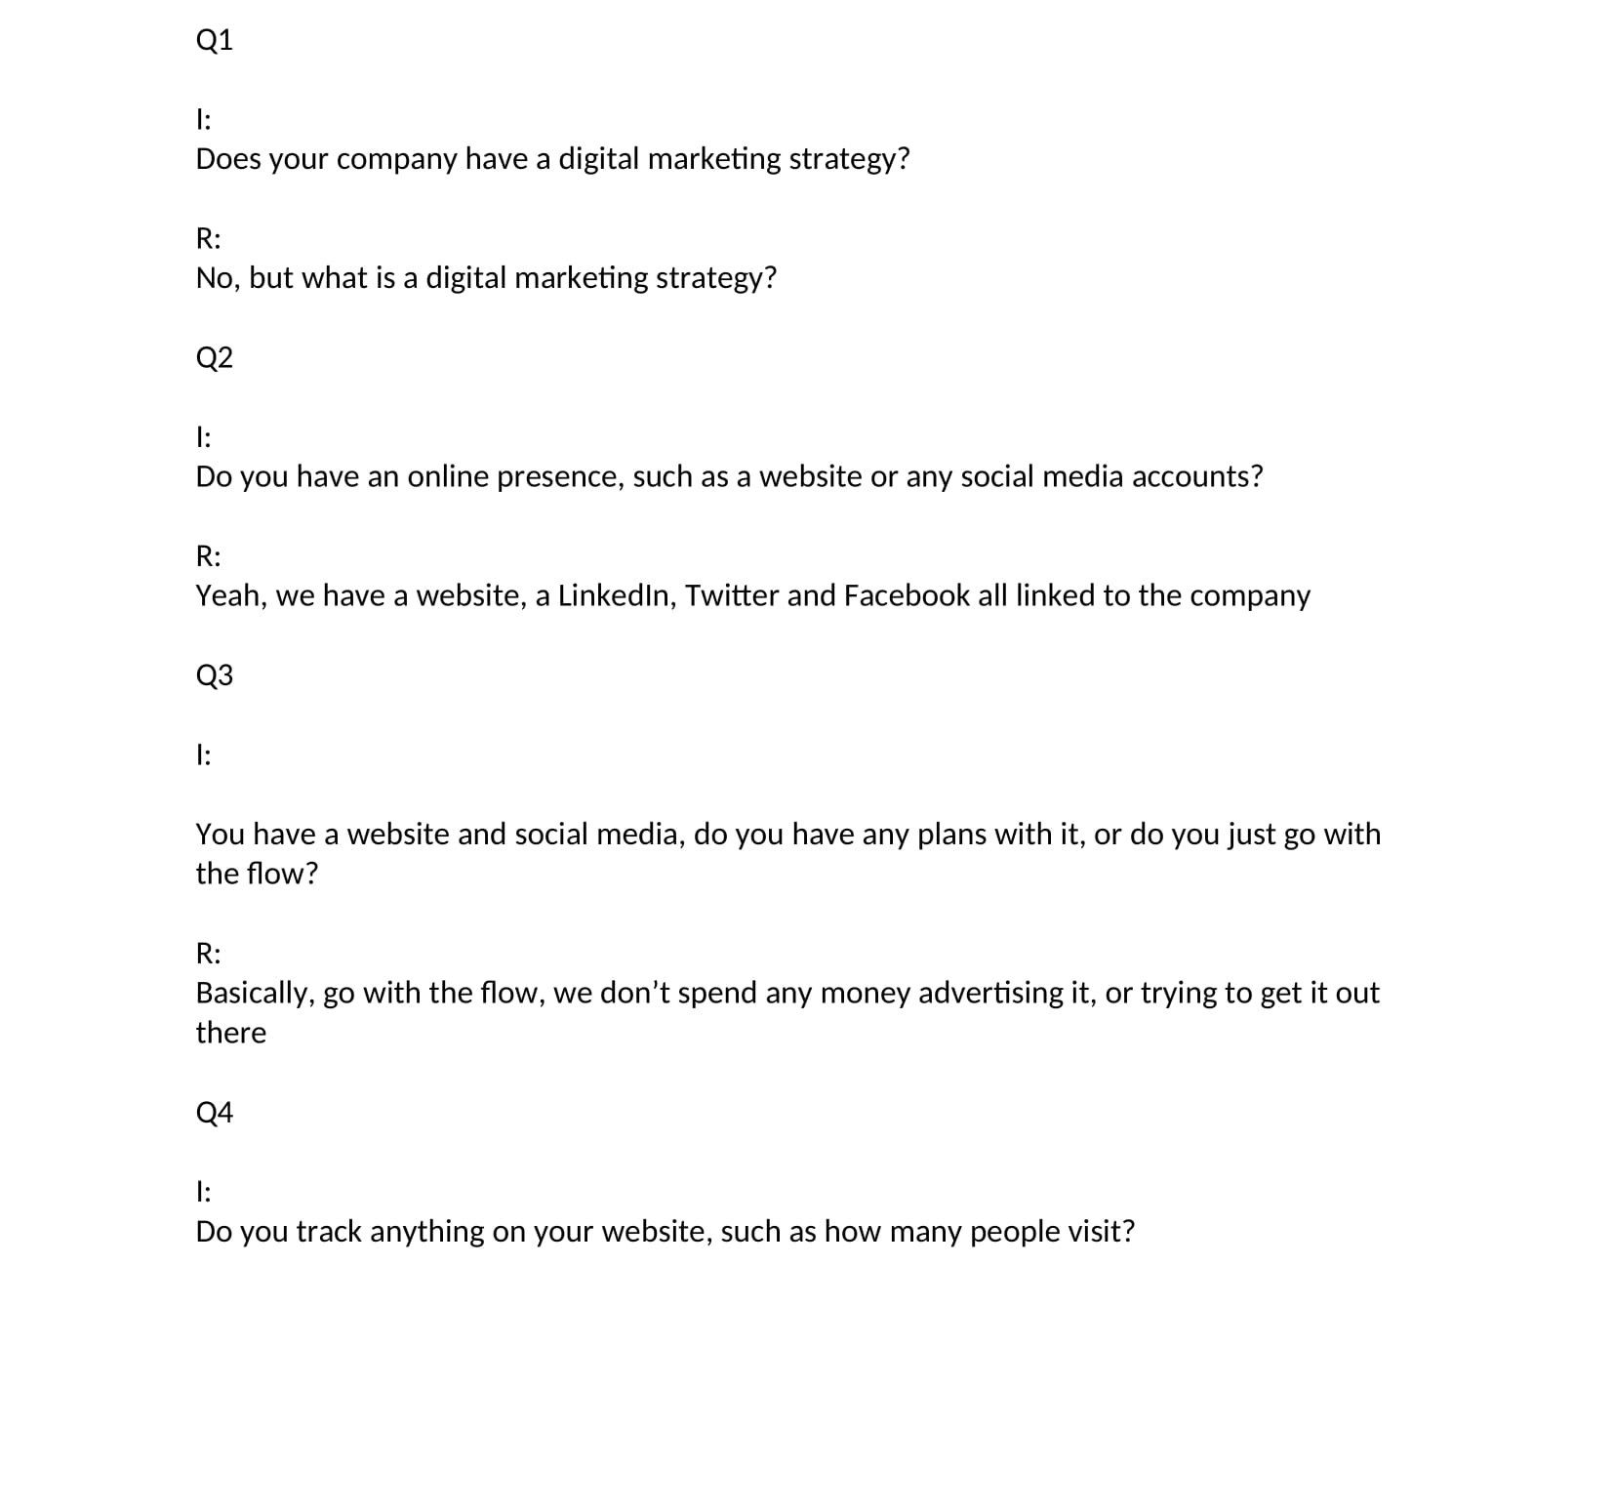
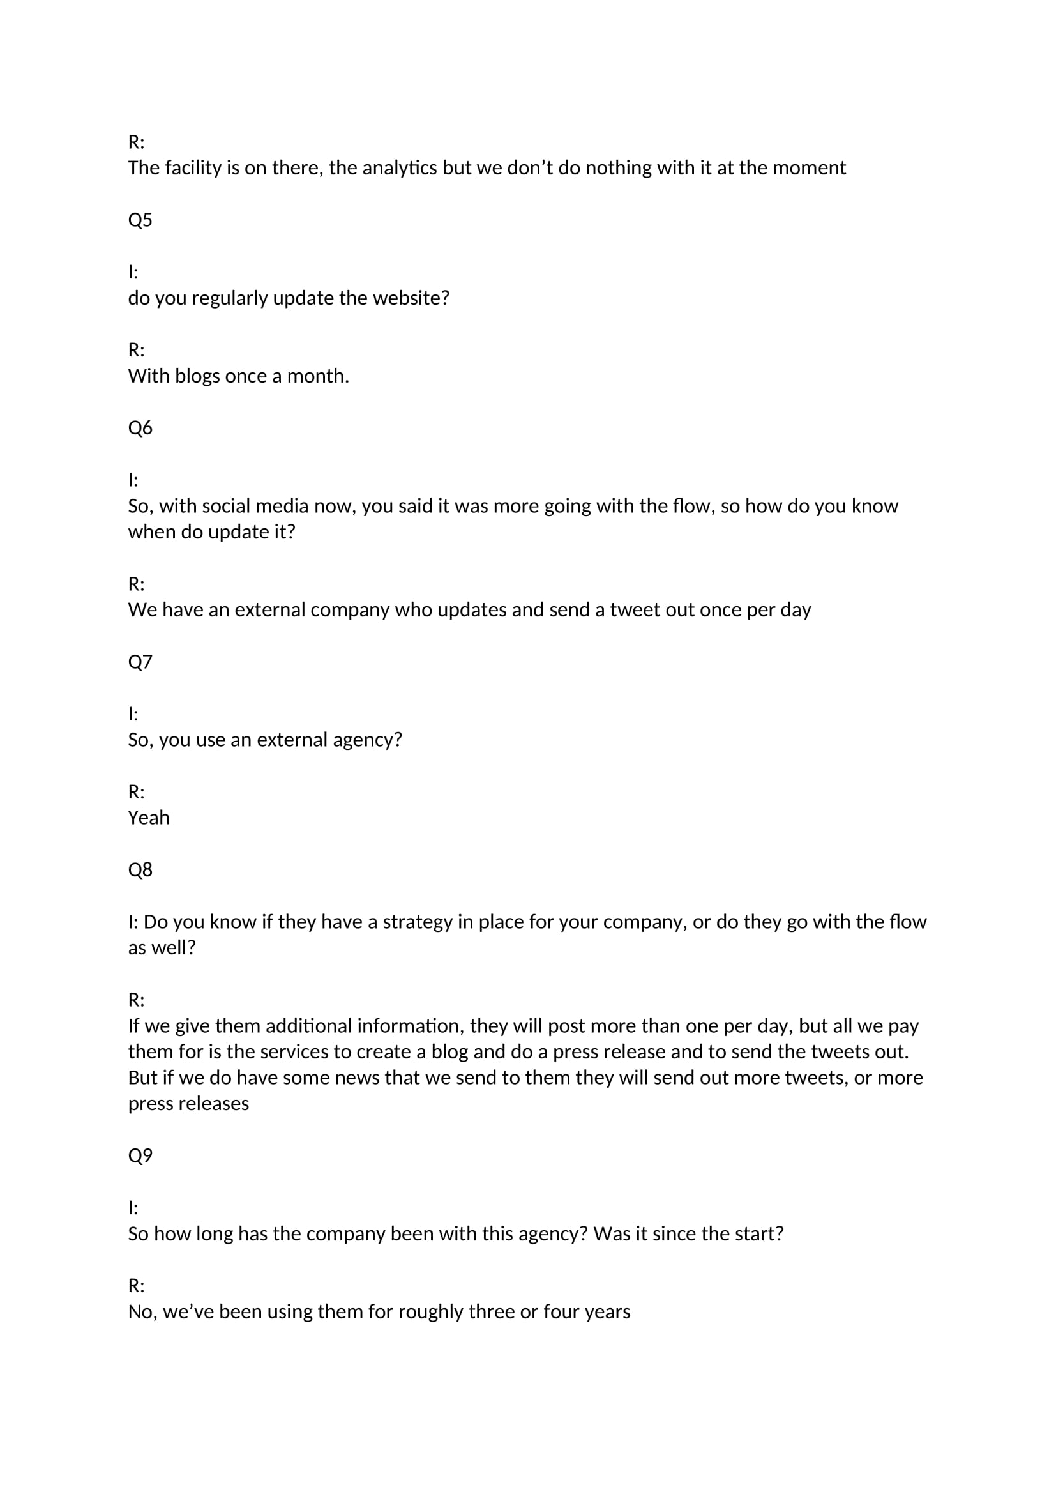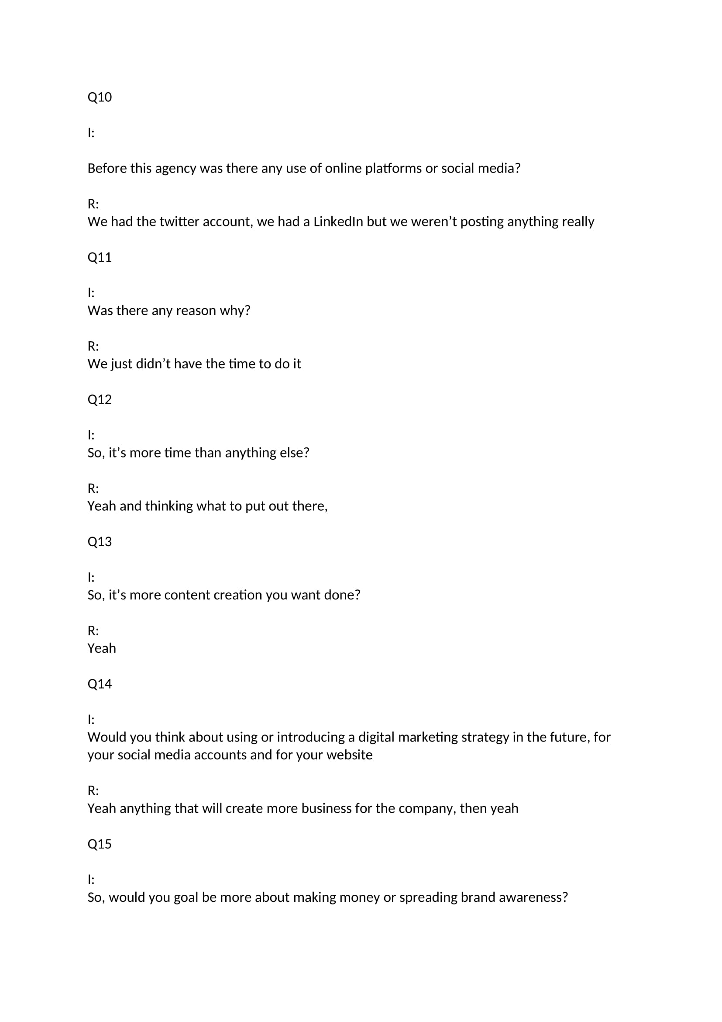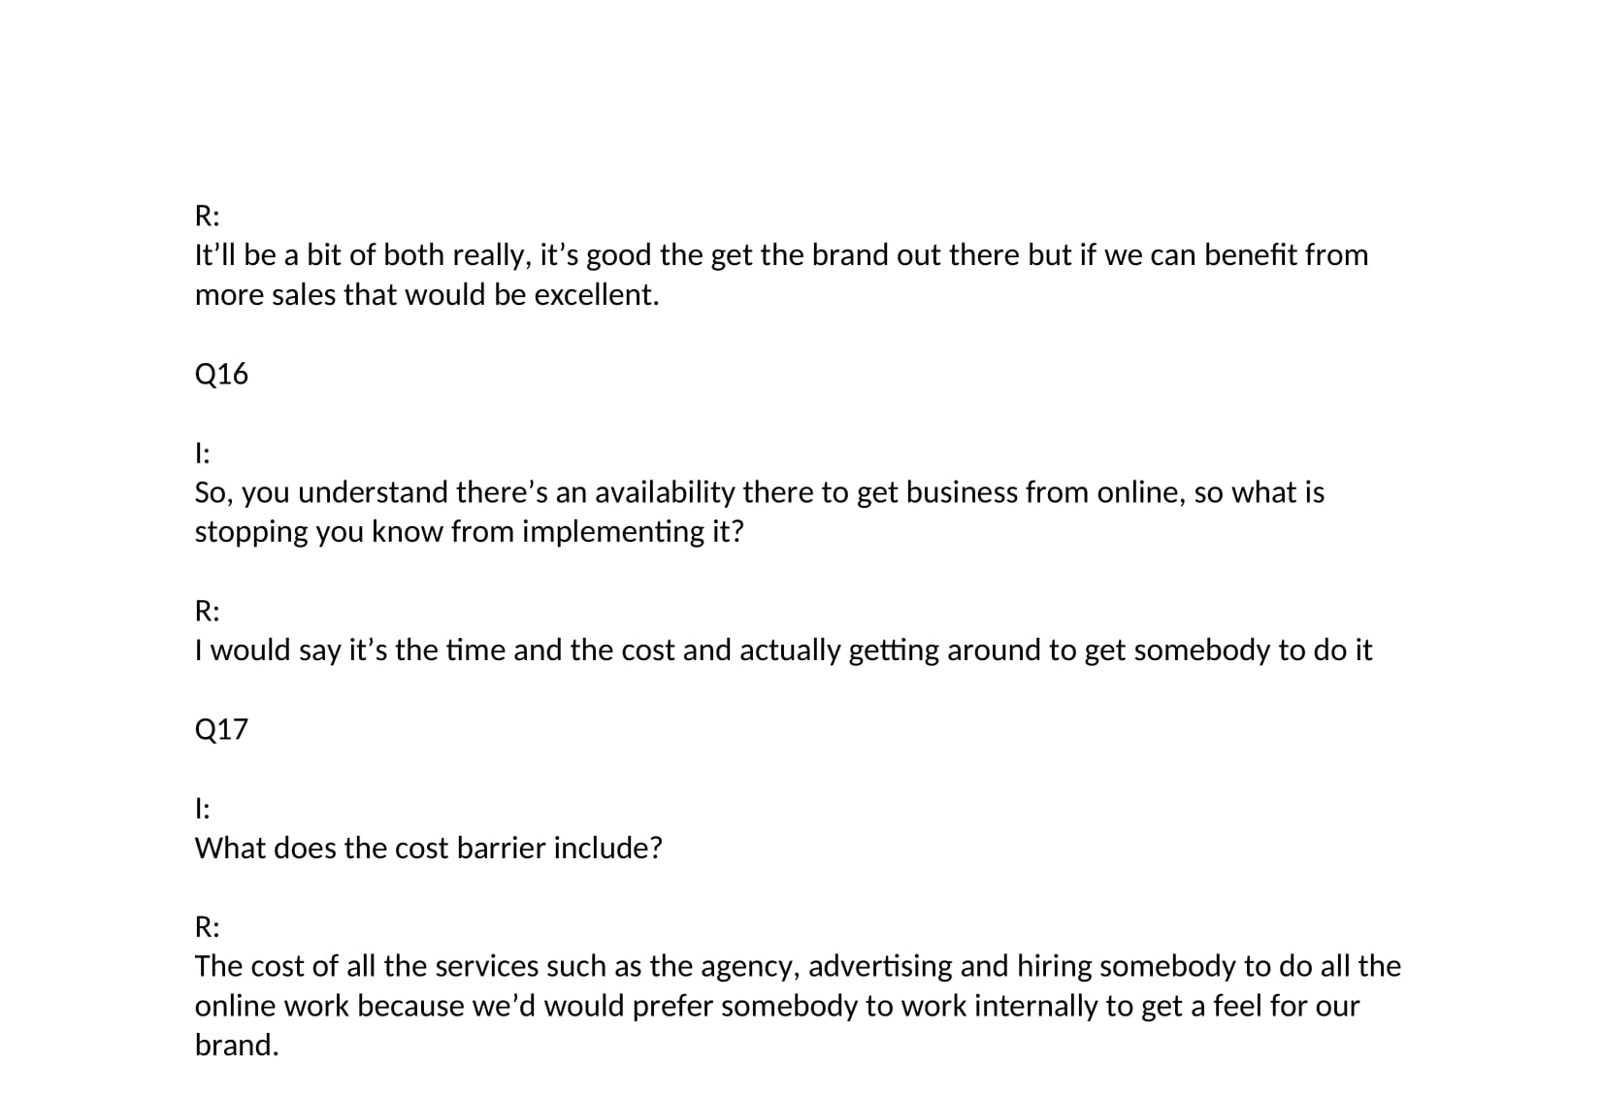

P2: 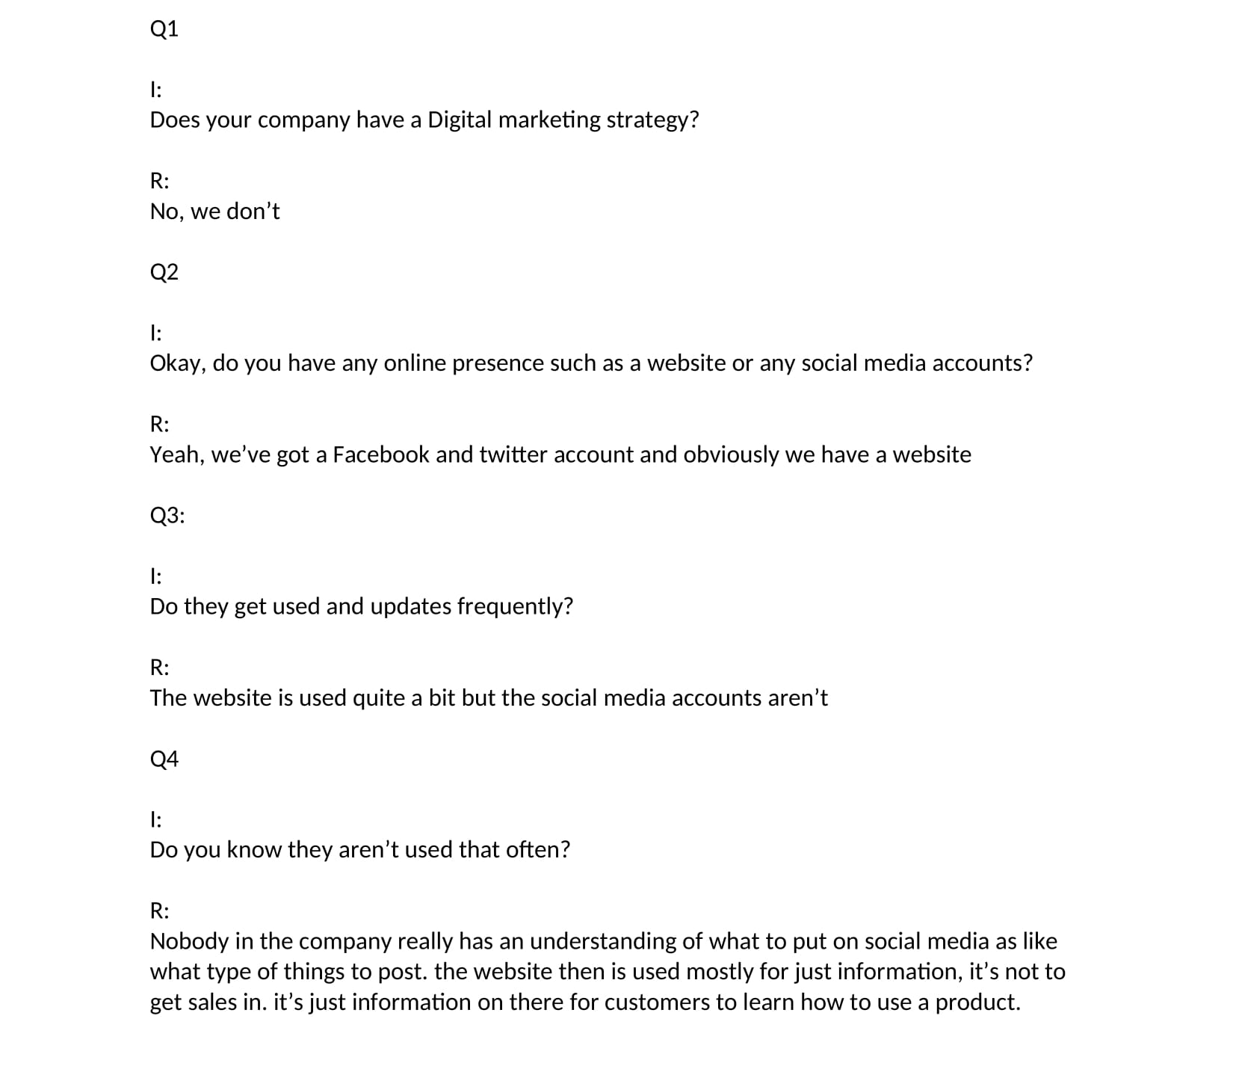
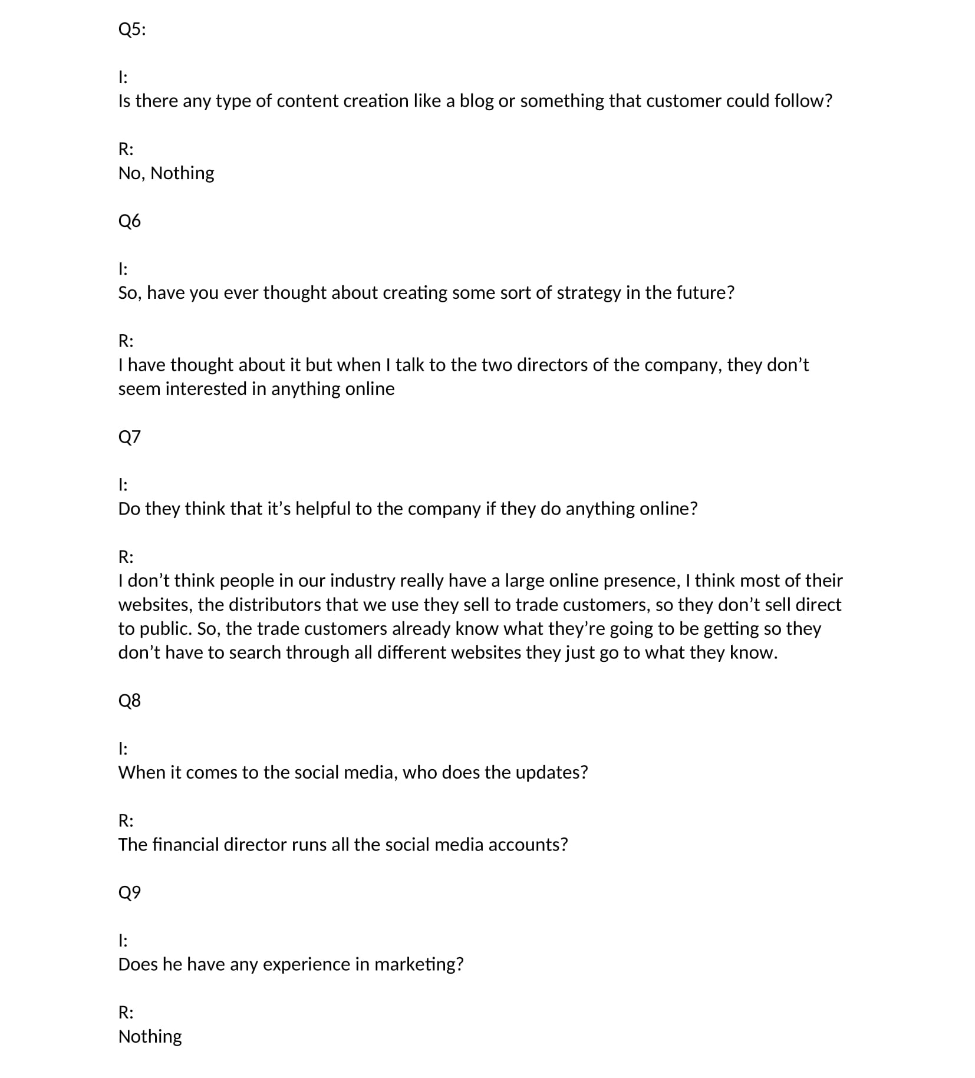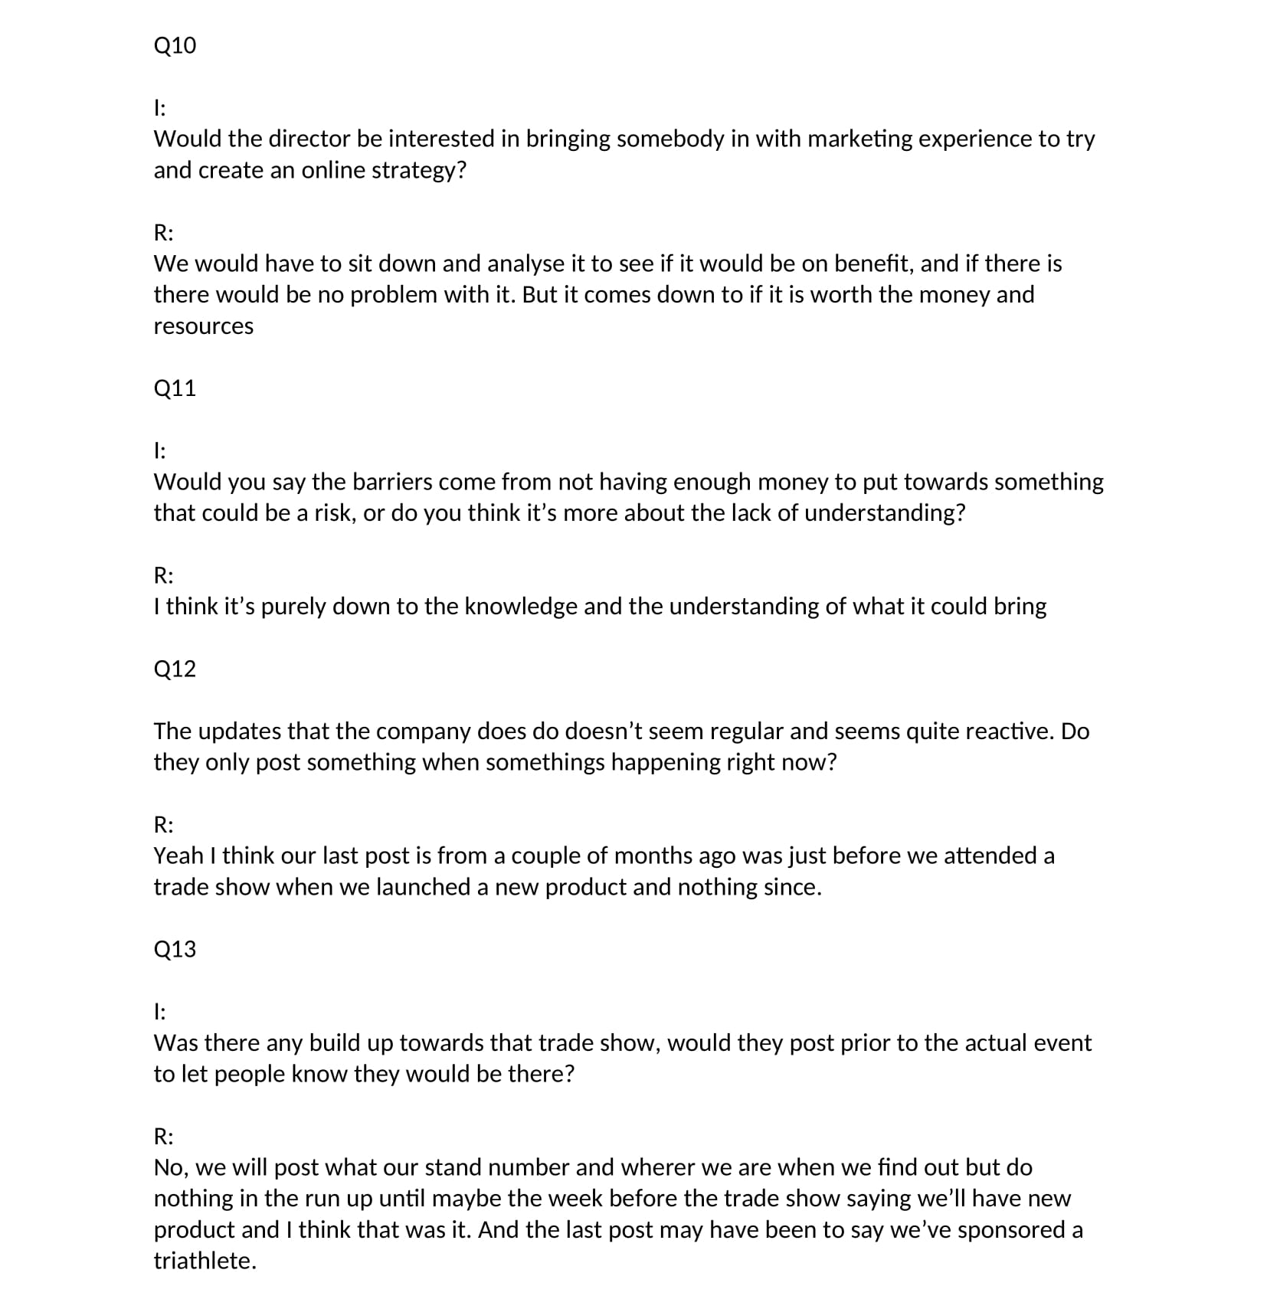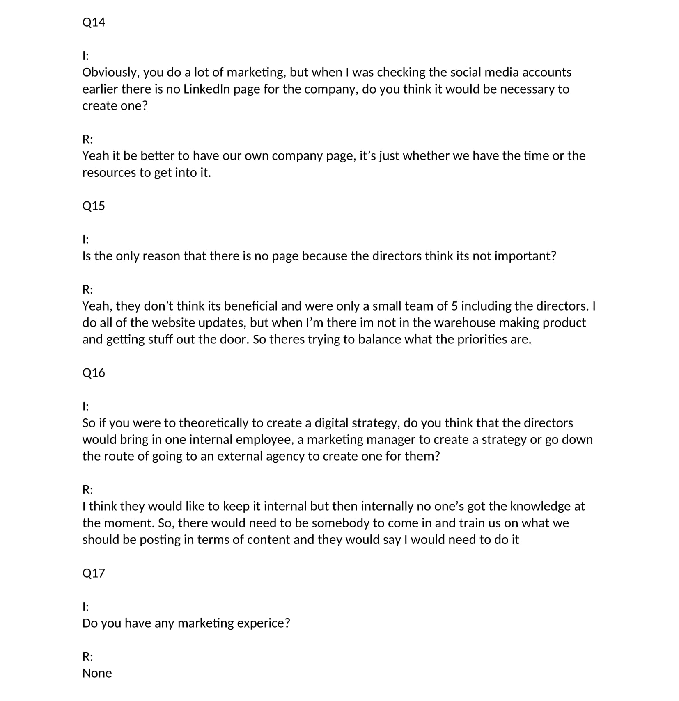

P3:
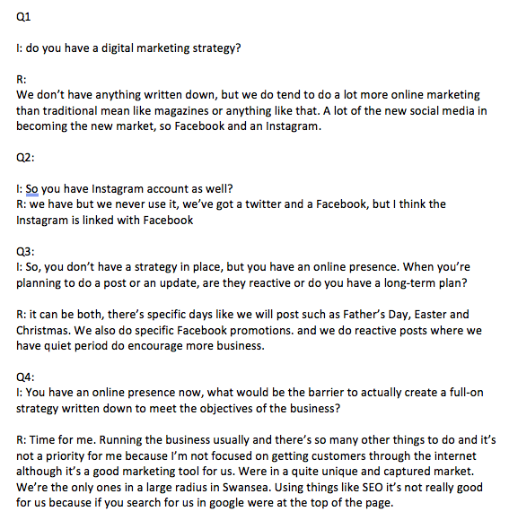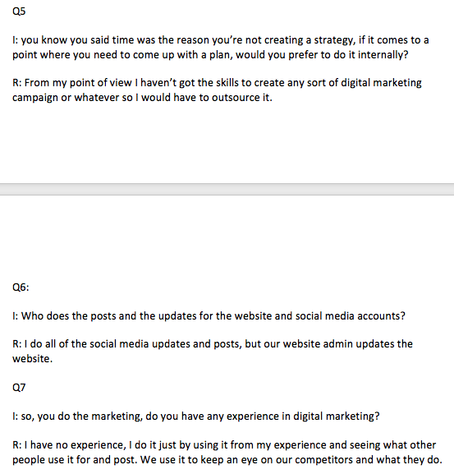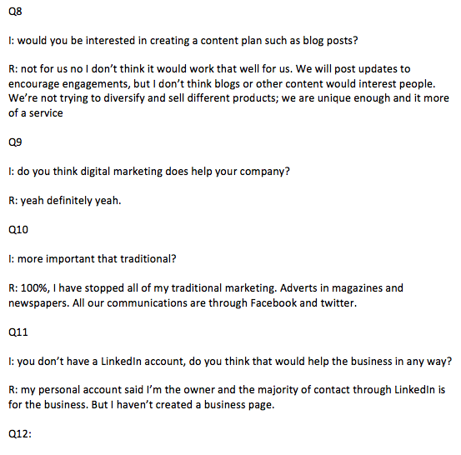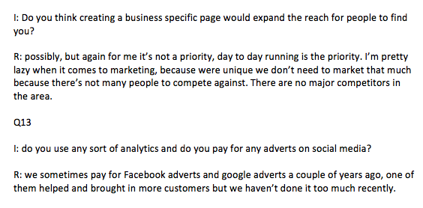

P4: 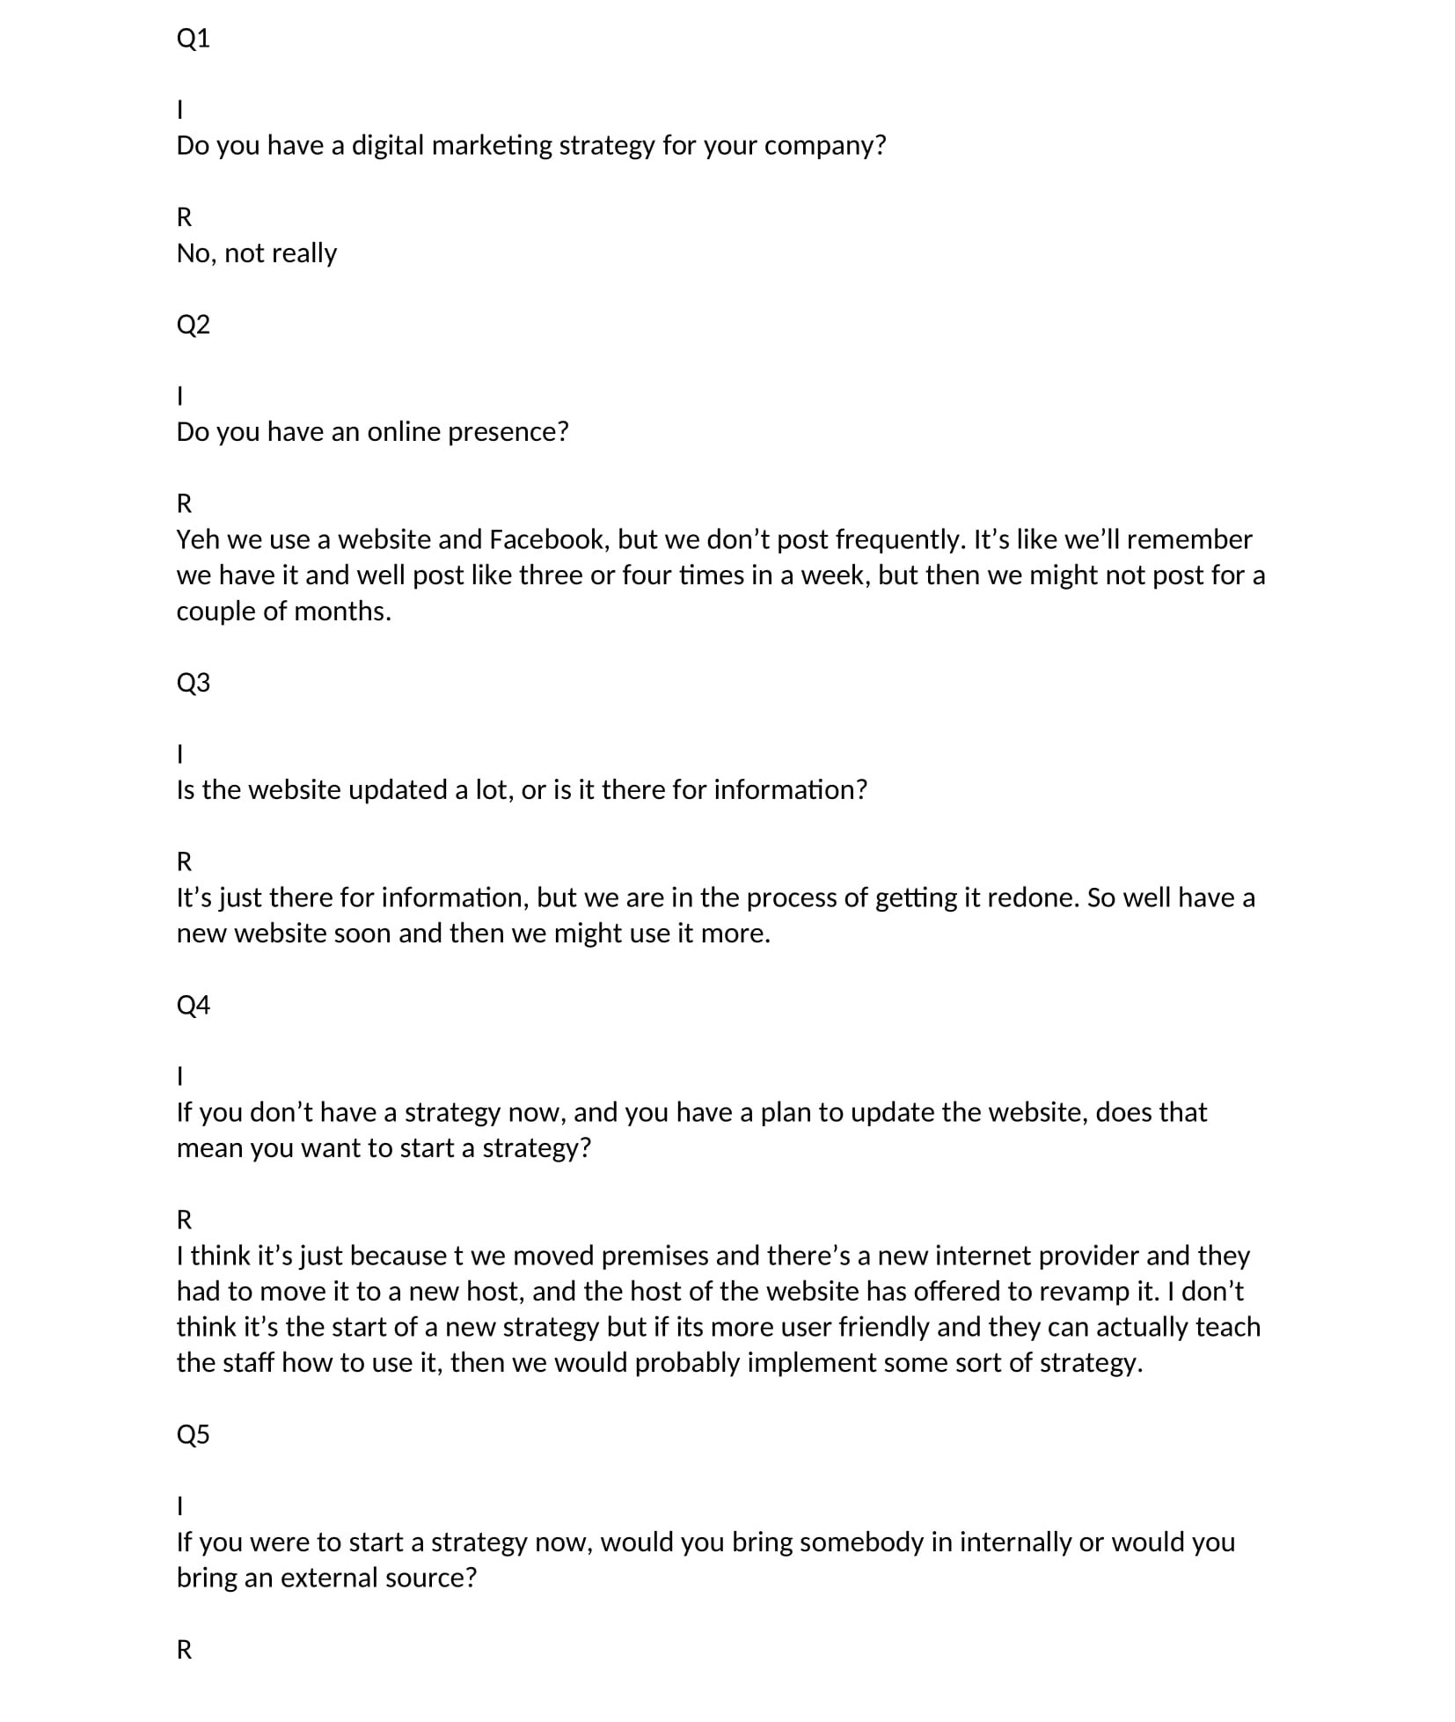
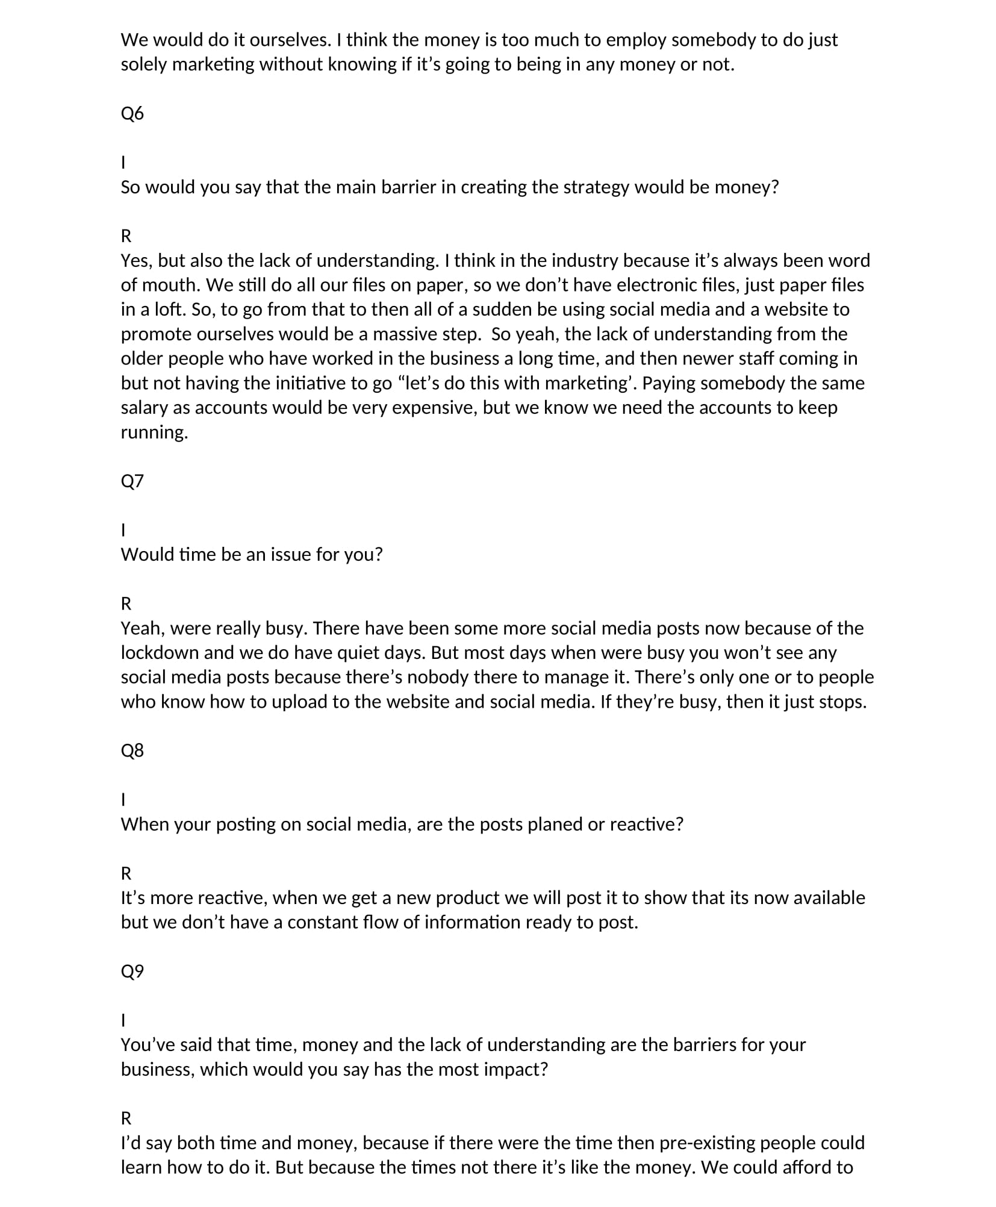

Appendix 4

P1:
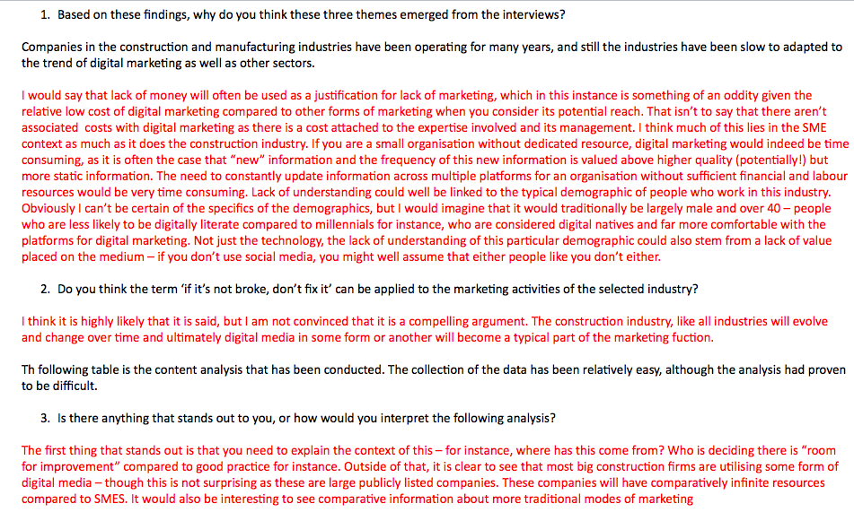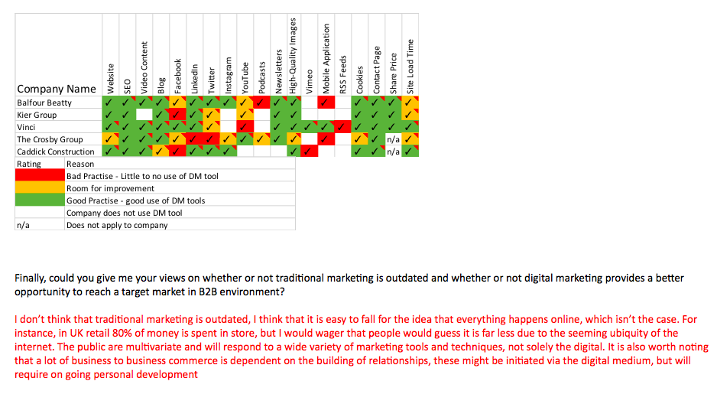

P2.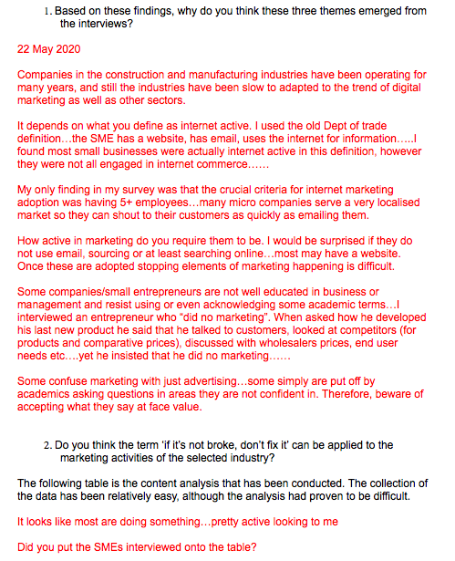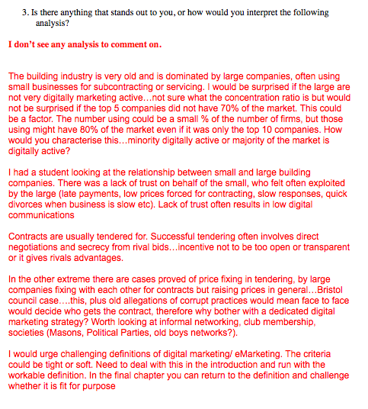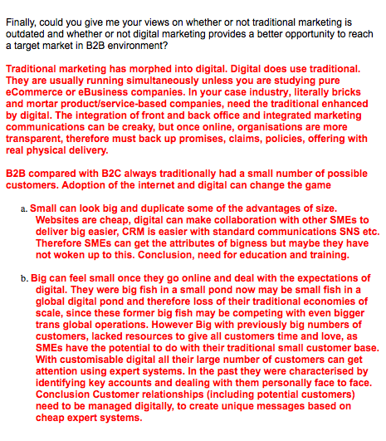
P3.

