

Student Name: Rahul
Student Number: 2511912

Module Code and Title: Introduction to Health and Social Care' (LCHS4003_BIRM)

Lecturer’s Name: AyazUllah Safi

Assignment Title: Portfolio Task 1 Poster/ Task 2 Essay

Date: 20TH February 2026

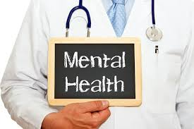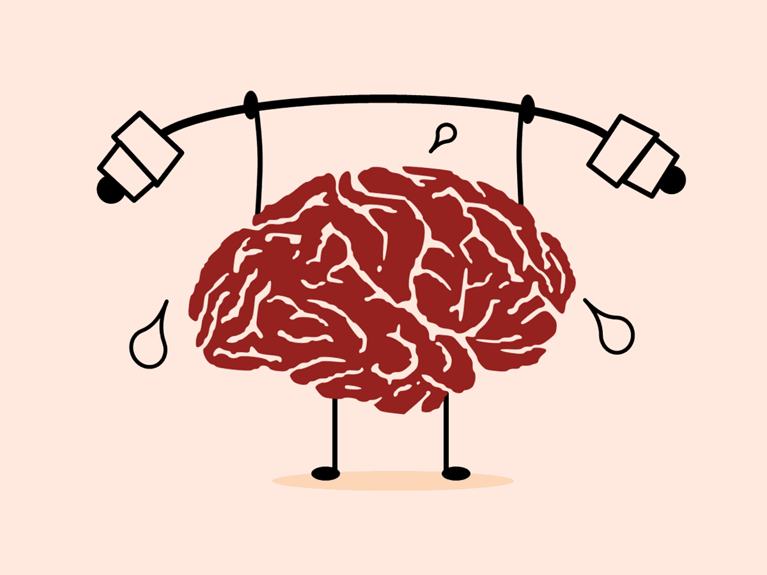

Community Mental Health Services (CMHS)
Supporting Wellbeing, Independence & Recovery in the Community


Community Mental Health Services (CMHS) help people who have mental health problems by giving them help, treatment, and a way to get better. They also help people live as independently as possible in their own neighbourhoods (Department of Health, 2014).

The goal of these services is to
• Help with mental health (Mental Health Foundation, 2016)
• Prevent individuals from accessing the hospital (NHS England, 2016)
• Help people get better and be able to do things by themselves
• Give care that is full and focused on the person (WHO, 2021)
• Work with families, carers, and other professionals (Royal College of Psychiatrists, 2018).
CMHS usually has
• Nurses who work in their communities to help people with mental health issues
• People who do social work
• Psychologists
• Therapists who help people
• People who do work to help
• Doctors who work with people who have mental health issues
• Experts in helping each other (Royal College of Psychiatrists, 2018)




A Short History of Community Mental Health Services in Institutions from the 1950s to the 1960s

Most of the mental health care was provided in extensive psychiatric hospitals, where patients frequently resided for extended periods and had minimal engagement with the community (Department of Health, 2014).1970s–1980s: Move Away from Institutionalisation
The government made rules that encouraged care in the community because more and more people understood that being in the hospital for a long time made people less independent. (NHS England, 2016) Day centres and early community teams started to form.
1990s: Bringing Community Mental Health Teams (CMHTs) to life
The NHS and local governments put together teams of people from different fields who worked together to give care, help with emergencies, and get people help early (Royal College of Psychiatrists, 2018).
2000s to now: Care that focuses on the person and their recovery
As crisis teams, early intervention services, and psychological therapy have grown, there has been more focus on empowerment, choice, and general health (NICE, 2011). Community-based help has improved because it is now connected to housing, jobs, social care, and volunteer groups (Mental Health Foundation, 2016).

How Community Mental Health Services Work
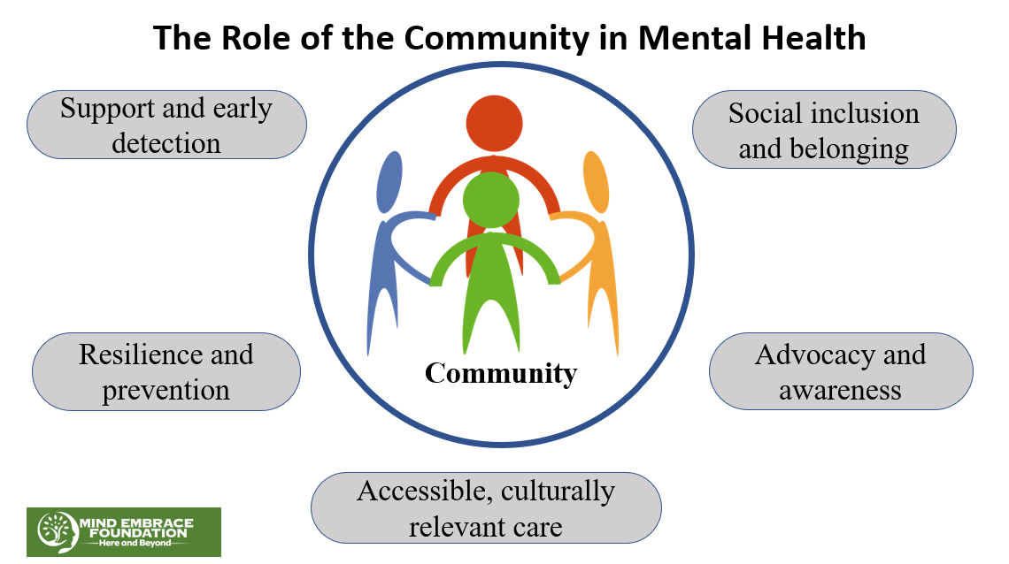

1.The Multidisciplinary Team (MDT) Approach
Professionals collaborate to develop optimal treatment programs tailored to provide best possible care to individual (Royal College of Psychiatrists, 2018).
2. Important Services Given
• Planning for care and evaluation
• Tests for mental health
• Looking at risks
• Plans for your care that are made just for you
• Reviews on a regular basis (NICE, 2011)
• CBT• Counselling
• Therapy that takes trauma into account
• Group therapy (NHS England, 2016)

Taking care of medicines
• Writing down prescriptions
• Keeping an eye out for side effects
• Assisting people in taking their medicine (Royal College of Psychiatrists, 2018)
Help during a crisis

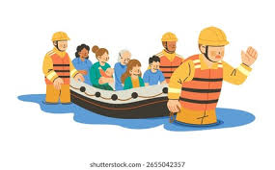

• Groups that help with disasters
• Help in an emergency at any time of day or night
• Getting care at home to avoid going to the hospital (Department of Health, 2014)
• Tips on how to get benefits
• Help with finding work
• Skills for daily life (Mental Health Foundation, 2016) Rehabilitation and Recovery Services
• Getting involved in the community to feel surer of yourself
• Groups for peers to get help (WHO, 2021)

Two Big Problems for CMHS

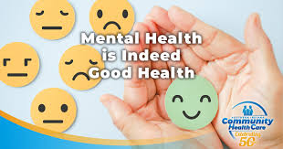

1.There are too many cases and not enough workers.
There are a lot more people who need mental health help, but there aren't enough staff, which means longer wait times, fewer appointments, and more stress on staff (NHS England, 2016).
Impact: People may have trouble getting help when they need it, which makes it more likely that they will have a crisis or need to go to the hospital (Department of Health, 2014).
2. Limited Funding and Resource Pressures
Mental health services usually don't get as much money as physical health services. This makes it harder to hire new staff, deal with crises, run outreach programs, and find therapists (Mental Health Foundation, 2016).
Impact: Services may not be able to meet the needs of the community as they grow, especially in areas that are already poor (NHS England, 2016).

Why Community Mental Health Services Are Important

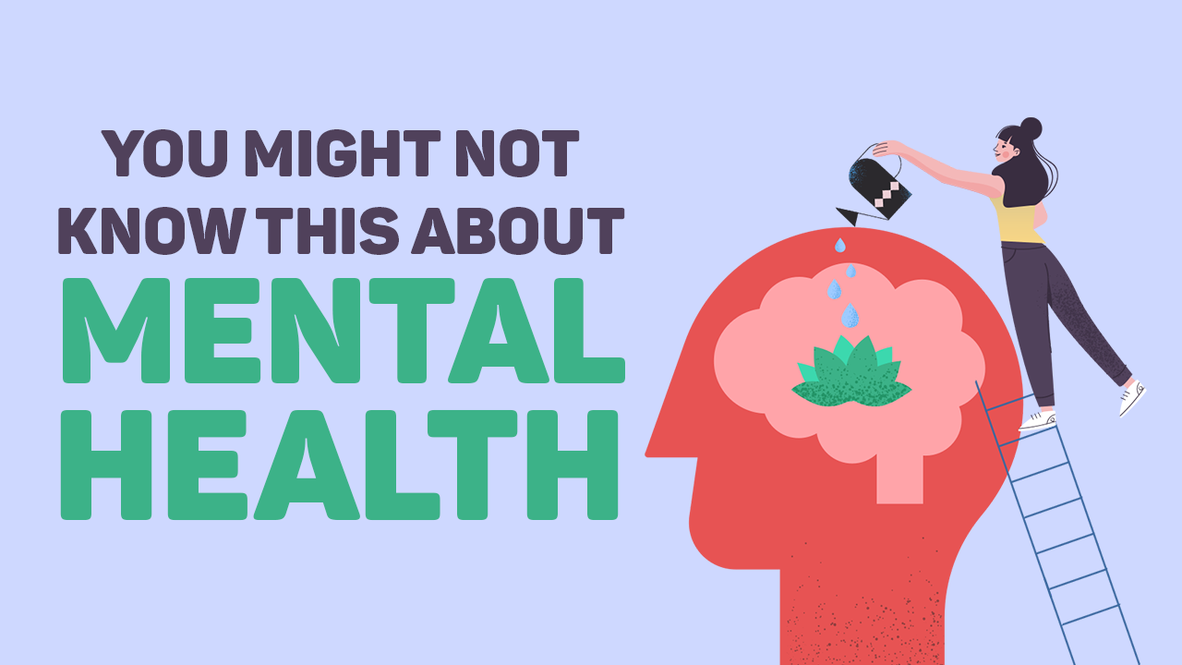

• They make people feel less ashamed by making care available in public places (WHO, 2021).
• They help people live happy lives even if they have mental health problems (Mental Health Foundation, 2016).
• They help stop disasters from happening by acting quickly (NICE, 2011).
• They make patients feel better all-around by meeting their social, emotional, and practical needs (Royal College of Psychiatrists, 2018).
• They help hospitals and emergency services by taking some of the stress off them (Department of Health, 2014).



Community Mental Health Services are very important for helping people with mental health issues feel safe, live on their own, and trust their communities (WHO, 2021). Working in groups, getting personalised care, and focusing on rehabilitation are all parts of these programs that help people take charge of their health. CMHS are still an important part of modern social care because they support dignity, inclusion, and hope (NHS England, 2016). This is still true even if there aren't enough workers or resources.

Reference List
Department of Health (2014) Closing the gap: priorities for essential change in mental health. London: Department of Health.
Mental Health Foundation (2016) Fundamental facts about mental health. London: Mental Health Foundation.
National Institute for Health and Care Excellence (2011) Common mental health problems: identification and pathways to care (CG123). London: NICE.
NHS England (2016) The five years forward view for mental health. London: NHS England.
Royal College of Psychiatrists (2018) Community mental health teams: guidance for commissioners and providers. London: Psych.
World Health Organization (2021) Guidance on community mental health services: promoting person‑centred and rights‑based approaches. Geneva: WHO.

Task 2 Essay

Ambulance Services, A brief history
UK ambulances respond quickly; check on patients clinically and safely transport those who are critically ill or injured. These services have changed because of things that have happened in the past, social needs, and new technologies. Ambulances and other medical services save lives and improve health.
Where it came from and how it grew
Ambulances started to show up in the early 1800s. Dominique Jean Larrey, a surgeon during the Napoleonic Wars, came up with the idea for "flying ambulances." They quickly took people who had been hurt on the battlefield to the hospital (West, 2013). This is how modern EMS started.
In the late 1800s, ambulances were used for things that weren't emergencies. The UK St. John Ambulance Association and hospitals in the area used horse-drawn ambulances to take care of people who had been in accidents or were sick with contagious diseases (St. John Ambulance, 2020). Motorised ambulances made it easier to get help in the early 1900s.
The NHS set a standard for ambulances in the UK in 1948 (NHS, 2023). At first, the service moved people around instead of giving them care. There was a need for emergency medical staff because car accidents were on the rise in the 1960s and 1970s. This made paramedics. They learned how to save lives before the patients got to the hospital (College of Paramedics, 2018). It turned ambulances into mobile emergency medical units and transportation.
This is how modern ambulances work.
Modern ambulance services are well-organised, use the latest technology, and handle a lot of emergencies and non-emergencies. According to NHS England (2019), there are emergency response vehicles, air ambulances, call-handling centres, and Hazardous Area Response Teams. Today, paramedics check the heart, give drugs that save lives, use defibrillators, and keep the airway open.
Emergency call centres like NHS 111 and 999 put cases in order of importance. It makes the best use of resources (NHS Digital, 2022). When there are more demands, fewer staff, and more pressure, this is what emergency rooms need. "See and treat" and "hear and treat" are new ways for paramedics to give home care or advice without putting someone in the hospital. The NHS can treat more patients if it stops admitting people who don't need to be there (College of Paramedics, 2018).
Ambulances have problems, even though they are useful. The system is under a lot of stress because there aren't enough workers, there are long wait times, and demand is rising. If hospitals don't move patients on time, ambulances can't respond to new emergencies, which makes the service more stressful (NHS England, 2023). Mental and physical stress is a problem for paramedics. Staff turnover and burnout can happen.
Important for a happy life
Ambulances make people's lives better. A quick response to a heart attack, stroke, or trauma increases the chances of survival (British Heart Foundation, 2021). In an emergency, having experienced professionals around makes people feel safer.
An ambulance takes sick or weak people to medical appointments that aren't emergencies Communities keep patients safe at home, making them more autonomous and reducing hospital visits (NHS Digital, 2022). Ambulances improve community safety, health, and enjoyment.
In conclusion, ambulance services have developed from basic transportation to advanced medical interventions needed in modern healthcare. Improvements indicate larger changes in medicine, technology, and public health. These are crucial for helping others, making health care decisions, and handling emergencies. Despite its issues, ambulances save lives and improve life.

References

College of Paramedics (2018) A career in paramedicine: Professional guidance. Bridgwater: College of Paramedics.
NHS (2023) History of the NHS. Available at: https://www.nhs.uk (Accessed: [15.02.2026]).
NHS Digital (2022) Ambulance quality indicators. Leeds: NHS Digital.
NHS England (2019) The NHS Long Term Plan. London: NHS England.
NHS England (2023) Urgent and emergency care recovery plan. London: NHS England.
St John Ambulance (2020) Our history. London: St John Ambulance.
West, G. (2013) The development of ambulance services. Journal of Paramedic Practice, 5(4), pp. 200–205.

