
ASSESSMENT COMPONENT 1
MARKETING ENVIRONMENT ANALYSIS
A Critical Analysis of BHP’s Marketing Environment, Strategic Growth and Competitive Positioning During the Transition Towards Lower-Carbon Products

Student Name: Sejalben Keshwala
Student id: 2612433
Lecturer:
Taonga Kaonga Sobere-Snithers (Birmingham)

Programme: Master of Business Administration
Module: Marketing Management
Module Code: LCMB7024
Assessment: Component 1 – Marketing Environment Analysis
Word Count: 2,500 words
Table of Contents

1. Introduction 3
2. Marketing Environment Analysis 3
2.1 Company and Lower-Carbon Transition Context 3
2.2 Environmental Actor Analysis 4
2.3 Political and Regulatory Actor 5
2.4 Social and Stakeholder Actor 5
2.5 Critical Synthesis of External Influences 6
3. Strategic Growth and Competitive Positioning 7
3.1 Application of the Ansoff Matrix 7
3.2 Evaluation of Strategic Growth Options 8
3.3 Recommended Growth Strategy 8
3.4 Competitive Advantage in a Lower-Carbon Business Model 9
4. Managerial and Professional Reflection 10
4.1 Rationale for Company and Actor Selection 10
4.2 Rationale for Strategic Growth Recommendation 10
4.3 Limitations of the Analysis 11
4.4 Additional Information Required for Consultancy Analysis 11
5. Conclusion 12
References 13

1. Introduction
The industry of metals and mining is under intense scrutiny to minimize environmental footprint and promote a lower carbon economy. BHP is a suitable case given the scale of the business, the environment of climate change and variations in customer, regulatory and other stakeholder expectations. BHP's operational greenhouse-gas emissions totalled 8.7 MtCO₂-e in FY2025, which demonstrates the magnitude of BHP's decarbonisation challenge (BHP, 2025). This report examines three external actors in the marketing environment that are impacting BHP's shift towards lower carbon products, focusing on the environmental actor. It then utilises the Ansoff Matrix to suggest an appropriate growth strategy and assess the potential for BHP to gain competitive advantage in this process.

2. Marketing Environment Analysis

2.1 Company and Lower-Carbon Transition Context
BHP is a major global resources company active in copper, iron ore and other minerals that are essential for industrial development and the energy transition. Strategic positioning of the company is becoming more affected by the necessity to decrease operational emissions and address the growing demand for materials for the lower carbon technologies. BHP's operational GHG emissions in FY2025 are 8.7 MtCO₂-e, reflecting the magnitude of its environmental challenge and the need for decarbonisation in its business model (BHP, 2025). But the flip side is also a marketing opportunity as consumers are worried about the carbon intensity and sustainability of the materials they use in their value chains. Thus, BHP needs to think not only about ways to reduce its carbon footprint but also how to identify and market lower-carbon products to business customers. This is especially significant in the external marketing environment as conditions in the environment may affect customer value and the competitive positioning of BHP.

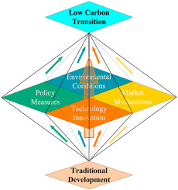
Figure 1: Key Drivers of Low-Carbon Transition
Source: Adapted from Yao et al. (2023).

2.2 Environmental Actor Analysis
Climate change is creating pressure for mining companies to lower their emissions, making the environmental actor the greatest external influence on BHP's transition towards lower carbon emissions in its products. The impact of this environmental stress is substantial, as the metals and mining industry generates about 25% of the world's 12,000 top companies' reported GHGs; decarbonisation is increasingly a key consideration in corporate strategy and positioning (Kotler, Armstrong and Balasubramanian, 2024). This pressure is a double edged sword for BHP. Developing emission reduction investments in cleaner energy, operational technologies and production processes can result in costs and implementation risks. Conversely, if more demand emerges for responsibly produced materials, BHP could differentiate itself based on its lower carbon credentials. This is especially true for copper, which is anticipated to be a key material for electrification and renewable-energy infrastructure (IEA, 2024). Therefore, environmental pressure must not be considered solely a compliance exercise, as it also has the potential to affect customer choice, product positioning and long-term value creation. BHP's ability to achieve tangible emissions reductions would therefore make it more appealing for customers looking for emissions reductions in their supply chains (McKinsey, 2024).

2.3 Political and Regulatory Actor
BHP is also seeing pressure from political and regulatory factors, with governments bolstering climate policies, emissions standards and reporting. This is an approach that may raise the costs and complexity of mining, and it also can stimulate investments in cleaner technology. For BHP, regulatory pressure is thus a strategic challenge of balancing regulatory compliance with cost competitiveness. Yet regulation could also ramp up the demand for lower carbon materials by incentivizing industries downstream to lower their upstream emissions (Lin et al., 2024). BHP can do this by incorporating regulatory expectations into product development, environmental reporting and customer communication. This can help build market confidence as consumers are increasingly demanding proof of responsible sourcing and emissions. However, the cross-border nature of BHP's operations can introduce further complexity due to inter-country regulatory variations and environmental priorities/policy needs (OECD, 2025). Political and regulatory actors therefore also shape BHP's operational and marketing decisions, as well as the company's capacity to market lower-carbon products consistently, on a global basis.

2.4 Social and Stakeholder Actor
BHP is increasingly shaped by social and stakeholder expectations, as customers, investors, employees, communities and society value environmental responsibility more than ever. The stakeholders can influence BHP's demand, corporate reputation and investment access, which demands credible progress, not just environmental commitments. For business customers aiming to lower the carbon intensity of their own value chains, the environmental attributes of purchased materials can affect their own sustainability performance (Liu et al., 2025). BHP must, therefore, provide measurable emissions reductions and show how this lowers carbon emissions and creates value for customers and other stakeholders. But priorities can be conflicting as stakeholders have their own expectations, such as environmental performance and affordability and employment and operational continuity. This does not imply that BHP can assume stakeholder pressure to decarbonise the fastest. Rather, it should be flexible in developing and promoting lower-carbon products, depending on varying expectations. Therefore, stakeholder engagement is an important way of building trust and differentiation, but poor or inadequate environmental claims can undermine credibility and diminish the marketing potential of BHP's transition (Wang et al., 2025).

2.5 Critical Synthesis of External Influences
The three external actors are interrelated and all influence BHP's lower carbon transition. The need for emissions reduction is driven by environmental pressures and political and regulatory requirements are what BHP must achieve. The social and stakeholder expectations also shape BHP's environmental value to customers and other stakeholders. These impacts can also generate conflicting pressures, as investments in decarbonisation can drive up costs, whilst customers are increasingly seeking enhanced environmental outcomes. Hence, the competitive answer from BHP needs to be more than just the reduction of operational emissions, it should also be based on the realization of environmental improvements that are meaningful to customers. The key takeaway is that BHP must ensure environmental performance, meeting regulatory requirements, and stakeholder expectations are aligned, not addressed independently. This alignment may lead to product differentiation and enhance BHP's profile as demand for responsibly sourced materials grows (International Council on Mining and Metals, 2024).
Table 1: External Marketing Environment Actors Influencing BHP
External actor | Key influence on BHP | Marketing implication
Environmental | Climate pressure and demand for lower-carbon production | Opportunity for lower-carbon product differentiation
Political and regulatory | Emissions standards, climate policies and reporting requirements | Higher compliance requirements and need for credible environmental reporting
Social and stakeholder | Customer, investor, employee and community expectations | Greater need for transparency, trust and stakeholder engagement

3. Strategic Growth and Competitive Positioning

3.1 Application of the Ansoff Matrix
The Ansoff Matrix is a useful tool to assess BHP's growth possibilities in its shift to a low carbon business model. The framework indicates four strategic options: market penetration, product development, market development and diversification. Market penetration may help bolster BHP's existing product portfolio in current markets, but is less effective at meeting evolving environmental expectations related to mining. Market development involves taking existing products into new geographical or customer markets, but it may not necessarily differentiate BHP through decarbonisation. Product development is more relevant as BHP have the potential to create and market lower carbon products to current customers, thereby ensuring that environmental performance meets changing customer needs. Diversification may offer space to new low carbon markets and bring higher financial, technological and market risk. Because of this, product development offers the greatest strategic fit, as it leverages BHP's current expertise and its growing need for lower-carbon materials (Cullen, 2024).
Table 2: Ansoff Matrix Options for BHP’s Lower-Carbon Transition
Ansoff Strategy | Application to BHP | Strategic Implication
Market Penetration | Increase sales of existing lower-carbon minerals to existing customers | Strengthens market position
Market Development | Enter new markets where demand for transition minerals is growing | Expands revenue opportunities
Product Development | Develop lower-carbon mineral products and production solutions | Supports differentiation
Diversification | Invest in new low-carbon businesses and technologies | Creates long-term growth opportunities

3.2 Evaluation of Strategic Growth Options
The best possible fit for BHP between growth potential and strategic risk, of the four Ansoff strategies, is product development. Market penetration would do little to differentiate BHP in an existing market if its products were not significantly changed. Market development could lead to additional demand through new customer markets, or geographically, but wouldn't necessarily address a quantitative growth in demand for the lower carbon material. Diversification may open up opportunities in some new clean energy markets, but it would involve BHP in new fields in which it may not be as well known, adding financial and operational risk. Product development, in contrast, allows BHP to leverage its current mining capabilities, customer relationships and resource expertise, and to bring in products with better environmental attributes. This is, therefore, a more manageable way to grow and meets head-on environmental and stakeholder demands (Grant, 2022). The strategy, however, will only succeed if BHP can prove that lower-carbon products offer real value beyond just sustainability claims, and credible emissions measurement and customer evidence will be the key to this (Appiah and Essuman, 2024).

3.3 Recommended Growth Strategy
BHP's primary growth area is identified as product development, as this will align best with the company's capabilities and emerging environmental expectations. BHP is able to create and differentiate lower carbon products, minimise emissions at product level and equip its customers with credible product-level environmental information. This could provide value for customers wanting to lower emissions in their supply chains as well as for BHP to leverage existing mining knowledge and customer relationships. But product development isn't just about a new product. If BHP can show measurable environmental benefits, product quality will need to be maintained and BHP will need to ensure that customers see enough value to justify any price premium. It should also integrate operational decarbonisation with digital carbon measurement, customer engagement, and technology-driven marketing and provide a more transparent and technology-enabled environmental information to customers. This would allow BHP to incorporate environmental performance into one of the areas of differentiation while minimizing the chance of unsupported sustainability claims (Janik and Ryszko, 2026).

3.4 Competitive Advantage in a Lower-Carbon Business Model
As per the definition of Competitive advantage, firms can gain competitive advantage when they are able to deliver value that the firms are not able to replicate (Schweizer and Koscher, 2023). This could be achieved at BHP through investments in lower emissions production, clear environmental data and improved collaboration with customers looking to decrease the supply-chain footprint. These can set BHP apart in an era when customers are increasingly choosing products based on their environmental performance. But the sustainable advantage of environmental differentiation can only be achieved if it is accompanied by measurable performance and organisational skills that cannot be easily copied by the competition (Andersén, 2021). BHP should thus embed decarbonisation into product development, customer relationships and the use of marketing communication as a separate corporate activity. This will help build customer trust, reinforce premium positioning when the market demands it, and establish longer-term relationships with customers transitioning towards lower carbon operations (Riva, 2024).
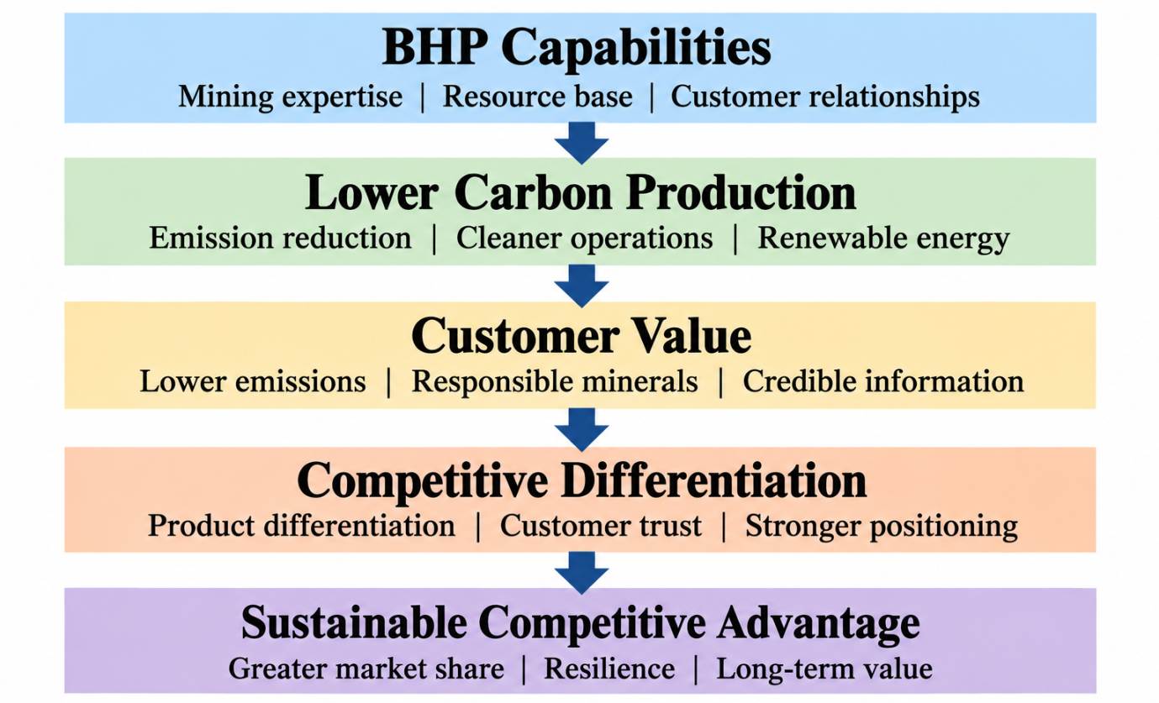
Figure 2: BHP’s Lower-Carbon Competitive Advantage
Source: Author’s own construction based on BHP (2025), Andersén (2021) and Schweizer and Koscher (2023).

4. Managerial and Professional Reflection

4.1 Rationale for Company and Actor Selection
BHP was chosen given the scale, environmental exposure and strategic significance to the energy transition, as these offer a solid foundation for discussion of lower carbon marketing challenges. The environmental actor was chosen as a priority as it directly impacts the company's activities, positioning and expectations. The political and regulatory factors were incorporated as they shape the environment in which BHP should function; social and stakeholder pressures are included as they contribute to the perception of BHP's environmental performance. Customer expectations are also considered because they influence BHP's product requirements, environmental performance and regulatory expectations (BHP, 2026). This combination thus provides an integrated assessment of the impact of external pressures on BHP's strategic response.

4.2 Rationale for Strategic Growth Recommendation
Product development was recommended because it offers BHP something useful that is in tune with what is needed in a lower carbon market. The strategy enables BHP to leverage existing mining experience, existing customer base and enhance the environmental attributes of its products. This is better than diversification, which carries a higher financial and capability risk; or market penetration, where there is a risk of little differentiation if the product does not change. A manager's perspective is that product development can also make environmental performance a part of BHP's customer value proposition, instead of being just an operational objective. But it will rely on customers seeing value in products with lower carbon footprints and BHP's ability to demonstrate environmental benefits. Hence, measurable carbon performance is needed to back up the strategy, with customer involvement and clear communication (Appiah and Essuman, 2024).

4.3 Limitations of the Analysis
One of the biggest weaknesses of the analysis is that it is secondary data, so it does not offer a detailed picture of BHP's actual customer preferences, profitability of its products or the internal decision-making process. The analysis also reflects general environmental, political and stakeholder effects, but does not necessarily apply to all markets, products and groups of customers. The recommended product development strategy further assumes that customers will value lower carbon products sufficiently to justify differentiation, which may vary based on market conditions and competitive products. The analysis is therefore a strategic analysis and not a prediction of the future performance of BHP. The secondary analysis is not used to assess and adapt capabilities due to changing and uncertain market conditions, which is the case in strategic decisions. (Mero and Haapio, 2022) There would then be a need for more detailed primary and internal evidence to support the recommendation prior to making significant investment decisions.

4.4 Additional Information Required for Consultancy Analysis
A consultant would need more information on customer and competitor data, product-level emissions and BHP's financial results before making a final strategic recommendation. Customer research could be used to gauge whether customers are willing to pay for reduced carbon materials and what environmental factors affect customer buying. Competitor Benchmarking would also be required to determine if BHP's proffer of a lower carbon brand is a differentiating advantage or not. Furthermore, product-level carbon data, investment needs and returns would allow for a better financial viability assessment on product development. Availability of internal management information would also help inform the analysis, providing an indication of barriers to operation and current decarbonisation capability. These extra data would allow for a more evidence-based study of market attractiveness, strategic feasibility and competitive benefit prior to implementation (Basu et al., 2023).

5. Conclusion
Environmental, political and stakeholder pressures are all connected, and are growing more influential on customer expectations and positioning in BHP's transition to a lower carbon business model. The analysis suggests that the environment is especially important, as it needs to be taken into account for decarbonisation needs and to differentiate lower carbon products. Of the Ansoff options, Product Development offers the highest level of strategic fit, enabling BHP to leverage on its current capabilities and address evolving market demands. Sustainable competitive advantage will rely, however, on credible emissions reductions, environmental evidence which is transparent and ongoing alignment to customer needs. In conclusion, BHP can enhance their market position by making lower carbon production a customer value and a source of strategic differentiation, as well as an environmental responsibility.

References
Andersén, J. (2021) ‘A relational natural-resource-based view on product innovation: The influence of green product innovation and green suppliers on differentiation advantage in small manufacturing firms’, Technovation, 104, 102254. Available at: https://doi.org/10.1016/j.technovation.2021.102254.
Appiah, L.O. and Essuman, D. (2024) ‘How do firms develop and financially benefit from green product innovation in a developing country? Roles of innovation orientation and green marketing innovation’, Business Strategy and the Environment, 33(7), pp. 7241–7252.
Basu, R., Lim, W.M., Kumar, A. and Kumar, S. (2023) ‘Marketing analytics: The bridge between customer psychology and marketing decision-making’, Psychology & Marketing, 40(12), pp. 2588–2611..
BHP (2025) Annual report 2025. Melbourne: BHP Group Limited.
BHP (2026) Annual report 2026. Melbourne: BHP Group Limited.
Cullen, M. (2024) ‘Exploring the Application of Ansoff’s Growth Strategies in the Context of Digital Transformation and Corporate Performance’. Available at SSRN: 7231900.
Grant, R.M. (2022) Contemporary Strategy Analysis. 11th edn. Hoboken, NJ: Wiley.
IEA (2024) Copper: Outlook for key energy transition minerals. Paris: International Energy Agency.
International Council on Mining and Metals (2024) Climate change: Position statement. London: International Council on Mining and Metals.
Janik, A. and Ryszko, A. (2026) ‘Greenwashing in sustainability reporting: A systematic literature review of strategic typologies and content-analysis-based measurement approaches’, Sustainability, 18(1), 17.
Kotler, P., Armstrong, G. and Balasubramanian, S. (2024) Principles of marketing. 19th edn. Harlow: Pearson.
Lin, J., Cao, X., Dong, X. and An, Y. (2024) ‘Environmental regulations, supply chain relationships, and green technological innovation’, Journal of Corporate Finance, 88, 102645. Available at: https://doi.org/10.1016/j.jcorpfin.2024.102645.
Liu, W., Cao, Y., Hou, J., Cheng, Y., Chan, H.K. and Tang, O. (2025) ‘Green procurement or green supply? A meta-analysis of their impacts on firm sustainability performance’, International Journal of Logistics Research and Applications, 28(12), pp. 1387–1421.
McKinsey (2024) Materials ‘green’ premia: Trends and outlook to 2030. McKinsey & Company.
Mero, J. and Haapio, H. (2022) ‘An effectual approach to executing dynamic capabilities under unexpected uncertainty’, Industrial Marketing Management, 107, pp. 82–91. Available at: https://doi.org/10.1016/j.indmarman.2022.09.021.
OECD (2025) Enhancing Regional Mining Ecosystems in the European Union. Paris: OECD Publishing. Available at: https://doi.org/10.1787/97ba1224-en.
Riva, F. (2024) ‘Beyond the hype: Deciphering brand trust amid sustainability skepticism’, Business Strategy and the Environment.
Schweizer, L. and Koscher, E.M.K. (2023) ‘Competitive advantage’. In: Idowu, S.O., Schmidpeter, R., Capaldi, N., Zu, L., Del Baldo, M. and Abreu, R. (eds.) Encyclopedia of Sustainable Management. Cham: Springer, pp. 669–671. Available at: https://doi.org/10.1007/978-3-031-25984-5_365.
Wang, S., Shen, H., Zhang, H., Asif, M. and Shahzad, M.F. (2025) ‘From greenwashing to genuine sustainability: Insights from FinTech and banking executives in emerging market experience’, Journal of Environmental Management, 373, 123690. Available at: https://doi.org/10.1016/j.jenvman.2024.123690.
Yao, H., Xu, P., Wang, Y. and Chen, R. (2023) ‘Exploring the low-carbon transition pathway of China’s construction industry under carbon-neutral target: A socio-technical system transition theory perspective’, Journal of Environmental Management, 327, 116879.

