Intercultural Competence Report

Deere (2023)

Student name: Anat Dranciuc-Georgescu
Student Id: 2125394
Module: Foreign Languages and Cultural Awareness (BMIH5003)
Lecturer name: Heidi Prosser
Word Count: 981


Executive Summary

This report will highlight the following subjects: intercultural competence and leadership, the country’s culture and customs, country analysis, cultural intelligence and sensitivity in the hospitality industry, and recommendations based on the found research.

Contents

Intercultural Competence Report 0
Executive Summary 1
Introduction 3
Main body 3
Conclusion 6
Recommendations 7
Reference List: 9

Introduction

According to European Institute for Gender Equality (2023) Italy scores a 68.2 and rising 3.2 percentage and ranks 13th in the European Union country on the Gender quality index. The above graphs show the country’s scores since 2020 and the improvement’s compared to other European countries.
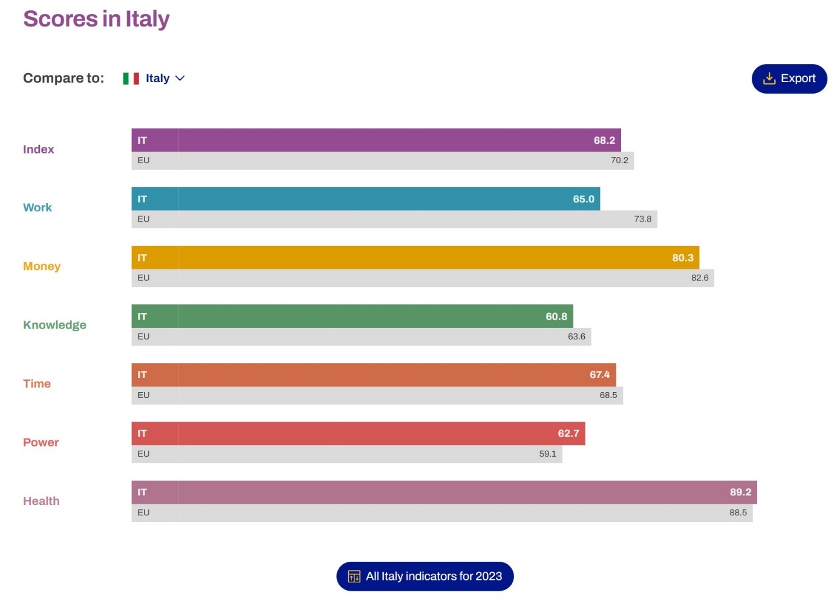European Institute for Gender Equality (2023)
Taking this into account recruiting and training staff needs to be without any bias and of course taking into consideration the country’s culture and traditions as well as the employee’s ways of life at home and at work.

Following, Eurostat Statistics Explained (2018) indicates 39.0 hours worked per week as a full-time job in Italy and 29.9% of women work part-time and 8.3 % are men. As for temporary workers, there are roughly 17.1%.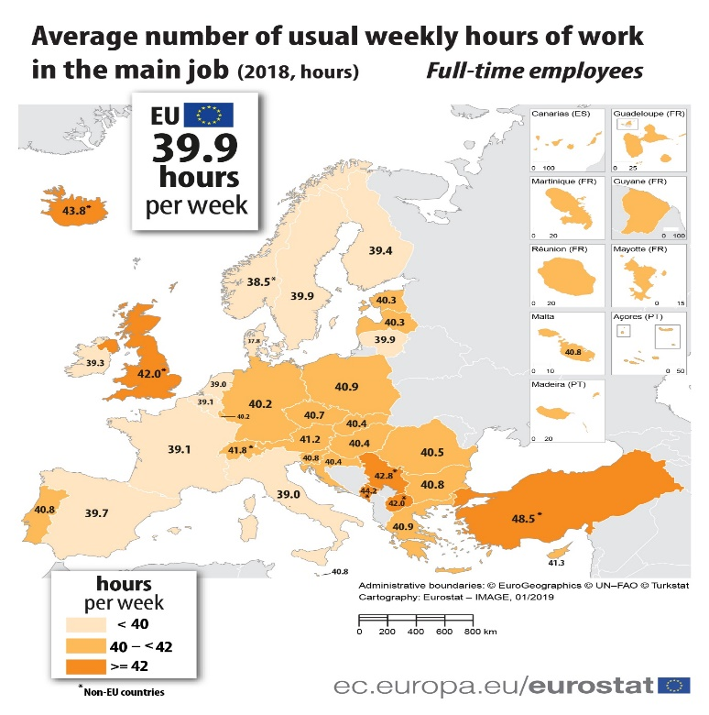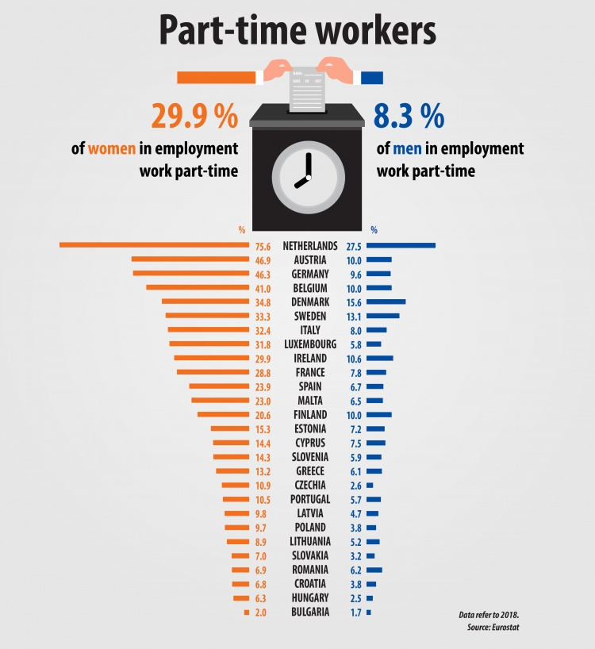
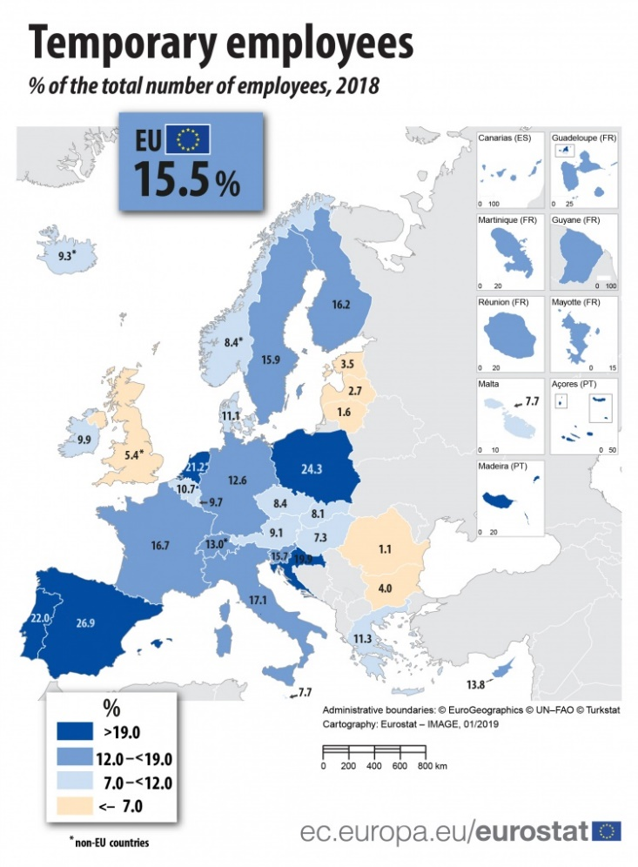

Taking all this into consideration while hiring and administrating employees, the company will be able to train and contain more staff with the new leadership involved.
On another note, as Seric (p1,2 2018) suggests, culture is a multilayered social reaction that is influencing customers decisions regarding the services provided and experience. Culture can easily influence a customer’s perception towards a positive or negative experience, Italy as a travel destination puts the country in the fifth position after France, the USA, Spain, and China.
As such these aspects need to be taken into consideration while changing location and leadership to another country.
New adventure(2021) points out some Italian traditions and celebrations that are imperative to remember while having Italian employees: Carnevale which is a very important Italian festivity and it starts in February and ends in March and it is celebrated in Florence and Venice, La Befana and it start in six of January where children get gifts, La festa de Angi Sante that starts in first of November and it celebrates all saints and last but not least La Note Bianca that starts in thirty of April and lasts all night and it leads to another national spring celebration next morning.
As the general manager of the new Diversity Hotel and Spa in Italy, acknowledging these cultural festivities helps to soothe the process of leadership changes and adaptation.
Giulia (2020) states that Italy has around 55 or more UNESCO sites, on the other hand, lunch break takes around one hour since it takes a long time to prepare, Sunday lunch is as important for Italians as Christmas lunch since it is served with the whole family.
As such family is the most important factor in Italy as stated by Gordon and Zimmermann (2022), it is also where most Italians spend their free time and whom they make decisions with, Italians will likely accept changes from someone closer to their family or their friends.
With all these considered, there are several other factors to be taken into consideration while taking the ropes of a new hotel in another country.

Main body
Globe (2020) provides access to a variety of cultural and leadership data collected around the world and in local countries. As for the tables, those are the exact numbers extracted from the graphs below.
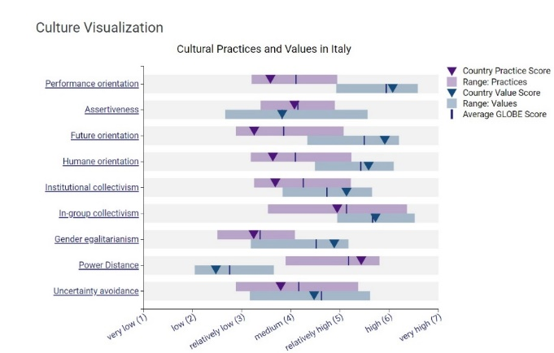 Globe (2020)

Culture Visualization | Range Practice | Range Values | Average Globe Score Practice | Average Globe Score Values
Performance Orientation | 3.58 | 6.07 | 4.1 | 5.94
Assertiveness | 4.07 | 3.82 | 4.07 | 3.82
Future Orientation | 3.25 | 5.91 | 3.85 | 5.49
Humane Orientation | 3.63 | 5.58 | 4.09 | 5.42
Institutional Orientation | 3.68 | 5.13 | 4.25 | 4.73
In-Group Orientation | 4.94 | 5.72 | 5.13 | 5.66
Gender Egalitarianism | 3.24 | 4.88 | 3.37 | 4.51
Power Distance | 5.43 | 2.47 | 5.17 | 2.75
Uncertainty Avoidance | 3.79 | 4.47 | 4.16 | 4.62

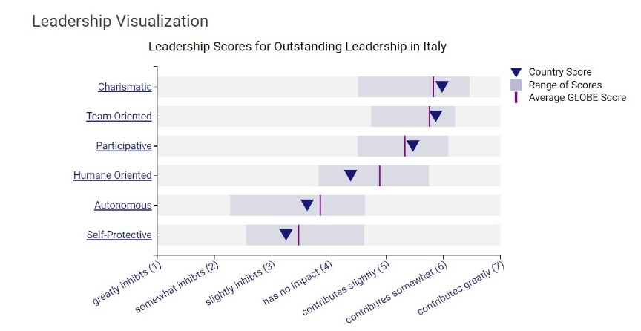Globe (2020)

Leadership Visualization | Country Score | Average Globe Score
Charismatic | 5.98 | 5.83
Team Oriented | 5.87 | 5.76
Participative | 5.47 | 5.33
Humane Oriented | 4.38 | 4.89
Autonomous | 3.62 | 3.85
Self-Protective | 3.25 | 3.47

Between practice and values there is considerable difference, but it is still a factor to be taken into consideration as well as the way leadership has been appreciated in certain aspects of the workplace.
As for the Rules and Regulations “Council Directive 2004/113/EC of December 2004 establishes a framework for the implementation of the principle of equal treatment between men and women, implementing the obligation of equal treatment in the labour market (Department of Equal Opportunities, 2023).
On the other hand, the Department of Equal Opportunities (2023) points out another piece of regulation “The National Strategy for Gender Equality 2021-2026”, inspired by “European Union’s Gender Equality Strategy 2020-2025” represents the foundation of values, work income skills, time and power all to be achieved by 2026.

Conclusion
Taking all these factors into consideration and accepting others' cultures, appreciating the smallest of details while considering another’s country traditions and holidays, habits and religion and of course binding by the rules and regulations of European Law, companies’ new leadership should have an easy and swift transition.

Recommendations

As for recommendations, Ulusoy (2023) points out ways to prevent unconscious bias in the workplace, while understanding the damage that it is causing.
Starting with the disadvantages:
- Creating unfair disadvantages.
- Preventing diversity and cultural harmony.
- Affecting teamwork and decision-making.
- Preventing effective succession planning.
All these can happen while: recruiting, interviewing, onboarding, feedback, illness, performance recognition and leadership selection.
To prevent these from happening there are a few steps:
- Understanding unconscious bias.
- Learning to identify bias.
- Overcome denial.
- Leading by example.
- Breaking stereotypes.
- Focusing on growing the company.
- Promoting accountability.
- Hiring diverse candidates.
- Setting diversity equity and inclusion goals.
- Encouraging good practice.
- Encouraging employee feedback.
- Tracking progress.
With all these steps and data collected in this report, managers can keep a stable and prosperous working environment within the new company.

Reference List:

Kiki Deere (2023). Hilton Lake Como. [Online] Available at: https://www.telegraph.co.uk/travel/destinations/europe/italy/italian-lakes/lake-como/hotels/hilton-lake-como-hotel/#gallery (Accessed: 6 November 2023).
Globe (2020) Results - Italy GLOBE Project. [Online] Available at: https://globeproject.com/results/countries/ITA?menu=country#country (Accessed: 7 November 2023).
European Institute for Gender Equality (2023) Gender Equality Index. [Online] Available at: https://eige.europa.eu/gender-equality-index/2023/country/IT (Accessed: 9 November 2023).
ŠERIĆ, M., (2018). A cross-cultural study on perceived quality in upscale hotels in Italy and Croatia. Journal of Hospitality and Tourism Insights, 1(4), pp. 340-366. [Online] Available at: https://www.proquest.com/docview/2447267447?accountid=130472&parentSessionId=Xg5lFsggMe8zs4Z2fBO5Xu%2B%2FK%2B6vq7DprMaEXQ1U5rQ%3D&pq-origsite=primo (Accessed: 8 November 2023).
Only One Giulia (2020). 5 Interesting Things about Italian Culture | Let's Take a Walk | Episode 3 - YouTube. [Online] Available at: https://www.youtube.com/watch?v=SYhWVWI03-Y (Accessed: 8 November 2023).
Jonathan Gordon, Kim Ann Zimmermann (2022) Italian Culture: Facts, customs & traditions. [Online] Available at: https://www.livescience.com/44376-italian-culture.html (Accessed: 8 November 2023).
Department for Equal Opportunities (2023). -Gender equality and women's empowerment. [Online] Available at: https://www.pariopportunita.gov.it/it/politiche-e-attivita/parita-di-genere-ed-empowerment-femminile/il-principio-della-parita-di-trattamento-tra-uomini-e-donne-nell-accesso-a-beni-e-servizi-e-loro-fornitura/ (Accessed: 10 November 2023).
Department for Equal Opportunities (2023). - National Strategy for Gender Equality 2021-2026. [Online] Available at: https://www.pariopportunita.gov.it/it/politiche-e-attivita/parita-di-genere-ed-empowerment-femminile/strategia-nazionale-per-la-parita-di-genere-2021-2026 (Accessed: 10 November 2023).
Berfu Ulusoy (2023) Unconscious Bias in The Workplace: How to Identify It + 12 Practical Ways to Tackle. [Online] Available at: https://www.zavvy.io/it/blog/pregiudizi-inconsci-sul-luogo-di-lavoro (Accessed: 10 November 2023).
Eurostat Statistics Explained (2018) Beginners: Labour market - employment. [Online] Available at: https://ec.europa.eu/eurostat/statistics-explained/index.php?title=Beginners:Labour_market_-_employment#What_is_the_employment_rate.3F (Accessed: 9 November 2023).

