Coaching and Mentoring (BMSW6007_SWAN)
Navigating growth and change through coaching and mentoring
Ancuta Nutu (1918834)
2023

Executive Summary

This report describes how coaching and mentoring can be used as a tool for optimizing performance within an organization, its benefits, and its applications.
To navigate the complex landscape of these interventions, this report provides organizations with useful insights based on scholarly sources and real-life examples. The insight comes from analyses of both scholarly sources and real-world examples.
A strategic assessment of their strategic contributions to employee satisfaction and leadership development is presented in the report, emphasizing the tangible and intangible benefits. Using a peer coaching session as an example, the report concludes with a critical analysis of the dynamic nature of coaching skills.

Contents
Executive Summary 1
1.0 Introduction 3
2.0 Main Findings 4
2.1 Assessing Tangible and Intangible Benefits of Coaching, Mentoring 4
2.2 An analysis of skills and behaviors of line managers as coaches and mentors 5
2.3 Coaching and Mentoring in Change Management 7
2.4 Companies that used coaching and mentoring during the pandemic 8
3.0 A Critical Analysis of Peer Coaching 9
4.0 Conclusion 11
5.0 Appendices 12
6.0 Reference list 13

Introduction

This report explores how coaching and mentoring as essential tools to assisting organizational development will consider tangible and intangible benefits, clarify roles, uncover similarities and differences, and explore how coaching and mentoring can aid in structuring a successful organization.
Therefore, it exposes the many facets of the role that line managers play in shaping the culture of an organization through their role of leadership, management, coaching, and mentoring through their leadership, management, and coaching responsibilities.
As a final point in this report, a critical analysis of peer coaching is proposed along with identifying strengths and weaknesses associated with peer coaching, as well as proposing actions for future sessions.

2.0 Main Findings

2.1 Assessing Tangible and Intangible Benefits of Coaching, Mentoring

Definition of Coaching
According to Parsloe and Melville Leedham coaching ‘’was initially used to describe the activity of helping transport a person's knowledge and skills towards a higher level, mainly by a form of teaching or tutoring. In the 20th century, however, it became most widely applied in the context of sport and performance’’ (2009).
When viewed within the framework of an organizational context, coaching is characterized as a structured development process whereby a coach collaborates with the coachee to achieve a specific goal. According to Whitmore (2017), the academic definition, unlocking potential for optimal performance is the key to unlocking potential.
Sir John Whitmore devised a popular coaching model, the GROW model, which guides coaching sessions by moving them through a process of goal setting, reality exploration, options analysis, and willingness to act to help them achieve their goals. There is no doubt that coaching emphasizes the task-specific and results-oriented nature of what it is all about.
Definition of Mentoring
Another widely used learning intervention is mentoring, which is characterized by a relationship-based process that promotes learning. The purpose of mentoring is to provide guidance and support to a less experienced individual, the mentee, so they can grow professionally and personally.
‘’In the USA mentors are generally defined as individuals with advanced experience and knowledge who are committed to providing upward mobility and career support to their mentees – often called protégés’’ (Poulsen, 2006, pp 251-258).
The mentoring relationship tends to be longer-lasting and encompass a broader range of development than coaching relationships, which tend to be time-bound and task-focused.
Similarities and differences between coaching and mentoring
Whether in the realm of professional advancement or personal development, coaching and mentoring both have the same fundamental purpose: to develop individuals' skills, knowledge, and performance (Garvey et al., 2008).
Similarities: Regardless of the approach taken, both coaching and mentoring aim to improve the skills, knowledge, and performance of an individual, and both work towards achieving goals. Individuals, whether for professional or personal development, use them to achieve specific objectives.
Differences: Typically, coaches are knowledgeable about coaching techniques and processes, assisting the coachee in discovering their solutions. As a mentor, you often receive guidance and share experiences from an individual who is more experienced than you are in the same field.
Understanding coaching and mentoring about other interventions can be facilitated by applying Clutterbuck's Four Styles of Helping. A coaching style emphasizes goal achievement and skill development, as described by Clutterbuck (2004). Alternatively, mentoring emphasizes holistic development through a supportive relationship, aligning more with the mentoring style.
To gain a better understanding of the organizational perspective, coaching and mentoring can be compared to other learning interventions, such as programs that provide formal training and peer-to-peer assistance are some examples.
‘’Coaching and mentoring are supportive, developmental, learning relationships where support and challenge are provided to achieve personal outcomes and to realize potential. Coaching and mentoring nurture professional and personal development by enhancing performance and work satisfaction’’ (Jones and Smith, 2022).
As part of a training program, students will engage in structured, formal activities to learn a certain skill or knowledge. As opposed to peer-assisted learning, peer-assisted learning is a more informal way when members of an organization informally share knowledge and experience over time rather than in a formal setting.
Tangible and Intangible Benefits of Coaching, Mentoring
Organizations must evaluate the tangible and intangible benefits of coaching and mentoring based on their Return on Investment (ROI). Employee performance is enhanced, productivity is increased, and overall organizational effectiveness is improved. It has been maintained by Wallace and Gravells (2007) that while intangible benefits, such as enhanced employee satisfaction, retention rates, and a positive organizational culture, are equally important, they can be challenging to quantify.
A significant aspect of coaching and mentoring for employers is its role in developing leaders, planning succession, and cultivating skilled personnel. The employees, on the other hand, can develop professionally and personally, experience a heightened feeling of job satisfaction, and feel like they belong to the organization. According to this perspective, learning intervention strategies should consider the organizational context as well as a strategic and holistic perspective (Zachary and Fain, 2022).

2.2 An analysis of skills and behaviors of line managers as coaches and mentors

Multi-facing role of a line manager
In an organization, a line manager plays many roles, including leadership, management, coaching, and mentoring. ‘’Line managers increasingly play a key role in organizational career development systems, yet few studies have examined the nature of this role or its implications for employee career attitudes and behaviors’’(2014, pp.1182 – 1203).
In contemporary workplaces, there is a growing need for integrating roles and responsibilities to reflect the evolution of leadership. The complexity and dynamics of line managers' dual roles as coaches and mentors must be examined critically as McMillan (2008) says. Additionally, the process involves a type of assessment that identifies the essential skills and behaviors that are required for success.
A typical characteristic of a line manager is that he or she has to balance their leadership, management responsibilities, coaching, and mentoring responsibilities. A manager's role as a leader is to set the direction of the organization, inspire the team, and ensure the success of the organization. The authors Wilkinson et al. (2020) state that managers are responsible for ensuring operational efficiency, allocating resources, and overseeing daily tasks. Moreover, line managers act as coaches, focusing on personal improvement, performance enhancement, and goal achievement. They are individuals who play a role in the growth of their team members as a mentor by providing guidance, sharing experiences, and supporting their professional and personal growth.
Nonetheless, according to Decenzo et al. (2016), managing line staff in the role of coaches and mentors brings many benefits, including a significant boost to employee engagement. Having access to the team on an immediate basis allows them to provide real-time feedback and tailored guidance, as they are close to them. An organization that adopts this approach will be able to improve employee performance, accelerate skill development, and promote a positive organizational culture as a result. Furthermore, a line manager's dual role as coach and mentor ‘’promotes trust and engagement among team members’’ (Armstrong, et, al, 1998).
Benefits of line managers as coaches/mentors
- A commitment to employee development is demonstrated when line managers offer coaching or mentoring opportunities.
- In addition to enhancing employee engagement and job satisfaction, this commitment can lead to higher employee retention rates.
- Coaches and mentors promote a culture of continuous learning in organizations when they actively engage in coaching and mentoring.
- For an organization to keep its competitive edge, it must have a culture of adaptability, innovation, and fostering.
‘’To be effective as a coach/mentor, a manager must be very skilled at acquiring and using power, building, and using relationships, and teaching and coaching others’’ (Orth et al., 1987, pp 66-74).
Nevertheless, this multifaceted role does have some drawbacks, and line managers may find it challenging to manage the various responsibilities of the position, thus creating the risk of potential conflict of interest situations (Parsloe et al., 2023).
Moreover, Dixon (2007) states that as managers have daily responsibilities, they may also find themselves unable to devote the time and focus that is needed to coach and mentor their teams effectively. The impact of coaching and mentoring initiatives may be hampered by managers lacking the specialized skills and training required.
Tugade et al., (2016) state that an important management skill is the ability to demonstrate empathy, which enables the manager to understand the unique challenges and viewpoints of their employees, and to adapt their management strategies to meet these needs. Considering the dynamic nature of coaching and mentoring relationships, Hill (2019), has asserted that flexibility and adaptability are crucial factors.
For line managers to be successful in coaching/mentoring, coaching models must be incorporated into practice. A structured framework, such as the GROW model (Goal, Reality, Options, Willingness), can assist with setting goals and solving problems. To ensure an effective and systematic way of interacting with team members, managers must have a good understanding of and apply such models (MOGONEA, 2022).
Coaching/mentoring is a complex, yet powerful component of organizational leadership, and the line manager can play an important role in it and is important to consider the benefits and drawbacks of each role when balancing them (Connor, 2012). Line managers need to choose and develop these competencies carefully if they want to contribute effectively to the growth and success of their team members and the organization.

2.3 Coaching and Mentoring in Change Management

An organization's ability to navigate transitions successfully requires strategic approaches to change management (Magretta, 2012). An evaluation is conducted to assess how coaching and mentoring can facilitate and manage change. The focus of the chapter is on the definition of change management, the drivers and trends associated with change management, and the specific contribution that mentoring and coaching can make in this regard.
Definition of Change Management:
A change management plan involves implementing structured approaches to transition individuals, teams, and organizations from their current state to their desired state, according to Paton and McCalman (2000). Organizing and managing change effectively means minimizing resistance and maximizing the benefits of organizational transformation. It consists of methodologies, tools, and processes that enable change to be implemented and managed effectively.
Drivers and Trends in Managing Change:
Several factors drive the need for change management at work, as highlighted by Carnall (2018), and innovations in technology, fluctuations in the market, and shifting customer expectations are all contributing to existing drivers. In Carnall's view, organizations must manage change if they are to ensure their success and adapt to the dynamic and evolving nature of the modern workplace.

Role of Coaching and Mentoring in Change:
Mentoring and coaching play important roles in providing support to individuals and teams going through change processes, as Western (2012) points out. A coaching and mentoring approach can be adapted across various stages of Lewin's Change Management Model (unfreeze, change, refreeze).
A coaching approach is one of the most powerful ways to help individuals overcome their resistance to change during the 'unfreeze' phase. A mentor's experiences navigating similar transitions become valuable during the 'change' phase.
The final step in the change process is the "refreeze" phase, in which coaching reinforces newly acquired behaviors, resulting in an enduring and sustainable improvement. Considering the stages of change management, Western's insights underscore the versatility of coaching and mentoring.
Berry and Fehrmann (1993) provide valuable insight into coaching and mentoring's strengths and weaknesses. It is noteworthy that these tools provide personalized support and in addition to addressing individual concerns, it fosters a profound sense of commitment to implementing the changes. It's critically important to recognize that coaches' and mentors' effectiveness depends on employees' readiness and openness to change, according to Berry and Fehrmann.

2.4 Companies that used coaching and mentoring during the pandemic

Boots
An employee coaching program may have been implemented at Boots, during the pandemic, and it is possible to benefit from coaching sessions on navigating health and safety procedures, addressing increased demand for health products, and managing stress in a healthcare setting. In an industry that is constantly evolving, Boots ensures that its employees are guided and supported to achieve high-quality customer service while delivering competitive prices in a wide range of retail formats.
Sainsbury’s
In the course of the pandemic, Sainsbury's, one of the largest supermarket chains in the United Kingdom, might have implemented coaching and mentoring programs for its employees. The coaching sessions can assist staff in adapting to changes in customer behavior, improving safety measures, and managing the demands of an ever-changing retail landscape. By empowering employees, Sainsbury's aims to enhance their skills, help them cope with challenges, and contribute effectively to the company's operations.

3.0 A Critical Analysis of Peer Coaching

During this coaching session, I played the role of the coach, and I will use the Gibbs Reflective Cycle as a framework to reflect on my performance during this coaching session.
Description:
I was primarily concerned with Andrei's stress resulting from a recent promotion, the challenges he was experiencing managing the increased workload, and his issues throughout the session.
As part of the delegation process, time management, and communication, I demonstrated empathy and provided practical advice to the team. I provided support and suggestions regarding both professional and personal issues, offering both advice and guidance.
Feelings:
In understanding Andrei's multi-faceted challenges, I felt an immediate bond with him, and I felt that I had a genuine connection to him.
Provided support and guidance professionally and courteously.
Embraced the notion that it is important to address not only the professional aspect of the coachee's life but also the personal one as well.

Evaluation: Strengths & Weaknesses
S: Ensured that an open, supportive, and self-advocating environment was created by demonstrating empathy and active listening.
Solved work-related challenges practically by using available resources.
Provided HR support to clients concerning their issues and encouraged open communication about them.
W: Andrei may have been able to express his feelings or reflections more deeply about the coaching process by probing deeper into his emotions.
The scope of the investigation into potential obstacles to the implementation of the solutions provided was limited.
Analysis:
In this coaching session, we focused on providing some immediate solutions to the coachee's concerns and used the Instant Pay Off Model to guide us throughout the coaching process.
Conclusion:
Using the Instant Pay Off Model, Andrei was able to resolve immediate concerns and receive actionable advice that was aligned well with the practical challenges he was facing in his work environment.

Action Plan:
I intend to balance immediate solutions in future coaching sessions with exploring the coachee's emotions and reflecting more deeply on their journey in the future. To provide a more structured approach to setting goals and solving problems, consider incorporating elements from other coaching models, such as GROW. Assess potential obstacles to the implementation of suggested solutions and develop methods to overcome them.
Future Application:
Future coaching sessions can benefit from developing active listening skills, empathy, and practical advice.
Examine both immediate and deeper emotional issues as part of a more comprehensive approach.
Enhance the ability to recognize potential obstacles and address them.
Further Development:
Learn more about the coachee's emotions by receiving additional training or resources.
In conclusion, I recognize that in future sessions, a more balanced and comprehensive approach will be needed, in addition to the Instant Pay Off Model. Developing my coaching skills and meeting the evolving needs of my coachees will require continuous learning and development.

4.0 Conclusion

With the assistance of scholarly sources and examples drawn from real-world situations, this report examines coaching and mentoring in organizational contexts. Employee satisfaction and leadership development are integral to the strategic assessment of line managers. As well as a multifaceted role in shaping organizational culture, this focus is on tangible and intangible benefits. Many parallels between coaching and mentoring are explored in the report, including definitions, benefits, and applications. A focus is placed on leadership development and employee satisfaction as well as their tangible and intangible benefits. This report discusses the challenges and specialized skills that line managers face as mentors and coaches.
As part of the report's exploration of Lewin's Change Management Model, it explores the alignment between coaching and mentoring. To demonstrate this, real-world examples from Boots and Sainsbury's are provided. As a result of analysing a peer coaching session critically, it is important to emphasize the importance of continuous learning and improvement.
I believe the report concludes with some valuable insights for organizational leaders, with specific emphasis on the dynamic nature of coaching skills and the commitment to meet individual and organizational growth needs as they evolve.

5.0 Appendices

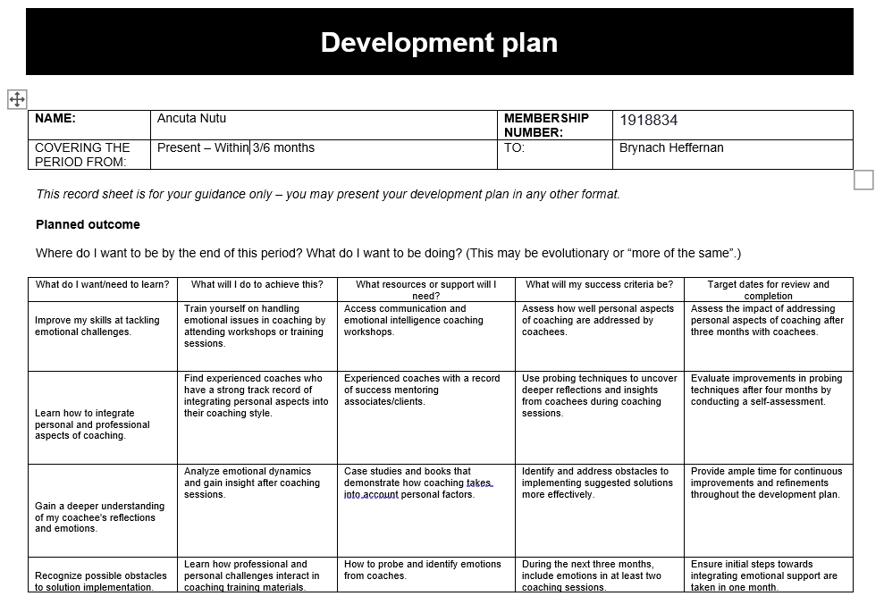

6.0 Reference list

- Armstrong, Michael, and Industrial Society. Managing People: A Practical Guide for Line Managers. London, Kogan Page, 1998.
- Berry, Donna, and Joe Fehrmann. 50 Activities for Coaching and Mentoring. Human Resource Development, 1 Jan. 1993.
- Carnall, Colin. Managing Change. S.L., Routledge, 2018.
- Clutterbuck, David. Everyone Needs a Mentor: Fostering Talent in Your Organisation. London Chartered Institute Of Personnel And Development, 2004.
- Connor, Mary P. Coaching and Mentoring at Work. Milton Keynes, Open University Press, 2012.
- Crawshaw, Jonathan R., and Annilee Game. “The Role of Line Managers in Employee Career Management: An Attachment Theory Perspective.” The International Journal of Human Resource Management, vol. 26, no. 9, 14 July 2014, pp. 1182–1203, https://doi.org/10.1080/09585192.2014.934886.
- Decenzo, David, et al. Fundamentals of Human Resource Management. John Wiley & Sons, 16 May 2016.
- Dixon, Rob. The Management Task. Routledge, 22 Aug. 2007.
- Garvey, Bob, et al. Coaching and Mentoring. SAGE, 18 Nov. 2008.
- Hill, Linda A. Becoming a Manager. Harvard Business Press, 26 Feb. 2019.
- Jones, Jenni, and Helen A. Smith. “A Comparative Study of Formal Coaching and Mentoring Programmes in Higher Education.” International Journal of Mentoring and Coaching in Education, vol. ahead-of-print, no. ahead-of-print, 10 Jan. 2022, https://doi.org/10.1108/ijmce-03-2021-0054.
- Magretta, Joan. What Management Is? Profile Books, 6 Dec. 2012.
- McMillan, Elizabeth. Complexity, Management and the Dynamics of Change. Routledge, 28 Aug. 2008.
- MOGONEA, Florentina. “A Possible Mentoring Model: The GROW Model.” 'Analele Universității Din Craiova Seria Psihologie-Pedagogie/Annals of the University of Craiova Series Psychology- Pedagogy ', vol. 44, no. 2, 30 Dec. 2022, pp. 60–70, https://doi.org/10.52846/aucpp.2022.2.05.
- Orth, Charles D., et al. “The Manager’s Role as Coach and Mentor.” Organizational Dynamics, vol. 15, no. 4, Mar. 1987, pp. 66–74, www.sciencedirect.com/science/article/pii/0090261687900453, https://doi.org/10.1016/0090-2616(87)90045-3.
- Parsloe, Eric, and Chartered Institute Of Personnel And Development. The Manager a Coach and Mentor. London, Chartered Institute Of Personnel And Development, 2003.
- Parsloe, Eric, and Melville Leedham. Coaching and Mentoring: Practical Methods to Improve Learning. London, Kogan Page, 2009.
- Paton, Robert, and James Mccalman. Change Management: A Guide to Effective Implementation. London; Thousands Oaks, Sage Publications, 2000.
- Poulsen, Kirsten M. “Implementing Successful Mentoring Programs: Career Definition vs Mentoring Approach.” Industrial and Commercial Training, vol. 38, no. 5, Aug. 2006, pp. 251–258, https://doi.org/10.1108/00197850610677715.
- Tugade, Michele M, et al. Handbook of Positive Emotions. New York, The Guilford Press, 2016.
- Wallace, Susan, and Jonathan Gravells. Mentoring. Exeter, Learning Matters Ltd., Reprinted, 2007.
- Western, Simon. Coaching and Mentoring. SAGE, 18 July 2012.
- Whitmore, John. Coaching for Performance. Createspace Independent Publishing Platform, 5 July 2017.
- Wilkinson, Adrian, et al. Handbook of Research on Employee Voice. Edward Elgar Publishing, 2020.
- Zachary, Lois J, and Lisa Z Fain. The Mentor’s Guide. John Wiley & Sons, 1 June 2022.

