
Marketing Fundamentals Assessment 1
Module Leader: Turshara Balendran
Student Name: Nikolinka Nedelcheva
Student ID: 2115610

Introduction
In the current business environment, each individual business organisation must make an operation plan in order to remain competitive in the market. The moment they present something new, they should take advantage of the help of advertising, which intends to bring new products and better supply chain management. This report includes the distinctive views of the Nike company that have been taken into account in previous evaluations.
According to Gregory (2018), Nike is probably the most famous brand that offers a range of sports shoes and gear. The organization wants to differentiate its range of products with the introduction of a new item, such as warm boots during winter. This report includes the mission and vision of the Nike Association. In addition, advertising review is guided by the use of various marketing tools.

Section 1
Mission and vision
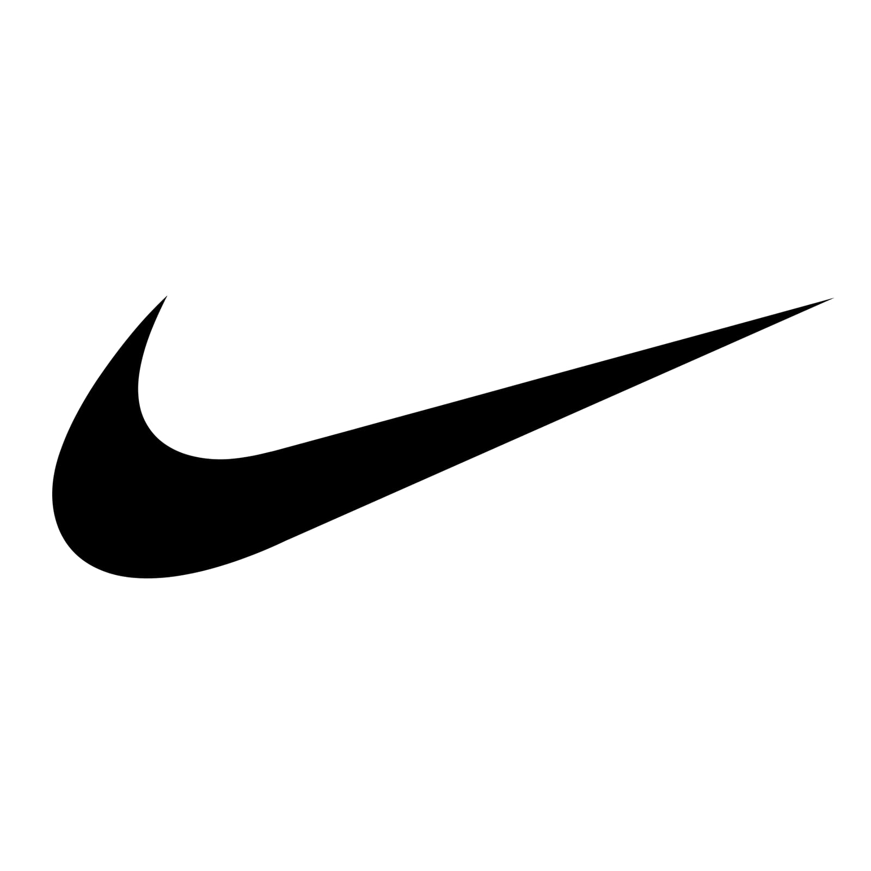
Nike Logo
Nike is a founding organization founded in the United States in 1969. The association is involved in the planning, assembly and maintenance of footwear, hardware, sports clothing and additional sports item. The primary aim of Nike are to give sports shoes, shoes and also additional equipment for sporting activities (Gregory, 2018). The association operates in various countries such as Japan, China, Europe, India, New Zealand and other emerging business sectors. The mission and purpose of this organization created the opportunity to show exactly the situation of the business position. Nike's stated goal is to "bring progress and motivation to every single person on the planet." The declaration of mission of the organization shows the main purpose of contact with the shoes and equipment of the game. The current explanation for CSR's vision is to help Nike and its customers succeed in an economic economy where benefits, people and the planet are adjusted (Nike, 2021). The association now needs to make and develop an appropriate vision proclamation to educate financial supporters and workers about what business goals there may be in the future in setting up a global market for sports equipment just like any other company (Armstrong, Kotler and Opresnik, 2019).
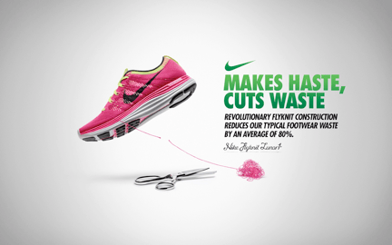
Digital HBS (2016) - https://digital.hbs.edu/platform-rctom/submission/just-did-it-how-nike-found-the-idea-of-sustainable-innovation-and-ran-with-it/

Section 2
Marketing Mix Analysis
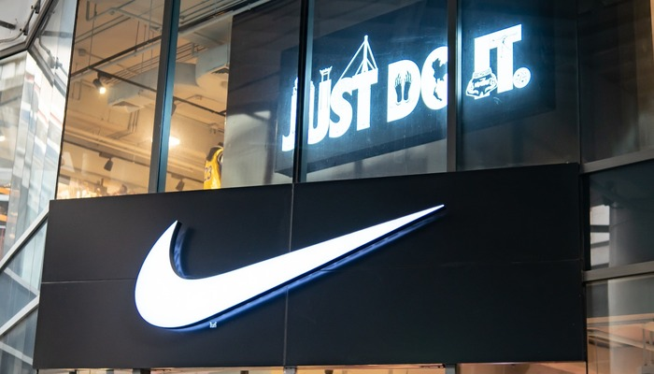
Starting Business (2020) - https://www.startingbusiness.com/blog/marketing-strategy-nike
The including 4Ps marketing mix of Nike evaluates the advantage and improvement of the games shoes, apparel and equipment business. An association's publicizing blend indicates the systems and procedures carried out to carry out the show plan, based on item, spot, advancement, and value (Mba Skool, 2021). For this situation, Nike has a promoting blend that incorporates sports things. For instance, the association has reasonable involvement with footwear that is intended to address the issues of experienced b-ball and soccer players. Regardless, these things are promoted to all clients all over the planet, for sports and relaxation works out, considering the subtleties of Nike's corporate mission and vision. Set up in 1964, the association's 4Ps are advancing as illustrated by components of the worldwide outside supply industry. Such advancement is a significant accomplishment factor that empowers organizations to utilize their special blend to react to show models and changes that influence the premium of the nearby, neighborhood and worldwide market in its things.
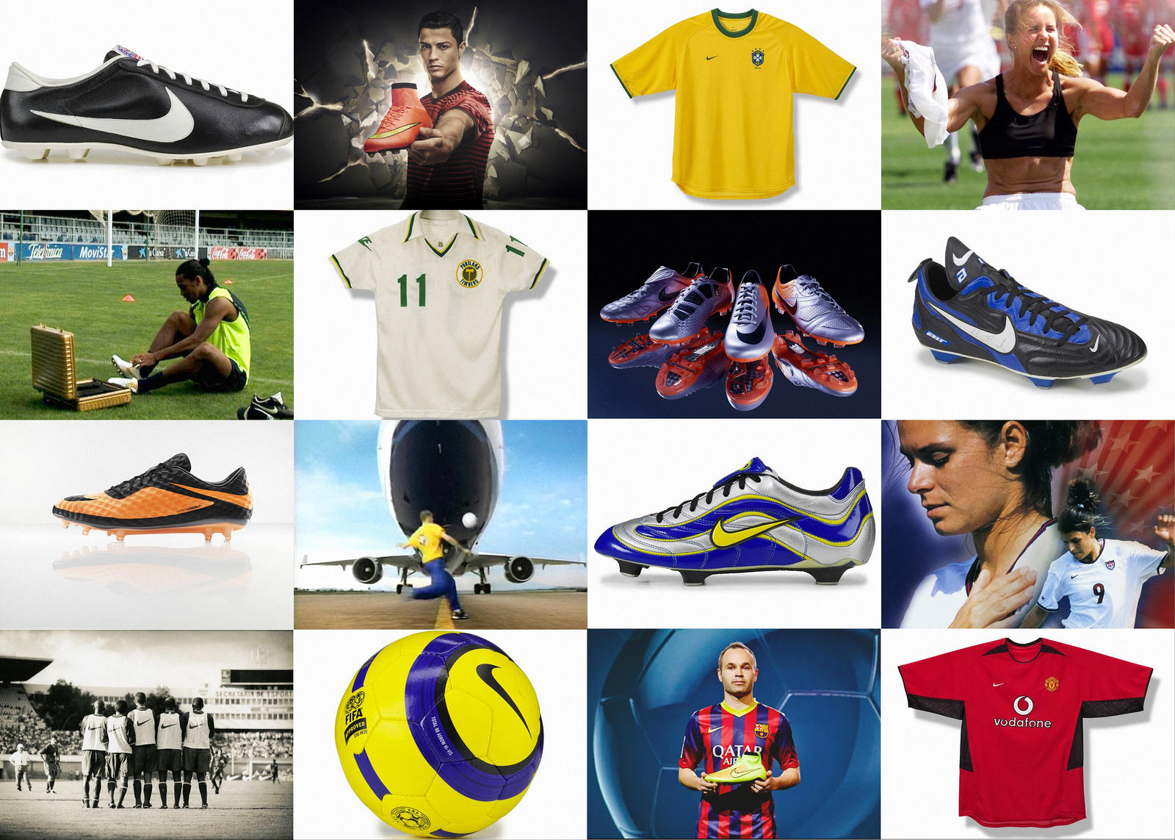
Nike News (2016) - https://news.nike.com/news/the-definitive-history-of-nike-in-football
Product: Shoes are the most popular things of Nike Inc. The business is progressively adding more items to this class. For instance, the association as of now offers tennis shoes, running shoes and shoes for a scope of various games, including cricket. Nike likewise sells attire like shirts, shorts and related things. In addition, the association's item contributions incorporate guiding haggle, like golf clubs (Mba Skool, 2021). These things are accessible under a portion of the association's brands, including Air Jordan, Hurley and Talk. With this part of the promoting mix as a primary concern, Nike is growing its mix of things to address the issues of its true business areas and market pieces.
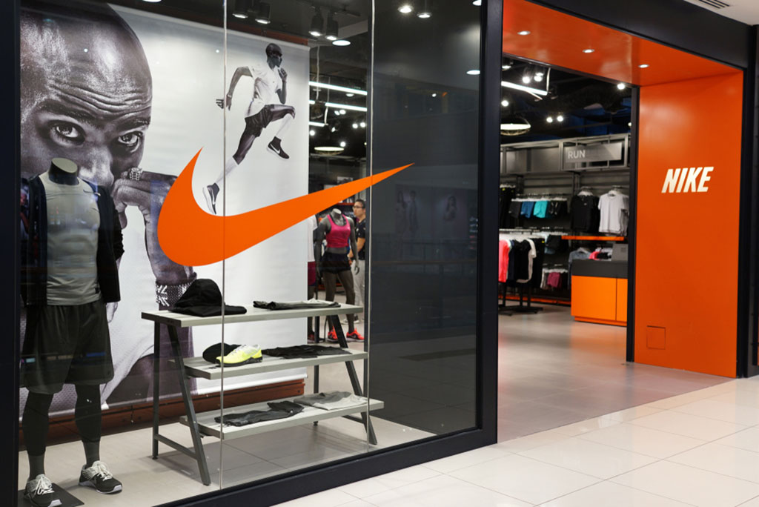
Footwear News (2019) - https://footwearnews.com/2019/business/opinion-analysis/nike-best-place-to-work-2019-1202767487/
Place: Retail outlets are the principle spots where Nike things are sold in light of the fact that these scenes are definitively and viably presented in different business areas all over the planet. These retailers incorporate enormous organizations like Walmart), just as hardly any close by and country stores. This 4P part likewise shows that clients can purchase Nike games, attire and equipment through the association's online store (Shastri, 2021). In addition, the business works in its Nike stores. These retail outlets are claimed by an association and permit admittance to business and market information that upholds crucial corporate organization as far as promoting techniques and systems for current, new and arising things. Considering this part of the promoting blend, Nike Inc. controls the misappropriation and supply of its things, particularly through its Web based store and Nike outlets. All things considered, the association has restricted command over the transportation and offer of its things through different outlets.
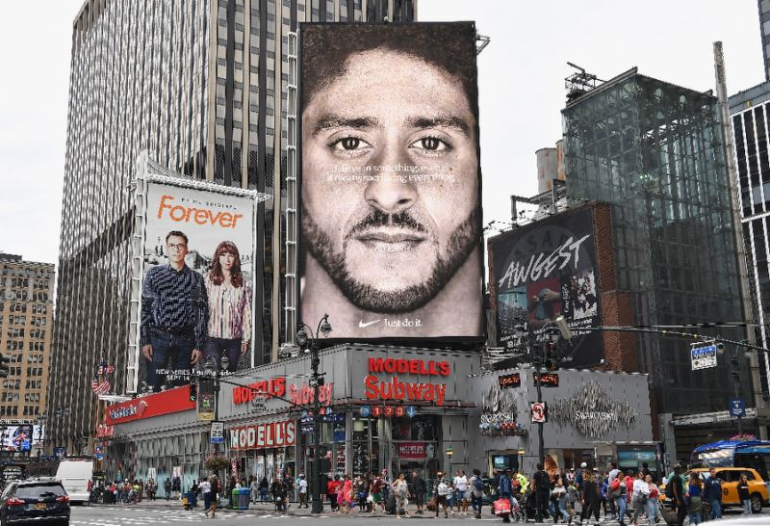
The Globe Post (2018) - https://theglobepost.com/2018/09/19/nike-kaepernick-sales/
Promotion: Distributing is maybe Nike's greatest ally of drawing in clients. The association is intensely subject to news, particularly those including high-positioning whizzes, for example, experienced competitors and sports gatherings. This part of the association's publicizing mix further incorporates individual deals through manages educators who convince target purchasers to buy the association's things. For instance, exchange instructors at Nike outlets will utilize such leverage (Shastri, 2021). Activities to straightforwardly advance the association incorporate direct correspondence with colleges, close gaming gatherings, and different affiliations.
Concerning 4Ps, direct portrayal alludes to planning contact with relationship to lift components to people from such affiliations. What's more, Nike arbitrarily applies limitations and extraordinary proposals to draw in more clients and make more arrangements. These limitations offer organized methodologies for the business progress of the association. Furthermore, in publicizing, the association supports and offers monetary help to different affiliations, like nearby associations, to modernize their games shoes, attire and gear. Considering the systems remembered for this part of Nike's demo blend, the business depends on its associations with high-profile allies to progress as far as business headway and its things in the worldwide outside consumables market.
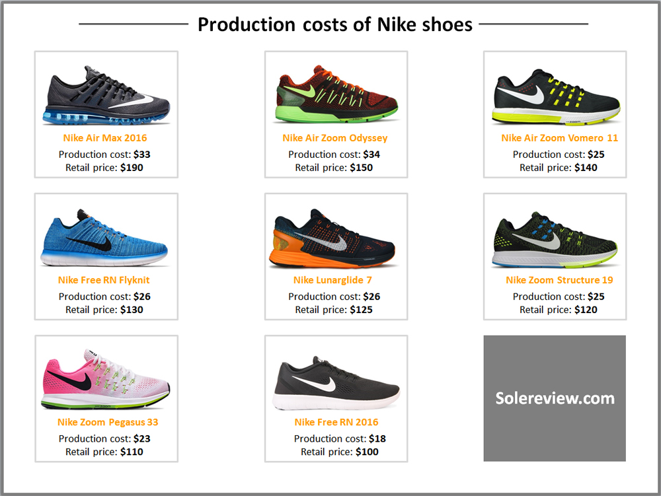
Solereview (2016) - https://www.solereview.com/what-does-it-cost-to-make-a-running-shoe/ https://www.solereview.com/what-does-it-cost-to-make-a-running-shoe/
Price: Value-based pricing technique: Using the value-based valuation technique, Nike Inc. thinks about recognizing the buyer in terms of the value of their items. With regard to the demo mix, this value is used to determine the most extreme costs that buyers will pay for the organization's shoes, clothes and gaming equipment. In this regard, superior valuation techniques involve excessive costs, in light of a first-class labeling methodology that makes Nike items better and more valuable than competing items. To keep up with the deals and benefits, Nike is committed to ensuring consistency in monitoring and good evaluation. In this way, Nike organizations have adopted a value-based system to harmonize the piece of the pie with increasing the organization's benefits. The value-based technique evaluation system ensures that what the organization assumes it offers is worth the amount it pays for. This technique is used to invent the ideal amount that customers will pay for items, for example, decorating sports shoes at a time. Cases, for example, in 2014 Nike increased the cost of various items and this led to expanded transactions and revenues. The value-based valuation technique has played a gigantic age for income and benefits, while maintaining an emphasis on quality and building high respect. Conversely, Adidas solves the cost of items, such as footwear for clothing, by estimating the cost of creation corresponding to the desired net revenue.

Section 3
Generic Strategy and Evaluation
Nike has an invaluable way to cope with the use of systems over its competitors. Part of the implemented agreements are the non-exclusive methodologies obtained from the input model. This system includes a cost initiation procedure and a separation technique. The non-exclusive cost administration system is up to date with proper valuation and costs are up to date both during creation and in transactions. This includes reducing set-up costs to increase benefits and occasionally reducing sales costs. Nike has reduced the selling price of shoes since 1990 (Shah, 2021). The most affected contender for this system is Adidas, which is struggling to cut costs by a huge amount. Improving non-exclusive separation procedures has helped to develop exclusive footwear items during planning and processing. The Conventional Authority's cost methodology has supported Nike to use innovation to build a head start-up and thereby reduce set-up costs. In monetary terms, conventional separation systems have helped the organization increase net revenue from new brands of items. Adidas and Reebok have yet to come up with ways to create innovations that match Nike's innovations.
Overall, the Nike company is very encouraged to ensure that they complete in accordance with the commitment and adjusted methodologies during the appropriation and advancement of items. In the same way, Nike has effective guidelines and guidelines that ensure that all laws are obeyed everywhere and the business is very up to date, along these lines, controlling government issues in the administration. Although she is enthusiastic about inventing benefits, it is vital for the organization to offset total revenue with the help of the client's government in the business. Overall, the administration provided by Nike both in the organization and in retail outlets and online stores is an added advantage within the market mix. Nike's organization offers the best administrations among its competitors, including Adidas.

References
Armstrong, G., Kotler, P. and Opresnik, M.O. (2019). Marketing: an introduction. Upper Saddle River: Pearson.
Gregory, L. (2018). Nike Inc.’s Marketing Mix (4Ps/Product, Place, Promotion, Price) – An Analysis. Panmore Institute [online]. Available from: http://panmore.com/nike-inc-marketing-mix-4ps-product-place-promotion-price-analysis [Accessed: 13/12/2021].
MBA Skool (2021). Nike Marketing Strategy & Marketing Mix (4Ps). MBA SKOOL [online]. Available from: https://www.mbaskool.com/marketing-mix/products/16893-nike.html [Accessed: 13/12/2021].
Nike (2021). Corporate Responsibility News. Nike News [online]. Available from: https://news.nike.com/corporate-responsibility [Accessed: 13/12/2021].
Shah, F. (2021). Marketing Mix of Nike (4Ps of Nike). Howandwhat [online]. Available from: https://howandwhat.net/marketing-mix-nike/ [Accessed: 15/12/2021].
Shastri, A. (2021). Researched Marketing Mix of Nike with Complete Explanations for 4Ps. IIDE [online]. Available from: https://iide.co/case-studies/marketing-mix-of-nike/ [Accessed: 15/12/2021].

