

Entrepreneurship
Written Report

1)BA Entrepreneurship BABM
Lecturer. Amer Kareem
2) Ivan Sendrev (2235334)

Table of Contents

Introduction 3
Business Description and Market Opportunity 3
Industry Analysis 4
Operations and Management Team Plan 4
Marketing Plan and Strategy 5
Financial Plan 7
Conclusion 10
References 11

Introduction
The prerequisite aim of this assessment is to discuss and describe a unique business idea which is based on food. The name of this business is Gourmet Food Truck and this food truck mostly focuses on providing their customers best cheese sandwiches according to their requirements and preferences. It will also describe the market opportunities that this new venture can use to enhance its business and achieve growth in this competitive marketplace. This assessment will also describe marketing strategies and plans for this venture which will be useful for them to capture the marketplace. This assessment will also provide industry analysis, management team plan, USP, STP, and financial analysis for this company.

Business Description and Market Opportunity
Business Description - The company whose name is Gourmet Food Truck is one of the most unique business ideas which will generate lots of profit for them in the marketplace. This venture will produce crispy, succulent grilled, delicious sandwiches on the preference or requirement of the customers of the organisation to fulfil their demand, these cheese sandwiches will be prepared according to the requirement of customers and their preference which is the USP for this organisation. The Gourmet Food Truck venture will use completely fresh framing products that are organic and high quality throughout this kind of initiative they want to provide their customers best organic products in the marketplace place which no one is thinking about, so the company has decided to produce their sandwiches through grilling them which will taste differently and tasty to their customers. This business will operate around food trucks and will try to meet the expectations of their customers for targeting the core customers of this business. As this company has decided to use social media for their marketing and branding that is why it can be able to capture lots of customer range into their business through low-budget marketing and it will also be useful for saving the operations or marketing costs.
Market opportunities - In the marketplace place there are very few kinds of companies doing that kind of thing and it is also a very demanding venture in the market that is why the company will have to face very little competition in the market, however, the company have to also face some kind of giant food organisation who are in competition with them. As the business idea of the company explained they will provide fresh organic farming products in their food items that is why due to this reason they can easily capture the marketplace and can also find various kinds of opportunities in many ways. For any new venture, it is very essential to find a gap in the market. If they will find the gap then it will help them to build their USP in the marketplace (Kim and Ji, 2018). Gourmet Food Truck company can use those gaps to fill the demand of customers and provide efficient supply to the marketplace. To overcome the competition in the market place they need to follow an efficient way to capture the market and make positioning in the marketplace a competitive area.

Industry Analysis
The food industry of the UK combines high-quality produce with cutting–edge technology which helps in showing the forefront of innovation. The food industry of the UK was found to be the biggest ma manufacturing sector which is valued at £104.4 billion. It leds to create opportunities for exporters, international buyers and investors. The steady demand for functional food has been notified which has led to the modification of the food that claims to improve the health of the consumer. The UK is at the forefront towards the development of the food industry with an estimation of 9.5% (GOV, 2024). This industry mainly provides the employment of 456,000 which comes to 0.1% in the year 2021. The export of the food product from the UK was found to be £25 billion across more than 220 countries. This industry consists of more than 12,460 food and drink manufacturing businesses and holds an investment worth £3.1 billion which comes to 22.7% in the year 2021 (FDF, 2023). In the year 2024, the revenue related to the food market holds 171.60 billion USD. The growth rate of the food market of the UK was found to be 4.15% (Statista, 2024).

Operations and Management Team Plan
Team | Responsibility
CEO | The main responsibility of the CEO of Gourmet Food Truck is to set and execute the strategy of the organisation. Furthermore, the CEO held responsible towards building the senior leadership team. It also is responsible towards allocating the capital. It also led to set the vision, mission, value and corporate culture of the organisation.
Chief and Culinary Expert | The responsibility of the chief and culinary expert of Gourmet Food Truck is to provide training and mentoring to the staff of its kitchen through culinary techniques along with the best practices. It is also responsible towards managing the operation of the kitchen which mainly includes budgeting, controlling the inventory, and procurement of fresh produce as well.
Operational Manager and Executive | The operational manager of Gourmet Food Truck is held responsible towards overseeing the regular operation, optimising the process, ensuring the quality of the food, developing the strategies and leading the team towards achieving the goals of the organisation. The operational manager also enables supervising, hiring and providing training to the employees for managing the quality and assurance program as well.
Marketing Coordinator and Marketing Team | The marketing coordinator of the Gourmet Food Truck is responsible towards the development, coordination, and execution of the marketing campaigns. It enables gathering data related to the demographics structure and the marketing trend which helps in the development of products that match the needs of the consumer. The responsibility of the marketing team is to track the sales record along with the work of the marketing team which helps in achieving the set goals.
Sales representative | The responsibility of the Sales representative of Gourmet Food Truck is to identify the needs of the consumer along with pitching the relevant product being offered by the organisation. It is responsible for making outbound sales along with the activities of marketing.

Marketing Plan and Strategy
Marketing mix
Product
Product is the first element of the marketing mix which is the service or item offered by the business (Thabit and Raewf, 2018). Gourmet Food Truck is offering various types of food products wherein the main product is cheese sandwiches that are prepared through grilling.
Price
The amount paid by customers in return for products or services is the price. The company is focused on a dynamic pricing strategy. According to Dublino, (2023), companies in dynamic pricing strategies change the price of products based on various external factors. Gourmet Food Truck will increase prices during peak selling hours and minimise flexible prices during off-peak selling hours.
Place
The main place where products will be sold is the food truck. However, the company will also operate through social media and its mobile application from where customers can make orders. Their products will be delivered to their homes.
Promotion
The company will mainly be focused on social media marketing wherein various types of marketing campaigns will be developed and executed. Social media promotion will help the firm to gain a strong brand presence in the market. According to data, 82.8% of the entire UK population uses social media (Dixon, 2024).
STP
STP can be defined as a strategic marketing framework which is a combined form of segmentation, targeting, and positioning (Ing et al. 2020). Gourmet Food Truck is focused on targeting people from 18 to 65 and more. The main reason behind choosing this wide range of target market is that there is fast food consumption in people of diverse groups. Therefore, the company will be able to target all age groups of people above 18. The firm is focused on targeting British people. People with working professions are the main target. People who seek ready-to-eat meals in the shortest time are welcome to this food truck.
USP
USP is known as Unique Selling Points and it highlights the uniqueness of products and services that make a company different and better from its competitors (Basal, 2019). The company has multiple points that make Gourmet Food Truck better and unique from its competitors. The first USP is that the firm provides a diverse menu that includes high-quality and tasty meals. The ingredients used in food products are sourced from locals while ensuring a high quality of food standards. The most unique USP of this business is that the options mentioned in the menu are customisable as per the requirements of customers.

Financial Plan
In the books of Gourmet Food Truck
Start-up Expenses (£)
Particulars | Amount (£)
Basic Materials and Cooking Utensils. | £10,000
Licensing and Insurance | £5,000
Promotional and Marketing Costs | £5,000
Total Expenditure | £20,000
Required Assets for Start-up (£)
Particulars | Amount (£)
Permanent Premises | £25,000
Food Truck | £15,000
Inventory | £15,000
Total Assets | £55,000
Total Required Amount for Start-up | £75,000
Table 1: Start-Up Costs
(Source: Own-estimated, 2024)
Friend and Family
The major source of capital mainly comes from friends and relatives by reason of trust. This can be advantageous if only there are rich relatives who can easily part with their cash and are willing to do it. When taking loans from friends and family members, the borrowed capital has to be repaid with interest and therefore the relations with these people have to be respected (Brex, 2024).
Angel Investors
Angels investors are people who invest money from their personal pocket into a new business; normally they receive shares in exchange for their capital. The likely experience of actually commissioning an angel investor is a vastly different proposition from standing in front of someone with a great idea that will earn high returns (Edelman et al. 2017).
Venture Capitalists
Venture Capitalists are defined as professional financiers who underwrite high-risk prospective high-return investments utilising funds derived from various places. Venture capital, as opposed to other sources of financing, cannot be obtained without any preparation and hard considerations for the venture including the business plan and the growth model (Lerner and Leamon, 2023).
Loans
Credit-qualified entrepreneurs have diverse funding avenues for their ventures and these include SBA loans and other personal loans. One should compare the lending institutions in relation to the interest rates and the free terms in order to get the right deal (Corporate Finance Institute, 2024).
Grants
A grant implies a sort of financial aid that one is offered by the government, a foundation, or any other organisation and does not have to cover with cash or in part at least. Grants are mostly given for exhibitions, innovations, and employment opportunities for the youths (Stevenson et al. 2021).
In the books of Gourmet Food Truck
Cash Budget for Six Months
Particulars | Month 1 | Month 2 | Month 3 | Month 4 | Month 5 | Month 6
Opening Balance | - | 6425 | 36068 | 44750 | 67192 | 90143
Cash Receipts:
Cash Sales | 25000 | 27500 | 35750 | 50050 | 75075 | 129129
Collection Debtors | - | 36000 | 42000 | 55000 | 50000 | 53000
Total (A) | 25000 | 63500 | 77750 | 105050 | 125075 | 182129
Cash Payments:
Cash Purchases | 15000 | 17000 | 23000 | 25500 | 28000 | 31000
Payment to Creditors | - | 7000 | 6500 | 8900 | 3500 | 4800
Wages | 2500 | 2500 | 2500 | 2500 | 2500 | 2500
Electricity | 850 | 620 | 680 | 635 | 580 | 608
Miscellaneous Expenses | 225 | 312 | 320 | 323 | 352 | 345
Total (B) | 18575 | 27432 | 33000 | 37858 | 34932 | 39253
Closing Balance (A-B) | 6425 | 36068 | 44750 | 67192 | 90143 | 142876
Table 2: Cash Budget
(Source: Own-estimated, 2024)
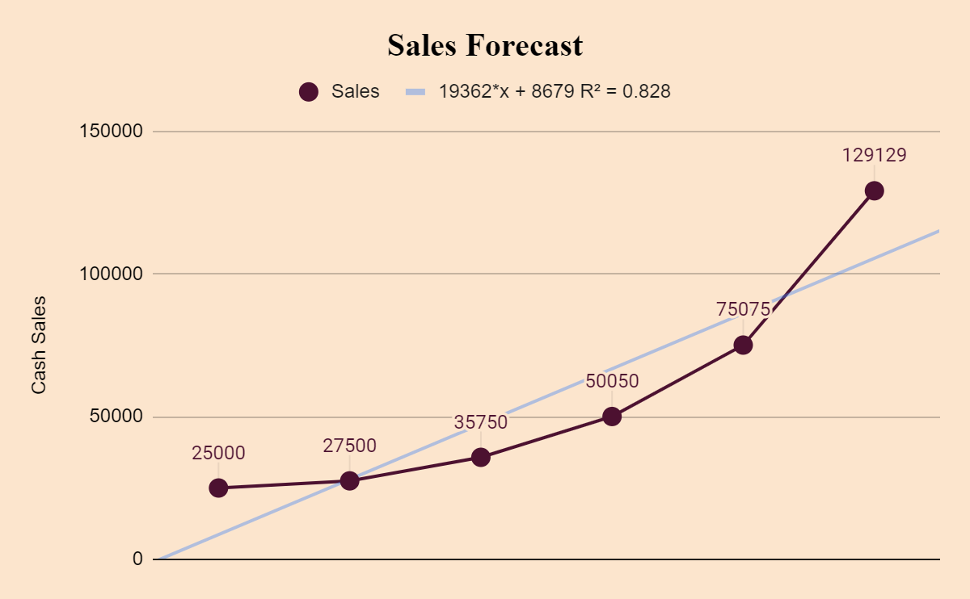
Diagram : Sales Forcast
(Source: Own-estimated, 2024)
From the anticipated 6 months budget of Gourmet Food Truck, it is evaluated that the upcoming financial operations of the business will be satisfactory. Especially as per the sales estimation it is revealed that during the first six months, the sales of the business will increase gradually in the first six years which is reflected by the updated trendline in the above diagram. With the assistance of increasing sales can ensure the financing sustainability of Gourmet Food Truck.

Conclusion
The report has described a business plan in detail where the report has explained the products or services offered by the upcoming business Gourmet Food Truck. There is a good opportunity for expansion in the UK market as the number of businesses with this concept is very few. The report has analysed the food industry in detail where different types of factors have been found. In the marketing plan, this report has constructed a full marketing mix of 4ps along with STP as well as USP. This report also includes a financial plan from funding the business to sales forecasting.

References
Basal, B., (2019). Historical Transformation of Unique Selling Proposition (USP) in Advertising Narration. In Handbook of Research on Narrative Advertising (pp. 141-150). IGI Global. https://www.academia.edu/download/75865556/viewtitlesample.pdf

Brex, (2024) A guide to friends & family funding for startups, Brex. Available at: https://www.brex.com/journal/family-and-friends-funding (Accessed: 25 August 2024).
Corporate Finance Institute, (2024) Loan, Corporate Finance Institute. Available at: https://corporatefinanceinstitute.com/resources/commercial-lending/loan/ (Accessed: 25 August 2024).

Dixon, S.J. (2024) Social Media penetration UK 2024, Statista. Available at: https://www.statista.com/statistics/507405/uk-active-social-media-and-mobile-social-media-users/#:~:text=The%20United%20Kingdom%20(UK)%20was,the%20population%20of%20the%20UK. (Accessed: 25 August 2024).

Dublino, J. (2023) What is dynamic pricing?, business.com. Available at: https://www.business.com/articles/what-is-dynamic-pricing-and-how-does-it-affect-ecommerce/ (Accessed: 25 August 2024).

Edelman, L.F., Manolova, T.S. and Brush, C.G., (2017). Angel investing: A literature review. Foundations and Trends® in Entrepreneurship, 13(4-5), pp.265-439. https://www.nowpublishers.com/article/Details/ENT-051
FDF (2023) Food and drink industry - facts and stats, The Food & Drink Federation. Available at: https://www.fdf.org.uk/fdf/business-insights-and-economics/facts-and-stats/ (Accessed: 25 August 2024).

GOV.UK (2024) Food and drink, Food and drink - great.gov.uk international. Available at: https://www.great.gov.uk/international/content/investment/sectors/food-and-drink/#:~:text=Combining%20high%2Dquality%20produce%20with,automotive%20and%20aerospace%20industries%20combined. (Accessed: 25 August 2024).
Ing, P., Osman, Z. and Tze-Yin, L., (2020). Marketing mix and STP strategies: An exploratory study into grocery retailers in Malaysia. Asian Journal of Entrepreneurship, 1(4), pp.129-143. https://myjms.mohe.gov.my/index.php/aje/article/download/11665/5622
Kim, S. and Ji, Y., (2018). Gap analysis. The international encyclopedia of strategic communication, 8, pp.1-6. Link https://www.com.cuhk.edu.hk/images/content_people/publication/sora-ch-2019-gap.pdf
Lerner, J. and Leamon, A., (2023). Venture capital, private equity, and the financing of entrepreneurship. John Wiley & Sons.

Statista (2024) Food - United Kingdom: Statista market forecast, Statista. Available at: https://www.statista.com/outlook/cmo/food/united-kingdom#revenue (Accessed: 25 August 2024).

Stevenson, R., Kier, A.S. and Taylor, S.G., (2021). Do policy makers take grants for granted? The efficacy of public sponsorship for innovative entrepreneurship. Strategic Entrepreneurship Journal, 15(2), pp.231-253. https://onlinelibrary.wiley.com/doi/abs/10.1002/sej.1376
Thabit, T. and Raewf, M., (2018). The evaluation of marketing mix elements: A case study. International Journal of Social Sciences & Educational Studies, 4(4). https://www.researchgate.net/profile/Thabit-Thabit/publication/324923406_The_Evaluation_of_Marketing_Mix_Elements_A_Case_Study/links/5aeb827a458515f59981df6e/The-Evaluation-of-Marketing-Mix-Elements-A-Case-Study.pdf

