James Hunt (2215832)
2115832@student.uwtsd.ac.uk

ACDA4013
Abstract
This report provides an analysis of an embedded C code developed for the PIC18F45K50 microcontroller using the PIC_CCS compiler. The code incorporates functionalities such as motor control, LED manipulation, ADC interfacing, and button control.
The report outlines the code structure for each task including headers, global definitions, variables, and functions. Task one covering motor control contains execution details based on both ADC input and using a button press. Task two describes a ‘Knight Rider’ pattern LED effect, whilst task three details real-time ADC value display on both LCD and a terminal.
Additionally, within this report, code modifications and potential future improvements are discussed including optimisation and enhancements. Overall, the code demonstrates effective implementation of embedded systems functionalities and presents opportunities for further refinement and enhancement.
Contents
Table of Figures 1
Introduction 2
Background Research 2
Overview of Code Structure 2
Header Inclusions 2
Global Definitions 2
Global Functions and Variables 2
Main Function 2
Functions 3
CLR 3
MOTORADC 3
KITT 3
ADC_LCD 3
MOTORBTN 3
analog 3
print2lcd 3
read_switch 3
Task Execution 3
Screenshots of Simulation 4
Details of Testing/Development 6
Future work and Conclusion 6
Future Changes 6
Conclusion 6
References? 7
Appendix 7

Table of Figures
Figure 1- Displaying ADC value via LED array and number on LCD/Terminal 2
Figure 2 - Motor control dependant on value of the ADC 2
Figure 3 - Sequential LED array control 3
Figure 4 - Motor control via push to make button 3

Introduction

This report provides an overview of the embedded C code developed for the PIC18F45K50 microcontroller and compiled using the PIC_CCS compiler. The code’ was developed to fulfil the requirements of the ACDA4013 assignment brief and includes functionalities such as motor control, LED manipulation, ADC interfacing, and switch/button input recognition.

Background Research

Most of the code has been developed from examples presented from within Dr Gary Jones Embedded C lectures.
Further code references, such as the ‘do while’ loop have been researched from a variety of sources, including W3 schools and PIC-CCS own help functions.

Overview of Code Structure

The code is organized into several sections:

Header Inclusions
The code begins with necessary header file inclusions such as main.h and lcd.c, which provide essential functions and definitions for the program such as the RS232 control and which pins are required for this.

Global Definitions
Important pin definitions for interfacing with the LCD are inserted here. Additionally, other pins are assigned definitions either here or within the main.h to allow both for ease of programming and porting to other PIC microcontrollers if required.

Global Functions and Variables
Function routines are declared and comments are added to explain their functions, this is considered good practice as it assists with human readability and placing them at the start allows the compiler to catch any misassigned functions quickly.
Within this section several global variables are declared to store important values and states throughout the program execution. These include variables for storing ADC values, switch positions, and LED patterns.
Main Function
The main function serves as the entry point of the program. It initialises peripherals and enters a continuous loop to monitor the switch inputs and execute corresponding tasks.

Functions
The program includes several functions to handle specific tasks:
CLR Resets outputs and variables, this run between switch inputs to avoid any errors.
MOTORADC Controls motor direction based on ADC input.
KITT Implements a ‘Knight Rider’ pattern LED sequential scrolling effect.
ADC_LCD Outputs ADC value to LCD and terminal.
MOTORBTN Controls motor based on push to make button input.
analog Reads ADC value, and outputs the value to be used by other functions with the main programme.
print2lcd Controls LCD outputs. This is a switch case statement that helps tidy the functions to keep them compact and readable.
read_switch Reads switch position. This is another switch case statement that calls the required function depending on the position of the 4-way switch.

Task Execution

Motor Control: The MOTORADC and MOTORBTN functions are responsible for controlling the motor direction based on ADC input and button press, respectively. Depending on the ADC value or button state, appropriate signals are sent to the motor driver to control the motor's direction of rotation.

LED Manipulation: The KITT function creates a Knight Rider LED effect by sequentially lighting up LEDs in a pattern reminiscent of the Knight Rider TV theme tune. This function iterates through an array of LED patterns and updates the LED outputs accordingly.

ADC Interface: The ADC_LCD function reads ADC values using the analog function and displays them on the LCD screen and terminal. This allows users to monitor analogue input values in real-time.

Button Control: Motor operation can also be controlled using button inputs. The MOTORBTN function monitors the state of a button input and adjusts motor operation accordingly. Pressing the button initiates motor movement, while releasing it stops the motor.

Screenshots of Simulation

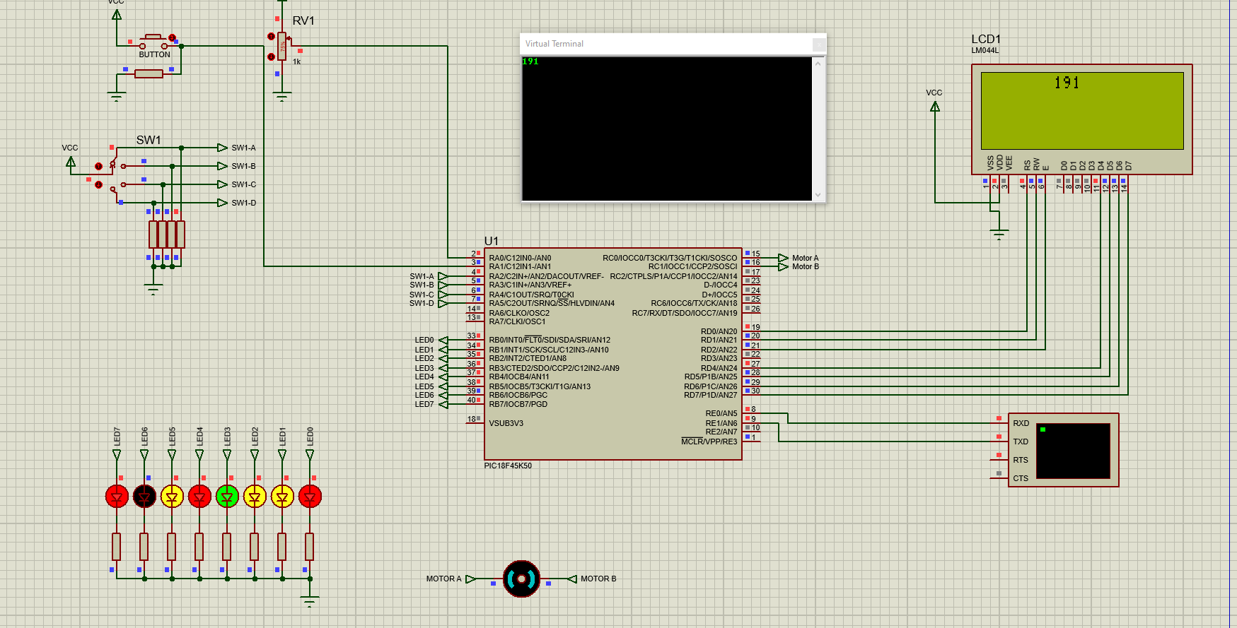
Figure 1- Displaying ADC value via LED array and number on LCD/Terminal

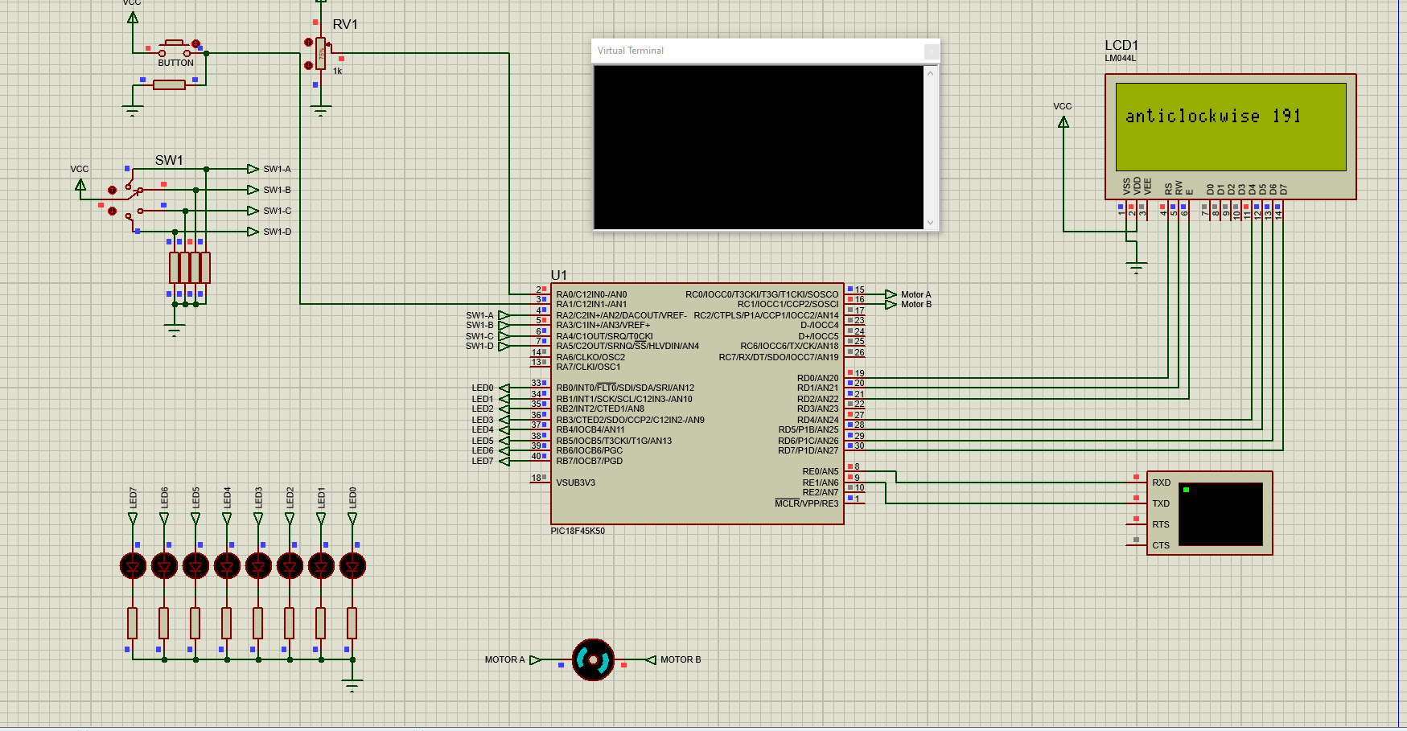
Figure 2 - Motor control dependant on value of the ADC
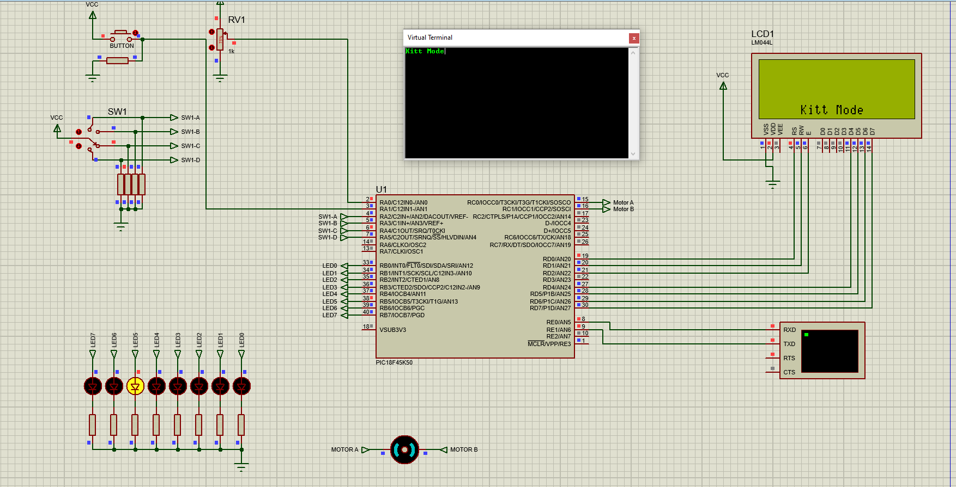
Figure 3 - Sequential LED array control
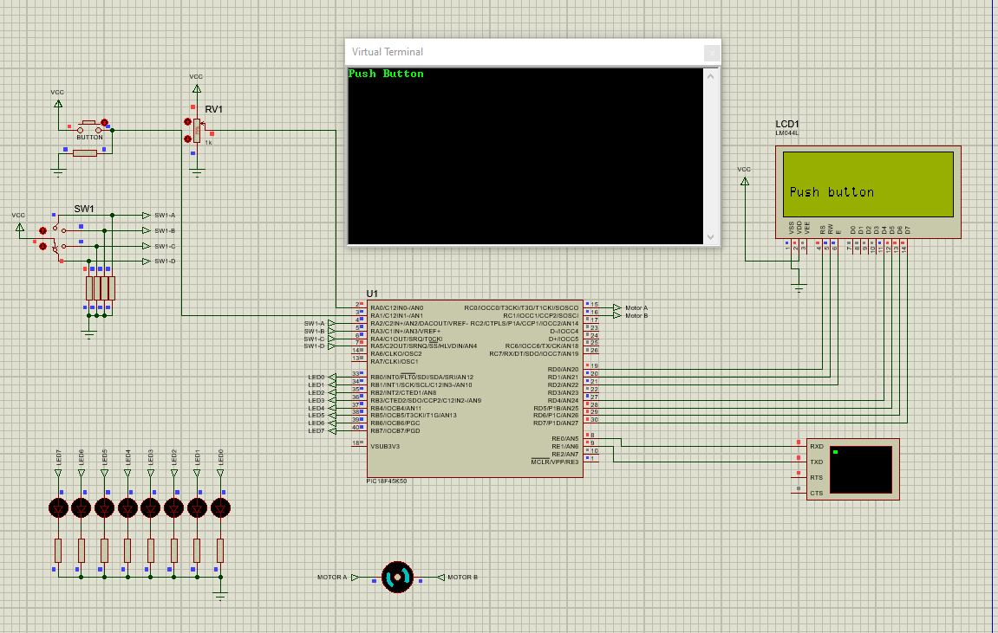
Figure 4 - Motor control via push to make button

Details of Testing/Development

The following points are taken directly from the change log and now expanded on:
- Added details and developers notes at start of code, to allow for easy tracking of any issues, ideas and how to overcome or implement them.
- Wrote functions to match assignment brief.
- Modified main.h so Rs232 pinout matched circuit.
- Looked into why MOTORADC LCD display isn't displaying on line 2 correctly on clockwise and anticlockwise - /f after lcdgoto resets back to default start corrected by moving above.
- Looked at why adc value isn't displayed immediately when switching between different tasks - needed to reset adc0 and old_adc0 between reuse in different function.
- Added Button ‘NOT’ pushed to MOTORBTN - got caught in the loop but now fixed.
- Investigated what is causing the illegal opcode when KITT mode is 1st ran - left interrupt enabling code in which caused issues on RB0 as external interrupt.

Future work and Conclusion

Future Changes
Code Optimisation - Further changes to code structure would help to improve efficiency and readability.
Continued Modularisation - Look to see if the code could be made into smaller, reusable functions for better maintainability and flexibility.
Error Handling - Investigate how to implement error-handling mechanisms for unexpected scenarios and improve system stability.

Conclusion

This embedded C code designed for the PIC18F45K50 microcontroller demonstrates effective implementation of various functionalities crucial for embedded systems development. By exploring the code structure, it shows a comprehensive understanding of its organisation and functionality.

The code displays a range of capabilities possible on a microcontroller including; motor control based on ADC input or button press, ‘Knight Rider’ pattern LED effect generation, real-time ADC value display on both LCD and terminal interfaces. These functionalities serve as foundational elements for building diverse embedded systems with enhanced control and feedback mechanisms.

Furthermore, the discussion on code modifications and potential future improvements shows how even with a fairly simple design brief how flexible both the language and microcontroller are.

Overall, the assignment brief encourages best practices in embedded systems development by creating a robust framework paving the way for building further more sophisticated applications. This research shows that by continuing to embrace the principles of readability, modularity, and adaptability it develops a sure footing to future skills not only in this programming language but across a range widely used across industry.

