PROJECT MANAGEMENT REPORT
This report has been written as an assignment to Project Management course at T.S.D. University, London Campus

Biancamaria Di Napoli

Japher Motors Integrated System
realized by



--TABLE OF CONTENT--

Introduction---------------------------------------------pg. 3
Project Object and Scope----------------------------pg. 4
Work Breakdown Structure-------------------------pg. 5
Gantt Chart--------------------------------------------pg. 6
Critical Path Method--------------------------------pg. 8
Prototype----------------------------------------------pg. 10
Data Migration and Training---------------------pg. 13
Risk Management and Quality Assurance----pg. 14
Reference--------------------------------------------pg. 16

INTRODUCTION

This report is intended to illustrate how “Japher Motor Integrated System” has been developed in a team. It will show all the steps in details of our project as ‘beginners’ and all the effort and commitment to make it as much possible close to a real scenario. As a part of this project, a lot of researches has been made with the scope to have a better understanding of our topic. The most challenging part has been to act as a professional team giving our own personal contribution to reach our final target: realise a prototype that could meet our customer expectation.
Having clear in our mind the goal to reach, we start our path trying to understand Mr Japher requirement.
Mr Japhet is the owner of Japher Motors a small business in German car repairing service from twenty years in the market. So, their main business activities are repairing, services and spare part sales. There is no computer system inside the company and all the booking services, invoices, are made manually, recording information with a pen inside a book. Mr Japhet contacted us requesting a Software System that could help his company to enter in the ‘future’, in a digitalised reality where with few clicks data can be exacted to monitor the company business profit. A kind of reality that through the internet could open the door of his garage to all the world increasing the profit and build a reputation around his name.

PROJECT OBJECT AND SCOPE

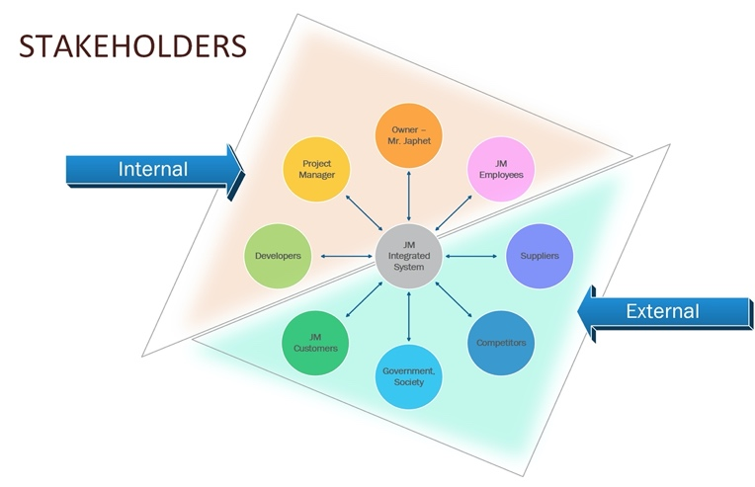
As a project management team, we had a clear idea of what to do, but we did not know how to start to plan our project. The Step Wise approach gave us strong guidance on how to direct our first steps and drive us to identify the project objectives. It was clear that we had to design a simple Web Site to enhance the business activity of Japher Motors, as booking services online and an easy software system easy to work with because Japher Motors team are not used to technology and informatics system. According to our objectives, our scope has been to create a reliable product, able to be trusted, and above all affordable to be within the budget. From the beginning all the stakeholders have been involved about the objectives and purpose of the project.
In this process Internal and External stakeholder have been identified.
The Internal are the Project build team:
- Developers;
- Project Manager;
- Japher Motors’ employees;
- Mr Japhet;
The External are end user and authorities:
- Japher Motors’ customers;
Figure 1. Stakeholders (author: Nikolova,2019)
- Government (legislation and standards);
- Suppliers (Hardware trade companies and Software suppliers and Mr. Japhet’s suppliers);
- Competitor companies;
We had to establish a communication plan between the internal stakeholders, to be aligned about the project progress and be ready to make modifications through the feedback received. So, we also had to set an infrastructure inside our team identifying a Project Manager who could coordinate and manage all the project activities including Internal communication.

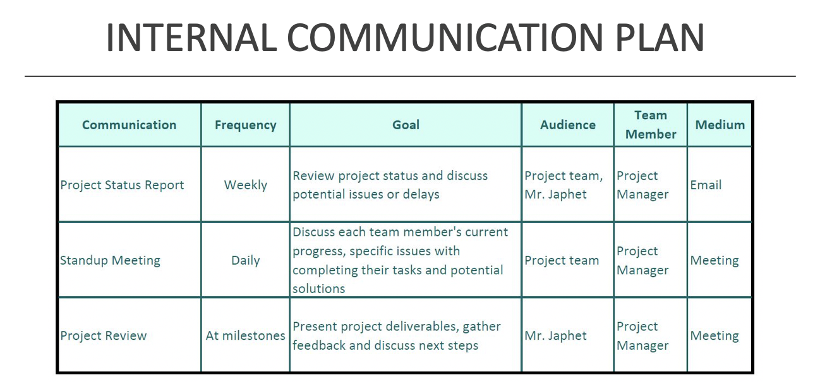
Figure 2. Internal Communication Plan (author: Nikolova,2019)

WORK BREAKDOWN STRUCTURE

Following the defined objectives, what should be done concretely? Creating a Work Breakdown Structure (WBS)was one of the first steps to take in planning our project. The WBS is a tool for the analytical decomposition of a project, it shows all its parts at different levels of detail. The hierarchical representation defines increasingly small subsystems, up to the identification of work packages. At this level is possible to plan, budget and finally control them. Based on Japher Motors Integrated System, we had to break the main tasks in more manageable pieces, as a result, our WBS has nine main tasks:
- Scope;
- Analysis;
- Design;
- Development;
- Testing;
- Data Migration;
- Documentation;
- Deployment;
- Training.
From the main tasks we identify smaller subtasks that can be easily assigned individually. In our WBS we also identify the three main development area:
- The yellow part represents the initial stage that defines our project;
- The part in pink is the development and testing part where the web site and the software system prototype are created;
- The green part represents all the phases that take place after the prototype creation, such as data migration and training.
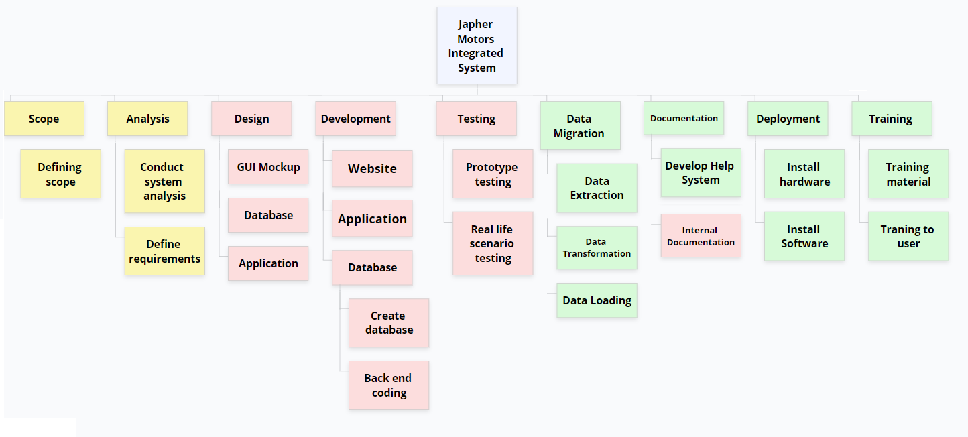
Figure 3. Work Breakdown Structure(author: Ventimiglia,2019)

GANTT CHART

After the design of WBS, the next logical step has been estimated the effort in term of time for each task and the Three-point estimation method has been very helpful. So, we had to define an optimistic(To), pessimistic(Tp) and a most probable (Tm) time for each task, to calculate the estimated time (Te) according to the following formula:
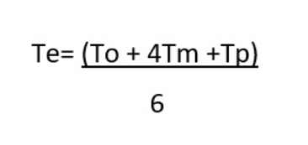
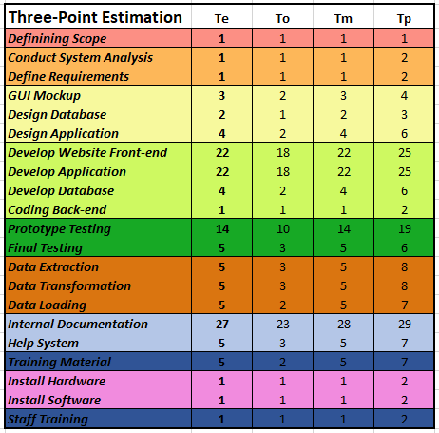
Figure 4. Three-Point Estimation (author: Ventimiglia,2019)
We expressed in working days the unit of measurement of the estimated time. The more accurate this estimate is, the more reliable the Gantt chart that will be. The Gannt chart is a very effective tool in project management and is used to give a graphic visualization of the timing and progress of the project. So, by graphing the tasks defined by WBS and the time estimate calculated, the Japher Motor Integrated System Gannt chart is the following:

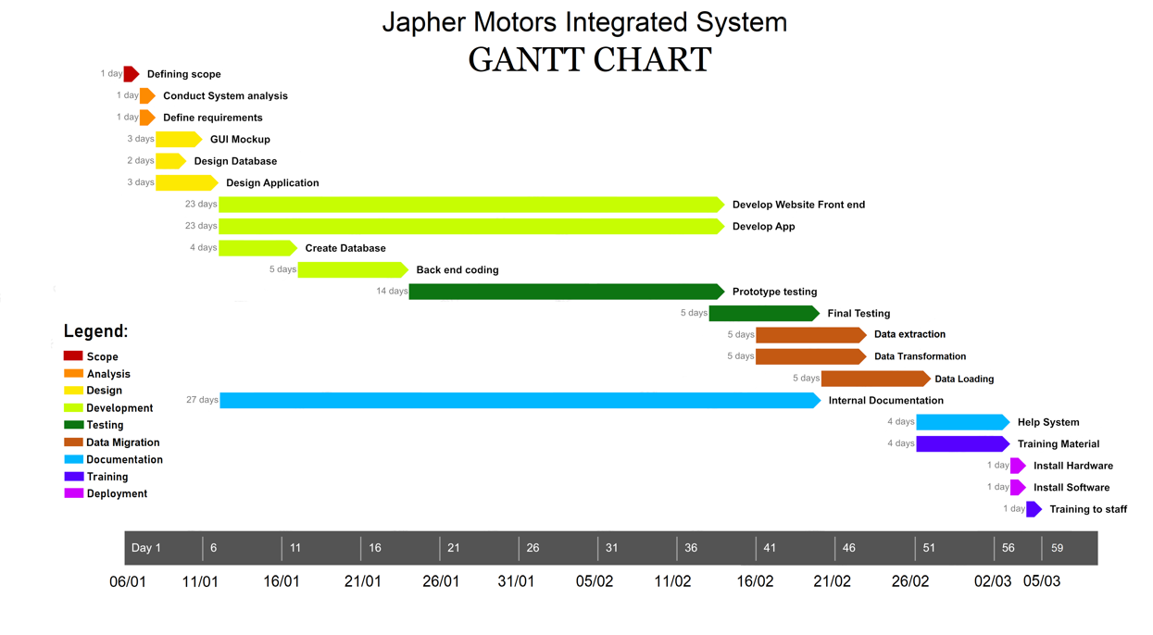
Figure 5. Japher Motors Integrated System Gantt Chart
(author:Ventimiglia,2019)
From the Gantt chart, we can have a few important outputs, as the starting date, the final date and above all the total amount of day to deliver the project to Mr Japhet. Based on this information, the Project Manager, according with the internal communication plan, will periodically take stock of the situation comparing the planned activities and eventually identifying in collaboration with the resources the possible corrective actions and the need for rescheduling.

CRITICAL PATH METHOD

After defining the Gantt chart, another tool at our disposal was the Critical Path Method. In this process all the tasks, previously defined by the WBS, are correlated by a dependence relationship, so each task, except for the first one, has a predecessor and a successor and the set of dependency relationships will constitute the logical grid.

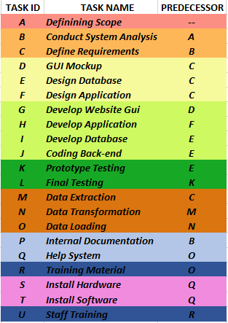
Figure 6. Dependency Table (author:Ventimiglia,2019)
At this point, some paths will be highlighted within the grid that leads from the beginning to the end of the project. The longest one is the critical path and basically, it determines the total duration of the project. The critical stretch clearly defines the activities that will have to be managed more carefully. If one of the activities on the critical path takes longer than the estimated duration or starts later than expected, or ends later than expected, it will impact the entire project.

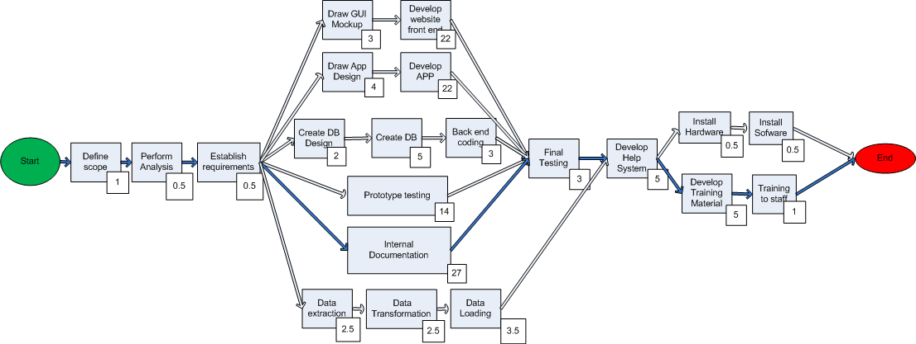
Figure 7.Critical Path Method(Ventimiglia,2019)
From our Diagram, the way highlighted by the blue arrows is the Critical path, that gives us an indication to prioritize these tasks over the non-critical one. So basically, helped us to focus our efforts on the main thing optimizing our project.

PROTOTYPE

In all the different phases of analysis and planning, we used the Rapid Prototyping Methodology, that can be explained basically by a series of processes that leads to the rapid realization of a prototype. The Web Site and the Software System Prototype has been made simultaneously by two different teams.

The Web Site has been built customer-oriented with very easy functionalities. From the Home Page, we try to capture the user attention on the online booking service, to satisfy Japher Motors requirement to expand and implement his business.

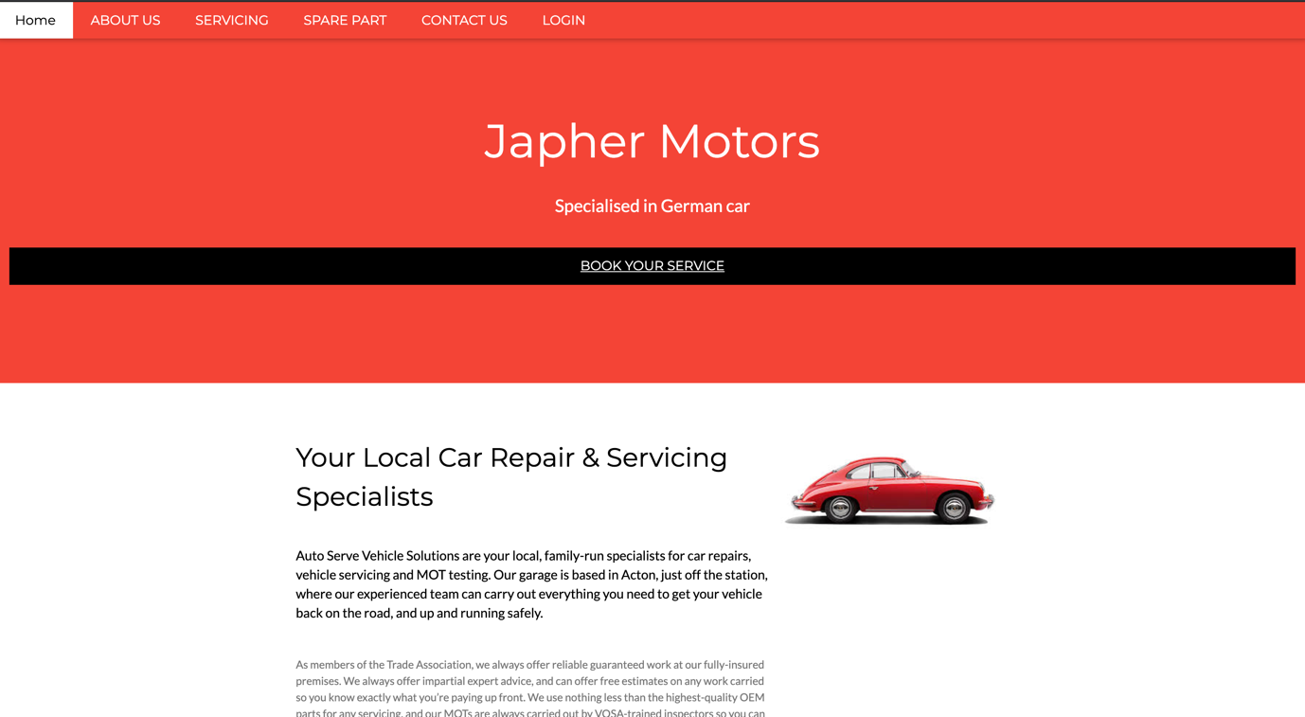
Figure 8. Japher Motors Home Page (source: author)
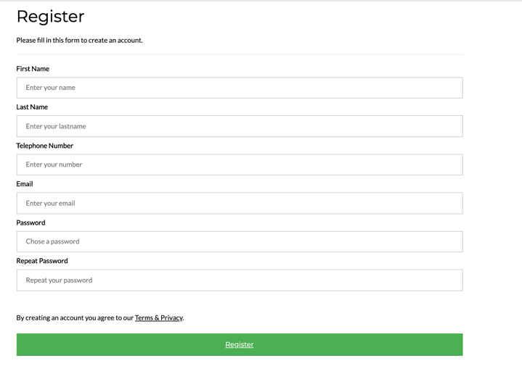
Clicking on ‘Book your Service’ a registration form guide the customer to set up a password, that will give him access to a personal area where he can easily check all his services or repairing and update his personal data. Once the customer is registered in the system he can have access to the booking service page, where he can choose between different kind of services and he can select the date he prefers to do it. The calendar system is managed from the software system where the Japher Motors employee keeps constantly update their agenda to show available slot to the customer who wants to book online.
Figure 9. Japher Motors Registration Form (source: author)

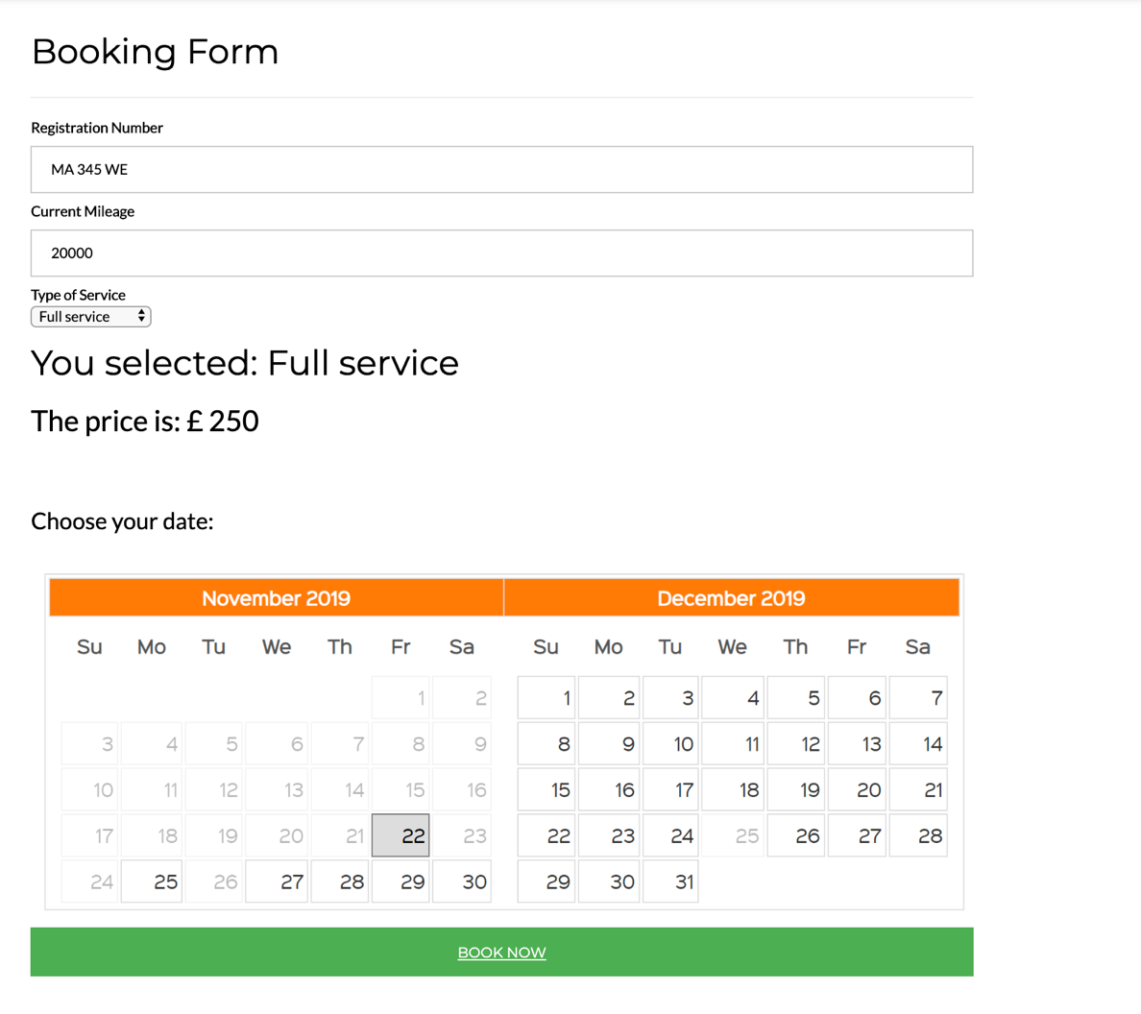
Figure 10. Japher Motors online booking area (source: author)

All the customers’ data are stored in a connected database, according to Mr Japhet request to have a historical file about all the customers and business activities. The Web Site could also be implemented in the section Spare Part, where at the moment there is only a list of car components available to buy in loco, but it may include selling directly online.

The Software System has been designed to be very easy to use and therefore intuitive. Indeed, it is a Desktop Application where the first step is to login inside the system, so each user has his own username and password set up.

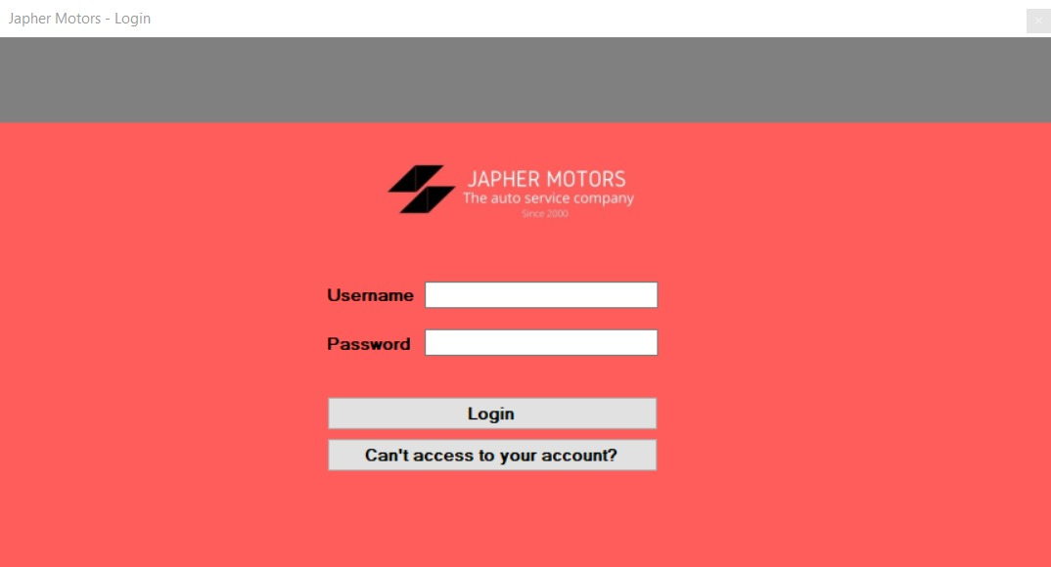
Figure 11. Japher Motors Software System Login (Chiarello,2019)
After the login section, the user will have access to the main screen where he can decide to perform different operations, as shown from the buttons, as make a Booking, make Payments, have access to the customer database, check or insert the Inventory or produce business reports. The desktop application can also be implemented adding a function of automatic reordering of the items, calculation based on comparing the data of the pieces sold or replaced during servicing and warehouse stock.

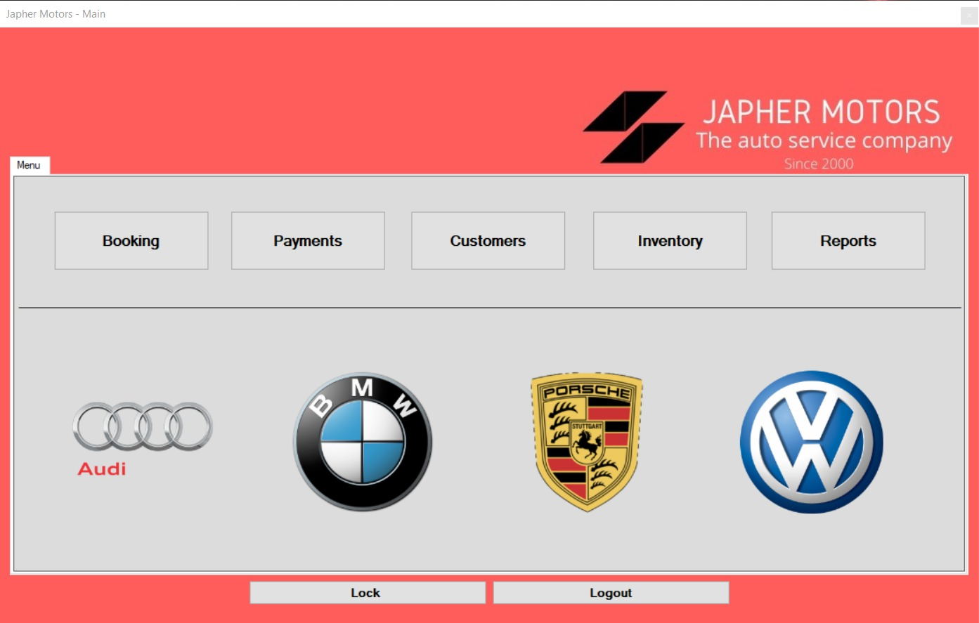
Figure 12. Japher Motors Software System Main Screen (Chiarello,2019)

DATA MIGRATION AND TRAINING

Before to deploy the project, we had to face it the data migration of all the data in Japher Motor System available in register written manually. So, the first step has been collecting all the data, including the complete catalogue of the spare parts, and then transform this information in digital records, to upload in the database.
In this final part of the process, we had to proceed to install in Japher Motors Office the hardware and the software components. The day after the installation, training has been planned with the owner, Mr Japhet, and the employees that will use the Desktop Application. The training has been organised in one day and divided in two part, the first part more theoretical showing through PowerPoint Presentation the main aspect of the two prototypes, and the second part, practical, with a real-life scenario to ensure a smooth transition to the new system. Also, the desktop application has been provided with a link to have access to a help file containing the user manual as additional support.
We also offered an additional service for the next three months after the deployment, in which Mr Japhet can require to modify aspects of the Integrated System.

RISK MANAGEMENT AND QUALITY ASSURANCE

The term Risk management refers to a set of processes through we can identify, analyse, quantify, eliminate and monitor the risks associated with our project. The main objective of Risk Management is to minimize losses and maximize the effectiveness and efficiency of production processes. As a first step for the risk management process, there is the risk assessment where we need to answer to questions like:
What is the probability that risk occurs?
What will be the impact of this risk on the company's business?
We identify as risk an event which, when it occurs, causes problems and we can be categorize in:
- Actor, related to all the Management Team;
- Technology, refers to the methodology and tool;
- Structure, report to the management structure;
- Task
As part of our project, some of the risks related to the implementation of the Integrated System have been addressed in the following table of Risk Analysis:

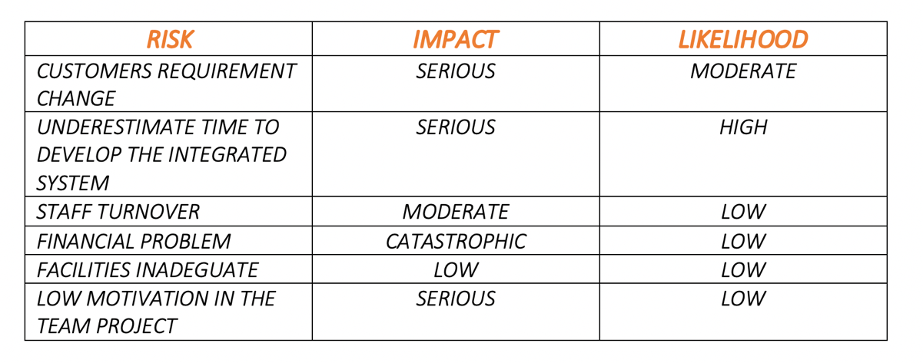
Figure 13. Risk Analysis (source: author)

When the risk has been identified, the following step is to find a good strategy to help the management and minimize the risk impact:

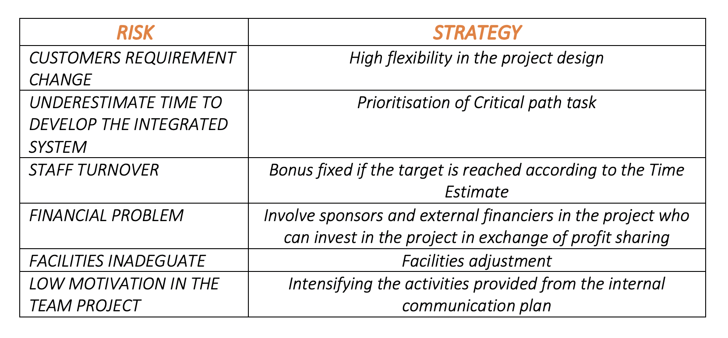
Figure 14. Strategy to Help to Manage the Risk (source: author)

Quality Assurance, such as Risk Management, is evaluated in the early stage of Project Analysis. Quality assurance, indeed, requires operating in a preventive way, setting up reliable production processes. The Project Manager needs to be familiar with both, the internal and customer standards, in order to incorporate them within the project and declare them in the Quality Plan together with all the systematic and sample interventions that it is intended to implement to manage quality. So basically, the project quality corresponds with the customer quality expectation, for this reason, we kept in place weekly meeting with the internal stakeholder, fixing as our main target meet the customer requirement.

REFERENCE

Clarizen, 2019, What Are the Objectives of Project Management? Available at: https://www.clarizen.com/objectives-of-project-management/ (Accessed 27/12/19)

Axelos, 2019, What is PRINCE2, Available at:https://www.axelos.com/best-practice-solutions/prince2/what-is-prince2 (Accessed 27/12/19)

Project Manager, 2019, Project Management, Available at: https://www.projectmanager.com/project-management (Accessed 27/12/19)
2019

Nikolova R., Ventimiglia G., Chiarello M., Di Napoli B. (2019),Japher Motors Integrated System Presentation

20/20, 2019, Work Breakdown structure, Available at: https://2020projectmanagement.com/resources/cost-management/the-work-breakdown-structure-wbs (Accessed 31/12/19)

Project Management.com,2019, 3-point estimating, Available at:
https://www.projectmanagement.com/wikis/368763/3-Points-Estimating (Accessed 27/12/19)

Project Management Skills, 2019, What is quality assurance? Available at:
https://www.project-management-skills.com/what-is-quality-assurance.html (Accessed 28/12/19)

Kukhnavets, P. (2018), What is Critical Path Method For in Project Management?, Available at:https://hygger.io/blog/what-is-critical-path-method-for-in-project-management/ (Accessed 27/12/19)

Project Manager,2019, The Risk Management Process in Project Management, Available at: https://www.projectmanager.com/blog/risk-management-process-steps (Accessed 31/12/19)

