+

Graduate Diploma Professional Police Practice

LEVEL 6 - 40 Credits

Workbook title: Competency Based Workbook 2 (DHEP)

(SOUTH WALES POLICE, GWENT POLICE AND UWTSD)

Learner name: MARTELLE WILSON

Learner’s University Registration Number:
2131956

FACULTY OF BUSINESS AND MANAGEMENT
PUBLIC SERVICE PROGRAMME

Module title: Policing in the Workplace 3 (DHEP) - BMPP6001D

Workbook Guidance

Please read these notes carefully. They provide essential information. The documents you will use in developing your workbook are on the following pages.

What is the workbook for?

The purpose of this workbook is to enable learners to demonstrate and provide evidence of how they meet the learning outcomes set by the College of Policing, for the Graduate Diploma in Professional Policing Practice. You are being asked to outline your experiential learning based upon your theoretical understanding in a range of operational situations.

- Wellbeing and Resilience
- Criminal Justice
- Conducting Investigations
- Decision making and discretion
- Maintaining Professional Standards
- Leadership and Team working
- Policing the roads
- Information and Intelligence

You may wish to use the same incidents as you have outlined in the Occupational Competence Portfolio.

How should the workbook be presented?

Blank electronic copies can be found on Moodle of this workbook. You must submit this document electronically therefore it is important that you save your work regularly and upload the final typed version through Turnitin on Moodle.

Word count policy can be found in chapter 7 of the Academic Quality under section 7.7 (this applies to presenting work above and under the specified word count).
(https://www.uwtsd.ac.uk/media/uwtsd-website/content-assets/documents/academic-office/aqh-chapters/chapters---en/Chapter_07_Assessment_Taught_Programmes_Pages_72-79-UPDATED-05-11-2019.pdf)

Reflective practice is a core aspect for your workbooks and although there is a variety of useful resources on Moodle, there is one particular book, that is specifically based on reflective practice in policing, here is a link to one chapter from Selina Copley’s Reflective Practice for Policing Students:
https://moodle.uwtsd.ac.uk/pluginfile.php/298870/mod_resource/content/1/Reflective%20Practice%20for%20Policing%20Students%20-%20Selina%20Copley%20Chapter5.pdf

How is the workbook assessed?

Advice and support about the completion of this workbook is available to you. Please contact Kelly Andrews direct using k.andrews@uwtsd.ac.uk with any questions or queries you may have.

Dates of workbook submission can be located within the General information tile within Moodle.

Once submitted your workbook will be assessed and marked independently. You will be provided with individual feedback once the work has been marked.

Confidentiality

It is important that no individual can be identified either directly or indirectly from the information in the workbook. However, you must:

- adhere to guidance in the Candidate Handbook about confidentiality.
- not identify individuals including witnesses, victims, or offenders by name.
- not write information that enables any individual to be identified indirectly through the description you provide. This includes references to names, colleagues, places (including hospitals, schools, town, villages, streets) specific incidents which were high profile and could be identified due to past publicity, other professionals or any other personal information including medical or other conditions.
- take personal responsibility for adhering to confidentiality rules.
- not include any dates of any incidents or anything that specifically identifies an actual incident.

Please be aware that any content that is deemed to be inappropriate, disrespectful, or abusive will not be tolerated. Following review of any content of this nature the information will be shared with the employer of the student responsible.

Should any health and wellbeing concerns be raised because of disclosures made by the student within this workbook, the employer of the student will be informed.

NOTE

Your workbook will be submitted electronically via Turnitin on Moodle. Guidance on this is in the Candidate Handbook.

Remember that the workbook is YOUR responsibility you must not rely on the assessor or anyone else to pick up any confidentiality breaches as this is your work and you must accept full responsibility for confidentiality. Meeting all the confidentiality requirements is particularly important.

Dyslexia and other special circumstances

If you have any condition that you feel may affect your ability to deal with any part of the programme, please see the Candidate Handbook for further guidance. The University has a Student Services Unit that may be able to help but it is the learner’s individual responsibility to contact them.

Competency Based Workbook 2 - Learner Workbook

Guidance:

- Your workbook must contain items 1 - 5 below (in the order given).
- You should use the pro-forma to insert your text within each section.
- Note that this module has 2 components with each weighted at 50% of the overall 100% marks total.
- You should upload your completed document as a saved pdf file of this workbook; if this is not possible then a Word Doc file is acceptable. Do not send a scanned file from a photocopier, an apple.dot file, or a Microsoft publisher file as Turnitin will not be able to assess them, despite you being able to upload them.

Contents

Component 1  50% | Area of Professional Practice | Word count
Task 1 | Vulnerability and Risk  Evidence-based policing | 2000
Task 2 | CHOOSE ONLY 1 OF THESE 'ADVANCED LEARNING AREA’ OPTIONS. IT SHOULD BE ONE THAT HAS BEEN AGREED WITH THE FORCE TO STUDY IN YEAR 2. | All options are 2000 words
Task 2  Option 1  Option 2  Option 3  Option 4  Option 5 | Response Policing  Policing Communities  Road Policing  Information and Intelligence  Conducting Investigations | 2000
 | Bibliography

Task 1

Relevant areas of the National Policing Curriculum:
Vulnerability and Risk, Evidence-based policing

You must choose a policing incident in which you played a significant role with a victim of crime or anti-social behaviour and reflect on what happened.

Give a brief description of the incident including social and legislative contexts and any relevant cultural, ethnicity and language issues.

Critically evaluate the appropriateness of different approaches (by professionals and the police) in supporting or managing vulnerable people or people at risk of harm.

Explore what works in relation to tackling repeat victimisation and repeat offending. Consider the use of evidence-based policing.

2000 words (+/- 10%: include your actual word count at the end of each section)

ANSWER:

During essay I will discuss and evaluate a policing incident where I have played a significant role with a vulnerable victim of crime. I will reflect upon the actions taken, critically analysing this and referencing several literary sources.
The below incident highlights the prevailing issues present within gang and drug culture in British society. Its impact has a widespread effect on the local community and leads to an increase in violence and subsequently demand for emergency services.
Boulton-Laura et el, (2019) discuss one form of organised crime known as ”County Lines”. They then deliberate the exploitation of children and vulnerable people as a means to distribute drugs and money, stating “the individual is exploited through manipulation techniques, enticement-based methods of compliance, and violence or threats of violence”. (Boulton-Laura et el., 2019). Moyle (2019) adds some supporting evidence to the exploitation of the vulnerable through National Crime Association statistics, “12% of police regions reported exploitation of adults with physical disabilities; 37%, the exploitation of adults with mental health problems; and 61%, the exploitation of drug users “
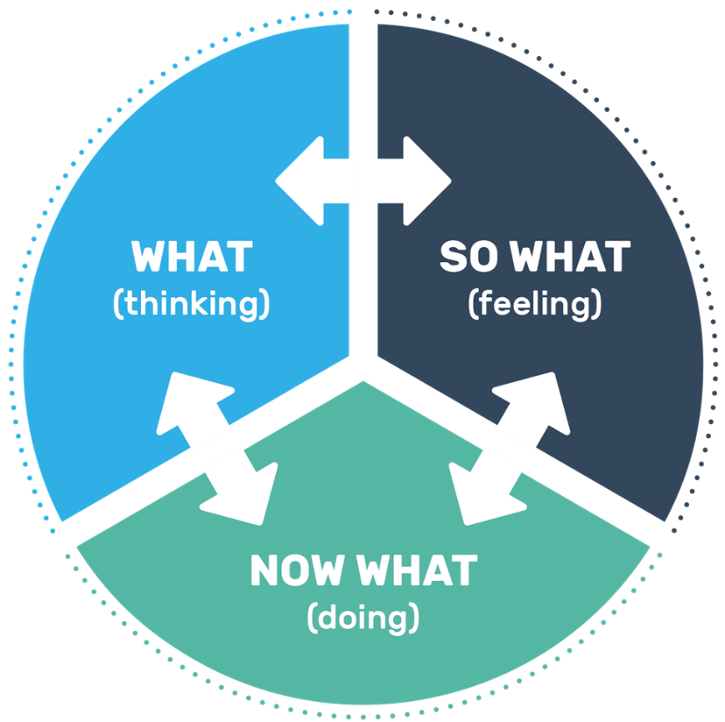
County lines is becoming an ever-growing issue in British Culture. Gangs operate through the use of disposable mobiles and a hierarchal system, recruiting members as young as 10 and below to act as drug runner. These gangs look to recruit vulnerable adults to manipulate or control through money or gifts or threats of extreme violence as a means of compliance. Moyle, (2019) evidences the threat of violence directly from the account of a victim of County lines exploitation who states “we were too scared to say anything. My partner started drinking heavily and the dealer was, like, “can you go and take this out to so and so,” but he was drunk, he used to beat him, so the beatings became daily”.
In order to prevent this it is important to understand risk factors increasing the likelihood of somebody being recruited into these gangs. Boulton-Laura et el (2019) States “risk factors included living in a neighbourhood with known SOC activity, exposure to violence in the home, involvement in the criminal justice system, being excluded from school or not being in mainstream education and a history of substance abuse.” The opposite also holds true as a preventative factor. Boulton-Laura et el (2019) discuss the research behind preventative measure, stating that “prosocial involvement, strong social support, strong attachments, positive attitude towards authority, and strong commitment to school or work” can all act as proactive and preventative factors.
Police must look to work with families, schools, social services, drug and alcohol support agencies, and other relevant external agencies. By taking a preventative approach alongside any proportionate convictions there is a likelihood that a multi-agency approach will be more effective than single agency intervention. Moyle (2019) discusses the effectiveness of one of these supporting agencies stating one user “explained that gaining access to methadone maintenance treatment enabled him to give up an exhausting role as a runner”. This is a strategy employed by Gwent police, detainees in custody are given the option to speak to a drug, alcohol or mental health service. The hope is that by implementing this we may see a reduction in crime due to drug dependency.
During this incident I attended an emergency following a report that a male had been assaulted. The level of initial response grading is discussed by Robinson and Tilley (2009) as follows. “There are two decisions being made… whether an officer should be dispatched to the scene…and what priority is given to attending the scene”. There was little information known at this time so during attendance I asked the call handler who was in contact with the reporting person to establish any name or description of involved offenders or direction of travel.
Blockley et el (2022) discuses the importance of Evidence-based policing, stressing the importance of “using research to support decision-making…to ensure that the decisions you make and the actions you take have solid grounds”. By requesting the control room make these initial attempts to establish a known offender, my intent was to generate further information and intelligence via system checks of any previous incidents involving the subject. Any prior knowledge such as Warning markers or flags revealed would assist me in calculating the risk to attending officers, the victim and members of the public. Upon arrival I located the victim who disclosed that he had been kidnapped and tortured by the subject over a dispute involving drugs. He also disclosed that he had severe anxiety which prevented him from working, due to this he fell into debt which became the means the subject used to exploit him. Due to the above disclosure, I deemed the victim to be vulnerable in line with Section 16 of the Youth Justice and Criminal Evidence Act 1999 (Legislation.gov.uk, 2023).
Legislation.gov.uk (2023) defines a person as vulnerable if they suffer “from mental disorder within the meaning of the Mental Health Act 1983.” With mental disorder from the legislative standpoint meaning “any disorder or disability of the mind” (Legislation.gov.uk, 2023).
During this stage of the investigation I used the SARA Model as discussed by the College of Policing (2021)
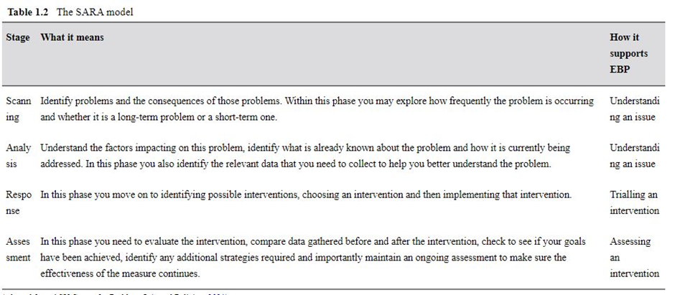
By Scanning the information disclosed by the victim I was able to assess the primary issue of violent altercation. In terms of analysis, this was the first disclosure made by the victim with no prior knowledge. The ‘Response’ provided was to immediately safeguard the victim by conveying him for treatment of his injuries whilst also requesting further units attempt to locate and arrest the subject. I notified the Criminal Investigation Department to review what was reported to be a serious crime of Grievous Bodily Harm with Intent contrary to section 18 of the “Offences against the Person Act 1861” (Legislation.gov.uk, 2020), and a common law offence of False Imprisonment as stated in the “Sentencing Act 2020”, (Legislation.gov.uk, 2020). With these actions taken and an ‘Assessment’ of my initial response I was satisfied that all the necessary urgent decisions and actions had been completed by police.
I assessed the victims’ injuries, they had significant burns to their hands and face, multiple puncture wounds to their forearms and arms and a swollen black eye. Their care became my primary priority and I liaised with the Force Control Room and a medical practitioner, assessing the risk of transporting the victim via police vehicle. I used the National Decision-Making Model, a term used by The College of Policing to breakdown fundamental steps in decision making to provide an easy-to-follow model that can be continuously reviewed and reused in an emergency response or when carrying out other police responsibilities. It is designed to be fluid and flexible allowing it to be applied to nearly any situation. “The national decision model (NDM) is suitable for all decisions and should be used by everyone in policing.” (The College of Policing, 2013)
The College of Policing (2013) describes the model with the following fundamental elements “Code of Ethics, Gather information and intelligence, Assess threat and risk and develop a working strategy, Consider powers and policy, Identify options and contingencies, Take action and review what happened.”
I had the information and intelligence that the victim had several serious wounds that were inflicted by the subject. The threat and risk present were that if he did not seek urgent medical treatment then these injuries could worsen. There was also potential risk that by conveying the victim ourselves, we could worsen his condition. These risks were all taken into consideration and ambulance were consulted in the first instance, stating it could take several hours before attendance. Given that the offender was still at large and the wait time it was decided that the risk of not conveying the victim ourselves was far outweighed by the risk of leaving him untreated. I considered the powers and policies available and sought authorisation from the Force Incident Manager to convey, I also consulted with a medical professional to ensure that the existing injuries were unlikely to be exasperated by moving of the victim. I placed the victim into my marked police vehicle and conveyed him to the nearest accident and emergency unit where I requested a private room with a password for visiting friends and family as a further safeguarding step.
When satisfied that the victim was no longer at risk of further harm from the subject or injuries, I turned my attention towards carrying out further investigative enquiries by relying on Evidence Base Policing. Sherman (1998) states “evidence-based policing uses research to guide practice and evaluate practitioners. It uses the best evidence to shape the best practice.” It Is certainly true that research plays a pivotal process in reviewing best practice, but I would make the argument that Blockley et el (2022) better describes evidence in a policing role “There are two ways that you will gather evidence. Pre-existing evidence is what is already known and is available. Second, there is evidence that you generate directly through your own research. Your evidence needs to be reliable and valid”.
A large part of this evidence would be in the form of Forensic Evidence.
Giles and Wullenweber (2021) describes the importance of Forensic Science from an evidential perspective and the importance of the role of attending officer in identifying it “They are responsible for assessing the scene and evaluating the need for the attendance of a Crime Scene Investigator.”
As attending officer I was responsible for establishing any relevant scope for CSI or forensics, I was able to ascertain that there was potential for forensics from the victim, the subject, and the location at which the incident occurred.
Rahama M (2020) discusses Edmund Locard’s popularised theory of ‘Exchange Principle’ as the following “a perpetrator of a criminal activity will typically acquire something from the crime scene and leave something that can subsequently be used in the construction of forensic evidence… It is widely agreed that there is a trace for every contact. There are two main pieces of evidence that are often left at a crime scene and are capable of providing trace evidence ― DNA and fingerprints.” From this principle I was able to determine that the victim would likely hold the subjects DNA on his clothing from the contact and vice versa. I was also able to determine items at the location of the incident would likely hold the subject’s fingerprints and prove that he had utilised these items causing injury to the victim. Due to the significant impact the incident had on the victim, and his already existing mental health diagnosis, the decision was made to complete a Public Protection notification report, a form of police report that can be shared with partner agencies, for sharing with adult social services so that the victim could receive support for his mental health. I was aware of further potential risk to the victim, both from the subject who knew where he lived and from his associates. Due to the extent of his injuries and the remaining risk the decision was made to relocate the victim to a different county by liaising with local council housing. To further safeguard the victim the subject was remanded in custody and subsequently prison to prevent any further harm or potential witness intimidation prior to trial.
I will now reflect upon the scenario using Driscoll’s Model of Reflection (Driscoll, 2007) to use the experience and information obtained to develop my own future policing response to these forms of incident.
What - I have discussed the incident in detail and the actions taken by myself, evaluating the decisions made using literary sources to provide a rational on why this course of action was undertaken. I identified the victim as vulnerable as defined by appropriated legislation
So What – The incident to which I responded needed unique and dynamic decision making. I felt that by relying on means tested strategies such as the NDM (National Decision Making) Model and Evidence Based Policing I was still able to evaluate the appropriate response that led to collection and preservation of evidence, and collection of the necessary evidence that led to the arrest of the subject. As a result I was able to provide immediate safeguarding of the victim from my involvement and more permanent safeguarding through working with partner agencies to support the victims vulnerability and protect them from further harm
Now What – Having reflected on the incident I will alter my approach for further similar calls in the future.
I will also look into proactive measures to detect these organised gangs, by utilising intelligence submissions, carrying out plain clothes operations, and stop searches the aim is to provide intervention and police action prior to these incidents occurring and as a result minimise the further risk to victims and associates of these gangs. I will also continue to work with relevant partner agencies to safeguard those that are deemed vulnerable and believe that the knowledge gained from this incident will assist in overcoming barriers in future incidents involving those that are intimidated or vulnerable.
Word Count 2165

Task 2

Choose 1 of these 5 options to answer

(Note for officers who have an interest in becoming a detective and wish to specialise in this role, you MUST choose option 5)

  - Response Policing.
  - Policing Communities.
  - Road Policing.
  - Information and Intelligence.
  - Conducting Investigations.

Task 2 Option 1:

Relevant areas of the National Policing Curriculum:

Response Policing

A core part of the policing mission is to prevent crime and disorder. Domestic abuse causes both serious harm and constitutes a considerable proportion of overall crime

You should choose a domestic abuse incident that was of a complex nature, in which you played a significant role in providing a response.

Critically assess the challenges associated with a domestic abuse incident that you have attended, and the strategies developed for effective policing in such challenging situations.

2000 words (+/- 10%: include your actual word count at the end of each section)

ANSWER:

Response Policing

A core part of the policing mission is to prevent crime and disorder. Domestic abuse causes both serious harm and constitutes a considerable proportion of overall crime

You should choose a domestic abuse incident that was of a complex nature, in which you played a significant role in providing a response.
Critically assess the challenges associated with a domestic abuse incident that you have attended, and the strategies developed for effective policing in such challenging situations.

During this essay I will discuss a domestic abuse incident of a complex nature where I provided an initial emergency response. I will evaluate the safeguarding carried out via risk assessment and safety advice to the victim, along with the relevant partner agency referrals. I will also discuss the golden hour enquiries carried out and the rationale behind why these were deemed relevant and proportionate.
In order to understand the police response to domestic abuse incidents it is important that we understand its definition. Legislation.gov.uk (2021) states that in order for behaviour to amount to domestic abuse both parties must” each be aged 16 or over, personally connected to each other” and the behaviour must be abusive in nature.
The legislation also features many ways two persons may be personally connected however for the purpose of this essay I will focus on the two most predominant. “They are, or have been, in an intimate personal relationship with each other, they are relatives.” (Legislation.gov.uk, 2021). The above source also states that in order for the behaviour to be abusive it must “consists of any of the following, physical or sexual abuse; violent or threatening behaviour; controlling or coercive behaviour; economic abuse, psychological, emotional or other abuse;” (Legislation.gov.uk, 2021).
After several high-profile domestic violence related murders the police attitude to domestic incidents changed, it was deemed that ‘Positive Action’ should be taken where possible to safeguard the victim from the perpetrator. Whether this be by means of arrest for offences or where there is a high likelihood of a breach of the peace occurring, or by means of relocating one of the involved parties temporarily to an appropriate place of safety. Alongside these proactive measures was also a requirement that officers complete a DASH Risk Assessment. Hohl et el (2023) states “In 2009, chief officers endorsed a standard model for identifying, assessing and managing risk: the Domestic Abuse, Stalking and Harassment and Honour-Based Violence risk identification, assessment and management model (DASH).”
In practice the DASH Risk Assessment model can be a useful tool, it allows officers to detect and assess perceived risk and share these findings with other local officers and relevant partner agencies. It is however not without its flaws. Officer attitude, lack of resources, and call demand can result in this being treated as a rushed questionnaire and tix box exercise. When such an assessment becomes rushed it fails to capture an accurate or full extent of the risk posed to the victim.
With the above providing some background and taken into consideration I will now discuss the incident in question. Another officer and I received an emergency graded call to attend a convenience store after the shopkeeper had reported a female had attended in a distressed state with visible injuries to her face and bleeding. The shopkeeper reported that she had disclosed that she had been assaulted by her partner but that he had not witnessed the incident himself. Incidents of Domestic Abuse are a prevalent issue within emergency response, making up a large proportion of attended calls. Jones (2023) supports this by providing statistics “The Crime Survey for England and Wales estimated that 2.1 million people aged 16 years and over (1.4 million women and 751,000 men) experienced domestic abuse in the year ending March 2023,”
Whilst on route to the emergency I began to carry out the dynamic National Decision-Making Model. The College of Policing (2013) describes the model with the following “Code of Ethics, Gather information and intelligence, Assess threat and risk and develop a working strategy, Consider powers and policy, Identify options and contingencies, Take action and review what happened.”
I asked the force control who were still landline with the caller to gather any relevant details that they could pass whilst we were on route to the emergency such as name of victim or offender, description of what they were wearing or direction travelled so that we could gather this information and intelligence and cross reference these details on our database. It was hoped that by doing so we would be able to assess the threat and risk from any previous incidents or flags or warning markers contained on either the address, subject or victim. Unfortunately, the caller was unable to provide any name of those involved so the only information we had to carry out a dynamic risk assessment was that there was an injured and vulnerable domestic violence victim and unknown violent subject in the area. We made the decision to attend together in full Personal Protective Equipment to minimise the risk of harm to ourselves. My working strategy became prioritising identifying and safeguarding the victim whilst looking to detain the subject.
Upon arrival I spoke to the shopkeeper that had reported the incident. He disclosed that he had not witnessed the incident directly but received the disclosure from an injured female in her 40’s with blonde hair who had walked in the direction of a high-rise block of flats. Based off of this limited information the reporting person had passed a description that partially matched one of a domestic victim who’s address we had attended two weeks ago. There was nothing other than the matching description and similar Modus Operandi to suggest involvement however the decision was made to attend the address to prove or disprove their involvement in the incident and exhaust the enquiry.
Upon arrival the victim answered the door, she had injuries that matched those described by the reporting person and was visibly shaking, she struggled to speak and there was also a broken glass on the floor indicating some form of altercation. I was satisfied that this was the same person that had been described by the shopkeeper. This provided me with far more information to assess the threat and risk. From previous incidents I was able to establish that the subject was a serial domestic violence aggressor to the current victim and also historically to multiple previous victims. The current victim had a history of non-engagement with police and partner agencies, there were clear identifiable risk factors and previous incidents had resulted in injury where she had refused to provide any account, refused any risk assessments or referrals being made on her behalf and demanded police leave her address. Myhill and Kelly (2023) attribute this non-engagement as an attribute of the victim’s crisis in response to the incident of domestic violence “Victims may at this time be at a point of crisis and at varying points on a ‘spiral’ of controlling abuse that may affect their propensity to disclose.” This is something seen all to often on response with the majority of domestic calls resulting in both parties stating to attending police that nothing has happened or there has only been a verbal argument. Alleyne et el (2017) attributes the lack of co-operation to the victim’s belief systems that they are somehow to blame stating “research has found that victims hold negative beliefs about themselves, believing that they are helpless or to blame for their victimization”
This once again highlights one of the prevalent issues to attending officers in cases of domestic incidents. Domestic incidents typically happen behind closed doors without the presence of CCTV or independent witnesses, as a result without the co-operation of the victim it can be very difficult to gather the necessary information and evidence for the CPS to make a charging decision, whilst there is scope for Evidence Led Prosecution the majority of these incidents end with no further action due to insufficient evidence. The below chart from Jones (2023) shows the figures to support this argument, showing that less than two percent of estimates cases of domestic abuse end with a conviction.
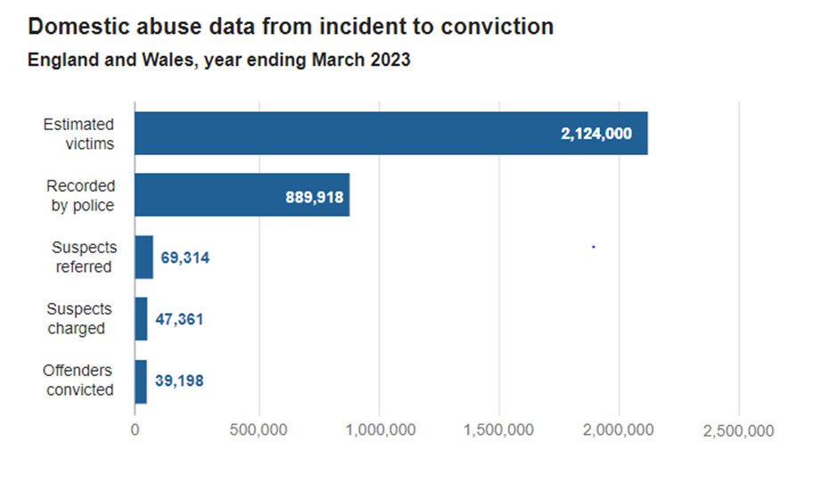
Another barrier in communication with victims that are reluctant to provide disclosure has been coined as the ‘Officer Effect’ by Hohl et el (2023), they state that “Multi-level modelling reveals an ‘officer effect’ whereby victims’ responses to the DASH risk assessment are influenced by the specific officer that completes the assessment.” This officer effect theory is supported by Alleyne et el, (2017)
“many domestic abuse victims express negative attitudes towards police officers, often viewing them as unsympathetic or lacking empathy”
I suspected from my last encounter with the victim that she held feelings of mistrust towards police and probably also held some of the negative attitudes associated with the above officer effect theory. This incident of Domestic abuse was complex due to the severity of the victim’s injuries and lack of co-operation with police for such a long period previously, there was a very high perceived risk as the victim had a laceration to her head and was also refusing any medical treatment or ambulance. Ariza et el (2016) highlights that “Policy dictates that it is the responsibility of the attending officer or first responder to carry out a primary risk assessment at the first opportunity, usually at the scene.” It was my duty as attending officer to exhaust all reasonable attempts to gain disclosure from the victim so that I could adequately safeguard her.
With this in mind I took a patient approach with the victim relying on communication skills highlighted by the college of policing, in particular I was reliant on the Leaps Model as discussed by The College of Policing (2020) “This simple mnemonic offers a flexible and structured approach to communicating in all situations. Listen, listen to the whole message and the feelings. Empathy, be open-minded about what is said, show understanding, and try not to judge. Ask, use effective questioning to establish or clarify the facts, seek opinions and check understanding.
Paraphrase, repeat back your understanding of what you have heard. Summarise, condense everything that has been said into a concise and simple statement, and check on any agreed actions.”
In line with this I made sure to ask open ended questions and listen, allowing periods of silence for the victim to speak, I lowered myself on to one knee so that I wasn’t stood over the victim and took a more submissive approachable stance. This led to her beginning to provide an account of the incident. I allowed her to continue to provide disclosure with no interruption, only speaking as a prompt if she began to veer away from the incident and on to irrelevant topics.
Part of the issue with disclosure to officers from victims is a perceived lack of empathy, Myhill and Kelly (2023) observe this stating “sceptical attitudes towards the accounts of some victims of abuse persist among some officers inhibiting full accounts being given.” Alleyne et el (2017) have also observed similar findings stating “many domestic abuse victims express negative attitudes towards police officers, often viewing them as unsympathetic or lacking empathy”
Still continuing to follow the Leaps model I would empathise with the victim’s situation and the abuse she had endured asking further questions relevant to the incident. I chose to paraphrase and repeat certain parts of the disclosure back to her and ended by summarising the incident. This calm and patient approach led to the victim making her first disclosure to police after the numerous previous calls. She began to disclose how her boyfriend was exceedingly jealous and controlling and tonight’s incident had begun after he left her alone after a night out, the victim stated she had gone to a pub on the way back, but the subject had been observing her from a distance and noticed she was late returning home. He proceeded to rush up behind her and take hold of her forcefully by her hair, using this as leverage to push her head into a set of concrete steps causing the visible laceration to her head. This ultimately led to police being able to complete a DASH without her consent due to the perceived high risk from her disclosure. With the disclosure qualifying as high risk this also allowed us to make referrals to external agencies without her consent through what is known as a Multi-Agency Risk Assessment Conference or MARAC for short. The purpose of this meeting is for the information for the highest risk domestic abuse cases to be shared between the relevant agencies with the ultimate goal of safeguarding the victim and developing an action plan. Agencies that may attend include Police, probation services, health, child protection, housing practitioners, IDVAs and other specialists. (College of Policing, 2018).
Due to the above the case was escalated to the Criminal Investigation Department and the subject was consequently arrested for the offence with Extensive enquiries revealing CCTV that captured part of the altercation.
In conclusion I feel that this incident highlights some of the history and challenges associated with domestic abuse incidents. I feel upon reviewing the actions taken by myself in initial attendance there is a logical and proportionate response in line with policing practices and framework.
WORD COUNT 2136

Authentication signature:

Please sign to confirm that the work submitted is your own and has not been copied from another:

Signed:

Date: 04/12/2023
Bibliography
The bibliography should only include sources referenced within the workbook using the Harvard referencing system. Information about referencing in written assignments and how to avoid plagiarism can be found on Moodle. It is important that you are aware of the importance of ensuring that the work submitted is your original work.
Ariza, J. Myhill, A. Robinson, A. (2016)
Cheaper, Faster, Better: Expectations and Achievements in Police Risk Assessment of Domestic Abuse.
Available at: Cheaper, Faster, Better: Expectations and Achievements in Police Risk Assessment of Domestic Abuse | Policing: A Journal of Policy and Practice | Oxford Academic (oup.com)
(Accessed: 30th October 2023)
Blockley, T. Hughes, C. Jones, P. Spooner, E. (2022) Police Research and Evidence-based Policing. St Albans : Critical Publishing.
Boulton, L. Kirby, S. Pythian, R. (2019) Diverting young men from gangs: a qualitive evaluation.
Available at: https://research.edgehill.ac.uk/en/publications/diverting-young-men-from-gangs-a-qualitative-evaluation
(Accessed:15th October 2023)
College of Policing (2013) National Decision Model. Available at: https://www.college.police.uk/app/national-decision-model/national-decision-model (Accessed: 15th October 2023)
College of Policing (2018)
Partnership working and multi-agency responses/mechanisms
Partnership working and multi-agency responses/mechanisms | College of Policing
(Accessed: 03/12/2023)
College of Policing (2019) Problem-solving Policing.
Available at: Problem-solving policing | College of Policing
(Accessed: 15th October 2023)
College of Policing (2020)
Conflict Management Skills
Available at: Conflict management skills | College of Policing
(Accessed: 30th October 2023)
Driscoll, J (2007)
A Reflective Approach for Healthcare Professionals.
Edinburgh: Elsevier
Giles, S. Wullenweber, S. (2021) The Effectiveness of Forensic Evidence in the Investigation of Volume Crime Scenes.
Available at: Forensic-Evidence-in-Volume-Crimes_Submission (cranfield.ac.uk)
(Accessed: 20th October 2023)
Hohl, K. Johnson, K. Myhill, A. (2023)
The ‘officer effect’ in risk assessment for domestic abuse: Findings from a mixed methods study in England and Wales.
Available at: The ‘officer effect’ in risk assessment for domestic abuse: Findings from a mixed methods study in England and Wales - Andy Myhill, Katrin Hohl, Kelly Johnson, 2023 (uwtsd.ac.uk)
(Accessed: 30th October 2023)
Legislation.gov.uk (2020)
Offences against the Person Act 1861
Available at: Offences against the Person Act 1861 (legislation.gov.uk)
(Accessed: 02/12/2023)
Legislation.gov.uk (2020)
Sentencing Act 2020
Available at: Sentencing Act 2020 (legislation.gov.uk)
(Accessed: 02/12/20203)
Robinson, A. Tilley, N. (2009) Factors influencing police performance in the investigation of volume crimes in England and Wales.
Available at: Full article: Factors influencing police performance in the investigation of volume crimes in England and Wales (uwtsd.ac.uk)
(Accessed:15th October 2023)
.
Legislation.gov.uk (2020)
Youth Justice and Criminal Evidence Act 1999.
Available at: Youth Justice and Criminal Evidence Act 1999 (legislation.gov.uk)
(Accessed: 02/12/2023)
Legislation.gov.uk (2023)
Mental Health Act 1983
Available at: Mental Health Act 1983 (legislation.gov.uk)
(Accessed: 02/12/2023)
Legislation.gov.uk (2021)
Domestic Abuse act 2021
Available at: Domestic Abuse Act 2021 (legislation.gov.uk)
(Accessed: 03/12/2023)
Moyle, L. (2019)
Situating Vulnerability and Exploitation in Street-Level Drug Markets: Cuckooing, Commuting, and the “County Lines” Drug Supply Model
Los Angeles, SAGE Publications.
Myhill, A. Kelly, L (2023
Whose Harm is it Anyway? Using Police Dat to Represent Domestic Abuse Victims’ Experiences
Available at: Whose Harm is it Anyway? Using Police Data to Represent Domestic Abuse Victims’ Experiences | Policing: A Journal of Policy and Practice | Oxford Academic (oup.com)
(Accessed: 03/12/2023)
Office for National Statistics
Domestic abuse in England and Wales overview
Available at: Domestic abuse in England and Wales overview - Office for National Statistics (ons.gov.uk)
(Accessed: 03/12/2023)
Rahma, M. (2020) Evaluation of the Impact of Fingerprinting Powders on DNA Profiling.
Available at: (PDF) Evaluation of the Impact of Fingerprinting Powders on DNA Profiling (researchgate.net)
(Accessed: 20th October 2023)
Sherman, L. (1998) Evidence-Based Policing.
Available at: https://www.policinginstitute.org/publication/evidence-based-policing/
(Accessed: 20th October 2023)

