DS Assessment 1

My Screenshots/Photos

Screenshot/Photo 1
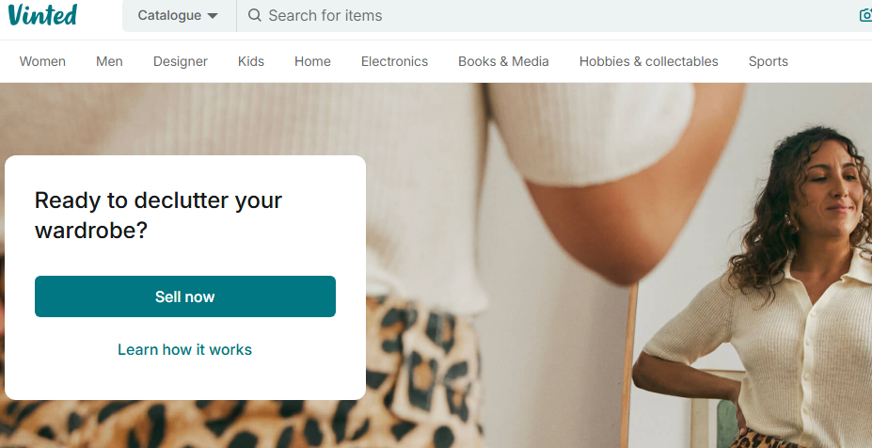
- I use digital tools to upload photos of clothing
- I feel confident when I use this app
- I want to improve sharpness of photos
- I often use these tools to highlight clothing in best format
- I sometimes feel nervous about losing uploaded items as I have over 2000
- I hope this module will help me save files in the best place
I use Vinted everyday to help clear unwanted clothes and source extra funds.

Screenshot/Photo 2
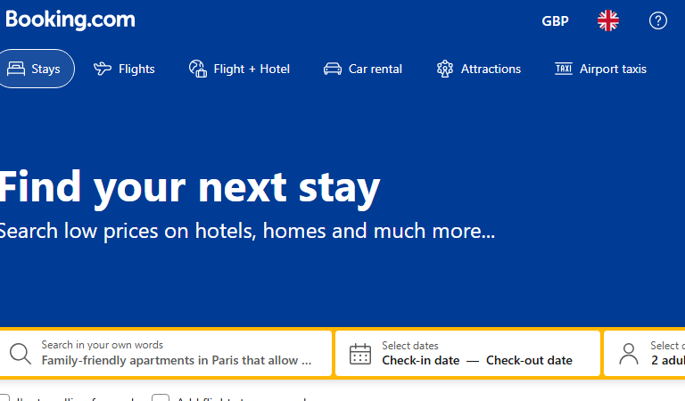
I use Booking.com to book accommodation and flights.
- I use digital tools to source best deals and compare
- I feel confident when I use this app
- I often use these tools to source holidays

Screenshot/Photo 3
- 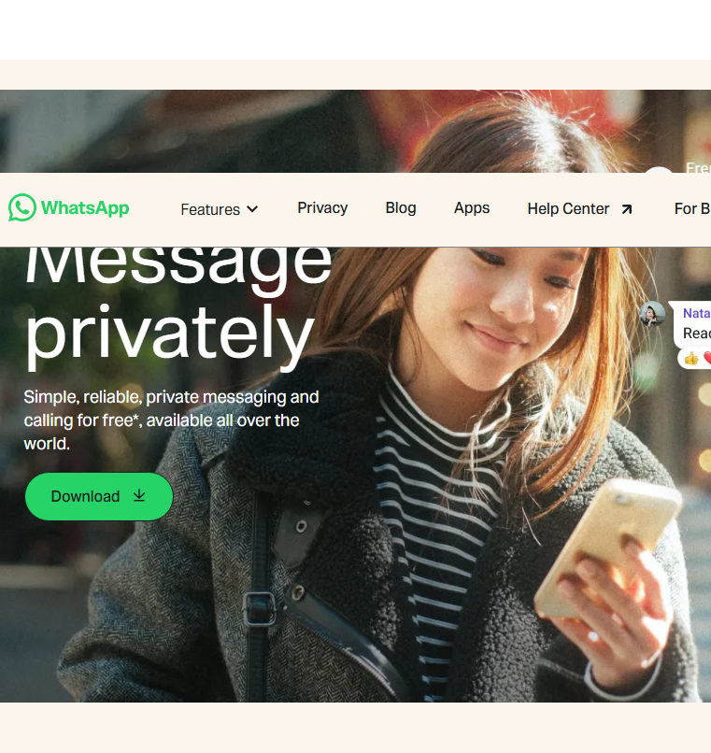 I use digital tools to connect with family and friend
- I feel confident when I use the audio app
- I want to improve using the video app
- I often use
- I sometimes feel nervous about saving links sent to me
- I hope this module will help me improve digital skills
I use Watsapp everyday to contact friends and family abroad. I seldom use video calls preferring audio

Screenshot/Photo 4
[Insert Photo/Screenshot below]
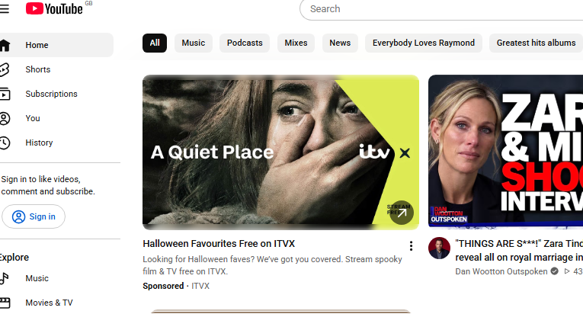
- I use digital tools to view videos daily
- I feel confident when I use this app
- I often use search tools on app to source genre etc of what I wish to watch
I use Youtube everyday as I no longer have a TV license. This platform lets me watch programmes and music at a moments touch

Screenshot/Photo 5
- 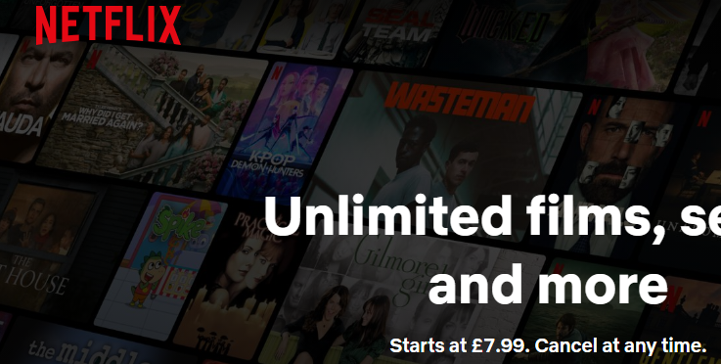 I use digital tools to choose movies etc
- I feel confident when I use this app
I use Netflix each day for sourcing movies and series

My Short Reflection
- Write 5–8 simple sentences about your digital life.
- You can use the sentence starters below if helpful.
I use these apps the most frequently.
They are an integral part of my everyday life.
Digital life is mostly on my mobile phone and occasionally on the laptop.
I hope this module will improve my skills on the laptop and give me more confidence to use this as my primary tool.

Sentence starters
- I use digital tools to …
- I feel confident when I …
- I want to improve …
- I often use these tools: …
- I sometimes feel nervous about …
- I hope this module will help me …
- Digital skills are important for me because …
You can write more if you want.

Submission Checklist
Before you submit, please check:
​​​ ☐ I added 4–6 screenshots
☐ I wrote short sentences for each screenshot
☐ I wrote my short reflection
☐ My work is my own
☐ My file opens correctly
​​☐ My file opens correctly

