Module Name: Food & Beverage Operations

Module Code: BMIH4002

Student Name: Mohammed Raju

Student ID: 2130225
Submission Due Date: 18/11/22

Table of Contents
Menu Planning 3
Prime rib 3
Christmas Turkey 3
Holiday Roasted Vegetables 3
Roasted Fingerling Potatoes 4
Vegan Mushroom Pie 4
Apple pie 4
Gingerbread Christmas Cookies 4
Wassail 4
Hot Buttered Rum 5
English Christmas Punch 5
References 6

Menu Planning
As Hotel Trinity is planning to host a party on Christmas day which will be served during the Christmas period and has decided to offer exclusive food and beverages for the customers who will be attending the party. In the UK, Christmas serves as a great chance for people to come together and have a feast and celebrate the birth of Jesus Christ. Hotel Trinity, for Christmas, has decided to change its menu and go for traditional Christmas food which is eaten during the Christmas period. The menu will not only be containing a single-course meal but also three courses meal during the period of Christmas. Some of the items which will be presented on the menu have been given below with the ingredients used in the dishes.

Prime rib
The ingredients which are used to prepare a prime rib dish for Christmas include a single 6-pound boneless prime rib roast, horseradish, Dijon mustard, Kosher salt, grounded black pepper, dried thyme, garlic powder, celery, carrot and unpeeled onion. These are the main ingredients which are required to make a traditional prime rib roast which can be served during Christmas (Halperin, 2021). The ingredients which have been used for the preparation of the dish will be sourcing the best prime rib which can be found in the local area and will be of A1 quality.

Christmas Turkey
The Christmas Turkey which will be presented by Hotel Trinity during the Christmas period will be steamed from the inside and crisp from the outside which will greatly enhance the texture of the dish and make the experience of the customers one in a lifetime (Smith-Carrier, 2021). The ingredients which will be used for the preparation of this dish are Bronze turkey, soft butter, pancetta, onions, leek, carrot, celery sticks, garlic, thyme, leaves and water.
The menu and delicacies are not only limited to non-vegetarian audiences but there will also be a wide variety of vegan dishes that can be catered to vegetarian and vegan customers. Some of the vegan dishes and items that will be easily available during the Christmas season have been provided below.

Holiday Roasted Vegetables
Cranberries, balsamic vinegar, pecans, Brussels sprouts, carrots, and some extra veggies or swapping of some of the favourite vegetables will be used to prepare the dish. The vegetables which the customers have a choice to decide on will be limited on the basis of the availability of those vegetables around the Christmas season (Spence, 2021).

Roasted Fingerling Potatoes
A perfect combination of golden and crispy potatoes on the outside and tender and buttery on the inside with a mix of fresh herbs such as thyme, basil, rosemary and parsley will be used while preparing the dish. This can greatly offer the customers a sense of warmness to the customers and is not just limited to the vegetarian and vegan customers but also to the non-vegetarian customers.

Vegan Mushroom Pie
During the cold and freezing Christmas period, customers can enjoy a pot which is filled with flavourful, creamy, tender and buttery vegetables which will be covered in a crisp crust. The ingredients which will be used in the dish are mushrooms such as shitake and creminis, onions, celery, cream, flour, veggie broth, peas and butter.

Apple pie
A sweet and tangy taste of a pot pie can be tasted by customers during the Christmas period which will be presented to the customers (Herrington and Mix, 2021). The ingredients which will be used in the preparation of the dish are granny smith apples, unsalted butter, pate sucre, sugar, brandy, heavy cream, dried prunes, apricots, dried figs, lemon juice, cinnamon, lemon zest and egg white.

Gingerbread Christmas Cookies
There is no Christmas celebration without making gingerbread cookies during the Christmas period which greatly gives childhood memories. The ingredients which will be used in the preparation of the dish are unsalted butter, brown sugar, golden syrup, flour, ginger, icing and food colouring.
Apart from the dishes which will be presented by the hotel during the Christmas period, several beverages will also be provided to the customers who are given below.

Wassail
The ingredient for this beverage has been segregated into alcoholic and non-alcoholic categories. The alcoholic category drink will include apples, brand and other hard liquor and other spices. The non-alcoholic beverage will include cloves, ginger, lemon, orange, and nutmeg, however, the customers can add alcohol to this beverage as well.

Hot Buttered Rum
Made with pure vanilla extract, unsalted butter, cinnamon, dark rum, nutmeg, allspice, and brown sugar, Hot Buttered Rum is a beverage which is irresistible during the Christmas season.

English Christmas Punch
The English Christmas Punch will be prepared with the ingredients such as dark rum, red wine, granulated sugar, orange juice, lemon juice and brewed tea.
The ingredient which will be used for the preparation of the vegan and non-vegetarian dishes and beverages are to be made with the local ingredients which will be available during the holiday season. The menu will be using descriptive language which will help the hotel to be able to make the customers understand the dishes and beverages.

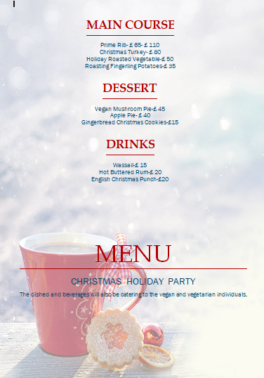

References
Halperin, R.H., (2021). A Partridge in a Pear Tree. In The Teacup Ministry and Other Stories (pp. 17-27). University of Texas Press.
Herrington, A. and Mix, T.L., (2021). Invisible and insecure in rural America: Cultivating dignity in local food security initiatives. Sustainability, 13(6), p.3109.
Smith-Carrier, T., (2021). ‘The (charitable) pantry is bare’: a critical discourse analysis of Christmas food hamper programs in Canada. Critical Policy Studies, 15(1), pp.90-106.
Spence, C., (2021). Explaining seasonal patterns of food consumption. International journal of gastronomy and food science, 24, p.100332.

