

MODULE CODE: ECPT6007

ASSESSMENT COMPONENT: A1 Curriculum Development Project

STUDENT NAME: Daniel Sion Rumbelow

STUDENT NUMBER: 2224566

Use of Generative AI in Assessment

(Lecturer to indicate Yes or No against each element)

RESEARCH | For this assessment, you can use Generative AI to support you in research, including searching for bibliography, using tools to summarise, compare and interrogate materials. | Yes ☒  No ☐
STRUCTURE | For this assessment, you can use Generative AI to support you in structuring your submission, including creating a draft argument structure, identifying parts and headings, etc. | Yes ☒  No ☐
PROOFREADING | For this assessment, you can use Generative AI to check your own text/creation for grammatical and syntactical mistakes, including rephrasing of your own work within specific standards. | Yes ☒  No ☐
WRITING | For this assessment, you can use Generative AI to create text for submission. | Yes ☐  No ☒
CREATIVE | For this assessment, you can use Generative AI to create creative materials, such as images. | Yes ☐  No ☒
PROGRAMING | For this assessment, you can use Generative AI to create and check code. | Yes ☐  No ☒
NONE | For this assessment, you are not allowed to use any type of Generative AI support. This includes research support, structure support, writing/proofreading support and creative support. | Yes ☐  No ☒

AI Acknowledgement
I confirm that I have not used any AI tools in the research and creation of this assignment.
I confirm that I have not presented any AI generated materials as my own work.
I confirm that I have copies of my drafts, notes, and other resources I used, which I may be asked to provide in evidence.

OR:

I acknowledge the use of [AI Tool] [(AI Tool url)] on [Date] to [Purpose my work]. I used the prompt(s):
1. [Prompt]
2. [Prompt]
3. [Prompt]
I confirm that I have not presented any AI generated text as my own work.
I confirm that I have copies of my drafts, notes, and other resources I used before and after the use of AI tools which I may be asked to provide in evidence.

Please refer to the next page for examples.
Prior to submission of your assignment, please delete any information on these pages that is not relevant to your submission, including the examples given below.

Examples of AI statements
Example 1:
I acknowledge the use of Grammarly (https://www.grammarly.com/) on 10 February 2024 to check my work using the prompt(s):
1. Please check the following text for readability, grammar and syntax.
I confirm that I have not presented any AI generated text as my own work. I confirm that I have copies of my drafts, notes, and other resources I used before, and after the use of AI tools which I may be asked to provide in evidence.
Example 2:
I acknowledge the use of SciSpace (https://typeset.io/) on 7 March 2024 to support my research using the prompt(s):
1. Please provide me with materials on the biology of the liver.
2. Please provide me with materials on liver cells.
I confirm that I have not presented any AI generated text as my own work. I confirm that I have copies of my drafts, notes, and other resources I used before, and after the use of AI tools which I may be asked to provide in evidence.
Example 3:
I acknowledge the use of ChatGPT (https://chatgpt.com/) on 13 April 2024 to write my notes into submission format using the prompt(s):
1. Please write up these bullet points as an essay paragraph at university level.
I confirm that I have not presented any AI generated text as my own work. I confirm that I have copies of my drafts, notes, and other resources I used before, and after the use of AI tools which I may be asked to provide in evidence.

Example 4 - acknowledgement of the use of multiple AI tools:
I acknowledge the use of SciSpace (https://typeset.io/) on 28 June 2024 to support my research using the prompt(s):
1. Please provide me with materials on the American Civil War.
2. Please provide me with materials on the reception of Gone with the Wind.
I confirm that I have not presented any AI generated text as my own work. I confirm that I have copies of my drafts, notes, and other resources I used before, and after the use of AI tools which I may be asked to provide in evidence.
I acknowledge the use of Adobe Express (https://www.adobe.com/express/) on 24 June 2024 to edit photographic material:
1. Remove background from Figure 1.
I confirm that I have not presented any AI generated materials as my own work. I confirm that I have copies of my drafts, notes, and other resources I used before and after the use of AI tools which I may be asked to provide in evidence.

Overview of the Curriculum:
The curriculum development project proposes a Strength and Conditioning Coaching module inside a Bachelor of Science Sports Coaching and Performance programme in post 16 education in Wales. The module will target Year 1 undergraduate students, embedding an industry recognised Level 1 Strength and Conditioning Coaching qualification within the academic programme. The curriculum will be delivered over a 10-12 week period, integrating both theoretical and practical learning within a higher education environment equipped with appropriate training facilities such as gym and classrooms. (Welsh Government 2026).
A focus point of the curriculum is the integration of the International Universities Strength and Conditioning Association Level 1 Certificate in Strength and Conditioning. Foundational knowledge of key principles, which include training adaptation, movement competency, programme design and safe coaching practice (International Universities Strength and Conditioning Association, 2019). Securing this certification allows students to gain both academic knowledge and a recognised vocational qualification, strengthening the alignment between education and industry expectations.
The module aims to respond to increasing demand within the sport and fitness environment for graduates who can apply coaching effectively. It is said by Baechle and Earle (2008) and Turner et al. (2022) that Strength and Conditioning is essential for enhancing performance and reducing injury.
Nevertheless a gap remains within many undergraduate programmes where opportunities to gain coaching qualifications are limited, especially in the early stages of study.
This curriculum aims to address this gap through structured academic learning with practical skill development and certification. Sport Wales (2026) highlights the link to broader priorities around workforce development and coaching pathways. The module will include lectures, workshops, applied coaching sessions and independent study. The module will support progression pathways, which is associated with professional standards, particularly the UK Strength and Conditioning Association (2025). This allows students to advance to higher level S&C qualifications in the later years of study and enhance long term employability.

Rationale for the Curriculum:
The rationale for this curriculum surpasses examining a simple gap in clause and responds to a wider structural and pedagogical limitations within strength and conditioning education. Weldo et al. (2022) highlights that the role of the S&C coach has transformed into a multidisciplinary profession, which involves a mixture of physiological knowledge, coaching practice, data analysis and interpersonal skills. Demand requires early development of technical and non technical competencies, which are underdeveloped in traditional degree programmes due to prioritising theoretical delivery over applied practice.
A primary concern within the literature is the deficient preparation of beginner S&C coaches, specifically in relation to real world coaching behaviour and decision making. A study by Martindale et al. (2021) explored the early career practitioners and emphasised that effective development needs hands on experience, reflective practice and situated learning environments instead of classroom based lectures. This supports this curriculum, as it provides applied coaching opportunities along with structured learning. Without this application, graduates may have theoretical knowledge but lack confidence and competence in working effectively in an applied environment.
In addition, there is an increase in evidence that experiential learning enhances employability outcomes, especially in sport degrees. Lin et al. (2021) research shows that students who engage in practical, work related learning experiences strengthen professional skills such as communication, problem solving and adaptability, which are highly valued by employers. This links to S&C, where employers require graduates to demonstrate practical capability. Embedding a Level 1 qualification within the curriculum provides a structured method which experiential learning can be validated and assessed.
Furthermore, a need to consider the rapid expansion and diversification of the strength and conditioning industry. Developing trends, such as applying sport science technologies, data analytics and interdisciplinary collaboration, has increased the expectations from practitioners (McMahon and Soileau, 2022). As a result, early exposure to professional frameworks and standards is vital for students that are not employable but adaptable. Launching a structure certification at Level 1 allows students to engage with the expectations from the outset of their academic journey.
Pedagogically, the curriculum is justified more through its alliance with constructivist and apprenticeship based models of learning, that increasingly advocates in coaching education. Research by Downes et al. (2022) and Szedlak et al. (2025) highlights the importance of guided practice, mentorship and reflection in developing effective S&C coaches.
The curriculum deals with the concerns regarding the lack of structured early career pathways in S&C. Read et al. (2017) clearly highlights that practical experience is vitally valuable and is often inconsistent and is lacking support, restricting its impact to development. By embodying a certification, structured delivery and guided practice to the module, this curriculum will provide a more coherent approach to early professional development.
The curriculum is justified through its response to changing industry demands, its evidence based pedagogical approaches and its competence to enhance employability through experiential learning. It indicates a purposeful shift towards vocational training and professional identity development, preparing students for the demands of S&C practice.

Curriculum Aims and Objectives:
The aim of this curriculum is to develop competent, reflective and employable entry level strength and conditioning coaches through applied coaching practice, theoretical knowledge and industry certification. The module will prepare students to work effectively in S&C environments, whilst promoting professional behaviour.
A key aim is to have students apply foundational principles of strength and conditioning, such as training methods, movement mechanics and programme design in the practical coaching environment. This mirrors Welsh professional standards, to “maintain up to date with subject knowledge and deliver structured, effective learning experiences that help develop learner progression” (Educators Wales, 2017).
The curriculum will also develop students ability to plan, deliver and evaluate coaching sessions that are safe, inclusive and appropriate to participants needs. This links to the professional expectations around planning and delivering effective learning, making sure learner wellbeing, that are vital components of post 16 teaching and coaching practice in Wales. Additionally, the module will cultivate professional behaviours and transferable skills, like communication, teamwork and reflective practice. Students will engage in critical reflection on their coaching performance, increasing continuous improvement (Welsh Government, 2023).
A further objective, will enhance students' capacity to work collaboratively and build effective relationships with peers, staff and participants. This supports collaboration and shared responsibility, promoting inclusive learning environments. Ultimately , the curriculum aims to create a clear foundation for progression within the strength and conditioning profession, enabling students to progress to higher level qualifications and pursue professional pathways.
The aims and objectives ensure that the curriculum not only enhances subject specific competence but also meets Welsh professional standards, developing practitioners to be more adaptable, skilled and reflective in the strength and conditioning field.

Professional Standards and Benchmarking:
The proposed Strength and Conditioning module is directly aligned with the Professional Standards for Further Education (FE) lecturers and Work Based Learning (WBL) practitioners. The standards assure that the curriculum design and delivery meet national expectations, especially the principle of dual professionalism, which asks for practitioners to demonstrate subject specific expertise and effective pedagogical practice. This is linked to the professional standard "commitment to learners, their learning, safety and wellbeing, ensuring safe and inclusive learning environments” working with others to ensure students are fully supported and supporting their wellbeing. In the Year 1 module it is achieved through the combination of academic theory and applied coaching, helping students work towards a Level 1 S&C coaching qualification as well as improving their foundational coaching competence in accordance with expectations set by Educators Wales (2023).
The curriculum is benchmarked against focus areas of professional practice, such as pedagogy, collaboration and student centred approaches which links to the standard “plan and deliver effective learning, teaching and assessment” as it supports and stretches students based on their starting points and pathway. It is supported by Kolb (1984) that application of practical coaching sessions, workshops and peer led activities supports active, experiential learning which develops skill and professional readiness. Peer coaching and structured feedback links to reflective and collaborative learning models appointed by Hwb (2017), which allows students to actively contribute to their own and other learning linking to “enable learners to share responsibility for their own learning and assessment, critically reflect on practice based on feedback and build positive and collaborative relationships”.
The standards concentrate on inclusion, wellbeing and safe practice which is the core fundamental design of this module, which aligns to “value and promote diversity, equality of opportunity and inclusion and ensure a safe and inclusive learning environment”. In a S&C environment, this is executed through coaching safe lifting techniques, risk assessment and session planning. These practices link with the guidance from Educators Wales (2023) and expectations from UK Strength and Conditioning Association (2025), safe and effective coaching practice is an essential requirement for entry level practitioners.
The curriculum significance on progression and employability, linking to “maintain and update knowledge of subject and teaching methods and engage with research and evidence to improve teaching practice”. Applying a Level 1 S&C Coaching qualification to the first year of BSc programme provides an early professional milestone and increases progression into higher level certifications, reflecting national priorities for workforce development (Welsh Government, 2026).
The module has strong alignment with educational and industry standards, assuring a vocational relevant, pedagogical and professional curriculum that develops early stages of strength and conditioning coaches.

Curriculum Structure:
The Strength and Conditioning module is designed as a 10-12 week progressive learning programme rooted in the Year 1 BSc Sports Coaching and Performance. A distinctive feature of this curriculum is that students are not only studying an academic module but are also actively working towards achieving the International Universities Strength and Conditioning Association Level 1 Certificate in Strength and Conditioning as an incorporated vocational qualification.
The structure ensures that academic learning and professional certification are fully unified rather than delivered separately. Therefore it is designed around a dual outcome model, as the students at the same time gain university credit and progress through the assessed expertise required for the International Universities Strength and Conditioning Association Level 1 Certificate in Strength and Conditioning.
The structure will be broken down into three progressive phases: theoretical foundations, applied coaching practice and professional integration and assessment. Light and Harvey (2017) using the staged approach this reflects recognised principles in coaching education, linking theory to practice in authentic environments.
Phase one (week 1-3) foundational knowledge needed for the Level 1 qualification, which includes anatomy, physiology, biomechanics and principles of training. The subjects are directly specific to the knowledge criteria of the IUSCA Level 1 certification, giving the student the required theoretical knowledge for safe and effective coaching practice (IUSCA, 2024). Strategies used will be primarily lecture ,seminar based, and guided independent study.
Phase two (week 4-8) focuses on developing applied coaching competence, as students will start their practical Strength and Conditioning coaching in gym and training environments. The topic will include resistance training (technique), movement development, programme design and coaching communication. The elements link to the practical assessment requirements of the IUSCA Level 1 qualification, where students must display safe and effective coaching behaviour in real or specific environments (Jeffreys, 2019).
Third and final phase (week 9-12) will cover integration, assessment and certification readiness. Students will need to deliver coached sessions, complete reflective evaluations and take part in practical and theoretical assessments aligning with Level 1 certification expectations. Completing this successfully will lead to achievement of the IUSCA Level 1 Certificate in Strength and Conditioning with university credit. This provides clear professional validation and enhances employability.
The module will have a blended learning model, uniting lectures, workshops, practical gym sessions, peer coaching and independent study. Kolb (1984) and Martindale et al. (2023) both approximately suggest that this approach of experiential learning will develop coaching competence and decision making ability. The structure of the curriculum aligns with the Hwb Wales Professional Standards for Further Education Teacher and Work Based Learning Practitioners, making certain that inclusive practice, student centred delivery and reflective teaching approaches are included (Welsh Government, 2023). The standards help build the assessment design, feedback and session delivery in the module.
Progression is key to the structure, as the plan is to provide the opportunity to the students to build towards a higher level Strength and Conditioning qualifications in the later years of the degree. Sport Wales (2026) essentially mentioned that it will help set up a clear vocational pathway to UK coaching development frameworks and develop long term professional readiness. This clear and effective structure ensures an academic and professional certification pathway and students enhance their knowledge, skills, applied competence and achieve an industry qualification within a single curriculum model.

Scheme of Work:

Programme Title:  Progressive Strength and Conditioning Coaching. | Venue: University or FE College -  - Gym or training environment.  - Classroom. | Lecturer: Module Leader
Hours per week: 4 | Day/Time: 2 sessions per week. | Number of weeks: 12

Module Aims:
To develop qualified entry level Strength and Conditioning coaches through a combination of theoretical knowledge, applied coaching practice and completion of the International Universities Strength and Conditioning Association Level 1 Certificate in Strength and Conditioning.
To enhance employability and professional readiness.

Module Outcomes:
- Apply core S&C standards to coaching practice.
- Plan and deliver safe, structured S&C sessions.
- Demonstrate correct exercise technique and coaching communication.
- Evaluate coaching performance through reflection.
- Meet the assessment criteria - IUSCA Level 1 Certification.

Week Number | Topic | Aim and Objectives | Teaching and learning activities | Resources required | Assessment
1  2  3  4.  5  6  7  8  9  10  11  12 | Introduction to Strength and Conditioning.  Anatomy and Physiology.  Training Principles.  Movement Competency.  Resistance Training.  Coaching Communication.  Programme design.  Progression methods.  Session delivery.  Testing and monitoring.  Reflection and review.  Final assessment. | Outline the module - expectations and standards.  Provide the framework to the certification pathway (Level 1).  Apply muscles to movement.  Applying overload, progression and specification.  Coach fundamentals of movement patterns. For example, coach a movement - squat or hinge.  Demonstrating lifting technique.  Develop instruction skills and leadership styles.  Plan and prepare S&C sessions.  Create and adapt sessions safely.  Deliver coaches session.  Apply basic performance tests.  Evaluate overall coaching performance.  Demonstrate skill, ability and expertise - competency. | Lecture + induction workshops  Lecture + applied tasks - movement examples.  Seminar + scenario tasks. Linking theory to practice.  Practical gym session. Coaching drills.  Supervised gym practice.  Peer Coaching + video analysis.  Workshop design + templates (warm up, main body and cool down).  Scenario tasks link to practice.  Practical coaching.  Sport Science Lab.  Reflective workshop and independent time.  Practical + theory test. | Course handbook.  PowerPoint presentation.  Facility induction - classrooms and gym.  Context + safety.  PowerPoint slides. Skeleton model and muscle - visual learning.  Whiteboard and case studies. Real specific links.  Gym facility, kit and equipment. Skill development.  Gym equipment - barbells, racks, free weights and resistance bands. Authentic setting.  Recording and video analysis - self review.  Session templates - structure learning.  Case studies - identifying and decision making.  Training environment or gym set up - real coaching.  Testing equipment, for example blood pressure and lung function tube - valid data.  Options of paper based or digital. Journals - critical thinking.  Available facilities, student choice. | Diagnostic quiz - identify characteristics and analyse performance.  Identify baseline knowledge.  Theory quiz. Checks applied knowledge.  Worksheet - application.  Formative assessment - skill and technique correction.  Observation and supervision for safety and technique.  Peer Feedback - reflection.  Draft programme - progress check.  Tutor feedback - refinement.  Assessed practical - assess skill, expertise and quality.  Gather data and record analysis.  Reflective log and SMART targets - measure development.  Summative assessment - certification readiness.
Indicative Reading List:

Callary, B., Gearity, B.T., Eagles, K. and Szedlak, C. (2022). Defining psychosocial strength and conditioning coaching competencies: A participatory action research approach. International Journal of Sports Science & Coaching, p.174795412211373. doi:https://doi.org/10.1177/17479541221137308.
Christoph Szedlak, Callary, B., Eagles, K. and Gearity, B.T. (2024). An exploration of how dominant discourses steer U.K. strength and conditioning coach education. Sport, education and society, pp.1–14. doi:https://doi.org/10.1080/13573322.2024.2318650.
Farrow , D., Baker , J. and MacMahon , C. (2023). Developing Sport Expertise: Researchers and Coaches Put Theory into Practice. Available at: https://www.routledge.com/Developing-Sport-Expertise-Researchers-and-Coaches-Put-Theory-into-Practice/Farrow-Baker-MacMahon/p/book/9781032258157. [Accessed 1 May 2026].
Frei, L. (2025). The Fundamentals of Program Design for Strength & Conditioning Coaches | TrainHeroic. Available at: https://www.trainheroic.com/blog/the-fundamentals-of-program-design-for-strength-conditioning-coaches/. [Accessed 1 May 2026].
Reiman, M.P. and Lorenz, D.S. (2011). INTEGRATION OF STRENGTH AND CONDITIONING PRINCIPLES INTO A REHABILITATION PROGRAM. International Journal of Sports Physical Therapy,] 6(3), p.241. Available at: https://pmc.ncbi.nlm.nih.gov/articles/PMC3164002/.
Strength & Conditioning Education (2023). ECM Phase 1 - Elite Coach Development - Strength and Conditioning Education. Available at: https://strengthandconditioningeducation.com/wp-content/uploads/2020/08/Phase-1- [Accessed 1 May 2026].
Turner, A. and Comfort, P. (2022). Advanced Strength and Conditioning: An Evidence-based Approach. London: Routledge. [Accessed 1 May 2026]..
UKSCA (2022). SECTION 2. THE SCIENTIFIC BASIS OF STRENGTH AND CONDITIONING CONTENTS. Available at: https://cdn.uksca.org.uk/assets/pdfs/UkscaIqPdfs/section-2-the-scientific-basis-of-strength-and-conditioning-637952035376224069.pdf. [Accessed 1 May 2026].

Timetable for the Curriculum:
The module will be delivered over 12 weeks, two sessions per week to balance theory and applied practice. Each week is composed of 4 contact hours, split into classroom (theory) and training environment (practical).
Day | Time | Session Type | Location | Focus
Monday | 10:00-12:00 | Theory -  Lecture and Seminar. | Classroom | - S&C Principles.  - Coaching Theory.  - Programme design.
Thursday | 13:00-15:00 | Practical - Applied Coaching | Gym, Training environment or Sport Science Lab. | - Movement - skills and technique.  - Resistance Training.  - Coaching delivery.
The timetable will support progressive learning, as theoretical concepts are delivered early in the week and then applied in practical sessions later in the week. It reinforces knowledge transfer and skill development, linking to Kolb (1984) experiential learning principles.
Independent study will be given 2 to 3 hours weekly to the students. This is expected to consolidate learning, complete assessments, plan and prepare for International Universities Strength and Conditioning Association Level 1 certification requirements. The structure will be consistent, engaging and effective for academic and vocational outcomes.

Assessment Strategy for the Curriculum:
The assessment strategy aligns directly to academic requirements and practical skills required for IUSCA Level 1 Certificate in Strength and Conditioning. The approach is balanced between using formative and summative assessment, giving students continuous support while also demonstrating competency in theoretical knowledge and applied coaching practice.
Formative assessment is applied throughout to enhance ongoing development and skill attainment. The initial stage of assessment includes quizzes, workshops, worksheets and tutor feedback (week 1-5) which are to monitor knowledge progression and reinforce fundamentals such as anatomy and training methods. Research from Carless and Boud (2018) suggests that low stake formative assessment improves learning retention and provides opportunity to students to identify gaps in their knowledge before increasing to higher stakes. Furthermore, Nicol and Macfarlane-Dick (2006) say that assessments like peer feedback and video analysis (week 6) promotes reflective practice and self regulation, which are crucial components in coaching development.
Summative assessment is used to reflect on real life coaching expectations and the competency requirements of the Level 1 qualification. The module incorporates a 70% practical and 30% theory, recognising the importance of applied coaching for Strength and Conditioning. The main summative assessment is a practical coaching assessment (40%), in which students need to plan and deliver an S&C session, showing safe technique, demonstrating clear communication and session structure. Villarroel (2018) supports this authentic assessment as it replicates professional practice and improves employability outcomes.
A written programme design task (20%) will have students develop a structured training plan based on a scenario given. This measures their ability to apply theoretical principles to practical environments, narrowing the divide between knowledge and application. A theoretical assessment (10%) , a small short test, will test students if they can underpin scientific knowledge needed for safe coaching practice.
The last part will be a reflective log (30%), which students will evaluate and critically analyse their coaching performances and identify areas for improvement. It is said by Cropley et al. (2012) that reflection is a prime component of coaching expertise and strongly develops professional growth and future learning.
This assessment strategy is very effective as it unites knowledge validation, applied competency and reflective development, allowing students to meet academic standards and practical requirements for IUSCA Level 1 Certification as well as increasing their employability in the sports industry.
Assessment Timetable:
Assessment | Hand out | Hand In
Theory Test (10%) | 6 October 2026 | 31 October 2026
Programme Design (20%) | 3 November 2026 | 21 November 2026
Practical Coaching (40%) | 10 November 2026 | 12 December 2026
Reflective Log (30%) - 2500 Words | 6 October 2026 | 19 December 2026

Skill and Knowledge Development:
The module is designed to develop progressive and unified profile of knowledge and skills, allowing students to work effectively as beginner level Strength and Conditioning coaches. The incorporation of the IUSCA Level 1 Certificate ensures that learning will not only be academic but will link to professional competency expectations.
Knowledge development will be developed through a classified curriculum that shifts from foundational scientific knowledge to applied performance contexts. Premature learning focuses on the function of anatomy, biomechanics and training adaptation, allowing students to clarify, explain movement and response to training instead of simply following prescribed exercises. Students extend their knowledge as the module progresses into areas such as programme design, load management and performance monitoring. Research by Stone et al. (2026) highlights that effective S&C practitioners demonstrate the ability to apply multiple knowledge specialties, such as physiology, coaching science and performance analysis to appraise decision making. The curriculum supports this synthesis through organised progression and applied tasks.
Skill development is focused on coaching execution and decision making in real environments. Students will improve technical proficiency in fundamental movement (e.g. hinge, push, pull, squat) along with the ability to observe, analyse and improve performance. Crucially, the curriculum highlights coaching behaviour, such as cueing, demonstrations and feedback delivery. It is said by Suchomel et al. (2016) that technical coaching skill, especially the ability to identify and correct movement errors is a critical characteristic of effective S&C practitioners. The skills are developed through repetitive practice, scaffolded feedback and increasing levels of autonomy.
A pivotal focus is the development of applied problem solving skills, which students need to adapt training sessions based on participants needs, ability levels and performance goals. This mirrors the real world coaching requirements, that variability and unpredictability are constant. Casey and MacPhail (2018) state that learning is most effective when students engage in context based challenges that need active decision making instead of passive instruction. This is why scenario based tasks and practical coaching sessions are used to strengthen this capability.
Self management and reflective practice is also encouraged and promoted by the curriculum, which are vital for long term professional development. Students will have to evaluate their own coaching sessions, identify performance errors and apply strategies for improvement. This links to Griffiths and Armour (2013) who say that reflective practitioners demonstrate better adaptability and progression in coaching careers.
The module builds and improves a multi dimensional skill set, unifying analytical knowledge, technical coaching and applied decision making, making sure students are fully prepared for study and practical challenges of the S&C profession.

Evaluation:
Evaluation is essential to ensure the curriculum remains effective, relevant and linked to professional standards, academic and industry expectations. To evaluate, a multi layered evaluation approach will be used, combining student performance outcomes, feedback and external constituents input to continue to improve. This mirrors Biggs and Tang (2011) principles of constructive alignment, where curriculum design, delivery and assessment are examined in relation to designed learning outcomes.
Student input will be recorded through module evaluations, focus groups and informal feedback, which will bring insight to engagement, inclusivity and relevance. But the evaluation will be exceeded by analysing achievement data, such as pass rates, practical coaching performance and success in achieving the IUSCA Level 1 Certificate. This will make sure that evaluation focuses on measurable and realistic learning and also competency development. The curriculum will be analysed in alignment with Welsh policy frameworks, such as Welsh Government post 16 education priorities (2022) and Educators Wales Professional Standards for FE and Work Based Learning practitioners (2023), which highlights reflective practice, student progression and inclusive delivery. The standards will direct teaching quality and curriculum relevance, having the module contribute to broader national goals around skills development and employability.
The Kirkpatrick Model (2006) will be applied to strengthen the evaluation, especially focusing on learning and behaviour. This is crucial for S&C education, as the ability to transfer learning into practice is critical. Constituents feedback, which includes employers and professional bodies such as the UK Strength and Conditioning Association, will be used to assess industry alignment. According to Jackson (2015) employer informed evaluation (expert analysis) has shown to enhance graduate readiness and curriculum relevance.
The success of the module has effects for future curriculum development and funding opportunities. Outcomes which are positive such as high achievement rates and employability progression could warrant expansion into a structured pathway, such as IUSCA Level 2 and Level 3 S&C qualifications in Years 2 and 3. This will link with Welsh Government priorities around workforce development and sustainable skills (succession pool).
The valuation strategy assures that the curriculum maintains a responsive, evidence informed and is associated with national policy and industry needs.

Conclusion:
The curriculum presents a structured and forward thinking approach to Strength and Conditioning education within post 16 education in Wales, handling a clear gap between academic study and industry readiness coaching competence. By integrating International Universities Strength and Conditioning Association Level 1 Certificate in Strength and Conditioning to Year 1 undergraduate module, the curriculum creates and sets up an early meaningful connection between theory, practice and professional certification.
The structure is supported by evidence and research based pedagogy, applying experiential learning (Kolb, 1984) with authentic assessment approaches which reflect real world coaching scenarios (Villarroel et al., 2018). This will ensure that students not only need disciplinary knowledge but to demonstrate applied competence, reflective capability and professional behaviours aligned with standards. In addition, links to Welsh Government Priorities (2022) and Educators Wales professional standards (2023) strengthen the curriculum's relevance to the national education and proficiency landscape.
More importantly, the module creates a foundation for sustained progression, supporting pathways into higher level S&C qualifications and long term employability. Although its unified structure, resilient assessment strategy and clear vocational focus, the curriculum provides a model for enhancing S&C education. It is a balanced, industry aligned and academically thorough framework which prepares students effectively for the growing demands and changing needs of the strength and conditioning profession.

Reference Page:
Baechle , T. and Earle , R. (2019). Google Books. Available at: https://www.google.co.uk/books/edition/Essentials_of_Strength_Training_and_Cond/rk3SX8G5Qp0C?hl=en&gbpv=1&dq=Baechle. [Accessed 29 April 2026].
Biggs , J. and Tang, C. (2011). Teaching for Quality Learning at University. Maidenhead, UK Open University Press. - References - Scientific Research Publishing. Available at: https://www.scirp.org/reference/referencespapers?referenceid=1856033. [Accessed 5 May 2026].
Carless, D. and Boud, D. (2018). The development of student feedback literacy: Enabling uptake of feedback. Assessment & Evaluation in Higher Education, 43(8), pp.1315–1325. doi:https://doi.org/10.1080/02602938.2018.1463354.
Carson, F., Leishman, B., Hinck, K. and Hoffmann, S.M. (2021). Identifying the habitual needs of novice strength and conditioning coaches. Journal of Hospitality, Leisure, Sport & Tourism Education, 28, p.100313. doi:https://doi.org/10.1016/j.jhlste.2021.100313.
Casey, A. and MacPhail, A. (2018). Adopting a models-based approach to teaching physical education. Physical Education and Sport Pedagogy, 23(3), pp.294–310. [Accessed 5 May 2026].
Cropley, B., Miles, A, and Peel, J. (2012). ‪Reflective practice: Value of, issues, and developments within sports coaching‬. Available at: https://scholar.google.com/citations?view_op=view_citation&hl=en&user=wwOOqVUAAAAJ&citation_for_view=wwOOqVUAAAAJ:R3hNpaxXUhUC. [Accessed 1 May 2026].
Downes, P.W. and Collins, D. (2022). Developing strength and conditioning coaches: a case for cognitive apprenticeship. Coaching: An International Journal of Theory, Research and Practice, pp.1–13. doi:https://doi.org/10.1080/17521882.2022.2089189.
Educators Wales (2017). Professional Standards | Educators Wales. Available at: https://educators.wales/professional-standards. [Accessed 30 April 2026].
Educators Wales (2023). Professional standards for FE teachers, WBL practitioners and AL practitioners | Educators Wales. Available at: https://educators.wales/professional-standards-practitioners. [Accessed 30 April 2026].
Griffiths, M.A. and Armour, K.M. (2013). Volunteer Sport Coaches and Their Learning Dispositions in Coach Education. International Journal of Sports Science & Coaching, 8(4), pp.677–688. doi:https://doi.org/10.1260/1747-9541.8.4.677.
Hwb (2017). Professional standards - Hwb. Available at: https://hwb.gov.wales/professional-learning/supporting-professional-development/professional-standards/. [Accessed 30 April 2026].
IUSCA. (2019). Level 1 Certificate in S&C | IUSCA. Available at: https://www.iusca.org/level1. [Accessed 29 April 2026].
International Universities Strength and Conditioning Association (2024). Level 1 Certificate in S&C | IUSCA. Available at: https://www.iusca.org/level1. [Accessed 30 April 2026].
Jackson, D. (2015). Employability skill development in work-integrated learning: Barriers and best practice. Studies in Higher Education, 40(2), pp.350–367. doi:https://doi.org/10.1080/03075079.2013.842221.
Jeffreys , I. (2019). PROFESSIONAL STRENGTH & CONDITIONING PROFESSIONAL STRENGTH & CONDITIONING GAELIC FOOTBALL ASSESSING CODD PROFESSIONAL STANDARDS FOR UKSCA. Available at: https://cdn.uksca.org.uk/assets/pdfs/UkscaIqPdfs/professional-strength-conditioning-issue-52-march-2019-637036277730670845.pdf. [Accessed 30 April 2026].
Kolb, D.A. (1984). Experiential Learning: Experience As The Source Of Learning And Development. Available at: https://www.researchgate.net/publication/235701029_Experiential_Learning_Experience_As_The_Source_Of_Learning_And_Development. [Accessed 30 April 2026].
Kirkpatrick, D. L., & Kirkpatrick, J. D. (2006). Evaluating Training Programs The Four Levels (3rd ed.). San Francisco, CA Berrett-Koehler Publishers, Inc. - References - Scientific Research Publishing. Available at: https://www.scirp.org/reference/referencespapers?referenceid=2702697. [Accessed 5 May 2026].
Light, R.L. and Harvey, S. (2017). Positive Pedagogy for sport coaching. Sport, Education and Society, 22(2), pp.271–287. Available at: https://doi.org/10.1080/13573322.2015.1015977.
Lu, H.-F. (2021). Enhancing university student employability through practical experiential learning in the sport industry: An industry-academia cooperation case from Taiwan. Journal of Hospitality, Leisure, Sport & Tourism Education, 28, p.100301. doi:https://doi.org/10.1016/j.jhlste.2021.100301.
Martindale, R., Fountain, H., Andronikos, G., English, C., Dugdale, J.H. and Ferrier, S. (2023). A mixed methods exploration of the parent perspective of talent development environments across a national multi-sport landscape. Psychology of Sport and Exercise, 69, p.102487. doi:https://doi.org/10.1016/j.psychsport.2023.102487.
McMahon, E. (2022). Exploring New Frontiers in Strength and Conditioning and Sport Science. Available at: https://www.nsca.com/education/articles/nsca-coach/exploring-new-frontiers/?srsltid=AfmBOooyG1w5WmK0UoHbNWAGrGi3zBsTwR-Mh7TPsTMJdQtiPth6y7sh [Accessed 30 April 2026].
Nicol, D.J. and Macfarlane-Dick, D. (2006). Formative Assessment and Self‐regulated learning: a Model and Seven Principles of Good Feedback Practice. Studies in Higher Education, 31(2), pp.199–218. doi:https://doi.org/10.1080/03075070600572090.
Read, P., Hughes, J.D., Blagrove, R., Jeffreys, I., Edwards, M. and Turner, A.N. (2016). Characteristics and experiences of interns in strength and conditioning. Journal of Sports Sciences, 35(3), pp.269–276. doi:https://doi.org/10.1080/02640414.2016.1161220.
SportWales (2026). Become a qualified strength & conditioning trainer | Sport Wales. Available at: https://sport.wales/strength-conditioning-trainer-course [Accessed 29 April 2026].
SportWales (2026). The development of Wales’ sport partnerships | Sport Wales. Available at: https://sport.wales/stories/development-wales-sport-partnerships [Accessed 30 April 2026].
Stone , M. (2026). Principles and Practice of Resistance Training. Available at: https://ifind.swan.ac.uk/discovery/fulldisplay?vid=44WHELF_SWA:44WHELF_SWA_VU1&docid=alma996151373402417&context=L [Accessed 5 May 2026].
Suchomel, T., Nimphius, S. and Stone, M. (2016). The Importance of Muscular Strength in Athletic Performance. Available at: https://pubmed.ncbi.nlm.nih.gov/26838985/. [Accessed 5 May 2026].
Szedlak, C., Callary, B. and Smith, M. (2025). Developing Elite Strength and Conditioning Coaches’ Practice Through Facilitated Reflection. Education Sciences, 15(5), pp.603–603. doi:https://doi.org/10.3390/educsci15050603.
Turner, A. (2022). Advanced strength and conditioning. Available at: https://api.pageplace.de/preview/DT0400.9781000534139_A42401823/preview-9781000534139_A42401823.pdf [Accessed 29 April 2026].
UKSCA (2025). The UK’s Professional Body for Strength and Conditioning. Available at: https://www.uksca.org.uk/home. [Accessed 29 April 2026].
Villarroel, V., Bloxham, S., Bruna, D., Bruna, C. and Herrera-Seda, C. (2018). Authentic assessment: creating a blueprint for course design. Assessment & Evaluation in Higher Education, 43(5), pp.840–854. doi:https://doi.org/10.1080/02602938.2017.1412396.
Weldon, A., Duncan, M.J., Turner, A., Lockie, R.G. and Loturco, I. (2022). Practices of Strength and Conditioning Coaches in Professional sports: A systematic Review. Biology of Sport, 39(3). doi:https://doi.org/10.5114/biolsport.2022.107480.
Welsh Government (2022). RENEW AND REFORM POST-16 AND TRANSITIONS PLAN ADDRESSING THE IMPACTS OF COVID-19 ON EDUCATION AND TRAINING SKILLS, HIGHER EDUCATION AND LIFELONG LEARNING. Available at: https://www.gov.wales/sites/default/files/publications/2023-08/renew-and-reform-post-16-and-transitions-plan_0.pdf. [Accessed 5 May 2026].
Welsh Government (2023). Professional standards for further education teachers, work-based learning practitioners and adult learning practitioners in Wales. Available at: https://educators.wales/sites/default/files/2023-07/Professional%20standards%20for%20FE%20%20WBL%20and%20ACL%20Practitioners%20-%20June%202023.pdf. [Accessed 30 April 2026].
Welsh Government (2026). 16 to 18 local curricula guidance [HTML] | GOV.WALES. Available at: https://www.gov.wales/16-18-local-curricula-guidance-html. [Accessed 29 April 2026].
Welsh Government (2026). Requirement to hold a further education teacher qualification [HTML] | GOV.WALES. Available at: https://www.gov.wales/requirement-hold-further-education-teacher-qualification-html [Accessed 30 April 2026].

Appendices:
Lesson Plan 1 - Theory session

Lesson Plan

Topic:  Principles of Training (Overload, Progression and specificity) and Application to S&C Programming. |  | Class:  Year 1 BSc Sports Coaching and Performance
Date: 13 October 2026 (Week 2) | Length of lesson: 1 hour |  | Number of students: 10+
Resources required:
- PowerPoint Presentation
- Whiteboard and Markers
- Case Study
- S&C Programme design template

Aim of Lesson

To develop students' knowledge of core strength and conditioning training principles and apply them to basic programme design scenarios relevant to coaching practice and the IUSCA Level 1 Framework.

Learning Outcomes – The Learners Should Be Able To:

- Clearly define overload, progression and specificity.
- Explain how each principle influences programme design decisions.
- Apply training principles to a basic athlete scenario.
- Justify programming choices using S&C terminology.

Previous student knowledge required for the session:

- Basic knowledge of anatomy and movement patterns - squat, hinge, pull, press.
- Introductory knowledge of training environments and safety.
- Awareness of coaching roles.

Anticipated difficulties (if applicable):

- Confusing overload with progression.
- Difficulty applying theoretical concepts into programme design.
- Lacking confidence.

Professional Standards (where are these being met within the session)

Demonstrate commitment to learners, their learning, safety and well-being -
- Lesson expectations, aims and structure explained.
- Case study based on realistic but safe training scenarios.
- Tutor led questioning, supporting students.

Value and promote diversity, equality of opportunity and inclusion -
- Case study is non gendered and anonymous.
- Extension opportunities allow higher achieving students to progress.

Maintain and update knowledge of my subject(s) and how best to teach and assess them -
- Current strength and conditioning principles.
- Assessment mirrors IUSCA Level 1 certification expectations.

Know how to use evidence and research to improve my practice -
- S&C literature.
- Links to experiential learning.
- Evidence based justification - programme design.
- Case study - performance testing, adaptation and fatigue (sport science thinking).

Plan and deliver effective learning, teaching and assessment -
- Structured flow.
- Clear learning outcomes.
- Case study + programme design provide authentic assessment
- Formative assessment
- Clear progression.

Enable learners to share responsibility for their own learning and assessment -
- Independent work.
- Peer discussion and comparison.
- Exit ticket - encourages self assessment.

Critically reflect on own values, knowledge and skills to improve learning -
- Final reflection questions.
- Evaluate decision making during the task and after during discussion.

Lesson Detail:

Stage | Focus | Strategy | Time
Introduction  Development 1  Development 2  Development 3  Plenary/conclusion | Context and Engagement.  Principles of training.  Guided Application - Case Studies  Independent Task.  Consolidation. | Brief recap of prior knowledge - movement patterns.  Examples -  - Squat  - Hinge  - Push  - Pull  Introduction to aims and learning objectives from IUSCA Level 1 programme design expectations.  Case study overview.  Tutor led explanations -  - Overload  - Progression  - Specificity  Provide real S&C examples to each.  Video to watch, for example - strength vs hypertrophy training.  Hand out case study.  Simple task - students analyse athlete case study and identify which principles to apply. Explain why and how?  Whole class discussion - feedback from the task.  Students have a choice on what programme they want to design.  Students design a basic 3 to 5 exercise programme using correct principles.  After completing the task, pair up and present your ideas and designs. Peer discussion and feedback.  Group discussion, feedback from the task + answers.  Identify areas for improvement and suggest recommendations.  Exit ticket activity, question students on their learning. For example “can someone tell me what is progression? Example?”. | 10 minutes  15 minutes.  15 minutes.  10 minutes.  10 minutes.

Assessment Strategies: when and how are they included within the lesson?

- Continuous ongoing questioning and discussion - during task and consolidation to monitor and test learning.
- Formative assessment - case study task.
- Peer comparison - decision making, feedback and identifying areas to improve.
- Discussion - selection, decision making and feedback.
- Observation - monitoring student progression during tasks and questioning.

Teacher Resource 1 -

Case Study:

Name: Player A
Age: 20

Sport: Rugby Union - Senior
Position: Back row (Flanker - 6 and 7)
Background in training: amateur gym experience (hobby) - no structured S&C programme.

Situation -
Player A has recently joined university performance squat (rugby).

The rugby coaching staff have already identified that although Player A has good natural fitness and aggression in contact, they lack structured strength training experience.

Key observations from testing:
- Squat has poor control under load (movement).
- Lacking lower body strength.
- Fatigue late in games.
- No previous experience in following a structured programme.

Player A goal, to improve:
- Lower body strengths, specifically squat strength.
- Movement efficiency under fatigue.
- Physical force - resilience, toughness and durability.

Player A training needs:
- 3 gym sessions per week.
- 1 rugby session + team training.
- Beginner in structured resistance training.
- Needs close supervision for technique.

Task:

As a Strength and Conditioning coach, design a basic training approach for Player A using the principles of -
- Progression
- Overload
- Specificity

Explain the following -
- What each principle means.
- How it applies to Player A.
- How it would influence training decisions.
Teacher Resource 2 - Principles of Training in S&C PowerPoint Presentation
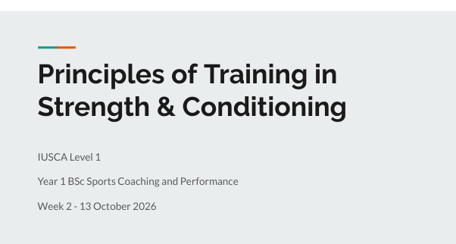

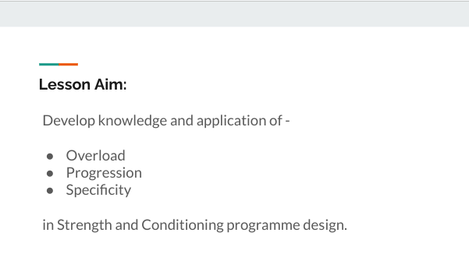

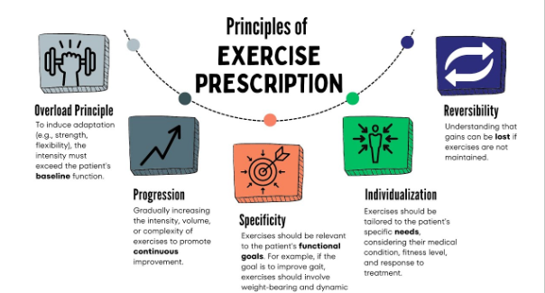

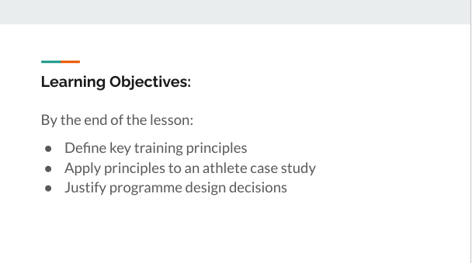

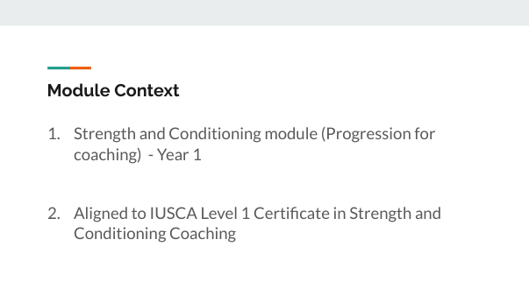

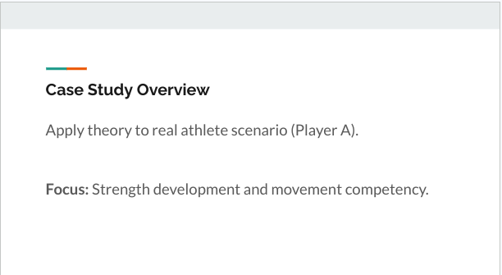

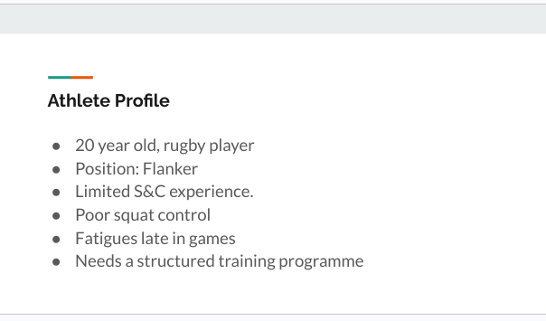

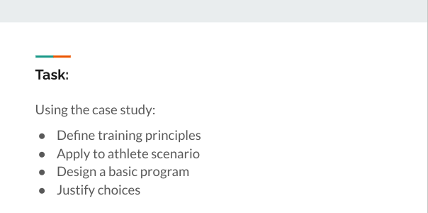

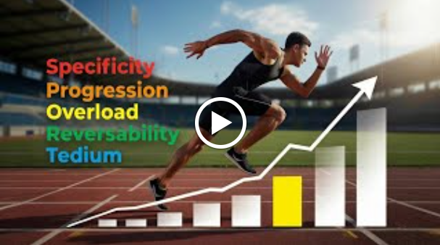

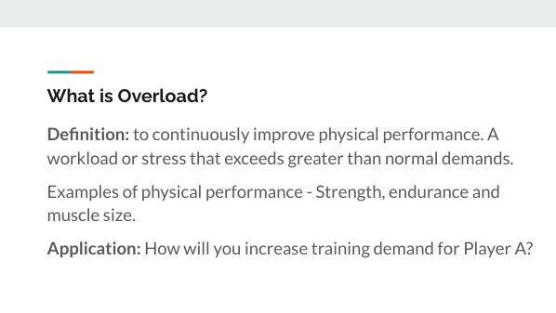

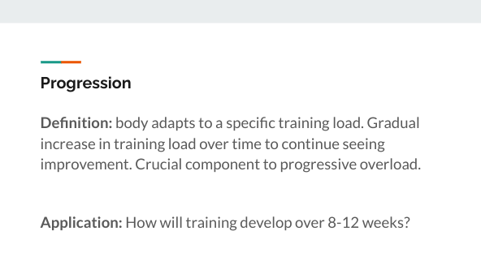

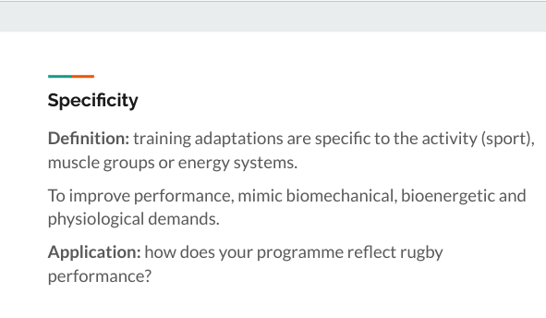



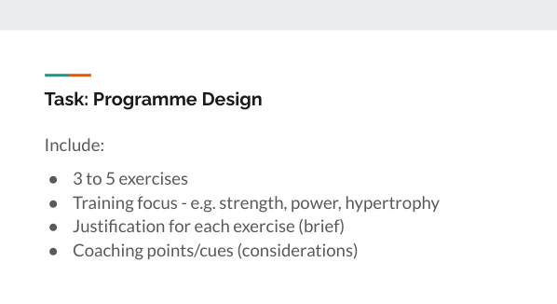

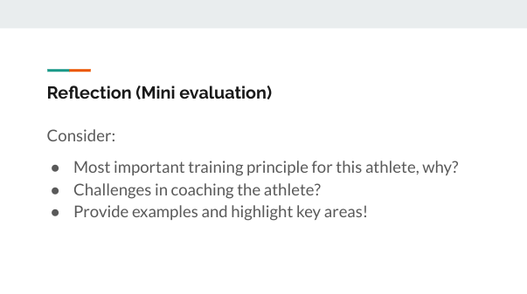

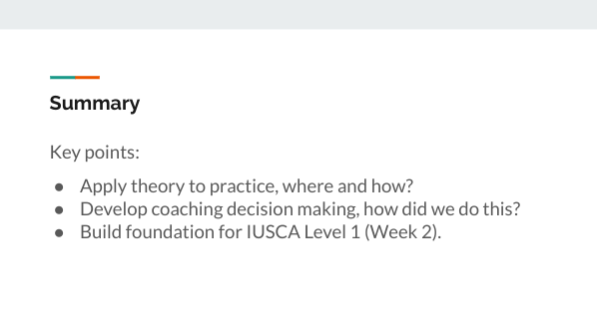

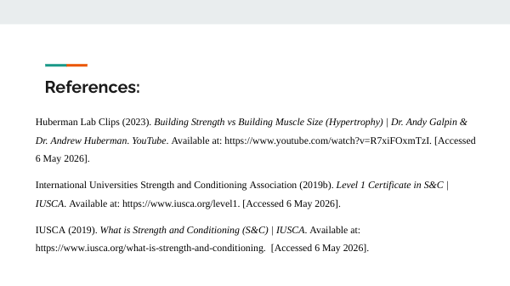

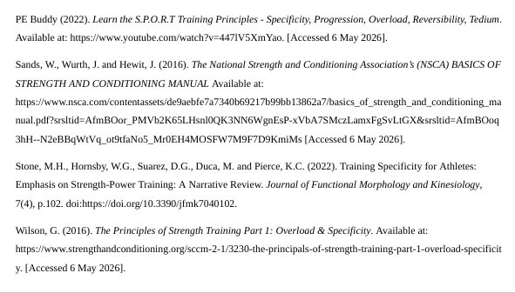

Lesson plan 2 - Practical

Lesson Plan

Topic: Coaching the Squat  Movement, Technique Development and Coaching Practice. |  | Class: Year 1 BSc Sports Coaching and Performance
Date: 3 November 2026  (Week 5) | Length of lesson: 1 hour |  | Number of students: 10+
Resources required:

- Gym - training space.
- Equipment - squat racks, barbells, plates and resistance bands.
- Mobile phones or tablets - video feedback.

Aim of Lesson

To develop student ability to safely coach and perform barbell squat, applying correct technique, coaching points and error strategies aligning with Strength and Conditioning practice and IUSCA Level 1 Standards.

Learning Outcomes – The Learners Should Be Able To:

- Demonstrate safe and technically correct squat movement.
- Identify technical errors.
- Apply effective coaching points/cues to improve performance.
- Reflect on coaching using video and peer feedback.

Previous student knowledge required for the session:

- Knowledge of basic movement patterns - hinge, squat, push and pull.
- Awareness of gym safety and equipment.
- Coaching communication and leadership styles.

Anticipated difficulties (if applicable):

- Mobility and stability limitations.
- Lack of confidence.
- Identifying technical errors.

Professional Standards (where are these being met within the session)

Demonstrate commitment to learners, their learning, safety and well-being -
- Gym safety and briefing.
- Tutor led demonstrations - squat technique.
- Supervision during lift

Value and promote diversity, equality of opportunity and inclusion -
- Differentiated progression
- Peer coaching
- Coaching roles.

Demonstrate dignity, courtesy and respect towards others -
- Professional communication and respectful coaching.
- Peer coaching - constructive and respectful feedback.
- Clear expectations for the gym.

Maintain and update knowledge of my subject(s) and how best to teach and assess them -
- Correct squat biomechanics and coaching cues.
- Progressive teaching methods.
- Assessment through observation.

Know how to use evidence and research to improve my practice -
- Technique before intensity.
- Video feedback - visual learning and motor skill development.
- Session structure links to experiential learning.

Plan and deliver effective learning, teaching and assessment -
- Clear session structure.
- Formative assessment - observation, peer feedback and questioning.

Build positive and collaborative relationships -
- Peer coaching - work collaboratively.
- Tutor Circulates - support and encourage students.

Critically reflect on own values, knowledge and skills to improve learning -
- Plenary discussion - reflect on technique and coaching.
- Video feedback - identify strengths and areas for improvement.
- Post reflection - set targets.

Lesson Detail:

Stage | Focus | Strategy | Time
Introduction  Development 1  Development 2  Development 3  Plenary/conclusion | Session focus - aims and objectives (IUSCA).  Safety.  Technical breakdown  Practical performance - execution  Coaching application.  Reflection. | A quick induction to the gym and show the space.  Gym safety briefing. Demonstrations on how to use gym equipment (safety).  Explain what a squat is, why it's used and the benefits - link to sport performance.  Show a clear demonstration of squat (technique).  Safety and supervision.  Breakdown the squat technique into phases - setup, descent, drive and finish.  Coaching points/cues to each phase - link exercises to each phase to help develop the squatting movement.  Identify and explain common faults to the squat.  Students perform exercises (warm up) and build up the squat.  Start off with bodyweight squats and progress to loaded squats.  In pair - peer coaching.  Coaching points + perform squat + record + video feedback.  Reflect on videos, adjust coaching points. Adapt coaching and training. Perform again after corrections are in place.  Group discussion (whole class) on technical errors identified and key coaching points used.  Future improvements for next time? | 10 minutes.  10 minutes.  15 minutes.  20 minutes.  5 minutes.

Assessment Strategies: when and how are they included within the lesson?

- Tutor observation on technique and safety.
- Peer coaching feedback - supervising and coaching points.
- Video analysis for reflective evaluation.
- Informal questioning to assess student learning and progress.

