From Lithography to WEB: the British Museum’s 1896 Enkomi Excavations by Dr Lindy Crewe: A review

Introduction
This essay is a review of Dr Lindy Crewe’s From Lithography to WEB: the British Museum’s 1896 Enkomi Excavations. This writing discusses the British Museum’s Enkomi excavation and their uploads of the excavated material to the online archive. Crewe tries to explain how archaeological methods such as excavation strategies and what she calls “archaeological agendas” can skew the understanding of a site. Also showing the usefulness of the online archive in researching the site years after the site was excavated in 1896.

Summary of argument
Crewe makes it known that the site was misinterpreted several times including as a Byzantine site due to the discovery of the remains of two small chapels and shallow graves found in the upper soil layer containing mediaeval wares. This, unfortunately, led to the damaging of the site, which has led to numerous pits that litter the site making the stratigraphy difficult to research. Making matters even worse, due to the Turkish invasion of Cyprus, we can no longer investigate the site further leaving our understanding of the site hindered by outdated archaeological practices. Crewe notes that the 1896 excavation spared no attention to where the artefacts were found, nor the human remains to which they were found with. Instead, the excavation was to collect artefacts that could be displayed in a museum et infinitum the so-called “aesthetic bias.” Particularly local pottery was discarded by the 1896 excavation despite being the second most common type of artefact found in the tombs with imported pottery seemingly being more common than local Cypriot pottery. Crewe put it like this “the selection of only the more valuable, exotic or aesthetically pleasing objects for collection, and even more so for final publication, by the British Museum expedition led to a perception of greater 'foreignness' of the contents of the 100 excavated tombs than is the case.” (Crewe, L. 2007) Essentially the value placed on the objects that are perceived to be more important due to their aesthetics or the “foreignness” means that the data set we have for the contents of the tombs. Furthermore, the lack of burial context given by the initial excavations leads to even further conjecture.

About the author
Lindy Crewe is from Sydney, Australia for a while she worked as a graphic designer before she enrolled at La Trobe University in Melbourne to study archaeology where she wrote her undergraduate thesis on spindle whorls after going on excavations in Cyprus with the Cyprus American Archaeological Research Institute. Since then, she has taken on a PhD under Edgar Peltenburg and subsequently undertook directorship of the Kissonerga-Skalia site. (Caari.org, 2022) Crewe is currently working with Diane Bolger on Sousikou-Laona. Additionally, Crewe has been very influential with papers she has written such as Feasting with the dead? Tomb 66 at enkomi.

Summary of contents
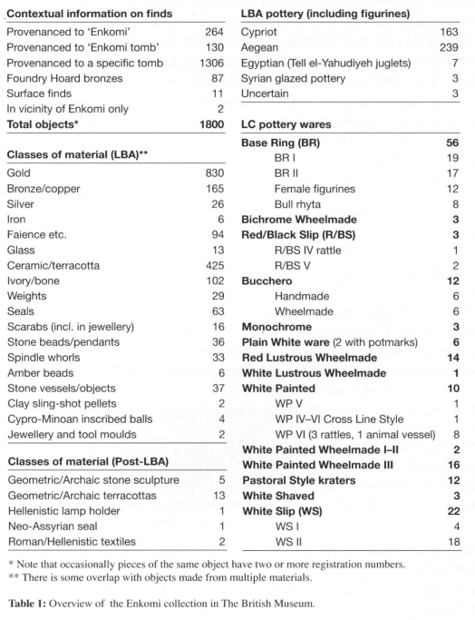
This chapter of Crewe’s book goes through the History of the Enkomi site including misunderstandings of the site such as the miss interpretation of the site as Byzantine it also shows how the tombs are typically laid out with. It then goes through interpretation of the British Museum’s Enkomi collection, including for example a table displaying type, the provenance of artefacts, and the location of manufacture of certain artefacts. (see below)
Then Crewe mentions how value judgements have been placed upon the objects as I mentioned previously the “aesthetic bias.” Crewe then concludes that, although these are certainly amongst the wealthiest tombs, the British Museum’s selection of artefacts has altered our interpretation of the sites.

Strength
One part I find particularly persuasive is the “aesthetic bias” as many of the objects I have looked at in the British Museum online collection of items found at Enkomi during the 1896 excavation. This is made more evident by the lack of context of where the items were found within the tombs for example the placement of the burial goods or the gender of the person they were buried with. (Crewe, L. 2007) This shows a huge flaw in the way how the British Museum excavated the site in 1896.

Weakness
What this chapter of Crewe’s book does not do well is the actual interpretation of the limited information we have. Instead, Crewe focused on the “aesthetic bias” of the objects on the British Museum's website rather than the methodology to interpret the items in the web archive. She posits that greater access to these materials online will allow for greater study as more people can have access to the objects. But, how valid can the information we glean from the objects be as much of the material has been specifically chosen for aesthetic purposes? While this may be a nihilistic view of the information available, we can never truly know how much information has been lost because of this.

Conclusion
Overall, Crewe makes some good points the aesthetic bias of the original excavation continues to hamper our understanding of the site. Furthermore, subsequent excavations of the site have damaged our understanding further with the use of pits to find more grave sites damaging much of the stratigraphy of the site. Crewe mentions that these subsequent excavations can help with alleviated the bias caused by the 19th century techniques and recovery strategies by giving more modern analysis. It is undoubtable that the understanding of Enkomi will be greatly helped by the online archive I still believe that the lack of understanding of the actual burial context i.e., where the objects were placed who they were placed with etc greatly depreciates the value of said resource.

Bibliography
Caari.org. 2022. Staff. [online] Available at: <https://caari.org/staff/> [Accessed 12 March 2022].
Crewe, L 2007, 'From Lithograph to Web: The British Museum’s 1896 Enkomi excavations.', Archaologia Cypria, vol. V, pp. 57-70.
British museum archive https://www.britishmuseum.org/collection/term/x31300

