
REPORT Component 2
Module name: Changemakers: Building your Personal Brand for Sustainable Employment
Module code:BMHP5015_LON)
Student name: Diana Kryemadhi
Student ID:2024820
Caroline Salami

TABLE OF CONTENTS

Introduction……………………………………………………………………………………………………………1
Analysis of Persona Employability Skills Required………………………………………………………..2
Evaluate the Assessment of My Skills Compared to Job Requirements…………………………….3
Maslow’s Hierarchy of Needs…………………………………………………………………………………….5
Building a personal brand and professional identity………………………………………………………5
Action plan………………………………………………………………………………………………………………6
Conclusion ………………………………………………………………………………………………………………8
References………………………………………………………………………………………………………………..9

Introduction
This report takes a close look at the Mental Health Social Worker job at Lancashire County Council posted on Indeed for 2025. This role sits at the intersection of health and social care, with a clear purpose: to support people facing mental health challenges.
Working well with other agencies' staff, housing teams, police, and voluntary groups really matters. When professionals maintain accurate records, they hold themselves accountable and ensure care remains consistent (Department of Health and Social Care, 2023, 2025).
The Care Act 2014 outlines clear responsibilities for assessing needs and providing support. Alongside this, the Mental Health Act (1983/2007) addresses compulsory treatment and protecting patients. Safeguarding is not just about identifying risks; it is about acting on them. You will find a screenshot of the job advert in Appendix A, Figure 1 (Indeed, 2025), so you can view the vacancy and check the details yourself. For me, this career is more than just a job. I have always believed that mental health matters as much as physical health. Personally, I feel a strong connection to this work. I see mental and physical health as equally important, and I am inspired by the opportunity to help people on their recovery journeys.
The opportunity to help people recover and be part of their journey is what motivates me. This role combines compassion with practical skills, which perfectly matches what I am seeking. In this report, I will explore the responsibilities, qualifications required, and how this path aligns with my own ambitions for the future.

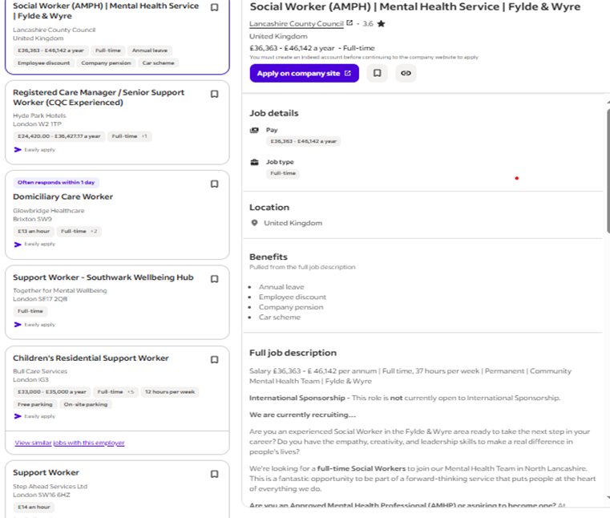

Fig.1 Indeed (2025)

Analysis of Personal Employability Skills Required
Being a Mental Health Social Worker at Lancashire County Council is not just about ticking boxes. You need to know the law inside out, especially the Care Act 2014 and the Mental Health Act 1983 (with the 2007 updates). Your responsibilities do not stop at day-to-day support. You are the one making tough calls, handling safeguarding, and managing risk, right at the heart of everything. It takes sharp judgment, strong record-keeping, and real teamwork across different agencies. The goal? Make sure adults with mental health needs get care that is not only safe, but built around them, person-centred, just like the Department of Health and Social Care lays out for 2025.
Communication sits at the heart of employability, verbal, non-verbal, all of it. Social workers need to listen closely, show real empathy, and shift their language to connect with patients who struggle to find the right words for their pain. The NHS Constitution for England puts respect, dignity, and compassion front and centre—these are not just ideals, they are requirements (Department of Health and Social Care, 2023). Then there is resilience. Mental health work demands it. The job pulls at your emotions, and it is on you to stay professional even when things get tough. Finch et al. (2013) point out that employability is not just about technical skills. It is about what you carry from job to job, teamwork, adaptability, and skills that sit right at the core of this profession.
Here is a real example from my placement that shows these skills in action. I worked with a patient who had just left the hospital. He started to withdraw and skip his medication. My job was to assess the risks and raise any concerns. So, I did a thorough risk assessment, talked things through with his psychiatrist, and brought in the housing officer to tackle the stress he faced at home. I flagged safeguarding issues and made sure to record everything on the NHS system. In the end, he did not get readmitted. He got back on track with his recovery plan, and his housing situation got better. This STAR example really highlights statutory awareness, safeguarding, and how well multi-agency teams can work together.
Reflective practice is not just a slogan; it genuinely boosts employability. Moon (2013) points out that Kolb’s Learning Cycle drives professional growth through four stages: concrete experience, reflective observation, abstract conceptualisation, and active experimentation. When I used Kolb’s model, I saw how crucial early intervention is. I linked housing stress and relapse and decided I will involve housing services sooner in the future. Reflection does not just help you look back; it turns experience into real learning, pushing practice forward all the time.
The Lancashire County Council role calls for more than just knowing the law or understanding safeguarding. You need strong communication, real resilience, and the ability to work well with others. Social workers here lean on frameworks like the Care Act, the NHS Constitution, and Kolb’s reflective cycle, not just to check boxes, but to show genuine skill and a real commitment to compassionate, evidence-based care.

Evaluate the Assessment of My Skills Compared to Job Requirements
Working as a Social Worker for Lancashire County Council’s Mental Health, they want you to be qualified, confident, and, honestly, good with people. I wanted to know if I am up for it, so I took a long, honest look at myself using a SWOT analysis and reflected on what drives me, looking at it through Maslow’s hierarchy of needs.
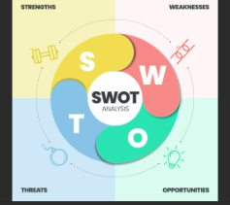
Fig.2 (Vecteezy, 2023).

Strengths
I connect easily with people. Empathy matters to me. I try to understand where others are coming from and treat everyone with respect.
Example
In my placement at a health and social care setting, I helped users with their daily needs and talked often with staff and outside professionals. I made sure everyone had the right information and kept records current. That way, care stays organised, and everyone is on the same page using teamwork and communication, which this role demands.
That lines up with the Council’s push for innovation and inclusion. I am clear when I write or speak, which helps teams work together, even when we come from different backgrounds. Pressure doesn’t throw me off; I stay steady and focused. In all this, I stick to the NHS Constitution’s values: dignity, respect, and compassion (Department of Health and Social Care, 2023).

Weaknesses
This role expects you to register with Social Work England. If you already have Approved Mental Health Professional (AMHP) status, great; if not, you can train for it once you are in post. They want someone who knows adults’ mental health services and feels comfortable with other agencies. They say we are not just filling a spot; they want you to grow. Supervision, training, and professional development are all part of this job, as you build your leadership and expertise.

Opportunities
There is a lot I can do to move forward. Lancashire County Council offers structured AMHP training, and I am planning to sign up. I want to take more professional development courses too, things like advanced safeguarding and leadership training, so I can handle complex caseloads with more confidence. Getting involved in community mental health projects as a volunteer will give me hands-on experience and help me learn how to supervise and lead a team. All this fits with the Care Workforce Pathway, which focuses on continuous learning and professional growth (Department of Health and Social Care, 2025).

Threats
Recruitment is tough. Plenty of applicants already have AMHP status and years of experience under their belts, which makes standing out a real challenge. Then there is the emotional toll that comes with mental health work. If I am not careful, that pressure chips away at resilience. I rely on reflective practice, good supervision, and well-being support to keep myself grounded and steady.

Maslow’s Hierarchy of Needs
Maslow’s hierarchy really lines up with what drives me. I want financial security, sure, that steady job matters. But there is more, I care about working with a team, building real connections with patients and colleagues. And I am always chasing something higher, that sense of self-actualisation. I want to be an AMHP, to lead, to make a difference. That is why I throw myself into new qualifications, training, volunteering, and anything that pushes me to grow and lets me help others in a real way.
Conclusion
I connect well with people, communicate clearly, and bounce back from challenges, qualities that fit what Lancashire County Council’s Mental Health Team looks for. Still, I know I need more hands-on experience, extra qualifications, and stronger leadership skills. I’m determined to close those gaps. I plan to take AMHP training, volunteer, and keep learning, all driven by a real desire to grow and reach my potential as a skilled, compassionate social worker.

Building a Personal Brand and Professional Identity
As a future Mental Health Social Worker, I want my work to reflect what matters most to me: empathy, respect, and fairness. I see each person as an individual, no matter their background or diagnosis. These are not just my values; health and social care demand them. Listening, supporting people’s choices, and keeping them safe (BASW, 2021).To stand out, I keep my CV fresh. I highlight my university work, hands-on experience, and the volunteering I have done in mental health. LinkedIn helps me build a professional profile. I connect with others in the field, join social work and mental health groups, and grow my network. This helps me pick up new ideas and hear about job opportunities (NHS Careers, 2023). What makes me different? I build trust fast. Holland’s Theory of Career Choice (Sheu et al., 2010) says people enjoy their jobs more when their work matches their personality, and my “social” and “helping” side fits this field perfectly. The Career EDGE model, Mayangsari et al. (2019), shows how reflection, emotional intelligence, and strong communication skills boost employability.
Action plan

This action plan consolidates my objectives and outlines the steps I will take to achieve them, integrating my studies, work experience, and personal development into a cohesive plan for the next few years.

Short-term goals
- First up: I want to finish my current health and social care course by the end of the year and sharpen the skills I have already started to build.
- I will pay close attention to feedback from my tutors, use it to tighten up my academic writing, get organised, and speak up more in class or on placement.
- Meanwhile, I am going to stick with part-time or voluntary care work. Nothing beats real-life experience for learning how to communicate well, keep good records, and handle basic safeguarding.

Long-term goals
- In the next year or two, I want to land a paid position as a support worker or healthcare assistant.
- That way, I’ll get real, hands-on experience working with service users and see how professionals work together.
- After that, say, two or three years down the line, I am aiming for more responsibility.

Timeline and activities
- In the first year, the plan is simple: build a strong foundation. Take CPD courses on mental health and other key topics. Keep track of what you’re learning, write it down, and reflect on it.
- Around the six-month mark, start ramping up. Spend more hours on care work, volunteer more, shadow experienced colleagues, and meet regularly with a supervisor.
- By the end of the second year, you’ll update your CV and get ready to aim higher, go for senior positions or apprenticeships. Resources and support
- I am planning to keep my studies and mental health in check by using student funding and picking up a part-time job.
- I will talk to tutors and mentors when I need advice on my courses or when stress starts piling up. Study-skills workshops and online tools will help me stay organised with my research, too.

Period | Key Action | Smart Goal Focus
0-6 months  6-12 months  1-2 years  2-3 years | Enrol in the Level 6 HSC Course  Gain a part-time care role; attend a CPD workshop on safeguarding.  Apply for AMHP training, engage in mentoring and supervision.  Secure a full-time Social Worker post, advance CPD, postgraduate course | Specifically, complete the first module  Measurably pass the initial assessment  Time-bound: finish by June 2026  Specific, secure role  Mesurabke:20h/week  Relevant: builds frontline experience  Achievable; supported by the employer  Time-bond; achieve AMHP by 2027  Specific: manage caseload  Relevant: matches career goal  Time bond: by 2028-2029

SMART goals and self-efficacy
I am building this plan around SMART goals, so every step is clear, realistic, and has a deadline. For example, I am set on finishing one accredited safeguarding course and logging at least twenty hours of supervised practice in the next six months. As my skills and self-confidence grow, a future in health and social care feels increasingly within reach.

Conclusion
Becoming a Mental Health Social Worker means stepping up for people who need support the most. It is about standing by values like empathy, resilience, and clear communication, really being there for others. Sure, there is still more to learn and more training ahead, but I see that as a chance to grow. Maslow’s hierarchy inspires me; I want to find real personal fulfilment and make a difference in mental health care. At the core, it is about fairness and respect for every person I work with.

References
Department of Health and Social Care (2023). The NHS Constitution for England. London: Department of Health and Social Care. Available at: https://www.gov.uk/government/publications/the-nhs-constitution-for-england (Accessed: 15 December 2025).
Department of Health and Social Care (2025). Care workforce pathway for adult social care. London: Department of Health and Social Care. Available at: https://www.gov.uk/government/publications/care-workforce-pathway-for-adult-social-care (Accessed: 17 December 2025).
Finch, D., Hamilton, L., Baldwin, R. and Zehner, M. (2013) ‘An exploratory study of factors affecting employability’, Education + Training, 55(7), pp. 681–704.
Indeed (2025) Mental Health Support Worker – London. Available at: https://uk.indeed.com/jobs?q=mental+health+support+worker&l=London%2C+Greater+London&vjk=7388766d1e92fec8 (Accessed: 8 December 2025).
Mayangsari, E., Hermawan, M. and Juwono, V. (2019). Indonesian accounting professionals and ASEAN’s mutual recognition arrangement: An exploratory study of employability factors. Medan: European Alliance for Innovation (EAI).
Moon, J. (2013). Reflection and employability: Reflection on learning and employability. London: Routledge.
Morris, T.H. (2020) ‘Experiential learning – a systematic review and revision of Kolb’s model’, Interactive Learning Environments, 28(8), pp. 1064–1077.
Sheu, H‑B., Lent, R.W., Brown, S.D., Miller, M.J., Hennessy, K.D. and Duffy, R.D. (2010) ‘Testing the choice model of social cognitive career theory across Holland themes: A meta‑analytic path analysis’, Journal of Vocational Behaviour, 76(2), pp. 252–264.
Vecteezy (2023) SWOT analysis infographic with icons template. Available at: https://static.vecteezy.com/system/resources/previews/013/421/030/original/swot-analysis-infographic-with-icons-template-has-4-steps-such-as-strengths-weaknesses-opportunities-and-threats-business-and-marketing-strategy-visual-slide-presentation-or-banner-diagram-vector.jpg (Accessed: 16 December 2025).
Wijnen-Meijer, M., Gartmeier, M. and Berberat, P.O. (2020) ‘Overview on research in the field of medical education’, *HNO

