Gallwch ychwanegu’ch targedau o’ch aseiniad diwethaf (Ond yn berthnasol os yr ydych wedi cwblhau aseiniad) / Please add your targets from the previous assignment (Only relevant if you have completed an assignment)
Targed/Target 1
Targed/Target 2
Targed/Target 3
Targed/Target 4
Targed/Target 5

Critically reflect on your pedagogical progress demonstrated through required elements of the Professional Learning Passport, identifying a specific area for professional development and justifying next steps for improvement.

Link to Professional Learning Passport:
https://v3.pebblepad.co.uk/spa/#/public/kwhG4ZjyWGy64nqxz64mnjr75Z

Part 1
An educational theorist called David Kolb, introduced a reflective model that has four stages and in 1988, another theorist called Graham Gibbs further developed this reflective model. Gibbs’ reflective model (see appendix one) asks 6 questions that enhance and encourages reflective practice. Reflective practice is thinking about an experience with a view to gain an improved understanding of that experience and involves an ordered and systematic approach to do so. By reflection and analysis, we try to understand experiences. In order to reflect on my teaching practice, I have used Gibbs reflective model which has allowed me fully to analyse and reflect on my decisions and choices when planning and teaching.

Digital competence is the set of skills, knowledge and attitudes that enable the confident, creative and critical use of technologies and systems. It is vital and essential for children if they are to be informed, capable and have the potential to be successful in today’s society and future’s society to be digitally competent and have digitally transferable skills. In order to ensure that in any classroom that I teach I will be confident to use any digital skill.
With COVID-19 having a lasting effect on education and learning in 2020 and 202, children across Wales have been required to learning from home which had meant that teachers and educators have had to use their digital knowledge to apply it to real life situations. Within my final teaching placement that I completed throughout and out of lockdown I was required to teach using SeeSaw and Teams. I was provided with an iPad that included various educational apps with my own login by my placement school. I soon became familiar with the apps that other staff were using to create their lessons on SeeSaw and mirrored what other teachers were doing to keep a similar teaching style throughout the school.
As we are not sure what education in September in Wales will look like as COVID-19 is unpredictable, I have undertaken an online course that trained me how to use Google Classroom (see appendix two) as many schools across Wales used it in lockdown. Even though my school did not use this educational tool, it is still valuable to my teaching practice because as lockdown eases some schools may choose to keep some of the new approaches they have adapted in their normal routines. For example, at the end of my placement, all the children were in school like usual, school assemblies were still no longer available and thus had to take place online. The school I was in used Microsoft Teams which I was familiar with but in other schools Google Classroom may be their chosen educational tool to use.
To ensure I further how digital competent I am as a teacher I will continue to facilitate the use of ‘events’ in HWB as they are very helpful. There are many courses there that will allow me to develop my subject knowledge in all areas of learning.

Throughout my teacher training it has been apparent that the Welsh language is a vital part of the new curriculum. For my teaching practice to improve, it is imperative that I am confident in my own Welsh language ability. To ensure that I am as confident as I can be when delivering Welsh language lessons to primary school children I have undertaken an online course which will later result in improved fluency (see appendix three). I am sent an email every week with selected vocabulary that will aid me in developing the use of my incidental Welsh in and out of the classroom environment. However, there is a shortage of Welsh teachers that are able to teach the Welsh language which results in a problem with promoting a thriving Welsh language throughout Wales. By learning Welsh, myself I am combating this issue by educating myself in the Welsh language, so it is authentic for the children I teach. There is a growing need for immediate action to build teachers and school leaders’ confidence so that they can lead children to also become confident with their Welsh language abilities both informal and formal settings (Donaldson, 2015). The Welsh language is very important in and out of schools across Wales. This is why I am completing a course which will enable me to eventually become fluent which will help me to deliver authentic Welsh confidently in the classroom. I believe that this has helped my teaching practice during each placement I have undertook as I have felt confident enough to use incidental Welsh during all times of the day and not just in Welsh language lessons. Now, I have the confidence to deliver new material to the children with multiple activities and introduce new vocabulary outside of a conventional Welsh language lesson.
Within my time at university I have also been a part of the Welsh Society (see appendix four) which requires members to pay a fee. The Welsh Society are a society that holds events that encourage members to speak Welsh and engage with Welsh and Welsh language activities. This experience was a good experience to aid my Welsh language development. Again, it is imperative that I feel confident to deliver real-life authentic contexts for primary school children to experience. With this experience I have accessed an authentic part of the Welsh language that is invaluable. This has given me the opportunity to learn from other Welsh speakers from all areas of Wales with all varied experiences of living in Wales/being Welsh. However, it could be argued that this has not been valid authentic experience due to the effects that COVID-19 has had on university events. During the time in which COVID-19 has affected events, the Welsh Society have been unable to accommodate these events due to restrictions. As unpredictable the global pandemic was, I do believe that more could have been done to ensure all students who are members of the Welsh Society were experiencing an authentic Welsh experience. For example, this could have been combatted with zoom calls whereby quizzes could have become a way for everyone to communicate.

During my time within my final placement school where I have made lots of progress with my teaching practice I have had an opportunity to plan for progression in a sequence of lessons. By planning for a progression in a sequence of lessons it allowed me to develop the children’s skills in various Areas of Learning. The term learning progression refers to the purposeful sequencing of teaching and learning experiences across various and multiple developmental stages, ages and areas of learning.
I had the opportunity to teach and plan for year 5/6 classes whereby I planned for various Areas of Learning. The key stage two topic was ‘celebrations’ which I was given full responsibility for. This planning and teaching was completed online over SeeSaw due to the result of COVID-19’s effect on education. I created a series of lessons on SeeSaw that all related to Day of the Dead which linked to the children’s topic of ‘celebrations’.
To ensure the children were able to be leaders of their own learning I created a Google Form document (see appendix five) whereby the children were able to choose what celebration they wanted to focus on for their topic work. The children were given a choice of various celebrations that take place across the globe e.g. Mardi Gras, Day of the Dead, Diwali. The children all mostly chose Day of the Dead which resulted in the planning being solely based on their decision.
I started the topic by introducing the celebration of Day of the Dead by asking the children to use their digital skills to find out more about the celebration themselves. They were required to watched linked videos about the chosen celebration to then make a voice over about all the important information they found. Throughout the three weeks I had planned for this topic to take place, I planned and taught 12 lessons/activities for the children to complete which included a variety of Areas of Learning for the children to develop a range of various skills e.g. problem solving. By planning each of these lessons I have demonstrated that I have a sound understanding of how learning develops ‘incrementally and tangentially’ builds on prior experience and learning and plans for progress in learning based on this. Throughout the three weeks’ worth of sessions and lessons the children gradually learnt more and more about a topic that they chose to learn more about.
I believe that the children benefited from the planned and taught lessons during the three weeks as it included scaffolding because each time they would complete a lesson they would learn more about Day of the Dead as they were building on previous knowledge and also applying that same knowledge to future tasks. As the children have had disrupted learning through the course of COVID-19, I believe that scaffolding was a very effective strategy. By using the children’s previous knowledge each lesson, I was using the educational theory of scaffolding to enhance their interest and responses (Wood, Bruner and Ross, 1976). Wood et al (1976) defined scaffolding as a process ‘that enables a child to solve a task or achieve a goal that would be beyond their unassisted efforts’. Scaffolding is a useful educational tool. I have used this during my topic lessons whereby I used the children’s previous understanding of the word ‘calavera’ which means ‘sugar skull’ to plan more activities whereby they would need the vocabulary. This could result in a stronger understanding as they can solely focus on the new activity without trying to understand the activity itself. I also demonstrate the use of prior knowledge when I recap the Welsh vocabulary for a family tree and compare it to a Spanish family tree. The children were required to use their previous knowledge of members of a family tree in Welsh to help them learn new information and vocabulary of members of a family tree in Spanish.
In order to help the children, progress further in their learning with the topic of ‘celebrations’ I would continue to use effective scaffolding to help build on the children’s previous knowledge.
I also planned and taught a series of maths lessons that showed a progression of learning. Again, due to the effects that COVID-19 has had on education and learning it meant that I had the opportunity to teach remotely and develop my digital skills. The children in the class had a wide range of abilities and to help plan for every child that was in the class I ensured to look at the relevant progression steps and the what matters statements (Welsh Government, 2020) which meant that I differentiated each of my planned maths activities three ways. This ensured that the children were being challenged at an appropriate level. I planned and taught a series of lessons on area then followed by volume in the following week. The children were given appropriate levels of tasks for their ability which meant I could appropriately show a progression when changing their focus. For example, with the lower ability children I planned for them to count the squares to calculate the area of a shape then followed by counting how many cubes a shape has to calculate the volume of a shape the following week. Throughout the lessons the children were building on their previous knowledge each time using scaffolding. This was an effective strategy to use because it ensured they were developing their previous skills and applying them to more difficult and complex questions and problems. This showed great progression in the children’s learning. In the future it could have been beneficial to push the lower ability to use the cubes to understand what numbers to multiply together to calculate the volume. This would have helped the children in the future when they finally arrive at using numbers to calculate the volume of a shape.

As I was given full ownership over the topic of ‘celebrations’ within my final teaching placement. This planning and teaching was completed online over SeeSaw due to the result of COVID-19’s effect on education. I created a series of lessons on SeeSaw that all related to Day of the Dead which linked to the children’s topic of ‘celebrations’.
To ensure the children were able to be leaders of their own learning I created a Google Form document (see appendix four) whereby the children were able to choose what celebration they wanted to focus on for their topic work. The children were given a choice of various celebrations that take place across the globe e.g. Mardi Gras, Day of the Dead, Diwali. The children all mostly chose Day of the Dead which resulted in the planning being solely based on their decision. To ensure the children had an authentic learning experience relating to the Day of the Dead it was vital that I understood and learnt about the celebration myself. To learn about this celebration more in depth I watched documentaries about Day of the Dead and in result I learnt lots about the traditions and customs of the celebration. After watching many documentaries, I felt comfortable and confident to deliver three weeks’ worth of lessons and activities for the children to follow at home through SeeSaw. Throughout learning about Day of the Dead I planned an activity for the children to create a family tree using Welsh and Spanish. Day of the Dead is a celebration whereby family is very important. It is a time where families come together to celebrate the lives of lost family members so therefore it was vital that I understood and was confident using the Spanish words for family members so that the children could learn more about Spanish/Mexican culture and history.
As the children were learning remotely, I recorded myself saying the Spanish vocabulary and the children listened then tried it themselves using the record tool on SeeSaw. The children all gave a fantastic effort to show me their family trees in Spanish and it made them understand the importance of family in Spanish and Mexican culture especially during Day of the Dead. In the future, it could be beneficial to have a video of a native Spanish speaker showing examples of how to say the Spanish vocabulary. This would have created a more real-life authentic context for the children to have their learning take place. Within the school there was a fluent Spanish speaker which I could have taken advantage of. In the future I would have asked the teacher to record themselves saying the Spanish vocabulary, so I could use it for my lesson. The children would have benefited from hearing someone who confidently speaks Spanish to confidently understand Spanish and Mexican culture and history.

My final placement school initiated a whole school project called Four Core Purpose Ninjas whereby they developed the well-being of their pupils. The Four Core Purpose ninja initiative allows all of their children to complete 101 activities that will enable them to become ambitious capable learners, enterprising creative contributors, healthy confident individuals and ethical informed citizens. A Google Form was sent out to parents/guardians asking them for their input, ideas and thoughts on this initiative which aided the staff’s task of putting together the 101 activities and tasks. During my time teaching at this school I had the opportunity to experience the project being launched. The children are required to collect coloured bands (like ninjas) which have all been categorised into the four core purposes. Within my class I led many of my lessons and days based around adding to this whole school project. For example, the literacy lessons were planned around Roald Dahl’s Revolting Rhymes and we learnt to have a whole class debate about whether or not Little Red Riding Hood was innocent or guilty of killing the wolf. Having a debate was one part of the tasks for the whole school project: ‘take part in a written or spoken debate’. I had used my past experiences as I have taught a whole class debate in previous classes which enabled me to reflect on my practice to ensure I was progressing the children’s learning. Last time I did not have any questions ready to start conversations between the children and I previously did not establish what a debate and as a result of this some children were confused as to what was asked of them. This time I ensured that as a whole class we all had the same understanding of what a debate was, what they are used for and why they are used. The children were able to give some good evidence of understanding what a debate was. If I were to engage with this in the future I would ensure the children understood that when someone else is speaking they need to be quiet. There should only be one person speaking as in this activity the children did not understand taking turns and understanding when it is their turn to speak. By understanding and appreciating that they cannot speak over their peers they would learn to become ethical informed citizens.
During my time on placement I was also taking part with online learning whilst also being in school teaching the children whose parents are essential workers. The school started a weekly day of ‘Well-being Wednesday’ which allowed children to take time away from the screen and take time to be children and enjoy being outside and learning new skills – rather than sat behind a screen for many hours a day. As there were still children attending school, I planned for activities that did not require them to sit at a screen or writing in their books. To plan for these activities, I used the whole school project of ‘four core purpose ninjas’ as a reference and a starting point. Every week I would put on the board the activities that were available to complete in school and the children would vote on what activities they would like to take part in. I took the most popular activities and resources them and then on the day the children would choose which activities they would like to complete. For example, knitting, learning a new card game, building a den and going on a mini-beast hunt were all activities that were on the 101 four core purpose ninja task list.
By engaging with the whole school’s project of ‘four core purpose ninjas’ during my final teaching placement I have learnt that it is vital for schools and teachers to imbed the four core purposes into children’s learning as it allows them to develop new and old skills that will prepare them for their future so that they have the opportunity to progress.

Throughout all of my teaching placements I have had the opportunity to plan and teach for all areas of learning. Using the university’s lesson plan template, I have been able to plan with the four core purposes in mind. For example, in my second teaching placement I had the opportunity to take responsibility for the topic of ‘jobs’. One lesson was planned in mind of the four core purposes and most specifically in developing the children to become enterprising creative contributors who are ready to play a full part in life and work. The children were required to rank jobs on how much they contribute to society and then how much they were thought they made annually into a diamond ranking and the bottom being the least. It was interesting to see what the children’s thoughts were on both of these topics especially the annual salary as some children understood well what this meant, and others did not understand what ‘annual’ meant let alone how much an average person in the United Kingdom made in a year. At the end of the lesson I asked them what core purpose they believe that they developed, and all of the children were able to tell me what core purpose I had planned to develop. Next time I could have asked them how they could have developed other core purposes. For example, how could they have become ethical informed citizens during that lesson?

Part 2:
The Four Core purposes play a vital role in the Welsh curriculum, they are the starting point for most decisions made within a school and the school’s curriculum should be designed around the four core purposes. They will develop children and young people as (Welsh government, 2019):
Ambitious, capable learners who ready to learn throughout the entirety of their lives.
Enterprising, creative contributors who are ready to play a full part in life and work.
Ethical, informed citizens of Wales and the wider world.
Healthy, confident individuals who are ready to lead fulfilling lives as valued members of society.

Progression is an essential part to education which is why it is important for schools to have a shared understanding of what ‘progression’ means. As a year three pupil, Sophie will be expected to achieve progress in various skills from the Welsh curriculum. Principles of progression (Welsh Government, 2020) are included in the curriculum for Wales 2022 which suggests that “learning should always be at the heart of the curriculum design” which solidifies the importance of ensuring pupils are given opportunities to progress in various skills throughout the whole of the new curriculum, in all areas of learning. The design on Sophie’s reward-based intervention is personalised to fit her goals and abilities. Personalised learning approaches have shown compelling research that some approaches were found to be reliable and increased motivation in pupils. (Sebba et al, 2007). However, it was also added that schools and teachers who are using personalised teaching approaches are recommended to be selective and cautious as some approaches were found to be more reliable than others. It was noted that a change in teaching and learning practices with more personalised learning approaches, the children found there was more flexibility and autonomy which improved the communication between school and home (Sebba et al, 2007). Prain et al (2013) would possibly agree with Sebba et al (2007) as they also studied research that found that personalised learning demonstrated high-quality teaching and learning, target setting and tracking and highly supportive of children’s wider needs.
My final placement school initiated a whole school project called Four Core Purpose Ninjas whereby they developed the well-being of their pupils. The Four Core Purpose Ninja initiative allows all of their children to complete 101 activities that will enable them to become ambitious capable learners, enterprising creative contributors, healthy confident individuals and ethical informed citizens. A Google Form was sent out to parents/guardians asking them for their input, ideas and thoughts on this initiative which ensured the staff of the school were collaborating with the community. During my time teaching at this school I had the opportunity to experience the project being launched. The children are required to collect coloured bands (like ninjas) which have all be categorised into the four core purposes.
Curriculum for Wales has been designed that all children and young people have a purpose in their own learning because it underpins everything that they will learn and experience. During my time at this school I had the opportunity to take part with this project. The school started a weekly day of ‘well-being Wednesday’ which allowed children to take time away from the screen and take time to be children and enjoy the outside by learning new skills – rather than sat behind a screen for many hours a day. As there were still children in school as their parents were essential workers throughout COVID-19 lockdown restrictions, I still had to be present in school. As the children at home were enjoying their well-being Wednesday, I had to plan a enjoyable tasks for the children who were in school. I planned for activities that did not require them to sit at a screen or open their books to write. To plan for these activities, I used the whole school project of ‘four core purpose ninjas’ as a reference and starting point. Every week I would write various activities onto the board that I had taken from the list of 101 activities. The children would then vote for what tasks they would most like to try and take part in. I then took the most popular activities and resourced them to plan for the children on the Wednesday. For example, knitting, learning a new card game, building a den and going on a mini-beast hunt were all activities that were included on the four-core purpose ninja task list.

The Four Core Purposes provides children and young people with learning and an education that has a bigger meaning than just memorising information for examinations. The new Welsh curriculum 2022 guides the children and young people of Wales with a deeper understanding and importance of education as it has been designed to be more adaptable for teachers and educators to design their own school curriculum to best fit the children in their school. The children and young people of Wales in education will develop skills that are transferable for the rest of their lives which will set them up for the Wales and the wider world.

Donaldson (2015) stated in his review does not imply emphasis on any particular teaching approaches but instead suggests that decisions about teaching and learning are very context and purpose specific. This suggests that educators and teacher should use the four core purposes as inspiration and create a curriculum for their school tailored to their children. To tailor the learning experiences to the children it is important to ensure they are also having some input to being leaders of their own learning.

By using the four core purposes within a curriculum teachers and staff of schools across Wales are also using Donaldson’s pedagogical principles (2015). The 12 pedagogical principles ensure the teachers and staff of the school are identifying each of their children’s greatest needs by matching this need with a pedagogical principle and then by assessing the teaching approach.
For children and young people, the new arrangements will help to ensure that they experience the full benefits of primary education (Donaldson, 2015).
Mintz (2004, cited in Ricci, 2012) states that learner-centered education is ‘an approach that is based on the interest of the student rather than curriculum driven, where someone else has the idea of what you ought to be learning’. This suggests that when a school has a curriculum it is driven as an ideology that informs teachers what to teach. With the four core purposes as part of curriculum for Wales 2022, the new curriculum focuses on skills rather than certain topics to learn. Donaldson (2015) would argue that the new curriculum and assessment arrangements will have significant implications for teaching and learning and therefore for the ways in which teachers’ skills, and those of the wider workforce as the new approach that the new curriculum for Wales 2022 involves defining all children should experience and that there’s a belief that subject knowledge has ‘stood the test of time and remains the best path to a sound and relevant education’. In order to further my own teaching practice, it is imperative that I plan with the four core purposes in mind each time I deliver a lesson. This can be achieved across a range of Areas of Learning and in teaching approaches such as different assessment for learning techniques. For example, reward-based systems can teach children many skills from the four core purposes such as how to become enterprising creative contributors because it enables each child to exchange their reward points for something positive. This could teach the children the world of work and that when we do a job we can get paid for it. Children who learn through real-life authentic contexts learn to become enterprising, creative contributors to Wales (Donaldson, 2015). If I carry the four core purposes with me throughout my teaching practice it will ensure the children progress into their futures with skills from each of the four core purposes in mind. They will be prepared for future jobs and learning experiences.

Overall, it is vital that the four core purposes are taken into account when planning and teaching for children across Wales. The Four Core purposes play a vital role in the Welsh curriculum, they are the starting point for most decisions made within a school and the school’s curriculum should be designed around the four core purposes. The new Welsh curriculum 2022 guides the children and young people of Wales with a deeper understanding and importance of education as it has been designed to be more adaptable for teachers and educators to design their own school curriculum to best fit the children in their school which means that I need to develop the four core purposes throughout all of my planning.

Reference List

Donaldson, G. (2015) Successful Futures. Crown Copyright. Cardiff. Available at: http://gov.wales/docs/dcells/publications/150317- successful-futures-en.pdf [Accessed: 25 May 2021] p.68
Malthouse, R. and Roffey- Barentsen, J., 2013. Reflective Practice in Education and Training. London: Learning Matters Limited [Imprint], p.8.

Ricci, C. (2012). Unschooling and the willed curriculum. Encounter: Education for Meaning and Social Justice, 24, 45–48. Retrieved from https://great-ideas.org/Encounter/
Ricci243.pdf

Sebba, J., Brown, N., Steward, S., Galton, M. and James, M., 2007. An investigation of personalised learning approaches used by schools. Nottingham: DfES Publications.

Welsh Government, 2020. Principles For Designing Your Curriculum - Hwb. [online] Available at: <https://hwb.gov.wales/curriculum-for-wales/designing-your-curriculum/principles-for-designing-your-curriculum/#principles-of-progression> [Accessed 26 April 2021].

Welsh Government, 2020. Professional Standards - Hwb. [online] Available at: <https://hwb.gov.wales/professional-development/professional-standards#professional-standards-for-all-school-practitioners> [Accessed 27 April 2021].

Wood, D., Bruner, J., & Ross, G. (1976). The role of tutoring in problem solving. Journal of Child Psychology and Child Psychiatry, 17, 89−100.

Appendices
Appendix One:
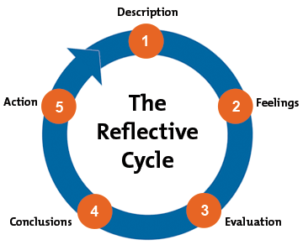

Appendix Two:
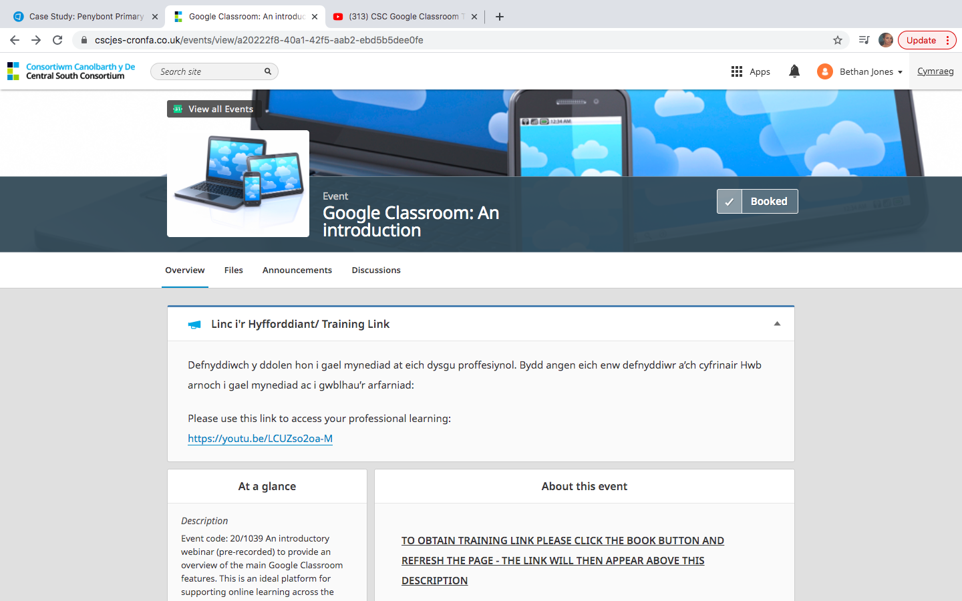

Appendix Three:
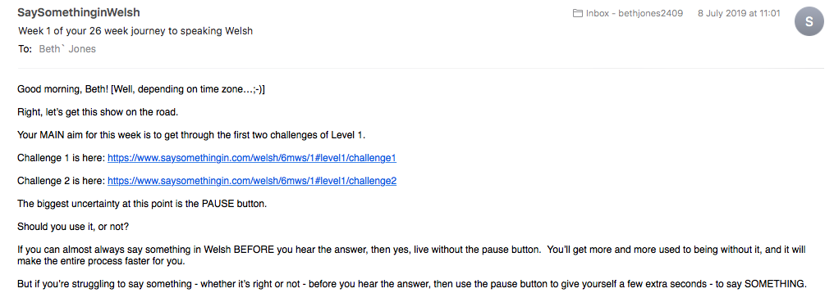

Appendix Four:
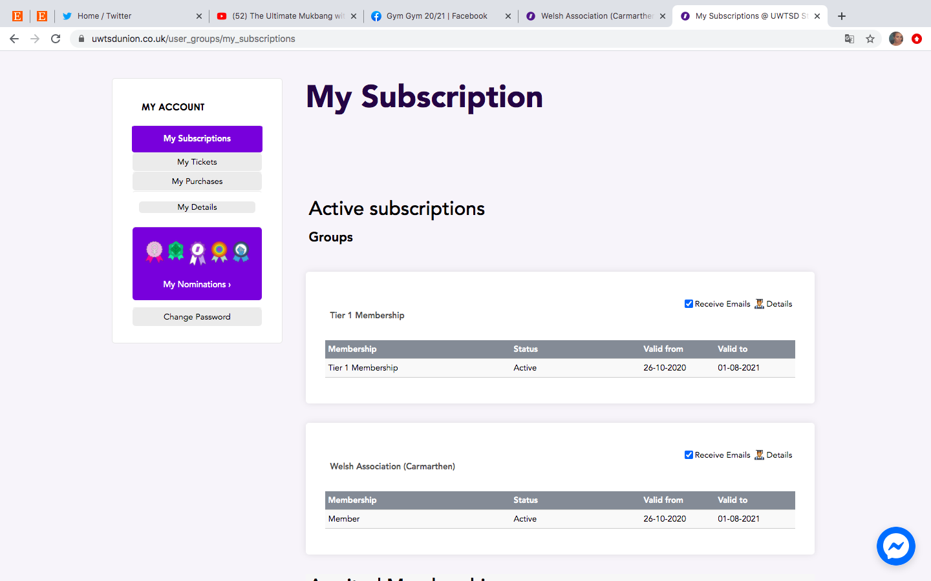

Appendix Five:


