

Converting Research into Practice
(LCDB7010_LON)
Investigating Digital Payment Transaction Dispute Management Practices and Their Role in Consumer Trust in Banks and Financial Institutions in Nepal

DBA Level 7

Student Name: Sobita Adhikari
Student Number: 2508627
Professor Name: Amare Desta

2026

Abstract
By increasing transaction efficiency, accessibility, and financial inclusion, the quick development of digital payment technologies has completely changed the banking industry. However, the prevalence of digital transaction issues, such as unsuccessful transfers, duplicate debits, and delayed settlements, has also increased due to the rising reliance on digital financial services. Therefore, efficient dispute resolution procedures are crucial for both operational effectiveness and preserving customer confidence in digital payment systems. The operational management of digital payment disputes within banking institutions has received relatively little attention in the literature, which has mostly concentrated on the adoption of digital payments and technological innovation.

This study investigates on how banks and other financial institutions in Nepal handle disputes involving digital payments and how this affects customers' trust in these services. A structured questionnaire was given to banking professionals who handle disputes involving digital payments as part of the research's exploratory pilot study design. The study investigates how organizational coordination mechanisms, operational procedures, and technical aspects impact dispute resolution procedures.

The results show that manual verification processes, poor system integration, and coordination issues between internal departments and external payment service providers frequently impact dispute resolution procedures. According to earlier studies (Liébana-Cabanillas et al., 2020; Alalwan et al., 2021; Hassan et al., 2022), prompt and transparent service recovery procedures are essential to preserving customer confidence in digital financial services. By analyzing the operational aspects of digital payment dispute management and offering practical suggestions for enhancing dispute resolution procedures and boosting customer confidence in digital banking systems, the study adds to the body of literature.
By demonstrating that dispute management quality is a trust-shaping service recovery mechanism in emerging payment ecosystems rather than just an operational issue, the study expands on the literature on digital banking trust.

Keywords: Digital payment systems; transaction dispute management; consumer trust; digital banking; financial institutions; banking operations.

Table of Contents
Abstract ii
Part One 1
1. Overview 1
1.1 Context and Background 1
1.2 Problem Statement 1
1.3 Research Goals and Purpose 2
1.4 Research Questions 2
1.5 Importance of the Research 3
1.6 Article Structure 3
2. Literature Review 3
2.1 Digital Payment Systems in Banking 3
2.2 Digital Transaction Disputes and Operational Challenges 4
2.3 Service Recovery and Dispute Resolution in Banking 4
2.4 Consumer Trust in Digital Financial Services 5
2.5 Literature Synthesis and Research Gap 5
3.1 Foundational Theories 6
3.2 The Study's Conceptual Framework 6
Figure 3.1: Conceptual Framing of the Study 7
3.3 Link Between Conceptual Framing and Research Questions 8
4. Methodology 8
4.1 Research Philosophy 8
4.2 Research Design 9
4.3 Research Methodology 9
4.4 Participants and Sampling Technique 10
4.5 Data Collection Technique 10
4.6 Data Analysis Techniques 10
4.7 Ethical Aspects 11
5. Data Analysis and Conclusions 11
5.1 Overview of Data Analysis 11
5.2 Profile of Respondents 11
Table 5.2.1: Respondents profile 12
5.3 Nature of Digital Payment Disputes and Reporting Channels 12
Figure 5.3.1: Nature of digital payment disputes 13
Reporting Channel 13
Table 5.3.2: Common channels for reporting digital payments disputes 13
Source: Survey Data (2026) 13
5.4 Digital Payment Dispute Resolution Process 14
Table 5.4.1: Digital payment dispute resolution process 14
Source: Survey Data (2026) 14
Table 5.4.2 Digital payment dispute resolution process 15
5.5 Operational and Organisational Factors Affecting Dispute 15
Resolution 15
Figure 5.5.1: Operational & organizational factors affecting dispute resolution 16
Figure 5.5.2: Operational & organizational factors affecting dispute management 16
Source: Survey Data (2026) 17
5.6 Technology and System Support in Dispute Management 17
Figure 5.6.1: Technology and System Support in Digital Payment Dispute 17
Management 17
Figure 5.6.2: Impact of Dispute Resolution Delays on Customer Trust 18
5.7 Consumer Trust and Perception of Dispute Resolution 19
Figure 5.7.1: Consumer trust & perception of dispute resolution 19
5.8 Process Improvement and Strategic Solutions 20
Figure 5.8.1: Key Improvement Factors in Dispute Management 20
Table 5.8.1: Supporting Responses on Improvement Area 20
Figure 5.8.2: Usefulness and Feasibility of Improving Dispute Management 21
5.9 Thematic Analysis of Qualitative Improvements 22
Table 5.9.1: Thematic Analysis of Institutional Dispute Management Improvements 22
5.10 Summary of Important Results in Connection with Study Goals 23
6.1 Overview 23
6.2 Conceptual Implications 24
6.4 Implications for Policy and Regulation 25
6.5 Contribution to Practice 25
6.6 The Study's Limitations 25
6.8 Conclusion 26
Appendix: Survey Questionnaire 27
Part 2. Reflective Account 32
1 Introduction 32
2. Selecting a Topic and Professional Environment 32
3.Engagement with Literature 33
4. Methodological Choices and Research Design 33
5. Experience with Data Collection and Analysis 34
6. Challenges Encountered and Solutions 34
8. Research Development and Learning Outcomes 35
9. Reflection's Conclusion 36
References 37

Part One

Overview

1.1 Context and Background
Faster transactions, increased accessibility, and better financial inclusion have all been made possible by the quick development of digital payment systems, which has drastically changed the global banking industry. In order to fulfill changing client expectations and stay competitive in a technologically advanced environment, banks in both established and emerging economies have rapidly embraced digital platforms like mobile banking, online banking, and electronic payment systems (Feyen et al., 2021; Ozili, 2021). The modernisation of the banking industry in Nepal has been aided by the growth of digital financial services, which has been aided by regulatory measures and a rise in the use of electronic payment methods.

Nevertheless, in addition to these advantages, digitalisation has brought additional operational risks and complications, especially with regard to transaction errors, system failures, and service interruptions (Frost, 2020; Vives, 2021; Ozili, 2021). The growing number of digital payment transaction disputes which arise when transactions fail, are delayed, are completed improperly, or are disputed by customers is one of the most significant issues arising from digital banking systems. Due to the fact that these conflicts include numerous departments, systems, and frequently outside payment service providers, they pose a serious operational risk to banks and need lengthy and complicated resolution procedures (Kou et al., 2021; Vives, 2021).

1.2 Problem Statement
Even with improvements in digital payment infrastructure, many institutions still struggle to effectively handle transaction disputes. Service delivery may be delayed and inconsistent as a result of the manual verification procedures, interdepartmental coordination, and communication with external institutions that are frequently involved in dispute resolution (Kou et al., 2021; Gomber et al., 2021). In developing banking environments like Nepal, where digital systems are still developing and institutional integration may be restricted, these operational inefficiencies are especially noticeable.
Customers may become dissatisfied, frustrated, and lose faith in digital banking services if digital payment disputes are not resolved promptly. Adoption and sustained usage of digital financial services are largely dependent on trust, and even in cases where the underlying technology is dependable, poor dispute resolution can erode trust in banking institutions (Alalwan et al., 2021; Rahi et al., 2021).
The adoption and trust of digital banking have been thoroughly studied in the literature, but the operational management of digital transaction disputes and its effects on customer trust have received very little attention. This draws attention to a significant gap in banking practice and scholarly study, especially when it comes to emerging financial systems.

By focusing on the practical reality of dispute management within banks and utilizing the perspectives of banking professionals who are directly involved in resolving disputes involving digital transactions, this study fills this gap. In doing so, it sheds light on how corporate procedures affect consumer trust and service results in online banking settings.

1.3 Research Goals and Purpose
The purpose of this study is to look into digital payment transaction dispute resolution procedures and how they affect Nepalese consumers' faith in banks and financial institutions.
The following goals are pursued by the study in order to accomplish this goal:

• To determine the kinds of digital payment transaction conflicts that are frequently seen in banking operations

• To investigate the difficulties and operational procedures related to conflict resolution

• To examine how organizational and technology elements influence dispute resolution procedures.
• To assess the impact of dispute resolution procedures on customer confidence in online banking services.
· To make practical suggestions for enhancing banking organizations' dispute resolution procedures

1.4 Research Questions

The following research questions represent the study's direction:
1. What operational and organizational factors influence digital payment transaction dispute management practices in Nepalese banking sector?
2. Which stages of the dispute resolution process create operational challenges in digital payment systems?
3. How do dispute resolution procedures influence consumer trust in digital payment services?
1.5 Importance of the Research
Both scholarly research and banking practice benefit from this study. Theoretically, by highlighting the significance of dispute management as a service recovery mechanism rather than just an operational procedure, it expands on previous research on digital banking and customer trust. This study emphasizes the significance of post-transaction service quality in influencing consumer impressions, whereas previous research has mostly concentrated on adoption and technology acceptance.

Practically, the study provides insight into the operational difficulties banking personnel encounter when handling disputes involving digital payments. The report provides suggestions that can assist banks in improving dispute resolution procedures, raising customer confidence in digital financial services, and identifying important inefficiencies and opportunities for development. In emerging banking contexts, where digital transformation is advancing quickly but operational systems and coordination mechanisms are still developing, this study is especially pertinent. This is in line with previous research that highlights the importance of recovery procedures and service quality in determining consumers' trust in digital financial services (Alalwan et al., 2021; Rahi et al., 2021).

1.6 Article Structure
The rest of this article is organized as follows. Section 2 examines pertinent research on consumer trust, dispute resolution, and digital payment systems. The study's conceptual framework is presented in Section 3. The research approach used for the pilot project is described in Section 4. The empirical results are presented and analyzed in Section 5. The implications for theory and practice are covered in Section 6, and the study is concluded with suggestions and future research areas in Section 7.

2. Literature Review

2.1 Digital Payment Systems in Banking

Digital payment systems have become an essential component of modern banking, enabling real-time transactions, improved accessibility, and enhanced financial inclusion. The expansion of contemporary banking, internet banking, and electronic payment platforms has significantly transformed financial service delivery across both developed and emerging economies (Feyen et al., 2021; Ozili, 2021; Gomber et al., 2021). In developing nations such as Nepal, regulatory assurance and increased technological adoption have accelerated the transition towards digital financial services

However, Digital transformation increases productivity, but it also brings with it new operational risks. Incomplete or inaccurate transactions can result from transaction failures, system problems, and network disruptions, which raise the risk of service failures (Frost, 2020; Vives, 2021; Kou et al., 2021). These dangers draw attention to a fundamental conflict in digital banking systems, where new operational vulnerabilities are created as technical advancements enhance service delivery.

Convenience, usability, and innovation have been highlighted in the literature that has already been written about the acceptance and advantages of digital payment systems (Alalwan et al., 2017; Rahi et al., 2021). The operational effects of digitalization, particularly with regard to transaction conflicts and their handling, have received very less attention, though. This indicates a lack of knowledge about how digital banking systems operate when there is a service outage.

2.2 Digital Transaction Disputes and Operational Challenges

Digital transaction disputes arise when payment transactions are not completed as expected, including failed transactions, delayed settlements, duplicate debits, or improper processing. These disputes represent a significant operational challenge because they involve complicated interactions between multiple systems, departments, and external institutions such as payment service providers and clearing networks (Vives, 2021; Gomber et al., 2021).

From a practical perspective, the process of resolving disputes involves a number of steps, including the registration of complaints, transaction verification, investigation, coordination, and final resolution. Any level of inefficiency can lead to delays and higher operating expenses (Kou et al., 2021; Davenport, 2021). Resolution is made more difficult by the fact that dispute management procedures in many banking settings, especially in poor nations, frequently rely on human intervention and disjointed systems.
Despite its significance, previous research has tended to view transaction failures more as technical problems than as organizational and process-related difficulties. This restricts knowledge of how internal operational elements, such system integration, interdepartmental cooperation, and process efficiency, impact conflict resolution results. As a result, rather than viewing dispute management as a discrete technical issue, it is necessary to consider it as an integrated operational process.

2.3 Service Recovery and Dispute Resolution in Banking

A significant structure for comprehending how businesses react to service outages is provided by service recovery theory. It highlights that customer satisfaction after a failure depends on the speed, fairness, and transparency of the recovery process in addition to the result (Van Vaerenbergh and Orsingher, 2016; Gelbrich and Roschk, 2011).
When it comes to banking, dispute resolution can be seen as a type of service recovery, whereby banks try to gain back the trust of their clients after a transaction goes wrong. Timely response, transparent communication, and equitable resolution results are essential components of successful service recovery. According to research, bad experiences can be lessened and trust can be rebuilt when clients believe that recovery attempts are just and effective (Tax, Brown, and Chandrashekaran, 1998; Van Vaerenbergh and Orsingher, 2016).

However, the majority of service recovery studies concentrate on general service industries and fail to sufficiently address the complexity of digital payment systems, where inter-organizational coordination and technology systems are involved in dispute settlement. This suggests that service recovery theory needs to be applied to the field of digital financial services, especially with regard to transaction disputes.

2.4 Consumer Trust in Digital Financial Services

The adoption and ongoing utilization of digital banking services are known to be significantly influenced by consumer trust. Perceptions of financial institutions' responsiveness, security, and dependability influence trust (Gefen, Karahanna, and Straub, 2003; Alalwan et al., 2021; Rahi et al., 2021).
Trust is particularly vulnerable to service failures in digital payment contexts. Customers' trust in the system is dependent on how well transaction issues are handled. While delays and inadequate communication can seriously erode customer confidence, effective and transparent dispute resolution can strengthen trust by exhibiting institutional dependability (Zhang et al., 2021; Hassan et al., 2022).

Few studies have specifically looked at how dispute resolution procedures affect customer trust, despite the fact that previous research has shown a high correlation between service quality and trust. This is especially crucial in developing nations, where the use of digital banking is growing quickly yet operational systems may still be in the early stages of development.

2.5 Literature Synthesis and Research Gap
A number of important insights are highlighted in the evaluated literature. First, although digital payment systems have many advantages, they also come with operational concerns that may result in disagreements over transactions. Second, while being a complicated organizational process with many steps and players, scholarly research on dispute resolution is still lacking. Third, the efficiency of service recovery procedures has an impact on customer trust in digital banking in addition to system dependability.
Despite these discoveries, there is still a dearth of comprehensive studies looking at how internal operational factors impact dispute resolution procedures and how these procedures impact customer trust outcomes. Previous research has mostly concentrated on client impressions or technology adoption, paying little attention to how operational procedures and behavioral results interact.

By looking at digital payment dispute resolution from the viewpoint of banking experts and analyzing how operational procedures affect customer confidence in digital banking services, this study fills this knowledge gap. Through the integration of perspectives from consumer trust literature, operational management, and service recovery theory, the study advances both scholarly comprehension and real-world enhancement of dispute resolution procedures in financial institutions.
3. Conceptual Framework of the Study

3.1 Foundational Theories
Three major literary strands service recovery theory, consumer trust in digital financial services, and operational process management are integrated to form the conceptual framework of this study. These viewpoints offer a theoretical foundation for comprehending how disputes pertaining to digital payment transactions are handled and how these procedures affect consumers' confidence in financial institutions.

The theory of service recovery describes how businesses react to service breakdowns and how recovery initiatives affect customer satisfaction and perceptions. The idea specifically highlights the significance of prompt response, transparent communication, and procedural fairness in rebuilding customer trust (Van Vaerenbergh and Orsingher, 2016; Gelbrich and Roschk, 2011). Because transaction disputes are a type of service failure in digital banking systems, dispute resolution procedures can be thought of as methods for service recovery.

This viewpoint is further supported by consumer trust theory, which emphasizes how perceived dependability, responsiveness, and institutional competence affect trust in digital financial services (Gefen, Karahanna, and Straub, 2003; Alalwan et al., 2021). Customers' faith in digital banking systems is significantly influenced by the efficiency of dispute resolution when they encounter transactional problems. While poor communication and delays can undermine consumer confidence, prompt and transparent dispute resolution can strengthen trust (Rahi et al., 2021; Zhang et al., 2021).

Additionally, the literature on operational and process management highlights how crucial efficiency, coordination, and system integration are to providing high-quality services. According to von Brocke and Mendling (2018), business process management (BPM) emphasizes that efficient workflow is supported by technical systems, well-organized procedures, and efficient unit coordination. Operational effectiveness is a crucial factor in determining performance outcomes in the area of digital payment disputes because resolution procedures usually entail several phases and stakeholders.

This study conceptualizes digital payment dispute management as a process that connects internal operational aspects with external consumer trust outcomes by incorporating various theoretical viewpoints. When combined, these viewpoints imply that digital payment dispute resolution is a crucial organizational process that connects internal service performance with exterior consumer trust results rather than just a technological or operational problem.

3.2 The Study's Conceptual Framework
To direct the pilot inquiry, this study uses a modified conceptual framing that was taken from the literature. To arrange important concepts, make connections clear, and match study design to theoretical knowledge, conceptual frameworks are frequently employed (Miles, Huberman, and Saldaña, 2019; Saunders et al., 2023). These frameworks function more as analytical guidelines than as formal models for hypothesis testing in exploratory pilot investigations.
The conceptual framework is predicated on the idea that operational, organizational, and technological issues all have an impact on how well digital payment dispute resolution procedures work. In particular, four crucial elements are found:
- dispute resolution process efficiency
- interdepartmental coordination
- technological system support
- communication with customers
These elements, which are derived from service recovery and process management literature that highlights efficiency, coordination, and responsiveness as important determinants of service quality, reflect crucial aspects of operational performance (Davenport, 2021; Kou et al., 2021).
The following analytical relationship is proposed by the study:
Operational Factors
(Process Efficiency, Interdepartmental Coordination,
Technological System Support, Customer

Digital Payment Transaction Dispute Management Practices

Consumer Trust in Digital Payment Services

Figure 3.1: Conceptual Framing of the Study
Source: Adapted from relevant literature
By converting internal operational efficiency and coordination into customer-facing service results that affect trust perceptions, this conceptualization presupposes that conflict management procedures serve as a mediating tool.between external customer outcomes and internal operating conditions. Customers are more likely to view digital banking services as dependable and trustworthy when complaints are handled effectively, openly, and within reasonable timelines. On the other side, ineffective dispute resolution procedures may have a detrimental impact on client opinions and erode confidence.
This interpretation is in line with research on digital banking that emphasizes the importance of responsiveness and dependability in building trust (Alalwan et al., 2021; Hassan et al., 2022) and service recovery literature that emphasizes how organizations respond to service failures has a significant impact on customer trust (Van Vaerenbergh and Orsingher, 2016).

Most importantly, this conceptual framework is offered as a contextualized synthesis of previous research, tailored to the particular circumstances of digital payment dispute resolution in Nepalese financial institutions rather than as a brand-new theory. Therefore, by connecting operational process management with service recovery and customer trust in the particular setting of digital payment disputes, this framing allows the study to add to the body of current knowledge.

3.3 Link Between Conceptual Framing and Research Questions
The conceptual framing provides a structured basis for addressing the research questions of this study. It links internal operational factors to dispute management practices and examines how these practices influence consumer trust outcomes.
Specifically:
- Research Question 1 is addressed by identifying the types of digital payment disputes and examining how operational factors contribute to their occurrence.
- Research Question 2 is addressed by analysing the operational challenges associated with dispute resolution processes, including coordination, system limitations, and process inefficiencies.
- Research Question 3 is addressed by evaluating how dispute management practices influence consumer trust in digital payment services.
The study guarantees coherence between theory, data collection, and analysis by coordinating the conceptual framing with the research questions. In pilot studies, when the goal is to produce significant insights and lay the groundwork for further study, this alignment is especially crucial.

4. Methodology

4.1 Research Philosophy

This study employs a pragmatic research philosophy, which is suitable for studies that tackle actual organizational issues and seek to produce knowledge that is practically applicable. In order to generate significant insights, pragmatism encourages flexibility in integrating several approaches and emphasizes the choice of methods that best address the study challenge (Mark Saunders et al., 2023; Morgan, 2022). For applied research in banking, where both theoretical comprehension and practical applicability are crucial, this approach is especially appropriate.

Critical realism, which holds that real-world structures and processes like digital payment systems and dispute resolution procedures exist independently of individual perceptions but may be experienced and interpreted differently by practitioners, informs the study from an ontological standpoint (Bhaskar, 1978; Fletcher, 2017). Critical realism is still relevant in organizational and management studies, especially when it comes to comprehending intricate operational systems and institutional procedures, according to recent study (Easton, 2022).

The research takes a pragmatic approach to epistemology, acknowledging that knowledge can be produced by both visible facts and real-world experience. In order to comprehend dispute management procedures and their effects on customer trust, standardized questionnaire data is used in conjunction with interpretive analysis of practitioner responses. In order to effectively address applied research concerns, pragmatic epistemology encourages the combination of quantitative and qualitative findings (Mark Saunders et al., 2023; Morgan, 2022).

Considering axiology, the study adopts a value-aware stance, recognizing that the choice of research topic, study design, and interpretation of results are influenced by the researcher's professional background in banking. Simultaneously, systematic data collection and analysis are used to minimize bias and preserve academic rigor. Acknowledging researcher values improves transparency and credibility in applied research, according to recent methodological discussions (Saunders et al., 2023).
In terms of methodology, the study uses a mixed-method exploratory pilot approach that combines qualitative thematic analysis of open-ended responses with quantitative descriptive analysis of survey data. The pragmatic philosophy, which encourages methodological pluralism and the use of several approaches to obtain a thorough grasp of challenging research issues, is in line with this strategy (Saunders et al., 2023)

4.2 Research Design

In order to investigate dispute resolution procedures for digital payment transactions, this study uses an exploratory pilot study methodology.
Pilot studies are frequently used to investigate new problems, evaluate research tools, and produce initial findings for additional study (Thabane et al., 2021). Pilot studies are especially helpful in understudied environments where exploratory understanding is necessary prior to doing large-scale studies, according to recent literature.

4.3 Research Methodology
The study uses a structured questionnaire and an exploratory descriptive methodology, producing mostly quantitative data with some qualitative insights.

In pilot studies when hypothesis testing is not the main goal, descriptive techniques are suitable for finding patterns and trends in organizational processes (Mark Saunders et al., 2023).

4.4 Participants and Sampling Technique

Purposive sampling is used in the study to choose participants who have firsthand knowledge of digital payment operations and dispute resolution.
In applied research, purposeful sampling is frequently employed to get information-rich data from participants with pertinent knowledge (Etikan and Bala, 2022). In pilot investigations, where the emphasis is on depth of understanding rather than statistical generalization, this method is especially suitable.

The study has 40 respondents in total, which is deemed sufficient for exploratory pilot research meant to produce initial insights (Thabane et al., 2021).

4.5 Data Collection Technique
A systematic questionnaire intended to capture important facets of digital payment dispute resolution was used to gather data.
Organizational research frequently uses structured questionnaires to guarantee response consistency and comparability (Hair et al., 2021). In order to ensure congruence between theoretical notions and empirical data collection, the questionnaire design was informed by research on service recovery, operational procedures, and consumer trust.

4.6 Data Analysis Techniques

A variety of descriptive and analytical methods suitable for an exploratory pilot study were used to analyze the data gathered for this investigation.
To find trends in digital payment dispute resolution procedures, quantitative data from structured questionnaire responses were first examined using descriptive statistical techniques, such as frequency distribution and percentage analysis. But the study went beyond straightforward description to analyze linkages and trends in the data, especially with regard to operational difficulties, inefficient processes, and their effects on customer trust.
This strategy supported the investigation of how dispute management procedures affect trust outcomes and allowed the study to progress from basic data summarization to analytical interpretation, which was in line with the research goals (Saunders et al., 2023).

Furthermore, Virginia Braun and Victoria Clarke's (2006) methodology was used to analyze the answers to the open-ended question using thematic analysis, using updated methodological guidelines from Braun and Clarke (2021). This required finding recurrent themes pertaining to system constraints, operational difficulties, and solutions for improvement.
In keeping with the pilot study's exploratory design, the combination of quantitative pattern analysis and qualitative thematic analysis produced a more thorough grasp of conflict management techniques.

4.7 Ethical Aspects
Voluntary participation, informed permission, and respondent confidentiality were all upheld throughout the research procedure (Mark Saunders et al., 2023).
4.8 Research Limitations
The research has various limitations because it is a pilot study. The use of standardized questionnaires may limit the depth of responses, and the comparatively small sample size restricts generalizability.
However, rather than yielding generalizable results, pilot studies are intended to offer initial insights and pinpoint important areas for more research.

5. Data Analysis and Conclusions

5.1 Overview of Data Analysis
The analysis and conclusions of the empirical data gathered via the survey questionnaire are presented in this chapter. Examining digital payment dispute management procedures in banking institutions and identifying important organizational, technological, and operational elements affecting dispute resolution procedures are the goals of this investigation.
Based on the sections of the questionnaire, the results are given in an organized fashion. The data is interpreted using descriptive statistical methods, such as percentage analysis and frequency distributions. When necessary, tables and graphical representations like pie charts and bar charts are employed to improve comprehension and clarity of the findings.

An overview of the respondent profile opens the chapter, which then analyzes the nature of conflicts involving digital payments, dispute resolution procedures, organisational and operational aspects, technology support, customer trust, and methods for process improvement.

5.2 Profile of Respondents

The respondents' professional and demographic details are shown in this section. Interpreting the survey results and determining their applicability to digital payment dispute resolution procedures requires an understanding of the respondent profile.

Table 5.2.1: Respondents profile

Variable | Category | Frequency | Percentage
Current Role in the Bank / Financial Institution | Branch operations staff | 24 | 60%
Current Role in the Bank / Financial Institution | Digital banking department | 1 | 2.5%
Current Role in the Bank / Financial Institution | Payment operations / settlement team | 1 | 2.5%
Current Role in the Bank / Financial Institution | Managerial position | 8 | 20%
Current Role in the Bank / Financial Institution | Customer service / complaint handling | 6 | 15%
Years of Experience in the Banking Sector | Less than 1 year | 0 | 0%
Years of Experience in the Banking Sector | 1–3 years | 3 | 7.5%
Years of Experience in the Banking Sector | 4–6 years | 14 | 35%
Years of Experience in the Banking Sector | More than 6 years | 23 | 57.5%
Frequency of Handling Digital Payment Disputes | Very frequently (daily) | 21 | 52.5%
Frequency of Handling Digital Payment Disputes | Frequently (weekly) | 11 | 27.5%
Frequency of Handling Digital Payment Disputes | Occasionally | 8 | 20%
Frequency of Handling Digital Payment Disputes | Rarely | 0 | 0%
Source: survey data (2026)
The demographics of survey participants are shown in the table. Branch operations engage the majority of responders (60%), followed by managerial roles (20%) and customer service or complaint handling positions (15%). Just 2.5% of responders are directly employed by the payment settlement teams and the digital banking department.
In terms of professional experience, the majority of participants (57.5%) have worked in the banking industry for more than six years, whereas 35% have worked there for four to six years. This suggests that the majority of the survey responses came from seasoned banking experts who were conversant with operational protocols.
27.5% of respondents address issues on a weekly basis, whereas 52.5% of respondents deal with digital payment disputes extremely regularly (daily).

5.3 Nature of Digital Payment Disputes and Reporting Channels
This section examines the types and reporting channels of digital payment disputes encountered within banking institutions. The analysis helps to find out the most common dispute issues and how they are communicated for resolution.

Figure 5.3.1: Nature of digital payment disputes
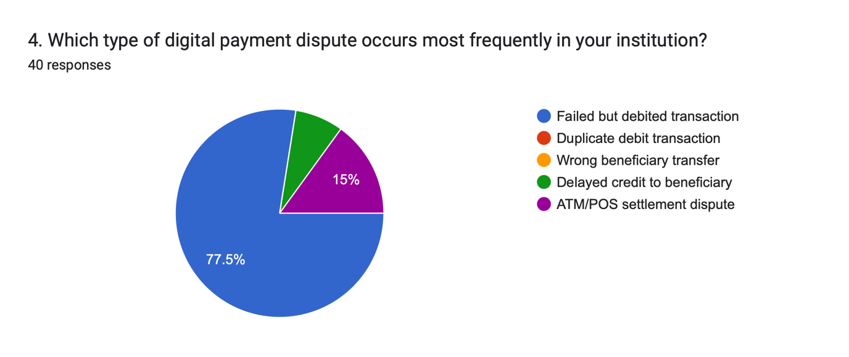
Source: Survey Data (2026)
Table shows the most frequently occurring digital payment disputes reported by respondents. The majority of respondents(77.5%) identified failed transactions where the amount is debited but the transaction is not completedas the most common type of dispute. This indicates that system or network failures remain a major operational challenge in digital payment processing.
ATM/POS settlement disputes account for 15% of reported issues, while 7.5% involve delayed credit to the beneficiary’s account. Interestingly, none of the respondents reported unauthorized transactions as a common dispute in their institutions. These results indicate that in digital payment systems, operational and system-related problems are more common than security-related disputes.

Reporting Channel

Table 5.3.2: Common channels for reporting digital payments disputes

Reporting Channel | Frequency | Percentage
Branch counter | 18 | 45%
Mobile banking application | 14 | 35%
Email or written complaints | 4 | 10%
Call centre | 3 | 7.50%
Internet banking | 1 | 2.50%
TOTAL | 40 | 100%

Source: Survey Data (2026)
The most frequently used channels for consumers to report disputes with digital payments are shown in the table. According to the results, branch counters continue to be the dominant reporting channel (45%), with mobile banking apps coming in second (35%). This implies that consumers still mainly rely on physical bank offices to handle transaction-related problems even in the face of growing digitization.
Less frequently utilized reporting channels include online banking platforms (2.5%), call centers (7.5%), and email or written complaints (10%). These findings demonstrate the ongoing significance of branch-level customer support in resolving disputes involving digital transactions.

5.4 Digital Payment Dispute Resolution Process
This section analyses the stages at which disputes arise and evaluates the efficiency of the dispute resolution process. It highlights key operational areas where delays or challenges may occur.

Table 5.4.1: Digital payment dispute resolution process

Survey Aspect | Response Category | Frequency | Percentage
Stage where digital transaction disputes most commonly arise | During transaction processing | 28 | 70%
Stage where digital transaction disputes most commonly arise | During settlement between banks | 7 | 17.5%
Stage where digital transaction disputes most commonly arise | During system reconciliation | 1 | 2.5%
Stage where digital transaction disputes most commonly arise | During customer complaint stage | 4 | 10%
Stage of dispute resolution process taking the longest time | Complaint registration | 2 | 5%
Stage of dispute resolution process taking the longest time | Investigation and verification | 7 | 17.5%
Stage of dispute resolution process taking the longest time | Coordination with banks and service providers | 20 | 50%
Stage of dispute resolution process taking the longest time | Final settlement and refund | 11 | 27.5%

Source: Survey Data (2026)
The operational stages where digital payment disputes usually occur and the stages that take the longest to resolve are shown in the table according to respondents' opinions. The findings show that 70% of disputes arise during the transaction processing phase, indicating that the most frequent reasons for disputes involving digital payments are system malfunctions, network failures, or incomplete transactions.
17.5% of conflicts occur during bank settlement, compared to 10% during the customer complaint stage and 2.5% during system reconciliation. These results show that rather than occurring later in the payment process, the majority of conflicts start at the operational transaction level.

The coordination stage with other banks and service providers is the most time-consuming part of the dispute resolution process, according to respondents (50%), followed by the final settlement and reimbursement procedures (27.5%) and the investigation and verification (17.5%). The most time-consuming step, according to just 5% of respondents, is complaint registration. These findings highlight the need for better system integration and communication across financial institutions by indicating that interbank coordination and settlement processes are the primary causes of delays in settling disputes involving digital payments.

Table 5.4.2 Digital payment dispute resolution process

Survey Aspect | Response Category | Frequency | Percentage
Disputes resolved within expected settlement timeframe | Always | 9 | 22.5%
Disputes resolved within expected settlement timeframe | Often | 17 | 42.5%
Disputes resolved within expected settlement timeframe | Sometimes | 11 | 27.5%
Disputes resolved within expected settlement timeframe | Rarely | 3 | 7.5%
Perceived effectiveness of dispute management process | Very effective | 4 | 10%
Perceived effectiveness of dispute management process | Effective | 25 | 62.5%
Perceived effectiveness of dispute management process | Moderately effective | 10 | 25%
Perceived effectiveness of dispute management process | Ineffective | 1 | 2.5%
Source: Survey Data (2026)

Respondents' perspectives about the effectiveness of digital payment dispute settlement in their organizations are displayed in the table. According to the results, 22.5% of respondents said that disagreements are always settled within the necessary timeframe, whilst 42.5% of respondents said that disputes are frequently resolved within the anticipated settlement timeframe. However, 7.5% of respondents said that disagreements are rarely settled within the allotted time, and 27.5% said that they are only occasionally settled within the anticipated time.
62.5% of respondents thought the dispute management method was effective, and 10% said it was extremely effective. Although dispute management systems are generally effective, there is still room for improvement, as seen by the smaller percentage (25%) who thought the process was moderately effective and 2.5% who thought it was ineffective.

5.5 Operational and Organisational Factors Affecting Dispute

Resolution
This section explores the internal factors influencing dispute resolution processes, including procedural clarity, coordination, and organisational support. The analysis provides insights into operational challenges within institutions.

Figure 5.5.1: Operational & organizational factors affecting dispute resolution
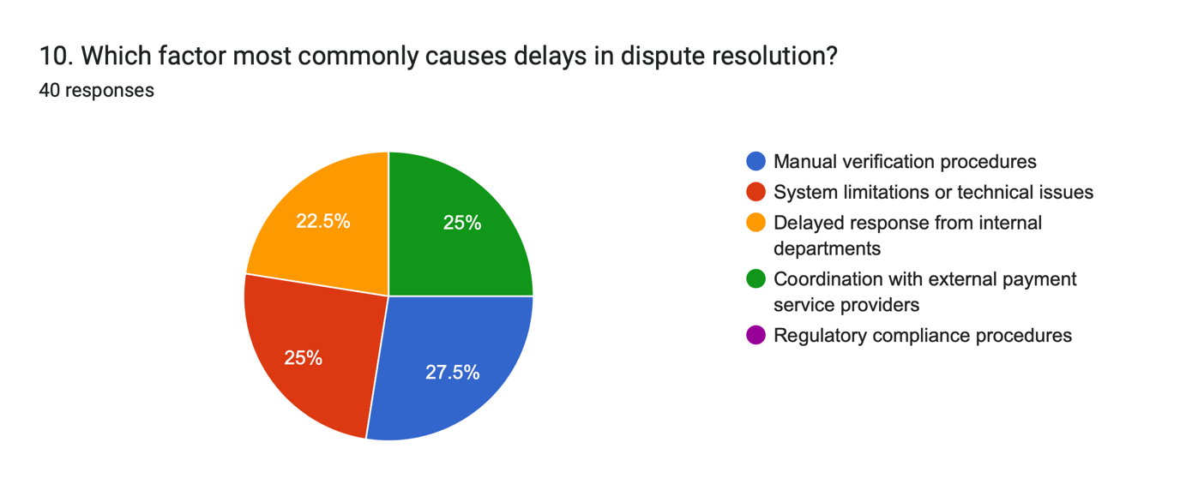
Source: Survey Data (2026)
The findings indicate that manual verification procedures are the most frequently cited cause of delays in digital payment dispute resolution(27.5%), suggesting that reliance on manual processes slows the verification and investigation stages of dispute handling. System limitations or technical issues(25%) and coordination with external payment service providers(25%) were also identified as major contributing factors to delays. Additionally, 22.5% of respondents reported delays caused by slow responses from internal departments, highlighting the importance of efficient interdepartmental coordination in dispute management. Interestingly, none of the respondents identified regulatory compliance procedures as a significant cause of delay, indicating that operational and technological factors play a more prominent role in prolonging dispute resolution processes.

Figure 5.5.2: Operational & organizational factors affecting dispute management

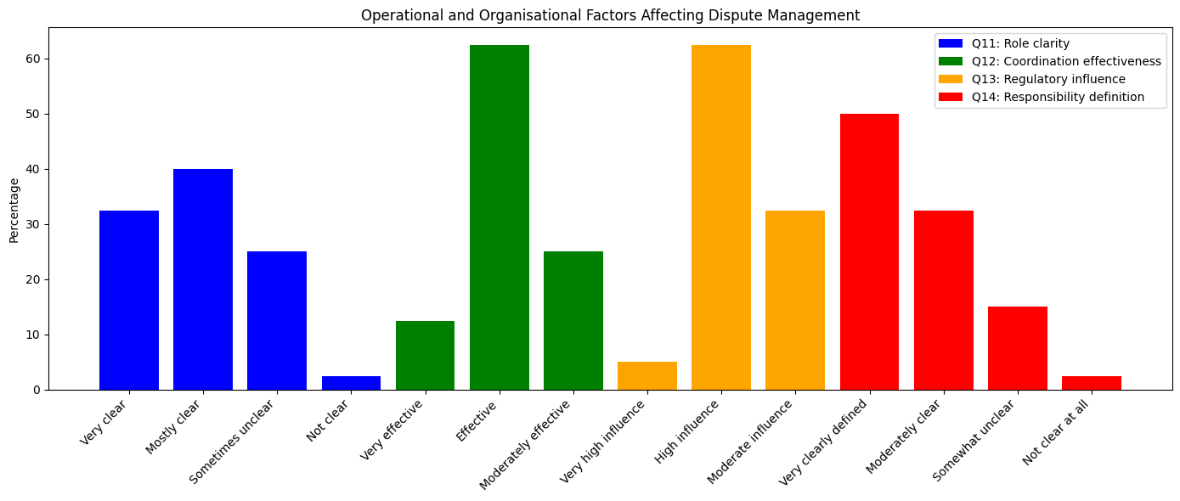

Source: Survey Data (2026)

Note:
Q11–Q14 relate to operational and organisational factors influencing dispute management (see Appendix)
The findings show that institutions generally have a good understanding of how to handle disputes. Procedures are fairly clear, according to 40% of respondents, and extremely clear, according to 32.5%. Nonetheless, 25% of respondents said that procedures are occasionally confusing, indicating that certain institutions can still have slight difficulties guaranteeing complete procedural clarity.
Departmental cooperation generally supports the dispute management process, as evidenced by the fact that 62.5% of respondents regarded internal coordination in dispute resolution as successful and 12.5% thought it was extremely effective. In a similar vein, 62.5% of respondents said that organisational support had a high degree of influence on dispute settlement.
Additionally, the results demonstrate that most institutions have clearly defined roles and duties in dispute management, with 50% of respondents saying that these are quite clearly defined. Overall, these findings point to the importance of organizational structures, coordination systems, and well-defined roles in facilitating efficient digital payment dispute resolution, even while there are occasionally small procedural ambiguities.

5.6 Technology and System Support in Dispute Management

This section examines at how digital systems help with tracking, investigating, and coordinating disputes. It evaluates the degree to which technology infrastructure supports dispute resolution procedures.

Figure 5.6.1: Technology and System Support in Digital Payment Dispute

Management

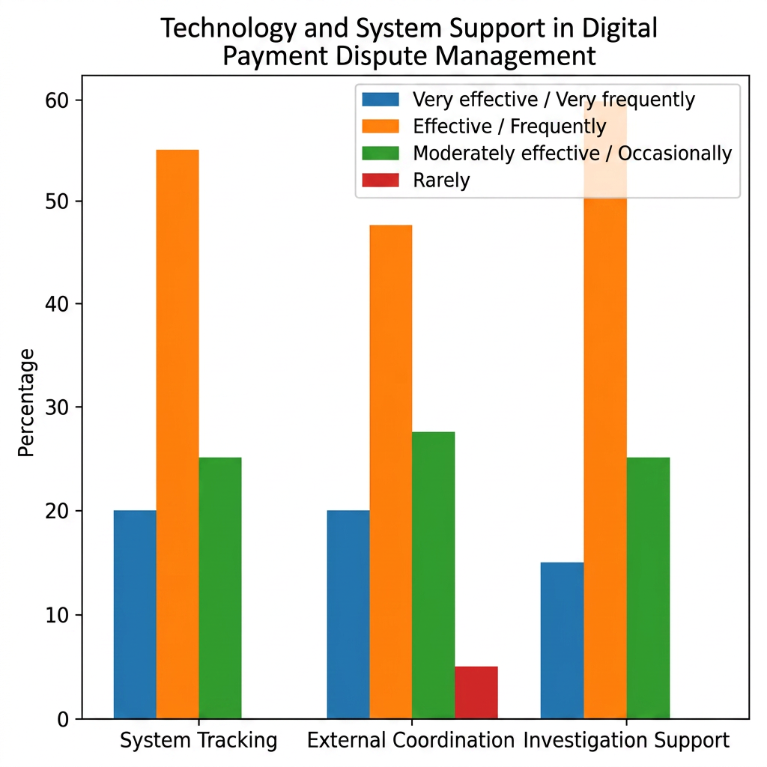
Source: Survey Data (2026)
The findings demonstrate how technology systems help with digital payment dispute resolution. The majority of respondents (55%) thought their institution's digital systems were effective for tracking disputed transactions (Q15), while 20% thought they were very good and 25% thought they were moderately effective. Although there may always be room for improvement, this indicates that the majority of institutions have operational mechanisms for tracking disputed transactions.
In reference to coordination with other banks or external payment service providers (Q16), 20% of respondents said it happens very frequently, while 47.5% said it happens frequently. This result emphasizes how crucial cooperation between banks and service providers is to settling disputes involving digital payments.
In a similar vein, 60% of respondents said the systems were helpful for assisting with the investigation of disputed transactions (Q17), and 15% thought they were extremely successful. All things considered, these results indicate that technology solutions are essential for recording transactions, conducting investigations, and coordinating digital payment dispute resolution.

Figure 5.6.2: Impact of Dispute Resolution Delays on Customer Trust
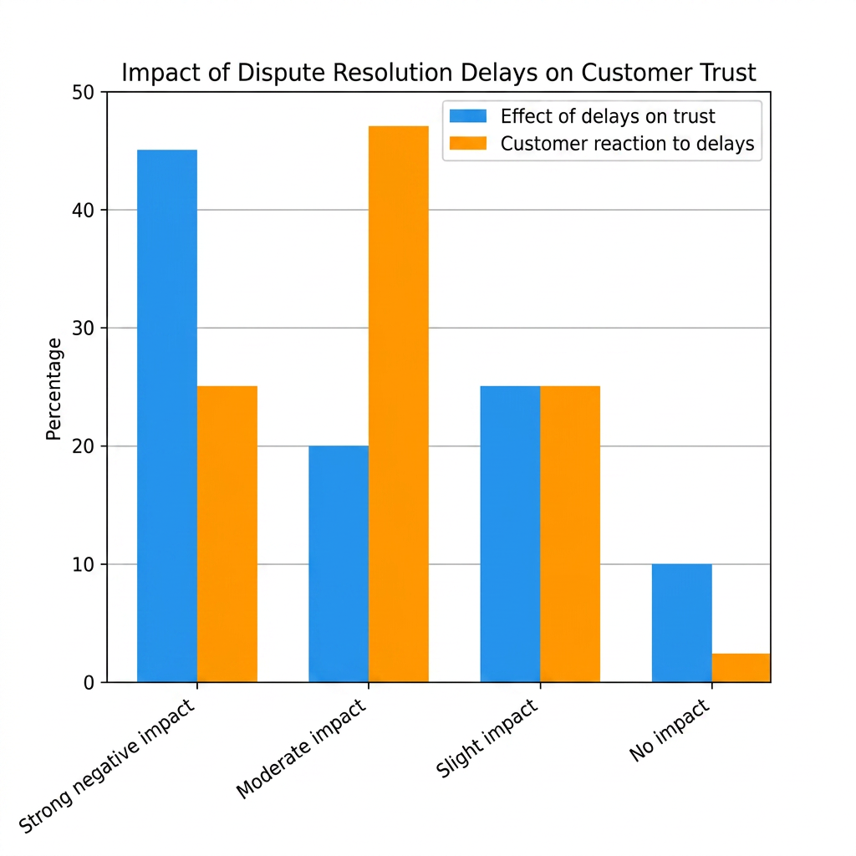
Source: Survey Data (2026)
The findings show that customer trust is significantly impacted by delays in digital payment dispute resolution. Delays severely lower customer trust, according to a sizable majority of respondents (45%), whilst 20% said they only somewhat lower trust. In a similar vein, 47.5% of respondents noted that consumers lose confidence in digital payment services when disputes take longer than anticipated to resolve, and 25% said that consumers severely lose faith. According to these results, customers' opinions and trust in online banking services may suffer if disputes are not resolved promptly.

5.7 Consumer Trust and Perception of Dispute Resolution
This section examines how dispute resolution practices influence customer trust and confidence in digital payment services. It highlights the importance of timely resolution and effective communication in maintaining customer relationships.

Figure 5.7.1: Consumer trust & perception of dispute resolution

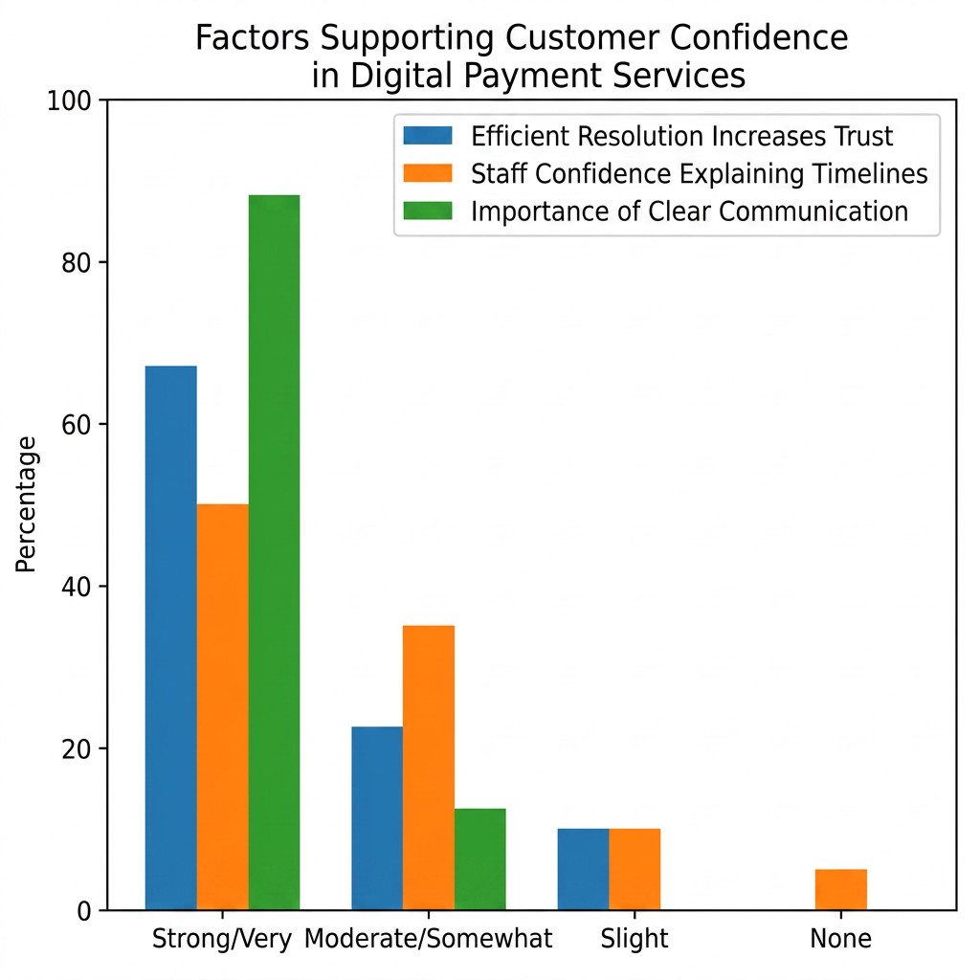
Source: Survey Data (2026)
The results emphasize how crucial effective communication and dispute resolution are to preserving client confidence. While 22.5% reported a slight rise in trust, the majority of respondents (67.5%) said that effective dispute resolution significantly boosts customer trust. Furthermore, 50% of frontline employees said they were extremely confident when describing dispute resolution timescales to clients, indicating that employees are crucial in controlling client expectations throughout the dispute resolution procedure. Furthermore, 87.5% of respondents emphasized that clear communication with customers during dispute resolution is very important, indicating that transparent communication and timely updates are essential for maintaining customer confidence in digital payment services.

5.8 Process Improvement and Strategic Solutions
This section presents respondents’ views on potential improvements in dispute management processes. It identifies key priority areas and evaluates the perceived feasibility of implementing these improvements.

Figure 5.8.1: Key Improvement Factors in Dispute Management
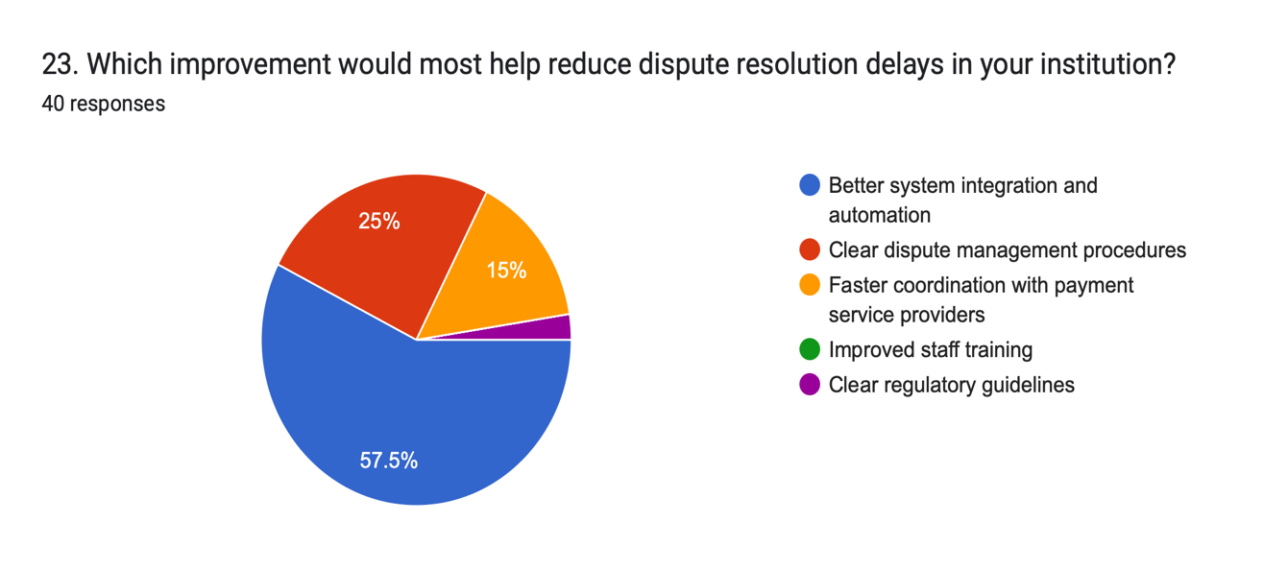
Source: Survey Data (2026)

Table 5.8.1: Supporting Responses on Improvement Area

Improvement Area | Frequency | Percentage
Process standardization | 8 | 20%
Technology Upgrade | 24 | 60%
Staff Training | 3 | 7.5%
Inter-Bank Coordination | 5 | 12.5%
Regularity Clarity | 0 | 0%
TOTAL | 40 | 100%
Source: Survey Data (2026)
The results show which areas respondents think are most crucial for enhancing digital payment dispute resolution procedures. While 60% of respondents ranked technological advancements as the primary area for enhancing dispute management procedures, the majority of respondents (57.5%) cited improved system integration and automation as the most crucial improvement to reduce dispute resolution delays.
Other enhancements that were acknowledged as crucial supporting measures included staff training (25%) and transparent conflict management procedures (25%). Furthermore, 12.5% of respondents identified interbank cooperation as a top priority, and 15% said that quicker coordination with payment service providers may help cut down on delays. These findings imply that system integration and technology advancement are thought to be the most important elements for raising the effectiveness of digital payment dispute resolution.

Figure 5.8.2: Usefulness and Feasibility of Improving Dispute Management
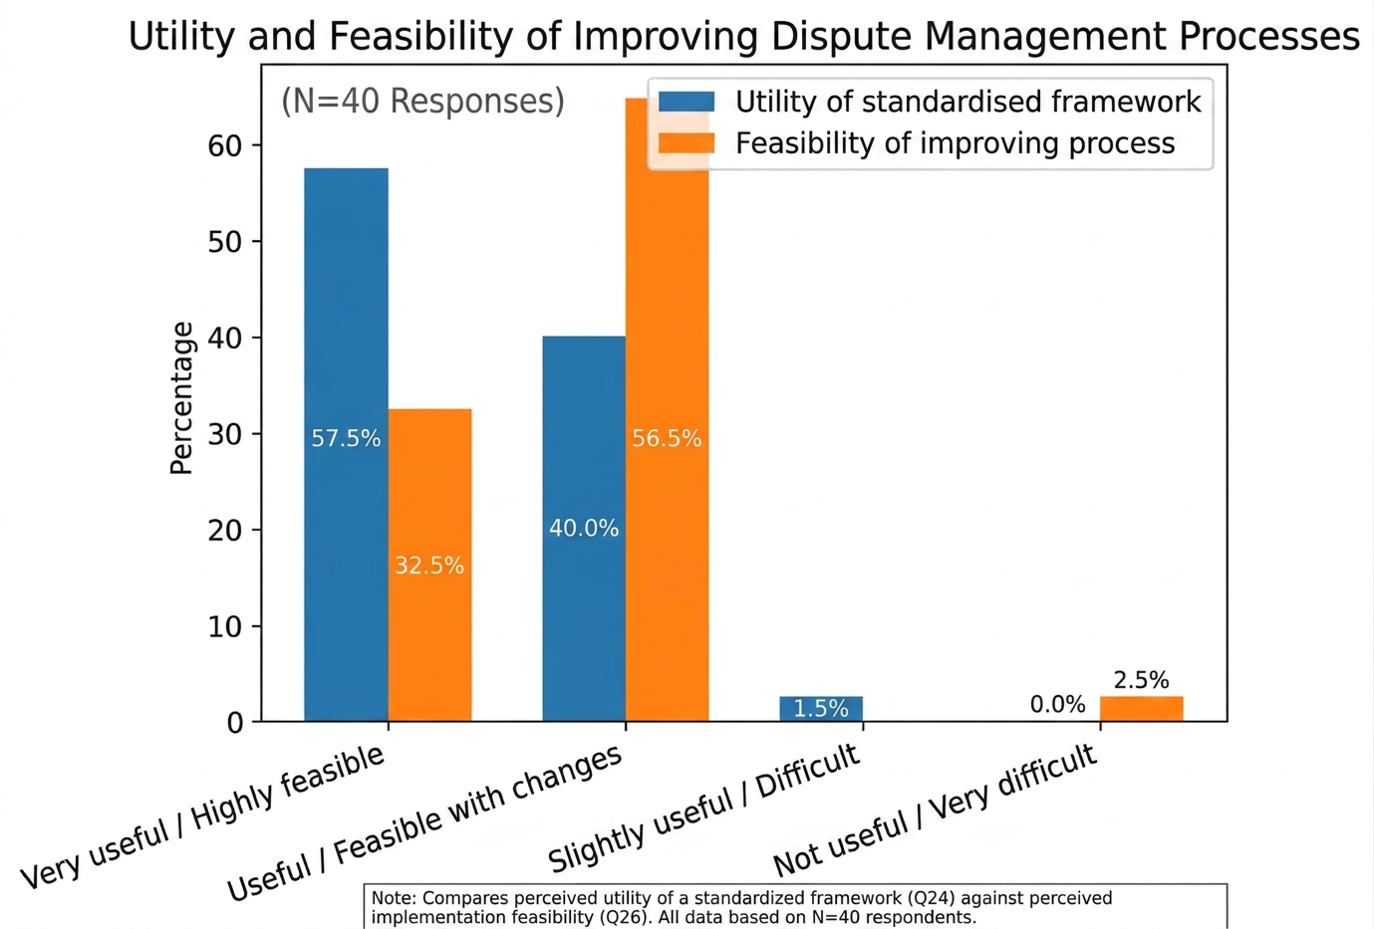
Source: Survey Data (2026)
The findings show that there is substantial support for enhancing financial institutions' procedures for handling disputes involving digital payments. 40% of respondents said that a standardized dispute management framework would be helpful for enhancing dispute resolution procedures, while the majority of respondents (57.5%) thought it would be very helpful. Just 2.5% of respondents thought it was somewhat helpful, and none thought it was useless.
In a comparable way, respondents had favorable opinions on the feasibility of enhancing the present dispute resolution procedure. While 32.5% thought that improvements are extremely feasible, 65% said that improvements are possible with some organizational adjustments. Just 2.5% said it would be extremely difficult to enhance the procedure. According to these results, the majority of institutions acknowledge the value of process improvement and think that workable improvements may be made to improve digital payment dispute resolution systems.

5.9 Thematic Analysis of Qualitative Improvements

Table 5.9.1: Thematic Analysis of Institutional Dispute Management Improvements

Theme | Description | Frequency (n) | Key Indicators / Keywords
System Automation & Integration | The necessity for high-tech infrastructure and seamless backend integration. | 7 | Automation, System Integration, High-tech, Metadata.
Real-time Tracking & Monitoring | Demand for digital platforms that provide visibility into the dispute lifecycle. | 5 | Online tracking, real-time updates, centralized platform.
Operational Synergy & Training | Improving inter-departmental coordination (front vs. back office) and staff technical skills. | 4 | Staff training, branch-digital coordination, quick response.
Standardization & Governance | Requirement for clear protocols, transparent guidelines, and defined Turnaround Times (TAT). | 2 | T+2 days, standard TAT, clear guidelines, transparency.
Source: Survey Data (2026)
According to the topic analysis, participants mostly link structural efficiency and technological maturity with the optimization of digital payment dispute resolution. The theme of System Automation and Integration (n=7) dominates the conversation, indicating that respondents view current technical constraints as the main barrier to institutional performance rather than just a barrier. This is consistent with the quantitative data, which showed that "Feasibility with changes" was the most common response, suggesting that the necessary "changes" are mostly infrastructure-driven.
In addition to technical improvements, operational synergy and human capital were given a lot of attention. Respondents emphasized that "coordinated internal responses" and "staff training" are necessary for even sophisticated tracking systems to be successful. This indicates a multifaceted need: human resource capacity and interdepartmental coordination particularly between branch and digital teams remain the engines of execution, even as technology offers the means for transparency and real-time monitoring.
Lastly, the demand for Process Clarity shows that transparency is seen as a strategic asset for customer trust, as demonstrated by references to standardized Turnaround Times (TAT). According to these qualitative findings, a successful dispute management system in the Nepalese environment needs to incorporate strict procedural standards and transparent communication protocols with external Payment Service Providers (PSPs) in addition to software deployment.

5.10 Summary of Important Results in Connection with Study Goals
The results of the survey offer valuable insights into the organizational and operational procedures related to digital payment dispute resolution in financial institutions. The findings show that unsuccessful digital transactions in which money is taken out but the transaction is not finished represent the most frequent type of dispute, underscoring the necessity of better transaction processing systems.
The data also showed that while coordination with other banks and external payment service providers is the stage that usually takes the longest to settle disputes, conflicts most commonly occur during the transaction processing stage. These results imply that inter-institutional coordination issues and system constraints are frequently associated with operational delays.
Additionally, respondents said that while dispute resolution procedures are often successful, delays might have a detrimental impact on consumers' faith in digital payment services. The results also highlight how crucial it is to preserve consumer trust in digital banking services through effective dispute resolution, transparent client communication, and staff confidence in outlining dispute timescales.
Respondents emphasized the significance of technological capabilities, transparent protocols, and efficient internal coordination mechanisms in bolstering dispute management processes from an organizational standpoint. Furthermore, the improvement-oriented responses show that the most crucial priorities for increasing the effectiveness of conflict resolution are system integration, technology advancements, and process standardization.

Overall, the results indicate that improving customer communication channels, operational coordination, and technology infrastructure can greatly enhance banking institutions' procedures for resolving disputes involving digital payments. These observations give the suggestions made in the next chapter an empirical basis.
6. Conclusion and Implications

6.1 Overview
This chapter concludes with a discussion of the study's consequences for academic theory and banking practice. The section outlines important areas for development in banking operations and emphasizes how digital payment dispute management methods impact consumer trust based on the empirical findings of the pilot research.

6.2 Conceptual Implications
By expanding the knowledge of dispute management as a crucial organizational procedure impacting customer trust, this study adds to the body of knowledge already available on digital banking, service recovery, and operational management.
First, the results support the applicability of service recovery theory in digital financial settings. Recent study emphasizes the growing significance of recovery processes in digital service ecosystems, where service failures are frequently system-driven, whereas previous studies concentrated on traditional service environments (Van Vaerenbergh and Orsingher, 2016; McColl-Kennedy et al., 2020). The results verify that promptness, openness, and procedural effectiveness are crucial in determining how customers react to service failures.

Second, the study adds to the body of knowledge on consumer trust by showing that post-transaction service experiences have an impact on trust in digital banking in addition to system security. According to recent research, trust in digital financial services is mostly determined by timeliness and dependability in service recovery (Alalwan et al., 2021; Hassan et al., 2022; Zhang et al., 2021).
Third, by demonstrating that conflict management is a multi-stage process impacted by coordination, system integration, and organizational structure, the study expands on the literature on operational and process management. According to recent studies, managing complex digital service systems requires efficient process integration and coordination (Davenport, 2021; Verhoef et al., 2021).

By connecting operational procedures, service recovery strategies, and customer trust in the context of digital banking, the study offers a comprehensive theoretical contribution overall.
6.3 Useful Consequences for Financial Institutions
The study's conclusions have a number of useful ramifications for financial institutions.
Since unsuccessful transactions were shown to be the most frequent source of disputes, banks should first prioritize process efficiency and system reliability. Dispute incidence can be decreased by enhancing system performance and real-time monitoring (Kou et al., 2021).
Second, it's imperative to improve interbank and interdepartmental collaboration. The results reinforce recent study on the significance of integrated digital ecosystems by demonstrating that coordination issues play a major role in delays (Gomber et al., 2021).

Third, in order to decrease dependency on manual processes and increase operational efficiency, banks should make investments in automation and technological integration (Verhoef et al., 2021).
Fourth, preserving trust requires improving customer communication and openness, especially in digital service environments where consumer interaction is scarce (Alalwan et al., 2021).
Finally, since frontline staff members are crucial to customer satisfaction and dispute resolution, banks should concentrate on staff training and capability development.

6.4 Implications for Policy and Regulation
The findings has significant ramifications for regulatory bodies and legislators as well. To guarantee uniformity among financial institutions, regulators should stress the necessity of standardized dispute resolution procedures and deadlines. According to recent research, regulatory frameworks can improve confidence and accountability in digital financial systems (Feyen et al., 2021).
Furthermore, in order to minimize coordination delays and enhance service efficiency, it is necessary to encourage integration between payment systems and institutions (Gomber et al., 2021).
Additionally, it is crucial to improve consumer protection regulations in digital banking, especially with regard to openness and prompt dispute settlement.

6.5 Contribution to Practice
By offering a comprehensive understanding of digital payment dispute resolution procedures and highlighting the main operational difficulties faced by banking professionals, this study advances practice.
The study facilitates the creation of a workable dispute management framework that balances operational effectiveness, technological competence, and customer communication by fusing empirical findings with theoretical ideas. This is consistent with recent studies that highlight the value of practice-oriented research in tackling actual organizational problems (Verhoef et al., 2021; Saunders et al., 2023).

6.6 The Study's Limitations
The research has various limitations because it is a pilot study. In comparison to qualitative methods, the use of standardized questionnaires may limit the depth of insights, and the relatively small sample size limits generalizability.
However, the goal of pilot studies is to identify important concerns for more research and offer exploratory insights (Saunders et al., 2023).
6.7 Recommendations for Future Studies
In order to have a deeper understanding of conflict management procedures, future research can expand on this study by employing larger samples and qualitative techniques like interviews. Customer perspectives on dispute resolution and the contribution of cutting-edge technology like artificial intelligence to the enhancement of dispute management systems could be the subject of future research (Verhoef et al., 2021).

6.8 Conclusion
This study looked at dispute resolution procedures for digital payment transactions and how they affect Nepali consumers' confidence in banks and other financial organizations.
The results show that operational effectiveness, coordination, and technology capabilities all have an impact on the crucial organizational process of dispute management. These elements have a direct impact on how disputes are resolved and how much customers trust online banking services.
The paper emphasizes the need of enhancing dispute management systems to improve service quality and promote confidence in digital financial services, especially in emerging economies, by fusing theoretical ideas with empirical data.

Appendix: Survey Questionnaire

Investigating Digital Payment Transaction Dispute Management Practices and Their Role in Consumer Trust in Banks and Financial Institutions in Nepal

This survey aims to investigate how digital payment transaction disputes are managed within banks and financial institutions and how these practices impact consumer trust in digital payment services. The study is conducted for academic research purposes as part of a pilot study. All responses will remain confidential and will be used only for research purposes.

Section A: Respondent Profile
1. What is your current role in the bank or financial institution?
- Customer service / complaint handling
- Branch operations staff
- Digital banking department
- Payment operations / settlement team
- Managerial position
2. How many years of experience do you have in the banking sector?
- Less than 1 year
- 1–3 years
- 4–6 years
- More than 6 years
3. How frequently do you deal with digital payment transaction disputes?
- Very frequently (daily)
- Frequently (weekly)
- Occasionally
- Rarely
Section B: Nature of Digital Transaction Disputes
4. Which type of digital payment dispute occurs most frequently in your institution?
- Failed but debited transaction
- Duplicate debit transaction
- Wrong beneficiary transfer
- Delayed credit to beneficiary
- ATM/POS settlement dispute
5. Through which channel are digital payment disputes most commonly reported?
- Branch counter
- Call centre
- Mobile banking application
- Internet banking
- Email or written complaint
Section C: Dispute Resolution Process
6. At which stage do digital transaction disputes most commonly arise?
- During transaction processing
- During settlement between banks
- During system reconciliation
- During customer complaint stage
7. Which stage of the dispute resolution process usually takes the longest time?
- Complaint registration
- Investigation and verification
- Coordination with other banks or service providers
- Final settlement and refund
8. Are digital payment disputes generally resolved within expected settlement timeframes (e.g., T+1, T+2, T+3 depending on transaction type)?
- Always
- Often
- Sometimes
9. How effective is the current digital payment dispute management process in your institution?
- Very effective
- Effective
- Moderately effective
- Ineffective

Section D: Operational and Organisational Factors
10. Which factor most commonly causes delays in dispute resolution?
- Manual verification procedures
- System limitations or technical issues
- Delayed response from internal departments
- Coordination with external payment service providers
- Regulatory compliance procedures
11. How clear are the roles and responsibilities for handling digital payment disputes in your institution?
- Very clear
- Mostly clear
- Sometimes unclear
- Not clear
12. How effective is coordination between branch staff and digital banking teams in resolving disputes?
- Very effective
- Effective
- Moderately effective
- Ineffective
13. How much do regulatory procedures influence the time required to resolve digital payment disputes?
- Very high influence
- High influence
- Moderate influence
- Low influence
14. How clearly defined are the responsibilities for digital payment dispute resolution in your institution?
- Very clearly defined
- Moderately clear
- Somewhat unclear
- Not clear at all
Section E: Technology and System Support
15. How effective are your institution’s digital systems in tracking disputed transactions?
- Very effective
- Effective
- Moderately effective
- Ineffective
16 How often do digital transaction disputes require coordination with external payment service providers or other banks?
- Very frequently
- Frequently
- Occasionally
- Rarely
17. How effectively do your institution’s digital systems support investigation of disputed transactions?
- Very effectively
- Effectively
- Moderately effectively
- Ineffectively
Section F: Consumer Trust
18. In your experience, how do delays in digital payment dispute resolution affect customer trust in digital banking services?
- Significantly reduce trust
- Moderately reduce trust
- Slightly reduce trust
- No noticeable effect
19. How does efficient dispute resolution influence customer confidence in digital payment services?
- Strongly increases trust
- Moderately increases trust
- Slightly increases trust
- No effect

20 How confident are frontline staff in explaining dispute resolution timelines to customers?
- Very confident
- Somewhat confident
- Slightly confident
- Not confident
21. How do customers generally react when digital payment disputes take longer than expected to resolve?
- Strongly lose trust in digital payments
- Become less confident in digital payments
- Slightly concerned but continue using services
- No noticeable change in trust
22. How important is clear communication with customers during dispute resolution?
- Very important
- Important
- Moderately important
- Not important
Section G: Process Improvement and Solutions
23. Which improvement would most help reduce dispute resolution delays in your institution?
- Better system integration and automation
- Clear dispute management procedures
- Faster coordination with payment service providers
- Improved staff training
- Clear regulatory guidelines
24. How useful would a standardised dispute management framework be for improving dispute resolution practices?
- Very useful
- Useful
- Slightly useful
- Not useful
25. Which area should be prioritised to improve digital payment dispute management?
- Process standardisation
- Technology upgrade
- Staff training
- Inter-bank coordination
- Regulatory clarity
26. Overall, how feasible is it to improve the current digital dispute management process in your institution?
- Highly feasible
- Feasible with some changes
- Difficult
- Very difficult
Section H – Additional Comments
27.In your opinion, what improvement would most enhance digital payment dispute resolution in your institution?

Part 2. Reflective Account

1 Introduction
The process used to conduct the research-based academic article on digital payment transaction dispute handling and its impact on customer trust in banks and financial institutions in Nepal is critically examined in this reflective account. Key phases of the research process, such as topic selection, literature engagement, research design, data collecting and analysis, and the difficulties faced during the study, are the focus of the reflection. It also considers the development of research skills at the doctoral level and the larger academic environment of publication.

2. Selecting a Topic and Professional Environment
My work experience in the financial industry had a big impact on choosing the research topic. I spent more than seven years working directly in customer care operations and digital banking services at a commercial bank in Nepal before starting this study project. During this period, I regularly came across instances where clients went to the bank to report issues with digital payment transactions, such contested payments, delayed credits, or unsuccessful transfers.

My job often involved helping clients fill out dispute complaint forms and inputting pertinent information into the bank's internal dispute management system. Even when the branch level started the dispute procedure, it frequently took a long time for these matters to be resolved. Consumers regularly came back to the bank to inquire about the status of their disputes, and it was frequently challenging to give precise explanations about the investigation's progress or the anticipated timetable for settlement.

This instance brought to light a discrepancy between the bank's operating protocols and the expectations of its clients with regard to dispute resolution. Even though regulatory bodies offer instructions for settling disputes involving digital transactions within predetermined times, the actual application of these procedures frequently seemed to include operational difficulties and delays.
The choice of a study topic centered on digital payment dispute management was influenced by these experiences. I developed an interest in learning why digital payment dispute resolution procedures take longer than anticipated and what organizational, technological, or operational issues cause these delays. Furthermore, my direct customer interactions generated significant concerns regarding the potential impact of unresolved complaints and delayed remedies on customers' trust in digital banking services.

The practical relevance of academic research can be increased and actual organizational difficulties can be investigated by choosing a study topic based on professional experience (Bryman, 2016). As a result, the subject of this study arose from the nexus of academic research and professional experience, enabling the study to advance both scholarly knowledge and useful advancements in banking operations.

3.Engagement with Literature
One of the most difficult but crucial parts of this research was interacting with the literature. At first, the emphasis was on finding research on customer trust and digital banking. But it soon became clear that there wasn't much written on managing disputes involving digital payments, especially when it came to poor nations.
Three important topics were included to the literature evaluation in order to close this gap: operational process management, customer trust in digital financial services, and service recovery theory. In order to develop a cohesive understanding of the study problem, it was necessary to synthesize views from several disciplines.

In order to find appropriate sources, a methodical approach was used, giving priority to peer-reviewed journal papers that were published during the previous five years. Seminal works were also included as needed. This strategy aligns with best practices in literature review technique, which highlight the significance of openness, pertinence, and critical assessment of sources (Snyder, 2019; Paul and Criado, 2020).
The construction of the study's conceptual framework was greatly aided by the process of interacting with literature. Additionally, it emphasized the significance of going beyond descriptive summaries to critical analysis and synthesis, which is a crucial requirement at the doctoral level.

4. Methodological Choices and Research Design
The goals and setting of the study were carefully taken into account when developing the research design. In order to handle the research topic, a pragmatic research philosophy was chosen, which permits flexibility in integrating quantitative and qualitative methodologies. Given the study's applied character and emphasis on useful results, this was especially relevant (Morgan, 2022).
To investigate the research challenge and produce initial insights, a pilot study approach was used. The requirement to assess the viability of the research design and the paucity of prior research on the subject had an impact on this choice. It is commonly acknowledged that pilot studies are useful for investigating new problems and improving research tools (Thabane et al., 2021).

An open-ended question offered more qualitative insights, while the use of a standardized questionnaire allowed for the collection of comparable data from several respondents. This illustrates a mixed-method strategy that improves the scope and depth of analysis (Saunders et al., 2023).
In general, the research design approach necessitated striking a balance between practical viability and academic rigor, especially with regard to time restrictions and data availability.

5. Experience with Data Collection and Analysis

A Google Forms questionnaire was used to collect data from banking professionals with prior experience in digital payment operations. Drawing on my background in the Nepalese banking sector, I initially anticipated that collecting empirical data for this study would be relatively straightforward. My familiarity with the field and access to professional networks gave me confidence that respondents would be willing to participate within the given timeframe. However, in practice, the data collection process proved more challenging than expected. Despite distributing the questionnaire widely, the response rate remained limited, with approximately 40–45% of targeted participants completing the survey. This highlighted a key practical limitation in organisational research, where access to participants does not necessarily guarantee engagement. Time constraints and the professional responsibilities of respondents appeared to significantly influence participation levels, making it more difficult to achieve a higher response rate.
To address this challenge, efforts were made to utilise professional networks effectively and ensure that the questionnaire was clear, concise, and easy to complete. Nevertheless, this experience emphasised the importance of adopting more proactive engagement strategies, such as follow-ups and reminders, in future research to improve response rates (Saunders et al., 2023). At the same time, I acknowledge and appreciate the valuable contributions of those participants who took the time to complete the survey, as their responses formed the empirical foundation of this study.
The data analysis process involved both descriptive and analytical interpretation of quantitative data, alongside thematic analysis of qualitative responses. Initially, there was a tendency to focus primarily on descriptive presentation of the data. However, through further reflection and guidance, the importance of deeper analytical interpretation became evident. This required moving beyond simply describing “what the data shows” to examining underlying patterns, explaining their implications, and linking findings to theoretical concepts such as operational efficiency and service recovery. This shift from descriptive to analytical thinking represents a significant development in research capability.
Furthermore, the integration of quantitative and qualitative findings enabled a more comprehensive understanding of digital payment dispute management practices. This mixed-method approach strengthened the overall analysis and aligns with the objectives of exploratory research, where multiple forms of data contribute to richer insights (Braun and Clarke, 2021). Overall, the experience of data collection and analysis enhanced my understanding of the complexities involved in field-based research and reinforced the importance of careful planning, time management, and critical interpretation in producing meaningful and reliable research outcomes.

6. Challenges Encountered and Solutions
The research method presented a number of difficulties.
First, because there aren't many studies that specifically cover digital payment dispute management, it was challenging to find pertinent research. To address this, the literature review's breadth was expanded, and perspectives from allied domains were incorporated.
Second, it was originally difficult to organize the data analysis at the DBA level. The original method lacked theoretical integration and critical examination and was unduly descriptive. Adopting a formal analytical framework that covered data presentation, interpretation, theoretical connections, and practical implications helped to tackle this problem.
Third, efficiently managing time was a major obstacle, especially when it came to striking a balance between collection of empirical evidence, analysis, and writing. This necessitated meticulous planning and job prioritization.

These difficulties demonstrate how difficult it is to do research at the doctoral level and how crucial flexibility and critical thinking are to overcoming them.
7. Reflections on Publishing and Academic Writing
Important insights into the difficulties of academic writing and publication were gained from this research approach. One important insight was that reading literature critically is more important than just summarizing previous research.
Furthermore, it became apparent that a clear contribution to knowledge and practice was required. Presenting results is simply one aspect of academic research; another is demonstrating how those results contribute to knowledge or have useful applications.

Originality, relevance, and effect are crucial in the competitive environment created by the growing number of journals and the mounting demand on academics to publish (Paul and Criado, 2020). This emphasizes how crucial it is to have a solid research focus and retain academic integrity at every stage of the investigation.

8. Research Development and Learning Outcomes
My growth as a researcher has been greatly aided by this endeavor.
Important learning objectives consist of:

• The capacity to carry out an organized review of the literature
• A better comprehension of research technique and philosophy
• Improved abilities to analyze and evaluate data
• The capacity to connect theory and practice
The study also emphasized the value of contemplation and critical thinking, both of which are crucial for doctoral-level research.
Additionally, the study has established the groundwork for further research, especially in creating a more thorough framework for managing disputes involving digital payments.

9. Reflection's Conclusion
To sum up, this study process has been enjoyable and hard. It has helped me grow as a researcher and offered insightful information about digital payment dispute resolution and how it affects customer trust.
The study shows how crucial it is to combine theoretical understanding with real-world experience in order to solve organizational problems. It also emphasizes the necessity of ongoing education and introspection in the quest for both professional and academic advancement.

References
Alalwan, A.A., Rana, N.P., Dwivedi, Y.K. and Algharabat, R., 2017. Social media in marketing: A review and analysis of the existing literature. Telematics and Informatics, 34(7), pp.1177-1190.
Alalwan, A.A., Dwivedi, Y.K., Rana, N.P. and Williams, M.D. (2021) ‘Consumer adoption of mobile banking in emerging markets: Examining the role of trust’, International Journal of Information Management, 56, 102205.
Bhaskar, R., 1978. On the possibility of social scientific knowledge and the limits of naturalism. Journal for the Theory of social Behaviour.
Braun, V. and Clarke, V., 2021. Thematic Analysis: A Practical Guide. London: SAGE Publications.
Braun, V. and Clarke, V., 2006. Using thematic analysis in psychology. Qualitative research in psychology, 3(2), pp.77-101.
Bryman, A., 2016. Social research methods. Oxford university press.
Davenport, T.H., 2021. Process Innovation: Reengineering Work through Information Technology. Boston: Harvard Business Press.
Feyen, E., Frost, J., Gambacorta, L., Natarajan, H. and Saal, M., 2021. Fintech and the digital transformation of financial services: implications for market structure and public policy. BIS Papers, (117).
Fletcher, A.J., 2017. Applying critical realism in qualitative research: methodology meets method. International journal of social research methodology, 20(2), pp.181-194.
Frost, J., 2020. The economic forces driving fintech adoption across countries. The Oxford Handbook of Banking and Financial Services.
Gefen, D., Karahanna, E. and Straub, D.W., 2003. Trust and tam in online shopping: An integrated model1. MIS quarterly, 27(1), pp.51-90.
Gelbrich, K. and Roschk, H., 2011. A meta-analysis of organizational complaint handling and customer responses. Journal of Service research, 14(1), pp.24-43.
Gomber, P., Kauffman, R.J., Parker, C. and Weber, B.W., 2021. On the fintech revolution: Interpreting the forces of innovation, disruption, and transformation in financial services. Journal of Management Information Systems, 35(1), pp.220-265.
Hassan, M., Anyanwu, C. and Kalu, E., 2022. Digital banking and consumer trust: An empirical study. Journal of Financial Services Marketing, 27(3), pp.145-158.
Kalpokaite, N. and Radivojevic, I., 2019. Demystifying qualitative data analysis for novice qualitative researchers. The Qualitative Report, 24(13), pp.44-57.
Kou, G., Akdeniz, E., Dinçer, H. and Yüksel, S., 2021. Fintech and blockchain-based smart contracts in the banking sector. Soft Computing, 25, pp.1-15.
Mulisa, F., 2022. Sampling techniques involving human subjects: Applications, pitfalls, and suggestions for further studies. International Journal of Academic Research in Education, 8(1), pp.74-83.
Ozili, P.K., 2021. Digital financial inclusion: determinants, benefits and issues. Handbook of Digital Finance and Financial Inclusion.
Paul, J. and Criado, A.R. (2020) ‘The art of writing literature review: What do we know and what do we need to know?’, International Business Review, 29(4), 101717.
Rahi, S., Abd. Ghani, M. and Ngah, A.H., 2021. Integration of unified theory of acceptance and use of technology and gameflow model to examine continuances intention to play online games. International Journal of Business Information Systems, 36(1), pp.1-23.
Saunders, M., Lewis, P. and Thornhill, A., 2023. Research Methods for Business Students. 9th ed. Harlow: Pearson Education.
Tax, S.S., Brown, S.W. and Chandrashekaran, M., 1998. Customer evaluations of service complaint experiences: implications for relationship marketing. Journal of marketing, 62(2), pp.60-76.
Thabane, L., Ma, J., Chu, R., Cheng, J., Ismaila, A. and Rios, L.P. (2021) ‘A tutorial on pilot studies: The what, why and how’, BMC Medical Research Methodology, 21(1), pp. 1–10.
Van Vaerenbergh, Y. and Orsingher, C., 2016. Service recovery: An integrative framework and research agenda. Academy of Management Perspectives, 30(3), pp.328-346.
Verhoef, P.C., Broekhuizen, T., Bart, Y., Bhattacharya, A., Dong, J.Q., Fabian, N. and Haenlein, M., 2021. Digital transformation: A multidisciplinary reflection and research agenda. Journal of business research, 122, pp.889-901.
Vives, X., 2021. Digital currencies and Dutch disease. Journal of Monetary Economics, 122, pp.100-115.
Vom Brocke, J. and Mendling, J. eds., 2018. Business process management cases. Cham: Springer.
World Bank, 2022. The Global Findex Database 2021: Financial Inclusion, Digital Payments, and Resilience in the Age of COVID-19. Washington, DC: World Bank.
Zaki, M. and McColl-Kennedy, J.R., 2020. Text mining analysis roadmap (TMAR) for service research. Journal of Services Marketing, 34(1), pp.30-47.
Zhang, T., Lu, C. and Kizildag, M., 2021. Banking on the go: examining consumer adoption of mobile banking services. International Journal of Quality and Service Sciences, 13(1), pp.1-18.

