Surveillance System Research Proposal
Jonathan Evans
Software Engineering
P151713

4/5/18
Contents
1. Introduction 2
2. Research into Machine Learning 3
2.1 Background Literature Review 3
2.2 Motivation for studying Machine Learning 7
3. Research and Development methods 8
4. Planning 11
4.1 Resources 11
4.1.1 Hardware 11
4.1.2 Software 11
4.2 Project Timeline 12
5. References 13

Introduction
This document proposes a research project that will discover how effectively a Computer Vision program can recognise a face with the use of Machine Learning. This data will be found by creating a surveillance application that will have a facial recognition component that will be used to help identify potential intruders through a video stream provided by a networked camera.
It is crucial that such a system would be easy-to-deploy. The reasoning for this is if a system can be deployed easily, an assumption could be made that the testing can be carried out more frequently as there are more installs of the application.
Before development on this program can begin, knowledge of Computer Vision programming and Machine Learning is required. The following section will contain research in these areas.

Research into Machine Learning
This section contains a literature review that will analyse the field of machine learning. This will be followed by a motivation for learning Machine Learning.

2.1 Background Literature Review
This literature review will contain brief information on Computer Vision to get an understanding how a facial recognition could be implemented using it. However, this section mainly focuses on Machine Learning as the research is more concerned with the effectiveness of Machine Learning as a component that could enhance Computer Vision capabilities.
Brief look into Computer Vision
Computer Vision is a field where a computer is trained to comprehend an image. A few common applications of computer vision include facial recognition, number plate recognition, and electronics component analysis. These kinds of applications are commonly created using programming libraries such as OpenCV, an open-source computer vision library for use with the C++ programming language, along with bindings for other languages such as Python. [1]
Machine Learning
Machine Learning is a field where computers are used to learn patterns and predict outcomes. The term Machine Learning was introduced in 1959 by Arthur Samuel in his research paper where machine learning was used to train a machine to play a game of checkers. [2] Ever since, machine learning has had been an area pursued by companies to create new applications for machine learning, such as autonomous driving vehicles [3], smarter game artificial intelligence [4], optical character recognition [5], and voice recognition software [6].
Overview of the machine learning process
At a glance, the process of machine learning consists of two kinds of learning. Supervised learning and unsupervised learning.
Supervised learning is the process of learning where a system learns from a set of data that the computer can understand, that is data with context, and use this data to predict patterns, such as creating a betting program to guess a given output based on data provided to it. [7]
A common technique in machine learning is the use of linear regression, which is also used in statistics. With linear regressions, a hypothetical best-fit line is drawn across a scatter graph where the most independent variables are plotted to estimate a result value by based on a given value. Using this technique, the computer can predict a continuous set of data based on the data that has been given to it.
The following page shows a chart that has a linear regression line which can be used to estimate a given value.
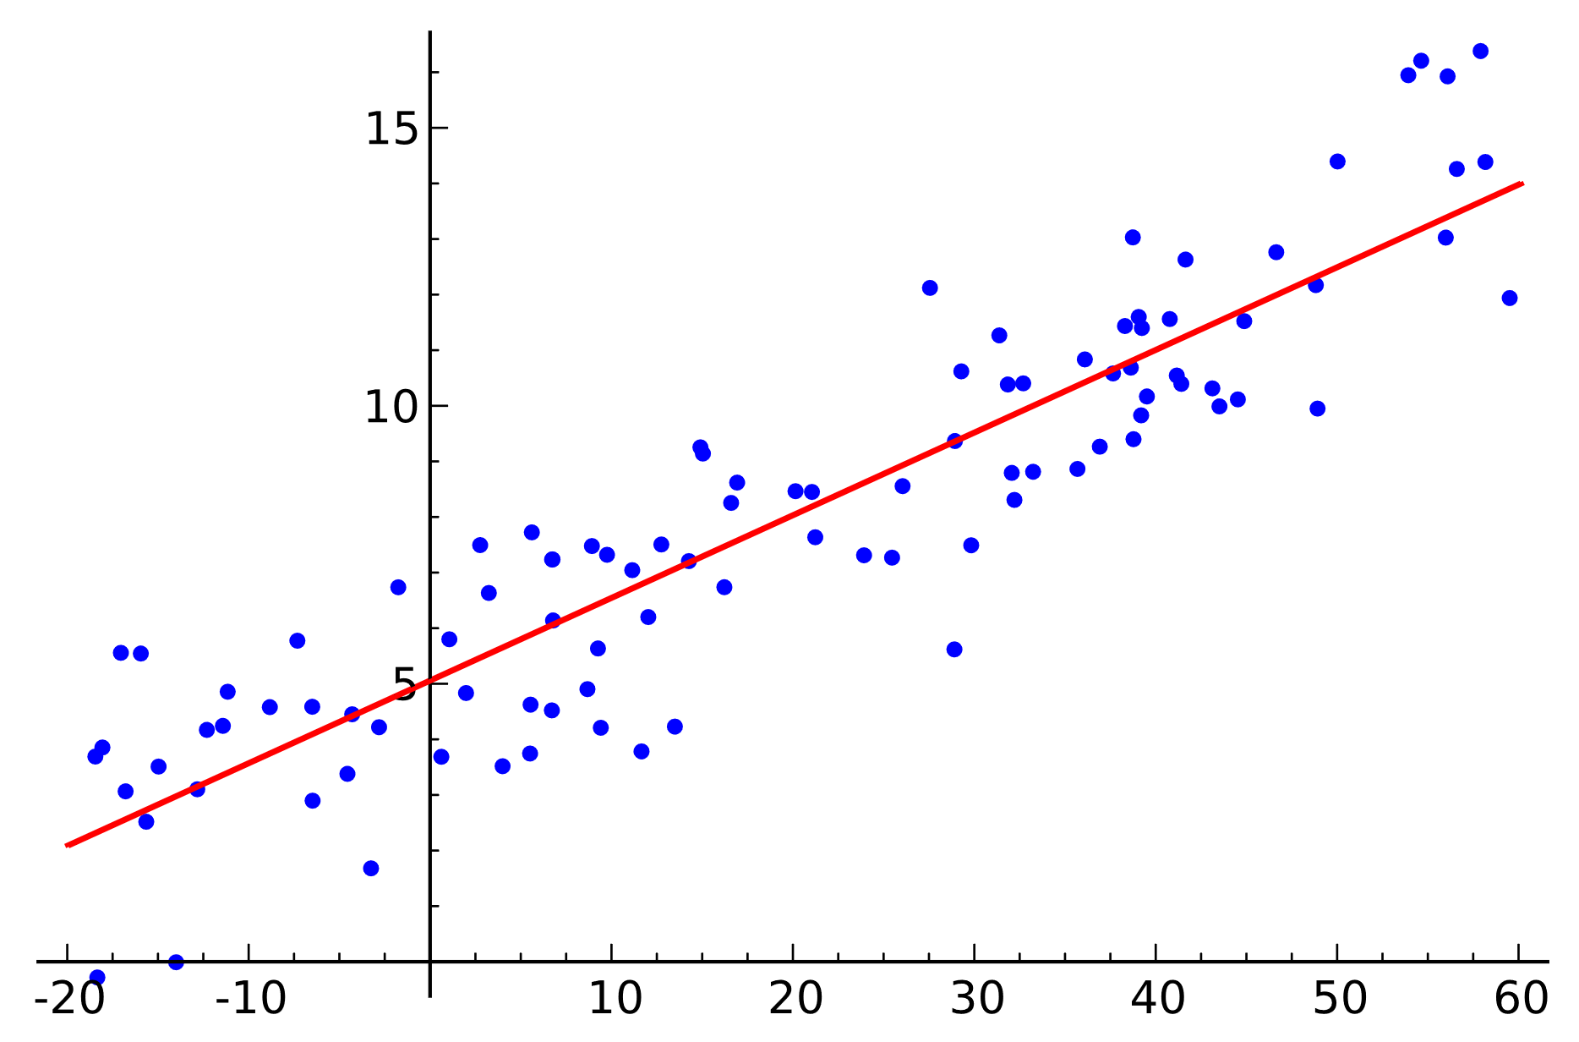
Figure 1 Scatter graph with linear regression line (taken from https://commons.wikimedia.org/wiki/File:Linear_regression.svg)
The above example shows a linear regression line that can be used to predict a value with a wide range of numbers, however, alternative machine learning systems may opt to use classification where that is desired. This is a method that given a set of numbers, estimates a given output that will be classified as one or more items.
An example of a machine learning system that may use classification could be a system that determines if heating in a house should be turned off or on based on data containing temperatures at different hours throughout the past week. In this case, the output is classified as off or on.
Classification could also be used in a system where a machine is required to classify different types of images to depict if a face is present or not in a facial recognition system.
As well as supervised learning, there is unsupervised learning, this kind of learning is used when a system is given data without any context as to what the data is. The machine can learn from this data by creating a context for different clusters of the data using a clustering algorithm. [7] How data is clustered depends on how the program is designed.

Advances in machine learning
This section will cover two interesting advances in machine learning – Deep learning, and the use of CUDA programming to accelerate the machine learning process.
Deep learning
Deep learning uses deep neural networks to train a system, which is a network of neurons - that can be considered a node which takes and input and computes and output in the context of machine learning. The performance of using Deep Learning with Machine Learning improves performance over time, that is the accuracy of a prediction over time. [8]
A CNN (Convolutional Neural Network) is a kind of deep learning network which is frequently used to detect images. [9]
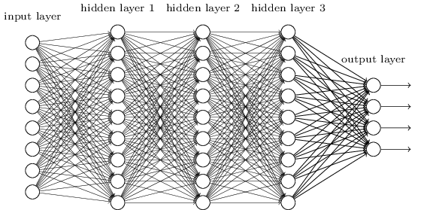
Figure 2 Convolutional Neural Network (Taken from http://neuralnetworksanddeeplearning.com/chap6.html)
The above illustration shows a CNN that consists of an input layer, three hidden layers and an output layer. Each circle is a neuron that represents a value that is indicative on the final output values. Each layer of neurons in the hidden layers have logic that activate neurons in the other layers of neurons. This is used to find the determined result on the output layer. [10]
CUDA Programming
Adam Coates et al. [11] shows that GPU computing can train a network, drastically faster than a large cluster of CPU cores can.
In recent years, new technologies have been created that can improve the performance of Machine Learning. One of which is the usage of CUDA (Compute Unified Device Architecture) platform from NVIDIA. This allows a programmer to create software that uses the GPU’s cores to perform tasks in parallel. In theory, a task that can execute on one core should execute twice as fast on two cores if the work-load is equally shared. [12]
Considering a consumer-grade graphics card, for example an NVIDIA GTX 1080 Ti, has 3584 CUDA cores, it should be competent at accelerating machine learning due to the high core count. Such a high number of cores is not currently available from a consumer-grade CPU product, thus the inclusion of a GPU in machine learning system is desired.
TensorFlow
TensorFlow is a newly created programming library by the Google Brain team, a group of researchers specifying in artificial intelligence in Google. This library will allow programmers to create machine learning programs in a language such as C++ or Python. In addition to this, TensorFlow has the benefit of being open-source, Apache-licenced, supports CUDA programming, and it runs on ASIC devices, namely, Tensor Processing Units. [13]
Because TensorFlow is apache-licenced, it can be deployed anywhere in compliance with the licence, which means that anyone can use it for free. [14]
One of the biggest benefits is that is supports GPU computing (CUDA), which will accelerate the performance drastically, as shown in the previous section. In addition to this, TensorFlow can utilise TPUs (Tensor Processing Units), which the Nvidia Tesla series of graphics cards combine CUDA cores with, which is ideal for enterprise-level machine learning. These GPUs are already being utilised by companies such as Netflix and Google for Machine Learning.
Notable companies utilising Machine Learning
Netflix
Netflix, an on-demand video streaming service, make use of machine learning algorithms for their streaming component of their service. They use it for two useful scenarios – video adaption, which predicts the quality throughput of a video based on the statistics that show the quality of the network, and predictive caching, which guesses what show is likely to be watched next, thus caching part of the show before the user decides to watch it. [13]
Google & IBM
Google and IBM own artificial intelligence (AI) super computers, known as Deepmind (Google) and Watson (IBM). Both Watson and Deepmind lease computation time to organisations.
The case studies on the website for IBM Watson shows many customers who use Watson for tasks such as analytical prediction [14] and optimising video stream delivery [15].
Deepmind is currently used in Google’s voice assistant and has been used in their data centres to predict when cooling is needed, this has saved them 40% on their cooling bill. [16] This AI has seen considerable breakthroughs in Machine Learning such as beating the world’s leading Go champion using the AlphaGo program [17].

2.2 Motivation for studying Machine Learning
This study is particularly interesting as it shows the benefit of Machine Learning with Computer Vision (being able to teach the computer to see), which is particularly useful knowledge when building a facial recognition system or any kind of system that must use Computer Vision.
Study aim
As outlined in the introduction, the aim of the study is to investigate the effectiveness the incorporation of machine learning with Computer Vision brings by creating a facial recognition component of a surveillance system, using Computer Vision and Machine Learning.
Objectives
There are five objectives that need to be completed for this research project.
- Literature review - Carry out an in-depth literature review into Machine Learning. The literature review carried out in this proposal briefly explains how machine learning works at a glance, however, more in-depth research is needed to understand different clustering algorithms and how CUDA programming can be utilised.

- Building the base system - This will consist of designing and programming the system. This will provide a minimum viable product of what a surveillance system should have. Specifics and on how this will be carried out is detailed in the following development methodology section.

- Incorporate the use of Machine Learning with the computer vision libraries. This will help the computer recognise faces more effectively than using computer vision by itself.

- System analysis – this will consist of two types of analysis, heuristic analysis and analysis of the times taken to recognise a face.

The heuristic analysis will be used to identify if the program meets the aim of being easy-to-deploy for barely computer literate users. This will be a questionnaire that will ask the user what they thought about various aspects of the system.

Timing analysis will be carried out to measure the speed it takes for a machine to recognise a face. In addition to this, the accuracy of the recognition will also be considered as this is also an important factor in face recognition software.

- Carry out a case study that will document all the findings from the analysis carried out.

Research and Development methods
Research methodology
This research will follow a positivistic philosophy. The reasoning for this is to test the effectiveness of machine learning combined with computer vision, two measurements will be needed, which will be the time taken for the computer to recognise a face as well as the accuracy of the recognition. The time taken to recognise a face will be measured in milliseconds and will be carried out through multiple experiments. The accuracy of the recognition will be examined by displaying a series of faces to the face-recognition system and recording a percentage of how many it can predict.
The research will have an inductive approach. This is because data will need to be collected before a conclusion is made. The result will answer the question: “How much does Machine Learning improve computer vision performance?”
The research for this project will consist of a carrying out an in-depth literature review, software development to test a theory, and a case study that will analyse the results of the experimentation.
Development methodology
The development method selected for this project is FDD (Feature Driven Development). FDD is a development method that consists of building a list of features to be implemented in a project and implementing them. [20]
In this project, the FDD cycle will consist of four stages:
- Build a feature list – This will consist building a list of features to be implemented in the project. For example, a feature to implement may be to: Create a user interface or implement facial recognition.

- Design solution – At this stage a feature will be taken from the feature list and designs will be created assuming the task is requiring a design. Such designs may consist of wireframes, for designing interfaces, and UML designs such as class diagrams and sequence diagrams, and any other designs that may be beneficial in the creation of the application.

- Implementation – This will consist of implementing code from the designs specified from the previous stage.

- Testing – This will consist of testing the software solution with a given testing method. The four that will be used on this project is: white-box testing, black-box testing, A/B (Split) testing, and unit testing.

White-box and black-box testing
The white-box testing is concerned with testing the system with access to its internals. This is useful as it provides the tester with more information which may help the tester find programs within the code. Meanwhile the black-box testing does not provide the tester with any access to the internals of the system, thus requiring the tester to find bugs through using the system.

A/B Testing
A/B Testing (or split testing) is a method of testing the user experience of the program by showing 50% of users an interface that will differ from what the other 50% sees. This will allow data to be collected that can be analysed to show which version of the program is easier to use.

Unit testing
Unit testing is concerned with testing specific parts of a program is tested. A test harness (code to test the functionality of other code) can be used to aid this.
Risks & Limitations
There are a few risks and limitations that pose a threat the deliverables being delivered on time.
Time is the immediate limitation. The project must be delivered by the end of the academic year. A timeline has been provided at the end of this document which illustrates the time the project will need to be completed in. As this timeline ends in on the 25th of October, there should be enough buffer room to account for any unforeseen circumstances such as illness.
Hardware for this project is a limitation. To make use of CUDA processing, a graphics card with CUDA cores is required. Currently, A GTX 1070 consumer-grade graphics card is available for this project. This card has 1920 CUDA cores. Therefore, a machine learning application can only make use of 1920 cores. With a bigger budget, a Nvidia Tesla v100 could be utilised, this is a graphics card with 5120 CUDA cores, which should perform tasks a great deal quicker than a card with 1920 cores due to parallel programming.
As the application will deal with networked cameras there is a risk that a vulnerability within the application or the operating system could potentially leak a network feed to a potential hacker. The chances of this happening can be mitigated by making sure that the computer itself is air-gapped (not connected to a network), although this may be an inconvenience for the user as the computer may be required to be connected to the Internet if the user needs to access the it.
Deliverables
This project will produce two deliverables, a surveillance system and a case study that will analyse the effectiveness of the implementation of machine learning and Computer Vision.
Surveillance system
The surveillance system that will be delivered with this project should meet the following criteria:
- It should be easy-to-deploy for non-computer literature users.
- Should give a user full understanding of what it can do
- Should recognise faces within a matter of seconds
Case study
The case study will provide specific detail of how fast the face recognition system can recognise a face with the use of Machine Learning. This data will be gathered by recording the times to recognise a face. This will be done with a stopwatch and paper. Use of in-software features can be used to measure this time too, such as a timer that is built-in to the program. In addition to this, data of how accurate the recognition is will also be recorded – this will be a percentage that will show how many times a computer recognised a face.

Planning
This section will cover the resources needed and planning required for the project.

4.1 Resources
The resources needed for this project consist of computer hardware, software and a group of individuals to test the software.

4.1.1 Hardware
GPU
A relatively powerful computer is needed for Machine Learning. In particular, a graphics card with CUDA cores is ideal. This is what will allow for a machine learning application to use parallel processing with the CUDA cores. This should reduce the time it takes for a machine to recognise a face. A GTX 1070 is currently in possession which has 1920 CUDA cores.

4.1.2 Software
OpenCV & TensorFlow
There are two primary programs required for this project – OpenCV and Tensorflow. OpenCV is an open-source computer vision library. Tensorflow is a Machine Learning library. Both have licensed that allow these libraries to be used anywhere.
QT
The interface will be created using QT. This is a library used for creating cross-platform interfaces. It works with C++ and has Python bindings. Qt has two licenses – LPGL and a commercial license. This means that any non-commercial software created with Qt can be distributed freely if the software complies with the LPGL, which means that the software should be free to use, free to modify, and open source [18]. If software must be distributed as a non-opensource application, the commercial license is required, which will cost a fee.
Testing group
A group of people will be needed to test the program. The people in this group should not be very computer literate and will be given a copy of the software to deploy themselves with little to no guidance as it is crucial that this software is usable, even by people who are less experienced with computers.

4.2 Project Timeline
Below is a table and Gant chart that details the expected time frame that project will be completed in. The table shows the data itself and the Gantt chart illustrates the timeframe.
Table 1Project Timeline
Task Name | Duration | Start | Finish
Learn OpenCV Programming | 7 days | Fri 01/06/18 | Mon 11/06/18
Learn TensorFlow Programming | 7 days | Tue 12/06/18 | Wed 20/06/18
Create requirements list | 1 day | Thu 21/06/18 | Thu 21/06/18
Class diagrams | 3 days | Fri 22/06/18 | Tue 26/06/18
Sequence diagrams | 4 days | Wed 27/06/18 | Mon 02/07/18
Wireframes | 4 days | Tue 03/07/18 | Fri 06/07/18
Storyboards | 3 days | Mon 09/07/18 | Wed 11/07/18
Create face recognition component (CLI Only) | 35 days | Thu 12/07/18 | Wed 29/08/18
Create Interface using QT | 10 days | Thu 30/08/18 | Wed 12/09/18
Unit tests | 1 day | Thu 13/09/18 | Thu 13/09/18
Black-box testing | 1 day | Fri 14/09/18 | Fri 14/09/18
White-box testing | 1 day | Mon 17/09/18 | Mon 17/09/18
A/B(Split) testing | 7 days | Tue 18/09/18 | Wed 26/09/18
Heuristic tests | 7 days | Thu 27/09/18 | Fri 05/10/18
Analyse data | 7 days | Mon 08/10/18 | Tue 16/10/18
Create case study | 7 days | Wed 17/10/18 | Thu 25/10/18

Table 2Timeline Gantt chart

References

[1] | O. Team, “About OpenCV,” [Online]. Available: https://opencv.org/about.html. [Accessed 3 May 2018].
[2] | A. L. Samuel, “Some Studies in Machine Learning,” 1959.
[3] | Adam Grzywaczewski. NVIDIA, “Training AI for Self-Driving Vehicles: the Challenge of Scale,” 9 October 2017. [Online]. Available: https://devblogs.nvidia.com/training-self-driving-vehicles-challenge-scale/. [Accessed 3 May 2018].
[4] | D. Taralla, “Learning Artificial Intelligence,” 2015.
[5] | D. S. D. S. Batuhan Balci, “Handwritten Text Recognition using Deep Learning,” 2017.
[6] | Deepmind, “About DeepMind for Google,” [Online]. Available: https://deepmind.com/applied/deepmind-google/. [Accessed 3 May 2018].
[7] | J. Brownlee, “Supervised and Unsupervised Machine Learning Algorithms,” 16 March 2016. [Online]. Available: https://machinelearningmastery.com/supervised-and-unsupervised-machine-learning-algorithms/. [Accessed 4 May 2018].
[8] | IBM, “ Deep learning performance breakthrough,” [Online]. Available: https://www.ibm.com/blogs/systems/deep-learning-performance-breakthrough/. [Accessed 4 May 2018].
[9] | M. Nielsen, “Deep learning, Chapter 6,” [Online]. Available: http://neuralnetworksanddeeplearning.com/chap6.html. [Accessed 4 May 2018].
[10] | “But what *is* a Neural Network? | Chapter 1, deep learning [Video],” [Online]. Available: https://www.youtube.com/watch?v=aircAruvnKk. [Accessed 4 May 2018].
[11] | B. H. T. W. D. J. W. A. Y. N. Adam Coates, “Deep learning with COTS HPC systems,” 2013.
[12] | A. Silberschatz, “4.2 Multicore Programming,” in Operating System Concepts, 9th ed, Wiley, 2012, p. 166.
[13] | Google, “About TensorFlow,” [Online]. Available: https://www.tensorflow.org/. [Accessed 4 May 2018].
[14] | Apache, “Apache License,” [Online]. Available: https://www.apache.org/licenses/LICENSE-2.0. [Accessed 4 May 2018].
[15] | Chaitanya Ekanadham, Netflix, “Using Machine Learning to Improve Streaming Quality at Netflix,” [Online]. Available: https://medium.com/netflix-techblog/using-machine-learning-to-improve-streaming-quality-at-netflix-9651263ef09f. [Accessed 4 May 2018].
[16] | IBM, “Medtronic [Use case],” [Online]. Available: https://www.ibm.com/case-studies/medtronic. [Accessed 4 May 2018].
[17] | IBM, “GameFly Streaming [Use case],” [Online]. Available: https://www.ibm.com/case-studies/gameflystreaming. [Accessed 4 May 2018].
[18] | Google, “DeepMind AI Reduces Google Data Centre Cooling Bill by 40%,” [Online]. Available: https://deepmind.com/blog/deepmind-ai-reduces-google-data-centre-cooling-bill-40/. [Accessed 4 May 2018].
[19] | Google, “AlphaGo,” [Online]. Available: https://deepmind.com/research/alphago/. [Accessed 4 May 2018].
[20] | Agile Modeling, “Feature Driven Development (FDD) and Agile Modeling,” [Online]. Available: Feature Driven Development (FDD) and Agile Modeling. [Accessed 4 May 2018].
[21] | The Qt Company, “Obligations of the LGPL,” [Online]. Available: https://www1.qt.io/qt-licensing-terms/. [Accessed 4 May 2018].

