
people management
[Document subtitle]

November 11, 2022
University of Wales Trinity Saint David

Executive Summary
The purpose of this report is to analyse……..
DO THIS SECTION LAST!!!!!!
NOT INCLUDED IN WORD COUNT

Table of Contents
Executive Summary 1
Introduction 3
Findings 4
Conclusion (average of 10% of word count) 5
Bibliography 6
UPDATE TABLE FREQUENTLY – CHECK IT HAS BEEN UPDATED PRIOR TO SUBMISSION

Introduction

Findings

Skills required by managers in supporting effective people management

Theories and models of effective leadership

Lewin triangle leadership model
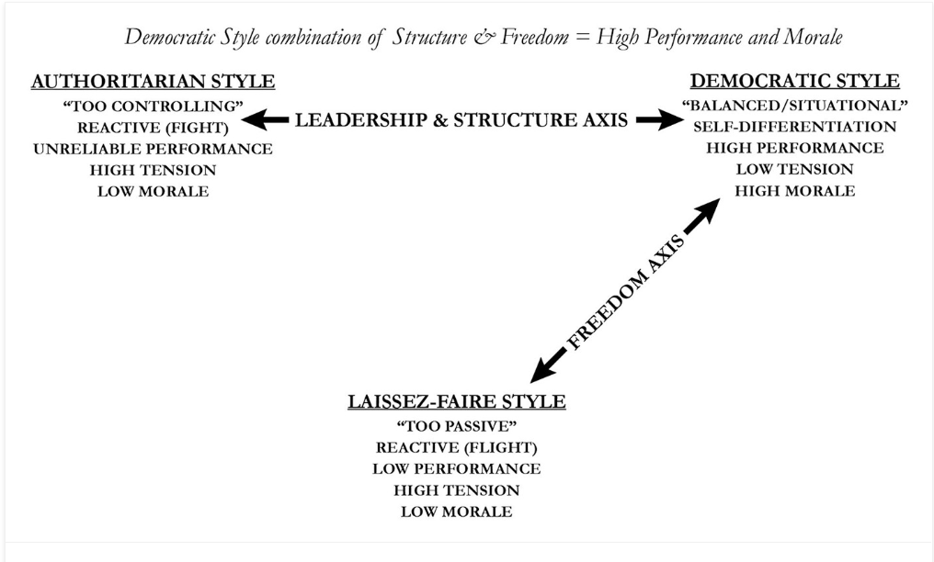
Figure 1. Lewin leadership styles (Crosby, 2021)

Effective teamwork- Belbin

The leadership style plays an important role in determining the efficiency of a team (Mullins & McLean, 2019). Team members are more likely to stay unite and work better if they are listened, given support, offered encouragement, guidance, and are provided with a balance in the workplace.
When analysing what makes a successful team, Meredith Belbin (Bednar & Ljudvigová, 2020) identified nine roles divided in three categories (action oriented, thinking and people roles). His theory has been validated and is universally applied not only because team members identify their natural role and their strengths, but also because they can learn to manage their weaknesses (Belbin, 2010 ).
Researchers have concluded that the presence of a larger number of these roles in the team guarantees a better performance thanks to the skills and knowledge needed to perform a task (Ureba, et al., 2022).
In terms of what role is most suitable for a successful leader, the Co-ordinator has come first, followed by the Shaper, who is more driven. In his research, Belbin concluded that even the managers who do not belong to one of these two roles, can prove to be successful leaders through motivation and self-awareness (Belbin, 2010)

Employee motivation
Employee motivation is one of the most important aspects in the success of every organisation and a challenging job for every leader (Khan & Wajidi, 2019).
Therefore, work management theories have become more important and are present in many leadership, management, and organizational courses. These help to explain why people behave in a certain way, what drives them towards achieving a goal and how satisfied they are in the workplace (Benson & Dresdow, 2019).
Two of the most common work theories that allow leaders to learn and understand motivation are Vroom’s Expectancy Theory and Adam’s Equity Theory (Swain, et al., 2020).
According to Vroom’s Theory, individuals are motivated by three things: valence- the value people associate to a certain reward, expectancy-the confidence they will be able to get good results by putting effort into something, instrumentality- the belief they will receive a certain reward that was promised for the obtained performance.
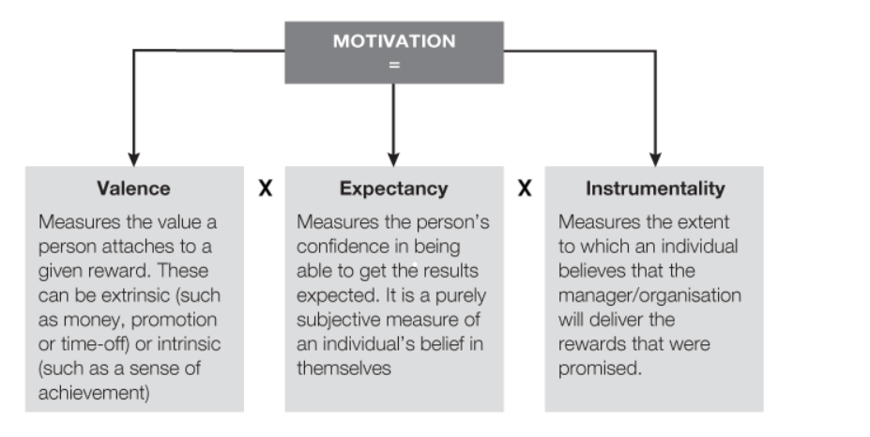 Figure 2. Vroom’s Expectancy Theory
The second theory revolves around people’s perception of equality and fairness. Individuals are more likely to remain motivated if they feel the remuneration received for their inputs is fair. In an organization, the inputs are all the things the employees are contributing with, like time, experience, resilience, education, trust, commitment, loyalty, enthusiasm. Among the outputs, the most important are the financial benefits, but also recognition, development, benefits, development opportunities and purpose.
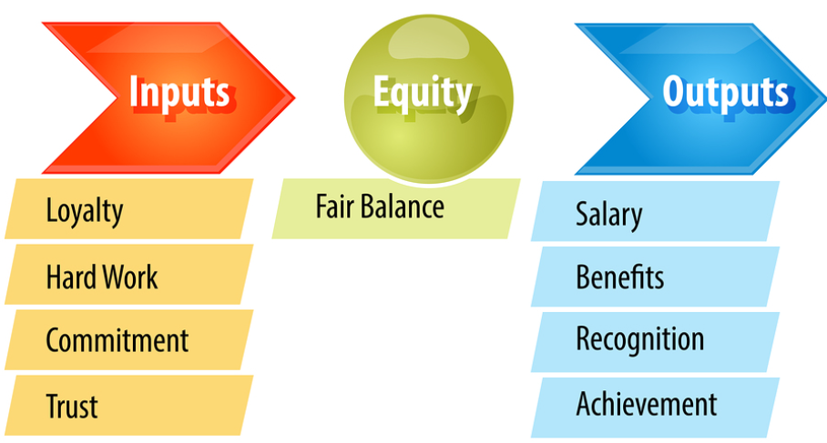
Figure 3. Adam’s Equity Theory
Recent studies have demonstrated there is a positive relationship between work motivation and high levels of employee’s perception of transformational leadership behaviours (Chua & Ayoko, 2021). A transformational leader is one who trusts his employees to perform their duties, actively listens, knows their strengths and weaknesses, and empowers them. Moreover, the employee’s self-determined motivation also improves work engagement.
When analysing the relationship between leadership competencies and employee motivation, studies have shown that the leader’s cognitive competencies are most important in keeping them motivated, followed by his emotional and social intelligence (Diskiene, et al., 2019).

Flexible working
Flexible working has become more popular over the years, especially in the context on the most recent pandemic, because of the benefits it brings to both the employer and the employees. It is predicted this will be become the normal way of working as opposed to just an exceptional one.
The main aspect of flexible working is providing the employee the control over where and when they choose to work (Chung & Van der Lippe, 2018). Among some of the flexible working arrangements, one can include part time, flexitime, remote working, hybrid working, zero contract hours, annual hours (CIPD, 2022)
Some of the benefits for the companies are increased employee engagement, productivity and wellbeing, higher retention, better diversity, lower absence (CIPD & Simply Health, 2022)

Treating staff equally

Managing the performance of the workforce
An effective performance management is one of the main objectives of every organisation as this leads to higher employee motivation, engagement, and achievement of the strategic goals (Stephen, 2022).
One of the theories that analysis what makes an effective performance management is AMO (Van Waeyenberg & Decramer, 2018), a model formed of three components: ability, motivation, and opportunity. It is because people perform better when they have the knowledge and skills required for their job (ability), are motivated and are offered opportunities to progress.
Recent research has shown that the organisations where effective performance management is conducted are more likely to deal with change, achieve their financial targets by 30% more and innovate (Delloite, 2018).
To ensure effective performance management is achieved, every organisation needs to invest its resources in several areas. Firstly, it needs to create a high performing work culture that can be achieved by offering learning and development opportunities, setting clear goals for the team, providing employees with regular feedback and coaching, offering performance evaluation, and creating a rewards and recognition tool (Delloite, 2022).
Secondly, the companies need to invest in their leaders and line-managers who are critical in improving employee performance. They need to be offered training and ongoing support and created a plan for them to prove their new skills.
Furthermore, companies should always embrace technology and search for tools that are meant to make their work easier, reduce their costs and allows them to grow.

Conclusion

References
- Bednar, R. & Ljudvigová, I., 2020. Belbin team roles in a start-up team. [Online]
Available at: https://www.proquest.com/docview/2456247351?accountid=130472&parentSessionId=BdTnJQjxs6yNIOgyHpQDm3P%2BwWgbbMpewTzeWeYNBv0%3D&pq-origsite=primo
[Accessed 23 10 2022].
- Belbin, M. R., 2010 . The art of building a team. In: Team roles at work. Oxford: Routledge, pp. 97-107.
- Belbin, M. R., 2010. Team leadership. In: Management teams : why they succeed or fail. Oxford: Butterworth-Heinemann, pp. 45-65.
- Benson, J. & Dresdow, S., 2019. Delight and Frustration: Using Personal Messages to Understand Motivation. Management Teaching Review, 6(2), pp. 112-122.
- Chua, J. & Ayoko, O., 2021. Employees’ self-determined motivation, transformational leadership and work engagement. Journal of management & organization, 27(3), pp. 523-543.
- Chung, H. & Van der Lippe, T., 2018. Flexible Working, Work–Life Balance, and Gender Equality: Introduction. Social Indicators Research volume, Volume 151, pp. 365-381.
- CIPD & Simply Health, 2022. Health and Wellbeing at work 2022. [Online]
Available at: https://www.cipd.co.uk/knowledge/culture/well-being/health-well-being-work
[Accessed 01 11 2022].
- CIPD, 2022. Flexible working practices. [Online]
Available at: https://www.cipd.co.uk/knowledge/fundamentals/relations/flexible-working/factsheet
[Accessed 01 11 2022].
- Crosby, G., 2021. Lewin’s Democratic Style of Situational Leadership: A Fresh Look at a Powerful OD Model. The Journal of applied behavioral science, 57(3), pp. 398-401.
- Delloite, 2018. Seven Top Findings from High Impact Performance Management Research. [Online]
Available at: https://www2.deloitte.com/content/dam/Deloitte/us/Documents/human-capital/us-human-capital-high-impact-performance-management.pdf
[Accessed 26 10 2022].
- Delloite, 2022. Better support your teams through better performance management practices. [Online]
Available at: https://action.deloitte.com/insight/1147/better-support-your-teams-through-better-performance-management-practices
[Accessed 26 10 2022].
- Diskiene, D., Pauliene, R. & Ramanauskaite, D., 2019. Relationships between Leadership Competencies and Employees' Motivation, Initiative and Interest to Work. Montenegrin Journal of Economics, 15(1), pp. 113-129.
- Khan, M. R. & Wajidi, A., 2019. Role of Leadership and Team Building in Employee Motivation at Workplace. Global Management Journal for Academic & Corporate Studies, 9(1), pp. 39-49.
- Mullins, L. J. & McLean, J. E., 2019. Organisational behaviour in the workplace. [Online]
Available at: https://ebookcentral.proquest.com/lib/trinity/reader.action?docID=5830196#
[Accessed 23 10 2022].
- Stephen, T., 2022. Improving organisational performance. In: Human Resource Management: People and Organisations. s.l.:Kogan Page, pp. 134-155.
- Swain, J., Kumlien, K. & Bond, A., 2020. An experiential exercise for teaching theories of work motivation: using a game to teach equity and expectancy theories. Organization Management Journal, 17(3), pp. 119-132.
- Ureba, S. A., Simon de Blas, C., Borras-Gene, O. & Macias-Guillen, A., 2022. Analyzing the Influence of Belbin’s Roles on the Quality of Collaborative Learning for the Study of Business Fundamentals. Education Sciences, 12(9), p. 594.
- Van Waeyenberg, T. & Decramer, A., 2018. Line managers’ AMO to manage employees’ performance: the route to effective and satisfying performance management’. International journal of human resource management, 29(22), pp. 3093-3114.

Bibliography

