Student Name: Sophie Walls

P Number: 1801483

Programme of Study: BA Illustration

Word count: 1529

Tutor: Ryan L. Moule

For this task it is required for me to curate an imagined space or place for an exhibition. This means that I need to choose an appropriate area for my discipline and decide on what I would I like to curate for this. In this essay I will include all of my research practices and approaches that I apply to my course and how I would use this gathered information to curate an exhibition in my agreed space.

Part 1
A theoretical perspective is a set of assumptions about reality that inform the questions we ask and the kinds of answers we arrive at as a result. The process of a curation is to gather information relevant to a particular topic or area of interest, bringing both areas together to create the ‘perfect’ exhibition can prove difficult for anybody. However, by doing this you can understand both the work you are exhibiting and the space you will be exhibiting in. Both need to be chosen very carefully, every space must fit the work and the work the space. My two examples of exhibition spaces are the End of Empire by Yinka Shonibare (Figure 1, Heather Parnell 2018) which was exhibited at the Glynn Vivian Art Gallery in Swansea during October 2018, and the Cell (Eyes and Mirrors) by Louise Bourgeois (Figure 2, Jonathan Jones 2010) exhibited at the Tate Modern during October 2016. I’m using these two specific examples because I believe one collection of work fits the space in which it is exhibited and the other does not.

Figure 1. End of Empire – Glynn Vivian by Yinka Shonibare MBE, Heather Parnell, 2018

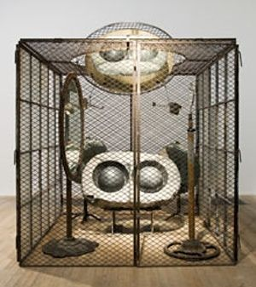

Figure 2. Cell (Eyes and Mirrors) by Louise Bourgeois, Jonathan Jones, 2010

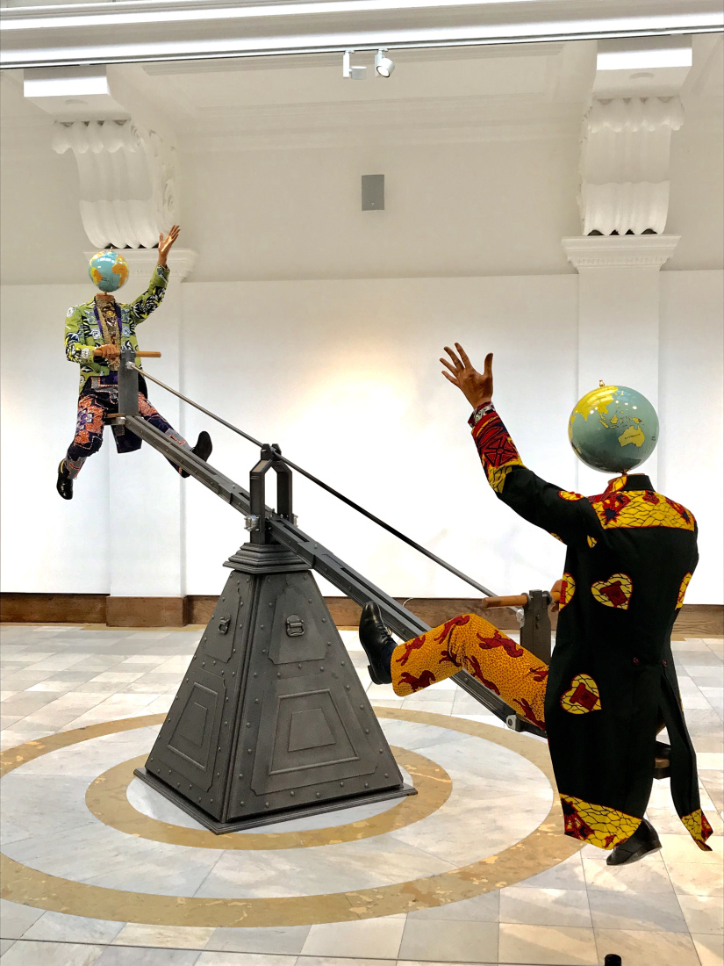
I will begin with the review and deconstruction of the End of Empire (Figure 3, Lauren Chard 2019) exhibition at the Glynn Vivian. This installation is “two Victorian men both dressed in Victorian costumes made in African textiles and they’ve got globe heads and the globe heads represent the opposing sides in the First World War.” It comments on the balance of power and its ups and downs of such power throughout the war between the French-British alliance and the Austro-Hungarian and German alliance. This gain and loss of power through those years at war are represented through a slow-moving seesaw. Shonibare’s work was “characterised by extensive reading and research”, understanding the war efforts made by many and uses this to demonstrate the historic global politics. When arriving in Swansea, I believe the venue did not fit the meaning or message of the art that was being portrayed for that short time. For it being an art piece that is representing World War One, you would have thought that the artist would have exhibited this in a space or area more suited to the story of the work, such as war museums, history museums or galleries that specify in such work. I would be expecting more from this artist if he was ever to exhibit work again, making sure the work fits the space and the space the work. (Sheerin, 2016)

Figure 3. End of Empire - Glynn Vivian by Yinka Shonibare, Lauren Chard, 2019
Louise Bourgeois, well known for her enormous spider installations outside the Tate Modern, uses her exhibition spaces to its full advantage. In October 2016, I had the opportunity to visit the Tate Modern and explore the exhibitions at the time, one of the most memorable exhibits that day was Louise Bourgeois Cell (Eyes and Mirrors) (Figure 2, Jonathan Jones 2010), Spider, Single I, Single II, Couple I and Couple IV. All of these pieces were exhibited in the same main space of the exhibit with a few smaller artworks off to a side room. Cell is an art piece that is assembled of “doors and windowpanes to form small cells”, when creating this she was “thinking about voyeurism and surveillance.” Bourgeois commented at the time that is was intended “to give meaning and shape to frustration and suffering… The Cells represent different types of pain: the physical, the emotional and psychological, and the mental and intellectual. (Quoted in The Secret Cells, p.81)”. The intention was to exclude the viewer physically but invite them to “penetrate visually”, it is an area in which the spaces or forms “provide shelter but also possible entrapments.” Spider was a smaller version, a replica, of the larger spider that was once installed outside of the Tate Modern. This seem to be the only piece that did not exactly fit in with the rest of the exhibit and did not tell a story or send a message. Single I, Single II, Couple I and Couple IV (Figure 4-8, Marcus Bunyan 2013; Marcus Leith 2013; Christopher Burke 2011-2013) were “corpse-like figures” which either hung from the ceiling or laid across the floor. Each piece was exhibited perfectly and took full advantage of the space it was curated in, every one of them linked in one way or another but mainly through shelter, violence and entrapment. All of this makes you feel a mixture of emotions and leaves you with many questions – the aim of a perfectly exhibited space. (Tate, 2010)

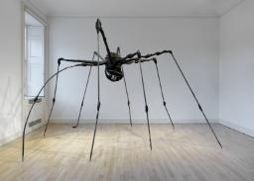
Figure 4. Spider by Louise Bourgeois, Christopher Burke, 2013
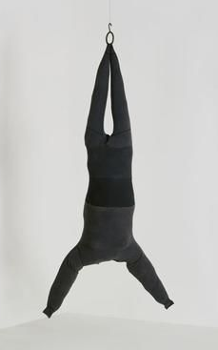

Figure 5. Single I by Louise Bourgeois, Pinterest

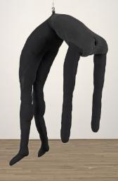
Figure 6. Single II by Louise Bourgeois, Christopher Burke, 2011

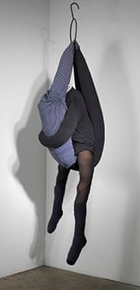

Figure 7. Couple I by Louise Bourgeois, Marcus Leith, 2013
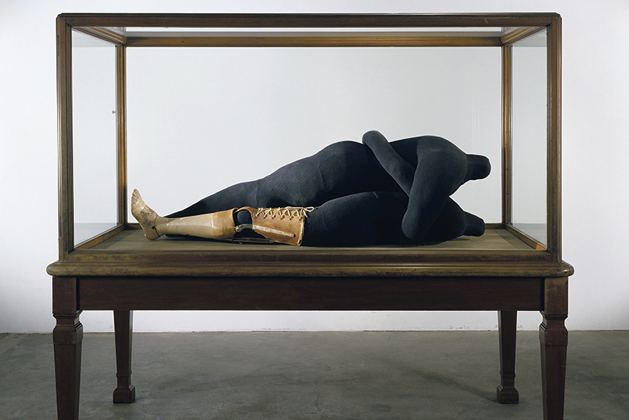
Figure 8. Couple IV by Louise Bourgeois, Marcus Bunyan, 2013

Part 2
To begin curating my exhibition, I begun to do research into my own exhibition space and the artworks I will be exhibiting in it. My original thoughts on this task was to combine two completely different eras – past and present – and use them to help show the evidence of the advancing technology over the centuries and what the implications and psychological effects that it has had. My initial though process was to begin with Renaissance paintings and the advancements made in the power of countries and technology and then finally combining the two together. The old and the new, fresco Renaissance paintings with technological aspects and the most famous presidents of the United States of America, this will show the long-term damage of technology and how the world now relies on it too much and what consequences it has.
For the idea that I am proceeding with, I mainly looked into cathedrals and churches that give the façade of innocence, life and death but is portrayed through a harmonic and approachable style. The two iconic buildings I have chosen is Notre Dame Cathedral and La Sagrada Familia. The Notre Dame Cathedral (Figure 9. Encyclopaedia Britannica 2019) is one of the “most famous of the Gothic cathedrals from the Middle Ages” and is known for its “size, antiquity and architectural interest”. The interior is 130 x 48 metres in plan, its stand 35 metres high, perfect sized space to hold an exhibition. (Encyclopedia Britannica, 2019)

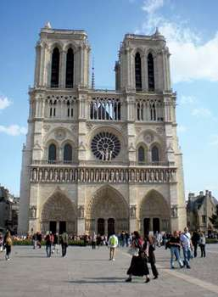

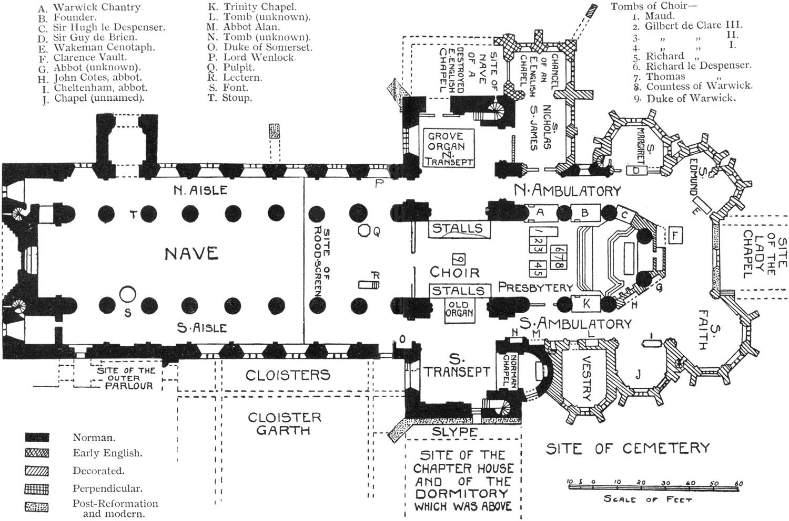
Figure 9. Notre-Dame de Paris, Encyclopaedia Britannica, 2019

Figure 10. Notre-Dame de Paris floor plan, Pinterest

Whereas the La Sagrada Familia (Figure 11. Paul Symonds 2010) would be the most appropriate space for my exhibition, for it is “a universal masterpiece combining all symbols of Christianity”, “an expiatory temple”, “a place made to commemorate the reparation of sins made against God or the laws of the Church”. There are three main areas of La Sagrada Familia that symbolises both life and death – The Nativity Façade (Figure 14, Céline Mülich 2013-2019), which symbolises the birth of Jesus, life and creation. It has astonishing “ornamentation, including animals and tools mixed with symbols, such as the Tree of Life”. In this area there are three entries that represent the “theological virtues: Hope (left), Faith (right) and Charity (centre), along with the Door of Jesus and the Tree of Life.” The next is the Passion Façade (Figure 13, Unknown), this is dedicated to the Passion of Christ which would explain its “simplicity”. Gaudí said: “Some will find this door too extravagant; I wanted it to impose fear. To achieve this, I did not avoid shadows, motifs coming in and out, and everything to gain a dark effect. I am ready to sacrifice this construction, to cut the columns to give an idea of the cruelty to sacrifice.” (Trillard, 2019)

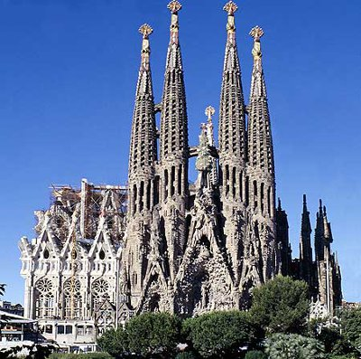

Figure 11. La Sagrada Familia by Paul Symonds, Eye On Spain, 2010

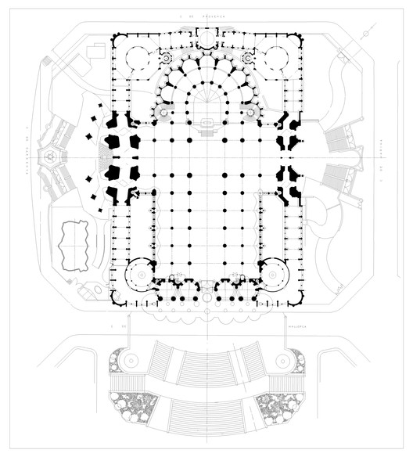

Figure 12. La Sagrada Familia floor plans by Rennie Jones, Arch Daily, 2013

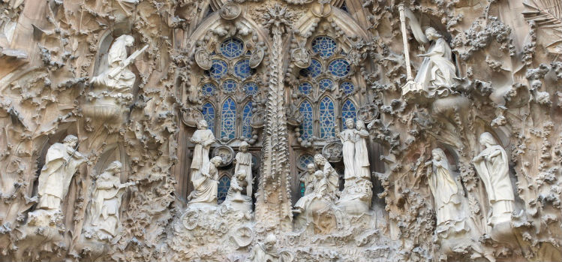
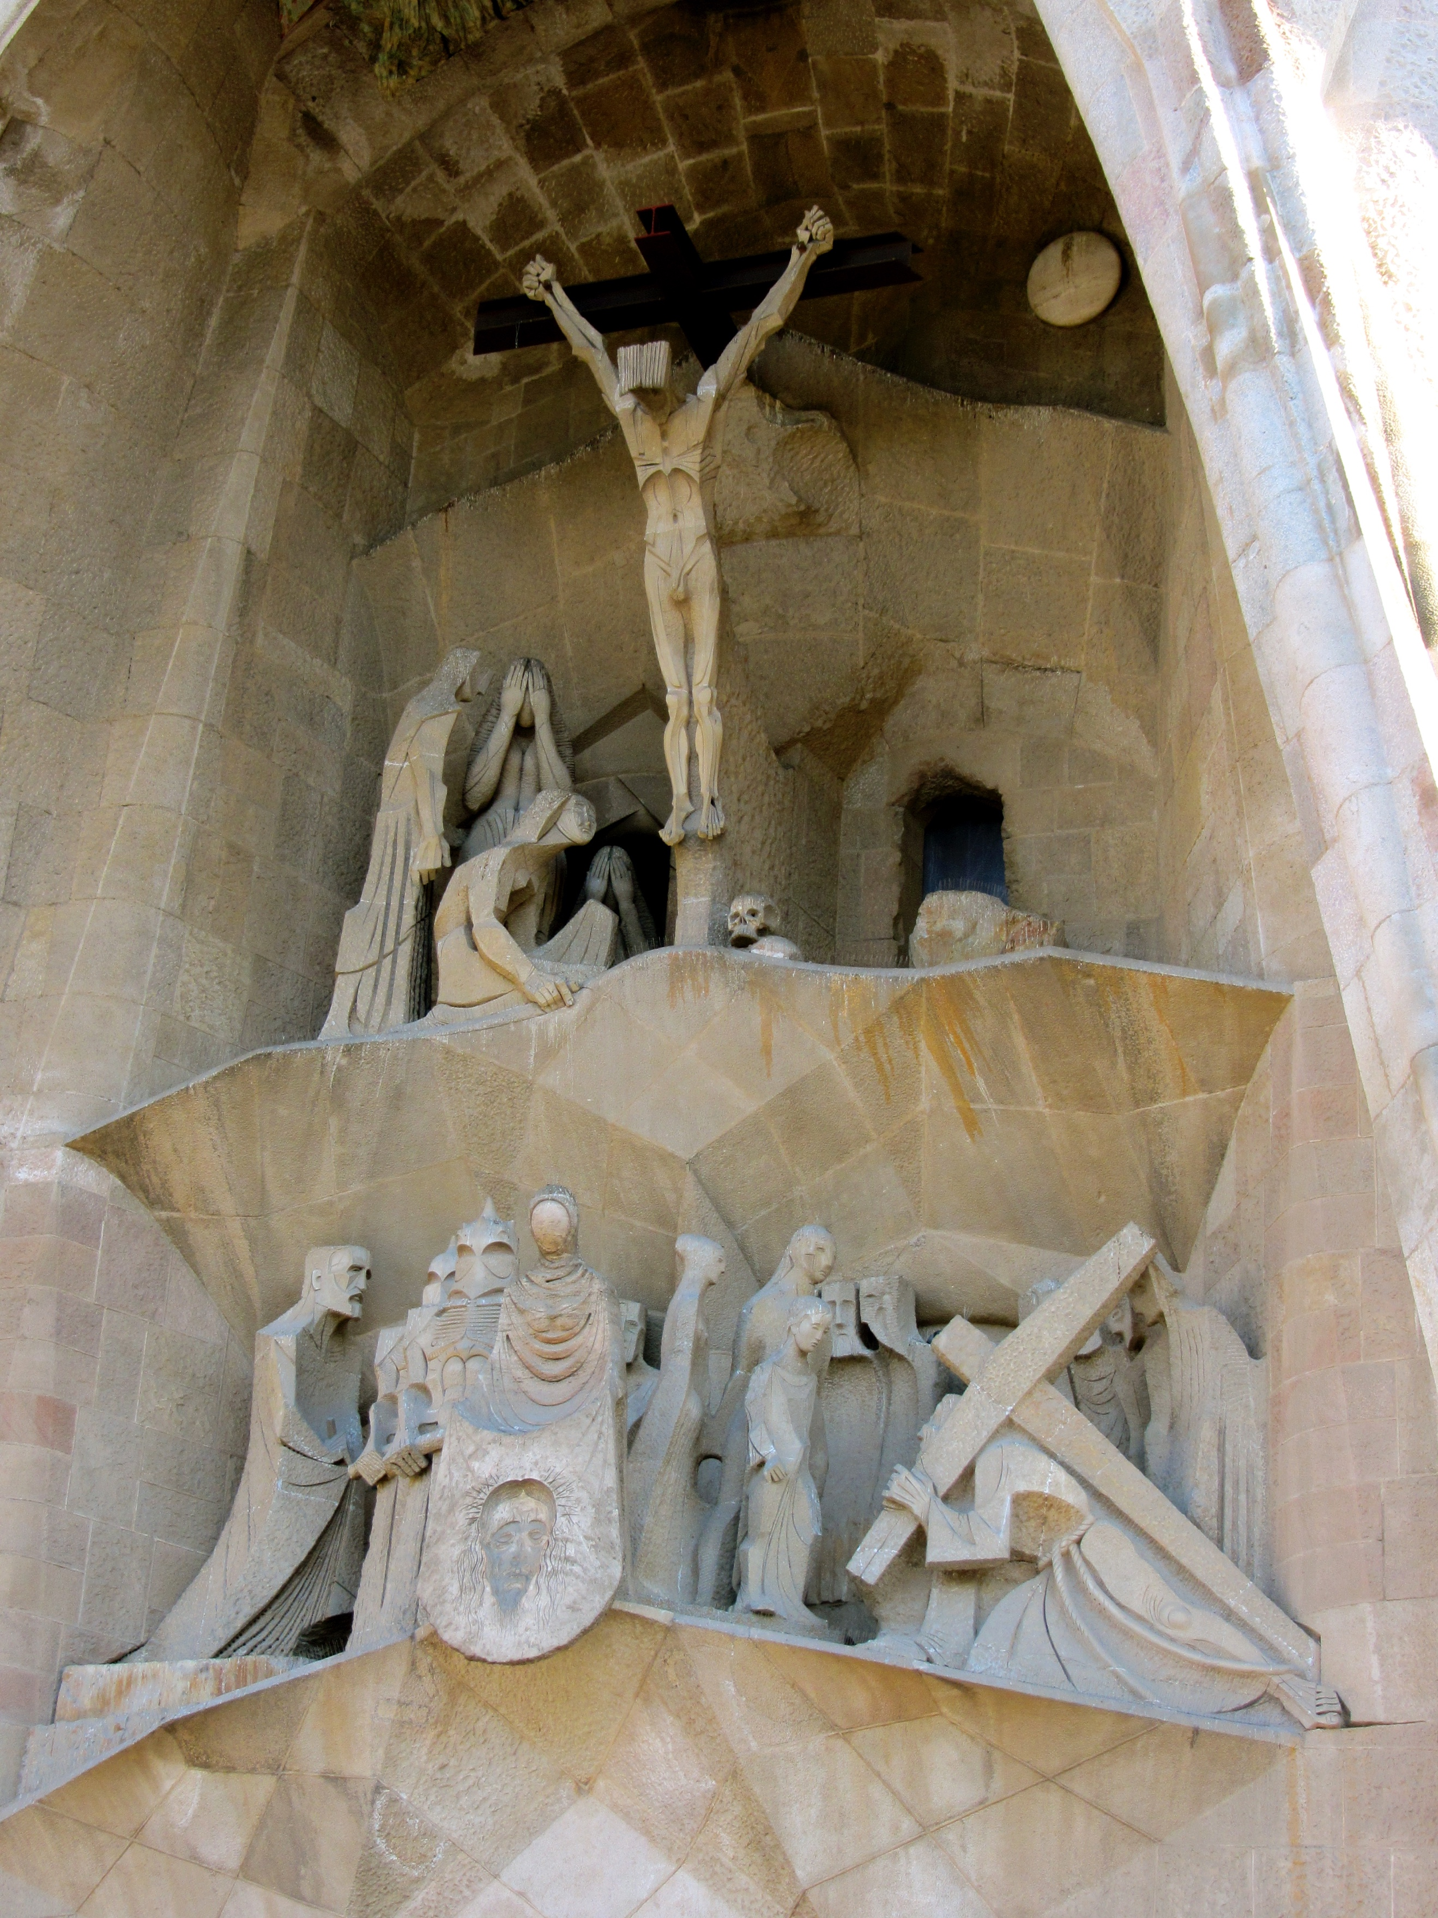
Figure 13. The Passion Façade, Unknown

Figure 14. The Nativity Façade by Céline Mülich, Barcelona Museum, 2013-2019

As La Sagrada Familia is everything I am looking for in a space for my exhibition, I would proceed with following up with my idea for my curation. To conclude, my exhibition of the Renaissance paintings: The Creation of Adam, The Birth of Venus, The School of Athens and The Last Judgement; then the technological advances through art and social life throughout the decades since the Renaissance, and then finally to draw it to a close, the old merging with the new – my adaptation of The Vitruvian Man, using American presidents as the man in the middle, along with the original architectural aspects of the basilica.

Bibliography
Tate. (2010). ‘Cell (Eyes and Mirrors)’, Louise Bourgeois, 1989-93 | Tate. [online] Available at: https://www.tate.org.uk/art/artworks/bourgeois-cell-eyes-and-mirrors-t06899 [Accessed 5 May 2019].

Trillard, A. (2019). Everything you need to know about the Sagrada Familia. [online] Spain-Holiday.com. Available at: https://www.spain-holiday.com/Barcelona-city/articles/la-sagrada-familia-a-sacred-work-of-gaudi-in-barcelona [Accessed 5 May 2019].

Sheerin, M. (2016). End of Empire: Yinka Shonibare MBE on his new exhibition at Margate's Turner Contemporary | Culture24. [online] Culture24.org.uk. Available at: https://www.culture24.org.uk/art/art552937-yinka-shonibare-turner-contemporary-end-empire [Accessed 5 May 2019].

Encyclopedia Britannica. (2019). Notre-Dame de Paris | History, Style, & Facts. [online] Available at: https://www.britannica.com/topic/Notre-Dame-de-Paris [Accessed 5 May 2019].

List of Figures
Parnell, H 2018, End of Empire – Glynn Vivian, digital image, Heather Parnell, 5 May 2019,
<https://heatherparnell.wordpress.com/2018/10/22/swansea-art-glynn-vivian-gallery/>

Jones, J 2010, Cell (Eyes and Mirrors), digital image, Jonathan Jones, 5 May 2019
<https://www.theguardian.com/artanddesign/2010/jun/01/louise-bourgeois-art-maman-sculpture>

Chard, L 2019, End of Empire – Glynn Vivian, digital image, Lauren Chard, 5 May 2019
<https://laurenchard.wordpress.com/2019/01/13/yinka-shonibare-mbe-end-of-empire-glynn-vivian/>

Burke, C 2013, Spider, digital image, Tate Modern Gallery, 5 May 2019
<https://www.tate.org.uk/art/artworks/bourgeois-spider-al00354>

Unknown, Louise Bourgeois SINGLE | 1996, digital image, Pinterest, 5 May 2019
<https://www.pinterest.co.uk/pin/36662184443606666/?lp=true>

Burke, C 2011, Single II, digital image, Tate Modern Gallery, 5 May 2019
<https://www.tate.org.uk/art/artworks/bourgeois-single-ii-al00229>

Leith, M 2013, Couple I, digital image, Tate Modern Gallery, 5 May 2019
<https://www.tate.org.uk/art/artworks/bourgeois-couple-i-al00344>

Bunyan, M 2013, Couple IV, digital image, Art Blart, 5 May 2019
<https://artblart.com/2013/03/01/>

Encyclopaedia Britannica 2019, Notre-Dame de Paris, digital image, Britannica, 5 May 2019
<https://www.britannica.com/topic/Notre-Dame-de-Paris>

Unknown, Notre Dame de Paris floor plan, digital image, Pinterest, 5 May 2019
<https://www.pinterest.co.uk/pin/283515739019717963/?lp=true>

Symonds, P 2010, La Sagrada Familia, digital image, Eye on Spain, 5 May 2019
<https://www.eyeonspain.com/spain-magazine/10-fact-sagrada-familia.aspx>

Jones, R 2013, La Sagrada Familia floor plan, digital image, Arch Daily, 5 May 2019
<https://www.archdaily.com/438992/ad-classics-la-sagrada-familia-antoni-gaudi>

Unknown, The Passion Façade, digital image, Death of Jesus WordPress, 5 May 2019
<https://deathofjesus.wordpress.com/ariel/gaudis-la-sagrada-familia/>

Mülich, C 2013-2019, The Nativity Façade, digital image, Barcelona Museum, 5 May 2019
<https://www.barcelona-museum.com/sagrada-familia.html>

