INTRODUCTION
IMPORTANCE OF PROBLEM SOLVING SKILLS
By definition is an analytical method to identify potential solutions to a situation. It's a complex process and judgment calls, or decisions, may have to be made on the way. The primary goal is to find the best solution. Problem-solving involves identifying an issue, finding causes, asking questions and brainstorming solutions. Gathering facts helps make the solution more obvious.
In work environment as in every day life, as it will not only increase the logic thinking when it comes to solve a problem, but it will also improve the creativity and imagination, as well as determination which will be the main skills in order to complete certain tasks.

BACKGROUND OF THE ORGANISATION
To ensure that there is a complete understanding of what I am going to explain is crucial to have a clear idea of what is the background of the organisation, which in this case is a restaurant founded in 1929 based in central London, precisely in St. James’s Mayfair, called “Quaglinos” in honour of his founder Giovanni Quaglino belonging to the D&D company which counts over 45 restaurant as well as bar and hotels mostly located in London but also with locations in Manchester, Leeds, Bristol, Birmingham, Paris and New York.
The company was co-founded back in 2006 by the CEO David Loewi.

WORKPLACE PROBLEM

The problem I am taking in consideration is, the really low morale Quaglinos restaurant staff is facing, due some not really pleasant review they received as a consequence of not enough staff. where the staff believes that there is need for more people for each shift but the new management believes on a different approach with just the essential number of staff. The problem unfortunately is not only effecting the restaurant itself, the problem is expanding worldwide. In fact, the whole company is suffering from it.

ACTUAL AND POTENTIAL IMPACT TO THE ORGANAISATION

Definitely the restaurant is facing a decline in revenue due the drop of cover the place is having, that has caused discouragement among the staff which is inevitably affecting the whole performance.
In a long run this could completely bring down the whole reputation of the whole company and staff could eventually start looking around towards different location where they feel more motivated, understood and take care off with some incentives for all the effort they constantly giving to this place.
ANALAYSING INFORMATION
After having done some literature review and document as well as a brainstorm with my colleagues and consequently a really honest and deep interview with the staff where I was trying to really dig into the situation.

That helped me to structure a really specific fishbone diagram which helped me and my colleagues to really understand what are the possible causes for the dissatisfaction of the employees at Quaglinos restaurant.

After have done a more detailed observation into the organisation in order to really understand what the actual root cause is, I had to put myself in both department shoes, the managerial one and the employees. This helped me to have a clearer idea of the whole situation. I have managed to dig deep into the situation and yes there are some really unpleasant issue like not having enough cutlery or not having a really good connection both requires the staff to move from where they are, either to go and check out for cutlery that they need or to move to a different section in order for the payment to go through. This can definitely slow down the service but clearly by observing the overall performance it did not take me long to understand that the actual root cause is not having enough staff available and on top of that there is a really big problem with the scheduling shift.

and there is definitely some problem within the restaurant things like not having enough cutlery might sound sth manageable, but when the restaurant is crazy busy and the waiters has to run all the section to check if there is any available or going to the kitchen to clean some it might compromise the whole service. As well as the card machine to take payment which yes are enough but due the really bad connection system they have to move to different section of the venue in order for the payment to come through, and by the time that happens guest get pissed therefore ask the staff to remove the service charge which at the end of the month is less tronc for the staff which means less money on their payslip. The major problem though is defently the number of staff there is available each shift, which gives the staff a really hard time.

Based on my finding I can firmly say that there are many little problems which are causing discomfort among the staff but the major problem surely is the shortage of stuff which is even more evident when the scheduling is not handled in a correct manner when the scheduling is not approached correct manner therefore the experience of the guests is completely ruined. Therefore i thought of 3 solution that might help me solve the issue at Quaglinos restaurant.
SOLUTION 1: Hiring staff from external company
SOLUTION 2: Every hour after the 40 will be paid double
SOLUTION 3: Stopping the reservation to a certain number/ Call an experienced manager from one of the restaurant of the company to train and improve the managerial skills.
ADKAR
CRITERIA | WEIGHT | SOLUTION 1 | SOLUTION 2 | SOLUTION 3
SCHEDULING | 5 | 4 | 3 | 5
STAFF AVAILIBILITY | 5 | 5 | 5 | 3
COST | 4 | 2 | 3 | 5
TIME | 4 | 5 | 4 | 3
TOT |  | 73 | 68 | 72
AWARENESS: The very first thing I did in order to officially address the problem was organise a meeting with all the staff, to let everyone know of the upcoming changes that the place will have.

DESIRE: What will be important in this stage is to communicate and make sure that no one would be negatively affected by this change actually everyone could only benefit from it, guests that will have more people to look after them and staff who will consequently have more income as we will afford the get more reservation without neglecting the attention to details.

KNOWLEDGE: To take in consideration at this point is to make sure that everyone will be able to work as a team, and to don’t see the person they will be working with as an enemy instead someone who they can share their duty with, therefore the knowledge I want everyone to gain in the first place is trust towards this person who will come as an external and making sure that everyone is aware that the person is here to only assist them during the daily tasks in order to make their life easier.

ABILITY: At this stage is important that everything the staff has been thought and told actually applies to the daily tasks at the workplace in order to truly understand that I decided to organise a training from one of the best manager in London who will teach and explain step by step how to take full advantage of external who comes to support the team. By doing this surely the team will embrace the change and will be only grateful if there is someone who might help them during the shift, even better they should see the person as someone who could do those things that might slow down the service due to not enough staff. Therefore making it nice and smooth for everyone. a director and the other more of a performer. Based on our finding after the two weeks, accordingly with the couple they will then decide who will take that position putting aside ego and just decided in the best interest of the company.
REINFORCEMENT: This is the time will be to fully make sure that the investment we will make on the company and on our staff, does not get wasted in order to do so, it is important to keep constantly monitoring the change until it will be fully addressed how are we going to do so? Obviously by constant feedback at the end of each shift where staff will have to be truly honest in order to do not leave any room for mistake, as we might still be able to adjust it and more importantly by monitoring reviews from guests. In order to keep the attention high as well as their performance we decided that every 2 months the person who has the most review under his name will go to any restaurant of our company and have a dinner for two. And to keep the concentration and the willingness to always to give their best the person who has the most reviews at the end of the year will win an all-inclusive holiday for two at our hotel in Dubai where every activities within the hotel policy will be fully on us.

STAKEHOLDER | POWER/INTREST | KEY INTREST/ISSUE | COMMUNICATION VEHICLE | FREQUENCY | COMMENTS
EMPLOYEES | HIGH/HIGH | HEALTHY ENVIROMENT AND FAIRLY TREATED/THEY ARE OUR FACE TO GUESTS | FACE TO FACE  EMAIL | DAILY
MEDIA | LOW/LOW | TO TALK ABOUT US/ IF A NEGATIVE SCOOP ARRIVES TO THEM THEY WILL TRY TO SHARE INFORMATION | EMAIL | NOT DEFINE
REVIEW ORGANAISATION | HIGH/LOW | MAIN INTREST FOR THEM IS TO KNOW ABOUT US/THEY HAVE POWER ON OUR REPUTATION | EMAIL | WHEN NEEDED
SUPPLIERS | HIGH/HIGH | THEY WANT US TO BE GO WELL AS THERE ARE GIVING US PRODUCT/THE LESS WE BUY THE MORE WE PAY | FACE TO FACE  CALL/EMAIL | DAILY
BUSINESS PARTNERS | LOW/HIGH | OUR SUCCESS IS THEIR AS WELL/WRONG REVIEWS COULD ALSO EFFECT US AS A COMPANY | EMAIL/MEETING | WEEKLY
CEO | HIGH/HIGH | THAT WE MAKE AS MUCH REVENUE AS POSSIBLE/HE HAS FULL POWER ON OUR DECISION | EMAIL | MONTHLY
COUNCIL REGULATORS | HIGH/LOW | THAT EVERYTHING RUNS SMOTHLY/ THEY HAVE POWER TO CLOSE THE PLACE | EMAIL | EVERY 2 MONTHS
CUSTOMERS | HIGH/HIGH | THEY BRING AS REVENUE/WE FULLY RELAY ON THEM | EMAIL | DAILY

POWE
R

O
F

S
T
A
K
E
H
O
L
D
E
R

MEET THEIR NEEDS  COUNCIL REGULATORS  REVIEWS WEBSITE | KEY PLAYER  EMPOLOYEES  SUPPLIERS  CEO  CUSTOMERS
LOW PRIORITY  MEDIA | KEEP INFORMED  BUSINESS PARTNERS  LOCAL ACTIVITIES
INTEREST OF THE STAKE HOLDER

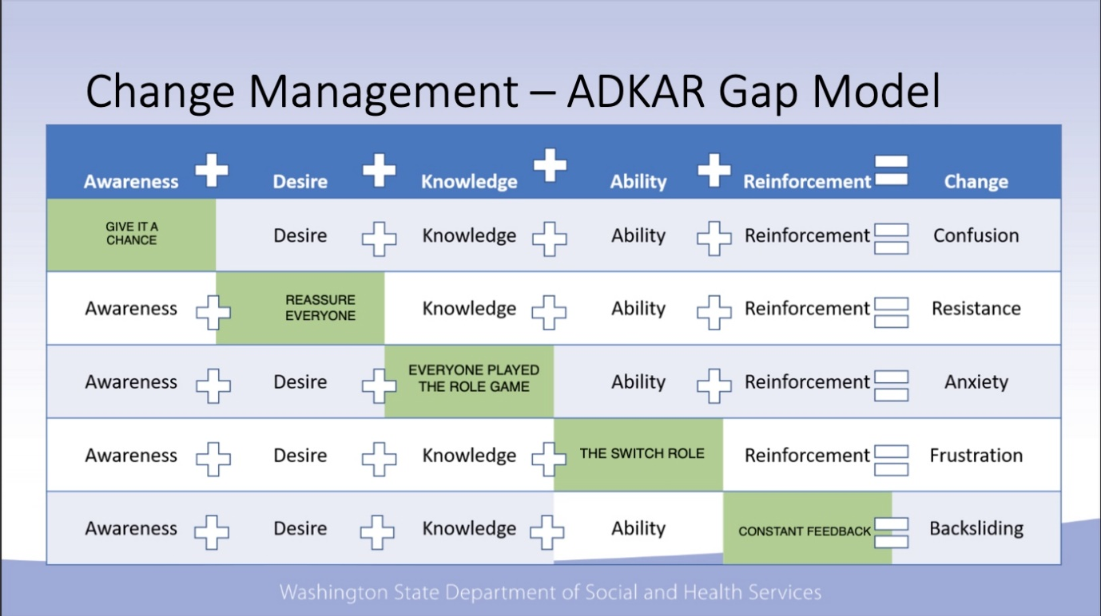

CONCLUSION
In conclusion I can proudly say that it was an honour to work for such a huge company dispite the end result I have managed to learn a lot trough this experience, I must say that thanks to some observation done personally, as well as some really good dose of brainstorming I managed to get the information I needed even before going to personally interviews the Quaglino’s staff which in fact only helped me to confirm my theory. Read some published literature really helped me through this path, there was need to take action immediately as this was not only effecting Quaglino’s London instead it was compromising the whole bruch and its reputation. The hard task though was the implementation of the solution I stipulated in order to keep the enthusiasm high, as every single individual reacts differently to change.

REFERENCES

Bibliography
About us. (2022). Retrieved from D&D London: https://www.danddlondon.com/about-us/
Birt, J. (2022, May 11). Decision-Making and Problem-Solving: What's the Difference? Retrieved from Indeed: https://www.indeed.com/career-advice/career-development/problem-solving-and-decision-making
Restaurant Supervisor Job Description. (2022). Retrieved from HiringPeople: https://www.hiringpeople.co.uk/job-descriptions/restaurant-supervisor-job-description/

