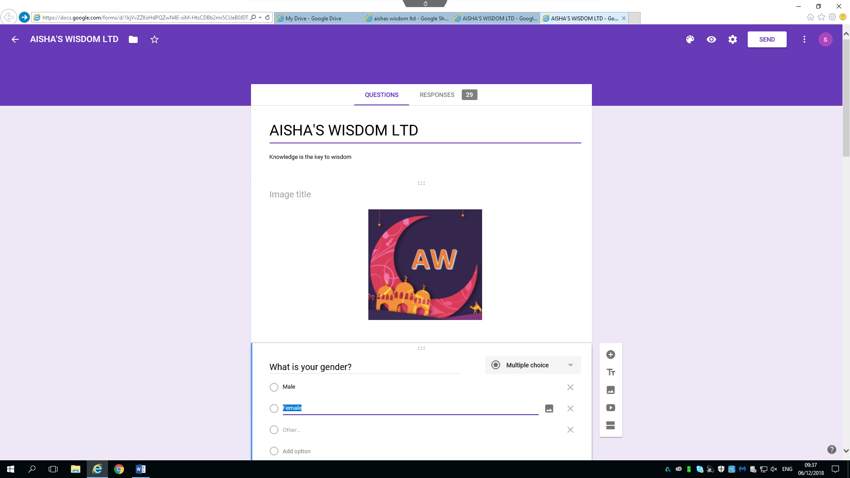
Aisha’s Wisdom Ltd
Weebly Email: Samaduddin1710009@gmail.com
Password: Nazifa123.
Online Islamic bookstore it is in partnership between Farzana Hussen: 1709301, Soyful Khan: 704983, Sufia khan: 1709300, Shamsur Rahman: 1709495 and Samad Uddin: 1710009

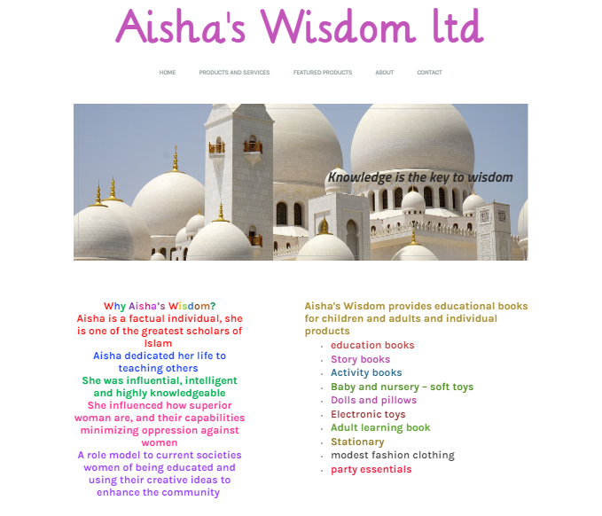

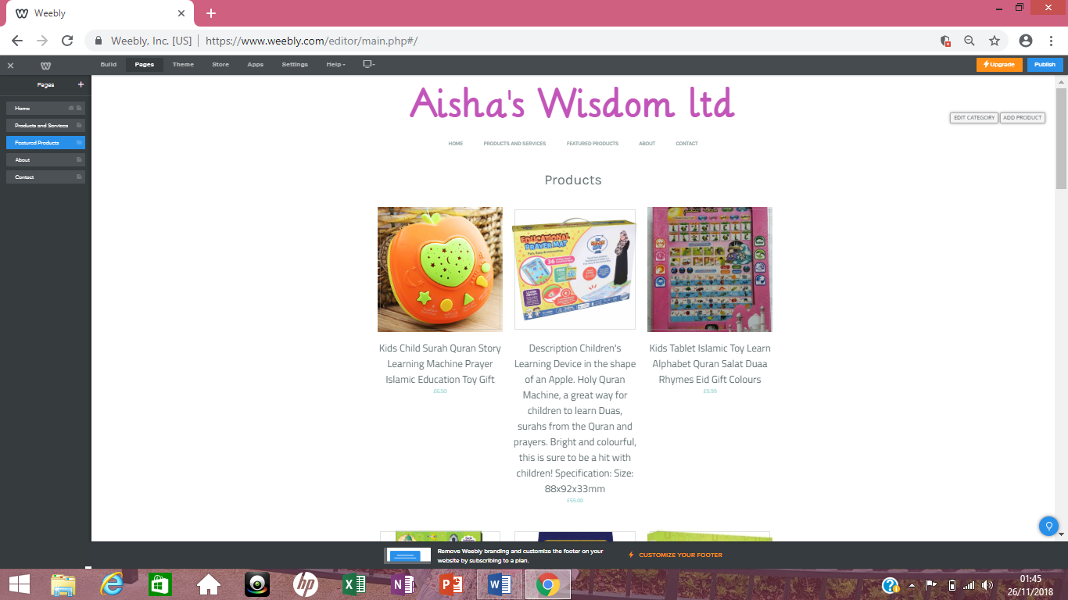

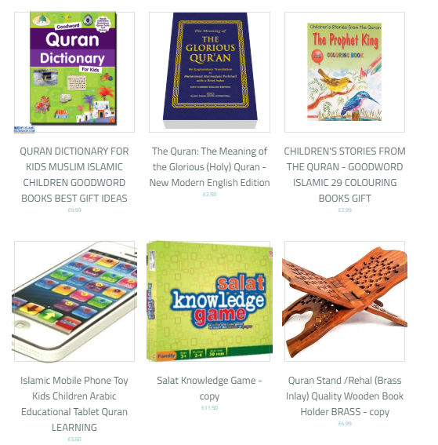

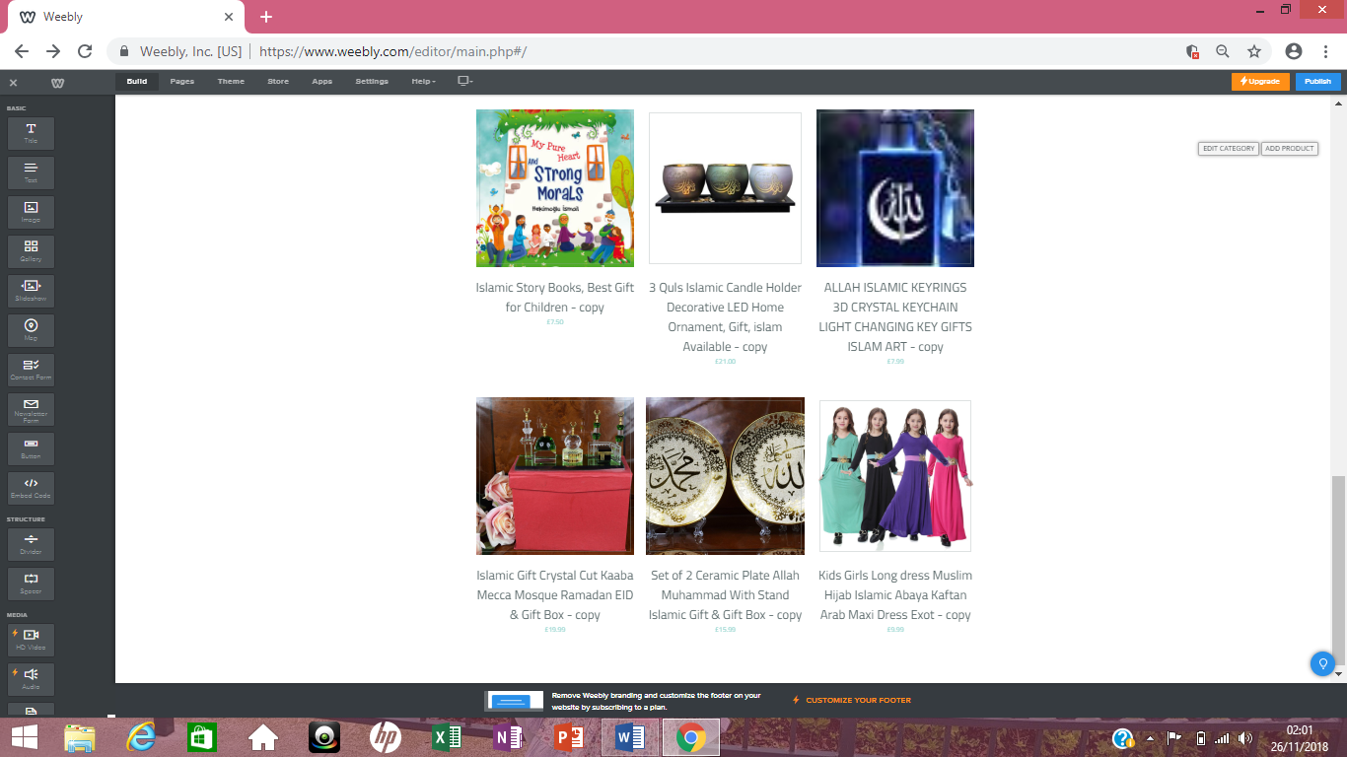
Above is my contribution for our business website for Aisha’s Wisdom Ltd. I have contributed towards the home page images and the layout for the website. My main role for the website design was image creation where I have taken some pictures and downloaded some images from pexels.com and price marked the products. I have been researching on similar products on different websites to see how much they selling the products for as it is a small business we don’t have to think about any extra costs such as wages for the staff so in this case I have decreased the price by an average of 5%.
I have also contributed towards writing the product descriptions where I have written a brief description for each and every products that we sell on our website to make it clear for our customers when they are purchasing or browsing on our site.

Questionnaire and Responses
Google Form email: Samaduddin1710009@gmail.com
Password: Nazifa123.

- What is your gender?

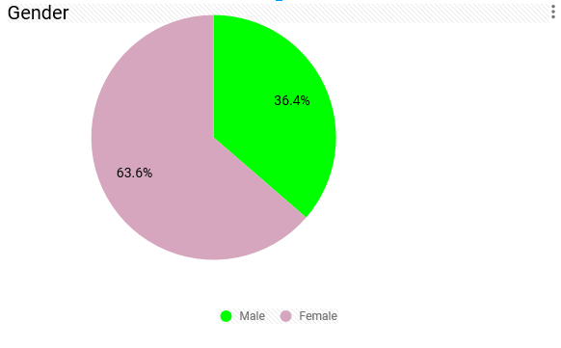

- What is your age group?

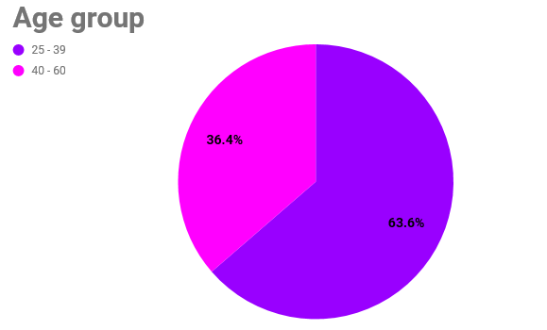

- What kind of books do you prefer?

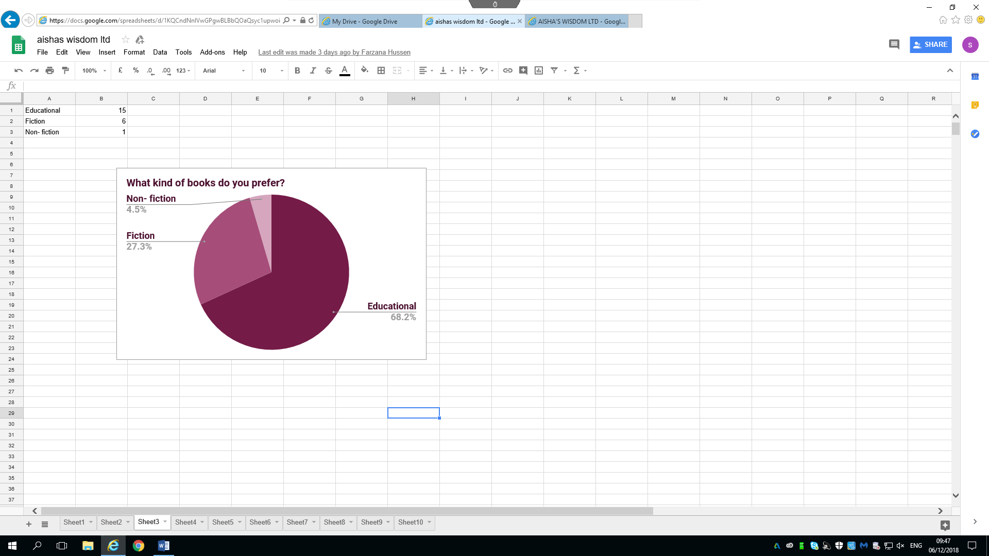

- How often do you read?

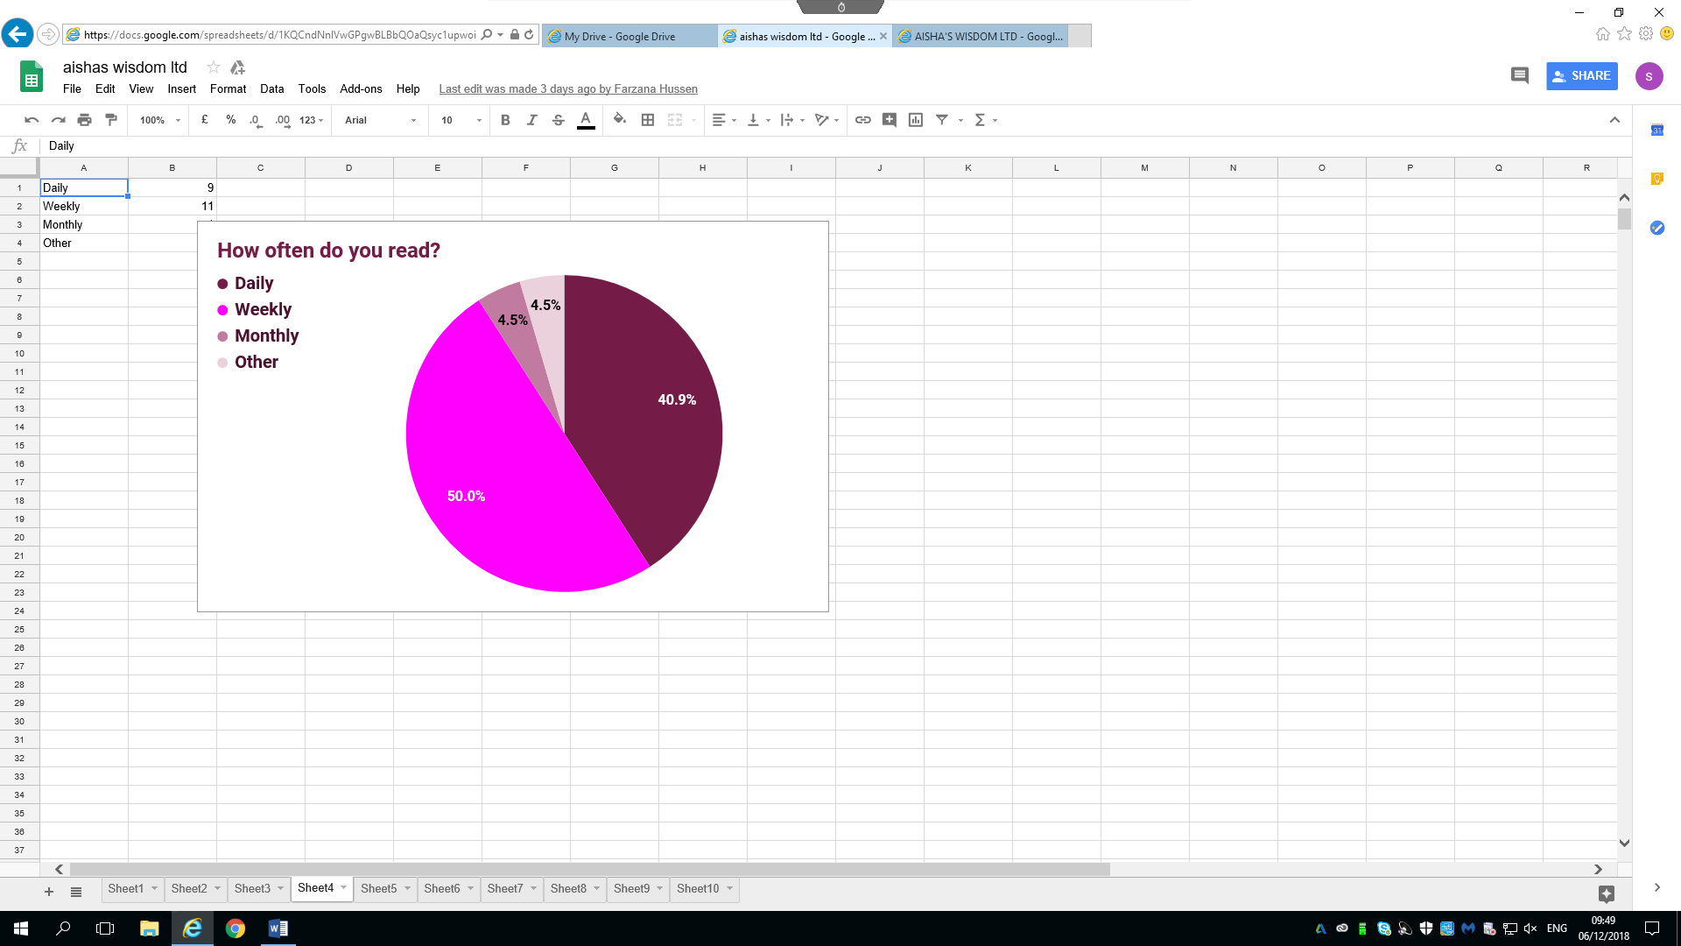

- How long do you like to read for?

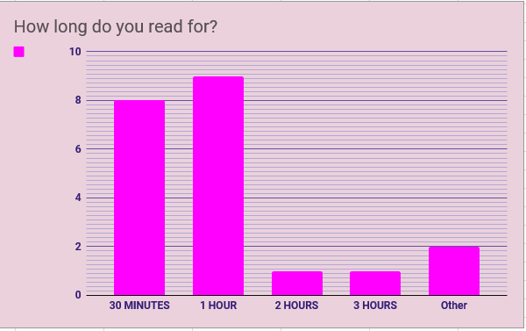

- Where do you purchase your books from?

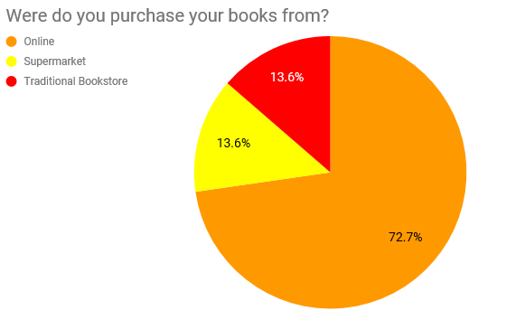

- If you do shop online on average how long does the delivery take?

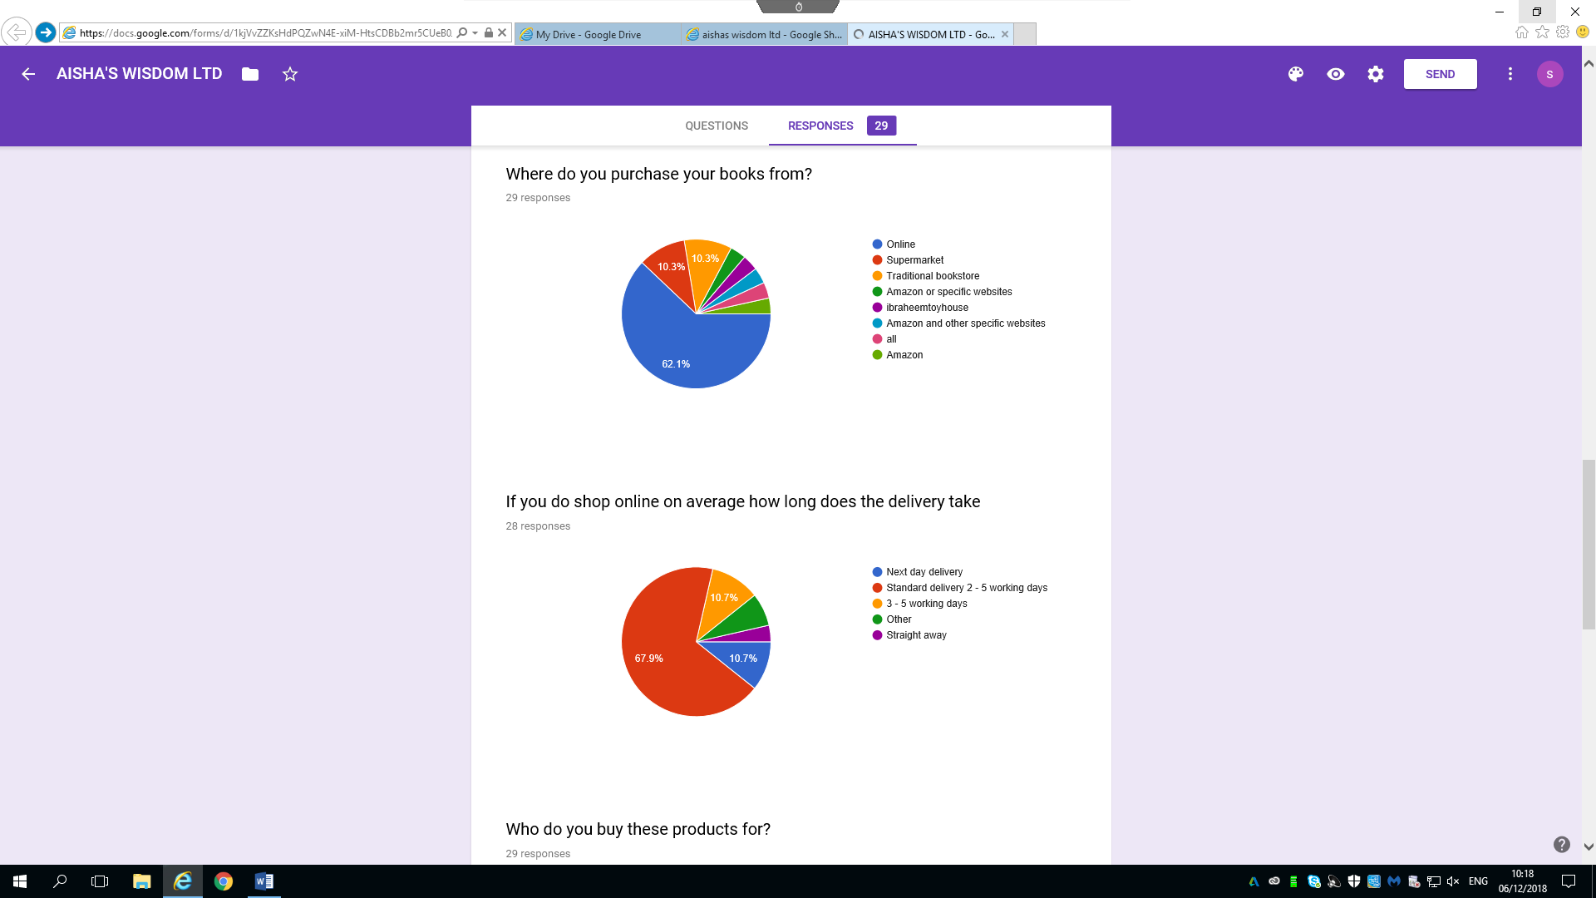

- Who do you buy these products for?

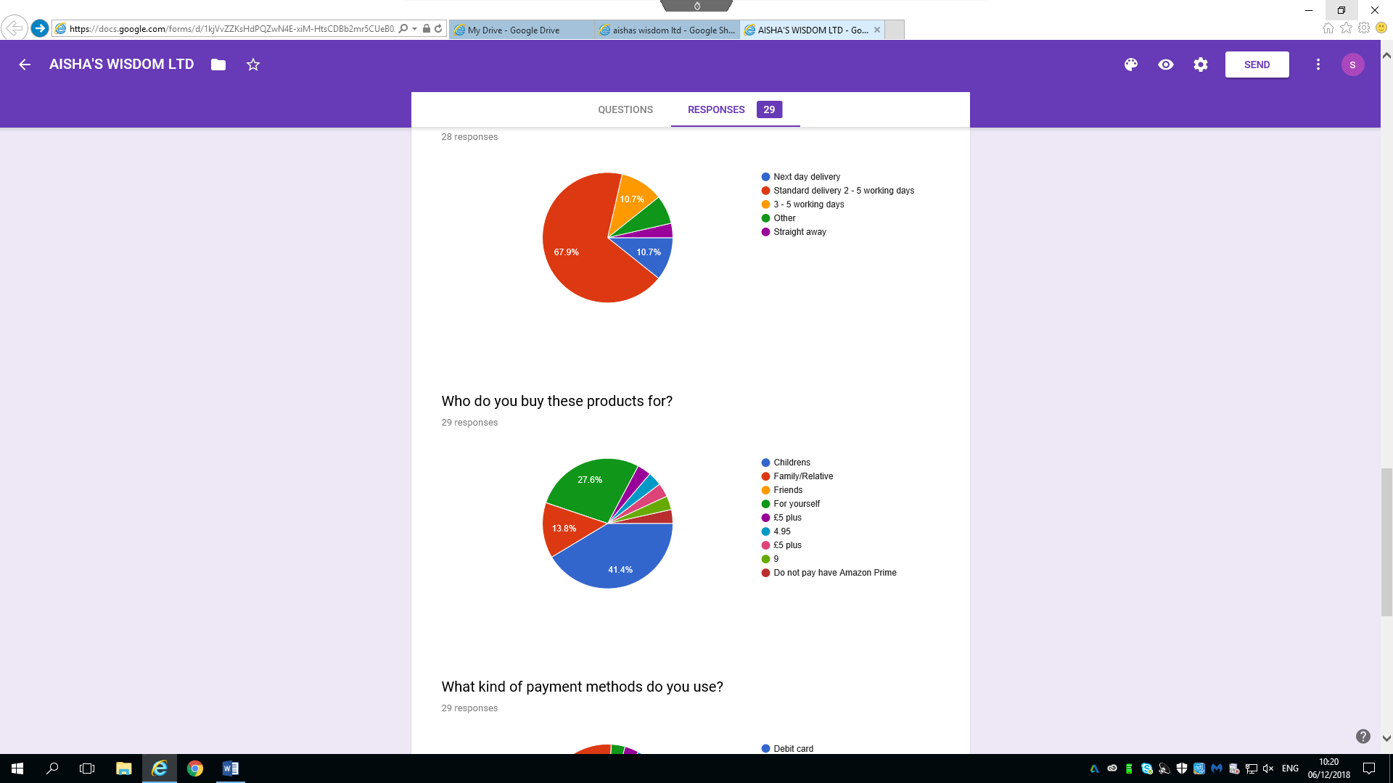

- What kind of payment methods do you use?

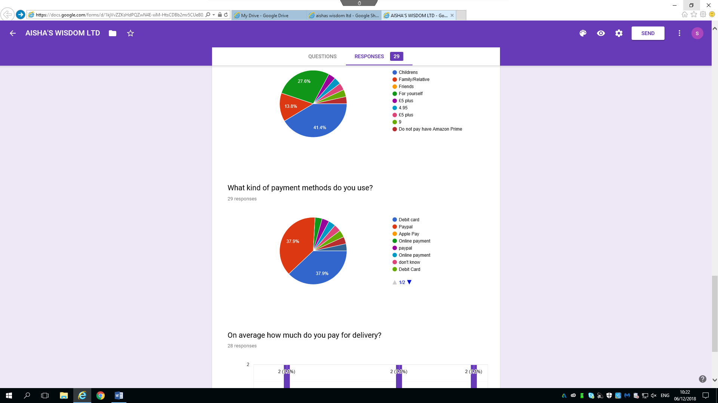
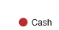

- On average how much do you pay for delivery?

Above I have the responses for our business questionnaire. By analysing this graph it shows that most people whom participated in our survey are female’s age 25 – 39 years old. This tells us that most of our customers will be young and middle aged people. By analysing question 3 and 4 it shows that 68.2% of the people like to read educational books and they read daily, which tells us that majority of the people who participated want to learn and increase their knowledge. Question 5 and 6 shows that people like to read for an hour daily and they purchase their books from online that gives us an idea that our online business will be a best idea to move forward towards as it is more convenient for our customers and saves time as they can easily browse and purchase the books online without having to leave the comfort of their own homes. Question 7 and 8 states that 67.9% of the people said they have to wait for their order between 2 to 5 working days which makes us aware that we in order to gain more customers and good reviews we have to provide a faster delivery service for our products.
Although we have all contributed towards the whole questionnaire we have delegated the questions equally amongst ourselves so everyone gets an equal opportunity to contribute from their part. Question 9 and 10 were the ones that I have contributed towards
9. What kind of payment methods do you use?
10. On average how much do you pay for delivery?
I have researched other online businesses and have come up with these two questions as it gives us an idea of how much people are willing to pay for their delivery and what payment methods they consider to pay with while ordering.
Question 9 and 10 shows that 37.9% of people that took part in our questionnaire stated they use PayPal as their payment method as it is considered safe and easy to use when purchasing online. By analysing question 10 it states that majority of people pay between £2.95 - £3.99 for their postage and packaging where some tend to pay more. We will be aiming to keep the postage and packaging low as possible as a start-up business to maximise our customers with occasional free deliveries on certain products over a certain amount.
I have added a hyperlink below for our business questionnaire.
https://docs.google.com/forms/d/e/1FAIpQLSfVpsVbOo59adJ_G-0-cB7NV1_nQth-hvQTqdteQ1pGMPaJpA/viewform?usp=sf_link

Contribution Audit Sheet

Digital Skills and Research method: BMSK4003
Aisha’s Wisdom ltd
Farzana Hussen 1709301 | Google form questionnaire | Q. 3&4 | Logo  Website design  Weekly blog  About us content  Homepage content
Soyful Khan 1704983 | Google form questionnaire | Q.7&8 | Secondary Research on website design, products, content and texts.  Pricing contributor  Website layout.
Sufia khan 1709300 | Google form questionnaire | Q.5&6 | Website designer/implementer  Images insert
Shamsur Rahman 1709495 | Google form questionnaire | Q.1&2 | Website text and content  About us content  Homepage content
Samad Uddin 1710009 | Google form questionnaire | Q.9&10 | Home Page Image and Layout  Product feature  Product image  Product description  Product pricing

