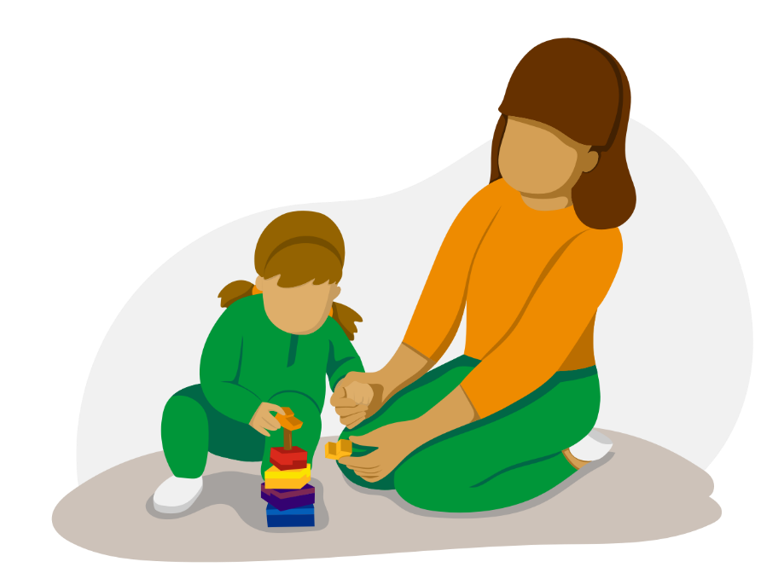
Transitions in Early Years: The Importance of Communication

A Handbook for Practitioners

Contents

Introduction to Transitions pg.3-5
The Needs of the Child pg. 6-8
The Role of the Adult pg. 9-11
Partnerships pg. 12
Interventions pg. 13
Proposed Outcomes pg. 14
Reference List pg. 15-17

- Introduction
The purpose of this handbook is to guide practitioners on how best to support children experiencing transitions into the nursery setting. This handbook will provide practitioners with a comprehensive understanding of the importance of effective and successful communication between all parties during a child’s transition into an early years setting.
The Welsh Government (2018) clearly states that Early Years Practitioners play a crucial role in supporting children’s development – and therefore must have a clear understanding of the developing child and their needs. This handbook provides practitioners with essential information regarding child development and key theories behind current practice. In addition to this, it will outline the skills and knowledge needed to support children’s development while planning smooth and gradual processes through transitions (Ferguson, 2020).



What is a Transition?
“Transitions are milestone events for children and have a definite effect on their development”, Early Years Matters (2018). A transition is a notable, changeable event or movement in a child’s life. Brooker (2008) suggests that transitions centre around change, particularly adjusting to change. As children face change, they are forced to develop and learn from their experiences. Vogler et al (2008) also recognises transitioning as central to young children’s experiences and well-being. Suggesting that a transition is a process, not simply a one-time event. Transitions are a part of a continuous process shaped by social structures and not only involves the child, but also practitioners, parents/ care givers and other professionals together.
Effective communication between all involved in the ongoing transition process is key to success, as the child’s development could be affected both positively and negatively during this process. Daly et al (2009) concludes that completing each transition as smoothly as possible for all involved, especially the child, will ensure that the child feels happy and settled in their new environment as they leave their ‘comfort zone’. Therefore, it is crucial that practitioners understand the significant impact the experience of transitions within an early years setting, has on a child’s development and wellbeing (Welsh Government, 2017).
For a child starting in an early year’s setting, they will be faced with new experiences, new faces and new environments. It is important that early year’s practitioners are aware that this transition for the child from home to Nursery is a momentous experience and that the child needs to feel valued and welcomed when going through this process. Daly et al (2009) believes for such a transition from home to Nursery to be successful, preparation needs to begin early. Dowling (2010) has also recognised that even children who may appear to be confident can be intimidated when starting in a group setting. Therefore, he concludes that a child’s early experiences with transitions will undoubtedly shape their future ability to deal with new experiences.
Children will experience many types of transitions as they develop, Kirklees (2013) describes the Care and Educational transitions a child will experience in an early years setting:
- Moving from parental home to childminder
- Childminder to Nursery setting
- Preschool to Reception class
- Reception to Y1
- KS1 to KS2

In addition to this, practitioners must also recognise other types of transitions children may face, including developmental milestones. HSE (2018) provides examples of developmental milestones:
- Physical – Crawling, Walking
- Communication – Talking, listening
- Fine and gross motor skills
- Problem solving

Furthermore, Environmental changes must also be considered by all practitioners. PACEY (2016) believes this type of transition can be identified by:
- New sibling arriving
- Parental separation
- Moving house
- Family bereavement
- Primary to Secondary School


As an early year’s practitioner, it is important to understand the many different transitions a child will experience in the setting, as they continue to develop. Practitioners must also be prepared for the possibility that children may experience more than one transition at any one time. This handbook will focus on children transitioning from home to Nursery in a Primary School, however many of the principles can also be applied to other transitions.
- The Needs of the child
In order to meet a child’s needs, practitioners should recognise that every child is an individual, and as such, so are their needs. Dowling (2014) states that effective practitioners centre learning around caring for the child. The emphasis must be on getting to know the child, their likes and dislikes, how they think and what their interests are. In addition to this, Lindon (2010) also recognises that an effective practitioner will consider the child as a whole. Taking a holistic view of a child and their development is considered good practice.
The Welsh Government (2018) discusses how in all aspects of the transition process, the needs of the individual child and family should be considered and delt with sensitively. To ensure that transitions are successful, practitioners are encouraged to:
- Allow sufficient time – Children will adjust to each transition uniquely. Therefore, practitioners should integrate children gradually into the setting, according to their individual needs.
- Consider individual circumstances –Every child will have their own unique circumstances with regards to family. Parental involvement and support will be different for every child.
- Inclusive - All families should feel welcome, without judgement.

Lindon (2010) suggests that when considering what a child’s needs are, in particular their development, practitioners should make themselves aware of the theories of child development that best inform practice. Lindon (2010) also empathises that an effective practitioner will have a grasp of multiple theories that have been proposed to explain child development. Theory shape’s educational philosophy and practice for school. Relying on one dominant theory can become part of a ‘cultural wallpaper’ and as a result basic assumptions are less likely to be challenged.
Maslow’s Hierarchy of Needs presents the idea that people are driven to meet fundamental wants before moving on to more sophisticated demands, as shown in the diagram below (Noltemeyer, 2012). The needs at the bottom of the triangle must be fulfilled before any of the higher needs can be achieved. Maslow’s theory can be applied when a child goes through a transition. A lack of safety and security may result in a child refusing the most basic of needs, such as food and water. As a result, the child will also be less likely to form relationships, develop as an independent learner and build self-esteem.
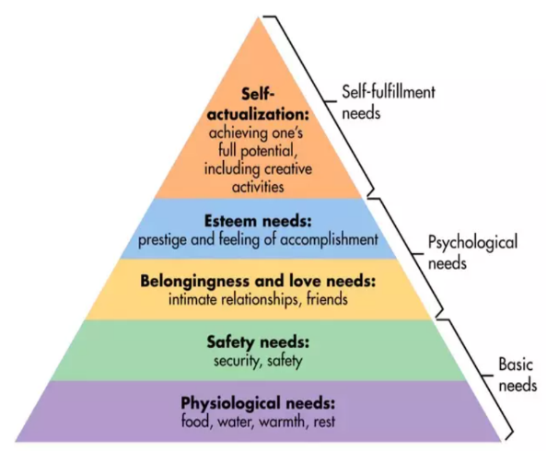

(Source: Simplypsychology, 2020)

TES (2019) acknowledges how Maslow’s Hierarchy of Needs can influence practice in schools, such as school policies and classrooms. These can often be seen, for example:
- Safety Needs - Practitioners are required to provide a safe and stimulating place for children to play.
- Physical Needs - Children are provided with free access to a drink and are always encouraged to bring healthy snacks for break time.
- Social Needs - A setting will create a whole school ethos by ensuring strong connections are formed with both the community and parents.
- Esteem Needs - Children are provided with both wellbeing and circle time. In addition to this, settings will provide children with the opportunity for their voice to be heard through the school council.

According to Maslow (TES, 2019) these can lead to self-actualisation and prepares children with the readiness to learn and achieve in their setting.
Practitioners should also consider Piaget’s theory on child development, a pioneer in the study of children’s cognitive development. His theory emphasises the importance of child-centred learning (Lindon, 2012). This initiative encourages the child to become and active learner, seeking out knowledge to construct their own understandings (Doherty and Hughes, 2014). Implementing such an approach in a setting will enable the practitioners to observe and plan for the children, taking into consideration and focusing on the child’s needs and interests. Incorporating these into learning and care will help the child to settle and transition smoothly in their new setting.
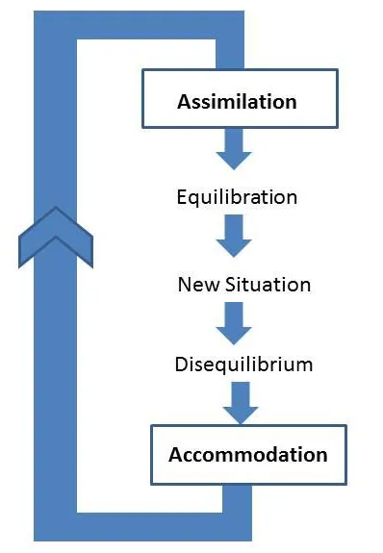

(Wadsworth, 2004)

According to Pound (2005) Piaget also believed child development was driven by the process of equilibrium. When children take in new information, they assimilate the information and place it alongside their existing knowledge. If a child then comes across a new situation or task they do not understand, they experience some discomfort or disequilibrium which causes them to rethink their idea. When a child does so, they are accommodating the new information, re-organising their thinking, to restore cognitive equilibrium. During periods of transitions, Piaget believed children would experience this process of equilibrium. Understanding Piaget’s cognitive balancing of new information with existing knowledge is crucial in understanding and facilitating children’s development as they transition within the setting. Smith et al (2003) stated that children will always experience some level of disequilibrium before reaching cognitive equilibrium. Therefore, the practitioner plays an essential role in being able to identify and recognise the child’s needs during the process, to ensure each transition occurs smoothly.
However, Machado & Lourenco (1996) suggests that Piaget’s theory neglects the role of social factors in children’s development. These critics believed Piaget concentrated more on the sequence of the cognitive stages rather than the factors that can accelerate, retard, and even prevent their appearance.
- The Role of the Adult
“The little, or almost insensible impressions on our tender infancies, have very important and lasting consequences” (Locke, 1692). This quote encapsulates how even the smallest of experiences can affect a child’s development and learning. Therefore, the role of the adult in a child’s life can significantly impact developmental transitions.
When children begin attending nursery, they will have to form new bonds with unfamiliar people. This is also known as forming attachments. Bronfenbrenner’s theory emphasises that within an early years setting it is important to create an inclusive environment for all children. As children develop to their best potential when they feel valued and maintain strong relationships with the people closest to them (Hayes et al, 2017). Bronfenbrenner’s model was based on the child being at the centre of an ecological system, as shown in the diagram below. Similarly, to Lindon (2010), Bronfenbrenner believed that a more holistic approach to a child’s development would be more beneficial. His theory consists of the following four parts:
- The microsystem- This is the immediate environment in which the child spends most of their time. Here, the child will typically remain active and confident. The long-term relationships within this microsystem have a stable and long-lasting effect on the child’s development.
- The Mesosystem- This is the child’s extended environment. Examples of this include extended family, school, nursery, community and so on.
- The Exosystem- These types of setting can influence a child’s development; it does not directly involve the child. This can include media, politics, neighbours, industry and so on.
- The Macrosystem- This is the much wider reaching ideology, laws, regulations, and cultural influences.

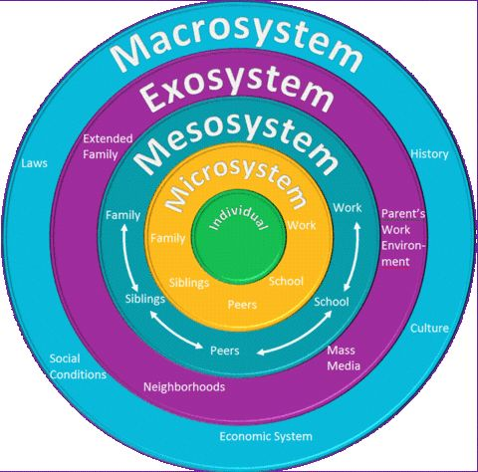

(Source: SusanMarie, 2017)

In addition to Bronfenbrenner’s theory, practitioners should also consider adopting Bowlby’s theory of attachment in the setting. Bowlby developed a model of the relationship between children and their prime carer, also known as attachment theory (Wilson-All, 2019).
Bowlby proposed that children are pre-programmed from birth to develop attachments and maintain proximity to their primary attachment figure, typically the mother or someone assuming the role of mother-figure. Bowlby defined such a relationship as ‘seeking and maintaining proximity to another individual’ (Bowlby, 1969, p. 194). Attachment behaviours allow infants to stay close to their attachment figure by either demonstrating signalling behaviours such as crying and smiling, or approach behaviours such as following and clinging (Ainsworth & Bell, 1970). Bowlby also believed that children could develop secondary attachment figures, known well by their primary attachment figure (Bowlby, 1969). In contrast to enduring primary attachments, Bowlby proposed secondary attachments could vary both in identity and quantity and could provide children security in the absence of their primary attachment figure. When a child is transitioning from home to a Nursery setting, the practitioner will effectively become the child’s secondary attachment figure. Maintaining a strong attachment relationship with a child, plays an important role in supporting children to develop to their potential (Colmer et al, 2011) and influence future physical and mental wellbeing (McCain et al, 2007). An infant’s brain is effectively shaped by their early experiences and the quality of these experiences has a substantial effect on development.
(Source: Simply Psychology, 2022)
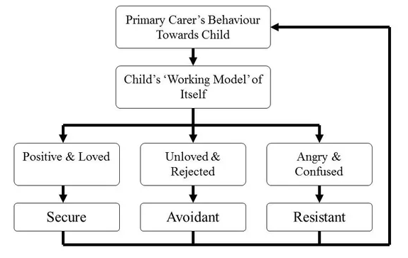

According to Bowlby’s theory (1969) when children form attachments, they also make a mental representation of what a relationship is. This lasting impact of Early attachment will affect children’s relationships in the future, such as friendships, working and romantic relationships. The diagram above, shows the three main attachment styles: secure, anxious, and avoidant. Attachments made based on a children’s early relationships. This would suggest that early interactions with practitioners could not only shape how a child understands and behaves in relationships, but that such impact could be carried forward into adult attachment.

- Partnerships
Partnership working is a fundamental part of committing to a child’s development. During any transition, the child is at the centre of the process. Working together for the interests of the child is vital to ensure a clear plan is in place for that child’s transition. Working in partnerships with a variety of other agencies, as well as parents, is crucial to ensure smooth transitions. The Welsh Government (2016) stated that maintaining effective partnerships, requires a good level of communication, where parents are fully engaged and encouraged to get involved in their child’s learning.
To develop a trusting relationships between practitioners and both the child and parents, effective communication is essential (Children’s Workforce Development Council, 2010). There are serval ways in which a practitioner can develop trust and create a positive relationships with children and their families:
- Time – Practitioners should spend time getting to know the child and their family to better understand their likes and dislikes and what interests them. An example of this, Bowlby’s attachment theory can be applied to create a strong bond with the child.
- Communication – An effective practitioner needs to be aware of the culture, background, ability and circumstances of the child and family. Practitioners should also encourage the child to be confident to share how they feel and to ask questions that can be explored together.
- Information – As a child transitions into a setting, the practitioner needs to relay any and all information to the parents regarding the school’s process for transitions. This can be accomplished verbally, with newsletters, drop-in sessions, planned visits and so on.

The practitioner will be responsible for involving parents from day one in the transition process. It is essential that parents remain update on their child’s progress as they transition into their new setting. Pacey (2018) suggests that daily chats are a vital way of communicating to build these strong, trusting relationships, as well as sharing resources, events and information sessions. Communication with parents should remain flexible, practitioners will need to remain mindful of adapting to different situations, such as working with a parent with additional learning needs.
- Interventions
To better support children through transitions, many interventions can be implemented within the early years setting. The following are aimed at building and maintaining close links with families and children as they transition from home to Nursery (Collins, 2010):

Morning Sessions
At the beginning of the transition, before a child starts in the nursery, they will be invited to a series of morning sessions (Collins, 2010, p.233). The first of which, parents are encouraged to stay with their child to provide reassurance as they first encounter their new environment. Thereafter, the child will complete the sessions without a parent. Each child will be assessed individually and depending on the child’s needs, the number of sessions they receive may vary.

Handovers
As stated in (Collins,2010, p.234) at the end of each Nursery session the practitioner should complete an informal handover with the parents. This provides the opportunity to discuss any issues or concerns regarding the child as they progress through their transition. Information shared during these handovers will help the practitioner to better understand the child’s needs and plan activities that best support that child.

Home Visits
Keenan et al (2016) also discusses the possibility for Home Visits to take place before the child starts Nursery. The settings practitioner is able to visit the child in their own home. Bronfenbrenner disagreed with the emphasis placed on observing children’s behaviour in strange places for short periods of time. Therefore, he suggested for practitioners to observe children in their actual environments. Home visits allow the practitioners relationship with the child and family to start to form in a comfortable and familiar setting. This can provide the practitioner with the opportunity to observe and assess the child in an environment where they feel happy and safe, allowing them to gain a true picture of the child’s personality.
- Proposed Outcomes
The desired outcome is for a child to be happy, confident, engaged and equipped wit the emotional and social skills to transition in a positive manner.
A child’s transition has been successful once the child demonstrates that they are settled in their setting. This can be measured in many different ways (Welsh Government, 2018). It will become evident if the child begins to play independently, relying less on their practitioners for reassurance. This sense of independence can also be transferred to the different relationships they hold. The child may want to develop their relationships with both peers and other practitioners within the setting.
As the child spends more time in their setting, they will become more comfortable within the environment. They will start to demonstrate a sense of self as they are comfortable in their surroundings. A fully settled child will engage in classroom activities and feel secure in exploring their surroundings independently. In addition to this, parents and carers of the child will feel confident to approach the members of the setting with any questions or concerns they may have. Parents should also feel a part of and included in their child’s learning, having been informed and kept update on their child’s transition.


Bibliography
Brooker, L. (2008) Supporting Transitions in the Early Years. McGraw-Hill Education.
Daly, M. and Byers, E. and Taylor, W. (2009) Early years management in practice. 2nd Ed. Essex: Heinmann, Pearson Education Limited.
Doherty, J & Hughes, M. (2014) Child development: theory and practice 0-11. Second edition. Harlow, England: Pearson.
Dowling, M. (2010) Young Children’s Personal, Social and Emotional Development. 3rd Ed. London: Sage.
Dowling, M. (2014) Young Children’s Personal, Social and Emotional Development. 4th Ed. London: Sage.
Every Child Matters (2018) Transitions. Available at: http://www.earlyyearsmatters.co.uk/eyfs/positive-relationships/transitions/ (Accessed: 2nd December 2022).
Ferguson, J. (2020) ‘Supporting Smooth Transitions in the Early Years’, Herts for Learning. Available at: https://www.hertsforlearning.co.uk/blog/supporting-smooth-transitions-early-years (Accessed: 29th November 2022).
HSE (2018) Your Child’s Developmental Milestones. Available at: https://www2.hse.ie/wellbeing/child-health/your-childs-developmental-milestones/how-your-child-develops.html (Accessed: 26th November 2022).
Kirklees Council (2013) Kirklees Guidance for Transitions in the Early Years. Available at: https://moodle.uwtsd.ac.uk/pluginfile.php/86471/mod_resource/content/1/early-years-transition-guidance-booklet-2013.pdf (Accessed: 21st November 2022).
Lindon, J. (2010) Understanding Child Development 2nd Ed. London: Hodder Education.
Lindon, J. (2012) Understanding child development: 0-8 years: linking theory and practice. 3rd ed. London: Hodder Education.
Machado, A and Lourenco, O. (1996) ‘Defense of Piaget's Theory: A Reply to 10 Common Criticisms'. Psychological Review.
Noltemeyer, A, Bush, K, Patton, J, Bergen, D. (2012) Children and Youth Services Review: ‘The relationship among deficiency needs and growth needs: An empirical investigation of Maslow's theory’. Volume 24, Issue 9. Pp. 1862-1867.
PACEY (2016) Transitions and Settling in. Available at: https://www.pacey.org.uk/Pacey/media/Website-files/PACEY%20member%20practice%20guides%20(PDFs)/PG10-transitions-and-settling-in.pdf (Accessed: 29th November 2022).
Pound, L. (2005) 'How Children Learn'. New Edition ed. London: Practical Pre-School Books, pp.86-93.
Simply Psychology. (2020) Maslow’s Hierarchy of Needs [on-line] Available at: https://www.simplypsychology.org/maslow.html (Accessed: 29th October 2021)
Simply Psychology. (2022) ‘What Is Attachment Theory: The Importance of Early Emotional Bonds’. Available at: https://www.simplypsychology.org/attachment.html (Accessed 2nd of December 2022).
Smith, P, Cowie, H, Blades, M. (2003)'Understanding Children's Development'. Fourth ed. Blackwell Publishing.
TES (2019) Pedagogy Focus: Maslow’s Hierarchy of Needs. Available at: https://www.tes.com/news/pedagogy-maslows-hierarchy-needs (Accessed: 29th November 2022).
Vogler, P, Woodhead, C & M. (2008) ‘Early childhood transitions research: A review of concepts, theory, and practice’. Bernard van Leer Foundation.
Wadsworth, B. J. (2004). Piaget's theory of cognitive and affective development: Foundations of constructivism. New York: Longman.
Welsh Government (2017) Flying Start- Annex Transition Guidance Available at: https://moodle.uwtsd.ac.uk/pluginfile.php/214826/mod_resource/content/1/141124-transition-guidance-en-v1.pdf (Accessed 26th December 2022).
Welsh Government (2018) Foundation Phase Framework revised 2015. Available at: https://gov.wales/sites/default/files/publications/2018-02/foundation-phase-framework-revised-2015.pdf (Accessed: 22nd November 2022).
Hayes, N, O’Toole, L and Halpenny, A-M. (2017) Introducing Bronfenbrenner: A Guide for Practitioners and Students in Early years Education. London: Routledge.
SusanMarie (2017) Bronfenbrenner’s Bioecological Approach [on-line] Available at: https://www.suemarie.info/2017/10/bronfenbrenners-bioecological-approach.html (Accessed: 28th November 2022).
Locke, J. (1692) Some Thoughts Concerning Education Available at: https://sourcebooks.fordham.edu/mod/1692locke-education.asp#Some%20Thoughts%20Concerning%20Education (Accessed: 29th November 2022).
Wilson-All, N, Barratt-Pugh, C and Knaus, M. (2019) Australasian Journal of Early Childhood: ‘Multiple perspectives on attachment theory: Investigating educators’ knowledge and understanding’. London: SAGE.
Bowlby, J. (1969) Attachment and loss: Volume 1. Attachment. New York: Basic Books.
Ainsworth, M. D., & Bell, S. (1970) Attachment, exploration and separation: Illustrated by the behaviour of one-year-olds in a strange situation. Child Development, 41(1), 49–67.
Colmer, K, Rutherford, L, & Murphy, P. (2011) Attachment theory and primary caregiving. Australasian Journal of Early Childhood, 36(4), 16–29.
McCain, M. N., Mustard, J. F., & Shanker, S. (2007) Early years study 2: Putting science into action.
Children’s Workforce Development Council. (2010) Common Core Skills and Knowledge for the Children’s Workforce.
Pacey. (2018) Partnership with parents. Available at: https://www.pacey.org.uk/working-in-childcare/spotlight-on/partnerships-with-parents/ (Accessed on: 29th of November 2022)
Welsh Government. (2016) Foundation Phase Action Plan. Available at: https://sites.google.com/a/bvsd.org/lucinda-schuettpelz/growth-mindset-1 (Accessed: 28^{h} November 2022).
Collins, S. (2010) ‘Thinking through the uses of observation and documentation’ in Moyles, J. (ed) Thinking about play. Berkshire: Open University Press.
Keenan, T, Evans, S, and Crowley, K. (2016) An introduction to Child Development. 3rd Ed. London: Sage.

