Student: Nicoleta Bichir

Title: The Impact of Remote Work on Amazon Employees’ Productivity, Well-being, and Job Satisfaction Post-COVID: A Study of Employee Perception.

BA (Hons) BUSINESS MANAGEMENT
UWTSD Cardiff
2025

Dissertation submitted as part of the requirements for the award BA DEVELOPING LEADERSHIP AND MANAGEMENT.

Declaration

This work has not previously been accepted in substance for any degree and is not being concurrently submitted in candidature for any degree.

Signed Nicoleta Bichir
Date 11th July 2025

STATEMENT 1
This dissertation is being submitted in partial fulfilment of the requirements for the degree of BA.
Signed Nicoleta Bichir
Date 11th July 2025
STATEMENT 2
This dissertation is the result of my independent work/investigation, except where otherwise stated. Other sources are acknowledged through footnotes, which provide explicit references. A bibliography is appended.
Signed Nicoleta Bichir
Date 11th July 2025
STATEMENT 3
I hereby give consent for my dissertation, if accepted, to be made available for photocopying and interlibrary loan, and for the title and summary to be made available to outside organisations.
Signed Nicoleta Bichir
Date 11th July 2025
STATEMENT 4
I hereby give consent for my dissertation, if accepted, to be available on the university’s IT system to those who have permission to use the system.
Signed Nicoleta Bichir
Date 11th July 2025

Acknowledgement
During my research on the topic “The Impact of Remote Work on Amazon Employees’ Productivity, Well-being, and Job Satisfaction Post-COVID: A Study of Employee Perception”, I had the opportunity to engage with a variety of individuals whose input and support have been invaluable to the success of this study.
Firstly, I would like to express my heartfelt thanks to my mentor, Rebecca Francis-Davies, for her dedicated support, expert guidance, and encouragement throughout this research journey.
I would also like to extend my sincere appreciation to Arpu Kumar, who provided essential support in guiding me through the ethical approval process and offering clear structural guidance that helped shape the foundation of this research.
My gratitude also extends to my friends and family members, whose motivation and ongoing encouragement kept me focused and committed throughout each stage of data collection and analysis.
Lastly, I am thankful to my relatives for the insightful conversations we shared, which further enhanced my understanding of the topic.
With warm regards,
Nicoleta Bichir

Table of Contents
Chapter 1. Introduction 6
1.1 Research Problem 8
1.2 Rationale for the study 8
1.3 Aim of the Study 8
1.4 Research Objectives 8
1.5 Research Questions 9
Chapter 2. Literature Review 9
2.1 The Evolution of Remote Work 9
2.2 Work-Life Balance and Employee Well-Being in Remote Work 9
2.3 Impact on Productivity, Motivation, and Engagement 10
2.4 Organizational Support, Leadership, and Communication 10
2.5 Challenges and Benefits of Remote Work at Amazon 11
2.6 Research Hypotheses: Theoretical Framework. 11
Chapter 3. Research Methodology 14
3.1 Aim and Objectives 14
3.2 Research Design 15
3.3 Research Paradigm 16
3.4 Data Collection 16
3.5 Population and Sample 17
3.6 Data collection and analysis 17
3.7 Reliability and Viability 17
3.8 Limitations of the Research 18
3.9 Research Ethics 18
Chapter 4: Analysis of Data and Discussion of Results 19
4.1 Data collection and analysis 19
4.2 Discussion of results 26
Chapter 5: Conclusion and Recommendations 30
5.1 Conclusion 30
5.2 Recommendations 30
Reference List: 32
Appendices: 37
Appendix 1: Questionnaire 37

List of figures
Figure 3.1: The Research Onion
Figure 4.1.1 Current work arrangement at Amazon
Figure 4.1.2 Experience of working in a hybrid model
Figure 4.1.3 Department of the different respondents
Figure 4.1.4 Changed productivity while working remotely
Figure 4.1.5 Distractions during working remotely
Figure 4.1.6 Ability to meet deadlines while working remotely
Figure 4.1.7 Effectiveness of virtual meetings in team collaboration
Figure 4.1.8 Feelings of isolation while working remotely
Figure 4.1.9 Remote work affecting the overall work-life balance
Figure 4.1.10 Remote work improving mental well-being
Figure 4.1.11 Satisfaction level while working remotely
Figure 4.1.12 Satisfaction level with the communication tools for remote work

Chapter 1. Introduction
Introduction: Amazon is one of the world’s most valuable public companies. It stands out as a global powerhouse and a leader in innovation, technology, and customer satisfaction. Initially launched in 1994 as an online bookstore, the company has grown exponentially to become a multinational enterprise, expanding its reach into various industries, including e-commerce, digital streaming, logistics, and artificial intelligence (Rivet, 2017). Amazon has been advancing Amazon Web Services (AWS) as a sophisticated and innovative cloud infrastructure. This infrastructure integrates a generative function and develops a cloud-based fashion platform by bringing all stakeholders together in one place. Amazon’s continued success is primarily attributed to its adaptability, customer-centric philosophy, and strategic use of technology (Watanabe et al., 2022).
Remote work has become a crucial aspect of contemporary employment, significantly transforming how teams collaborate and operate. The sudden shift from traditional office spaces to online environments has altered established norms and practices, presenting new global opportunities and challenges for organizations. The COVID-19 pandemic brought about a significant transformation for organizations worldwide, including Amazon. Like many other companies, Amazon transitioned its corporate and technology teams to remote work arrangements to safeguard employee health and ensure operational continuity. What initially emerged as a crisis-response measure evolved into a long-term strategy that has redefined traditional workplace dynamics. The shift has altered the physical workspace and impacted how employees perceive their work environment, interact with their teams, and balance their professional and personal lives (Boler, 2021).
The global pandemic has expedited the transition to remote work, profoundly changing enterprise team dynamics and management practices. This transition needs an awareness of the implications for communication, cooperation, and leadership. While remote work offers advantages such as flexibility, reduced commuting time, and the potential for increased autonomy, it also raises new challenges (Sharma & Kowalski, 2022). These include maintaining productivity, effective communication, sustaining team collaboration, and managing employee well-being. Kowalski and Ślebarska noted that this change can lead to delays, misunderstandings, and a reduction in the speed and depth of communication. Lack of physical presence and spontaneous interactions can hinder information flow and impact team unity. For Amazon, a company renowned for its high-performance culture and fast-paced operations, remote work introduces a complex dynamic: balancing efficiency with employee satisfaction and mental well-being. The abrupt shift in work settings has placed tremendous pressure on leadership, organizational support systems, and employee engagement practices.
Research by Barrero, Bloom, and Davis (2021) has demonstrated that remote work can impact employee productivity and well-being, depending on the role type, managerial support, and communication channels. Kassem (2023) further highlights that the strategic integration of remote work into organizational structures demands new frameworks for performance management, collaboration, and culture-building. Understanding these nuances is essential for Amazon as the company adapts to a hybrid or potentially fully remote future.
As Amazon transitions into this new era of work, it becomes increasingly important to examine the long-term implications of remote work on its employees. The challenges are not solely technological or logistical—they are deeply human. Employees are navigating blurred boundaries between work and home, digital fatigue, and varying access levels to support and resources. Conversely, many also report increased satisfaction due to flexibility and a more autonomous work style. This duality underscores the need for evidence-based insights into how remote work shapes the Amazon employee experience.

1.1 Research Problem
Despite the growing adoption of remote and hybrid work models, there is a lack of comprehensive research focusing specifically on the internal employee experience at Amazon. One of the primary challenges associated with working remotely is adapting to new communication patterns. Face-to-face interactions are being replaced by digital communication tools, resulting in a higher reliance on asynchronous communication methods, such as email and messaging platforms. The company’s rapid transition to remote work created opportunities and obstacles for its workforce. Understanding the effects of this transition—on productivity, stress levels, mental health, engagement, and job satisfaction—is essential for refining remote work strategies that align with organizational goals and employee needs (Baker et al., 2025).

1.2 Rationale for the study
This study is both timely and necessary. As one of the largest employers in the world and a benchmark for workplace innovation, Amazon’s internal policies will benefit from the research's outcomes. The research could also offer broader insights into remote work practices in the tech and corporate sectors. Additionally, as Amazon continues to face scrutiny and employee feedback regarding its return-to-office mandates, the study can provide valuable recommendations grounded in employee data and lived experiences.
By analyzing employee perceptions and experiences before and after COVID-19 and evaluating the impact of remote work on job performance, stress, well-being, and collaboration, this study contributes to understanding what works—and what doesn’t—in remote work models. It also helps identify the organizational supports needed to make remote work more effective and sustainable in the long term.

1.3 Aim of the Study
This study aims to investigate the impact of remote work on Amazon employees' daily experiences, focusing on their well-being, productivity, and overall job satisfaction. It evaluates changes in employee perceptions before and after the COVID-19 pandemic, analyzing factors such as organizational support, communication, and job type in shaping their experiences. This research examines remote work at Amazon from the employee's perspective, offering insights into its effectiveness and providing recommendations to improve productivity, job satisfaction, and overall well-being.

1.4 Research Objectives
- Identify Amazon employees' perceptions of remote work before and after COVID-19 and assess its impact on their work-life balance, mental health, stress levels, and overall well-being.
- Examine the role of Amazon’s organizational support, leadership, communication practices, and job types in shaping employee experiences and satisfaction with remote work.
- Assess changes in employee productivity, motivation, engagement, and collaboration in Amazon’s remote work settings, identifying key challenges and benefits in maintaining efficiency.
- Based on the findings, provide strategic recommendations to enhance the effectiveness of remote work at Amazon, with a focus on improving employee experience, productivity, and job satisfaction.

1.5 Research Questions
- Why has remote work impacted Amazon employees' work-life balance, well-being, and productivity, and how have their perceptions changed before and after COVID-19?
- How do organizational support, communication practices, and job type influence Amazon employees' experiences with remote work, and how can these factors enhance job satisfaction and performance?
- How has remote work affected employee productivity, motivation, engagement, and collaboration within Amazon? What are Amazon employees’ key challenges and benefits in maintaining efficiency while working remotely?
- What strategies can be implemented to improve their effectiveness and overall employee well-being?

Chapter 2. Literature Review

2.1 The Evolution of Remote Work
In the modern workplace, remote work is now recognized as a growing trend (Richter, 2020). Approximately 50% of individuals who were employed before the COVID-19 pandemic transitioned to remote employment during the pandemic (Brynjolfsson et al., 2020). During the pandemic, 70% of professionals engaged in remote work at least once a week, while 53% worked remotely at least half of the workweek (Browne, 2018). Research by Baert et al. (2020) highlights that while remote work was previously an emerging trend, the pandemic forced organizations worldwide to adopt it as a necessity rather than an option.

2.2 Work-Life Balance and Employee Well-Being in Remote Work
Multiple studies highlight the ambiguous effects of remote work on work-life balance and employee well-being, with Amazon's policies serving as a particularly notable case. While studies like those by Wang et al. (2021) highlight the role of self-control in remote work performance, Amazon’s workplace culture presents a unique challenge. The company’s high-performance environment, combined with remote work, has been reported to intensify workload expectations, increase monitoring, and heighten burnout risks (Abe, 2021). This finding is consistent with those from The Conference Board (2022), which revealed that 47% of remote workers in the U.S. expressed concerns about blurred work-life boundaries, and 41% reported increased burnout, both of which are challenges particularly relevant to Amazon’s workforce. The critical analysis suggests that employees with higher workloads and those under more intensive monitoring experienced less procrastination when working from home, resulting in higher performance levels. The study also highlighted the importance of self-control in remote work settings, suggesting that employees with strong self-control capacities can better manage their emotions and behaviors, potentially mitigating some of the challenges associated with remote work (Wang et al.,2021). Other sources highlight blurred work-life boundaries and an increased incidence of burnout. A survey by The Conference Board found that 47% of US remote workers worry about these blurred lines, with 41% reporting more burnout. Research indicates that remote workers face a higher risk of burnout due to constant availability pressures and blurred boundaries. These findings reveal the complexities of remote work and its effects on employee well-being and productivity (The Conference Board, 2022).

2.3 Impact on Productivity, Motivation, and Engagement
According to a study by Gajendran and Harrison (2007), remote work improves employee productivity in knowledge-based roles. Additionally, remote work can help public sector organizations attract top talent by offering a more flexible and modern work environment. However, it can hinder performance for those in positions requiring high levels of team interaction. Amazon employees in technical roles, such as software development, may experience increased productivity in remote settings, whereas employees in managerial and operational roles may struggle with coordination challenges (Petla, 2023).
Additionally, motivation and engagement play a crucial role in determining the success of remote work. Specifically, it suggested a holistic conceptualization of job engagement as representing a simultaneous investment of cognitive, affective, and physical energy into a role performance (Ferrara et al., 2022). Waldrep, Fritz, and Glass (2024) highlight that employees with greater flexibility in their work arrangements report higher motivation and lower stress levels. However, Amazon’s demanding work culture and performance-driven metrics may create obstacles for employees trying to maintain long-term engagement while working remotely.

2.4 Organizational Support, Leadership, and Communication
The effectiveness of remote work largely depends on the degree of organizational support, leadership effectiveness, and communication strategies. Research suggests strong leadership and well-structured remote communication practices can enhance employee engagement, satisfaction, and productivity (Golden & Gajendran, 2019). At Amazon, high-performance expectations challenge managers to communicate effectively and maintain team cohesion remotely. The COVID-19 pandemic shifted work from Face-to-Face (F2F) to virtual sessions using digital tools. However, excessive virtual meetings can cause communication fatigue, hindering employee focus and productivity (Kordova & Hirschprung, 2023). A study by Barrero, Bloom, and Davis (2021) indicated that structured communication, including well-defined meeting schedules and clear task delegation, significantly improves remote team performance.

2.5 Challenges and Benefits of Remote Work at Amazon
Remote work at Amazon presents advantages and challenges for employees and the organization. When analyzed from a different perspective, it offers a range of benefits, such as flexibility, cost savings, and improved autonomy, which can contribute to higher job satisfaction (Felstead & Henseke, 2017). Nevertheless, it can also be as demanding to separate work and personal life, reduce team collaboration, and potentially lead to miscommunication.
Amazon CEO Andy Jassy announced in September 2024 a mandatory return-to-office policy requiring corporate employees to work five days a week starting in January 2025. This decision to enhance collaboration and company culture has caused significant employee dissatisfaction (Kamalnath & Kaul, 2024).
Most Amazon employees are required to return to full-time work, but many are opposed to the change. Internal surveys show that 91% of employees are unhappy with the mandate, and 73% are considering leaving the company (MacNaughton, 2025).
The shift to remote work has raised concerns about mental health and burnout among Amazon employees. Reports indicate that the demanding work environment and loss of remote flexibility have increased stress and challenges to well-being. Moreover, highlighting the complex relationship between remote work policies and employee wellness underscores the need for organizations to strike a balance between business goals and workforce satisfaction (Business Insider, 2024).
In contrast, research suggests flexible work arrangements can enhance job satisfaction and reduce stress. According to the International Journal of Environmental Research and Public Health, employees with greater autonomy in their work schedules have been found to report higher job satisfaction and lower stress levels. Notably, this indicates that while in-person collaboration offers advantages, maintaining flexibility in work arrangements may be crucial for sustaining employee satisfaction (Pereira et al., 2022).

2.6 Research Hypotheses: Theoretical Framework.
Building on the findings from the literature review, which explored various studies on the effects of remote work on employee outcomes, it is evident that remote work arrangements can significantly impact key dimensions, including productivity, well-being, and job satisfaction. Scholars have emphasized that while remote work offers flexibility and autonomy (Gajendran & Harrison, 2007), it can also introduce challenges related to isolation, communication barriers, and work-life balance (Allen et al., 2015).
According to Karasek R., autonomy generally depends significantly on the work role. A qualitative study by Grant et al. (2013) concluded that level and responsibility within the organization were essential drivers of independence. They reported that those without leading functions reported less autonomy when working remotely than those with managerial roles.
Additionally, autonomy enables individuals to make faster decisions and adapt quickly without needing to consult higher-ups or request permission. Waiting for decisions creates uncertainty and delays, which can lead to stress. This can be particularly significant when working from home, as there are fewer spontaneous opportunities to coordinate with superiors on short notice. Autonomy may accelerate processes and achieve goals more quickly and effectively, thereby saving time and reducing uncertainty, which can have a positive impact on health and work-life balance. Overall, numerous positive effects have been observed in remote work settings with greater autonomy (Sardeshmukh et al., 2012). Lange and Kayser emphasized the importance of independence as a resource in remote work settings, arguing that autonomy may become even more critical in the absence of traditional workplace resources, such as social contacts and colleagues.
This study employs the Job Demands-Resources (JD-R) Model to gain a deeper understanding of these dynamics within the context of Amazon employees. This model posits that employee outcomes are shaped by the balance between job demands (e.g., workload, time pressure) and job resources (e.g., autonomy, support, feedback) (Bakker & Demerouti, 2007). The JD-R model provides a robust framework for examining how remote work conditions can serve as resources that enhance engagement and productivity, or as demands that lead to burnout and decreased job satisfaction. Its strength comes from being flexible enough to apply to different jobs and from ranging from the favourable to the challenging things people face at work. Grouping factors as demands and resources helps us understand and suggest ways to manage engagement, burnout and performance. Even so, it may not fully consider how people are different in their personalities and how they approach work situations. Managers may overlook important factors such as culture or social differences because it suggests that outcomes can be calculated by summing demands and resources. Measuring some things (for example, social support quality) can be hard, so the results may not be as accurate. Researchers might improve this area by paying more attention to changes over time and different interactions among family members.
When considering Amazon, job demands may include high-performance expectations, strict deadlines, extensive monitoring, and the pressure to maintain constant availability, particularly intensified by the company's competitive culture. These demands can lead to stress, emotional exhaustion, and burnout if not adequately managed. According to the Center for Urban Economic Development at UIC Report (2023), the intense job demands faced by Amazon workers include extensive monitoring, rapid pace of work, and high-pressure environments. Key findings include:
- 41% of workers report being injured due to work intensity and monitoring.
- 52% feel burned out, with burnout and injury rates elevated among those experiencing constant pressure to work faster.
- 69% had to take unpaid time off due to pain or exhaustion.
Analyzing the different perspectives on job resources in Amazon’s remote work environment reveals that it may include flexibility in scheduling, autonomy in task execution, access to digital tools, and managerial support. These resources help employees stay engaged, motivated, and productive by buffering the adverse effects of job demands and promoting goal achievement (Gutelius & Pinto, 2023).
By applying this theoretical lens, the following hypotheses are developed:

H1: Remote work positively impacts employee productivity at Amazon.
Rationale: Remote work may allow employees to work in a more comfortable environment, minimize workplace distractions, and offer flexible scheduling, increasing productivity. However, challenges such as a lack of direct supervision and communication barriers could moderate this effect (Gibbs et al., 2023).

H3: Remote work improves employees' well-being and work-life balance.
Rationale: Remote work can reduce stress and enhance well-being by eliminating commuting time and allowing for more flexible work arrangements. However, it may also increase isolation and make it difficult to maintain work-life boundaries (Fagerlin, 2008).

H5: Remote work enhances job satisfaction but may negatively impact teamwork and collaboration.
Rationale: Employees working remotely may experience higher job satisfaction due to greater autonomy and flexibility. However, limited face-to-face interaction, communication delays, and a lack of social engagement with colleagues could create challenges in collaboration and teamwork (Fried & Hansson, 2013).
In quantitative studies, researchers utilize quantitative research questions, hypotheses, and sometimes objectives to define the purpose of the study. Analyzing from two perspectives, quantitative research questions examine the relationships among variables the investigator aims to understand, commonly employed in survey studies. Conversely, quantitative hypotheses are predictions researchers make regarding the expected outcomes of these relationships. They serve as numerical estimates of population values derived from sample data. Testing a hypothesis involves statistical procedures through which the investigator draws inferences about the population based on the study sample. Because of this, the focus here will be on research questions and hypotheses (Creswell, 2009).
This study formulates three hypotheses to examine the impact of remote work on Amazon employees' productivity, well-being, and job satisfaction. Hypotheses provide a testable framework for evaluating potential cause-and-effect relationships between workplace flexibility and employee outcomes. The first hypothesis (H1) proposes that remote work has a positive impact on employee productivity by reducing workplace distractions and enabling flexible work schedules. The second hypothesis (H3) suggests that remote work improves employees’ well-being and work-life balance by eliminating commuting stress and providing greater autonomy. The third hypothesis (H5) asserts that remote work enhances job satisfaction but may negatively affect teamwork and collaboration due to limited in-person interactions and potential communication barriers. These hypotheses are grounded in organizational behavior theories, aligning with Herzberg’s Two-Factor Theory (1959) and Self-Determination Theory (Deci & Ryan, 1985), which explain how work conditions influence motivation and job satisfaction. By testing these hypotheses using structured survey data, this study aims to provide empirical insights into the impact of remote work on Amazon employees and inform future workplace policies.
The literature review highlights the complex and multifaceted effects of remote work on employee productivity, well-being, and job satisfaction, particularly in demanding environments such as Amazon. Theoretical insights, particularly from the JD-R Model, emphasize the crucial role of autonomy and organizational support in shaping remote work experiences. Building on this foundation, the formulated hypotheses provide a structured approach to empirically investigate how remote work influences key employee outcomes.

Chapter 3. Research Methodology

3.1 Aim and Objectives
Research methodology refers to the comprehensive approach, mechanisms, and methods used to collect, organize, and analyse data (Rojon & Saunders, 2012). Research methodology reflects an orderly way through which research is carried out (Novikov, 2013). The study will target Amazon Inc. employees in Bristol, United Kingdom. The purposive sampling technique will be employed to collect data from 40 participants for the study. Data will be gathered through a questionnaire to engage participants in answering questions related to the study’s aims and objectives. The research data will be collected using an anonymous online survey created and managed with Google Sheets.
The aims of this research methodology chapter are:
- The purpose of this research methodology is to outline, identify, and justify the procedures, methods, and approaches used in a structured manner to collect, analyze, and interpret data, thereby evaluating the impact of remote work on the productivity, well-being, and job satisfaction of Amazon employees currently or previously engaged in remote work.
- This study aims to target a sample size of 40 participants. However, if this number cannot be achieved due to limitations such as participant accessibility or response rates, a smaller sample will still be considered valid, provided it yields sufficient data for analysis and interpretation.
The Objectives of the methodology chapter:
- Justify the use of a quantitative, cross-sectional survey approach to assess employee perceptions regarding remote work.
- Adopt a positivist paradigm and employ deductive reasoning to test predefined hypotheses grounded in existing theories, such as the JD-R model.
- Utilize a structured online questionnaire to collect primary data from Amazon employees with current or previously remote work experience.
- Ensure that confidentiality is maintained, and participation is voluntary throughout the research process.
For the research methodology investigation, the principles, referred to as ‘research onions’ (see Figure 3.1), are enumerated by Saunders et al. (2012, p. 34). Moreover, this chapter, which forms the foundation of the research, contains the research philosophy, research strategy, research design, administration of the research instrument, research ethics, and limitations.
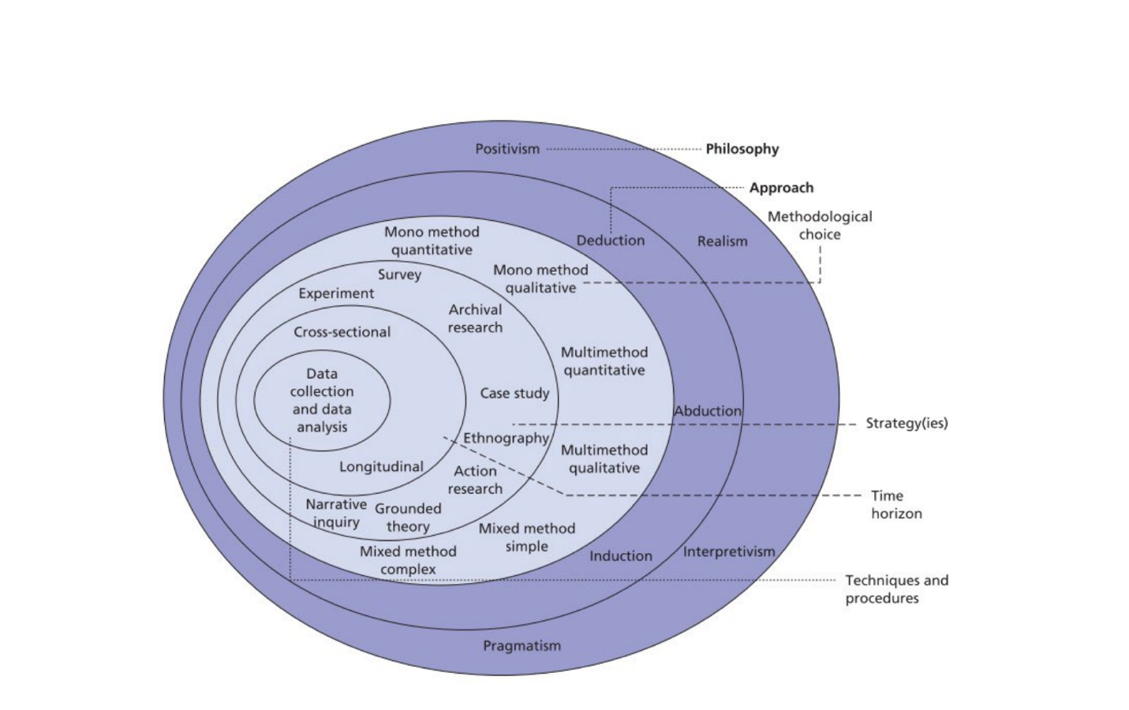
Figure 3.1: The Research Onion (Saunders et al. 2012, p. 34)

3.2 Research Design
Creswell (2014) defines research design as the process of gathering, evaluating, and analyzing data to address a research problem. Given (2008) identified research design as the road map to achieving the requirements of a study.
In this section, it is necessary to present and justify all the key research design choices made when discussing research design, which refers to the beliefs regarding how data about a phenomenon should be collected, analyzed, and utilized. This study obtained its data using a primary source. However, there are primary and secondary streams of the data (Creswell and Poth 2018). Primary data have the benefit of immediately answering research questions, as they are current, accurate, and collected explicitly for that purpose (Creswell and Creswell, 2018). This collection includes questionnaires, focus group discussions, interviews, and other methods. A secondary data source contains journals, books, newspapers, and other relevant materials (Holden and Lynch, 2018). Both sources were used for this study.

3.3 Research Paradigm
This approach adheres to a positivist research paradigm philosophy, emphasizing objectivity, empirical evidence, and statistical analysis. Park, Konge, and Artino (2020) describe positivism as being aligned with the hypothetico-deductive model of science, which involves verifying a priori hypotheses and experimentation by operationalizing variables and measures. Results from hypothesis testing are used to inform and advance science. Moreover, positivism relies on observable and measurable data, which makes it suitable for structured research. This approach helps identify patterns, test hypotheses, and establish cause-and-effect relationships, ensuring reliable and generalizable findings. This methodology, which consists of structured surveys and statistical analysis, aligns with Amazon’s analytical culture. It enables data-driven recommendations and ensures findings support evidence-based decision-making to improve remote work strategies (Park et al., 2020).
Positivism is a suitable research philosophy for analyzing the impact of remote work on the productivity, well-being, and job satisfaction of Amazon employees post-COVID, as it aligns with the quantifiable and objective nature of these variables. A justification based on the search results and positivist principles demonstrates that Amazon’s remote work policies, such as those that analyze productivity metrics or conduct job satisfaction surveys, rely on measurable data (Kumari & Natal, 2025). Research cited in the search results provides quantitative evidence linking remote work to changes in productivity. For instance, a study discovered a correlation between a 75% reduction in workplace distractions and increased output. At the same time, another noted a "strong positive impact" of remote work on productivity, as determined by regression analysis (Thompson, 2024). The regression analysis further supported these relationships by demonstrating that job satisfaction and work-life balance are significant positive predictors of employee productivity.
In contrast, job stress is an essential negative predictor, according to Gajendran and Harrison (2007), who concluded that telecommuting generally leads to improved job satisfaction and performance when there is organizational support. Furthermore, the study by Bloom et al. (2015) highlighted that remote work enhances productivity by reducing distractions and creating a quieter work environment, if employees receive adequate support to manage work-related stress. Kossek, Thompson, and Lautsch (2015) also emphasized that maintaining a healthy work-life balance and minimizing job stress are crucial for sustaining high productivity levels in remote work settings.

3.4 Data Collection
Data will be collected through a questionnaire to engage participants in answering questions related to the study’s aims and objectives. The research data will be gathered using an anonymous online survey created and managed through Google Sheets. Questionnaires that capture employee perceptions regarding enhanced benefits, financial rewards, opportunities for professional growth, and improved communication provide an in-depth overview of employee attitudes and motivations (Ortlieb, 2021).

3.5 Population and Sample
The study will target Amazon Inc. employees in Bristol, United Kingdom, who have current or prior experience working remotely. A random sampling method will promote diversity across Amazon's job roles and departments. This strategy ensures diverse representation and fair distribution, capturing the various perspectives of employees. The approach enhances the generalizability of the findings. A target sample size of at least 12 employees will be sought for survey responses, balancing data reliability with feasibility within the study constraints.

3.6 Data collection and analysis
Furthermore, it will design the survey to collect quantitative data, analyze it, and ensure there are no missing or duplicate entries. Descriptive statistics help identify trends, while correlational analysis explores the relationships between workplace variables and employee outcomes.
The descriptive statistics method suits Amazon’s large workforce, enabling broad pattern evaluations and supporting data-driven decisions for policy adjustments. Unlike qualitative research, which depends on subjective experiences, quantitative methods ensure reliability and consistency of generalizable results. Thus, this approach effectively assesses Amazon’s remote work dynamics and recommends improvements aligned with employee well-being and productivity goals (Rabianski, 2003).

3.7 Reliability and Viability
To achieve reliable and comprehensive results on the effects of remote work on productivity, it is necessary to employ various indicators and a substantial and diverse dataset (Erkinharju, 2023). Currently, there is no standardized measurement method, which complicates data analysis as it may not be comparable and negatively affects the reliability of the results. To ensure reliability, the questionnaire will be reviewed by academic peers and tested for internal consistency. Moreover, considering internal consistency is another aspect of reliability, as it concerns consistency among the questions. Do similar questions give rise to similar answers?
Additionally, random sampling enhances reliability by ensuring diverse representation across Amazon’s job roles and departments (Taherdoost, 2016). This study ensures content validity by designing survey questions based on established theories, such as Herzberg’s Two-Factor Theory and Self-Determination Theory. A random sampling strategy enhances external validity by ensuring that findings can be customized to the broader Amazon workforce (Cohen, Manion, and Morrison, 2017).

Validity will be supported through careful alignment with established constructs from existing literature. Researchers also need to consider the content validity of the questionnaire; that is, will it measure what it is intended to measure? The design and distribution method aim to minimize bias and enhance data quality (Singh, 2018).

3.8 Limitations of the Research
This study is limited by its small sample size of twelve participants, which makes it challenging to generalize the findings beyond the current sample and increases the risk of bias. Work will begin with a small group of participants, which may not accurately reflect the variety of experiences employees have across Amazon’s roles and locations. Furthermore, when relying solely on qualitative designs and omitting quantitative and mixed methods, the collected data will be shallow and limited, as statistical analysis of trends is not part of the research. This study did not have the space to consider surveys or follow people over time, as these could have enhanced its robustness. Increasing the sample size and using a blend of methods will help those who analyze the findings to have more trust in the results.

3.9 Research Ethics
Upholding individuals' rights to confidentiality and privacy is fundamental in every workplace. This study adheres to ethical guidelines for participant protection, data integrity, and research transparency. The questionnaire will be distributed online via a secure platform (e.g., Google Forms or SurveyMonkey), allowing for convenient and anonymous participation. To maintain anonymity, participants must not disclose their names, employee IDs, or any other personally identifiable details. Under data protection rules, all information gathered will be kept confidential and used solely for academic purposes (Barrow, Brannan, and Khandhar, 2017). This study ensures reliability through the use of a structured survey with set-up questions, thereby reducing response variability.

Chapter 4: Analysis of Data and Discussion of Results

4.1 Data collection and analysis
4.1.1 What is your current work arrangement at Amazon?
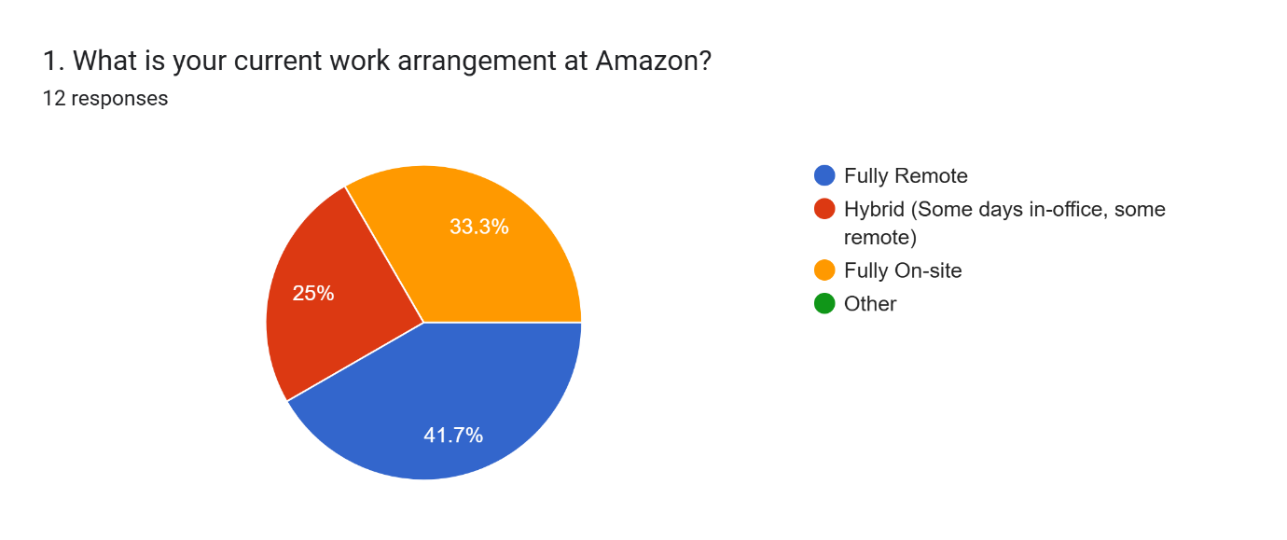
Figure 4.1.1 Current work arrangement at Amazon
(Source: Survey)
Analysis: From the above graph, it is clear that most respondents work in a fully remote setting, where they do not need to go to the office. 25% of the other respondents are working in a hybrid working method, and the other 33.3% are working on-site. From this, it can be analysed that not all employees from Amazon are working from home, as some are doing hybrid and others are visiting the workplace.
4.1.2 How long have you been working remotely or in a hybrid model?
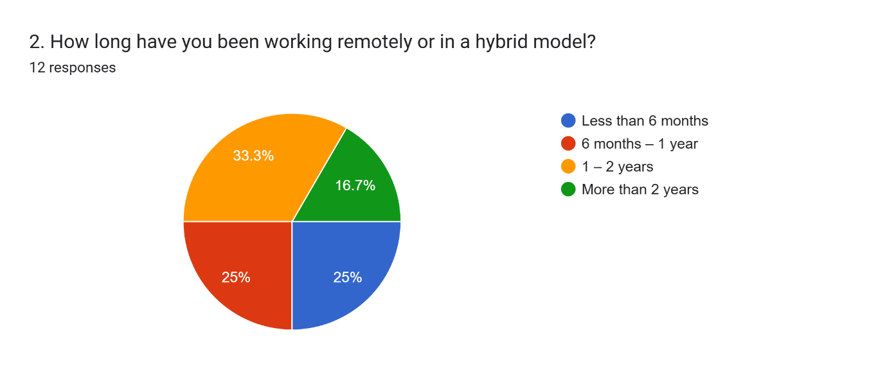
4.1.2 Experience of working in a hybrid model
(Source: Survey)
Analysis: Most of the respondents, almost 34% of them, are working from home within the timeline of 6 months to a year. 25% of the respondents have been working from home for 1-2 years, and less than 6 months. Only 16.7% of the employees have been working at home for the last two years. Therefore, it can be analysed that the employees are working from home at different times.
4.1.3 Which department do you work in?
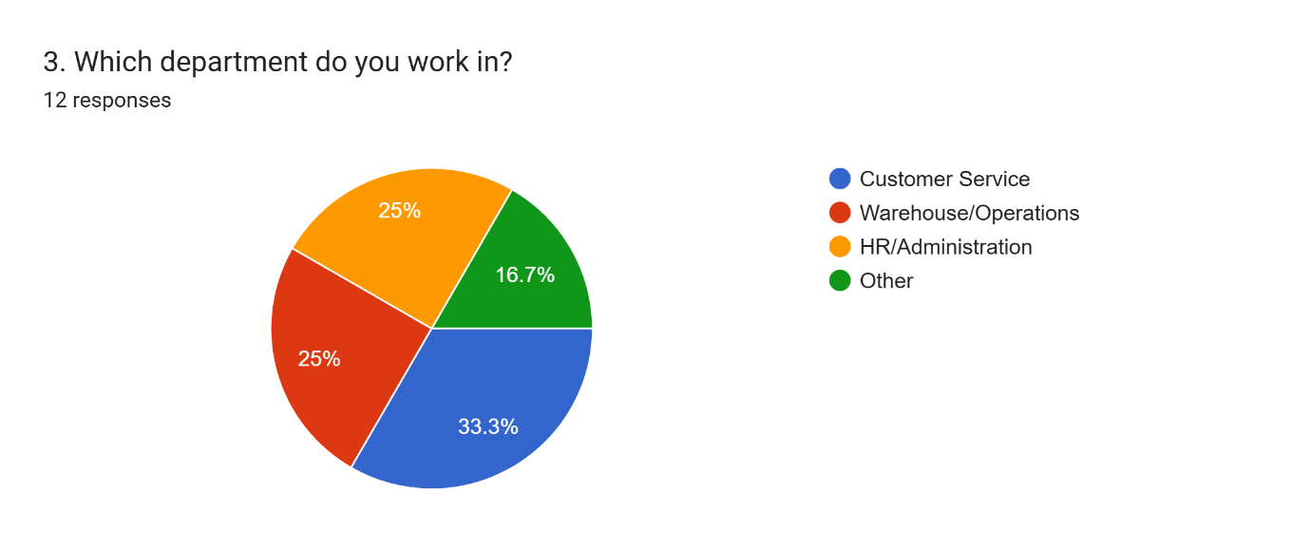
Figure 4.1.3 Department of the different respondents
(Source: Survey)
Analysis: From the respondents' responses, it is clear that 25% work in the HR/administration department, and the other 25% work in the warehouse/operations department. Only 16.7% of the respondents are not willing to share the department they work and 33.3% of them are working in the customer service department.
4.1.4 How has your productivity changed since working remotely?
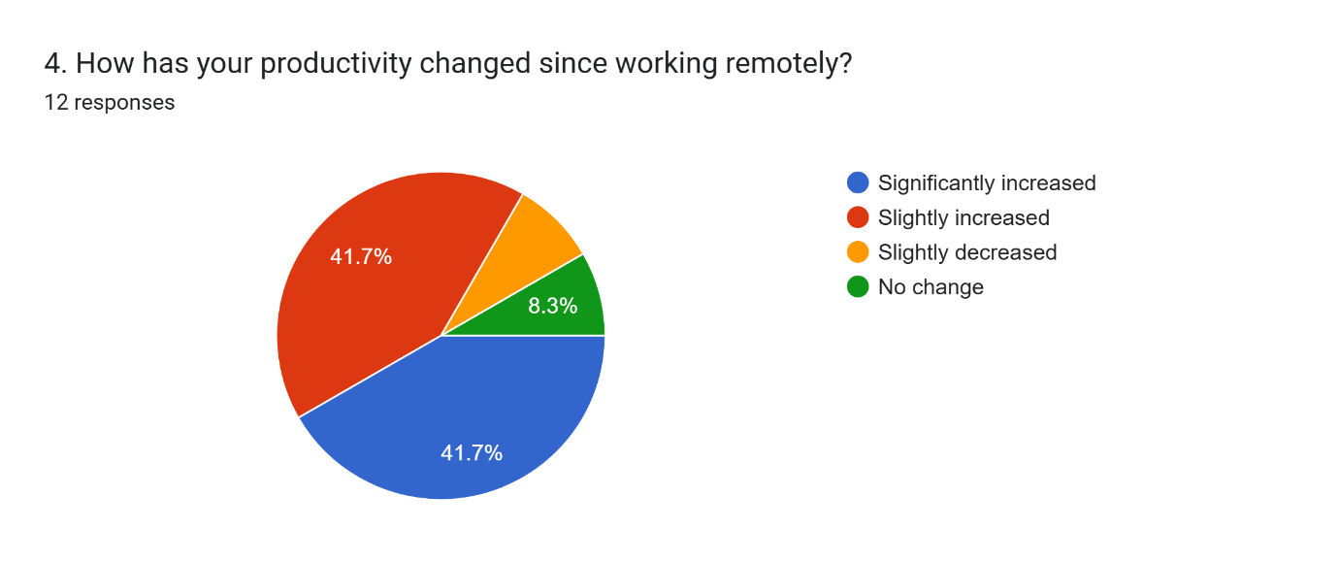
Figure 4.1.4 Changed productivity while working remotely
(Source: Survey)
Analysis: 41.7% of the respondents stated that their productivity has increased significantly after starting to work remotely, and the other 41.7% stated that their productivity has been slightly improved. On the other hand, only 8.3% of them reported no change in their productivity despite working remotely, and the other respondents stated that their productivity had decreased after starting to work remotely. This information helps to analyse the fact that remote working can significantly improve the productivity levels of the workers.
4.1.5 How often do you struggle with distractions while working remotely?
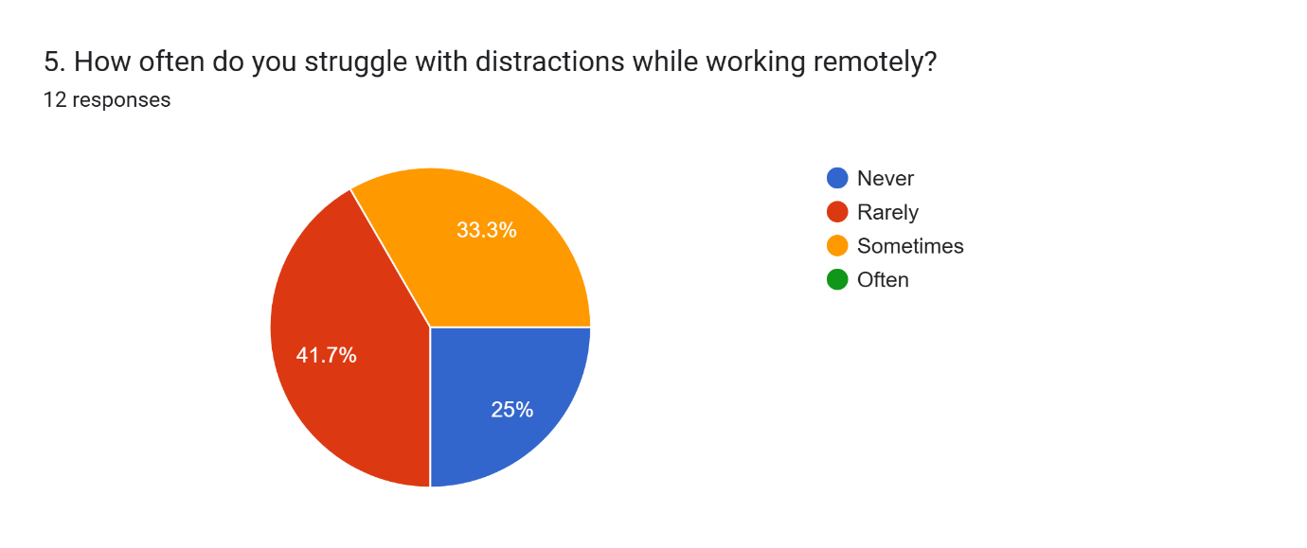
Figure 4.1.5 Distractions during working remotely
(Source: Survey)
Analysis: Distraction can be identified as one of the main disadvantages of working remotely. In this context, 25% of the respondents stated that they never struggle with distractions while working remotely, and 33.3% of them stated that they sometimes feel distracted while working in remote conditions. Therefore, it can be stated that employees sometimes feel distracted while working from remote locations.
4.1.6 How would you rate your ability to meet work deadlines while working remotely?
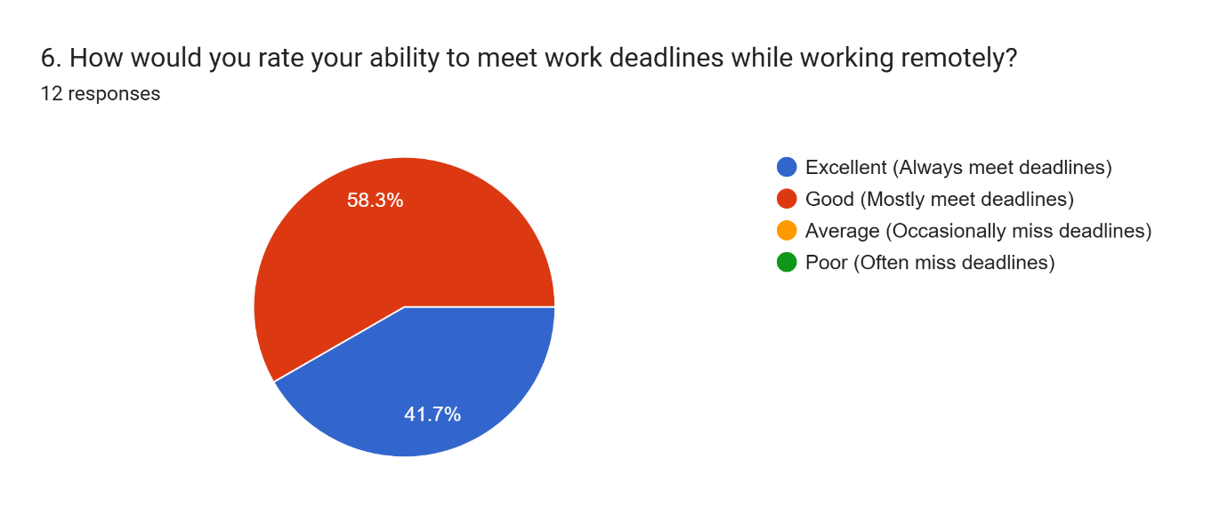
Figure 4.1.6 Ability to meet deadlines while working remotely
(Source: Survey)
Analysis: From the above graph, it can be observed that most employees feel their ability to meet deadlines has improved consistently with the help of remote working conditions. In this context, 58.3% of the respondents stated that they are fairly good at meeting deadlines, and 41.7% said that they have been very good at meeting deadlines during remote work.
4.1.7 How effective are virtual meetings in helping you collaborate with your team?
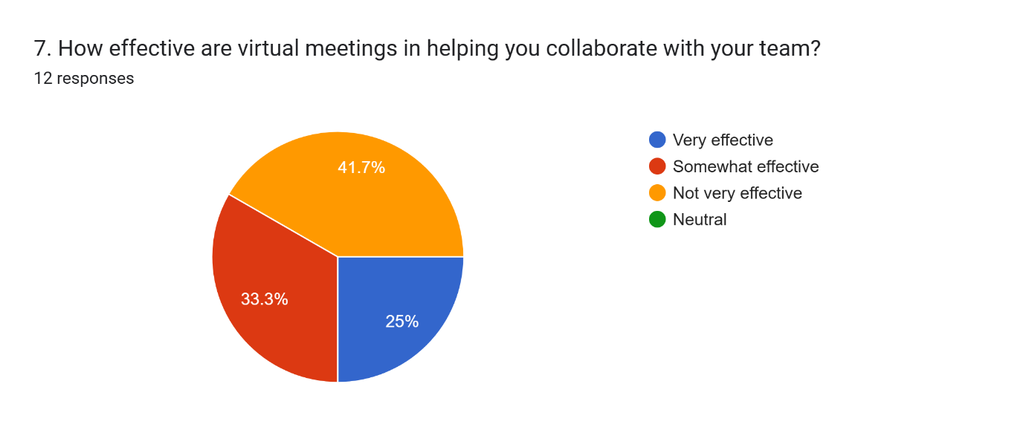
Figure 4.1.7 Effectiveness of virtual meetings in team collaboration
(Source: Survey)
Analysis: Virtual meetings are essential to ensure proper consistency and communication among remote team members. In this context, 41.7% of the respondents stated that the virtual meeting aspects are not particularly practical for them in terms of ensuring collaboration with the team. 33.3% of them selected the somewhat effective option, and approximately 25% selected the convenient choice. Therefore, the virtual meeting aspects of Amazon need some drastic improvements.
4.1.8 How often do you feel isolated while working remotely?
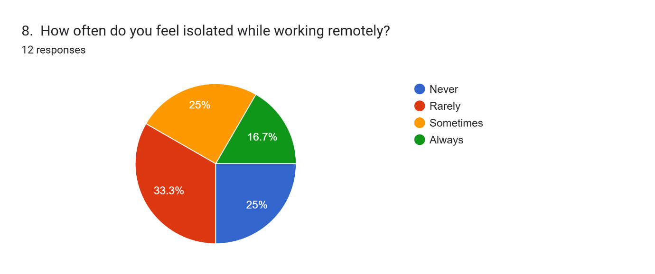
Figure 4.1.8 Feelings of isolation while working remotely
(Source: Survey)
Analysis: Working remotely can increase feelings of loneliness in the current times. However, 25% of the respondents reported that they never feel isolated while working remotely. Additionally, 33.3% of them reported feeling isolated sometimes, and the other 25% reported feeling the same sometimes. Lastly, 16.6% of the respondents stated that they are repeatedly feeling isolated while working remotely.
4.1.9 How has remote work affected your work-life balance?
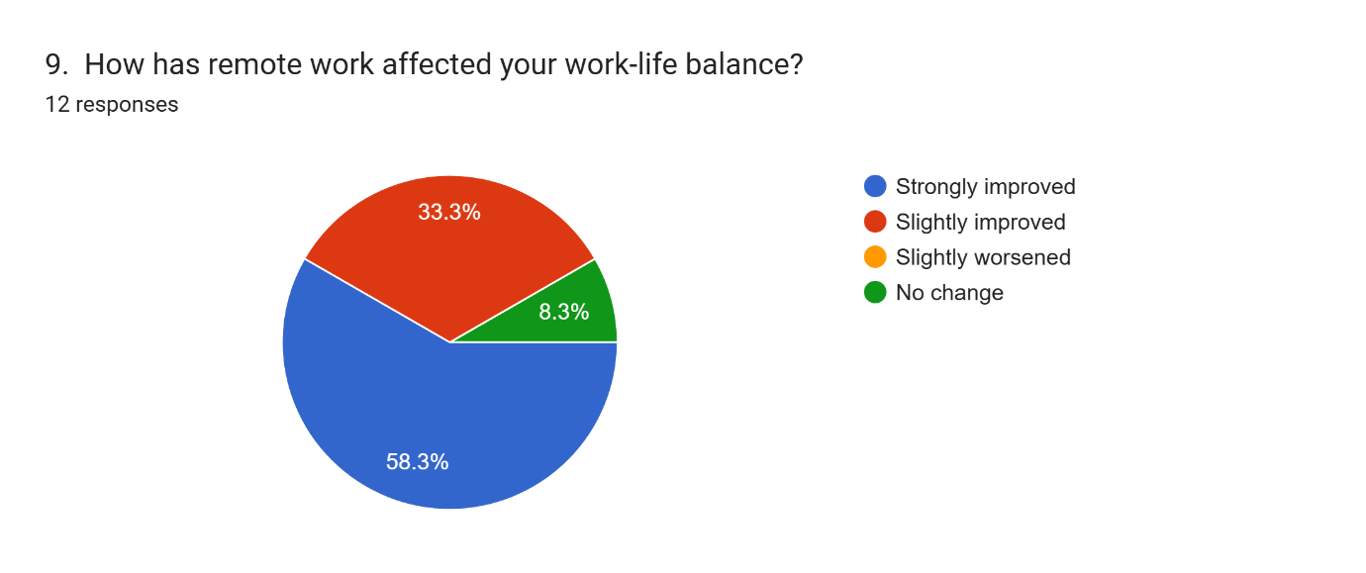
Figure 4.1.9 Remote work affecting the overall work-life balance
(Source: Survey)
Analysis: From the above graph, it is evident that remote working conditions are improving the work-life balance of various employees in the current times. 58.3% of employees stated that their work-life balance has improved significantly due to remote work, and 33.3% indicated that it has improved slightly. Only 8.3% of the respondents reported a change whatsoever.
4.1.10 Do you feel that remote work has improved your mental well-being?
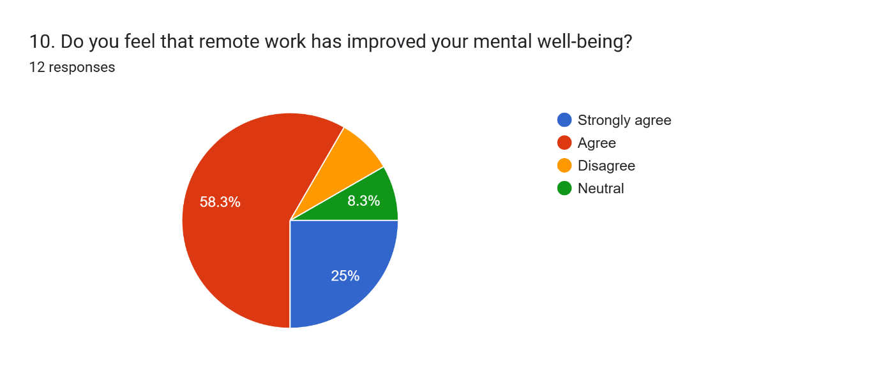
Figure 4.1.10 Remote work improving mental well-being
(Source: Survey)
Analysis: Most research respondents, 58.3%, reported that their mental well-being has improved significantly with the help of remote working conditions. The other 25% of them reported that they strongly agree with the fact that remote working can improve the mental well-being of the respondents. 8.3% selected the neutral option as they observed no change.
4.1.11 How satisfied are you with your job while working remotely?
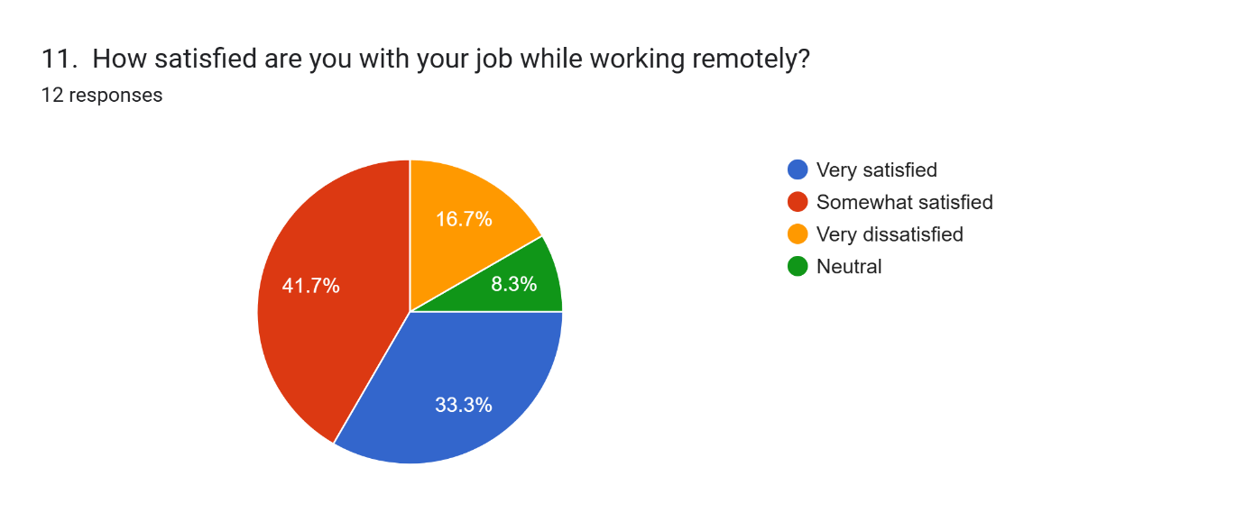
Figure 4.1.11 Satisfaction level while working remotely
(Source: Survey)
Analysis: 41.7% of the respondents reported being somewhat satisfied, and 33.3% of them reported being very satisfied with their respective jobs after starting to work remotely. Therefore, most research respondents are generally happy with their careers while working remotely. Only 16.7% of them reported being very dissatisfied, and 8.3% selected ‘neutral’.
4.1.12 How satisfied are you with the communication tools provided for remote work?
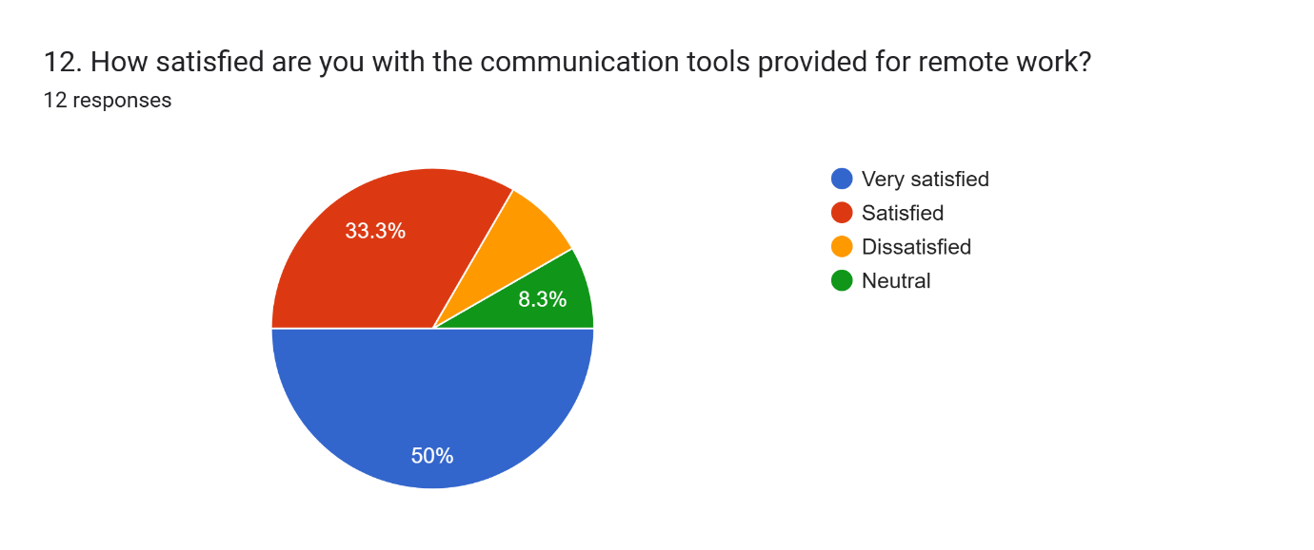
Figure 4.1.12 Satisfaction level with the communication tools for remote work
(Source: Survey)
Analysis: 50% of the research respondents are satisfied with the communication tools that are being used for remote work. Additionally, 33.3% of the respondents are happy with the communication tools. Therefore, most respondents are generally satisfied with the communication tools provided for Amazon employees' remote work.

4.2 Discussion of results
1. Why has remote work impacted Amazon employees' work-life balance, well-being, and productivity, and how have their perceptions changed before and after COVID-19?
The change to remote work for Amazon staff has had a significant impact on their views of work-life balance, health and efficiency, which stands out when compared to the time before COVID-19. Due to the COVID-19 pandemic, companies worldwide had to transition to remote work. In their study, Brynjolfsson et al. (2020) noted that more than 50% of employees who were accustomed to working on-site transitioned to working from home during the pandemic. This aligns with the primary research findings, which indicated that most Amazon employees were satisfied with their transition. The survey conducted showed that 58.3% of participants reported that their work-life balance had become significantly better, and 33.3% noted some improvement. Less than one in ten people saw no difference in their feelings. This suggests that Amazon employees benefit from flexible schedules because of remote work.
This is also reflected in literature, as Pereira et al. (2022) found that flexible schedules can improve someone’s mental health and reduce stress. On the other hand, workplace flexibility was praised, but people also worried that work would invade everyone’s time. The Conference Board (2022) noted that 47% of remote U.S. workers expressed concern about the overlap between work and personal life, and 41% reported experiencing burnout. The results for the primary data highlight the different experiences people have: 66.7% reported good outcomes, although 33.3% mentioned they experience isolation at times, and 16.6% often feel this way. Abe’s (2021) findings highlight that Amazon’s strong focus on excellence, combined with remote work, increases stress on employees as they are expected to work harder and be constantly monitored.
Similarly, the data reveal that employees are feeling well looked after by their workplace. Over half (58.3%) reported that their mental well-being had improved significantly during remote work, and another 25% agreed largely. This finding aligns with the results of Wang et al. (2021), which show that remote work supports emotional balance and happiness in individuals who possess a high level of self-control. Due to remote work, Amazon employees have more control over their time and shorter commutes, which is beneficial for their mental health. Even so, there are limits to how widely these benefits apply. Some of the remaining respondents chose neutral or mixed options, indicating that while remote work benefits many, it is not always sufficient to address the issues of heavy workloads and reduced social interaction for all workers.
Remote work has caused observable changes in how efforts are used for productivity. Out of the surveyed Amazon employees, 41.7% said their productivity improved a lot, and 41.7% noticed slight improvements. Close to 92% said their income had decreased slightly, and only 8.3% said it had not changed at all. This goes along with Gajendran and Harrison (2007), who showed that remote work improves productivity for jobs mainly focused on knowledge work done on own. Productivity is higher at Amazon partly due to its strategy of letting more employees in customer service and HR do their work remotely. In addition, according to Waldrep, Fritz and Glass (2024), having flexible options for remote work tends to increase employee motivation and decrease stress, which in turn leads to increased productivity. In short, the way Amazon employees feel about remote work has changed greatly since the pandemic and is now better for their well-being, home and work balance and productivity. Still, being isolated and feeling burned out is a problem experienced by some, especially those employees who have roles that are highly challenging or isolated.
2. How do organisational support, communication practices, and job type influence Amazon Employees' experiences with remote work, and how can these factors enhance job satisfaction and performance?
How successful remote work is at Amazon depends a lot on whether management trusts the staff, how information is shared and the nature of the work. According to gathered data, employees of the company are split between customer service (33.3%), HR and administration (25%) and warehouse and operations (25%). Such variations impact the experience of remote work a lot. Roles in customer service and HR that are primarily digital can be performed remotely more easily than warehouse or logistics jobs that require on-site work. According to Petla (2023), software development and other technical roles are better suited to remote work because they are not dependent on being in a specific location. This aligns with the survey responses, as it has been observed that most remote workers are satisfied with the communication tools provided during remote work. Therefore, helping remote workers has been effective in improving their motivation levels. Most Amazon employees are satisfied with the support provided by Amazon for their remote workers. However, logistical jobs in Amazon can be difficult due to issues with aligning different parts of the system, since Amazon relies heavily on logistics.
Satisfaction with remote work is also built on good organisational support. Of the individuals surveyed, approximately half (50%) reported being quite satisfied with Amazon’s communication tools, and a further 33.3% indicated satisfaction. It shows that the company has set up technology that allows employees to work from home. Around 41.7% of staff members still believed that virtual meetings were limited in their ability to encourage teamwork, indicating that tools must be complemented by other efforts. Digital communication, according to Kordova and Hirschprung (2023), should have a clear goal and be used sparingly to avoid making people feel tired or distracted. Additionally, Golden and Gajendran (2019) emphasize that effective leadership and clear communication channels facilitate employee engagement in virtual work environments. It is not the availability of tools that’s important for Amazon, but how they are applied.
The autonomy employees have and the strength of leadership are key factors in their satisfaction. Sardeshmukh et al. (2012) discuss how autonomy reduces uncertainty and encourages employees to make decisions earlier. It is beneficial here because direct supervision is often rare in remote locations. According to the JD-R model (Bakker and Demerouti, 2007), employees’ work success and wellness depend on the level of demands and resources at work. According to Amazon’s context, having high autonomy can support employees through high workloads and maintain both their performance and satisfaction. However, if independence is absent or the workload is consistently excessive, this balance may be disrupted, leading to stress or increased levels of disengagement.
Adjusting remote work for each job role could support both happiness and performance at Amazon. Those working in digital or administrative roles may have the option to work from home full-time, while those in operational roles can try a hybrid work system with firm support. Additionally, increasing managers’ clear communication, regular check-in meetings, providing feedback, and outlining goals can help reduce the disengagement some of them may feel. In line with Barrero, Bloom, and Davis (2021), when communication structures and leadership are present, remote work becomes more effective. Amazon’s ability to succeed with remote work will come from having the proper policies, tools and adapting them to meet specific employee requirements and maintaining one-on-one support.
3. How has remote work affected employee productivity, motivation, engagement, and collaboration within Amazon? What are Amazon employees’ key challenges and benefits in maintaining efficiency while working remotely?
Producing benefits and difficulties, remote work has changed the patterns of workers at Amazon in areas such as motivation, engagement, teamwork and productivity. Looking at the primary data, it becomes clear that over 80% of employees think their productivity has gone up either a lot or a little bit. This aligns with the argument of Gajendran and Harrison (2007), who suggest that autonomy and a lack of teamwork in a role can lead to increased productivity when working remotely. In Amazon’s corporate and customer service departments, running things by following a fixed structure and checking the outcomes makes it easier to have employees work remotely. With less distraction and travel time removed, staff in such positions can focus more attention on their work from home. Survey respondents also report that remote working has affected their satisfaction and work levels to some extent. 50% of the respondents agree with the fact that their career development aspects are improved with the help of remote working.
According to the survey, 33.3% of employees had very positive feelings about their work, and another 41.7% were somewhat satisfied working from home. This pattern indicates that remote flexibility, freedom at work and better work-life balance boost job satisfaction, as Ferrara et al. (2022) explained, because of the emotional and mental engagement employees experience when they decide how and where to work. Also, as noted by Waldrep, Fritz and Glass (2024), working remotely often helps reduce stress and encourages employees to stay motivated for a long time, which benefits Amazon and its employees.
There is still concern about teamwork. Although people were generally pleased with the communication tools, most respondents (41.7%) found that holding meetings online did not facilitate teamwork. A mere 25% thought they were highly effective. That’s why Kordova and Hirschprung (2023) warn that too many digital meetings can leave people tired and less efficient. Since they do not meet in person, it may be challenging for Amazon staff to develop a strong team spirit or handle complex matters efficiently. The stress caused by working alongside others could also result in the 16.6% of people who said they occasionally felt isolated when working at home.
Distractions are cited as one of the issues with efficiency by 33.3% of respondents who said they have them occasionally, while only 25% never stated they were distracted. From these numbers, it becomes clear that most staff can work effectively remotely, but having an office to look forward to each day helps people remain productive. Lacking direct oversight and relaxed interactions between teams may slow down decision-making and reduce the level of collaboration between teams. Limited team support and feedback, in particular, can make the demands for autonomy and self-regulation so stressful that this leads to burnout or disengagement.
However, despite the difficulties, working remotely has many advantages. Most employees reported that having a better work-life balance, enjoying their work, and feeling mentally healthy are the most significant benefits. They suggest that Amazon can enhance the effectiveness of remote work by addressing issues related to collaboration and interaction, while retaining its successful aspects. If managers establish clear schedules and involve peers in learning and designing hybrid approaches tailored to individual roles, people can still work independently and remain productive. Remote work has generally allowed Amazon employees to maintain their efficiency or even improve it, though to continue succeeding, extra support, flexibility at work, and more effort to build a teamwork culture online will be needed.
Although this study received only 12 survey responses from 17 participants, the findings offer valuable preliminary insights into the remote work experiences of Amazon employees. While the small sample size limits statistical generalizability and increases the margin of error, the consistency of key themes, such as improved work-life balance and productivity gains, suggests trends worth further exploration. This data serves as a first step in identifying variables and informing larger-scale investigations. To strengthen confidence in these results, future research should employ more extensive sampling, stratified by department and demographic group, as well as mixed-method approaches to validate and deepen understanding of remote work outcomes.

Chapter 5: Conclusion and Recommendations

5.1 Conclusion
This research analysis has shown that the perceptions of Amazon employees regarding remote work have undergone a significant transformation since the COVID-19 pandemic outbreak. Before the COVID-19 pandemic, remote work was an option available to only a small number of employees; however, it has now become a mainstream setup, with most research respondents reporting full-time or hybrid arrangements. The overall change has registered an indisputable positive impact on work-life balance: 58.3 percent of the participants expressed that it has dramatically improved, and 33.3 percent noted that it has improved moderately, demonstrating the results of Objective 1, which suggests that being able to work flexible schedules can improve well-being and reduce stress. Similar trends were observed in mental health benefits as well, with more than 80 percent of employees reporting an increase in their mental well-being. However, a more modest portion continued to report feeling neither better nor worse, indicating that the benefits of remote work are unequally distributed.
The communication practices and organizational support became important moderating factors in such experiences, satisfying Objective 2. Fifty percent of the respondents rated the technology and ergonomic support of Amazon as satisfactory and above, and 40-50 percent experienced virtual meetings as ineffective and managerial feedback as inconsistent. These conflicting findings highlight the issue that the presence of digital platforms alone does not guarantee employee engagement or understanding of expectations. Job type also played a role: the customer service and HR fields found it easier to work in remote conditions than operations and warehouse jobs, which were restricted by logistical limitations and could not operate remotely.
As part of Objective 3, there has been a substantial increase in productivity and motivation among remote workers. More than 83 percent of the survey participants reported experiencing moderate to high productivity, which was attributed to independence, reduced time spent on commutes, and fewer distractions at the workplace. Nevertheless, cases of inconvenience and loneliness (up to 50% of people reported these disturbances) often evolve around the problems of maintaining a collaborative culture and informal peer support. Half of the sample experienced no change regarding career development opportunities; however, about one‑third experienced slight negative or positive changes, which could suggest some future repercussions on the developmental opportunities of having a distributed workforce.

5.2 Recommendations
- Amazon should implement standardised training programs for managers to deliver clear, consistent feedback and support to all remote employees.
- The company should optimise virtual meeting protocols by setting clear agendas, time limits, and best-practice guidelines to improve collaboration.
- Regular virtual social events and peer-mentoring groups should be organised to reduce feelings of isolation among remote workers.
- Amazon must expand ergonomic equipment and technology stipends to ensure that all remote employees have access to high-quality hardware and software.
- Job-specific remote work policies should be tailored so that hybrid or on-site options remain available for operational roles requiring physical presence.
- Career development frameworks should be adapted to remote contexts, including virtual training modules and clear pathways for promotion.
- Performance goals and expectations must be clearly communicated and regularly reviewed to ensure alignment and reduce ambiguity.
- Periodic well-being surveys should be conducted to monitor mental health and stress levels, followed by targeted interventions for at-risk groups.
- Cross-functional collaboration tools and platforms should be assessed and refined based on employee feedback to enhance usability.
- Future research initiatives should include longitudinal studies tracking employee outcomes over time and comparative analyses across different job functions.

Reference List:

Abe, E.N. (ed.) (2021) Future of work, work-family satisfaction, and employee well-being in the fourth industrial revolution. Hershey, Pennsylvania: IGI Global. Available at: https://doi.org/10.4018/978-1-7998-3347-5.

Allen, T.D., Golden, T.D. and Shockley, K.M. (2015) 'How Effective Is Telecommuting? Assessing the Status of Our Scientific Findings, Psychological Science in the Public Interest, 16(2), pp. 40–68. DOI: 10.1177/1529100615593273.
Baert, S., Lippens, L., Moens, E., Sterkens, P., & Weytjens, J. (2020). The COVID-19 crisis and telework: A research survey on experiences, expectations, and hopes. IZA Discussion Paper No. 13229.
Baker, A.W., Salman, R.Y., Zaur, E.S. and Fahmi, A.M. (2024) The Impact of Remote Work on Team Dynamics and Management Strategies. Journal of Ecohumanism. 3(5), pp. 963–983. Available at: https://ecohumanism.co.uk/joe/ecohumanism/article/view/3949
Bakker, A.B. and Demerouti, E. (2007) 'The Job Demands‐Resources model: State of the art', Journal of Managerial Psychology, 22(3), pp. 309-328. DOI: 10.1108/02683940710733115.
Barrero, J. M., Bloom, N., & Davis, S. J. (2021). Why working from home will stick—National Bureau of Economic Research (NBER) Working Paper No. 28731.
Barrero, J. M., Bloom, N., & Davis, S. J. (2021). Why working from home will stick—National Bureau of Economic Research (NBER) Working Paper No. 28731.
BARRERO, J.M., BLOOM, N. and DAVIS, S.J. (2020) ‘COVID-19 Is Also a Reallocation Shock’, Brookings papers on economic activity, 2020(2), pp. 329–371. Available at: https://doi.org/10.1353/eca.2020.0012.
BARRERO, J.M., BLOOM, N. and DAVIS, S.J. (2020) ‘COVID-19 Is Also a Reallocation Shock’, Brookings papers on economic activity, 2020(2), pp. 329–371. Available at: https://doi.org/10.1353/eca.2020.0012.
Bloom, N., Liang, J., Roberts, J. and Ying, Z.J. (2015) ‘Does working from home work? Evidence from a Chinese experiment, Quarterly Journal of Economics, 130(1), pp. 165–218. https://doi.org/10.1093/qje/qju032
Boler Davis, A. (2021). How Amazon Accelerated Its Growth During the Pandemic. Northwestern University News. https://www.mccormick.northwestern.edu/news/articles/2021/02/how-amazon-moved-faster-than-ever-during-the-pandemic.html
Carraher-Wolverton, C. (2022) ‘The co-evolution of remote work and expectations in a COVID-19 world utilizing an expectation disconfirmation theory lens’, Journal of Systems and Information Technology, 24(1), pp. 55–69. Available at: https://doi.org/10.1108/JSIT-05-2021-0085.

Cohen, L., Manion, L., & Morrison, K. (2017). Validity and reliability. In Research methods in education (pp. 245-284). Routledge.
Ferrara, B. et al. (2022) 'Investigating the Role of Remote Working on Employees' Performance and Well-Being: An Evidence-Based Systematic Review', International Journal of Environmental Research and Public Health, 19(19), p. 12373. doi: 10.3390/ijerph191912373.
Fried, J., & Heinemeier Hansson, D. (2013). Remote: Office Not Required. London: Crown Business.
Gajendran, R. S., & Harrison, D. A. (2007). The good, the bad, and the unknown about telecommuting: Meta-analysis of psychological mediators and individual consequences. Journal of Applied Psychology, 92(6), 1524–1541.

Gajendran, R.S. and Harrison, D.A. (2007) 'The good, the bad, and the unknown about telecommuting: Meta-analysis of psychological mediators and individual consequences', Journal of Applied Psychology, 92(6), pp. 1524–1541. DOI: 10.1037/0021-9010.92.6.1524.
Gajendran, R.S. and Harrison, D.A. (2007) ‘The good, the bad, and the unknown about telecommuting: Meta-analysis of psychological mediators and individual consequences’, Journal of Applied Psychology, 92(6), pp. 1524–1541. https://doi.org/10.1037/0021-9010.92.6.1524
Gibbs, M., Mengel, F., and Siemroth, C. (2023). 'Work from Home and Productivity: Evidence from Personnel and Analytics Data on Information Technology Professionals. " Journal of Political Economy. DOI: 10.1086/721803.
Gutelius, B. and Pinto, S. (2023) Pain Points: Data on Work Intensity, Monitoring, and Health at Amazon Warehouses. Center for Urban Economic Development, University of Illinois Chicago. Available at: https://doi.org/10.25417/uic.24435124
Ipsen, C., van Veldhoven, M., Kirchner, K., & Hansen, J. P. (2021). Six key advantages and disadvantages of working from home in Europe during COVID-19. International Journal of Environmental Research and Public Health, 18(4), 1826.
Kamalnath, A., & Kaul, A. (2024). THE FUTURE OF WORK IN THE ERA OF HASHTAG CAPITALISM. Available at SSRN. Accessed at: [May 20, 2025].
Kassem, S. (2023). Work and Alienation in the Platform Economy: Amazon and the Power of Organization. Policy Press.
Kassem, S. (2023). Work and alienation in the platform economy: Amazon and the power of organization. Policy Press.

Kordova, S. and Hirschprung, R.S. (2023) ‘Effectiveness of the forced usage of alternative digital platforms during the COVID-19 pandemic in project communication management’, Heliyon, 9(11), pp. e21812. Available at: https://doi.org/10.1016/j.heliyon.2023.e21812.

Kossek, E.E., Thompson, R.J. and Lautsch, B.A. (2015) ‘Balanced workplace flexibility: Avoiding the traps’, California Management Review, 57(4), pp. 5–25. https://doi.org/10.1525/cmr.2015.57.4.5
Kowalski, T. & Ślebarska, K. (2024). The Impact of Remote Work on Team Dynamics and Management Strategies. Journal of Ecohumanism. 3(5), pp. 963–983. Available at: https://doi.org/10.62754/joe.v3i5.3949
Kumari, S. and Natal, M.S. (2025), A study on employee satisfaction and its impact on ecommerce firms concerning Amazon India, International Journal of Research Publication and Reviews, Vol 6, Issue 4, pp 8808-8812 [April 2025]. DOI: https://doi.org/10.55248/gengpi.6.0425.1564
Lange, M., & Kayser, I. (2022). The role of self-efficacy, work-related autonomy, and work-family conflict on employees’ stress level during home-based remote work in Germany. International journal of environmental research and public health, 19(9), 4955. doi: https://www.mdpi.com/1660-4601/19/9/4955
MacNaughton, L. (2025) Amazon is ending remote work. Its employees hope the company reconsiders: The tech giant and online retailer require workers to return to the office full time, CBC News. Toronto: Canadian Broadcasting Corporation.
Novikov, A. M., & Novikov, D. A. (2013). Research methodology: From philosophy of science to research design. CRC Press. Accessed at: [May 20, 2025].
Park, Y., Konge, L. and Artino, A. R. (2020) 'The Positivism Paradigm of Research', Academic Medicine, 95(5). doi: 10.1097/ACM.0000000000003093.
Park, Yoon Soo, PhD; Konge, Lars, MD, PhD; Artino, Anthony R. Jr, PhD. The Positivism Paradigm of Research. Academic Medicine 95(5): p. 690-694, May 2020. | DOI: 10.1097/ACM.0000000000003093
Petla, J. R. K. (2023). Cloud computing technologies are transforming public sector remote work standards post-COVID-19. Joshua Ratna Kishore Petla, "Cloud Computing Technologies Transforming Public Sector Remote Work Standards Post Covid-19", International Journal of Creative Research Thoughts (IJCRT), ISSN, 2320-2882.

Rabianski, J. S. (2003). Primary and secondary data: Concepts, concerns, errors, and issues. The Appraisal Journal, 71 (1), 43.

Rahman, M. S. (2016). The advantages and disadvantages of using qualitative and quantitative approaches and methods in language “testing and assessment” research: A literature review. Journal of education and learning, 6 (1).

Richard Fagerlin. 40 under Forty: 2008. Northern Colorado Business Report, 13(26),. Available at: https://www.proquest.com/trade-journals/40-under-forty-richard-fagerlin/docview/218522064/se-2?accountid=130472

Rivet, D.J. (2017) Amazon's Superior Innovation: A Study of Amazon's Corporate Structure. Senior Honors Thesis, University of New Hampshire. Available at: https://scholars.unh.edu/honors/343/
Rojon, C., & Saunders, M. N. (2012). Formulating a convincing rationale for a research study. Coaching: An International Journal of Theory, Research and Practice, 5 (1), 55-61. https://doi.org/10.1080/17521882.2011.648335 . Accessed at: [ 20 May 2025]
Sardeshmukh, S. R., Sharma, D., & Golden, T. D. (2012). Impact of telework on exhaustion and job engagement: A job demands and job resources model. New Technology, Work and Employment, 27(3), 193-207.
Sharma, R., Kowalski, T., & Ślebarska, K. (2022). The Impact of Remote Work on Team Dynamics and Management. Ecohumanism Journal. 3(1), 45-60. Available at: https://ecohumanism.co.uk/joe/ecohumanism/article/view/3949 (Accessed: 3 April 2025).
Singh, A.S. (2018) ‘Common procedures for development, validity and reliability of a questionnaire’, Journal of Advances in Medical Education & Professionalism, 6(2), pp. 103–107. Available at: https://www.academia.edu/74242572/Licensed_under_Creative_Common_COMMON_PROCEDURES_FOR_DEVELOPMENT_VALIDITY_AND_RELIABILITY_OF_A_QUESTIONNAIRE [Accessed 21 May 2025].
Taherdoost, H. (2016) 'Validity and reliability of the research instrument; how to test the validation of a questionnaire/survey in research', International Journal of Academic Research in Management, 5.

The Conference Board. (2022, April 1). Remote Workers Struggle with Work-Life Boundaries

Thompson, Z. (2024) ‘The impact of remote work on employee productivity: A study of IT companies in Silicon Valley’, University of Leeds, July—Journal of Business Management and Innovation.
Toscano, F., & Zappalà, S. (2020). Social isolation and stress as predictors of productivity perception and remote work satisfaction during the COVID-19 pandemic: The role of concern about the virus in a moderated double mediation. Sustainability, 12(23), 9804.

Waldrep, C.E., Fritz, M. and Glass, J. (2024) ‘Preferences for Remote and Hybrid Work: Evidence from the COVID-19 Pandemic’, Social sciences (Basel), 13(6), pp. 303-. Available at: https://doi.org/10.3390/socsci13060303.

Wang, B., Liu, Y., Qian, J., & Parker, S. K. (2021). Achieving compelling remote working during the COVID-19 pandemic: A work design perspective. Applied Psychology, 70(1), 16–59.

Wang, B., Liu, Y., Quan, J. and Parker, S.K. (2021) 'Achieving effective remote working during the COVID-19 pandemic: A work design perspective', Applied Psychology: An International Review, 70(1), pp. 16-59.

Watanabe, C., Akhtar, W., Tou, Y., & Neittaanmäki, P. (2022). Amazon’s initiative in pioneering seamless switching. Technology in Society, 69, 101953, https://doi.org/10.1016/j.techsoc.2022.101953

Appendices:

Appendix 1: Questionnaire
Question 1. What is your current work arrangement at Amazon?
Question 2. How long have you been working remotely or in a hybrid model?
Question 3. Which department do you work in?
Question 4. How has your productivity changed since working remotely?
Question 5. How often do you struggle with distractions while working remotely?
Question 6. How would you rate your ability to meet work deadlines while working remotely?
Question 7. How effective are virtual meetings in helping you collaborate with your team?
Question 8. How often do you feel isolated while working remotely?
Question 9. How has remote work affected your work-life balance?
Question 10. Do you feel that remote work has improved your mental well-being?
Question 11. How satisfied are you with your job while working remotely?
Question 12. How satisfied are you with the communication tools provided for remote work?

