

Managing Enterprise in the 21st Century

Business Plan

London Locum Ltd
www.londonlocum.com

Submission Date: 03/01/2023
Lecturer: Hossein Shokri

Group 1 Information

Student Name | Student Number | Written Section(s)
Caroline Akiotu | 2133382 | Business Concept
Adelina Angelova | 2132900 | Market Analysis and Marketing Plan
Oksana Mrsic | 2131895 | Management Team
Bernad Mrsic | 2133762 | Financial Plan (One Year)
Maria Diana Nita | 2133005 | Operations and Management Plan

Table of Contents

Group 1 Information 2
Executive Summary 5
Business Concept 6
Introduction 6
Business Concept 6
Modern workplace communications systems, including email and social networking 7
Usage of web-based and mobile applications within the workplace 7
Operations and management 8
Legal, ethical and security issues within the context of data protection 8
Prof Russell Ackoff’s definitions of data, information, knowledge, understanding and wisdom 8
Management Team 9
Potential sources of information to solve workplace problems 9
Numeracy, knowledge and reasoning are integral to most employment areas 10
Ways to be competent in basic numerical handling and the efficient organisation and management of files and folders 10
Improving digital skills within the workplace 11
Security and social media 11
Market Analysis and Marketing Plan 12
Introduction 12
Business executive summary 12
Management & Personnel 14
Products and services 14
Market analysis 14
Pestle analysis 15
Political factor 15
Economic factor 15
Socio-cultural factors 15
Technological factors 15
Environmental factors 15
Legal factors 16
Michael porter’s five forces analysis 16
The threat of intense segment rivalry 16
The threat of new entrants 16
The threat of substitute product 16
The threat of buyers’ bargaining power 16
The threat of supplier’s bargaining power 16
Marketing and sales plan summary 17
4p 17
Product or services 17
Price 17
Promotion 17
Pricing strategy 17
Physical location 18
Human resources strategy 18
Financial plan 18
Sources of finance 18
Conclusion 18
Management Team 19
Management Team and Their Background 19
Business Description and History 19
Organisational Chart 20
Business Structure 22
Key Milestones 23
Employee Terminations Are Handled By The Manager 24
The Success Of The Organisation 24
Financial Plan 25
Sources of Finance 26
Cash Flow Forecast 2023 27
Sales Forecast 30
Cost of Service Forecast 31
Break Even Analysis 31
Operations and Management Plan 32
Production of Good and Service 33
Technology Plan 33
Video Interviews 34
Applicant Tracking Systems 34
Candidate Assessment Software 34
Candidate Screening Software 34
Human Resource Plan 35
Expansion Plan 38
Reference List 39
Appendices: 43

Executive Summary

Executive Summary BM

London Locum Ltd. is a dental nursing agency based in the 1000 Great West Road, West London, covering clients in London within the M25. We provide fully insured, highly trained, and fully qualified nurses with a minimum of 3 years of experience working as a dental nurse. We are different from other agencies because we have direct experience in the dental business as well as a software development and management background spanning more than a twenty years, and an extensive network of colleagues willing and excited to work with us. We pride ourselves on excellence and attention to details; we personally screen all our staff and provide additional training, if necessary in order to achieve high standards. Our clients have an easy way of booking dental nurses 24/7/365, whether through their online account on the phone app or online. It is very easy to change, add, modify, leave feedback, or check the automatic invoicing system, which leaves them in full control of what they need with full cost transparency rather than calling and chasing agencies around to find an available nurse. Our automated booking system also gives us direct access to full data analysis at the touch of a button, enabling us to intervene, improve, and change our business model as necessary and plan for busy periods. In the first few years, we expect to concentrate on the development, testing, and application of software as well as expanding our customer portfolio in London. As soon as this is running at our full satisfactory standard, we expect to go nationwide within 2–3 years and start expanding to most of the major cities in the UK.

Executive Summary OM

Our group is a temporary and permanent dental recruitment agency run by a dental professional with over 8 years of experience. We specialise in providing temporary dental nurses and other regional dental professionals. We interview all our candidates and occasionally meet with the dental practises to have the best chance of finding a good fit. We always seek qualified and passionate dental nurses across the region to join our team. We have the best package where one receives excellent pay rates, support from an area manager, bonus schemes, paid travel, parking, and an in-house health and well-being program. We require our dental nurses to be experienced in various front-of-house systems. Our team is entirely patient-oriented. Management team considerations for recruitment are behavioural skills, which include leadership, management of relationships with others, flexibility, personal work, and meticulousness at work. Our funding requirements are cash available and already sunk into the project, solid commercial agreements, credit enhancement, and loan terms and conditions. We intend to have the best strategy so that we can have a connection with the right funders for our project.

Business Concept

Introduction

Technology is the combination of skills, processes, and scientific methodologies used to manufacture a variety of commodities and services or to solve a scientific conundrum that benefits human welfare. Workplace technology refers to the use of technology for efficient organisational management. In practically every sort of company, whether it is in the communication, production, control, management, accounting, or information departments, technology is frequently employed. Technology is not only essential; it is crucial for every company. Business success depends on technology adoption. Technology in the workplace makes it easier and faster to grow a firm.

Business Concept

Modern workplace communications systems, including email and social networking

In the contemporary workplace, email and social networking are two crucial communication methods. Email is a popular method for electronically sharing messages and information. It makes it possible for individuals to speak with one another regardless of where they are physically located and is a crucial tool for working with clients and coworkers. Email communications are often stored and are simple to search for, making it a useful method to keep and manage communication history. However, since individuals could get a lot of emails every day, it can also be daunting. Social networking is the process of transforming communication into an interactive discourse via the use of web-based and mobile technology. Facebook, LinkedIn, and Twitter are a few examples of social networking sites that are widely used. These websites let users set up personal profiles, interact with other users, and exchange data like images, status updates, links to articles, and other stuff. Given that it enables individuals to quickly exchange information and ideas with a broad group of people, social networking may be a beneficial tool for communication and cooperation in the workplace (Acevedo, 2010). It may also be utilised as a platform for job hunting and professional networking. It is up to people and organisations to decide how to utilise email and social networking for efficient communication in the workplace. Both offer benefits and drawbacks.

Usage of web-based and mobile applications within the workplace

Instead of being installed on a computer or other device, web-based applications can be accessed and used through a web browser. Because they can be accessed and used from any device with an internet connection and from any location, these applications are especially helpful in the workplace. This makes it simple for workers to collaborate, conduct remote work, and quickly access vital information. Software programmes created specifically for use on mobile devices, such as smartphones and tablets, are referred to as mobile applications, or "apps." Applications of this kind are increasingly being used at work to boost output and simplify procedures. A business might use a mobile app, for instance, to monitor and control employee attendance or to deliver real-time updates on project progress. Even when team members are not present in the same place, mobile apps can help with communication and collaboration (Summerfield, 2019).
Overall, the use of web-based and mobile applications has greatly improved employee productivity and efficiency. It has also made it simpler for them to access information, share it with others, and work together with coworkers (Grant, 2021). Additionally, these tools have made it possible for businesses to monitor and control employee performance as well as react quickly to changes in the business environment.

Operations and management

Legal, ethical and security issues within the context of data protection

When obtaining information in the context of data protection, there are a number of legal, ethical, and security issues to take into account. These consist of:
Privacy: Organizations are required by data protection regulations to preserve the privacy of people by making sure that personal information is only gathered, utilised, and released following legal requirements. To avoid unauthorised access, use, or disclosure, organisations must make sure that personal data is kept and sent securely.
Retention of data: Personal information shall only be kept for as long as is required to fulfil the reasons for which it was obtained.
Data breaches: Organizations must have effective procedures in place to identify and address data breaches, which may include notifying impacted parties and regulatory bodies.
Data sharing: Only with the individual's agreement or where it is required for the reasons for which it was obtained, personal data may be disclosed to third parties. Organizations are required to take reasonable measures to ensure that personal data is accurate and current.
Data access: Individuals have the right to enquire about the accuracy of their personal information and to seek its correction (Castagna, 2020).
When collecting and utilising personal data, companies must be aware of these legal, ethical, and security issues. They should also have the proper policies and processes in place to assure compliance. In order to respect people's rights and safeguard their privacy, it is crucial to give ethical considerations of information collecting top priority within the framework of data protection.

Prof Russell Ackoff’s definitions of data, information, knowledge, understanding and wisdom

Data: The term "data" refers to unedited facts and numbers that have been gathered, noted, and preserved. Typically, it is disjointed and devoid of context or significance.
Information: Data that has been appropriately structured, processed, and presented as information is known as information. We may use it to decide what to do and to help us make sense of the data.
Knowledge: Knowledge is the comprehension and use of information to address issues, make choices, and develop fresh ideas. It is the outcome of knowledge and experience, and it is often discussed and handed down down the generations.
Understanding: Understanding is the capacity to recognise the importance, meaning, or cause-and-effect connections of a concept, idea, or issue. It entails understanding the fundamental ideas and ideas, as well as being able to use this knowledge in new circumstances.
Wisdom is the capacity to make ethical and practical use of knowledge and understanding while having a clear understanding of the effects of one's actions. It requires the capacity for critical thought, solid judgement, and adaptation to changing conditions. The capacity to weigh many viewpoints and strike a balance between immediate and long-term objectives is another aspect of wisdom (Lodge et al., 2018).

Management Team

Potential sources of information to solve workplace problems

The managers/employees may get information from a variety of prospective sources to assist in resolving problems at the workplace. Some possibilities include:
Coworkers and colleagues: The colleagues may be an excellent resource for information and solutions to problems at work. They may have dealt with similar problems in the past and may provide insightful opinions and solutions.
Managers and supervisors: The managers and supervisors may be a great help in finding solutions to issues. They might be more qualified and experienced in dealing with challenges at work, and they could provide advice and support while you try to address problems.
Depending on the business, there may be professional groups or trade associations that may provide useful information and resources for resolving workplace problems. These organisations often have networks of experts on hand to provide guidance and assistance (Doyle, 2022).
Online resources: There are a variety of online resources that may assist firms in resolving workplace problems. For instance, managers might look for forums, blogs, and articles on a particular problem, or they can utilise online tools and resources like productivity apps or project management software.
External consultants or experts: Firms can think about enlisting the aid of an external consultant or expert if they are unable to resolve an issue on their own. These people may provide a unique viewpoint and specific expertise that can aid in solving the problem (Ibarra and Hunter, 2007).

Numeracy, knowledge and reasoning are integral to most employment areas

Since it enables people to comprehend and interpret numerical data and do precise calculations, numeracy is a crucial talent in many occupations. This is crucial in industries like banking, business, and science where decision-making and trend analysis rely on numerical data.
Most occupations also place a high value on knowledge since it enables workers to comprehend the employment in which they operate and to make wise judgements. This comprises basic knowledge about the world and how it functions as well as knowledge of the specialised subject matter, such as industry-specific expertise in a certain profession (Chai, 2021).
The majority of occupations need reasoning problems since they enable problem-solving and employment. This involves the capacity for critical and logical thought as well as the capacity for drawing inferences from data. In many fields of employment, basic statistics is a crucial tool for the interpretation and analysis of data. This involves having the knowledge and skills necessary to interpret numerical data using statistical concepts like mean, median, and standard deviation. Since they enable people to comprehend and make sense of the facts and information they are working with and make choices based on this understanding, numeracy, knowledge, and reasoning are, in general, essential to most employment fields.

Ways to be competent in basic numerical handling and the efficient organisation and management of files and folders

Learn addition, subtraction, multiplication, and division as a starting point for your mathematical education. The learner may hone these abilities by working through arithmetic problems on their own or by using online courses. Learn how to do calculations and produce graphs and charts using spreadsheet programmes like Microsoft Excel. Learn the fundamentals of utilising these applications by taking online lessons or enrolling in a class. Create a method for filing and arranging papers and files on the computer to improve organisational abilities. Keep everything organised using folders and subfolders, and properly label everything to make it simple to locate what the learner need. To locate certain files or documents fast, use search features and keywords. The learner can use software solutions to help in keeping organised and on top of assignments and deadlines, such as project management software (Abramovich, Grinshpan and Milligan, 2019). To improve the ability to manage numbers and organise files and folders, consistently practise these abilities.

Improving digital skills within the workplace

Security and social media

Cybercrime: social media has a significant effect on workplace hacking, fraud, spam messages, and viral tools. It also has a significant influence on workplace security. Hackers are always looking for new methods to breach security and harm a company on all fronts. Making safety and awareness apps at the time of releasing any sort of sensitive items that might make a difference in the company is necessary to protect yourself from these fraudsters (Newberry, 2018).
Monitoring and awareness: All workers of the company should get enough training and knowledge of the need of keeping all private and essential information to themselves, as well as refrain from sharing any images that may be detrimental to the company's operations. The management team should provide clear instructions regarding the negative effects of sharing, publishing, and improper use of potentially useful information to those who are always seeking methods to hack the company or rivals who are constantly hunting for useful information (Hashemi, 2019).
Identity and information: Sharing personal information on social media, such as photographs, personal mail, messages, and places, may have a detrimental influence on security. As a result, suitable security measures should be taken before sharing any posts, images, or locations.

Market Analysis and Marketing Plan

Introduction

More experienced nurses in the UK must be available to serve in emergencies. But there need to be more skilled nurses (Harris et al., 2018). For that reason, a new business called “Dental nurses’ agency” can be introduced. “Dental nurses’ agency” can be a liaison between doctors and patients, prison services, national health services, and so on. This study will cover the business and executive summary and the management and personnel of “Dental nurses’ agency.” After that, products and services will be introduced. A market analysis will be given, including Pestle analysis and porter’s five forces model relating to this business. After that, marketing and sales will be analyzed.

Business executive summary

Experienced and skilled dental staff must serve in the private and national health sectors. Patients need specialized healthcare and other specialized physicians for their treatment. These professional and experienced nurses also play the role of liaison between specialized healthcare and physicians with patients. They also cover national health and prison services in many hospitals. Experienced dental nurses are always ready to assist when they are needed. An organization in its field consistently seeks to establish long-term business ties with dental practices throughout the UK. These experienced nurses have the duties and responsibility to serve across the UK. The reason behind taking this kind of idea is the lacking of skilled and experienced nurses in the UK. It is known that available qualified nurses are required for the treatment of the entire people of the UK. But there is a scarcity of them. So, this kind of service can be essential in treating injured people (Watson, 2019).
So, the name “Dental nurses’ agency” can be taken for this purpose. The “Dental nurses’ agency” mission will be to recruit professional and experienced dental staff for short and long-term purposes. This business will aim to provide a wide range of treatment to injured people with skilled and professional nurses. The objective of this business will be to recruit appropriate staff. Research can be conducted about recruiting qualified staff. The activities of the competitors and the related nurses’ agencies can be carefully monitored. The further objective of this business will be to achieve profit levels within two years.

Management & Personnel

A committee of management will monitor the activities of the “Dental nurses’ agency.” The ownership style will be a partnership business. Because the “Dental nurses’ agency” will serve the whole UK. It has many business strategies, including marketing, recruiting, selecting, promotion, focusing on target customers and markets, and the financial system. All these activities are not possible for sole proprietorship businesses. Moreover, more time, effort, and financial assistance are required to run the business. All these activities cannot be completed by one person or group. So, partners can be selected for this purpose, and the activities will be divided among them. For example, one partner can monitor the business’s financial activities (Westgarth, 2020). Another partner can take responsibility for recruiting qualified staff for the “Dental nurses’ agency.” Other partners can take the market, selection, and promotion strategies to run the agency effectively and efficiently.

Products and services

The “Dental nurses’ agency” services will serve in the general private services and act as a liaison between specialized doctors and patients, assisting in the national health sectors. Their duties include Sedation, Radiography, oral surgery, and so on.

Market analysis

Public relation is a plan related to customers’ feelings about organizations or groups of people (George, 2020). Public relation plan may involve information about lawful actions and behavior of the customer of the “Dental nurses’ agency.” The target market of this business will be the people who need medical treatment. Old-aged people who are sick also can be its target market because the primary duties of dental nurses are to serve injured people by acting as a liaison between specialized doctors and patients, providing prison service in immediate cases, and working in national health services. This kind of work is more suitable for people who are sick, injured and need treatment. Several activities can be taken to promote the Dental nurse agency’s products and services. First, this agency's website can be upgraded and improved to look attractive. Secondly, the most attractive approach is offering a dental membership program. The website can be so informative that patients may seek to take services from that (Ernesta et al., 2020).

Pestle analysis

Political factor
Political factors include trade barriers and tariffs, environmental rules, ecological regulations, and political stability in the UK. Requirements for insurance, modifications to tax law, and consumer protection may affect the “dental nurse agency.” On the other hand, the UK government may increase subsidiaries in the dental services sector, which can benefit the sector (Kanli et al., 2022).

Economic factor
Interest rates, unemployment problems, and inflation may significantly impact the “Dental nurse agency.” Changes in these factors badly impact the spending ability of the patients. Also, it can affect the agency’s buying capability of modern machinery of modern medical equipment. If the inflation rate becomes high, it results in lower income for the general population (Busby, 2020).

Socio-cultural factors
“Dental nurse agency” must depend more on understanding the public value and human demographic. Different communities have different values, concerns, understanding, and beliefs. If the agency can understand these things, this will be an advantage for them. For example, nurses may use medicines, creams, and oil that can have side effects. These side effects harm severe patients and cause flu, cold, and fever (Busby, 2020).

Technological factors
Nurses can serve quickly and effectively with modern technologies. Improvement of medical equipment facilitates patients to take better service from them. Nowadays, patients use different types of apps to connect with dental care services. Using different apps allows them to take services from specialized doctor’s services from home (Kanli et al., 2022).

Environmental factors
Weather, climate, and climate change are environmental factors that could particularly affect the “Dental Nurse Agency.” For example, during the pandemic, people need more services from agencies.

Legal factors
Various laws and regulations in doing business may negatively affect the agency. Sometimes, the government imposes various restrictions on providing services and using machinery. They also restrict the import of modern machinery from other countries, which may negatively affect the “Dental Nurse Agency.”

Michael porter’s five forces analysis

The threat of intense segment rivalry
A market is unsuitable if there is full of aggressive and strong competitors. The initial cost of forming the “Dental Nurse Agency” may be high. Then exit barrier costs will also be high. In the UK, many vital dental agencies lead advertising battles, price wars, and aggressive advertisements to attract customers. In that case, they need to develop new and unique services and recruit qualified staff to compete with strong competitors (Kreps, 2019).

The threat of new entrants
A market is more suitable when there is a high entry cost and low exit cost. “Dental Nurse Agency” needs to find out that kind of market so that if any loss occurs in their business, they can withdraw from it. They can do their business in good times and withdraw under challenging times (Bruijl et al., 2018).

The threat of substitute product
A market is unsuitable when there are full of an actual and potential substitute product. These substitute products can lower the profit level of the “Dental Nurse Agency.” For that reason, they need to use advanced technology to provide services. They can also offer unique services with few or no substitutes (Bruijl et al., 2018).

The threat of buyers’ bargaining power
The customers of a market have strong bargaining power if the customers become organized and concentrated, lower switching costs, and are sensitive to quality and profit. This kind of market is always unsuitable. So, “Dental Nurse Agency” need to offer their services to customers with less bargaining power and also can develop a superior offer to the customers (Bruijl et al., 2018).

The threat of supplier’s bargaining power
A market where the supplier’s high bargaining power is unsuitable because they can increase or decrease the price of the products and services. This may happen when there are few suppliers, and they become organized. So, the “Dental Nurse Agency” can select two or more suppliers to solve this problem and maintain a win-or-win relationship with them (Bruijl et al., 2018).

Marketing and sales plan summary

4p

Product or services
Products are the visible things offered to customers, and they are willing to pay for them. Services are offered that can bring benefit to the customer. “Dental Nurse Agency” must provide unique services to gain competitive advantages. They may provide services like Orthodontics, Sedation, Implant Placement, Radiography, Oral Health Education, Oral Surgery, Endodontics, and Periodontology (Thabit and Raewf, 2018).

Price
Price is the amount charged to the customers for the products or services. The prices of services of “Dental Nurse Agency” should be relevant to the competitors’ services. The price should not be high from them. Sometimes, discounts or offers can be provided to them for more sales. The prices of the services should also be reasonably relevant to their services.

Promotion
“Dental Nurse Agency” must take promotional activities as a new business. Their promotional activities will promote their products. For that reason, an attractive website can be made to attract customers; the website can be made customer friendly with the features and benefits of all their services. Customers can be requested to review their services on the website. It can influence other customers. Patients can be offered a health safety program.

Pricing strategy
“Dental Nurse Agency” should focus on cost leadership and differentiation strategies to promote and sell their services. When their emergency happens, their experienced staff are hired. They must provide service at a low cost relevant to their competitors so that customers can be attracted. But the prices of their services should not be highly relevant to their competitors. They can reduce their cost by taking many steps like using their transportation system, their improved machinery, and so on. They can also focus on a differentiation strategy. Their services and way of providing them must differ from competitors (Thabit and Raewf, 2018).

Physical location
The “Dental Nurse Agency” location should be in a popular area of London. It should be located in a place that is easily visible to the patients and also in a place where their staff can provide service quickly.

Human resources strategy
Experienced, skilled, and professional nurses must run the business because they must provide emergency services. They must need to play a role provide immediate solutions and then can act as a link between specialized doctors and patients. A precise job specification will be published where nurses’ duties are detailed to recruit them. After that, a clear job description will be published. A Job description will clarify the types of jobs.

Financial plan

Sources of finance
As it is a new business, a substantial initial investment is required. The required money is challenging for a sole proprietorship to run. So, partners will be taken in that case. All partners equally invest in the business. The loan can be taken from the bank if necessary.

Conclusion
“Dental nurses’ agency” can play the role of prison service, immediate emergency cases, solving immediate solutions, and acting as a liaison between doctors and patients. Partners can be taken to run the business. The business aims to provide comprehensive treatment across the UK. Patients and injured people who need medical support are the target customer of this business. Government rules and regulation, inflation rate, and customers’ behavior and beliefs can affect their business negatively. They should focus on cost leadership and differentiation strategy for this purpose. The source of finance for this business will be the fund invested by partners.

Management Team

Management Team and Their Background

The company's most significant asset is its staff, which is looked after by the manager. Managers have the impression that employees are fully equipped to do their everyday tasks. They are also responsible for designing a welcoming environment that draws and retains skilled workers (Robert, 2022). Managers are responsible for a variety of tasks, including hiring, maintaining relationships with employees, and creating workplace standards. The manager does all essential responsibilities in businesses like our recently established London Locum Limited. Managers specialise in areas, such as sourcing and recruiting, rewards and benefits, administration, all legalisation, etc.

Business Description and History

Our dental staffing group aids in offering our regulars a high-quality dental workforce. We also propose a variety of office provision roles to suit your staffing needs. We aim to source appropriate, fully competent applicants to help accomplish any dental practice requirements. We are an extremely appreciated and already recognized team on the dental board. We can ensure that our team has the right candidates to choose from. Our company offer a full recruitment agency solution at competitive prices. Our objective is to create a network of private dental clinics all over London to scope to the not extended people and deliver great services to disadvantaged people of various populations.
As a newly opened London Locum Limited company, we will be required to do more as we have a team and we just bringing in new business at the same time. The leadership aspect will obviously be missed at this point, but constantly developing start-ups we must try each month to find time to work on our business, not just IN it, so that the development of our company's vision and strategy doesn't suddenly stop. Unquestionably, invoicing and managing is most important in these early phases since the company needs money to expand, but if you can set yourself a few hours once a month to examine your goal, that may be all you need to stay on course. (Sands, 2022) Once your company is profitable, a good leader will use that money to increase profits by investing in the infrastructure of the business, more employees, staff training, new hiring technology to make your team more effective, and finally, quality marketing, which in our opinion offers the highest return.
The companies eventually build in had flat management structures, a lot of genuine staff engagement and places where the staff looked forward to coming to work. We intended to maintain strong communication with our workers about the direction of the company as one of the business principles. We conducted monthly team meetings where we present all the company statistics, announce new goals and projects, and encourage questions from the team. We also advised the staff to use this as an opportunity to offer new suggestions for how the company might operate more effectively. The team felt more a part of the environment as a result and many ideas and methods that improved the company were also developed as a result. As a business leader, you'll never be able to know everything that can be done to make your company better, but by encouraging your employees to share ideas, you'll have a more comprehensive understanding of what the company can achieve.
We always try to follow the lead and look within first if something functions or goes wrong to learn from it and move forward. But it's also a great skill if you can identify the factors that have contributed to your achievement. If you're not sure how it happened, seek the specifics of how and why.
Many business owners have used their own poor experiences to act differently from their previous employer and gain from this negative learning.
We always check by asking people about their opinions on team management. Simply we wish our company to grow with solid principles.

Organisational Chart

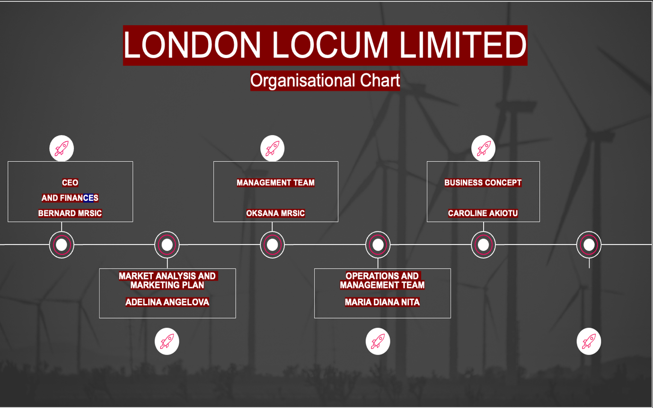

- CEO AND FINANCES: BERNAD MRSIC
Bernad is an expert. He manages an organization's financial and administrative operations, communicates with stakeholders, and advises on key projects.
- MANAGEMENT TEAM; OKSANA MRSIC
Oksana Mrsic has been a dental therapist for 8 years. She is perceptive and detail oriented.
She also spent two years as a TCO, lecturing patients and dental professionals about oral health and assisting in the selection of software to streamline appointment scheduling. She obtained manufacturer accreditation to educate dental assistants and other hygienists on a new appointment-booking system.
3. BUSINESS CONCEPT: CAROLINE AKIOTU
Caroline Akiotu has been an administrative assistant for six years since earning her business administration certificate. And the business concept assistant for the last three years. She handles customers, events, travel, and executive scheduling.
4. MARKET ANALYSIS AND MARKETING PLAN: ADELINA ANGELOVA
Customer service is the key to marketing campaign success. Connecting with your consumers helps you understand their demands and business voice, which improves your product. Adelina Angelova's has an eight-year marketing career and has focused on customer service.
5. OPERATIONS AND MANAGEMENT TEAM: MARIA DIANA NITA
Operations managers supervise all company operations. Maria Diana Nita redesigned the UK region's Supply Chain and Logistics division to satisfy organizational goals for the last five years. She led and inspired 100 multidisciplinary professionals.
Evaluated customer, delivery, and employee data.
Formulated, managed, and implemented supply chain activities from London to Europe to satisfy strategic goals and company regulations.

Business Structure

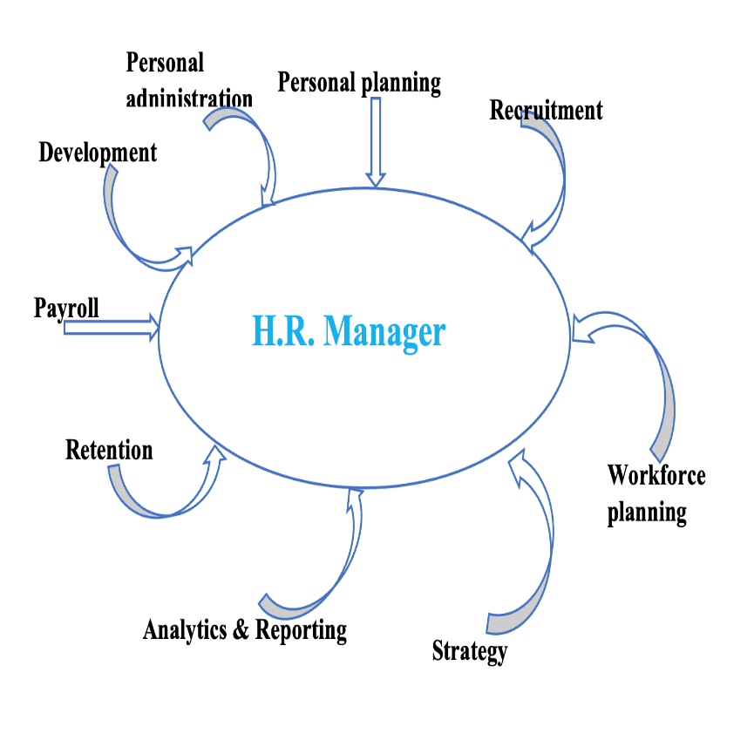
Personal Planning guarantees that the association has the exact number of workers with the essential experiences in all areas to accomplish the set objectives.
Enrollment is also referred to as talent acquisition because it defines all the actions a team needs to accomplish to reach new staff to profit the corporation.
Workforce Planning is mostly to ensure that your staff is arranged as professionally as possible to avoid holdups and congestion where they shouldn’t exist.
Personnel Management- Describes all the managerial tasks and procedures that fall within a sector’s space. It is involved in the creation of contacts and managing digital personnel files.
Development- Ensuring that management team and personnel crews help staff get restored at what they do, which includes creating durable performance organization processes and exposed values of the response.
Payroll- The manager must take caution in workforce and wage accounting. It happens either entirely in-house or moderately subcontracted and is held mutually with a software provider or tax specialist.
Preservation consists of all the procedures the management sector takes to hold staff and lower the firm’s overall abrasion rate.
Analytics & Recording- Personnel-related decisions informed by hard data are necessary for every modern management department. It includes having entree to a person's analytics to control worker headcount, progress rates, and prices.
Plan- Management is guaranteed to succeed if their focus on strategy and not much truly
on them, which includes creating time to be involved and implement initiatives.
Services
We can ensure that our dental nurses are fully qualified and have developed their craft over years of working with some leading clinics. We are confident that we can service your practice, reducing the need to disrupt your patients unnecessarily. Our team has highly skilled people who will make the journey to finding a new associate for your practice as simple as possible.

Key Milestones

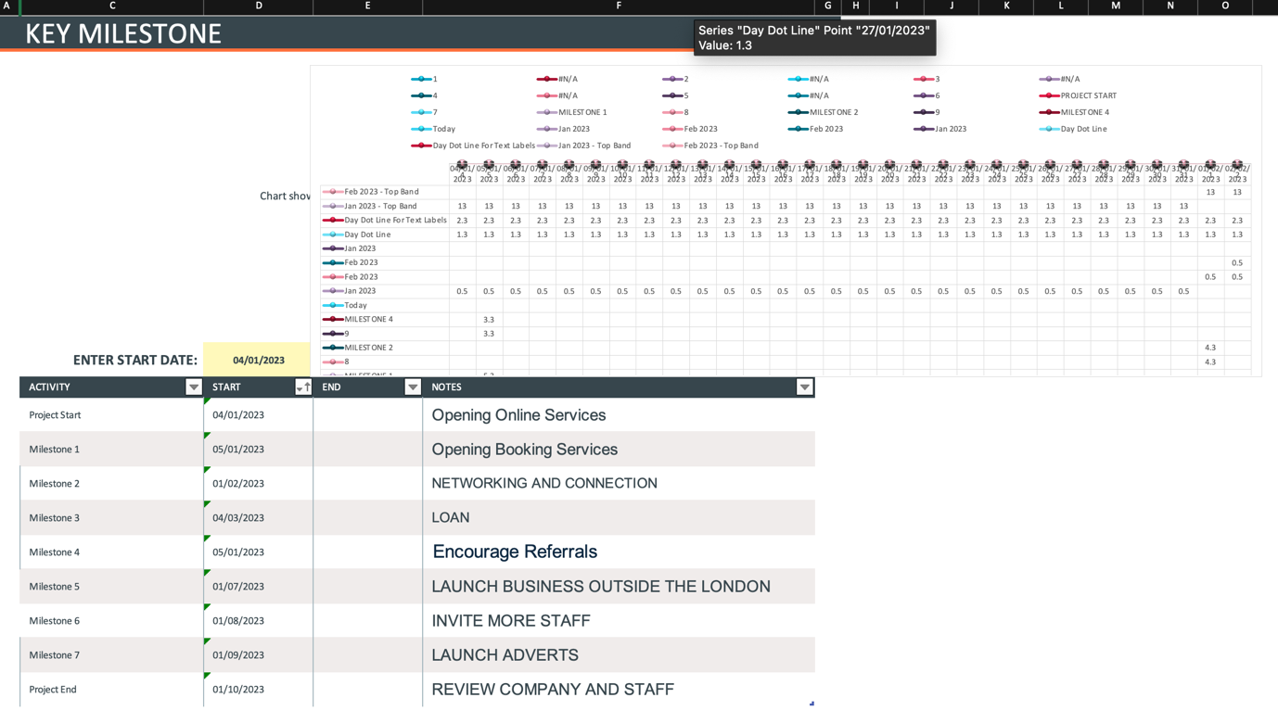

Employee Terminations Are Handled By The Manager

The function of the management team is crucial when it comes to firing an employee. Even though many businesses would like to avoid firing employees, occasionally it is necessary. During these times, management members make sure everything runs efficiently and professionally (Chron.com, 2011). Additionally, they strive to guarantee that all parties are handled fairly and according to the rules of the law. The manager representative must be present throughout the termination. A supervisor or a representative may explain the grounds for the termination to the fired employee while the latter takes notes and watches. The purpose of the manager is to act as an impartial third party. The employee must be told why their actions contravened a law, regulation, or corporate policy by the official present during the termination. Once the in-person termination meeting is over, human manager work is not over. It is expected that the manager will write up a summary of the discussion and put it in the file for the former employee. In the case of a lawsuit alleging discrimination or something less malicious, like a request to be hired back later, this evidence of how each party responded during the discussion may be important (Chron.com, 2011).

The Success Of The Organisation

The manager must be viewed in terms of the organization's overall strategic goals rather than as a separate lens that adopts a unit-based or micro approach. The objective is to approach the management team holistically such that there are no fragmented tactics, and that the policy is completely integrated with the company goals.
For instance, the company risks losing not just from the period that workers spend in training but also from a loss of direction if the training demands of the staff are only fulfilled by routine training on various themes (Doyle and Stern, 2006). Therefore, an organisation that is serious about its policies will make sure that learning is based on approaches that are both targeted and current.
To guarantee the effective use of people and higher returns to the companies in terms of return (Return on Investment) for each pound spent on them, manager practice must be linked with the overall strategy. Without such a design, enterprises risk losing out on the potential of their human resources. And this is not encouraging for the firm's future development.
The manager does all essential responsibilities in small businesses. Responsible for hiring, managing employee connections, and developing workplace policies. Management specialists also specialise in areas such as sourcing and recruiting, rewards and benefits, administration, legalisation, etc. When a company is profitable, a good leader will use that money to invest in the infrastructure of the business and make your team more effective. As a business leader, you'll never be able to know everything that can be done to make your company better, but by encouraging your employees to share ideas you'll have a comprehensive understanding of what the company can achieve.

Financial Plan

A financial plan provides a picture of how our organisation is doing right now. Our short- and long-term financial goals are informed by the predictions, which can serve as a springboard for establishing a plan of action. It aids us in establishing reasonable goals for the achievement of London Locum Ltd. as a business. Simply put, if we are well-versed in our finances, we are less likely to be taken aback by our current financial situation and better equipped to handle a crisis or rapid growth. A complete financial strategy also increases our appeal to investors in addition to helping us operate our firm more effectively. It reduces our risk and demonstrates that we have a solid strategy and track record for expanding our business. The financial plan for London Locum Ltd is based on the current business climate: following Brexit and the pandemic, there is a significant shortage of qualified nurses, particularly those willing to work full-time due to the high mental and physical demands of the job. This shortage has created a unique situation on the market where qualified nurses are looking for a better work-life balance as well as more flexible working terms adaptable to their needs. Our main philosophy of business is to create a platform that is easy to use, self-explanatory, and a fully automated, reliable system that can satisfy fully our clients' booking needs in dental practises while giving our nursing staff flexibility to work on terms and at times that suit their lifestyles and financial needs. Dental practises benefit from not employing full-time staff, which reduces their operating costs. They can also easily scale up or down on their work force in quiet or busy times, which also creates much better and safer cover for sickness, holiday, or maternity leaves. Our app and online software will automate admin and invoicing for the booking and invoicing processes. We are keeping our fixed costs very low and cutting the need for big physical offices and staff by using virtual offices for meetings only when required, VOIP for the phone system, and a dedicated communication app that allows us to work from any location. Automated booking systems and monitoring give us real-time data that can be analysed at the touch of a button, and new strategies can be implemented if needed. All of this reduces workload and helps keep our fixed cost spending at a very low level, which gives us the advantage to innovate and invest in the latest online app technology. Our short-term virtual office deals give us flexibility and ease of expansion or relocation. The implementation of rewording schemes as a cash incentive for all nursing staff who recommend and assist us in signing up new surgeries or nurses will help our expansion incentive. (Barrow, 2001)

Sources of Finance

There are many ways that businesses can be funded; some of them are by business angel investors, as well as by the founder's friends, family, and other current shareholders in the company. These are private investors, acting alone or in groups, who make direct investments in private businesses in exchange for equity interests and/or (perhaps) board seats. The "crowd," using a platform for equity crowdsourcing like the Angel Investment Network or Collection Pot. Early-stage and specialised venture capital funds may participate at this level by pooling their funds to put themselves on the map and have a say in subsequent investment rounds. Early-stage and specialised venture capital funds may participate at this level by pooling their funds to put themselves on the map and have a say in subsequent investment rounds. There are numerous methods for financing a business, considering all this options London Locum Ltd. management is focusing on internal financing to avoid unnecessary borrowing costs, especially given the market's current unstable and fluctuating financial situation. Each of the current five directors owns 20% of the company and will be responsible for running specific parts of the operation for their respective departments. Each will contribute £10,000 of their own funds to London Locum Ltd. This initial capital will be used to cover all day-to-day operating expenses (virtual office rental, bills, development costs, and so on) until the end of the weekly invoicing cycle, when we will begin to receive first payments from clients. Furthermore, we are able to generate income from the first booking, allowing us to reinvest in the business, and we are able to invest aggressively in the business due to low fixed costs until we reach our expansion goal. Our clients' invoicing cycle is done weekly, and payments to our service are automated and swift. Our management team will discuss and monitor the details of our financial situation and our strategy in our weekly meetings to ensure that we are on track to meet predicted targets. (Marcousʹe, 2014)

Cash Flow Forecast 2023

A method that businesses use to determine where their cash balances will be at specific future points is called a cash flow forecast. The different elements that go into determining what will make up or contribute to a future cash position are broken down in a cash flow projection. Usually, the finance team is in charge of making the cash flow forecast, which will help the business decide what to do in the future. By analysing our cash flow forecast for 2023 our starting capital of £50,000 shows a steady increase of cash reserves of 28.4% on average per month, which will give us a cash reserve of £212,211 by the end of the year. This capital will give us security and allow us to expand under more secure and self-founded terms without relying on external financing and the possible additional costs associated with that . (Blackwell, 2017) (BBC Bitesize, 2022)
See graph bellow:
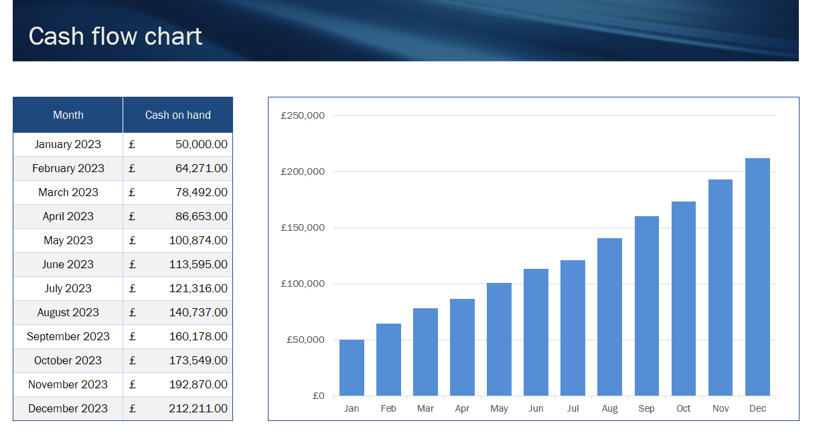

Please find bellow cash flow table analysis in full details:
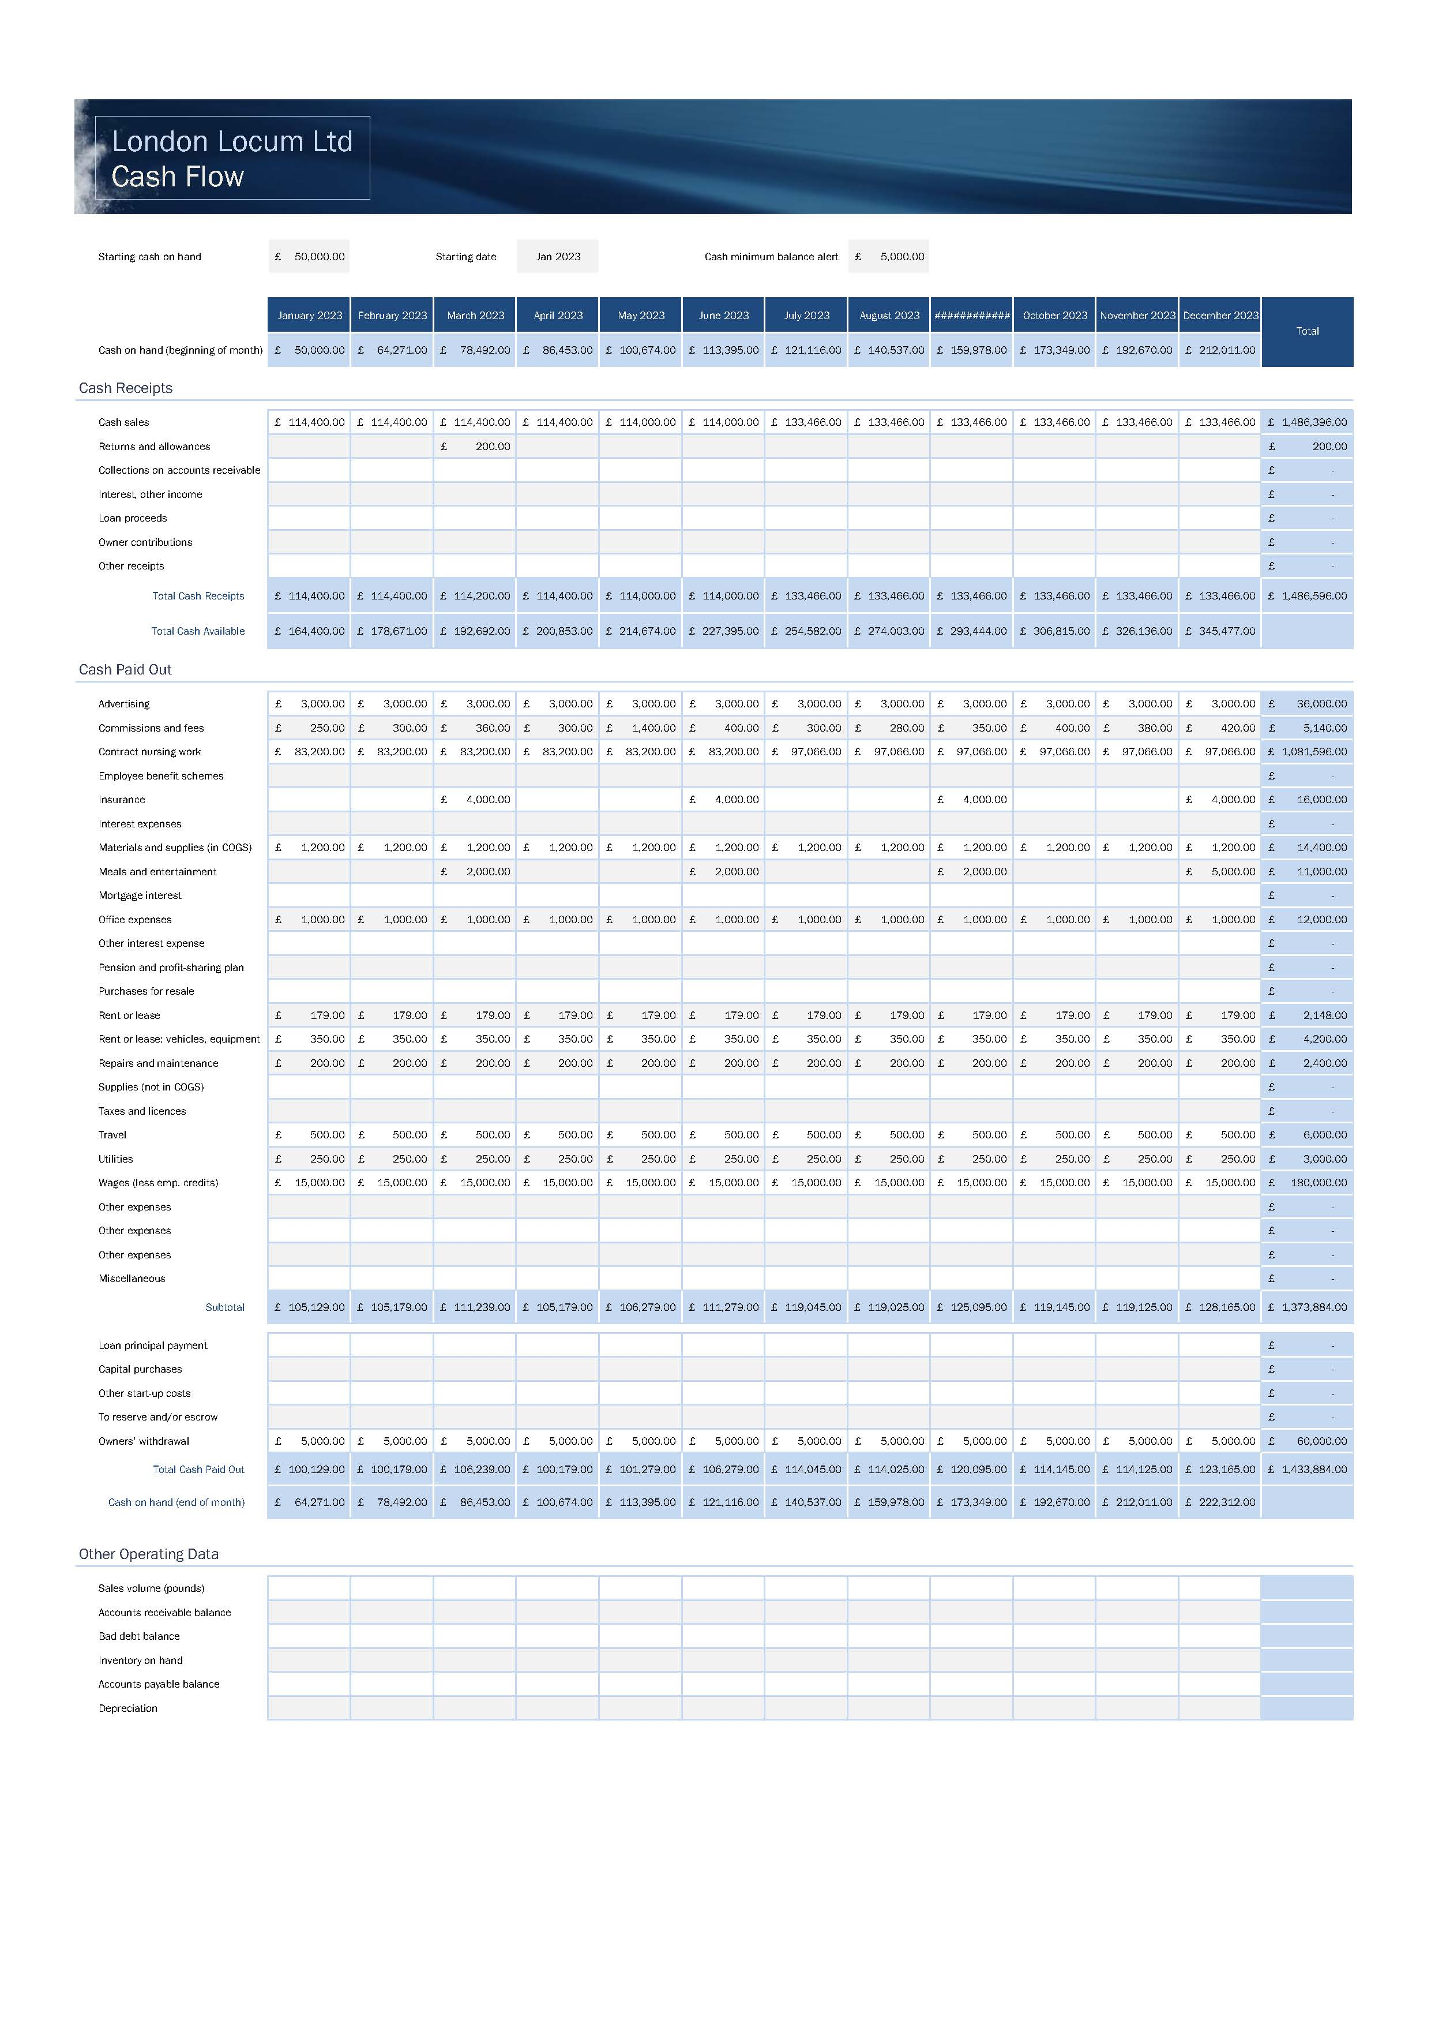

Sales Forecast

Future sales volume is predicted by a sales forecast. Since a forecast typically only covers a few months in the future and may not include a lot of supporting information, it is a less formal version of a sales budget. The sales force is more likely to base a forecast on bottom-up projections based on their expectations of sales to certain customers. It is more likely that a sales budget will include top-down sales projections from the management group. Resource requirements and urgent asset demands are projected using a sales forecast. A company uses a sales estimate, in particular, to determine whether or not to increase or decrease the amount of inventory it has on hand. Additionally, it is a crucial component of the research used to determine whether a company's bottleneck operation can manage an anticipated change in sales level; if not, sales will be limited to the bottleneck's capacity level. Additionally, the human resources division needs to prepare for equivalent adjustments in staffing numbers if sales levels are anticipated to fluctuate significantly from their existing level. Our modest sales forecast is based on using 30 fully booked dental nurses with two additional nurses on standby in the first six months, followed by 35 fully booked nurses with two on standby; each nurse will work an average of 40 hours per week. This is a very modest prediction, and we are sure that more nurses will be willing to join us. Based on the cash flow forecast, which predicts a 25% increase in the first half of 2023 and a 20% increase in the second half of the year, we can predict a minimum five-year profit increase of 20%, year on year. (Blackwell, 2011)



Cost of Service Forecast

Our business model is adaptable to the current political and economic situation and can react to the changes at a rapid pace. Our cost of service is expected to stay low and to fall even further after we finish APP and online software development, after which we are only paying for a running cost rather than full development. High demand will continue to grow and show no signs of slowing down in the next 2–5 years, and we are confident of that because of the shortage of nurses and the fact that it takes 3–4 years to train a fully qualified nurse. Our cost of the service can easily follow any changes in the market, keep up with increases in hourly wages for nurses by increasing chargeable hours by the same percentage, and keep profit margins in a steady and stable place. Our fixed operating costs should not increase more than standard inflation figures.

Break Even Analysis

By using the data from our cash flow table, our total cash paid out of £1,373,884 minus the total variable cost of contractual nurse wages of £1,081,596 gives us a fixed cost per year of £292,288. Then, by dividing it by the price of service per hour minus the variable cost per hour (£22 - £16 = £6), our calculation tells us that in order to break even in one year, we will need to produce 48,715 hours of work. Our total estimated number of hours per year is 62,400.
Please see below our graph and detailed explanation.


Operations and Management Plan

Business operations planning is a process that aims to assist organisations in providing better customer service, quick turn-around times, consistency in production rates, and ideal teamwork between the various departments of the organisation, such as production, finance, sales, operations, and human resources.
In the company, the operation management is crucial. The business activity of planning, organising, coordinating, and controlling the resources required to produce a company's products and services is known as operations management (OM). An administrative task is operations management. For instance, a restaurant performs a variety of tasks such as acquiring, receiving, managing, and requesting raw materials.

Production of Good and Service

Our company works as a dental nurse recruiting organization.
For dental businesses in need, our organization will offer dental nurses ready to start.
Due to the shortage of dental nurses in the UK, our service is excellent and crucial
Finding qualified people for open positions, adapting to change, lowering attrition, and boosting morale are all made easier for organizations. By investing in recruiting, we can guarantee we have the staff they require for success. Recruitment may help firms save time and money over time when done properly.
The recruiting and selection procedures used by our organization may directly affect turnover. It is essential to choose individuals who are appropriate for the position and the group. Employing individuals is a difficult process, and both the potential employer and the dental nurse must clear a lot of hurdles.

In terms of data gathering, practices must adhere to the law and make sure their hiring procedures don't constitute discrimination. They must establish a thorough interviewing procedure and do several pre-employment inspections. Dental nurses must also provide proof of their registration with the GDC or that they are pursuing a recognized dental nursing degree.
Our organization will offer dental nurses ready to start for dental businesses in need.
Due to the shortage of dental nurses in the UK, our service is excellent and crucial.

Technology Plan

Companies may stand out and fill positions with suitable individuals by utilising the appropriate recruitment technology.
The employment process is becoming more streamlined and effective thanks to recruiting tools. The way businesses acquire staff has evolved due to remote work, and talent acquisition technology is becoming a trend in recruiting.
People use their mobile devices for a variety of tasks, such as ordering food, paying bills, shopping, and browsing the internet. According to Statcounter, 60.67% of internet traffic as of August 2022 originates from mobile devices.
We will make sure our websites, particularly our career pages with job posts, are mobile search optimized to match the increased demand for mobile use. Mobile-friendly websites should include text stacked vertically to make it easier to read, simple navigation choices, and a click-to-call option.
Since March 2022, the number of daily active users for employment applications like Indeed, LinkedIn, ZipRecruiter, and Glassdoor have been increasing month over month. Due to the increased usage, our business team will consider these job boards in our mobile recruiting strategy as more individuals continue to utilize their smartphones for job searching.

Video Interviews

Using video technology, recruiters may expedite the interviewing process. Candidates can avoid traveling for early interviews. We can fill positions more quickly and keep the best candidates interested by using video interviews since the candidates answer more swiftly.
With video technology, scheduling several interviews and managing multiple schedules is also made simpler. Employers may choose which candidates to bring back for a face-to-face interview by using video to screen more candidates.

Applicant Tracking Systems

The best Applicant Tracking Systems are sufficiently flexible and intuitive that they can form a solid basis for your overall HR tech stack. Good options include Greenhouse, Smart Recruiters, Lever, Workable, Recruitee, and Bullhorn. Workday and iCIMS are particularly well suited for Enterprise teams, who often deal with thousands or even tens of thousands of candidates at a time.

Candidate Assessment Software

One of the easier TA activities to automate is aptitude testing, which recruiters use to get more dynamic information about applicants than they say about themselves. Recruiters may submit their applicants for a variety of exams through Testportal, Tazio, and Toggl Hire. To pre-screen applicants before they apply, TestCandidates is very helpful.

Candidate Screening Software

It takes time and effort to find the ideal candidate amid a sea of candidates. Nowadays, the more analytical portion of the screening process is replaced by digital instruments.
Solutions like Talogy, Trakstar Hire, or Ceridian use AI to automate routine administrative tasks and determine a candidate's suitability for a specific position during the screening process.

Human Resource Plan

Planning for human resources involves considering an organization's present and future "people requirements."
To ensure operational objectives are accomplished, productivity remains high, and future labour and talent demands can be met, this entails examining an organization's personnel structure and practices.

Who do we need?
- Planning – we need 5 human resources to start with which will help us with finding suitable candidates, doing payroll, doing marketing and administration, we would also need someone who can take care of the client (client relationship) and good customer service.

Important talents consist of:
- Get precise, useful HR and payroll data insights to control staff expenditures.
- With employee self-service, administrative duties and requests may be handled more quickly.
- For improved employee experiences, we will provide employees more access to and control over entitlements, withholdings, and payroll information.
- We will pay our employees correctly and on time each time. Confront obstacles with payroll that keeps us in control.
The purpose of human resources
- to surpass clients' expectations
- To advance fair policies and procedures
- To offer direction on hiring choices that complement the objective of the practices

Vision of human resources
- Human Resources shall provide services that promote and support the success of the practices and the community members as active participants in the strategic decisions that direct the practises toward attaining its goals.
- The Strategic Plan's Goals
- To support the mission of our institution, we must match our goals with the general direction of the practises, provide direction for our activities, and maintain openness in these efforts. Building on HR's base in a way that provides foresight to create long-term goals and flexibility to support the companies's quick expansion is a critical component of our strategic plan.
Collaboration
- Why it matters: We appreciate collaboration. Our cooperative, polite, and inclusive work environment helps us to build trust. We pay attention to our client’s demands, anticipate them, and strike a balance between novel ideas and rules and regulations.
- What this means for HR is that it depends on the satisfaction of our clients. Engaging with our clients to learn about their goals, procedures, and obstacles is essential for success. Customers' knowledge enables us to collaborate successfully to develop the finest solutions.
Integrity
- Why is this significant? Because we value honesty, mutual respect, and consistency. We recognize the value of delivering and keeping accurate data and top-notch services. Equally significant is our ongoing work to improve our procedures and establish a vibrant community.
- How this affects HR We follow our professional standards, which place a premium on making judgments that are consistent, and impartial, and serve as role models for the practice’s Ethical Principles and Code of Conduct, in order to perform our duties effectively.
- We provide our clients with just the best services, materials, and information.
Innovation
- Why it matters: We respect the original idea. Considering our practice’s explosive expansion, it is essential to look for the best and most practical solutions. By advancing us, enhancing our value, and keeping us current, innovation keeps us competitive.
- What this implies for HR is that we use cutting-edge approaches, technology, and work settings to better meet the changing demands of our clients.

- Diversity and Inclusion
- Why is this significant? Because we admire unique individuals and want them to succeed. The degree to which we are open, inviting, and varied helps our team members realize their full potential and provide the greatest possible service to our consumers.
- How this affects HR Within HR, we are aware of each person's distinctive talents. To better satisfy the individual requirements and experiences of our clients, we value and make use of everyone's traits, talents, and variety of abilities.

- Boost the general level of service quality
- Create yearly and irregular customer surveys to evaluate general opportunities and strengths
- Establish a procedure for survey distribution and start with an initial survey to collect baseline data.
- Implement pulse polls for targeted efforts
- things to focus on for development

- Create a centralised customer service architecture to address all inbound fundamental HR queries (inclusive of phone, face-to-face, and email inquiries)

To ensure that clients are aware of HR services, staff roles, responsibilities, and resources available, we will create, update, and manage an integrated HR website.
- Get client input to better comprehend how online resources may suit users' demands.
- Create a committee for the HR department's website to examine user comments, analyse web traffic, decide on a desirable site structure, and develop a new site.
- Examine traffic analytics and suggest site improvements to optimise the use of self-service
- Make that the website complies with requirements for mobile device use, ADA compliance, and literacy levels.

Implement best practices and tested tactics from efforts to combat unconscious bias
- 4 Help with hiring, keeping, promoting, and recruiting in order to boost and maintain diversity.
- Find more places where the effects of the best practices may be precisely measured.
- Establish baseline measurements and enhance patterns, such as the composition of the search and hiring committees.
- Provide search committees with training to help them lessen the effects of unconscious prejudice

To promote employee performance, provide clear expectations for leaders, managers, and supervisors.
- Create written guidelines for all stages of employee development.
Provide staff members at all levels with more opportunities to engage in ongoing education, career development, coaching, mentorship, and networking with other professionals.

Expansion Plan

- It is crucial that organizations concentrate on problems related to job expansion and job enrichment. The firm will need to strengthen HR operations as a result of the growth in locations in order to successfully handle these concerns. In the situation under discussion, we saw that both firms had tried to concentrate on their respective expansion plans. And for any other firm, they can concentrate on plans for horizontal or vertical expansion, as well as for mergers and acquisitions. There are companies that have attempted to grow internationally by acquiring other small companies. But using such growth techniques to succeed is not always essential.

Reference List

Abramovich, S., Grinshpan, A.Z. and Milligan, D.L. (2019). Teaching Mathematics through Concept Motivation and Action Learning. Education Research International, [online] 2019, pp.1–13. doi:10.1155/2019/3745406.
Acevedo, L. (2010). The Advantages of Email in Business Communication. [online] Chron.com. Available at: https://smallbusiness.chron.com/advantages-email-business-communication-122.html.
Barrow, C. (2001). The business enterprise handbook : a complete guide to achieving profitable growth for all entrepreneurs and SMEs. The Financial Position, [online] pp.57–96. Available at: https://read.kortext.com/reader/pdf-file/e0b05b27-9128-40fe-8e61-998abf207f4c/1 [Accessed 9 Dec. 2022].
Barrow, Colin., 2001. The business enterprise handbook : a complete guide to achieving profitable growth for all entrepreneurs and SMEs. London: Kogan Page.
BBC (2022). What is meant by a cash flow forecast - Cash-flow - Eduqas - GCSE Business Revision - Eduqas. [online] BBC Bitesize. Available at: https://www.bbc.co.uk/bitesize/guides/zmtrrj6/revision/2#:~:text=What%20is%20meant%20by%20a%20cash%20flow%20forecast.
Berry, T., 2006. Hurdle: The Book on Business Planning. s.l.:Palo Alto Software, Inc.
Blackwell, E. (2011). How to prepare a business plan. London ; Philadelphia: Kogan Page.
Blackwell, E 2017, How to Prepare a Business Plan : Your Guide to Creating an Excellent Strategy, Forecasting Your Finances and Producing a Persuasive Plan, Kogan Page, Limited, London. Available from: ProQuest Ebook Central. [9 December 2022].
Bruijl, D. and Gerard, H.T., 2018. The relevance of Porter's five forces in today's innovative and changing business environment. Available at SSRN 3192207.
Busby, M., 2020. Leading the Oral Healthcare Team in Risk Assessment. In Risk Assessment in Oral Health (pp. 189-202). Springer, Cham.
Castagna, R. (2020). What is GDPR? An Overview of GDPR Compliance and Conditions. [online] WhatIs.com. Available at: https://www.techtarget.com/whatis/definition/General-Data-Protection-Regulation-GDPR.
Chai, W. (2021). What is Big Data Analytics and Why is it Important? [online] SearchBusinessAnalytics. Available at: https://www.techtarget.com/searchbusinessanalytics/definition/big-data-analytics.
Chron.com. (2011). What Is the Role of HR During an Employee Termination? [online] Available at: https://smallbusiness.chron.com/role-hr-during-employee-termination-10085.html. [Accessed 28 Nov. 2022].
Doyle, A. (2022). Learn to Answer Interview Questions About Co-Workers and Supervisors. [online] The Balance. Available at: https://www.thebalancemoney.com/job-interview-answers-to-questions-about-your-supervisor-2061239.
Doyle, P. and Stern, P. (2006). Marketing management and strategy. Harlow: Financial Times Prentice Hall.
Ernesta, K., Dogley, M.H., Arissol, E. and Pothin, H., 2020. The Seychelles dental service. Neurotoxicology, 81, pp.246-253.
George, B. (2020) “Successful strategic plan implementation in public organizations: Connecting people, process, and plan (3PS),” Public Administration Review [Preprint]. Available at: https://doi.org/10.1111/puar.13187.
Grant, M. (2021). Software as A service (SaaS). [online] Investopedia. Available at: https://www.investopedia.com/terms/s/software-as-a-service-saas.asp.
Haag, Annette B, 2013. Writing a Successful Business Plan: An Overview. Workplace health & safety, 61(1), pp. 19-29.
Harris, M., Wilson, J.C., Hughes, S., Knevel, R.J.M. and Radford, D.R., 2018. Perceived stress and well‐being in UK and Australian dental hygiene and dental therapy students. European Journal of Dental Education, 22(3), pp. e602-e611.
Hashemi, M.S. (2019). The effect of infrastructure, corporate culture, organizational structure and information technology on Competitive Intelligence in Organizations. International Academic Journal of Organizational Behavior and Human Resource Management, 06(01), pp.32–39. doi:10.9756/iajobhrm/v6i1/1910003.
Ibarra, H. and Hunter, M.L. (2007). How Leaders Create and Use Networks. [online] Harvard Business Review. Available at: https://hbr.org/2007/01/how-leaders-create-and-use-networks.
Kanli, İ.B., Küpeli, İ.T. and Onat, A., 2022. A Comparative Analysis on the Bureaucratic Process in Establishing Health Cooperatives: The Cases of Turkey and the UK. In Eurasian Business and Economics Perspectives (pp. 309-330). Springer, Cham.
Lindell, P. G., 2010. Vision, Mission and Values. [Online].
Lodge, J.M., Kennedy, G., Lockyer, L., Arguel, A. and Pachman, M. (2018). Understanding Difficulties and Resulting Confusion in Learning: An Integrative Review. Frontiers in Education, 3(1). doi:10.3389/feduc.2018.00049.
Marcousʹe, I. (2003). Business studies for AS. Teacher’s book. London: Hodder & Stoughton.
Marcousʹe, I. (2014). OCR Business studies for AS. 2014th ed. London: Hodder Education.
Newberry, C. (2018). 8 Social Media Security Tips to Mitigate Risks. [online] Hootsuite Social Media Management. Available at: https://blog.hootsuite.com/social-media-security-for-business/.
Pilbeam (n.d.). OCR Customer Service: NVQ Level 2.
Robert, J. (2022). What Role Do Human Resources Play? [online] Available at: https://business360plus.com/2022/11/18/what-role-do-human-resources-play [Accessed 28 Nov. 2022].
Sands, N. (2022). Leadership or Management - What’s More Important to a Growing Recruitment Business? [online] Davidson Gray. Available at: https://www.davidsongray.co.uk/leadership-or-management-whats-more-important/ [Accessed 28 Nov. 2022].
Summerfield, J. (2019). Mobile Website vs. Mobile App (Application) – Which is Best for Your Organization? [online] Hswsolutions.com. Available at: https://www.hswsolutions.com/services/mobile-web-development/mobile-website-vs-apps/.
Susan Derek, N. (2002). Define and Deliver Outstanding Customer Service. Edition 2.
Thabit, T. and Raewf, M., 2018. The evaluation of marketing mix elements: A case study. International Journal of Social Sciences & Educational Studies, 4(4).
Wales, B., 2021. Making a Plan. [Online] Available at: https://businesswales.gov.wales/starting-up/business-plan/making-plan [Accessed 11 12 2022].
Watson, M.S. et al. (2019) Oxford Handbook of Palliative Care. Oxford: Oxford University Press.
Westgarth, D., 2020. COVID-19 and community dental services: the challenges ahead. BDJ In Practice, 33(6), pp.14-19.

Appendices:



