

MBA- Master of Business Administration
Marketing Management Assessment 1
Romeo Makiadi 1906720
LCMB7001
DR. Tushara Balendran

TABLE OF CONTENTS

INTRODUCTION
THE COMPANY ADIDAS
COMMUNICATION
SHANNON WEAVER MODEL OF COMMUNICATION
INTEGRATED MARKETING COMMUNICATIONS
NEW PROMOTIONAL STRATEGIES
- ONLINE WITH INTERNAL INCORPORATION
- OFFLINE WITH EXTERNAL INCORPORATION
BRANDING AND BRAND EQUITY
KELLER’S BRAND EQUITY MODEL
KELLER’S BRAND EQUITY MODEL APPLIED TO ADIDAS
- CRITICAL ANAYLISIS
CUSTOMER JOURNEYS
CUSTOMER TOUCHPOINTS
PRE-PURCHASE
PURCHASE
POST PURCHASE
CUSTOMER PERSONA
CUSTOMER JOURNEY MAP
- CRITICAL ANANLYSIS
THE TOTAL ENGAGEMENT MODEL
THE TOTAL ENGAEMENT MODEL APPLIED TO ADIDAS
RECCOMENDATIONS
CONCLUSION
REFRENCES

INTRODUCTION
This report's contents provide an in-depth examination of adidas' creative marketing approaches. Its marketing strategy, competitive research, and the various brand-awareness campaigns it implemented to increase brand awareness and equity. The research analyses the customer journey and touch points, determining its strengths and limitations, and suggests new marketing tactics for the business to entice both present and potential investors and consumers via online and offline. Conclusively, closing with the Total Engagement Model related to the company and effective recommendations for new touchpoints.
ADIDAS
Gebrüder Dassler Schuhfabrik was established in 1924 by Adi Dassler to offer sportsmen excellent equipment. Olympic medals in Berlin and Amsterdam helped the enterprise start out successful. Adi Dassler rebranded the business as "Adi Dassler adidas Sportschuhfabrik" in 1949 and debuted the adidas 3-Stripes, which are now internationally recognised. Due to the company's sponsorship of the German national football team during their 1954 World Cup victory, which helped them get publicity, they experienced substantial expansion and development into new markets and garments. adidas' most popular piece of clothing was the Franz Beckenbauer tracksuit, which opened the door for more success and expansion. (Adidas.com, 2023)
Adidas is a globally recognized sportswear brand that has expanded into a variety of sports and has a wide range of professionals who rely on their products. In 1986, their collaboration with hip-hop trio Run-D.M.C. helped launch urban fashion trends and led to non-athletic advertising in the recreational goods sector. In 2006, Adidas acquired Reebok, Rockport, and Reebok-CCM Hockey, and rebranded as Adidas AG. Their headquarters is located in Herzogenaurach, Germany, and all 5,400 employees work in one space where the company culture is embraced. In the early 2000s, Adidas launched a luxury streetwear category, collaborating with designers like Stella McCartney, Yohji Yamamoto, and Porsche Design Sport. These collaborations led to a high-end luxury collaboration with Gucci in 2022, further enhancing the brand's identity and reputation. (Adidas.com, 2023)
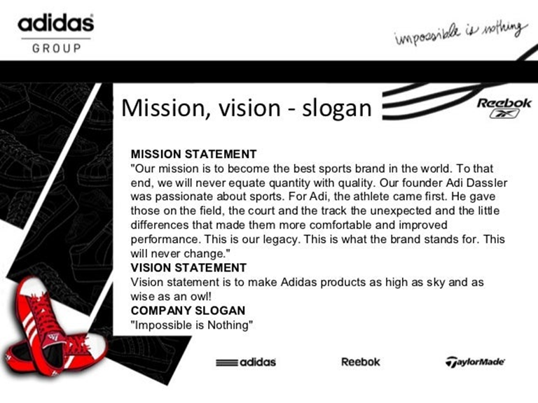
(Catovic, 2010)
COMMUNICATION.
Communication is a method by which people connect with one another, by using a shared set of signs, symbols, or actions (Merriam-Webster, Incorporated, 2023). Communication sets out to enlighten the marketplace on the characteristics of a company's offering, including customers, partners, corporate stakeholders, rivals, and society at large (Chernev, 2012)

COMMUNICATION MODEL.
The Shannon and weaver model is recognised as a formal representation of communication and offers a framework for evaluating the transmission and reception of messages.
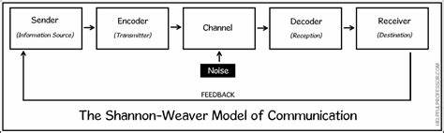
(Jarons Blog, 2022)

The sender, or "information source," is where the Shannon Weaver model begins. They are the one who originally possessed the data (or where the information was sourced, the procedure is initiated by the information source by selecting a message to transmit, a recipient for the message, and a medium via which to transmit it. Information may be transmitted in a variety of methods, including audibly (through speech), in literature or through nonverbal cues and mannerisms (Hooley, et al., 2012)
The device (or person) that encodes a concept so that it can be transmitted from the sender to the receiver is known as the encoder.
The "channel" is the following stage in the Shannon Weaver model. The system that transmits data from the sender and transmitter to the decoder and recipient is known as the channel of communication or transmission medium (Communication Theory.Org, 2023).
"Noise" is the following stage in the Shannon Weaver model. A message is interrupted while it is being transmitted from the sender to the recipient by noise. This term refers to the notion that "noise" may prevent us from interpreting an information correctly. Noise consists of two components: internal and external (Communication Theory.Org, 2023).
- When a transmitter or receiver makes a mistake while encoding or decoding communication, internal noise occurs.
- When something external—outside the control of the sender or the receiver—hinders the message, that is known as external noise.
Decoder
the location where a signal is received and converted into a message, a reverse encoding procedure (Drew, 2023).
The next phase in the Shannon Weaver framework is ‘receiver’. The receiver is where the Shannon and Weaver model of technical communication originally concluded. The message, or what is left of it after factoring for noise, is understood at this stage.
The final stage is feedback Norbert Weiner produced the feedback stage in regard to critiques of the linear structure of the approach (Hooley, et al., 2012).
INTEGRATED MARKETING COMMUNICATIONS.
The integrated marketing communications (IMC) plan transforms your marketing campaign from a collection of independent operations into one cohesive strategy. IMC combines your numerous marketing materials and channels, including digital, social media, PR, and direct mail, into one trustworthy message (pinegar, 2018).
It aims to combine all facets of marketing communication, including ad campaigns, sales promotion, brand management, direct marketing, and social media, through their individual mixtures of approaches, techniques, intermediaries, news outlets, and operations so that they all function as a single cohesive force. This approach is known as integrated marketing. The procedure is intended to guarantee that all messaging and communications strategies are uniform across all platforms and are focused on the consumer. IMC is not required in every campaign. This approach mixes traditional and modern approaches, and its applicability will vary on the campaign's message and the targeted results (Blakeman, 2015).
NEW PROMOTIONAL STRATEGIES FOR ADIDAS
ONLINE WITH INTERNAL INCORPARATION
- Collaborate with Influencers to raise adidas’s brand's visibility and trust, work with influencers and micro-influencers in your target market. These influencers have the ability to produce interesting material regarding Adidas items and distribute it to their online following. Adidas should look at high level influencers and consider the stability of the influencers public relations considering the Kanye west scandals experienced recently by the company (Crane, 2022)

- Adidas can provide clients who subscribe to their mailing list or follow them on social networking sites with access to unique online bargains. To get customers excited, these sales can be customized or scheduled depending on the merchandise and season. Furthermore, this can be implemented internally aimed towards staff emails and can give a sense of conclusion and add to staff retention.

- Consumers can virtually try on footwear and apparel by using a virtual try-on function on the Adidas website or through the mobile application. With this option, shoppers can obtain a better concept of how the merchandise will appear and look, which may lead to an increase in online transactions and appeal to technology euthenists and a younger demographic.

- Gamification elements such as point-based incentive schemes, rewards programs, and reference schemes can stimulate customers to interact further with Adidas' merchandise and its identity this should include all branch and warehouse staff plus management. This suggestion is due to rise in the gaming industry and the potential revenue and brand awareness that can be produced, is very tangible. This is due to considering the resources accessible to adidas, the barriers to entry are low.

- Adidas can use connective technology to give clients fully interactive interactions. Consumers can, for instance, utilise the camera on their smart device to view how a footwear item will appear on their feet instantaneously. This approach can revolutionise the industry and adidas would be a forefront leader as this can be monetised and provide more revenue for the company. Further gaining leverage over their competitors.

- Place a chatbot on Adidas' website or social media channels so that it may assist customers and address their queries whenever they arise. Consumers may profit from this software since it offers an individualised service, increasing their level of pleasure. Resulting in more brand awareness as the companies’ rivals do not possess such technology.
All suggestions online should incorporate internal departments to give a sense of involvement in the companies advances and innovation process.
OFFLINE WITH EXTERNAL INCORPARTION
- Annual Sports Events to promote its products, Adidas can organise or sponsor sporting events like tennis, rowing, or long-distance races. Additionally, they can develop branded products and extend special discounts to event attendees.

- Public Outreach: to promote a healthy perception and raise brand knowledge within different geographic community's and appeal to different demographics of the populace, increasing engagement, Adidas should take part in community events like charity marches or regional festivals. In addition, these events can be designed to connect with the demographic of the groups involved.

- Short term merges with creatives, working with well-known creatives to produce limited-edition merchandise or apparel can draw in enthusiasts who support both the company and the creator. Adidas could also offer cultural gatherings or shows that highlight and feature these alliances and collaborations.

- At congested shopping locations, Adidas can set up temporary shops where people can buy its merchandise and check out its latest offerings. Additionally, they can develop immersive experience like product testing, augmented reality, and specialised outfitting.
These offline events should involve the external stakeholders like suppliers, distributors, and governmental agencies. To assist with these procedures and add contributions like safety, adidas information and third-party partnership perks through adidas, giving a sense of full company conclusion. In addition, a personal message from the regional executive thanking everybody involved to add to the brands awareness and interaction being more aligned with the integrated marketing communications (Blakeman, 2015).

BRABNDING AND BRAND EQUITY
When a product or service is marketed, particular advantages may result due of the brand name, which would not happen if the identical product or service did not have the name. This is how brand equity is identified in the context of promotional effects that are specifically connected to the brands (Chernev, 2012).
The things offered under the brand's name are worth more just because it is a well-known one. Gaining awareness allows you to become more visible and familiar, which acts as a foundation for further favourable alliances. An attempt to associate a brand with desirable qualities, such as "exceptional," "quality," "luxury," and so forth. Positive brands have a good opportunity of dominating the market by providing consumers more motivations to purchase them. The perceived value is still another crucial element. Brand equity aids in establishing links between consumers' perceptions of a product's benefits and its expenses. Consumers will spend more money on a brand they trust (Hooley, et al., 2012).
Brands benefit from customer loyalty because it not only boosts the brand's value and gives them a significant competitive edge, but also lowers marketing expenses (Hooley, et al., 2012).

KELLERS BRAND EQUITY MODEL APPLIED TO ADIDAS
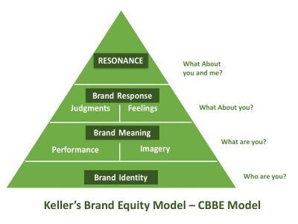
(www.qualtrics.com, 2023)
A solid reputation provides a higher likelihood of gaining and retaining consumers, emerging from the links between consumer and brand. This gives business significant edge. Organizations may apply the methodical tactics and provide their market with the right interactions by using the Brand Equity Pyramid (na, et al., 1999).
A brand has the chance to recognise and take advantage of its customers' views and allegiances, both beneficial and detrimental, as it moves up to the resonance level. Marketing companies may comprehend what their consumers desire and require prior to having purchased the goods, or even prior to becoming aware of the desire the item or service, by breaking CBBE into Keller's four stages (Bhasin, 2019).

1.Brand Identity (who are you?)
It investigates the phrases and mental pictures that consumers associate with a specific brand name. It is a highly crucial level and needs to be sturdy to sustain the levels that come after it in the pyramid. The fundamental essence of awareness among consumers of a brand is measured via a company’s brand identity (na, et al., 1999).
Adidas’s brand identity is known and established throughout the world, through sports fashion and merchandise. Adidas’s brand identity is tied into many sub-intermediary sports and apparel stores across the globe which in also includes global influencer endorsement. Moreover, the company is fortunate to have hereditary values which gives them an advantage on demographic aspects and geographical locations compared to threats of substitutes and threats to entry.
2.Brand meaning (what are you?)
Whenever a consumer is acquainted with a company, he will want to determine if it's trustworthy, suitable for long-term usage, offers outstanding client support, and other critical facts. The variables that determine what a brand means to consumers compose the second level of Keller's Brand Equity Model (Bhasin, 2019).
Brand performance: Product Attributes, Quality And reliability, Customer Relations, Appearance & Design, and the Selling Price of the Goods or Service, there are the five variables that make up brand equity. "It accomplishes what it promises as its brand name suggests, so when it delivers, customers will be happy (Raut, et al., 2019).
Adidas is well-known for its high-performance athletic wear, and it has consistently produced cutting-edge goods that satisfy the demands of sportsmen and sports fanatics. As a result, Adidas has developed a solid reputation for performance.
Brand imagery: Consumers' mental and behaviour demands are satisfied via visuals. How does the brand come across to consumers? Like KFC, family-friendly, finger-licking-good chicken buckets and their creator and mascot Colonel Harland David Sanders are brands we trust because of their prominence and longevity in the food industry. A brand's reputation can be strengthened through direct advertising and word-of-mouth publicity (Raut, et al., 2019).
Adidas has a strong brand image that is connected to inventiveness, fashion, and effectiveness. The company has been effective in reinforcing its reputation as an outstanding durability brand by leveraging its affiliation with elite athletes and sports organisations. Adidas has also branched out into the fashion sector, working with creators to create elegant, modern goods which cater to a broader market (Adidas.com, 2023).

3.Brand response (what are the feelings for the brand)
Towards this stage of Keller's approach, judgement and attitudes can be difficult to distinguish since they are so highly meaningful for every particular consumer. A business may be rendered worthless to one buyer while being absolutely relevant towards another. Someone else might compare a brand ’s visibility to another, favourably or unfavourably. its recognized how complicated it may be to place an amount on how people feel about a company and the extent to which they respect it (Bhasin, 2019).
Including adding factors of actual engagement and apparent reputation. Once a company is aware of these judgements, it must react to them and foster favourable brand perception. Whereas if product meets or exceeds, it creates a lot of excitement and might even influence the consumer to endorse the business as an advocate. Those satisfying encounters provide consumers with "Emotional responses” (feelings). However, this can also be reflected negatively if the product or service was appalling within the consumer perception causing an adverse effect which can be detrimental (Chernev, 2012).
Customers associate Adidas with excellent quality, dependability, and innovation, which has helped the brand establish a solid reputation. Adidas has successfully positioned itself as a company that values sustainability and the environment, and this has enabled the company to forge an intense psychological connection with customers.

4.Brand resonance (strong relations with consumer)
A brand advocate is someone who has ascended to the top of Keller's Brand equity pyramid. At this stage, there is a strong emotional and interpersonal bond between the brand and the consumer. Behaviours, values, and attitude of consumers, as well as their interaction, are many aspects that influence brand resonance.
The links and thoughts that occur when a buyer is devoted to a brand and regards it as exceptional, who refuses to purchase anything other, and recommends its benefits to everyone else is an advocate. Customers have strong feelings about a variety of factors, including lifetime moment, service quality, commodities, and value. An overall rating system that provides a useful indicator of resonance (Raut, et al., 2019).
Kanye West, Beyonce, and Pharrell Williams are just a few of the prominent individuals, athletes, and artists that Adidas has collaborated with to develop special edition products and marketing campaigns that appeal to their followers. Major athletic events, teams, and athletes like Lionel Messi, the NBA, and the FIFA World Cup have all been sponsored by the company. Adidas has been successful in doing this through cultivating a sense of community and allegiance among its consumers (Adidas.com, 2023).
Additionally, the brand's dedication to sustainability and societal accountability has contributed to its capacity to resonate well with consumers who are becoming more conscious of ecological issues and business ethics. In general, Adidas has been successful in forging an intense psychological connection with its consumer base, which has aided in the development of its brand equity and ongoing success (Adidas.com, 2023).
CRITICAL ANALYSIS
Through a critical analysation of the Keller's strategy, it is surprisingly elegant through its clarity, but creating consumer brand value is actually a difficult and time-consuming process. companies can build a brand that customers will admire, have faith and confidence with by positioning and implanting a strong brand identity that gradually introduces customers to the brand and business by Starting from the bottom of the Keller's framework. This method also enables an identification process where a brand can acknowledge which phase it currently occupies as well as its potential to move into the next phase. In the end, it helps brands develop brand awareness and reputation resulting in brand equity. Nevertheless, there are positive aspects and negative aspects.

Disadvantages
1. Constrained scope- The frameworks primary focus is on consumers' impressions of a brand; it ignores additional elements that can have an effect on brand equity, including market developments or competition.
2. Particular- The model depends on consumers' biased judgments of a brand, and these may be persuaded by a number of things, including personal prejudices and experiences.
3. Time compelled- It takes a long time to complete because it calls for considerable research and evaluation.
Only business to consumer and not business to business
Advantages
1. Substantial concerning consumers: Keller's concept of brand equity offers a broad framework for examining brand equity. It is a useful resource for advertisers since it considers a variety of brand-related factors, such as brand recognition, brand knowledge, and customer retention targeted at consumers.
2. Tangible insights: By highlighting subjects in need that require development, the model can offer tangible insights for enhancing brand equity. For instance, a marketer may concentrate on raising brand awareness if a brand lacks brand value.
3. Adaptable: The design is adaptable to many brands and industries. Additionally, it can be used to evaluate brand equity at various points in a brand's lifecycle.
CUSTOMER JOURNEY
When it comes to performing a targeted job or travelling the full customer lifecycle from candidate to consumer to devoted advocate, a customer journey is a method that assists businesses comprehend the related experiences that consumers want and require (Halvorsrud, et al., 2016)
Customer journey stages
In general, the following phases make the customer's journey:
Awareness: The need or interest for a good or service is recognised by the customer.
Consideration: the consumer starts looking into and weighing his options.
Decision: The consumer decides to purchase and enrols as a customer.
Retention/Experience: The consumer's interactions with the item or service being bought can affect their contentment and propensity to make another transaction.
Advocacy: When a consumer takes a service or item, they advocate it to others, which can affect their friends' and family's intentions to purchase it in the future.
To draw in new customers, keep them coming back, and encourage positive word-of-mouth advertising, it's critical for businesses to comprehend and optimise each stage of the customer journey (Grewal & Roggeveen, 2020).

ADIDAS CUSTOMER JOURNEY PERSONA

Working as an artistic designer
Earnings: 30K-37K
Lifestyle: tech smart, fashion-forward, and environmentally conscious
His objectives are to keep up with current trends, purchase comfortable, high-quality trainers for daily use, and display his appreciation of style on social media.
Difficulty elements: The inability to locate his size, the discomfort or lack of support in trainers, the fact that special-edition trainers sell out too soon.
ATHLETIC PERFORMANCE

FASHION FORWARD STYLISH

LIMITED EDITION HYPEBEAST

UNISEX

AGE 18 - 31

Goldie is young plays multiple sports is into all the emerging trends is an active social media user and has an influential following with his YouTube blogging career.

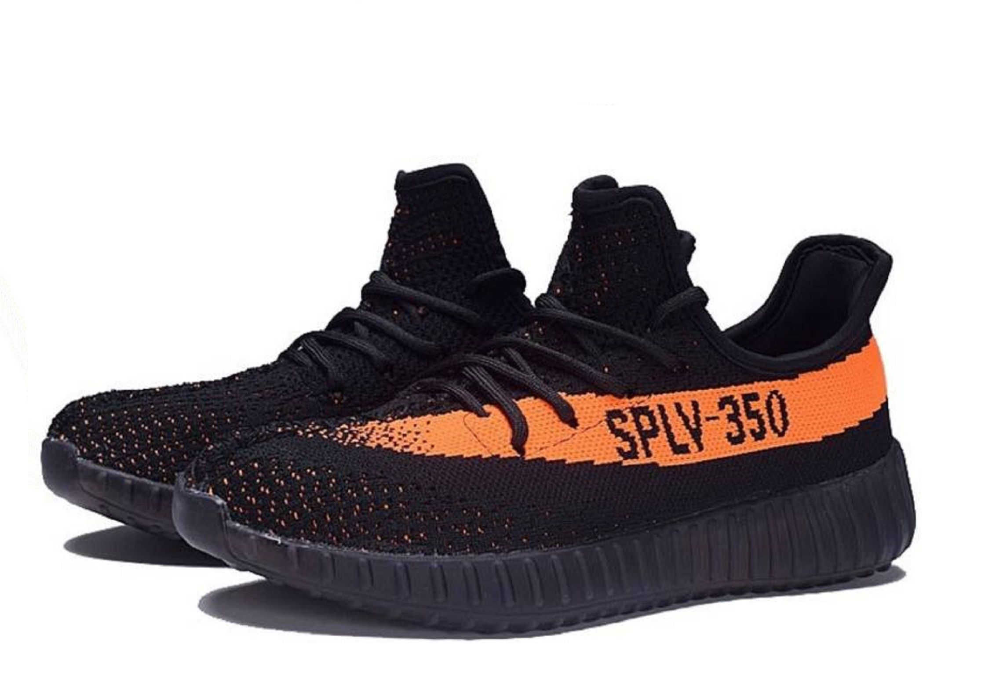


THE NEW YEEZY’S
Post purchase
Facebook posts and hashtags
Personal Reviews and ratings found online.
Email subscription verified.
Consider.
Kanye west enthusiasts
Social networking sites (Twitter, Instagram.
blogs and websites
famous sponsors
internet commercials
catalogues
Purchase
Acquired the yeezy trainer online from the Adidas website and another e-commerce site.
Compare.
contrasts with comparable shoes priced similarly.
suggestions made by friends or family.
Constant research on the trainer
Explore.
Ratings and reviews posted via the internet.
Looked online at various colourways and price ranges.
in-store fittings

CUSTOMER TOUCHPOINTS
Customer touchpoints are any points of contact, whether online or off, where a consumer and a business engage. These exchanges can take place via social networking sites, email, texts, and calls, in-person meetings, and much more (Kotler & Keller, 2016).
Customer journey touchpoints

Customer Touchpoints
POST PURCHASE
Customer service
Loyalty programme
Online forum

PRE PURCHASE
Word of mouth
Internet.
Email

PURCHASE
Sales person
Ecommerce
Physical store

PRE-PURCHASE
The various phases a consumer goes through before making a purchase decision are known as "Pre-Purchase Points," and include preliminary product research, exploring, contrasting cost (Grewal & Roggeveen, 2020).
Adidas prepurchase customer touchpoints have become integrated into the lives and communities of millions due to their longevity, being a forerunner in its industrial market via traditional aspects like word of mouth and their long-time involvement in sports, leading to athletics and football advocacy of the brand. Furthermore, their influence is also recognised in music industry and fashion having more involvement in the lives of people which then initials premeditated purchases from consumers. Kanye west is a prominent character and has a cult following involving him with adidas and utilising his designer expertise had consumers in a frenzy ready to pre purchase. Furthermore, the influence he has on other influential icons leads to extreme exposer of the product.
PURCHASE
The process of obtaining the item, whether it was in-store or online, as well as the selection that was available is known as purchased point (Kotler, 2020).
Adidas have thousands of stores and also integrated into mostly if not all intermediaries where their products can be found, experienced, and additional information can be sourced plus a variety of product can be explored. In addition, looking at the ecommerce standpoints adidas are high up in the web algorithms/internet where the brand is very accessible.
Adidas have a great organisational management which lead to incentives which lead to sale staff becoming advocates and leads to more passion providing information and encouraging purchases. Relating to the Yeezy product, this was a fundamental strategy used as you would find staff only wearing the brand within store invoking the need for consumer to purchase the trainer.
POST PURCHASE
The steps following a customer's purchase, such as getting the item, using it, and contacting customer service if necessary, recommendations to others or social media post connections are identified as post-purchase points (Kotler, 2020).
Adidas’s following is enormous compared to most apparel brands looking at the amount of blogs and social media campaigns dedicated to the brand shows the passion of advocates the brand possesses. Leading to (FOMO) fear of missing out or trending on social media reverting back to pre-acquisition of the brand by consumers. The yeezy product possessed this technique and displayed this through its financial gains.
ADIDAS CUSTOMER JOURNEY MAP

website |  | 3. Research on the price and the availability of the product, the reviews and delivery time as its trending |  | 7.Review of new releases or new colour ways to build a collection and remain trending.
store |  |  | 4.A personal review takes place within the store, comfortability of the product, additional information, new colourways and staff interaction.
Celebrity Indorsement | 1.New Adidas Kanye west yeezy’s trainers are out now.
Social media |  | 2.Kim kardashian just posted a picture of her new pair and its going viral as everybody aims at reproducing their own version of the picture | 6.Post picture online withtrainer box showing adimaration for the product and adding to the trend
Web forums |  |  |  | 8.Joined web forums for exclusive information only members may have access to on new releases and to also add their experience of the product.
email |  |  | 5.Accepts incetive at cash register and exchanges email adress for the shoe cleaning wipe helping the company secure retention and a more satified outcome for the consumer.
catalogue |  |  |  | 9.Reviewing fashion catalogues the shoe is issued in.
Intermediaries |  |  |  | 10.Utalising intermediaries as a form of access to the shoe first, as resellers may get shoe sold out to add a profit on the product
Word of mouth |  |  |  |  | 11.As a collector of the trainer the consumer uses his influence on others to promote his bond with the brand

CRITICAL ANAYLSIS

The adidas format of touchpoints for the yeezys trainer is purley trend and social status based. This was evident after the scandal the celebrity indorser caused (Crane, 2022). however it was one of adidas best business ventures to date producing enormous profits and revenue. Since then recent information suggests that both parties are coming back together for negoations causing controversy again. Although it is unknown if an posative or negative effect will arise. The type of consumer ranges between teenanger and middle aged adult the tranier is genderless adding value. However without the internets recognistion and famous endorsment this product is volitile and depends on the behaviour of the designer.

Strengths
- Reviewing the customer journey map, the celebrity indorsement is what keeps the consumer enchanted with this set product produced by adidas and due to ever growing sociographic status that comes with the product. Yeezy continued to peak in its product cycle. Adidas did not need to pay additional influencers as they did it for social status already.
- Social media propels the product into constant view of the demographic audience and maintains societal relevance.
- The website is the is the fundamental component to research on the product where cookies and additional information can be obtained from the customer.
- Intermediaries increases the fear of missing out (FOMO) element, as when the trainer is sold out via the main website the trainer is then sold on for extra and boost the value of the product. Resulting in more sold-out releases as consumers will want to avoid intermediaries’ prices and independent resellers.
Weaknesses
The positives are nice, but the negatives are detrimental, like what happened during the innovation period and negotiations between chairman’s at adidas and designer Kanye West which have been damaging for both parties and have left a stigma on adidas. Which led to bad word of mouth and negative media coverage.
- word of mouth as a touchpoint is hard to control and can easily become a negative to the brand as the celebrity indorsement holds the weight of the brands awareness which is extremely risky in light of the Kanye west situation losing the company billions.

TOTAL ENGAGEMENT MODEL
Consumer engagement at each touchpoint of the customer journey is the main goal of the total engagement model, a marketing framework. This strategy seeks to provide consumers with a continuous and satisfying experience in order to boost customer retention and boost sales (Kumar & Reinartz, 2012). All is combined into an arrangement that is effective and efficient under the total engagement approach. The solution is putting the company’s marketing entirety advertisements, delivery, product, and internal culture strategy under one coherent plan for consumer engagement.

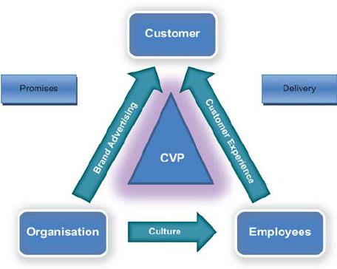
(Roberts & Alpert , 2010)
The complete engagement model, which aims to integrate the four crucial components of brand advertising, culture, customer experience, and customer value propositions, brings these connections together. These four components are defined as follows (Roberts & Alpert , 2010):
1. Your company's identity, not just your company's name or logo, is actually the culmination of who you are as a company and what you advocate for. Your company's image must be anchored by your value proposition.
2. Culture is "the status quo and refers to an organization's internal characteristics, including its guiding principles, core values, and institutional behaviours. This needs to be planned to develop a setting where employees are constantly providing your value proposition and intended customer experience.
3.What you actually give to your customers is your customer experience, which combines the physical and emotional aspects of their interactions with you.
4. Your customer value proposition, or CVP, is the benefit you provide to your consumers. In simple terms, this is the justification for why clients ought to choose you rather your rivals (Roberts & Alpert , 2010).

THE TOTAL ENGAGEMENT, MODEL APPLIED TO ADIDAS.
The Total Engagement Model has been successfully incorporated into Adidas' marketing strategies. The company has a robust social media following and a committed client base that interacts often with its content on numerous platforms. Adidas has also used engaging and interactive marketing initiatives to forge a stronger bond with customers. For instance, the adidas and Parley for the seas jointly developed the "Run for the Oceans" campaign, which urged customers to run and make a commitment to safeguard the seas. The campaign was a big success and generated a lot of interaction on social media (SportsShoes, 2021).
Ultimately Adidas is known for their history and heritage and also their user positioning power with sports institutions, celebrities, and athletes. Adidas has put a lot of effort into using storytelling to connect emotionally with its audience. The company has started a number of campaigns that emphasise the triumphs and challenges of athletes while emphasising the value of perseverance and hard work. For instance, the "Impossible is Nothing" advertising campaign highlighted Muhammad Ali's life (Baker, 2020). Narrative to encourage customers to go beyond their comfort zones and face challenges (Adidas.com, 2023).
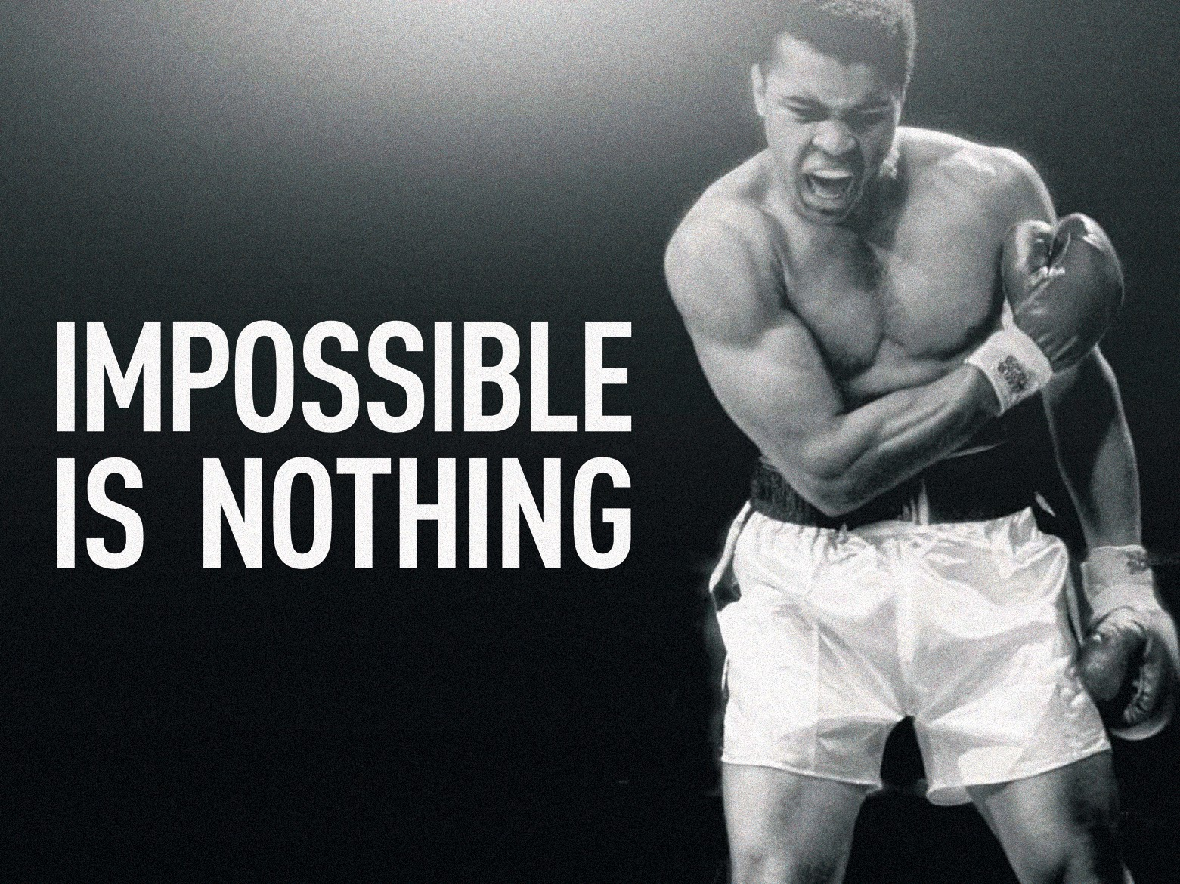
(Baker, 2020)

A streamlined and unified customer journey across all touchpoints is another accomplishment for Adidas. Through all of its marketing initiatives, websites, social media platforms, and physical stores, the company has maintained a consistent visual identity and ethos.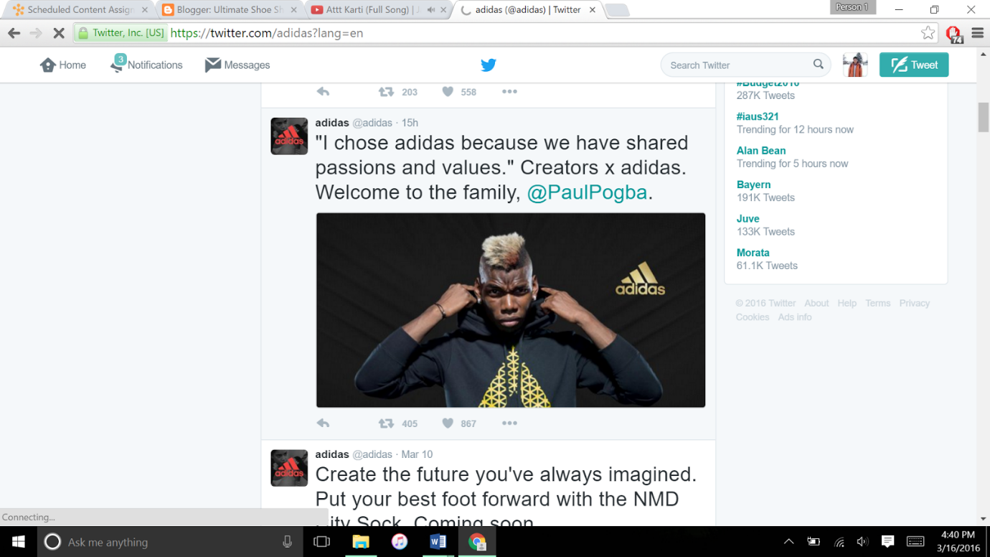
(Ultimateshopshoe, 2016)

By being consistent, the brand has developed a solid reputation among people and gained credibility (Adidas, 2023).
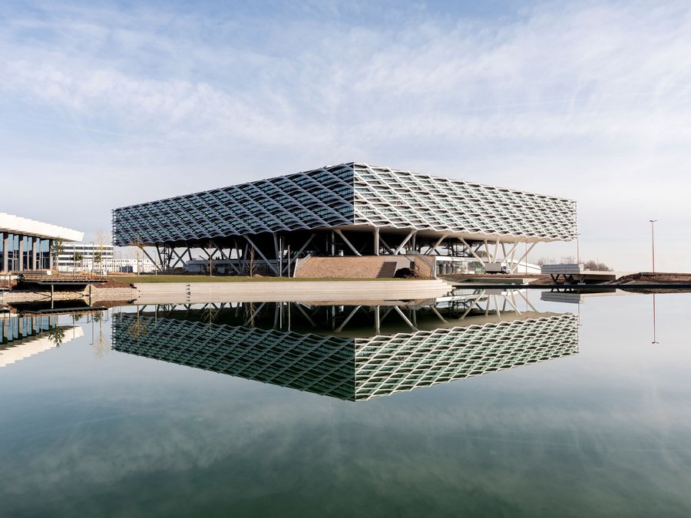
(Adidas.com , 2023)
the 'World of Sports' in Herzogenaurach, Germany, where the firm is based, has expanded. For the first time ever, all 5,400 workers working in Herzo are now housed on a single premises, where the distinctive corporate culture of the business is completely embraced. The widely used "MyArena" workplace model is completely integrated and provides places for activity-based work with an emphasis on adaptability and communication: Employees no longer have assigned desks and can pick from a range of rooms and places depending on their requirements, from informal interactions to formal conference rooms and areas for solo concentrate (Adidas.com, 2023).
Overall, Adidas' application of the Total Engagement Model has aided the brand in developing a strong brand image, a deep emotional connection with consumers, and an effortless brand experience, all of which have contributed to its commercial success.
RECOMMENDATIONS OF NEW TOUCH POINTS
- Adidas can create an augmented reality (AR) software that enables users to visually try on shoes and clothing in order to assist them make better purchasing decisions.

- Adidas might look at more environmentally friendly packaging solutions, such biodegradable or compostable materials, to better reflect their dedication to sustainability.

- Adidas can hold in-store activities like product releases or fitness classes to give customers a memorable experience and foster brand loyalty. In addition, invite celebrities to do meet and greets when releasing a special edition product.

- To provide a distinctive and memorable consumer experience, Adidas might provide personalised goods or services, such as custom shoe designs or specialised training plans.

CONCLUSION
Businesses must comprehend the customer satisfaction and the customer journey through time. Currently, customers interact with businesses through a wide range of touch points across numerous media and platforms, and customer experiences are more social than ever before. Due to these modifications, businesses must interconnect numerous business processes, including those of external partners, in order to create and provide satisfying consumer experiences (Blakeman, 2015)
Understanding the process that adidas has implemented for success with advertisement has broaden my personal view of the company and how to be a significant brand and forerunner in an industry by utilising all aspects of your company to produce the best results of branding and brand awareness.

REFERENCES
Adidas.com , 2023. HEADQUARTERS. [Online]
Available at: https://www.adidas-group.com/en/about/headquarters/
[Accessed 26 April 2023].
Adidas.com, 2023. About CULTURE. [Online]
Available at: https://www.adidas-group.com/en/about/culture/
[Accessed 24 April 2023].
Adidas.com, 2023. Adidas History. [Online]
Available at: https://www.adidas-group.com/en/about/history/
[Accessed 22 April 2023].
Adidas.com, 2023. Adidas inpossible is nothing. [Online]
Available at: https://www.adidas.co.uk/impossibleisnothing
[Accessed 23 April 2023].
Adidas.com, 2023. CLIMATE CHANGE AND DECARBONIZATION. [Online]
Available at: https://www.adidas-group.com/en/sustainability/environmental-impacts/climate-change-and-decarbonization/
[Accessed 24 April 2023].
Adidas, 2023. Adidas Blog Game Plan A. [Online]
Available at: https://www.gameplan-a.com/
[Accessed 26 April 2023].
Baker, T., 2020. Adidas Branding: History of Logos and Best Ads. [Online]
Available at: https://approval.studio/blog/adidas-branding-history-of-logos-and-best-ads/
[Accessed 25 April 2023].
Bhasin, H., 2019. Keller’s Brand equity Model – CBBE Model by Keller. [Online]
Available at: https://www.marketing91.com/kellers-brand-equity-model/
[Accessed 25 April 2023].
Blakeman, R., 2015. Integrated Marketing Communications creative straegy from idea to implementation. Second ed. London: Rowan & Littlefield .
Catovic, N., 2010. Managerial methods - adidas AG research. [Online]
Available at: https://www.slideshare.net/nermincatovic/managerial-methods-adidas-ag-research
[Accessed 22 April 2023].
Chernev, A., 2012. Creating Customer Value: Developing a value Propsition and positioning . In: Seventh, ed. Stratgic Marketing Managment . USA: cerebellum, pp. 37-44.
chernev, A., 2012. Identifying Target Customers: Segmentation and Targeting Analysis . In: Seventh, ed. Stratgic Marketing Management . USA: Cerebellum Press, pp. 25-35.
chernev, A., 2012. Managing Brands. In: seventh, ed. Strategic Marketing Management . USA: cerebellum, p. 89.
Chernev, A., 2012. Managing Brands. In: Seventh, ed. Strategic Marketing Management. USA: Cerebellum Press, pp. 95-96.
Chernev, A., 2012. Managing comunications . In: Seventh, ed. Stratgic Marketing Managment. USA: cerebellum Press, p. 119.
Chernev, A., 2012. Managing Price. In: Seventh, ed. Strategic Marketing Management . Usa: cerebellum, pp. 101-106.
Chernev, A., 2012. Managing products and services . In: Seventh, ed. Stratgic Marketing Mangement . USA: Cerebellum, pp. 79-86.
Chernev, A., 2012. Marketing Strategy . In: Seventh, ed. Strategic Marketing Management . USA: Cerebellum Press, p. 23.
Chernev, A., 2012. The 4-P Framework. In: Seventh, ed. Stratgic Marketing Management. USA: Cerebellum Press, pp. 19-20.
Chernev, A., 2012. The S-T-P Framework . In: Seventh, ed. Stratgic Marketing Management . USA: Cerebellum Press, p. 19.
Communication Theory.Org, 2023. Communication Theory. [Online]
Available at: https://www.communicationtheory.org/shannon-and-weaver-model-of-communication/
[Accessed 28 3 2023].
Crane, E., 2022. Adidas drops Kanye West after his anti-Semitic outbursts. [Online]
Available at: https://nypost.com/2022/10/25/adidas-to-drop-kanye-west-after-his-anti-semitic-outbursts/
[Accessed 3 3 2023].
Drew, C., 2023. Helpful professor.com. [Online]
Available at: https://helpfulprofessor.com/shannon-weaver-model/
[Accessed 28 3 2023].
Grewal, D. & Roggeveen, A. L., 2020. Understanding Retail Experiences and Customer Journey Management. Journal of retailing, 96(1), pp. 3-8.
Halvorsrud, R., Kvale, K. & Følstad, A., 2016. Inproving service quality through customer journey analysis. Journal of service theory and practice, 26(6), pp. 840-867.
Hooley, G., Piercy, N. F. & Nicoulaud, B., 2012. Competing Through the Marketing Mix . In: Fifth, ed. Marketing Strategy & Competitive Positioning. Harlow: Pearsons Education Limited, pp. 294-303.
Hooley, G., Piercy, N. F. & Nicoulaud, B., 2012. Competing Through The New Marketing Mix . In: Fifth, ed. Marketing Strategy & Competitive Postioning . Harlow: Pearsons Education Limited, pp. 306-308.
Hooley, G., Piercy, N. F. & Nicoulaud, B., 2012. Current Market position . In: Fifth, ed. Marketing Strategy & Competitive Positioning . harlow: Pearson Education Limited, pp. 251-257.
Hooley, G., Piercy, N. F. & Nicoulaud, B., 2012. Product/Brand status and volume . In: Fifth, ed. Marketing Strategy & competitive positioning . Harlow: Pearson Education Limited , p. 203.
Hooley, G., Piercy, N. F. & Nicoulaud, B., 2012. Purchasing Behaviour. In: Second, ed. Marketing strategy & competitive Positioning. Harlow: Pearsons Education Limited, pp. 198-200.
Hooley, G., Piercy, N. F. & Nicoulaud, B., 2012. Segmentation and Positioning Principles . In: Fifth, ed. Marketing Strategy & Competitive Positioning . Harlow: Pearson education limited , p. 184.
Hooley, G., Piercy, N. F. & Nicoulaud, B., 2012. The communication Process. In: Fifth, ed. Marketing Strategy and competitive Positoning. Harlow: Pearson Education Limited, pp. 309-310.
Jarons Blog, 2022. Shannon & Weaver’s Model of Communication Jarons Blog. [Online]
Available at: https://jaronong.wordpress.com/shannon-weavers-model-of-communication/
[Accessed 22 April 2023].
Kotler, P., 2020. Consumer Markets and Buyer Behaviour . In: Eighth, ed. Princeples of Marketing . Harlow: Pearson Education Limited, p. 161.
kotler, P., Armstrong, G., Harris, L. C. & HE, H., 2020. In: Eighth, ed. Principles of Marketing. Harlow: Pearsons Education Limited.
Kotler, P., & Keller, K. L. (2016). Marketing Management, 15th edition. Pearson Education Limited
Kotler, P., & Keller, K. L. (2016). Marketing Management, 15th edition. Pearson Education Limited. (Chapter 5: Understanding Consumer and Business Buyer Behavior, p.128-130)
Kumar, V., & Reinartz, W. (2012). Customer engagement: Concept, theory, and practices. Journal of Marketing, 76(4), 1-20
Merriam-Webster, Incorporated, 2023. communication definition and meaning. [Online]
Available at: https://www.merriam-webster.com/dictionary/communication
na, B. w., Rodger, M. & Keller, K. L., 1999. Measuring Brand Power: Validating a Model For Optimising Brand Equity. The journal Of Product and Brand Management, 8(3), pp. 170-184.
Peelen, E., & Beltman, R. (2013). Customer Relationship Management. Pearson Education Limited. (Chapter 3: Touchpoints, p.55-62)
pinegar, G., 2018. What is IMC? A Beginner's Guide to Integrated Marketing Communications. [Online]
Available at: https://www.g2.com/articles/integrated-marketing-communications
[Accessed 28 3 2023].
Raut, U. R., Pawar, P. . A., Brito, P. Q. & Sisodia, G. S., 2019. Mediating model of brand equity and its application. Spanish Journal of Marketing , 23(2), pp. 298-300.
Roberts, C. & Alpert , F., 2010. Total customer engagement: designing and aligning key strategic elements to achieve growth. Journal of product and brand management, 19(3), p. chapter 4.
seventh ed., 2012. Creating Company Value: Managing Sales Volume, Revenues and Profits . In: Stratgic Marketing Management . USA: cerebellum Press, pp. 49-50.
SportsShoes, 2021. ADIDAS RUN FOR THE OCEANS CAMPAIGN & STRAVA CHALLENGE. [Online]
Available at: https://www.sportsshoes.com/running-hub/motivation/adidas-run-for-the-oceans-campaign/#:~:text=Run%20for%20the%20Oceans%20is%20a%20global%20movement,by%20adidas%20in%20collaboration%20with%20Parley%20in%202017.
[Accessed 24 April 2023].
Ultimateshopshoe, 2016. Adidas & Nike Twitter obeservation. [Online]
Available at: http://ultimateshopshoe.blogspot.com/2016/03/adidas-nike-twitter-obeservation.html
[Accessed 27 April 2023].
www.qualtrics.com, 2023. What is customer-based brand equity?. [Online]
Available at: https://www.qualtrics.com/uk/experience-management/brand/customer-based-brand-equity/
[Accessed 3 April 2023].

