
Critical Evaulation of Brauns Multiplier and Wallace Tree Multiplier using VHDL
Electronics II
ACDA6001
Spanswick, Adam
S2218236
Table of Contents
Table Of Figures 3
Table of Tables 5
Introduction 6
Background Research 6
Logic Gates 6
AND Gate 6
OR Gate 7
NOT Gate 7
NAND Gate 8
NOR Gate 8
XOR Gate 8
XNOR Gate 9
Full Adder 12
Full Adder Truth Table: 12
Half Adder 14
HalfAdder Block Diagram 14
HalfAdder Truth Table 14
2-input Exclusive-OR Gate or Ex-OR Gate 15
2-input AND Gate: 16
Half-Adder logical circuit: 16
Methodologies 18
Advantages & Disadvantages of Types Multipliers 19
System Operation Flow chart 20
Task1 21
Logic Circuit Design 22
VHDL HalfAdder Coding 23
VHDL FullAdder Coding 24
VHDL Coding 25
Simulation Procedure Flowchart 36
Brauns Simulation Results 37
Synthesis Procedure Flowchart 39
Implementation Procedure Flowchart 40
Task 2 51
Dot Diagram of 8 X 8 Wallace Tree Multiplier 52
Logic Circuit Design 53
VHDL HalfAdder Coding 54
VHDL FullAdder Coding 55
VHDL WALLACE Coding 56
Simulation Procedure Flowchart 67
Wallace Simulation Results 68
Synthesis Procedure Flow chart 70
Implementation Procedure Flowchart 71
Task 3 80
Brauns Longest Delays 81
Wallace Longest Delay 83
Brauns Power Consumption 85
Wallace Power Consumption 86
Power Consumption Conclusion 87
Conclusion 88
Improvements 89
Bibliography 90

Table Of Figures

Figure 1 AND Gate Logic Design [1] 5
Figure 2 OR Gate Logic Design [4] 6
Figure 3 NOT Gate Logic Design [6] 6
Figure 4 NAND Gate Logic Design [8] 7
Figure 5 NOR GATE Logic Design [10] 7
Figure 6 XOR GATE Logic Design [12] 8
Figure 7 XNOR Gate Logic Design [14] 8
Figure 8 Brauns Multiplier Concept [17] 9
Figure 9 Wallace Multiplier Decline in transistor Count [4] 10
Figure 10 Full Adder Block Diagram [22] 11
Figure 11 Full Adder Logic Design Components [25] 12
Figure 12 Half Adder Block Diagram [27] 13
Figure 13 EX - OR Gate [31] 14
Figure 14 AND Gate [34] 15
Figure 15 Half - Adder Logical Circuit [36] 16
Figure 16 System Operation Flow Chart 19
Figure 17 Brauns Logic Circuit Design 21
Figure 18 Simulation Procedure Flowchart 35
Figure 19 Brauns SImulation Results 1 36
Figure 20 Brauns SImulation Results 2 36
Figure 21 Brauns SImulation Results 3 37
Figure 22 Synthesis Procedure Flowchart 38
Figure 23 Implementation Procedure Flowchart 39
Figure 25 Synthesis Procedure Schematic Brauns 40
Figure 24 Synthesis Procedure I/O Ports Picture 1 40
Figure 26 Synthesis Procedure Pin Package 41
Figure 27 Synthesis Procedure I/O Ports Picture 2 41
Figure 28 Combinational Delays 43
Figure 29 Synthesis Design 43
Figure 30 Design Timing Summary No Time Constraints 44
Figure 31 Combinational Delays picture 2 44
Figure 32 Timing Constraints 45
Figure 33 Create A clock 45
Figure 34 Braun Power SUMMARY 46
Figure 35 timing Constraints Picture 2 46
Figure 36 Timing Constraints Maximum Delay Picture 2 47
Figure 37 Timing Constraints Maximum Delay 47
Figure 38 Maximum/Minimum Time Delays 48
Figure 39 Time Delay Path Between A1 /P13 48
Figure 40 Brauns I/0 Planning 49
Figure 41 Implemented Design 49
Figure 42 Wallace Tree Multiplier [45] 51
Figure 43 DOT Diagram 8 X 8 Wallace Tree Multiplier 51
Figure 44 Wallace Tree Logic Circuit Design 52
Figure 45 Simulation Procedure Flowchart 66
Figure 46 Wallace Simulation Results 1 67
Figure 47 Figure 46 Wallace Simulation Results 2 67
Figure 48 Figure 46 Wallace Simulation Results 3 68
Figure 49 Synthesis Procedure Flow Chart 69
Figure 50 Implementation Procedure Flowchart 70
Figure 52 Synthesis Design Schematic 71
Figure 51 Synthesis Design Schematic picture 2 71
Figure 53 Synthesis Design Schematic PICTURE 3 72
Figure 54 Selecting I/O PINS 72
Figure 55 Wallace No timing Constraints 73
Figure 56 Wallace No user specified Timing Constraints 73
Figure 57 Synthesized Design Picture 2 74
Figure 58 Synthesized Design Picture 1 74
Figure 59 Wallace Power SUPPLY 75
Figure 60 Synthesized Design delay path 75
Figure 61 Wallace Power Summary 76
Figure 62 Utilization Summary 77
Figure 64 I/O Planning Schematic 78
Figure 63 Wallace Project SUMMARY 78
Figure 65 Brauns Delay Path A1/P13 80
Figure 66 Figure 65 Brauns Delay Path A1/P13 PICTURE 2 80
Figure 67 Brauns Logic Circuit fault Path Design 81
Figure 68 Wallace Longest Delay A1/ P13 PICTURE 2 82
Figure 69 Wallace Longest Delay A1/ P13 82
Figure 70 Wallace Logic circuit Design Fault Path 83
Figure 71 Brauns Power Supply Summary 84
Figure 72 Brauns Power /Utilisation 84
Figure 73 Wallace Porject Summary 85
Figure 74 Wallace Power Sumarry 85
Figure 75 Wallace utilisation and power 86

Table of Tables

Table 1 AND Gate Truth Table [2] 6
Table 2 OR Gate Truth Table [5] 7
Table 3 NOT Gate Truth Table [7] 7
Table 4 NAND GATE Truth Table [9] 8
Table 5 NOR Gate Truth Table [11] 8
Table 6 XOR Gate Truth Table [13] 9
Table 7 XNOR Truth Table [15] 9
Table 8 Full Adder Truth Table [23] 12
Table 9 Half Adder Truth Table [28] 14
Table 10 EX-OR Gate Truth TABLE [32] 15
Table 11 AND Gate [35] 16
Table 12 Methodologies [18] 18
Table 13 Advantages/ Disadvantages of Types of Multipliers [19] 19

Introduction

The aim of the following Assignment is to compare, synthesize and critically evaluate the performance of Brauns and Wallace Tree Multipliers techniques using VHDL.

Background Research

Logic Gates
“Logic gates are crucial components of digital systems and circuit design. It is an electronic circuit with a single output that is a part of a digital system. Although these gates can have one or more inputs, the majority of gates have two inputs. These gates go by different names depending on how the input and output are related: AND gates, OR gates, NOT gates, etc. Several kinds of gates exist:” [1]

AND Gate
Logic Design
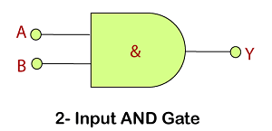

Figure 1 AND Gate Logic Design [1]

Truth Table
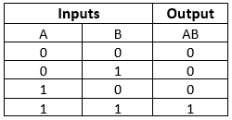

Table 1 AND Gate Truth Table [2]

OR Gate
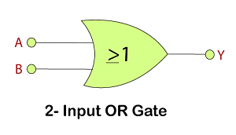
Logic Design

Figure 2 OR Gate Logic Design [4]

Truth Table
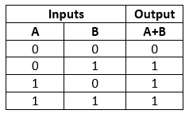

Table 2 OR Gate Truth Table [5]

NOT Gate
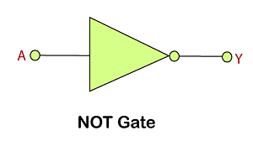
Logic Design

Figure 3 NOT Gate Logic Design [6]

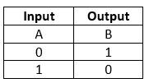
Truth Table

Table 3 NOT Gate Truth Table [7]

NAND Gate
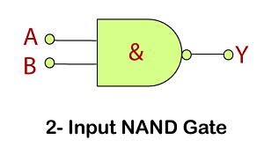
Logic Design

Figure 4 NAND Gate Logic Design [8]

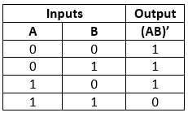
Truth Table

Table 4 NAND GATE Truth Table [9]

NOR Gate
Logic Design
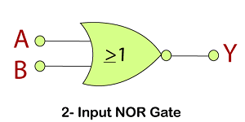
Figure 5 NOR GATE Logic Design [10]

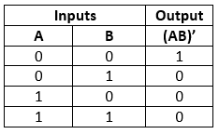
Truth Table

XOR Gate
Table 5 NOR Gate Truth Table [11]
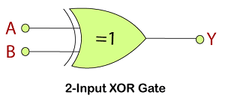
Logic Design

Figure 6 XOR GATE Logic Design [12]
Truth Table
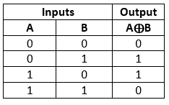

Table 6 XOR Gate Truth Table [13]

XNOR Gate
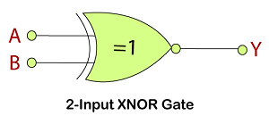
Logic Design

Figure 7 XNOR Gate Logic Design [14]

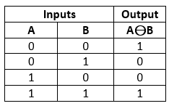
Truth Table

Table 7 XNOR Truth Table [15]
Logic Gates in Digital Electronics - Javatpoint
“Multipliers are essential components for a variety of digital circuits in the VLSI field. The multipliers' reduced power consumption will result in an efficient circuit with good power consumption parameters. The multipliers are constructed using adders at different levels to provide the required operation. Full adders are implemented, simulated, and analysed in order to achieve better results and minimise the total number of transistors required in the development of the multipliers that are utilised in various digital circuits.
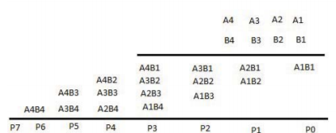
The most basic parallel multiplier available is the Braun multiplier. A level of adders gathers each partial product after it has been obtained in parallel. Classic multipliers have been modified by these multipliers, which make use of shift and add techniques. These possess important characteristics like speed, dynamic range, and precision when compared to regular multipliers. The number of bits used in the multipliers affects and determines two parameters of the multiplier: its dynamic range and accuracy.” [2]
Figure 8 Brauns Multiplier Concept [17]
Two unsigned numbers, A and B, multiplied

“The Wallace multiplier is a useful parallel multiplier for array multiplication. Multiple gates can be used to perform multiplication with an array multiplier. It therefore requires a large amount of processing power. The Wallace multiplier has the fewest partial products in comparison to the other multiplier.” [3]

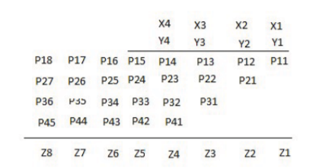
Figure 9 Wallace Multiplier Decline in transistor Count [4]

“The Braun Multiplier is 109X faster than Conventional array multiplier and 102X faster than conventional Braun. Braun consumes more power as compared to Wallace Multiplier.” [5]
Comparison between Braun Multiplier and Wallace Multiplier technique | by ASHUTOSH LAHOTI | MULTIPLIER TECHNIQUES IN VLSI | Medium

Full Adder
“A full adder is an adder that adds three inputs and produces two outputs.
His first two inputs are A and B, and the third input is the C-IN input.
The output transmission is called C-OUT and the common output is S (SUM).
The C-OUT is also called a majority detector.
If more than one input is High, the output is High.
The 's full adder logic is designed to combine eight inputs into a byte-wide sum and concatenate the carry bit from one sum to the other.
The full reader is used because the 1-bit half adder does not accept a carry bit.
Therefore, if a carry bit is available, a separate 1-bit adder must be used.
A 1-bit full adder adds the three operands and returns a 2-bit result.” [6]

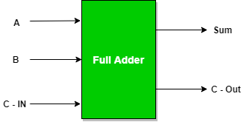
Figure 10 Full Adder Block Diagram [22]

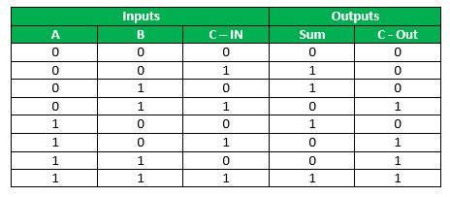
Full Adder Truth Table:
Table 8 Full Adder Truth Table [23]

“Logical Expression for SUM: = A’ B’ C-IN + A’ B C-IN’ + A B’ C-IN’ + A B C-IN = C-IN (A’ B’ + A B) + C-IN’ (A’ B + A B’) = C-IN XOR (A XOR B) = (1,2,4,7)
Logical Expression for C-OUT: = A’ B C-IN + A B’ C-IN + A B C-IN’ + A B C-IN = A B + B C-IN + A C-IN = (3,5,6,7)

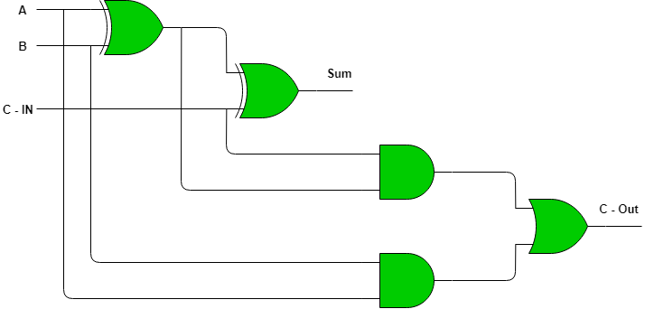
Therefore COUT = AB + C-IN (A EX – OR B)” [7]
Figure 11 Full Adder Logic Design Components [25]

Half Adder
“A half adder is a basic building block for adding two numbers as two inputs and producing two outputs.
Adders are used to compute the OR of two single-bit binary numbers.
Eyeset and added bit are the two input states, and "carry" and "sum" are his two output states of the half adder.” [8]

HalfAdder Block Diagram
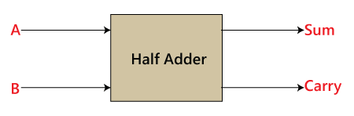
Figure 12 Half Adder Block Diagram [27]

HalfAdder Truth Table
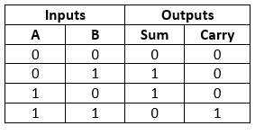

Table 9 Half Adder Truth Table [28]

“In the above table,
In the block diagram, you can see that it has two inputs and two outputs within the design.

A half adder is designed using the following two logic gates:

- 2-input AND Gate.
- 2-input Exclusive-OR Gate or Ex-OR Gate” [9]

2-input Exclusive-OR Gate or Ex-OR Gate

“The Sum bit is generated with the help of the Exclusive-OR or Ex-OR Gate.” [10]
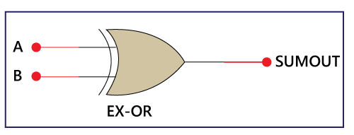
Figure 13 EX - OR Gate [31]

The truth table of the EX-OR gate is as follows:
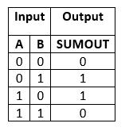

Table 10 EX-OR Gate Truth TABLE [32]

2-input AND Gate:

“XOR gates cannot generate carry bits.

For this purpose, we use another gate called an AND gate.

The AND gate provides the correct result for the carry.” [11]

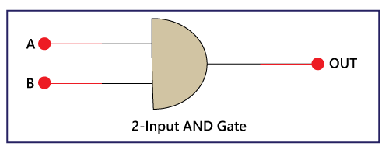
Figure 14 AND Gate [34]

There is the following truth table of AND Gate:

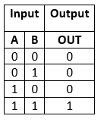
Half-Adder logical circuit:
Table 11 AND Gate [35]
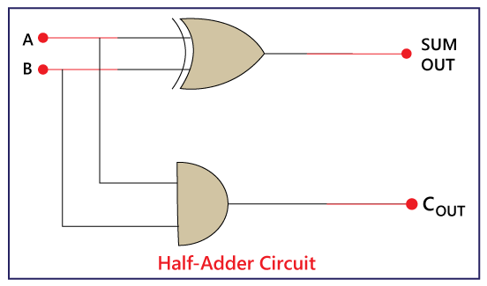
Figure 15 Half - Adder Logical Circuit [36]

“There is the following Boolean expression of Half Adder circuit:
Sum= A XOR B (A+B)
Carry= A AND B (A.B)” [12]

Methodologies

Types | Descriptions
Booth Multiplier | “This multiplier is used for binary multiplication and represents the output as a -2's complement (signed integer) IIR filter that uses a modified algorithm of the Booth multiplier to remove excess noise and distortion can be implemented.” [13]
Combinational Multiplier | “In those intermediate products, combinatorial multipliers are used to multiply unsigned binary variables.  However, generating intermediate numbers requires a lot of system memory and is a relatively slow process.” [14]
Wallace Tree | “This model, developed by Chris Wallace, is a relatively efficient implementation of a multiplier.  This eliminates the need to create partial products and allows you to add them using a selective carry adder.  While other multipliers he takes O(log2n) time, the Wallace multiplier takes O(log n) to multiply and not much longer than the addition time.” [15]
Array Multiplier | “Array multipliers are known for their ease of placement and wiring and are used for parallel multiplication.  In terms of speed, this multiplier is superior to traditional serial multiplication methods.  Using multiple gates increases the overall power consumption, but using pipelining can solve the problem.” [16]
Sequential Multiplier | “To better understand how a sequential multiplier works, consider the example of two binary numbers A and B with 'm' and 'n' bits respectively.  To multiply these numbers with a single adder of n bits, we need to build a circuit that generates a partial product in one cycle and repeats that cycle m times.  Such a circuit is called a successive multiplier.” [17]
Table 12 Methodologies [18]

Advantages & Disadvantages of Types Multipliers

Table 13 Advantages/ Disadvantages of Types of Multipliers [19]
Types | Advantages | Disadvantages
Booth Multiplier | - “Minimum complex  - Multiplication is speeded up.” [19] | - “Power consumption is high.” [19]
Combinational Multiplier | - “easily generate intermediate products.” [19] | - “occupies large areas.” [19]
Sequential Multiplier | - “occupies less area” [19] | - “slow process.” [19]
Wallace tree Multiplier | - “high speed  - medium complex design” [19] | - “layout design is irregular  - occupies a larger area.” [19]
Array Multiplier | - “simple in design  - regular in shape.” [19] | - “delay is high  - high power consumption.” [19]

System Operation Flow chart
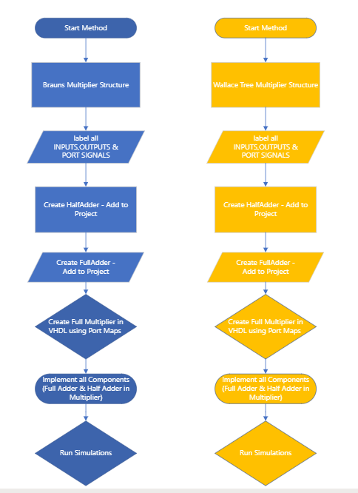
Figure 16 System Operation Flow Chart

Task1
Design an 8- bit Braun’s Multiplier. The following instructions to be considered in designing the multiplier.
- The multiplier can be designed by modifying any two unsigned number.
- The multiplier should generate partial products by multiplying each bit of A with each bit of B and then add these partial products to get the 16-bit result.
- Provide the complete logic circuit design.
- Implement the components in VHDL and then integrate the components using port maps to build the full multiplier.
- Simulate and extract its schematics and results.
- Synthesize the multiplier and implement the FPGA Design.

Logic Circuit Design
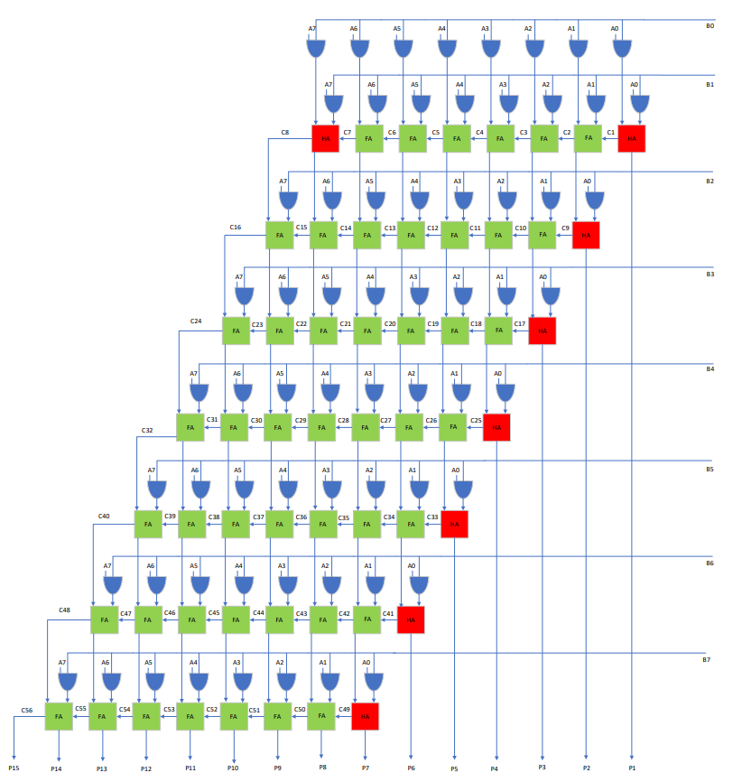
Figure 17 Brauns Logic Circuit Design

VHDL HalfAdder Coding
library IEEE;
use IEEE.STD_LOGIC_1164.ALL;

-- Uncomment the following library declaration if using
-- arithmetic functions with Signed or Unsigned values
--use IEEE.NUMERIC_STD.ALL;

-- Uncomment the following library declaration if instantiating
-- any Xilinx leaf cells in this code.
--library UNISIM;
--use UNISIM.VComponents.all;

entity HalfAdder is
Port ( A : in STD_LOGIC;
B : in STD_LOGIC;
S : out STD_LOGIC;
Cout : out STD_LOGIC);
end HalfAdder;

architecture Behavioral of HalfAdder is

begin
S <= A xor B;
Cout <= A and B ;

end Behavioral;

VHDL FullAdder Coding
library IEEE;
use IEEE.STD_LOGIC_1164.ALL;

-- Uncomment the following library declaration if using
-- arithmetic functions with Signed or Unsigned values
--use IEEE.NUMERIC_STD.ALL;

-- Uncomment the following library declaration if instantiating
-- any Xilinx leaf cells in this code.
--library UNISIM;
--use UNISIM.VComponents.all;

entity FullAdder is
Port ( A : in STD_LOGIC;
B : in STD_LOGIC;
Cin : in STD_LOGIC;
S : out STD_LOGIC;
Cout : out STD_LOGIC);
end FullAdder;

architecture Behavioral of FullAdder is

begin
S <= A xor B xor Cin ;

Cout <= (A and B) or (B and Cin) or (A and Cin) ;

end Behavioral;

VHDL Coding
library IEEE;

use IEEE.STD_LOGIC_1164.ALL;

-- Uncomment the following library declaration if using

-- arithmetic functions with Signed or Unsigned values

--use IEEE.NUMERIC_STD.ALL;

-- Uncomment the following library declaration if instantiating

-- any Xilinx leaf cells in this code.

--library UNISIM;

--use UNISIM.VComponents.all;

entity Brauns_Multiplier is

Port ( A : in STD_LOGIC_VECTOR (7 downto 0);

B : in STD_LOGIC_VECTOR (7 downto 0);

P : out STD_LOGIC_VECTOR (15 downto 0));

end Brauns_Multiplier;

architecture Behavioral of Brauns_Multiplier is

component FullAdder

port (A : in STD_LOGIC;

B : in STD_LOGIC;

Cin : in STD_LOGIC;

S : out STD_LOGIC;

Cout : out STD_LOGIC) ;

end component;

component HalfAdder

port (A : in STD_LOGIC;

B : in STD_LOGIC;

S : out STD_LOGIC;

Cout : out STD_LOGIC) ;

end component;

signal A1B0, A2B0, A3B0, A4B0, A5B0, A6B0, A7B0 : std_logic;

signal A0B1, A1B1, A2B1, A3B1, A4B1, A5B1, A6B1, A7B1 : std_logic;

signal A0B2, A1B2, A2B2, A3B2, A4B2, A5B2, A6B2, A7B2 : std_logic;

signal A0B3, A1B3, A2B3, A3B3, A4B3, A5B3, A6B3, A7B3 : std_logic;

signal A0B4, A1B4, A2B4, A3B4, A4B4, A5B4, A6B4, A7B4 : std_logic;

signal A0B5, A1B5, A2B5, A3B5, A4B5, A5B5, A6B5, A7B5 : std_logic;

signal A0B6, A1B6, A2B6, A3B6, A4B6, A5B6, A6B6, A7B6 : std_logic;

signal A0B7, A1B7, A2B7, A3B7, A4B7, A5B7, A6B7, A7B7 : std_logic;

signal C1, C2, C3, C4, C5, C6, C7, C8 : std_logic;

signal C9, C10, C11, C12, C13, C14, C15, C16 : std_logic;

signal C17, C18, C19, C20, C21, C22, C23, C24 : std_logic;

signal C25, C26, C27, C28, C29, C30, C31, C32 : std_logic;

signal C33, C34, C35, C36, C37, C38, C39, C40 : std_logic;

signal C41, C42, C43, C44, C45, C46, C47, C48 : std_logic;

signal C49, C50, C51, C52, C53, C54, C55, C56 : std_logic;

signal S2, S3, S4, S5, S6, S7, S8 : std_logic;

signal S10, S11, S12, S13, S14, S15, S16 : std_logic;

signal S18, S19, S20, S21, S22, S23, S24 : std_logic;

signal S26, S27, S28, S29, S30, S31, S32 : std_logic;

signal S34, S35, S36, S37, S38, S39, S40 : std_logic;

signal S42, S43, S44, S45, S46, S47, S48 : std_logic;

begin

A1B0 <= A (1) and B (0) ;

A2B0 <= A (2) and B (0) ;

A3B0 <= A (3) and B (0) ;

A4B0 <= A (4) and B (0) ;

A5B0 <= A (5) and B (0) ;

A6B0 <= A (6) and B (0) ;

A7B0 <= A (7) and B (0) ;

A0B1 <= A (0) and B (1) ;

A1B1 <= A (1) and B (1) ;

A2B1 <= A (2) and B (1) ;

A3B1 <= A (3) and B (1) ;

A4B1 <= A (4) and B (1) ;

A5B1 <= A (5) and B (1) ;

A6B1 <= A (6) and B (1) ;

A7B1 <= A (7) and B (1) ;

A0B2 <= A (0) and B (2) ;

A1B2 <= A (1) and B (2) ;

A2B2 <= A (2) and B (2) ;

A3B2 <= A (3) and B (2) ;

A4B2 <= A (4) and B (2) ;

A5B2 <= A (5) and B (2) ;

A6B2 <= A (6) and B (2) ;

A7B2 <= A (7) and B (2) ;

A0B3 <= A (0) and B (3) ;

A1B3 <= A (1) and B (3) ;

A2B3 <= A (2) and B (3) ;

A3B3 <= A (3) and B (3) ;

A4B3 <= A (4) and B (3) ;

A5B3 <= A (5) and B (3) ;

A6B3 <= A (6) and B (3) ;

A7B3 <= A (7) and B (3) ;

A0B4 <= A (0) and B (4) ;

A1B4 <= A (1) and B (4) ;

A2B4 <= A (2) and B (4) ;

A3B4 <= A (3) and B (4) ;

A4B4 <= A (4) and B (4) ;

A5B4 <= A (5) and B (4) ;

A6B4 <= A (6) and B (4) ;

A7B4 <= A (7) and B (4) ;

A0B5 <= A (0) and B (5) ;

A1B5 <= A (1) and B (5) ;

A2B5 <= A (2) and B (5) ;

A3B5 <= A (3) and B (5) ;

A4B5 <= A (4) and B (5) ;

A5B5 <= A (5) and B (5) ;
A5B5 <= A (5) and B (5) ;

A6B5 <= A (6) and B (5) ;

A7B5 <= A (7) and B (5) ;

A0B6 <= A (0) and B (6) ;

A1B6 <= A (1) and B (6) ;

A2B6 <= A (2) and B (6) ;

A3B6 <= A (3) and B (6) ;

A4B6 <= A (4) and B (6) ;

A5B6 <= A (5) and B (6) ;

A6B6 <= A (6) and B (6) ;

A7B6 <= A (7) and B (6) ;

A0B7 <= A (0) and B (7) ;

A1B7 <= A (1) and B (7) ;

A2B7 <= A (2) and B (7) ;

A3B7 <= A (3) and B (7) ;

A4B7 <= A (4) and B (7) ;

A6B7 <= A (6) and B (7) ;

A7B7 <= A (7) and B (7) ;

PO : P (0) <= A (0) and B (0) ;

P1 : HalfAdder port map (A1B0, A0B1, P (1), C1) ;

S2_1 : FullAdder port map (A2B0, A1B1, C1, S2, C2) ;

P2 : HalfAdder port map (A0B2, S2, P (2), C9) ;

S3_1 : FullAdder port map (A3B0, A2B1, C2, S3, C3) ;

S10_1 : FullAdder port map (A1B2, S3, C9, S10, C10) ;

P3 : HalfAdder port map (A0B3, S10, P (3), C17) ;

S4_1 : FullAdder port map (A4B0, A3B1, C3, S4, C4) ;

S11_1 : FullAdder port map (A2B2, S4, C10, S11, C11) ;

S18_1 : FullAdder port map (A1B3, S11, C17, S18, C18) ;

P4 : HalfAdder port map (A0B4, S18, P (4), C25) ;

S5_1 : FullAdder port map (A5B0, A4B1, C4, S5, C5) ;

S12_1 : FullAdder port map (A3B2, S5, C11, S12, C12) ;

S19_1 : FullAdder port map (A2B3, S12, C18, S19, C19) ;

S26_1 : FullAdder port map (A1B4, S19, C25, S26, C26) ;

P5 : HalfAdder port map (A0B5, S26, P (5), C33) ;

S6_1 : FullAdder port map (A6B0, A5B1, C5, S6, C6) ;

S13_1 : FullAdder port map (A4B2, S6, C12, S13, C13) ;

S20_1 : FullAdder port map (A3B3, S13, C19, S20, C20) ;

S27_1 : FullAdder port map (A2B4, S20, C26, S27, C27) ;

S34_1 : FullAdder port map (A1B5, S27, C33, S34, C34) ;

P6 : HalfAdder port map (A0B6, S34, P (6), C41) ;

S7_1 : FullAdder port map (A7B0, A6B1, C6, S7, C7) ;

S14_1 : FullAdder port map (A5B2, S7, C13, S14, C14) ;

S21_1 : FullAdder port map (A4B3, S14, C20, S21, C21) ;

S28_1 : FullAdder port map (A3B4, S21, C27, S28, C28) ;

S35_1 : FullAdder port map (A2B5, S28, C34, S35, C35) ;

S42_1 : FullAdder port map (A1B6, S35, C41, S42, C42) ;

P7 : HalfAdder port map (A0B7, S42, P (7), C49) ;

S8_1 : HalfAdder port map (A7B1, C7, S8, C8) ;

S15_1 : FullAdder port map (A6B2, S8, C14, S15, C15) ;

S22_1 : FullAdder port map (A5B3, S15, C21, S22, C22) ;

S29_1 : FullAdder port map (A4B4, S22, C28, S29, C29) ;

S36_1 : FullAdder port map (A3B5, S29, C35, S36, C36) ;

S43_1 : FullAdder port map (A2B6, S36, C42, S43, C43) ;

P8 : FullAdder port map (A1B7, S43, C49, P(8), C50) ;

S16_1 : FullAdder port map (A7B2, C8, C15, S16, C16) ;

S23_1 : FullAdder port map (A6B3, S16, C22, S23, C23) ;

S30_1 : FullAdder port map (A5B4, S23, C29, S30, C30) ;

S37_1 : FullAdder port map (A4B5, S30, C36, S37, C37) ;

S44_1 : FullAdder port map (A3B6, S37, C43, S44, C44) ;

P9 : FullAdder port map (A2B7, S44, C50, P(9), C51) ;

S24_1 : FullAdder port map (A7B3, C16, C23, S24, C24) ;

S31_1 : FullAdder port map (A6B4, S24, C30, S31, C31) ;

S38_1 : FullAdder port map (A5B5, S31, C37, S38, C38) ;

S45_1 : FullAdder port map (A4B6, S38, C44, S45, C45) ;

P10: FullAdder port map (A3B7, S45, C51, P(10), C52) ;

S32_1 : FullAdder port map (A7B4, C24, C31, S32, C32) ;

S39_1 : FullAdder port map (A6B5, S32, C38, S39, C39) ;

S46_1 : FullAdder port map (A5B6, S39, C45, S46, C46) ;

P11: FullAdder port map (A4B7, S46, C52, P(11), C53) ;

S40_1 : FullAdder port map (A7B5, C32, C39, S40, C40) ;

S47_1 : FullAdder port map (A6B6, S40, C46, S47, C47) ;

P12: FullAdder port map (A5B7, S47, C53, P(12), C54) ;

S48_1 : FullAdder port map (A7B6, C40, C47, S48, C48) ;

P13: FullAdder port map (A6B7, S48, C54, P(13), C55) ;

P14: FullAdder port map (A7B7, C48, C55, P(14), C56) ;

P15: P(15) <= C56 ;

end Behavioral;

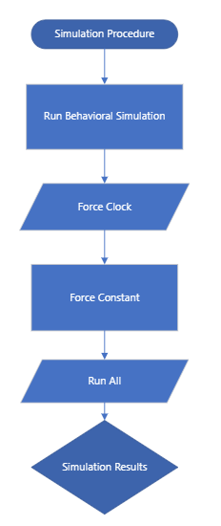
Simulation Procedure Flowchart
Figure 18 Simulation Procedure Flowchart

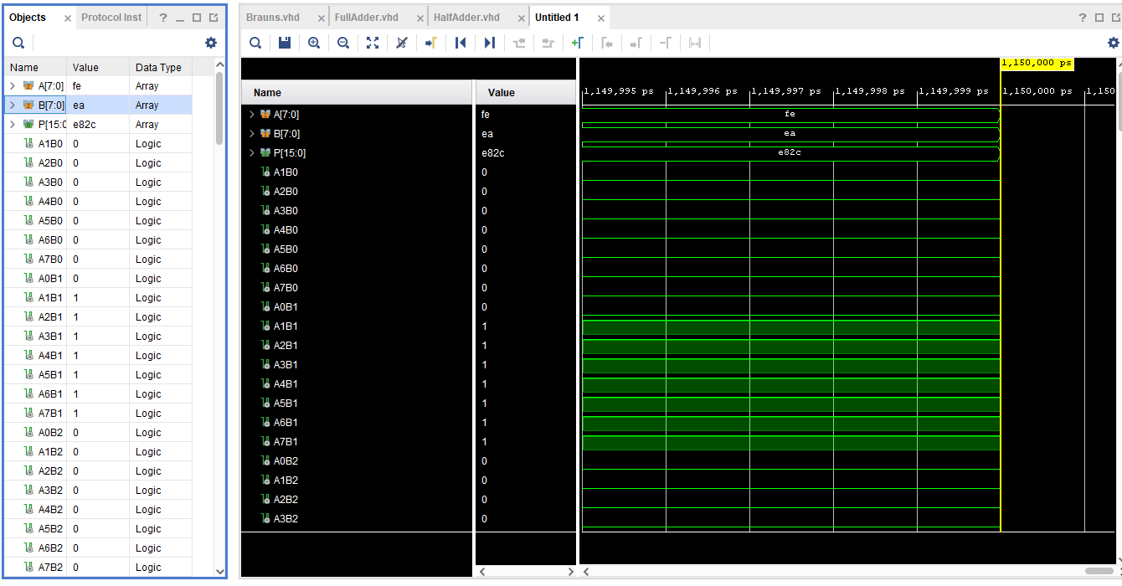
Brauns Simulation Results
Figure 19 Brauns SImulation Results 1
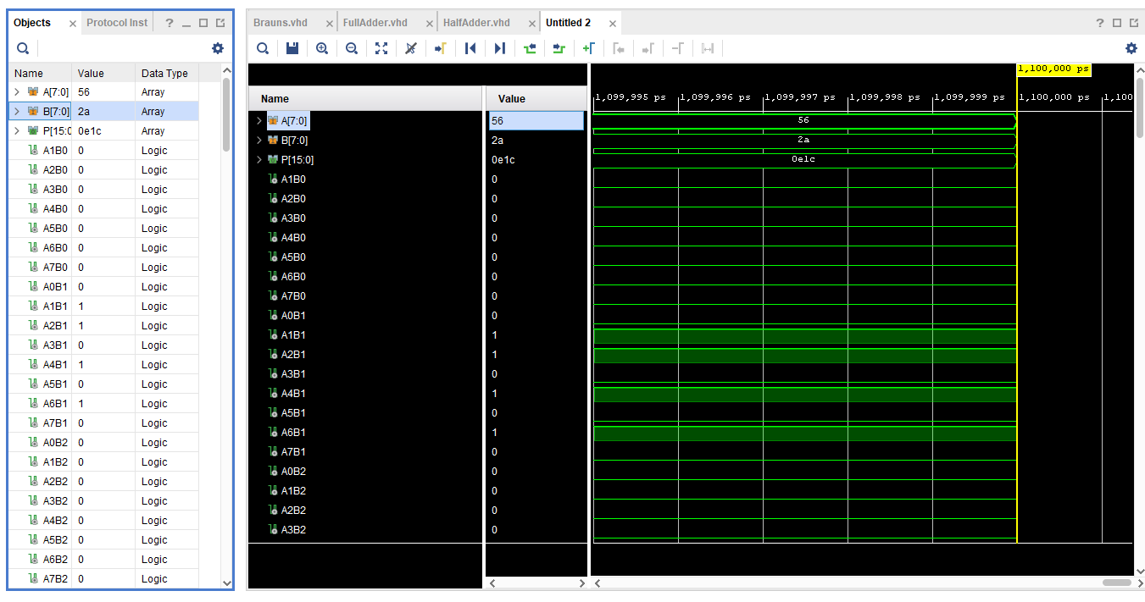
FE X EA = E82C
Figure 20 Brauns SImulation Results 2
56 X 2A = OE1C
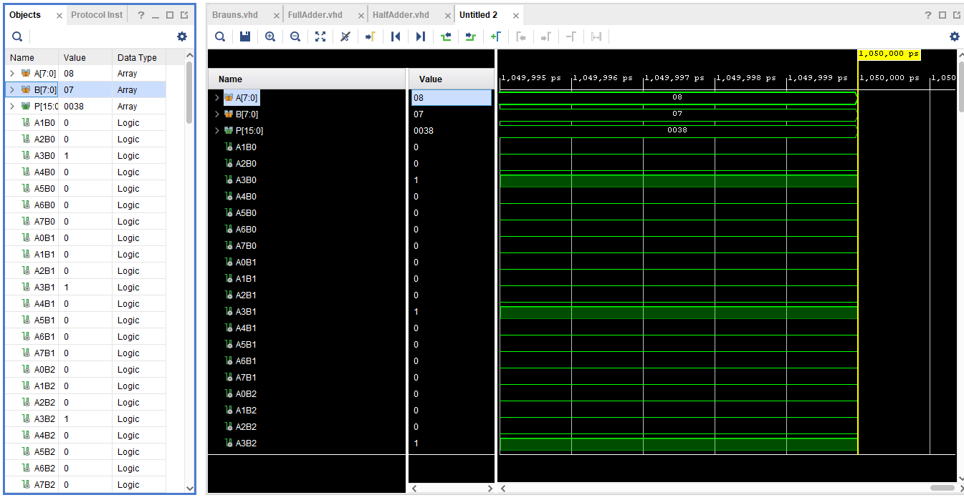
Figure 21 Brauns SImulation Results 3
08 X 07 = 0038

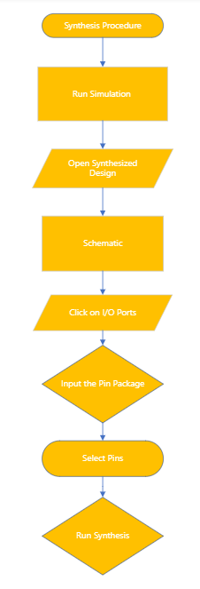
Synthesis Procedure Flowchart
Figure 22 Synthesis Procedure Flowchart

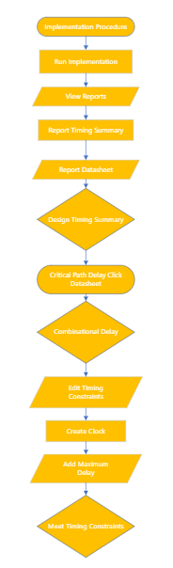
Implementation Procedure Flowchart
Figure 23 Implementation Procedure Flowchart
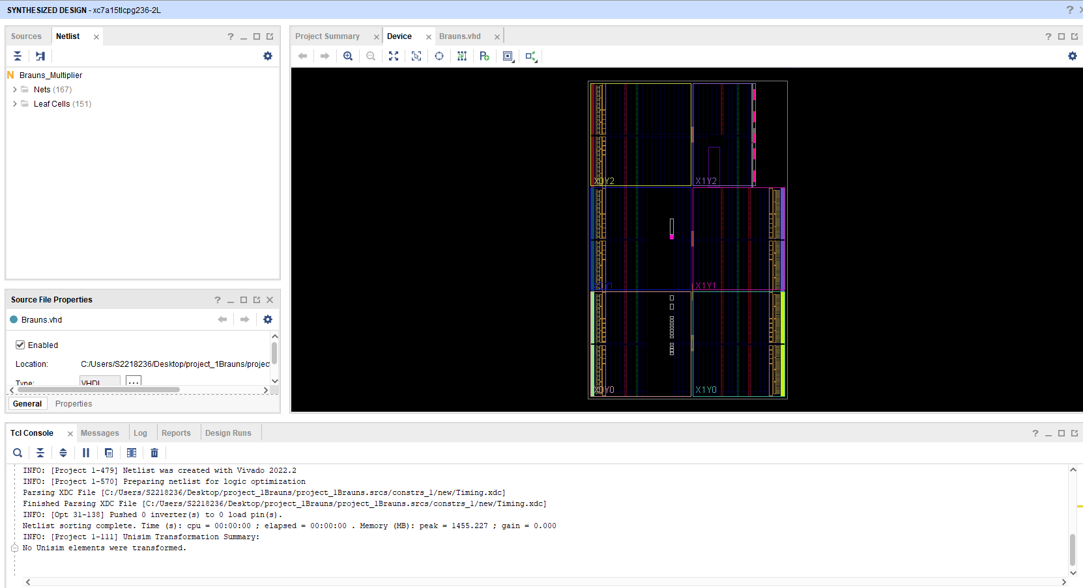
Below are Screen Shot of the Brauns Multiplier VHDL synthesis, Implementation Procedures. Creating Clocks for Time Constraints and power consumption.
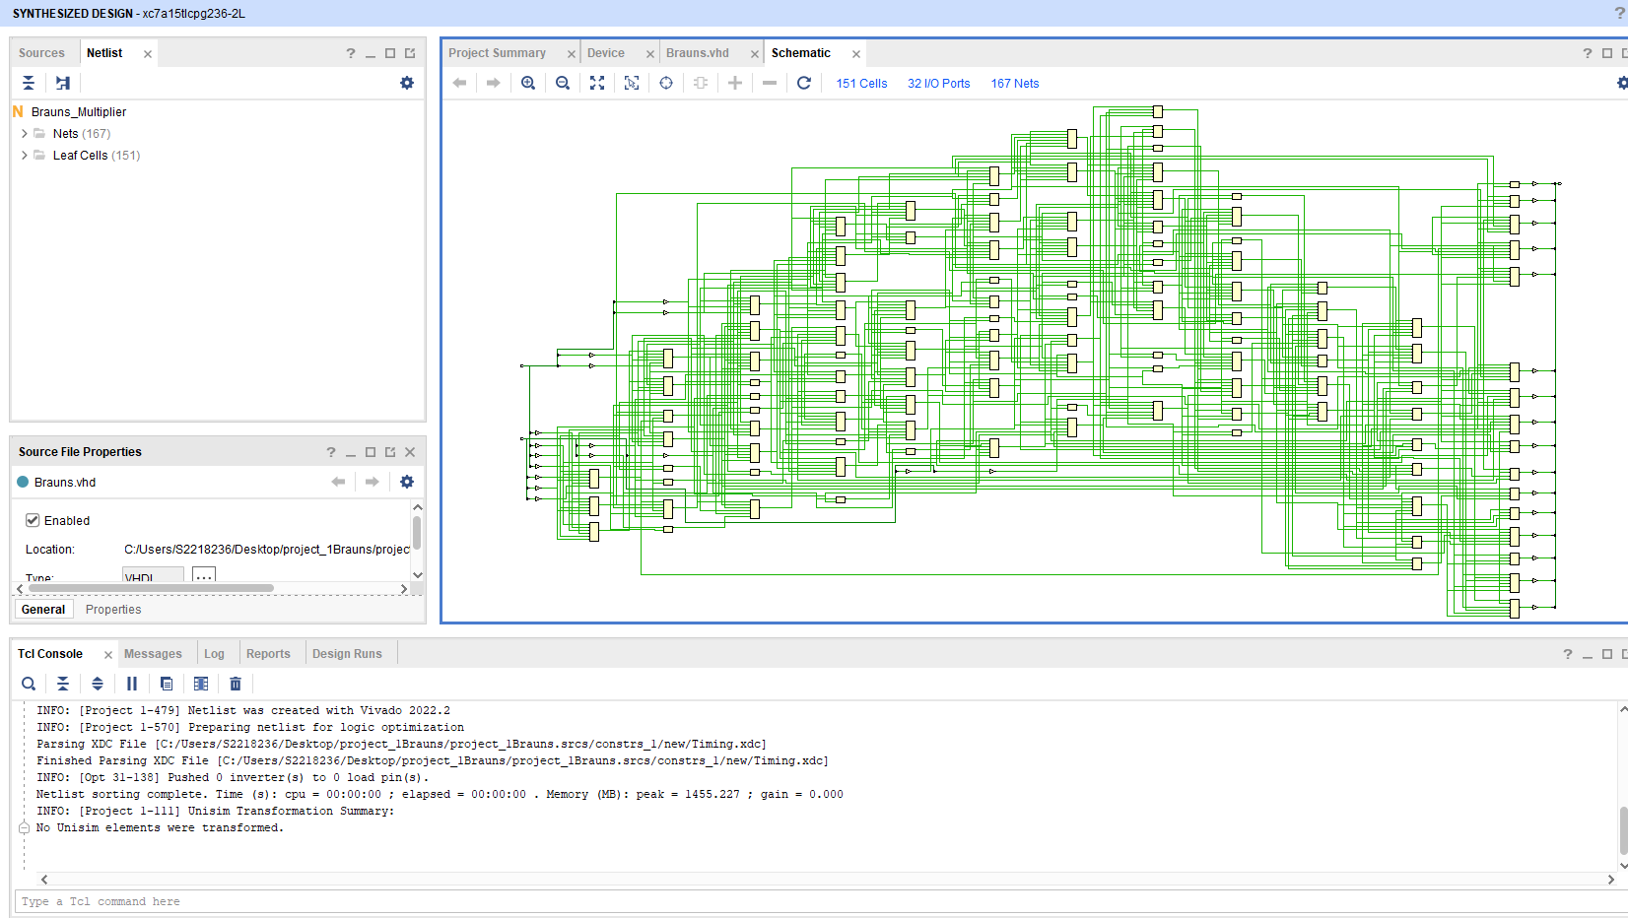
Figure 25 Synthesis Procedure Schematic Brauns
Figure 24 Synthesis Procedure I/O Ports Picture 1

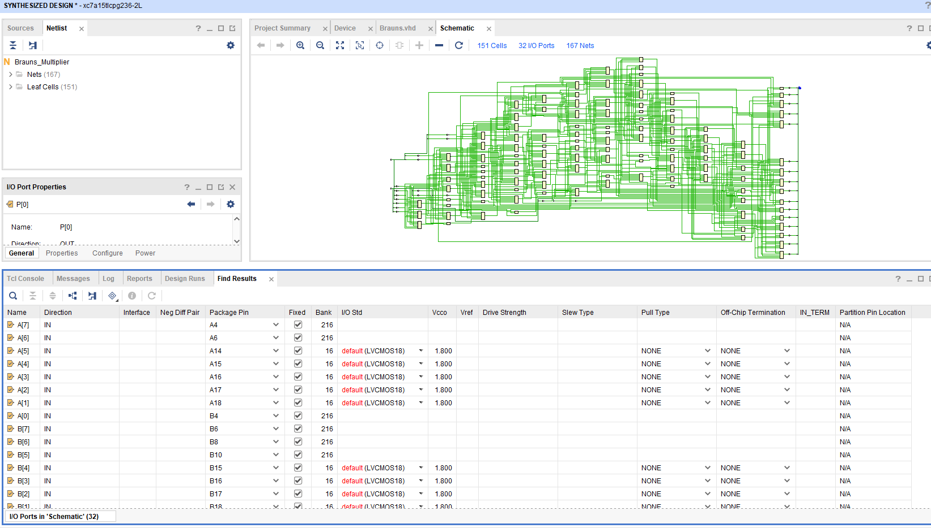
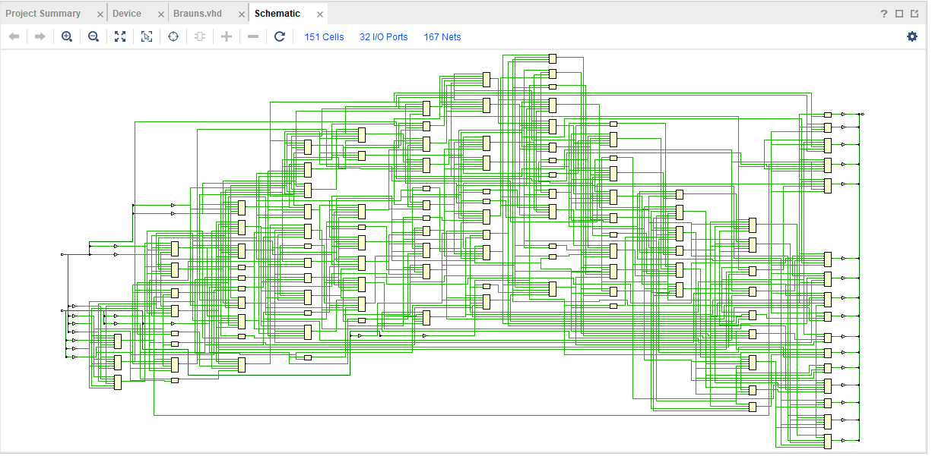
Figure 26 Synthesis Procedure Pin Package
Figure 27 Synthesis Procedure I/O Ports Picture 2

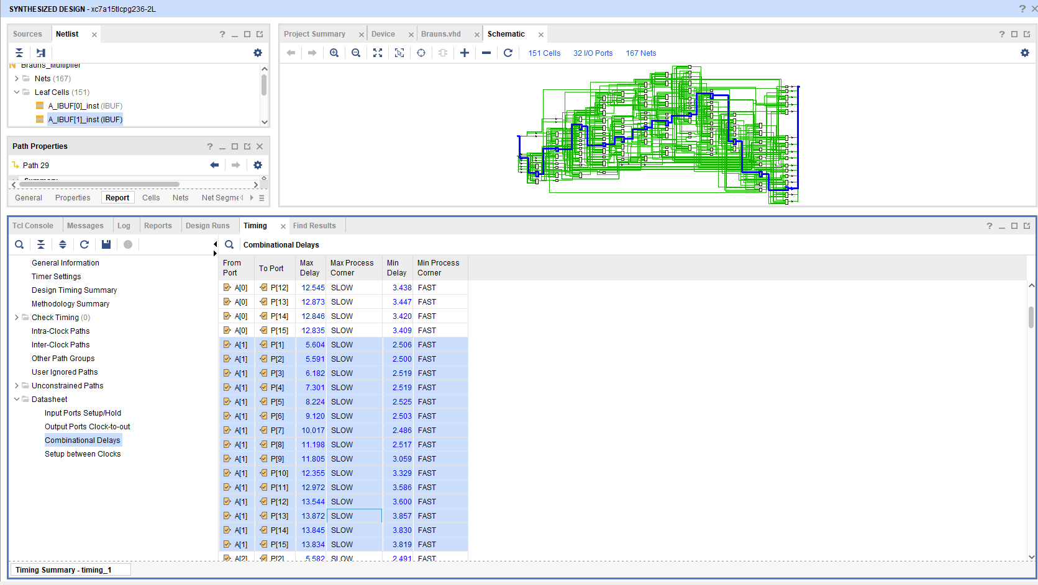
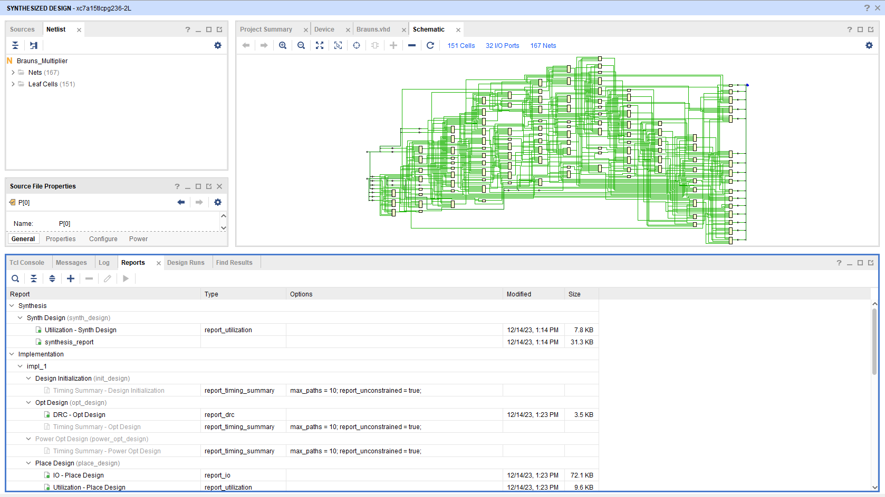
Figure 28 Combinational Delays
Figure 29 Synthesis Design
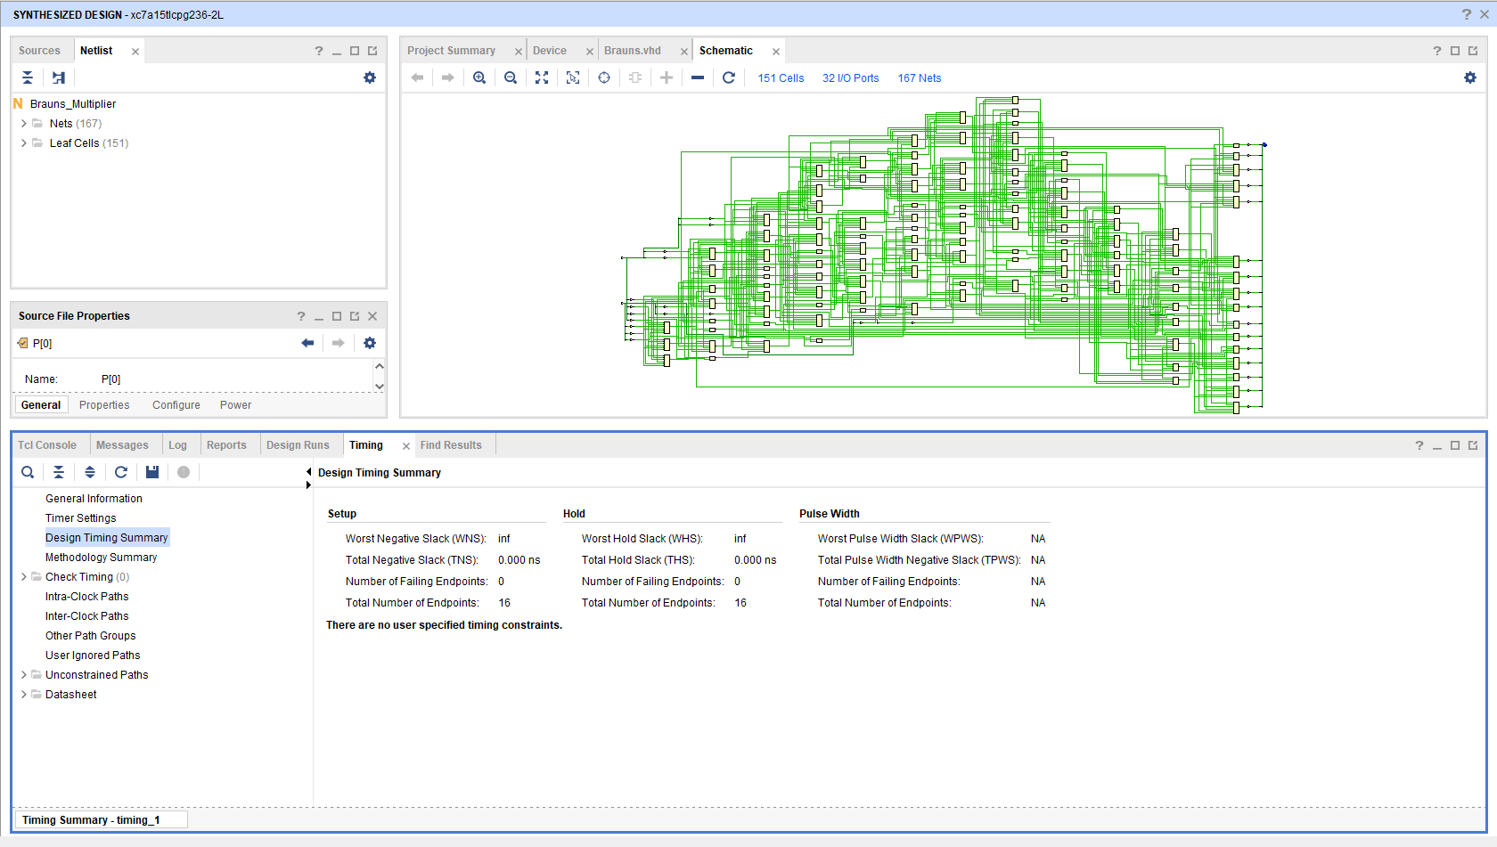
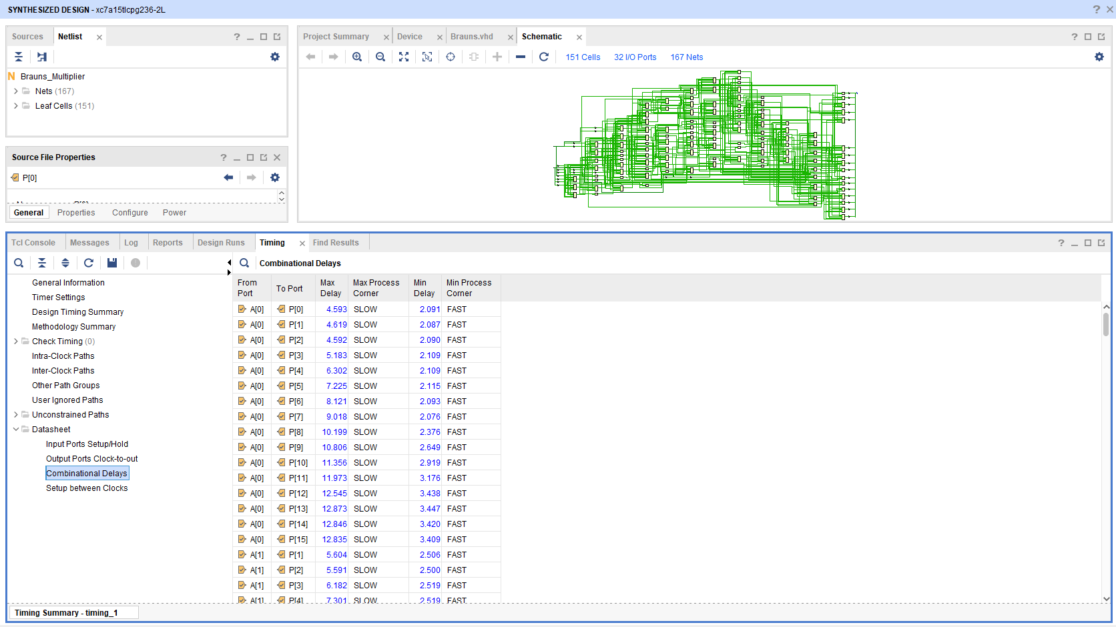
Figure 30 Design Timing Summary No Time Constraints
Figure 31 Combinational Delays picture 2
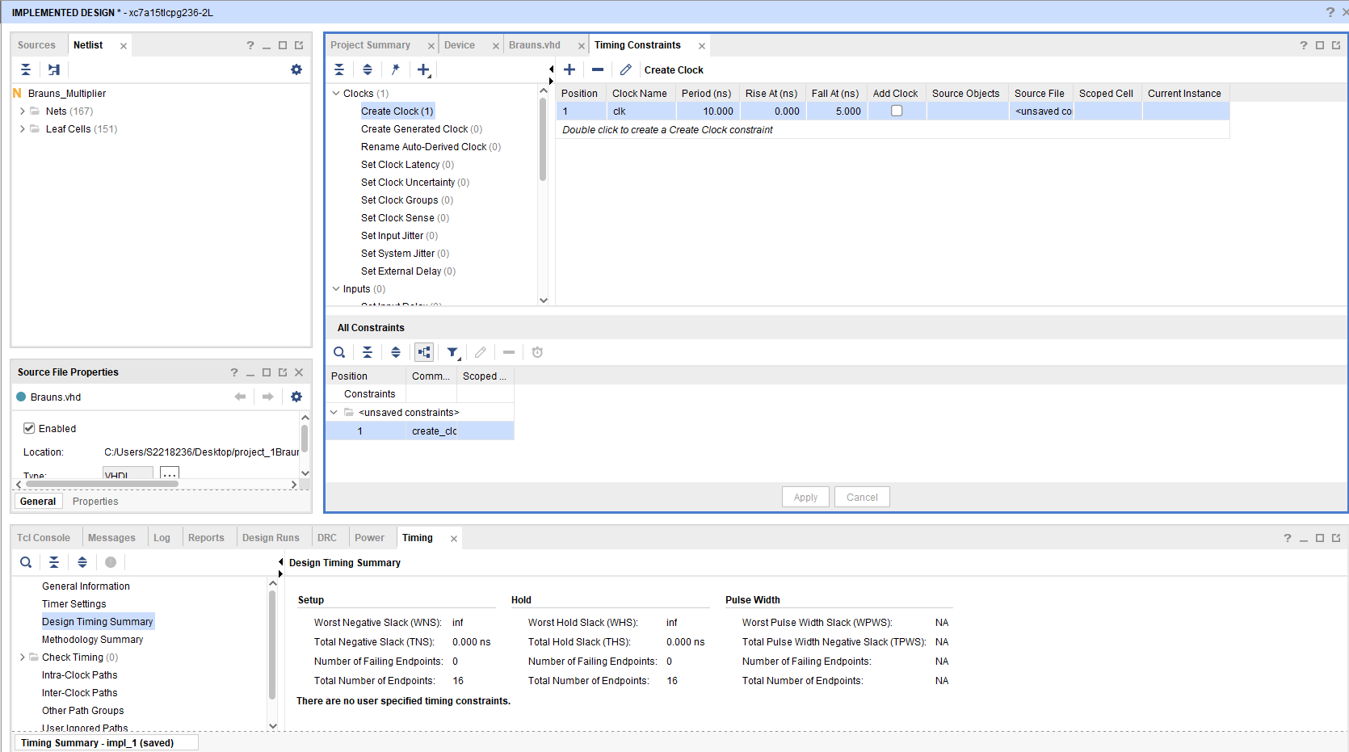
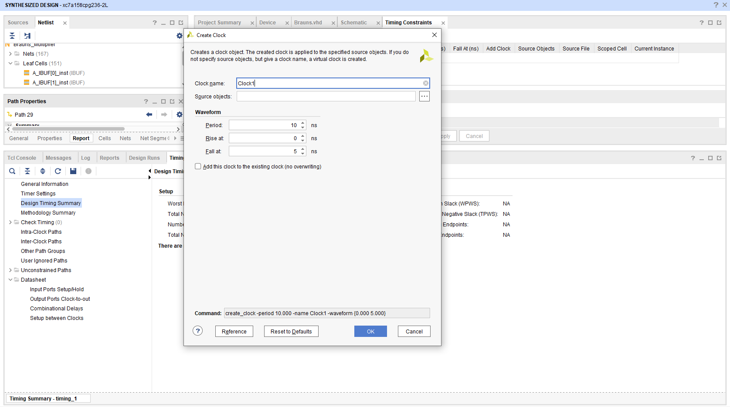
Figure 32 Timing Constraints
Figure 33 Create A clock

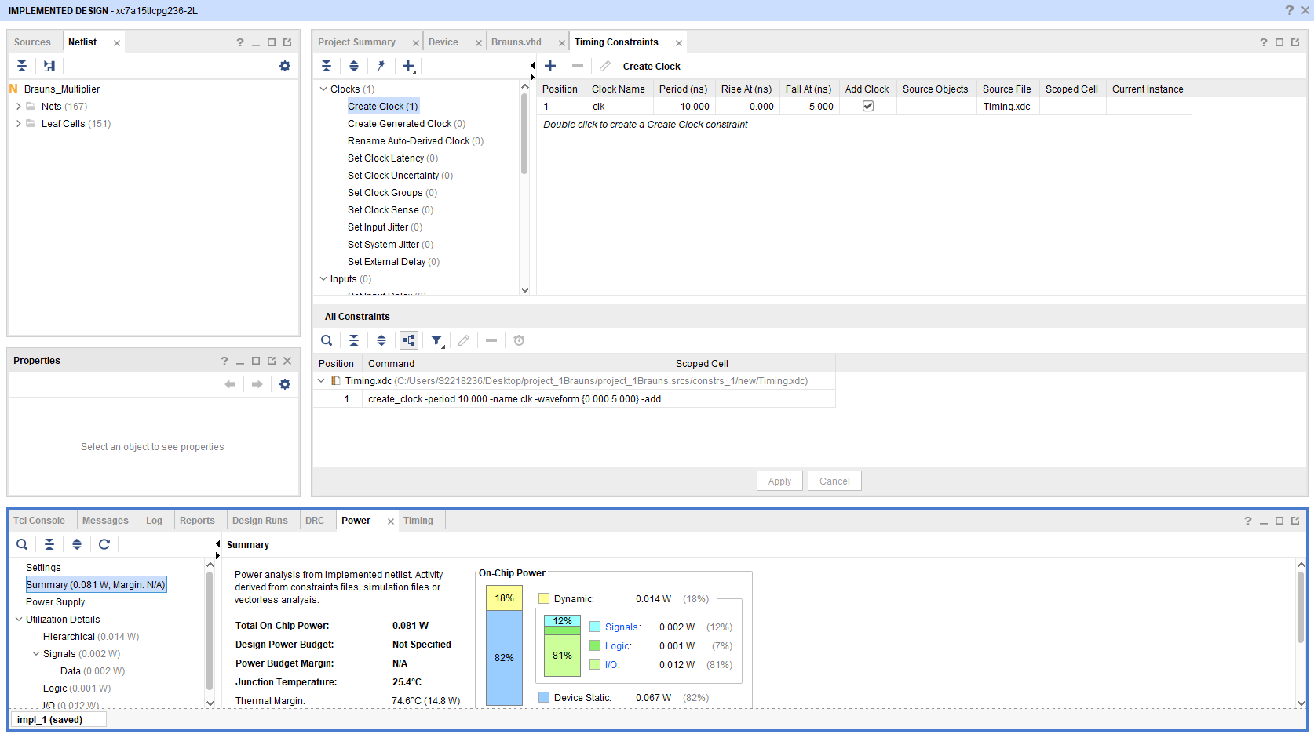
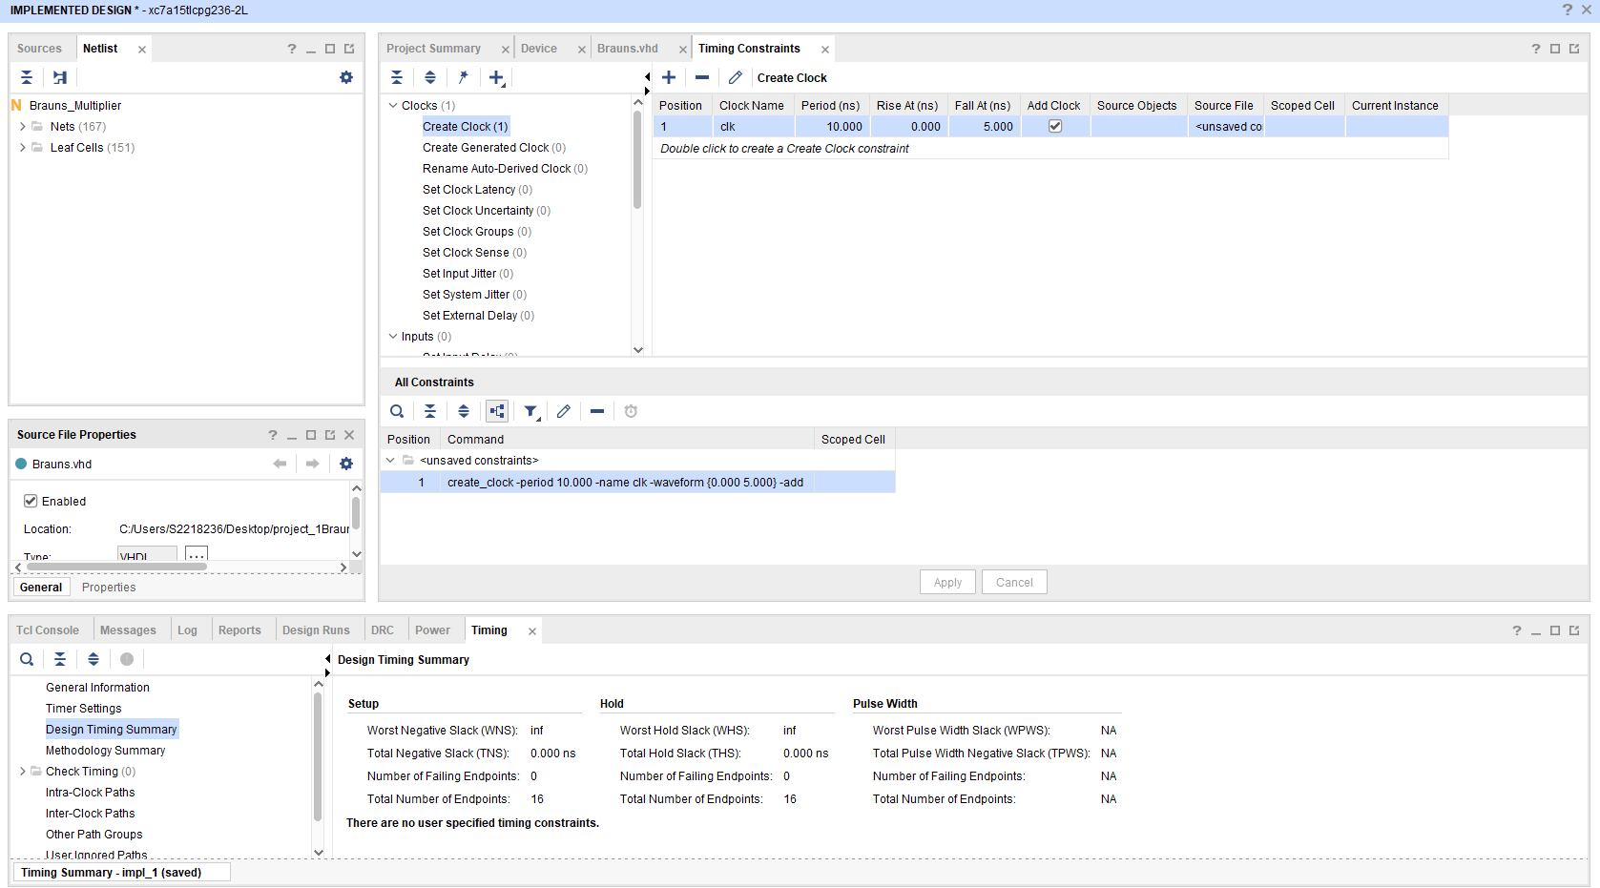
Figure 34 Braun Power SUMMARY
Figure 35 timing Constraints Picture 2

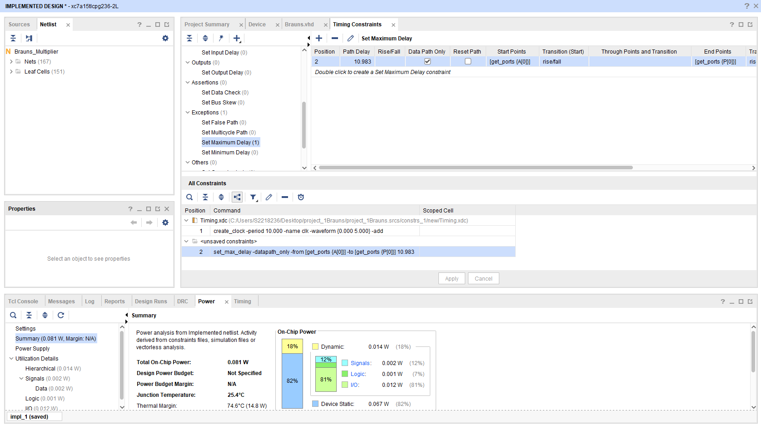
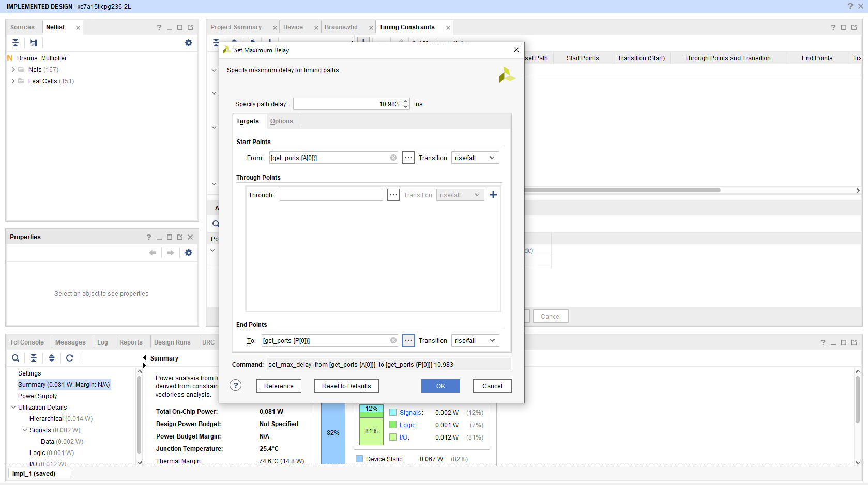
Figure 36 Timing Constraints Maximum Delay Picture 2
Figure 37 Timing Constraints Maximum Delay
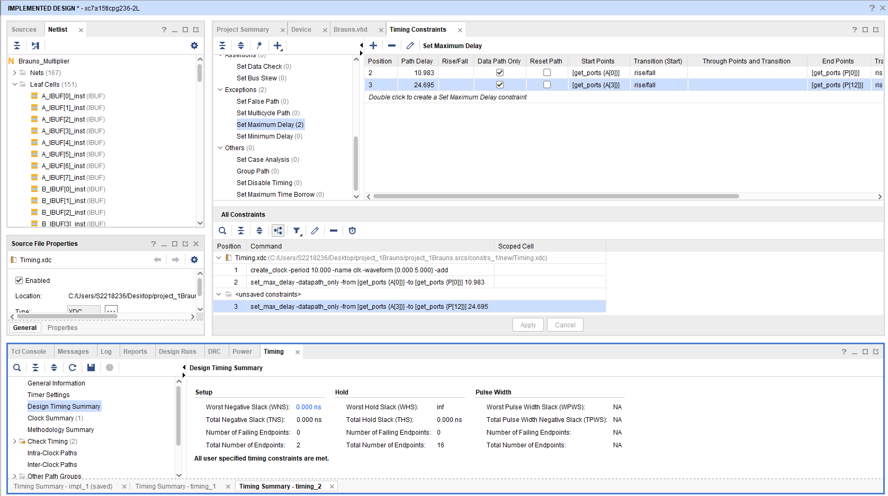
Figure 38 Maximum/Minimum Time Delays
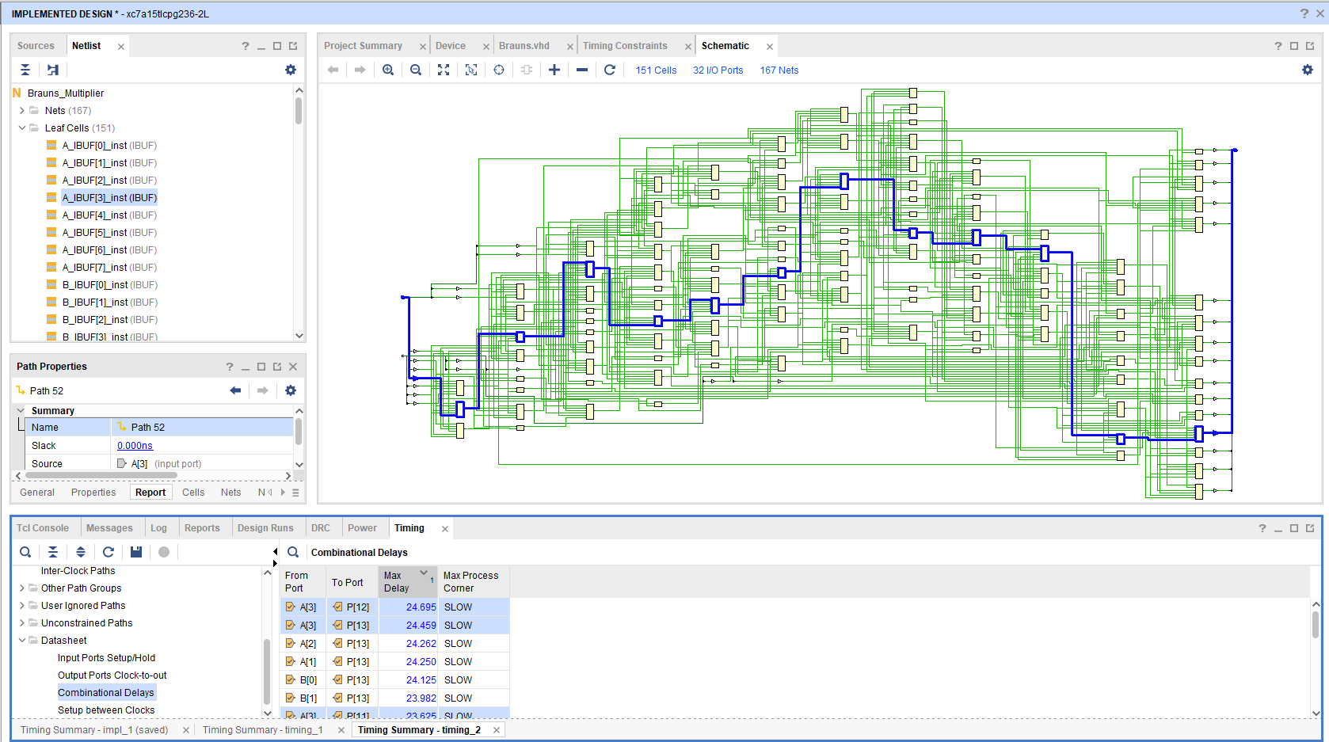
Figure 39 Time Delay Path Between A1 /P13
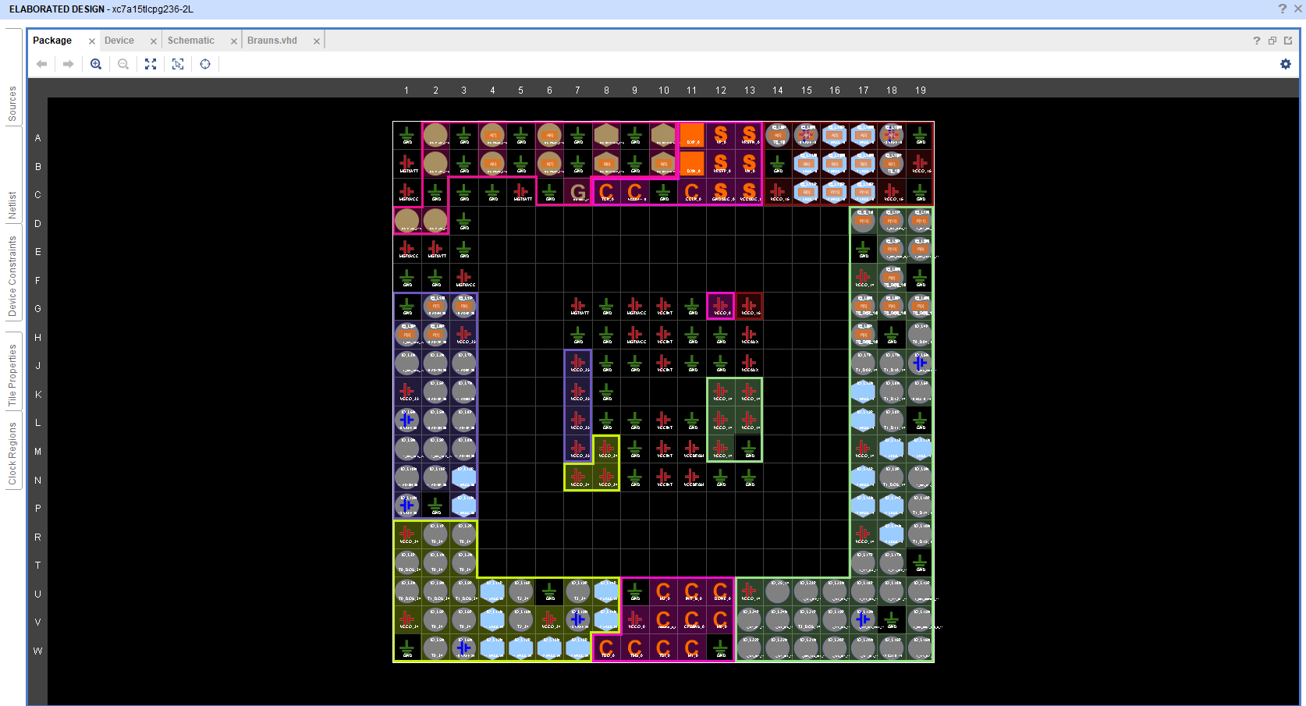
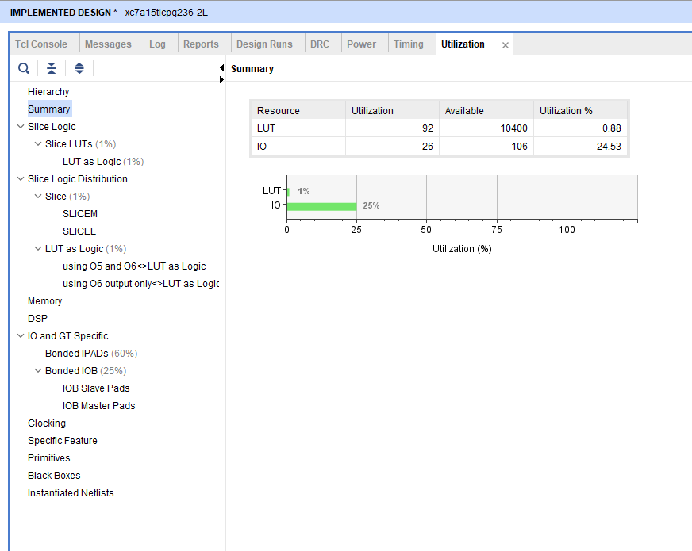
Figure 40 Brauns I/0 Planning
Figure 41 Implemented Design

Task 2

A 8 x 8 bit unsigned number is to be designed using parallel multiplication for the diagram given below. Implement this using Wallace Tree Multiplier.

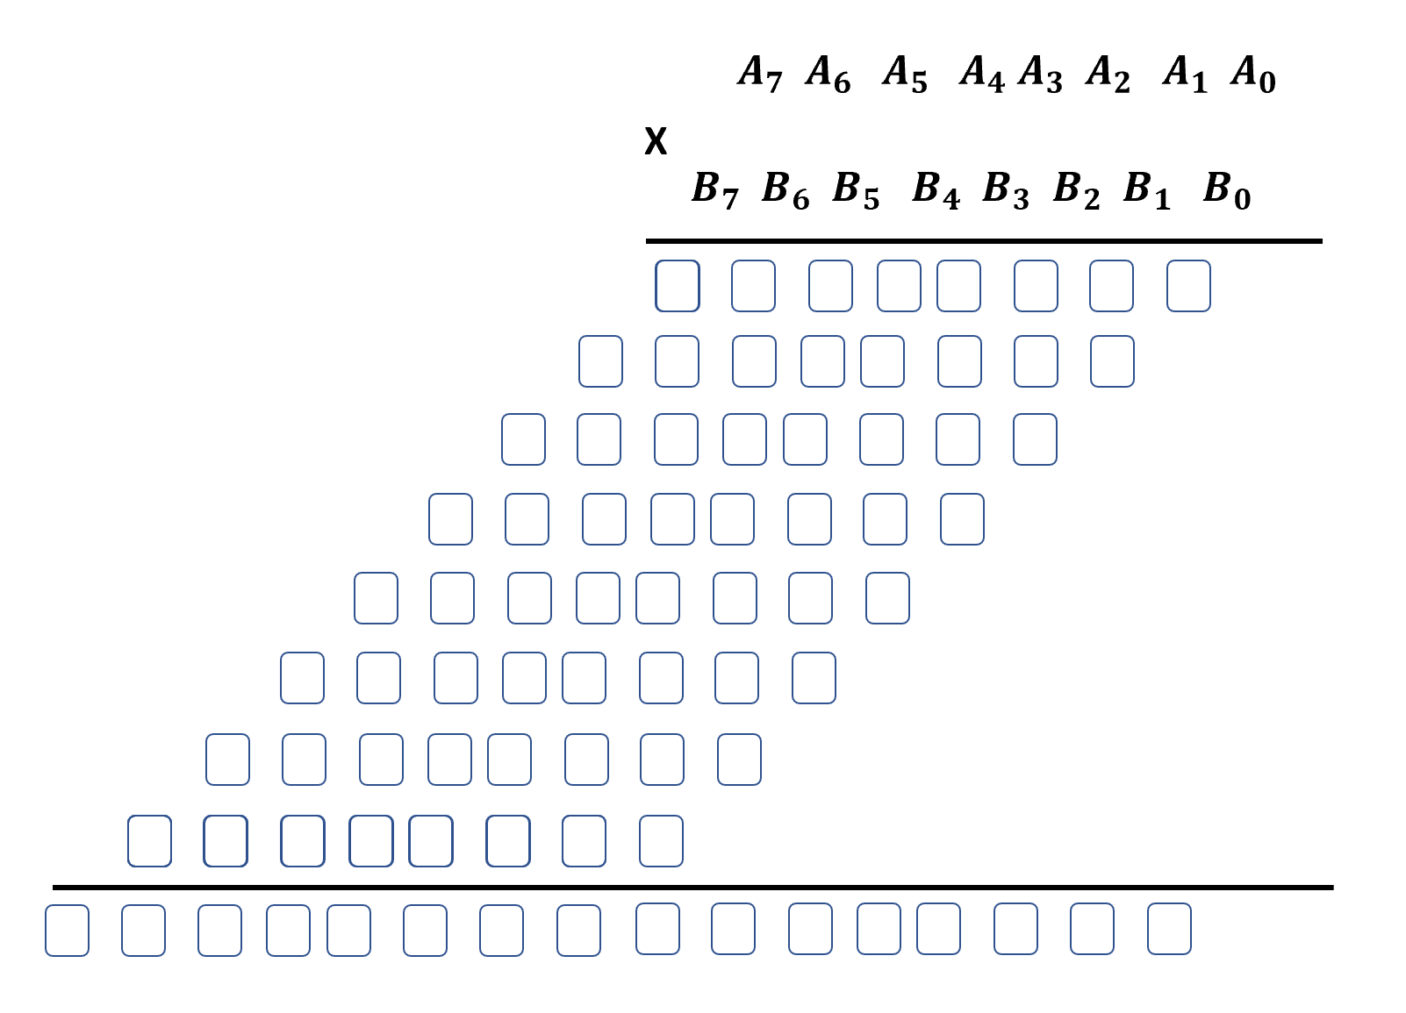
- Give a dot diagram of these multipliers, clearly indicating the number of Full Adders and Half Adders.
- Provide the complete logic circuit design.
- Implement the components in VHDL and then integrate the components using port maps to build the full multiplier.
- Simulate and extract its schematics and results.
- Synthesize the multiplier and implement the FPGA Design.

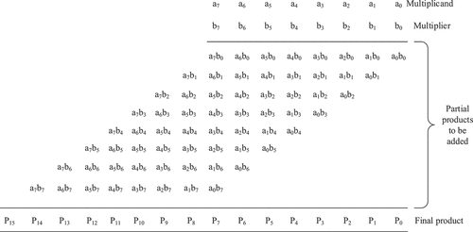
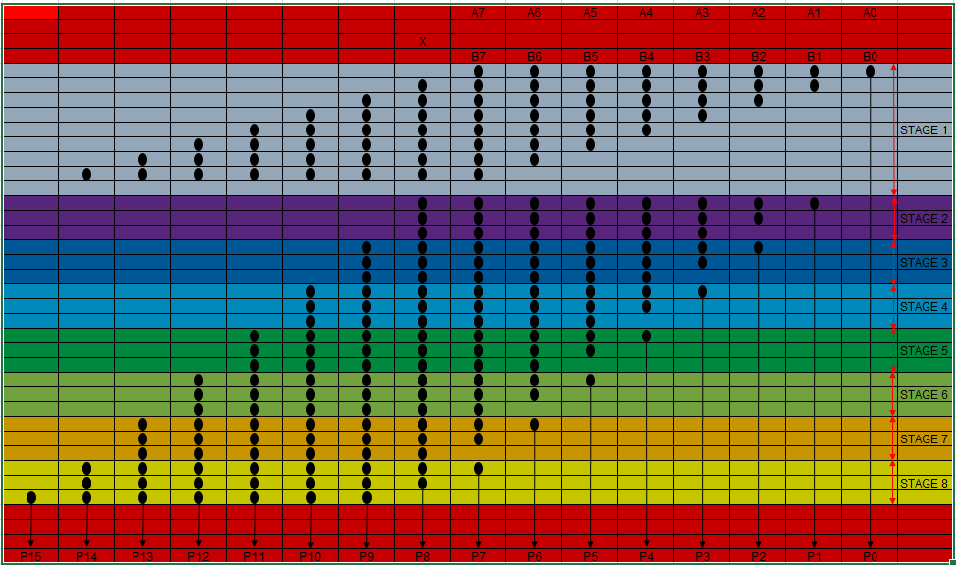
Dot Diagram of 8 X 8 Wallace Tree Multiplier
Figure 42 Wallace Tree Multiplier [45]
Figure 43 DOT Diagram 8 X 8 Wallace Tree Multiplier

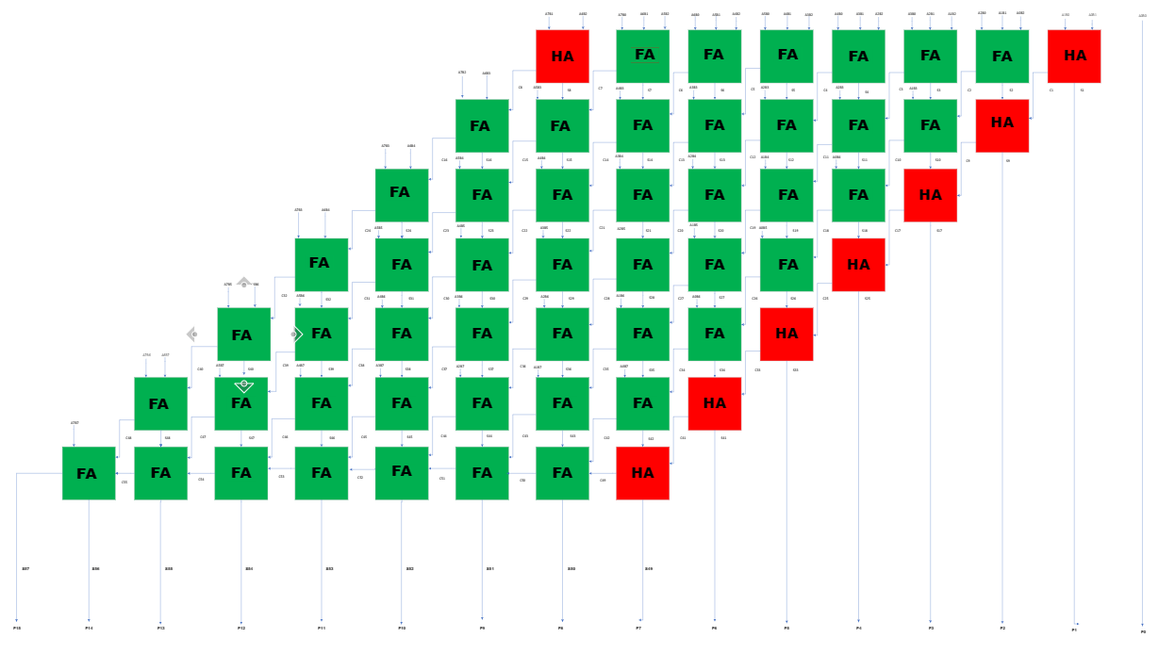
Logic Circuit Design
Figure 44 Wallace Tree Logic Circuit Design

VHDL HalfAdder Coding
library IEEE;
use IEEE.STD_LOGIC_1164.ALL;

-- Uncomment the following library declaration if using
-- arithmetic functions with Signed or Unsigned values
--use IEEE.NUMERIC_STD.ALL;

-- Uncomment the following library declaration if instantiating
-- any Xilinx leaf cells in this code.
--library UNISIM;
--use UNISIM.VComponents.all;

entity HalfAdder is
Port ( A : in STD_LOGIC;
B : in STD_LOGIC;
Sum : out STD_LOGIC;
Cout : out STD_LOGIC);
end HalfAdder;

architecture Behavioral of HalfAdder is

begin
Sum <= a xor b;
Cout <= a and b;

end Behavioral;

VHDL FullAdder Coding
library IEEE;
use IEEE.STD_LOGIC_1164.ALL;

-- Uncomment the following library declaration if using
-- arithmetic functions with Signed or Unsigned values
--use IEEE.NUMERIC_STD.ALL;

-- Uncomment the following library declaration if instantiating
-- any Xilinx leaf cells in this code.
--library UNISIM;
--use UNISIM.VComponents.all;

entity FullAdder is
Port ( A : in STD_LOGIC;
B : in STD_LOGIC;
Cin : in STD_LOGIC;
Sum : out STD_LOGIC;
Cout : out STD_LOGIC);
end FullAdder;

architecture Behavioral of FullAdder is

begin
Sum <= A XOR B XOR Cin;
Cout <= (A AND B) OR (Cin AND A) OR (Cin AND B) ;

end Behavioral;

VHDL WALLACE Coding
library IEEE;
use IEEE.STD_LOGIC_1164.ALL;

-- Uncomment the following library declaration if using
-- arithmetic functions with Signed or Unsigned values
--use IEEE.NUMERIC_STD.ALL;

-- Uncomment the following library declaration if instantiating
-- any Xilinx leaf cells in this code.
--library UNISIM;
--use UNISIM.VComponents.all;

entity wallace1 is
Port ( A : in STD_LOGIC_VECTOR (7 downto 0);
B : in STD_LOGIC_VECTOR (7 downto 0);
P : out STD_LOGIC_VECTOR (15 downto 0));
end wallace1;

architecture Behavioral of wallace1 is

component Fulladder is
Port ( A : in STD_LOGIC;
B : in STD_LOGIC;
Cin : in STD_LOGIC;
Sum : out STD_LOGIC;
Cout : out STD_LOGIC);
end component;

component Halfadder is
Port ( A : in STD_LOGIC;
B : in STD_LOGIC;

Sum : out STD_LOGIC;
Cout : out STD_LOGIC);
end component;

signal S2, S3, S4, S5, S6, S7 : std_logic;

signal S9, S10, S11, S12, S13, S14 : std_logic;

signal S16, S17, S18, S19, S20, S21 : std_logic;

signal S23, S24, S25, S26, S27, S28 : std_logic;

signal S30, S31, S32, S33, S34, S35 : std_logic;

signal S37, S38, S39, S40, S41, S42 : std_logic;

signal S44, S45, S46, S47, S48, S49 : std_logic;

signal C1, C2, C3, C4, C5, C6, C7 : std_logic;

signal C8, C9, C10, C11, C12, C13, C14 : std_logic;

signal C15, C16, C17, C18, C19, C20, C21 : std_logic;

signal C22, C23, C24, C25, C26, C27, C28 : std_logic;

signal C29, C30, C31, C32, C33, C34, C35 : std_logic;

signal C36, C37, C38, C39, C40, C41, C42 : std_logic;

signal C43, C44, C45, C46, C47, C48, C49 : std_logic;

signal C50, C51, C52, C53, C54, C55 : std_logic;

signal A1B0, A2B0, A3B0, A4B0, A5B0, A6B0, A7B0 : std_logic;

signal A0B1, A1B1, A2B1, A3B1, A4B1, A5B1, A6B1, A7B1 : std_logic;

signal A0B2, A1B2, A2B2, A3B2, A4B2, A5B2, A6B2, A7B2 : std_logic;

signal A0B3, A1B3, A2B3, A3B3, A4B3, A5B3, A6B3, A7B3 : std_logic;

signal A0B4, A1B4, A2B4, A3B4, A4B4, A5B4, A6B4, A7B4 : std_logic;

signal A0B5, A1B5, A2B5, A3B5, A4B5, A5B5, A6B5, A7B5 : std_logic;

signal A0B6, A1B6, A2B6, A3B6, A4B6, A5B6, A6B6, A7B6 : std_logic;

signal A0B7, A1B7, A2B7, A3B7, A4B7, A5B7, A6B7, A7B7 : std_logic;

begin

A1B0 <= A (1) and B (0) ;

A2B0 <= A (2) and B (0) ;

A3B0 <= A (3) and B (0) ;

A4B0 <= A (4) and B (0) ;

A5B0 <= A (5) and B (0) ;

A6B0 <= A (6) and B (0) ;

A7B0 <= A (7) and B (0) ;

A0B1 <= A (0) and B (1) ;

A1B1 <= A (1) and B (1) ;

A2B1 <= A (2) and B (1) ;

A3B1 <= A (3) and B (1) ;

A4B1 <= A (4) and B (1) ;

A5B1 <= A (5) and B (1) ;

A6B1 <= A (6) and B (1) ;

A7B1 <= A (7) and B (1) ;

A0B2 <= A (0) and B (2) ;

A1B2 <= A (1) and B (2) ;

A2B2 <= A (2) and B (2) ;

A3B2 <= A (3) and B (2) ;

A4B2 <= A (4) and B (2) ;

A5B2 <= A (5) and B (2) ;

A6B2 <= A (6) and B (2) ;

A7B2 <= A (7) and B (2) ;

A0B3 <= A (0) and B (3) ;

A1B3 <= A (1) and B (3) ;

A2B3 <= A (2) and B (3) ;

A3B3 <= A (3) and B (3) ;

A4B3 <= A (4) and B (3) ;

A5B3 <= A (5) and B (3) ;

A6B3 <= A (6) and B (3) ;

A7B3 <= A (7) and B (3) ;

A0B4 <= A (0) and B (4) ;

A1B4 <= A (1) and B (4) ;

A2B4 <= A (2) and B (4) ;

A3B4 <= A (3) and B (4) ;

A4B4 <= A (4) and B (4) ;

A5B4 <= A (5) and B (4) ;

A6B4 <= A (6) and B (4) ;

A7B4 <= A (7) and B (4) ;

A0B5 <= A (0) and B (5) ;

A1B5 <= A (1) and B (5) ;

A2B5 <= A (2) and B (5) ;

A3B5 <= A (3) and B (5) ;

A4B5 <= A (4) and B (5) ;

A5B5 <= A (5) and B (5) ;

A6B5 <= A (6) and B (5) ;

A7B5 <= A (7) and B (5) ;

A0B6 <= A (0) and B (6) ;

A1B6 <= A (1) and B (6) ;

A2B6 <= A (2) and B (6) ;

A3B6 <= A (3) and B (6) ;

A4B6 <= A (4) and B (6) ;

A5B6 <= A (5) and B (6) ;

A6B6 <= A (6) and B (6) ;

A7B6 <= A (7) and B (6) ;

A0B7 <= A (0) and B (7) ;

A1B7 <= A (1) and B (7) ;

A2B7 <= A (2) and B (7) ;

A3B7 <= A (3) and B (7) ;

A4B7 <= A (4) and B (7) ;

A5B7 <= A (5) and B (7) ;

A6B7 <= A (6) and B (7) ;

A7B7 <= A (7) and B (7) ;

--first stage

P0 : P(0) <= A(0) and B(0);

hall: HalfAdder port map (A1B0, A0B1, P(1), C1) ;

fa12: FullAdder port map (A2B0, A1B1, A0B2, S2, C2) ;

fa13: FullAdder port map (A2B1, A1B2, A0B3, S3, C3) ;

fa14: FullAdder port map (A2B2, A1B3, A0B4, S4, C4) ;

fa15: FullAdder port map (A2B3, A1B4, A0B5, S5, C5) ;

fa16: FullAdder port map (A2B4, A1B5, A0B6, S6, C6) ;

fa17: FullAdder port map (A2B5, A1B6, A0B7, S7, C7) ;

--second stage
ha21: HalfAdder port map (S2, C1, P(2), C8) ;

fa22: FullAdder port map (A3B0, S3, C2, S9, C9) ;

fa23: FullAdder port map (A3B1, S4, C3, S10, C10) ;

fa24: FullAdder port map (A3B2, S5, C4, S11, C11) ;

fa25: FullAdder port map (A3B3, S6, C5, S12, C12) ;

fa26: FullAdder port map (A3B4, S7, C6, S13, C13) ;

fa27: FullAdder port map (A2B6, A1B7, C7, S14, C14) ;

--third stage
ha31: HalfAdder port map (S9, C8, P(3), C15) ;

fa32: FullAdder port map (A4B0, S10, C9, S16, C16) ;

fa33: FullAdder port map (A4B1, S11, C10, S17, C17) ;

fa34: FullAdder port map (A4B2, S12, C11, S18, C18) ;

fa35: FullAdder port map (A4B3, S13, C12, S19, C19) ;

fa36: FullAdder port map (A3B5, S14, C13, S20, C20) ;

fa37: FullAdder port map (A3B6, A2B7, C14, S21, C21) ;

--Fourth Stage
ha41: HalfAdder port map (S16, C15, P(4), C22) ;

fa42: FullAdder port map (A5B0, S17, C16, S23, C23) ;

fa43: FullAdder port map (A5B1, S18, C17, S24, C24) ;

fa44: FullAdder port map (A5B2, S19, C18, S25, C25) ;

fa45: FullAdder port map (A4B4, S20, C19, S26, C26) ;

fa46: FullAdder port map (A4B5, S21, C20, S27, C27) ;

fa47: FullAdder port map (A4B6, A3B7, C21, S28, C28) ;

--Fifth Stage
ha51: HalfAdder port map (S23, C22, P(5), C29) ;

fa52: FullAdder port map (A6B0, S24, C23, S30, C30) ;

fa53: FullAdder port map (A6B1, S25, C24, S31, C31) ;

fa54: FullAdder port map (A5B3, S26, C25, S32, C32) ;

fa55: FullAdder port map (A5B4, S27, C26, S33, C33) ;

fa56: FullAdder port map (A5B5, S28, C27, S34, C34) ;

fa57: FullAdder port map (A5B6, A4B7, C28, S35, C35) ;

--Sixth Stage
ha61: HalfAdder port map (S30, C29, P(6), C36) ;

fa62: FullAdder port map (A7B0, S31, C30, S37, C37) ;

fa63: FullAdder port map (A6B2, S32, C31, S38, C38) ;

fa64: FullAdder port map (A6B3, S33, C32, S39, C39) ;

fa65: FullAdder port map (A6B4, S34, C33, S40, C40) ;

fa66: FullAdder port map (A6B5, S35, C34, S41, C41) ;

fa67: FullAdder port map (A6B6, A5B7, C35, S42, C42) ;

--Seventh Stage
ha71: HalfAdder port map (S37, C36, P(7), C43) ;

fa72: FullAdder port map (A7B1, S38, C37, S44, C44) ;

fa73: FullAdder port map (A7B2, S39, C38, S45, C45) ;

fa74: FullAdder port map (A7B3, S40, C39, S46, C46) ;

fa75: FullAdder port map (A7B4, S41, C40, S47, C47) ;

fa76: FullAdder port map (A7B5, S42, C41, S48, C48) ;

fa77: FullAdder port map (A7B6, A6B7, C42, S49, C49) ;

--Eighth Stage
ha81: HalfAdder port map (S44, C43, P(8), C50) ;

fa82: FullAdder port map (S45, C44, C50, P(9),C51) ;

fa83: FullAdder port map (S46, C45, C51, P(10), C52) ;

fa84: FullAdder port map (S47, C46, C52, P(11), C53) ;

fa85: FullAdder port map (S48, C47, C53, P(12), C54) ;

fa86: FullAdder port map (S49, C48, C54, P(13), C55) ;

fa87: FullAdder port map (A7B7, C49, C55, P(14), P(15)) ;

end Behavioral;

Simulation Procedure Flowchart

Figure 45 Simulation Procedure Flowchart

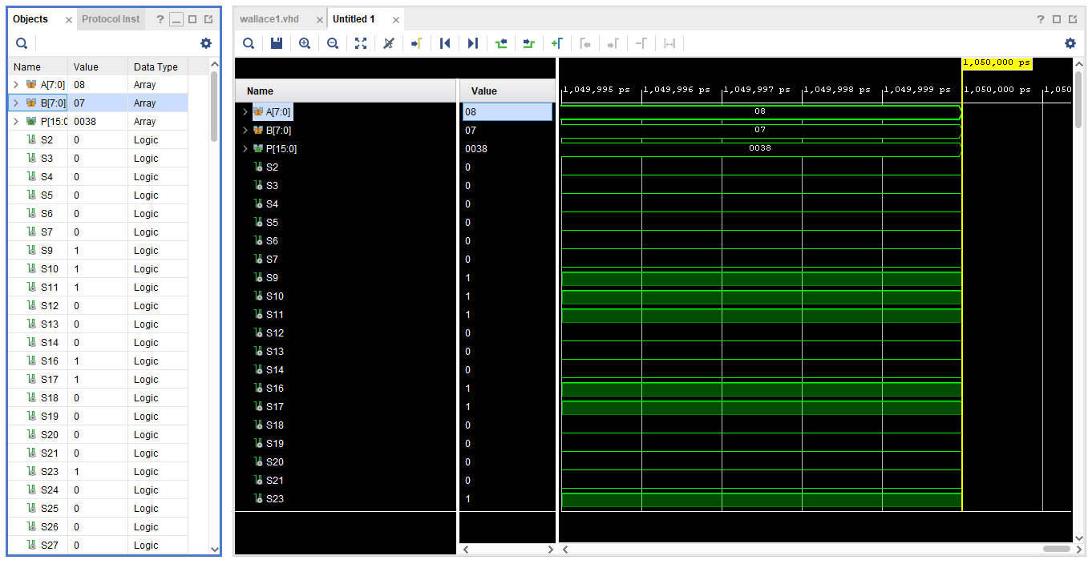
Wallace Simulation Results
Figure 46 Wallace Simulation Results 1
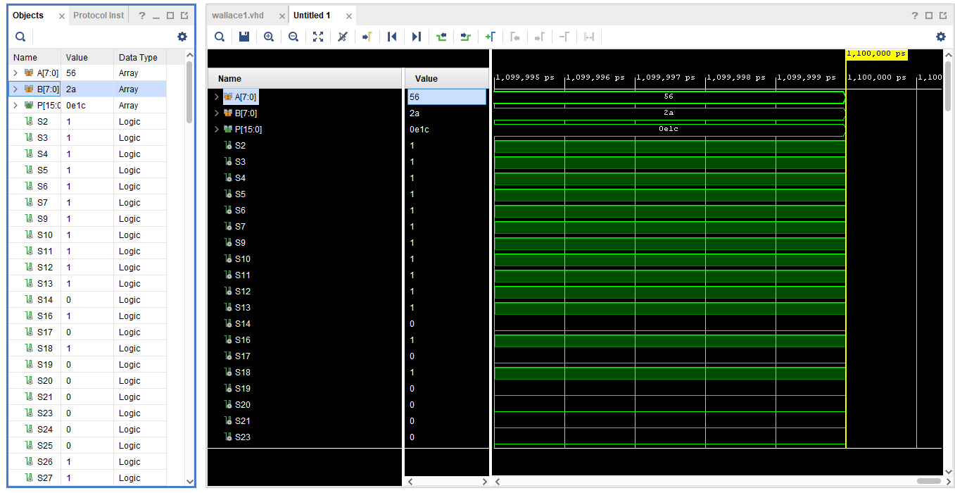
08 x 07 = 0038
Figure 47 Figure 46 Wallace Simulation Results 2
56 X 2A = OE1C
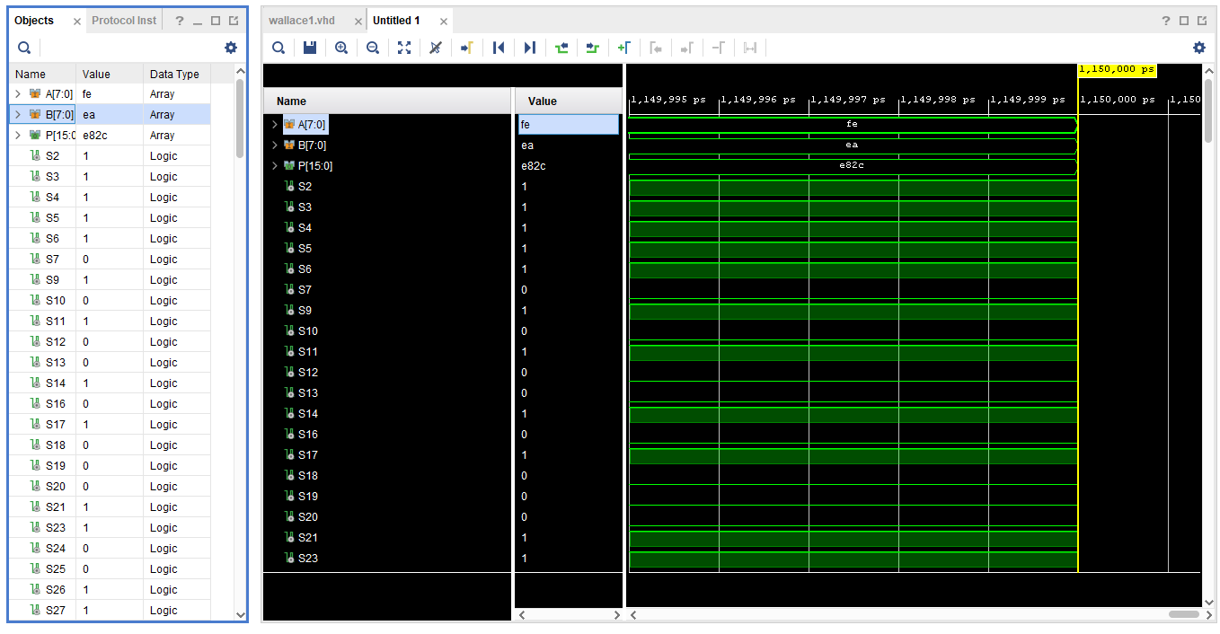
Figure 48 Figure 46 Wallace Simulation Results 3
FE X EA = E82C

Synthesis Procedure Flow chart
Figure 49 Synthesis Procedure Flow Chart

Implementation Procedure Flowchart
Figure 50 Implementation Procedure Flowchart
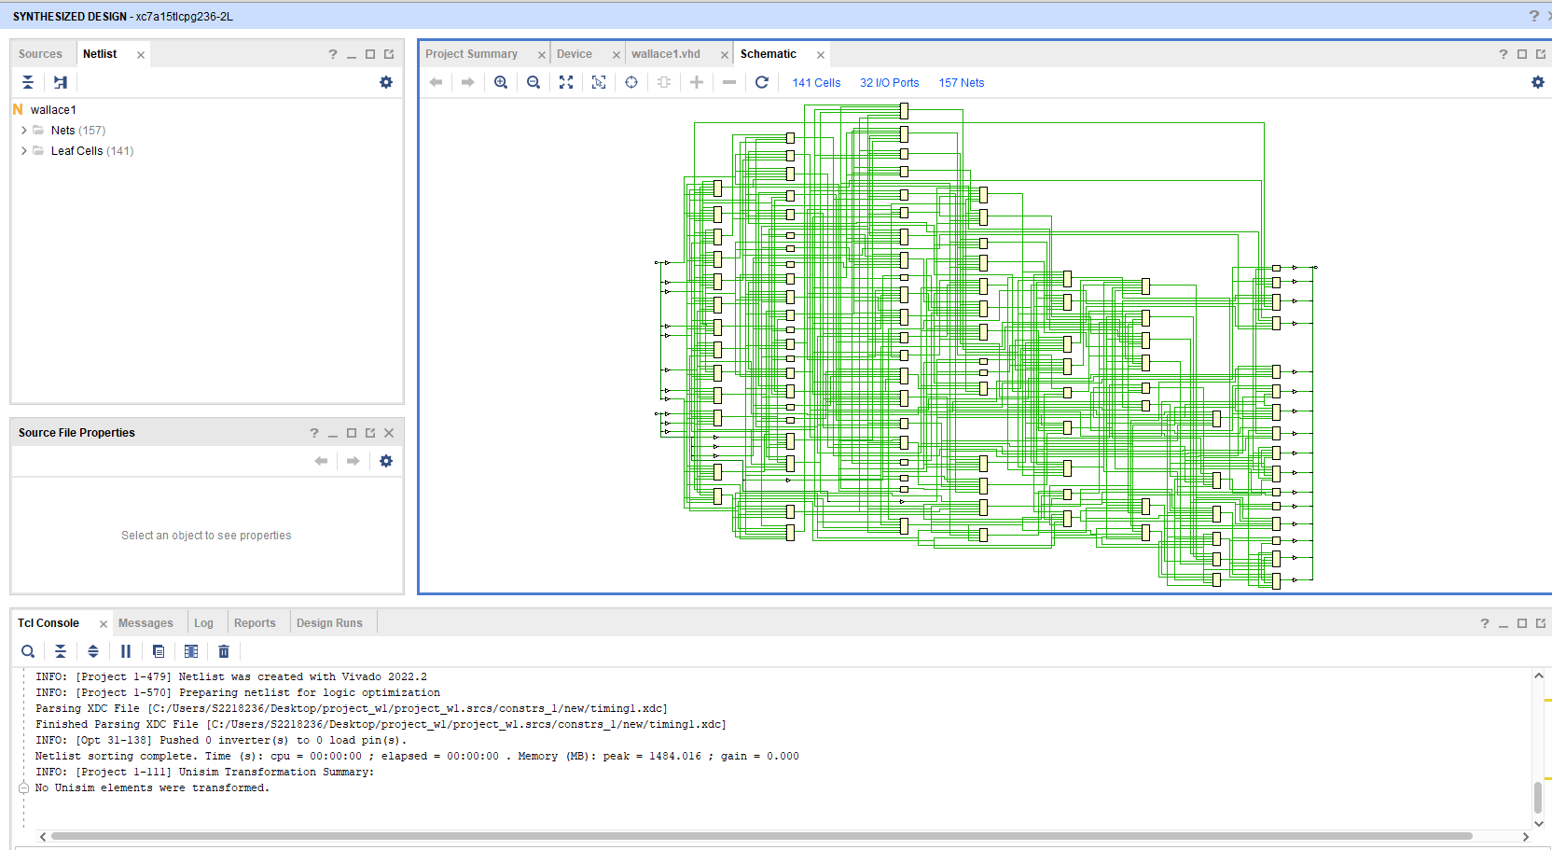
Below are Screen Shot of the Wallace Tree Multiplier VHDL synthesis, Implementation Procedures. Creating Clocks for Time Constraints and power consumption.
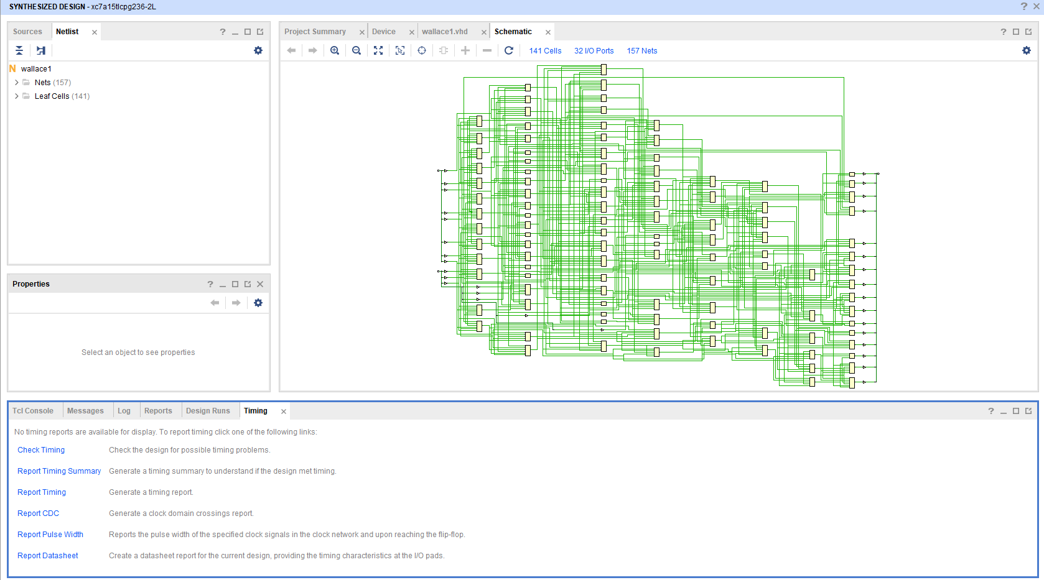
Figure 52 Synthesis Design Schematic
Figure 51 Synthesis Design Schematic picture 2
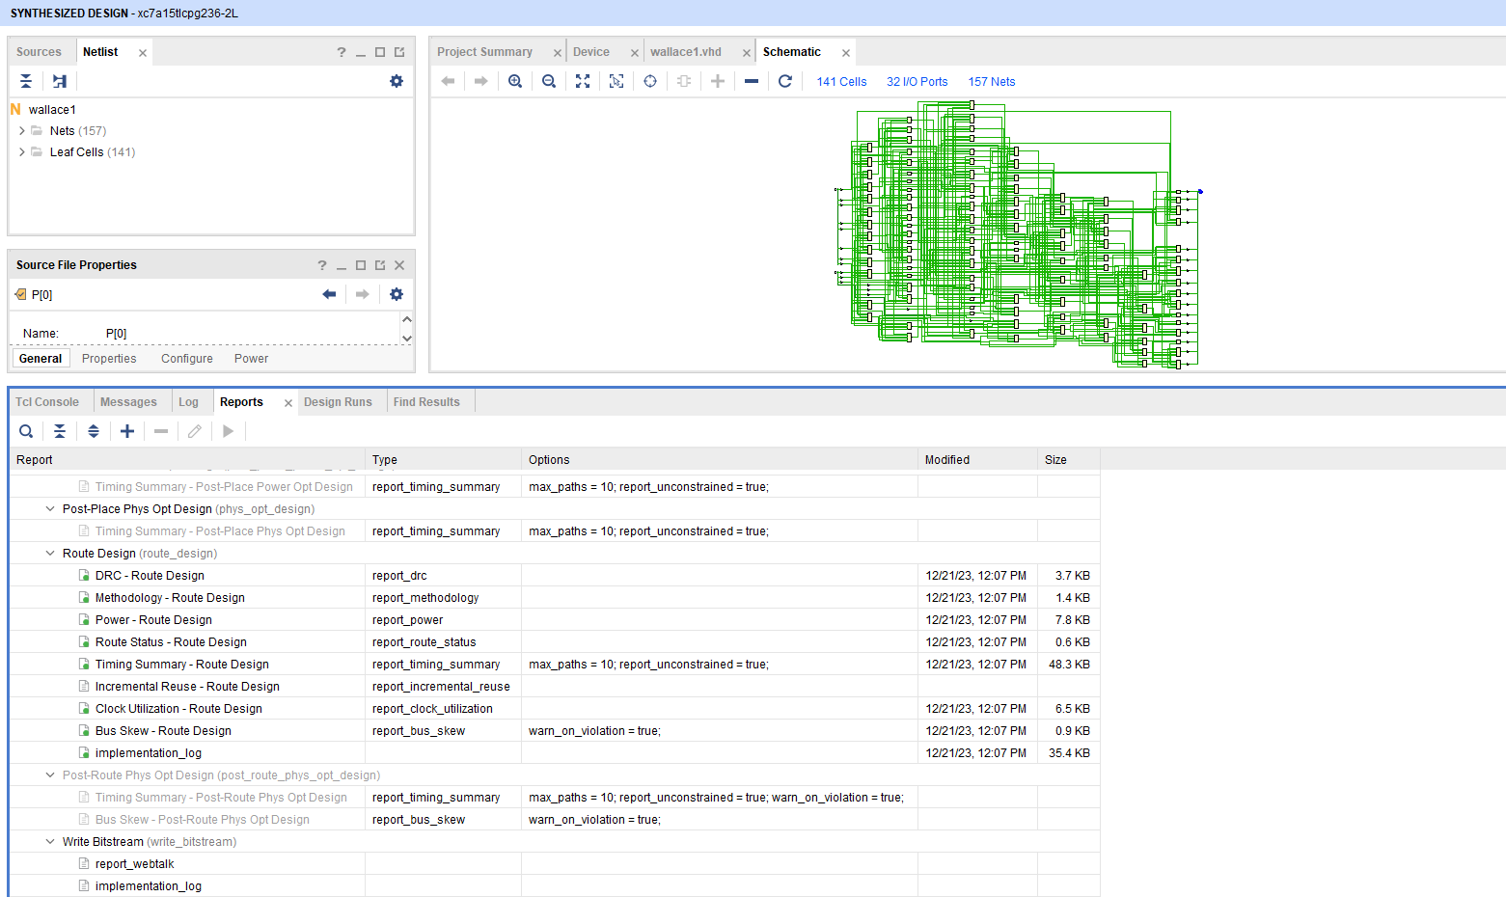
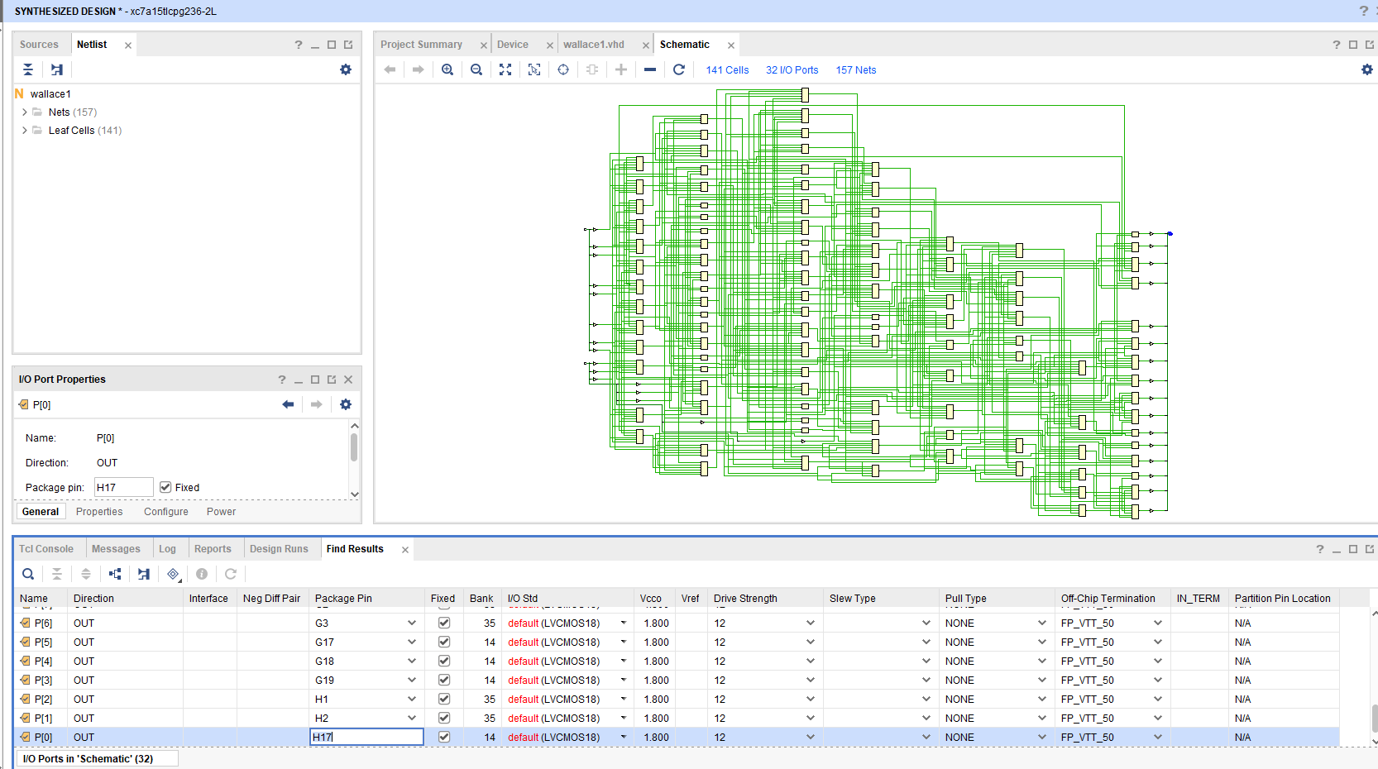
Figure 53 Synthesis Design Schematic PICTURE 3
Figure 54 Selecting I/O PINS

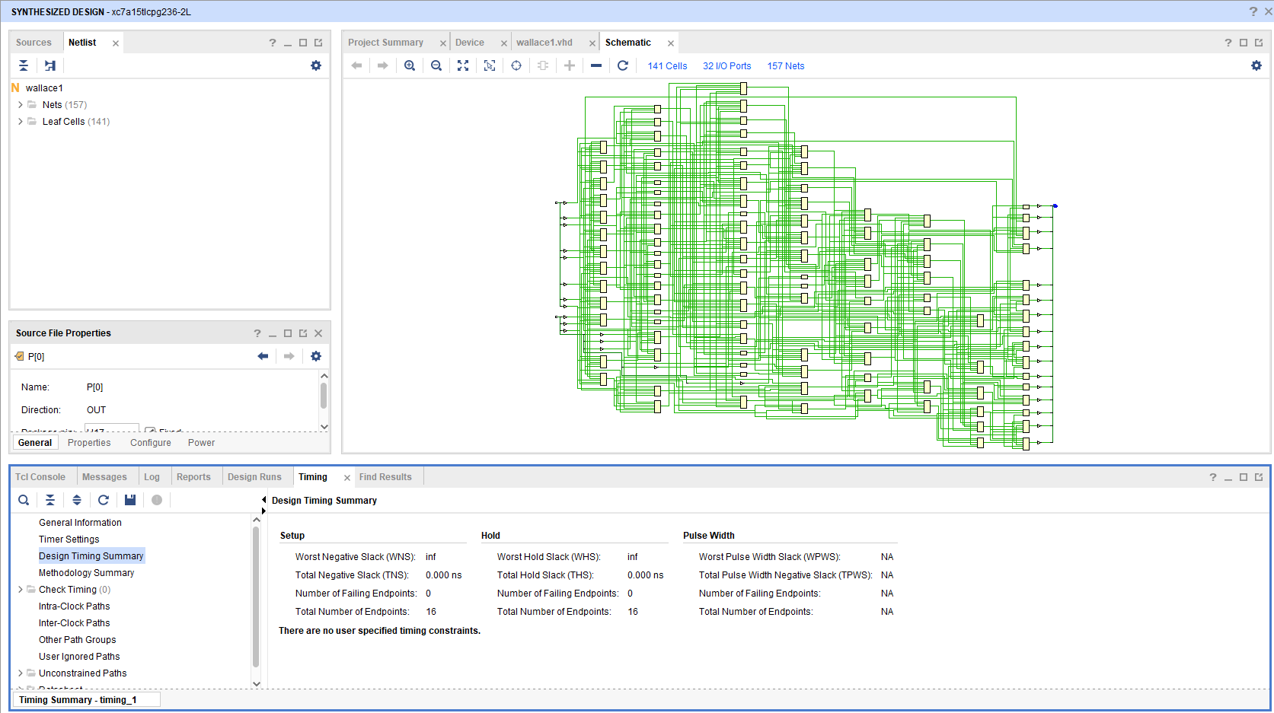
Figure 55 Wallace No timing Constraints
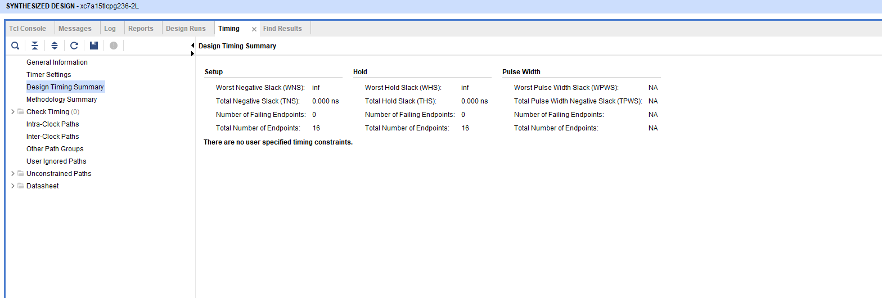
Figure 56 Wallace No user specified Timing Constraints

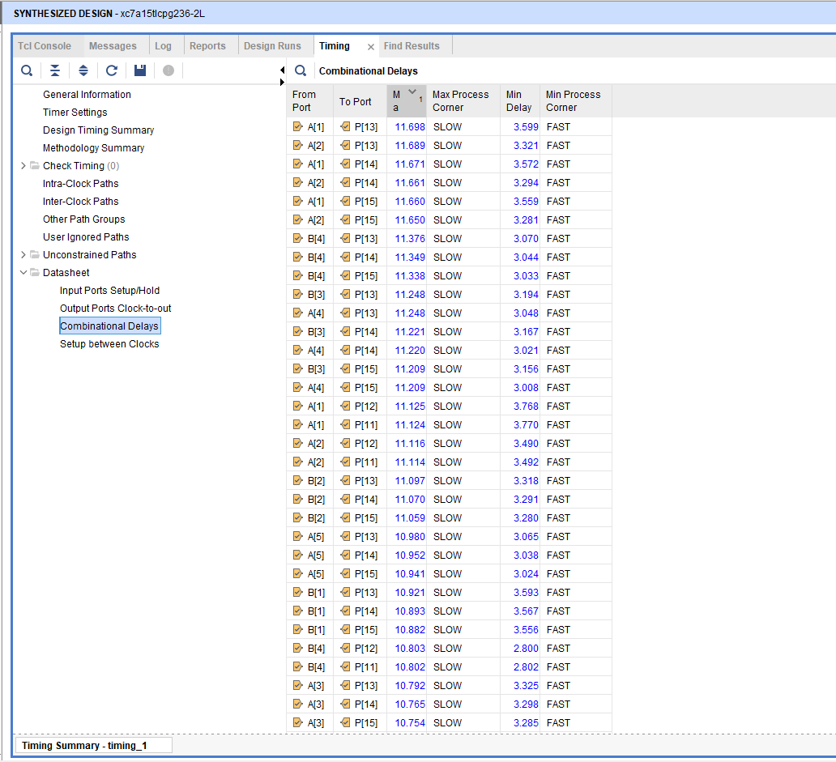
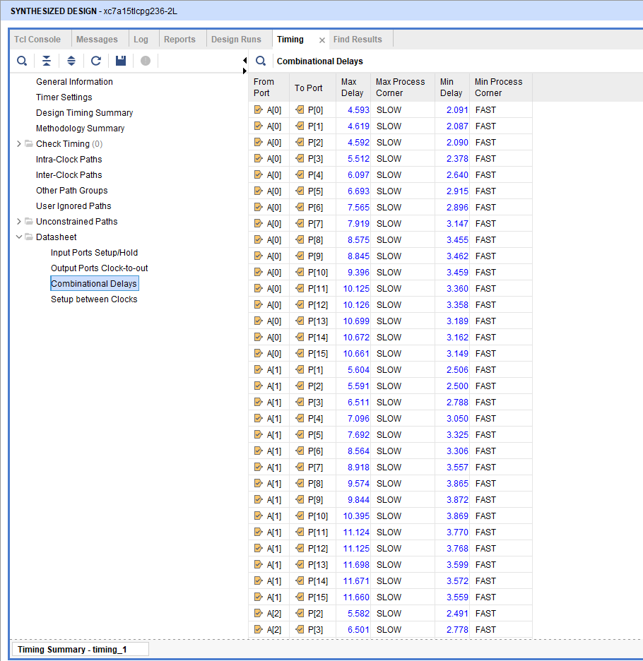
Figure 57 Synthesized Design Picture 2
Figure 58 Synthesized Design Picture 1
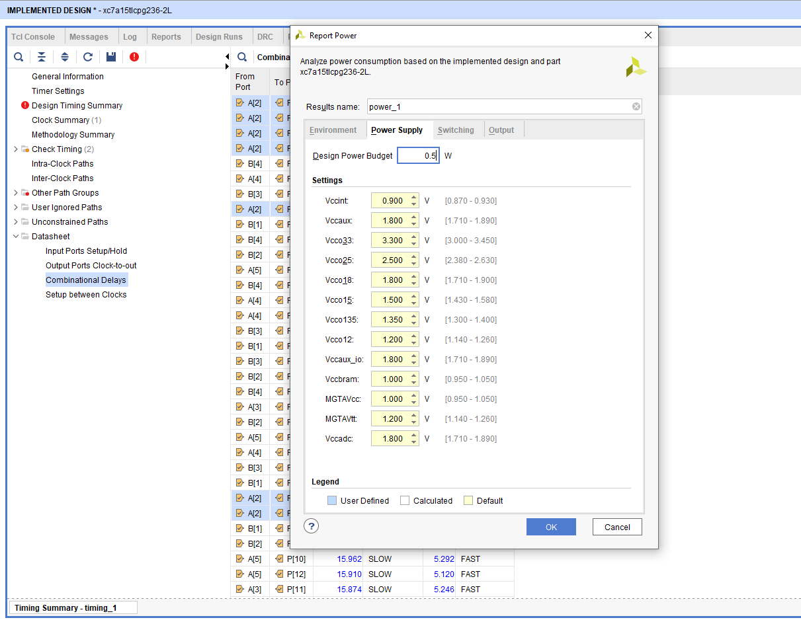
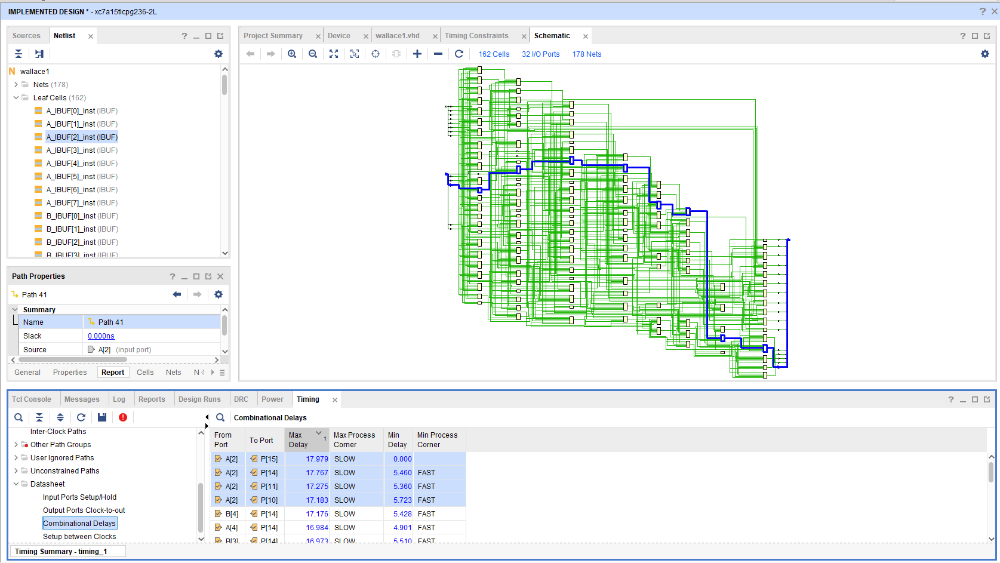
Figure 59 Wallace Power SUPPLY
Figure 60 Synthesized Design delay path

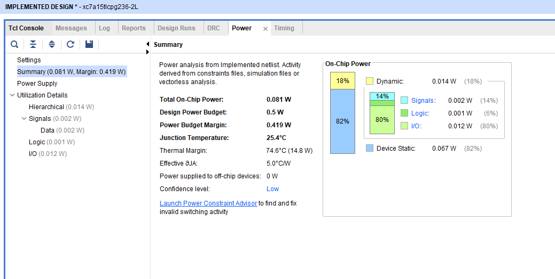
Figure 61 Wallace Power Summary

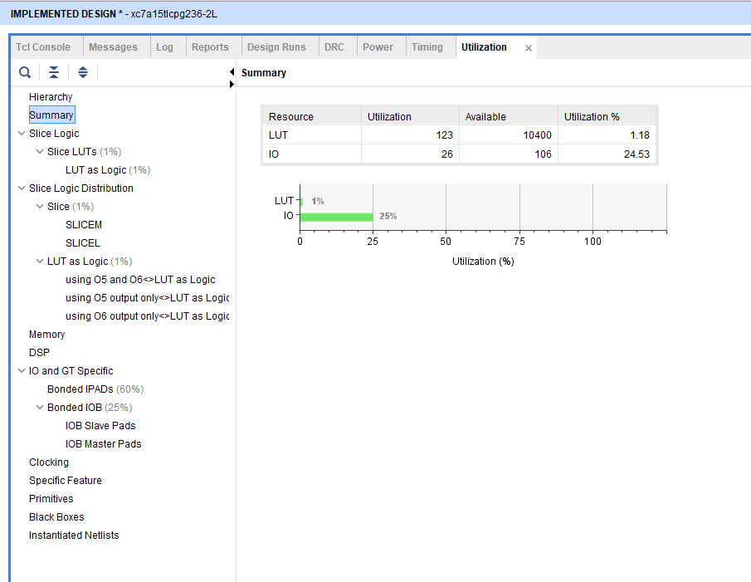
Figure 62 Utilization Summary

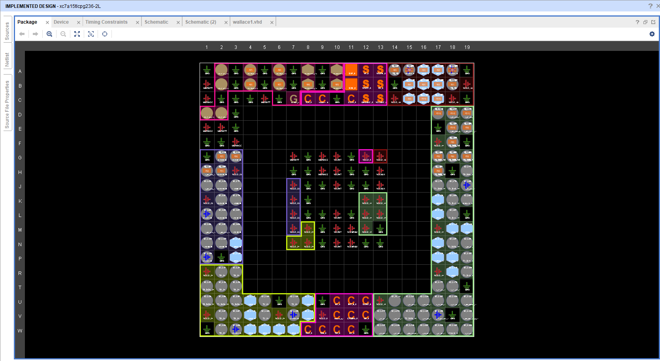
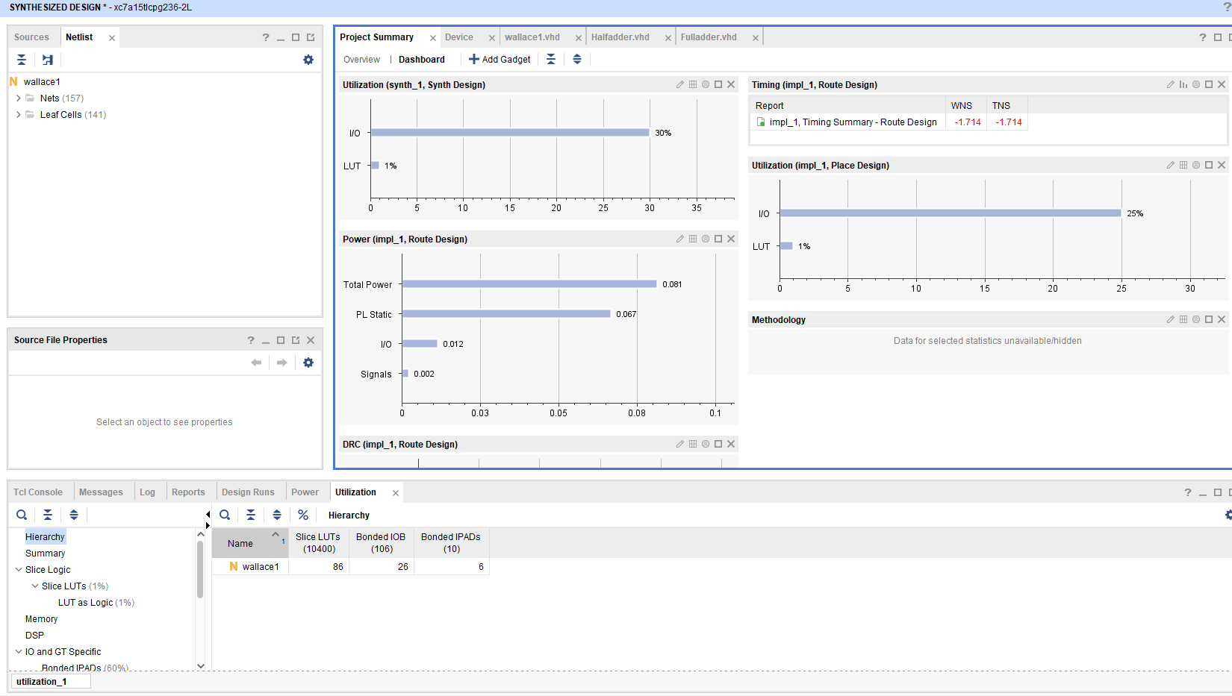
Figure 64 I/O Planning Schematic
Figure 63 Wallace Project SUMMARY

Task 3

Critically Evaluate the performance of both the multipliers with the aid of Xilinx Vivado Software. In addition, consider the following instructions.

- What is the longest delay in both the multipliers, assuming an AND gate delay is $t_{g}=1ns$, and n adder delay (full adder and half adder) is $t_{ad}=2ns$? Compute the delay manually.
- Highlight the Multipliers Critical Path.
- Compare the overall delay of both the Multipliers.
- Which of your implementations consumes more power and why?
- Further recommendations and suggestions to improve the speed and power of these multipliers.

Brauns Longest Delays
Figure 65 Brauns Delay Path A1/P13
Brauns Longest Delay is A1 13.872 & P13 3.857
Figure 66 Figure 65 Brauns Delay Path A1/P13 PICTURE 2

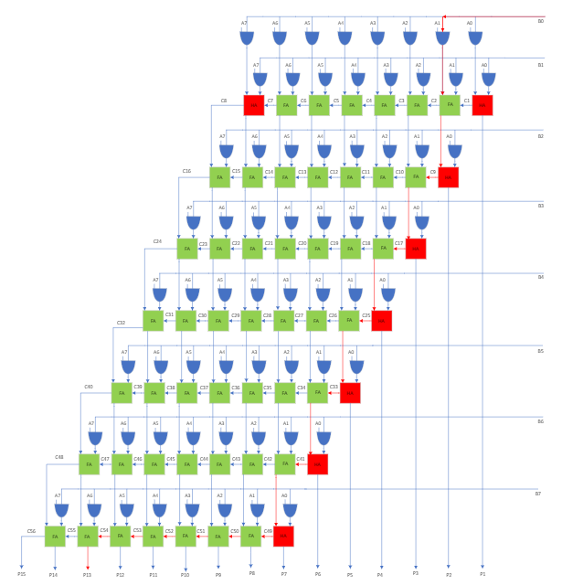
Figure 67 Brauns Logic Circuit fault Path Design
Longest Delay = Delay of 1st AND Gate + 2 * (Delay in Carry out Half Adder) + 4*(Dedlay in Carry out Full Adder)
Therefore the longest Delay is = 1ns + 6 * (2ns) +12*(2ns) = 37 ns

Wallace Longest Delay
Wallace Longest Delay A1 11.698 & P13 3.599
Figure 68 Wallace Longest Delay A1/ P13 PICTURE 2
Figure 69 Wallace Longest Delay A1/ P13

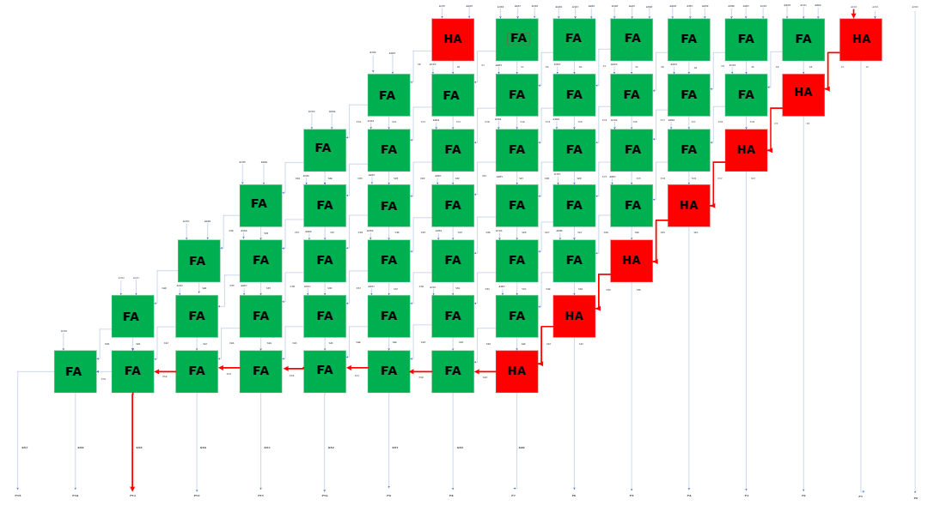
Figure 70 Wallace Logic circuit Design Fault Path
Longest Delay = Delay of 1st AND Gate + 2 * (Delay in Carry out Half Adder) + 4*(Delay in Carry out Full Adder)
Therefore the longest Delay is = 1ns + 7 * (2ns) +6*(2ns) = 27 ns

On Comparison of time delays on both 8 X 8 Braun Multiplexer & 8 X 8 WALLACE Tree Multiplexer it shows that the Wallace Tree Multiplexer it shows the Wallace tree multiplexer is quicker . This was proven by using Xilinx Vivado software and computing manually with logic diagrams.

Power Consumptions between implementations

Brauns Power Consumption
Figure 71 Brauns Power Supply Summary
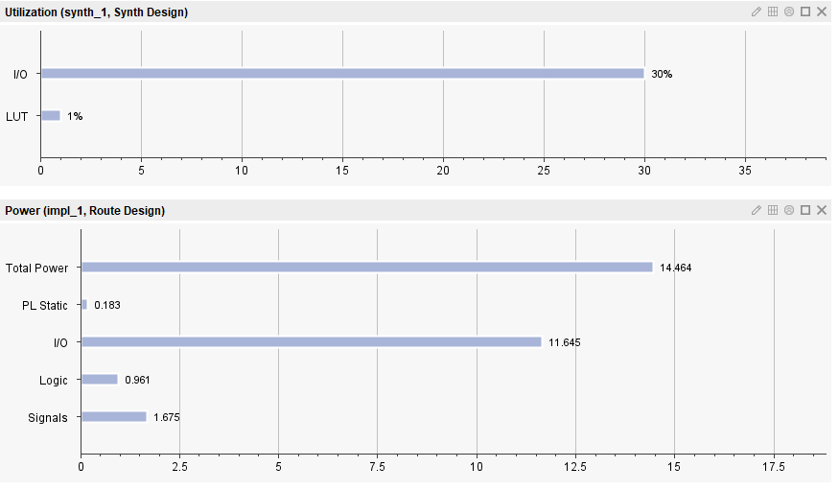
Figure 72 Brauns Power /Utilisation

Wallace Power Consumption
Figure 73 Wallace Porject Summary
Figure 74 Wallace Power Sumarry
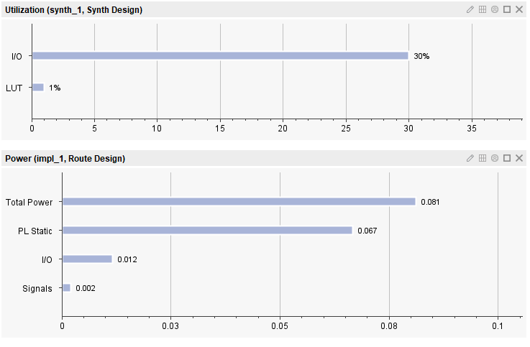
Figure 75 Wallace utilisation and power

Power Consumption Conclusion

On Comparison of both 8 X 8 Braun Multiplexer & 8 X 8 WALLACE Tree Multiplexer it shows that the Wallace Tree Multiplexer consumes less power compared to the Brauns Multiplexer this is down to its reduced number of partial product rows and improved efficiency in summing them.

Conclusion

Braun multipliers and Wallace tree multipliers are both hardware architectures designed for efficient multiplication in digital circuits.

The Braun multiplier is known for its simplicity and uses a recursive structure, while the Wallace tree multiplier uses a tree-like structure for parallel processing.

Which one you choose depends on your specific design requirements, such as area, power consumption, and speed.

Braun multipliers may be desirable for simpler implementations, while Wallace tree multipliers may offer parallelism and speed advantages for more complex designs.

Ultimately, your choice should be based on your application's specific requirements and limitations.

From the VHDL software we can see that Brauns power Consumption higher than Wallace Tree . Also the delay for Brauns is Longer than the Wallace Tree Multiplier even know Wallace tree more complex design it is more suitable selection.

Improvements

Braun multipliers could be an appropriate option if ease of use and space efficiency are your main concerns. Wallace tree multipliers, on the other hand, might work better if you value parallel processing and possibly faster multiplication, particularly in more intricate designs. To make an informed choice based on your priorities, take into account the particular requirements of your project, such as any area restrictions, power requirements, and the desired speed of multiplication.

To help determine improvements in Braun Multipliers and Wallace tree Multipliers. The following points should be considered:

- Performance - Evaluate the performance, power consumption and speed of both areas of the architecture.

- Complexity: - Estimate the complexity of multiplying requirements.
While the Braun multiplier may be simpler, the Wallace tree multiplier is great for more complex scenarios.

- Resource Usage: - Analyse how effectively each multiplier uses hardware resources. Consider space usage and performance.

- Parallelism: - Compare the parallel processing power of the Wallace tree multiplier and the recursive nature of the Braun multiplier.

- Application Constraints: - Consider specific constraints such as regional limits, power budgets and speed requirements.

- Testing and Verification: - Assess the ease of testing and verification of each multiplier model.

Bibliography

[1] | “Logic Gates in Digital Electronics - Javatpoint,” [Online].
[2] | “Comparison between Braun Multiplier and Wallace Multiplier technique | by ASHUTOSH LAHOTI | MULTIPLIER TECHNIQUES IN VLSI | Medium,” [Online].
[3] | “Comparison between Braun Multiplier and Wallace Multiplier technique | by ASHUTOSH LAHOTI | MULTIPLIER TECHNIQUES IN VLSI | Medium,” [Online].
[4] | “Comparison between Braun Multiplier and Wallace Multiplier technique | by ASHUTOSH LAHOTI | MULTIPLIER TECHNIQUES IN VLSI | Medium,” [Online].
[5] | “Comparison between Braun Multiplier and Wallace Multiplier technique | by ASHUTOSH LAHOTI | MULTIPLIER TECHNIQUES IN VLSI | Medium,” [Online].
[6] | “Full Adder in Digital Logic - GeeksforGeeks,” [Online].
[7] | “Full Adder in Digital Logic - GeeksforGeeks,” [Online].
[8] | “Half Adder - Javatpoint,” [Online].
[9] | “Half Adder - Javatpoint,” [Online].
[10] | “Half Adder - Javatpoint,” [Online].
[11] | “Half Adder - Javatpoint,” [Online].
[12] | “Half Adder - Javatpoint,” [Online].
[13] | “The Multiple Applications of Multipliers - ADSANTEC,” [Online].
[14] | “The Multiple Applications of Multipliers - ADSANTEC,” [Online].
[15] | “The Multiple Applications of Multipliers - ADSANTEC,” [Online].
[16] | “The Multiple Applications of Multipliers - ADSANTEC,” [Online].
[17] | “The Multiple Applications of Multipliers - ADSANTEC,” [Online].
[18] | “The Multiple Applications of Multipliers - ADSANTEC,” [Online].
[19] | “4x4 Array Multiplier : Construction, Working and Applications (elprocus.com),” [Online].
[20] | “Logic Gates in Digital Electronics - Javatpoint,” [Online].
[21] | “Logic Gates in Digital Electronics - Javatpoint,” [Online].
[22] | “Logic Gates in Digital Electronics - Javatpoint,” [Online].
[23] | “Logic Gates in Digital Electronics - Javatpoint,” [Online].
[24] | “Logic Gates in Digital Electronics - Javatpoint,” [Online].
[25] | “Logic Gates in Digital Electronics - Javatpoint,” [Online].
[26] | “Logic Gates in Digital Electronics - Javatpoint,” [Online].
[27] | “Logic Gates in Digital Electronics - Javatpoint,” [Online].
[28] | “Logic Gates in Digital Electronics - Javatpoint,” [Online].
[29] | “Logic Gates in Digital Electronics - Javatpoint,” [Online].
[30] | “Logic Gates in Digital Electronics - Javatpoint,” [Online].
[31] | “Logic Gates in Digital Electronics - Javatpoint,” [Online].
[32] | “Logic Gates in Digital Electronics - Javatpoint,” [Online].
[33] | “Logic Gates in Digital Electronics - Javatpoint,” [Online].
[34] | “Comparison between Braun Multiplier and Wallace Multiplier technique | by ASHUTOSH LAHOTI | MULTIPLIER TECHNIQUES IN VLSI | Medium,” [Online].
[35] | “Full Adder in Digital Logic - GeeksforGeeks,” [Online].
[36] | “Full Adder in Digital Logic - GeeksforGeeks,” [Online].
[37] | “Full Adder in Digital Logic - GeeksforGeeks,” [Online].
[38] | “Half Adder - Javatpoint,” [Online].
[39] | “Half Adder - Javatpoint,” [Online].
[40] | “Half Adder - Javatpoint,” [Online].
[41] | “Half Adder - Javatpoint,” [Online].
[42] | “Half Adder - Javatpoint,” [Online].
[43] | “Half Adder - Javatpoint,” [Online].
[44] | “Half Adder - Javatpoint,” [Online].
[45] | “tetn_a_2001853_f0003_b.gif (500×246) (tandfonline.com),” [Online].

