Research In Practice Proposal Essay

Student Name: Kaitlin Richards-Tang.
Student Number: 2100327.
Programme of Study: BA Hons Illustration.
Module: ADAD5004 Research in Practice.
Tutor: Delyth Lloyd-Evans.
Total Word Count: 2698 words.
Three Keywords: Anthropomorphism, Identify and Comfort.

Proposed question:
Why use anthropomorphised characters in children’s books to tackle difficult themes of mental health? Exploring the identifiability and comforting nature of this character genre for children.

Context:
Within the contexts of my research project, I will be exploring the three keywords of anthropomorphism, identify and comfort, in order to examine the ways in which anthropomorphised characters have been used within children’s picture books to communicate themes of mental health. ‘Illustrations can create emotional bonds between viewers and moments in their lives’ (Zeegan, 2009a, p.24). Therefore, I will be examining the ways in which anthropomorphised animals are used to comfort young readers and provide a level of identifiability for those who are struggling. I will argue, alongside various theorists and creatives, the importance of such characters and their effects on children. Illustrators such as Ernest H. Shepard and Toby Allen will provide visual support and strengthen the relation between my theory and practice.

Anthropomorphism
Defined as ‘the attribution of human characteristics, emotions, and behaviours to animals or other non-human things’ (Frisella, 2017), anthropomorphism has always been a staple way of communicating stories and characters to children within picture books. From Aesop’s fables between 650-564BC (Wimpenny, 2021, p.10) in ancient Greece to modern day Walt Disney films, such as Zootopia (2016), anthropomorphism of animals has remained a prevalent trend in children’s media for millennia. One key subgenre of media where anthropomorphism seems most persistent is illustrated picture books for children, which will be the main focus for the essay. Naturally, people have always gravitated towards animals for ‘companionship [and an] emotional bond’ (Podberscek, Paul and Serpell, 2005, p.238) in real life, so it is understandable that they have remained popular with audiences for so long when illustrated. Children, in particular, ‘learn to associate animals with comfort, play and home’ (Sussman, cited in Pichot and Coulter 2011, p.159), so illustrators utilise this natural affiliation to create lovable characters for them to interact with in stories.
It is theorised that ‘anthropomorphism derives from the comfort it gives us in seeing ourselves everywhere, or by extrapolation from the familiarity we have of ourselves’ (Guthrie, cited in Mitchell, Thompson and Miles, 1997, p.5). This reflexive human desire to relate to things supports the notion that anthropomorphism can help one relate themselves to a character within a picture book. Known as the familiarity bias, people of all ages generally tend to like and be attracted to things that are familiar to them and dislike those that are not (Reis, 2022, p.168). Therefore, children may see familiar traits or qualities within the animal character and feel connected to it without even knowing or fully comprehending why. For example, they may see a talking dog in a picture book and subconsciously note the familiarities between the character and their own pet dog at home. Therefore, ‘not speaking without language but using the [visual] tools of pre-language’ (Wells, 2008, p.99) to deconstruct a character. Essentially, the use of anthropomorphised animal characters encourages children to draw parallels within the illustrations to themselves or other familiar things that they know.
One key example of familiar anthropomorphism within children’s illustrated media is Winnie the Pooh, written by A. A. Milne and illustrated by E. H. Shepard (1926).

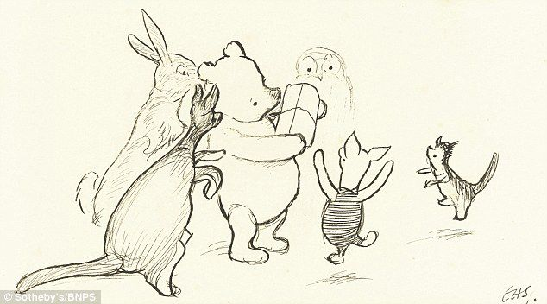

Figure 1: Shepard E. H. (1926), Pooh’s Party [graphite pencil on paper].
Inspired by his son, Christopher Robin, and his stuffed animal toys (Lowne, 2023), Milne’s Winnie the Pooh character designs utilise the familiarity that children may have with their own stuffed animal toys to be effective. Stuffed animals provide young children with stability and comfort (Barlow et al., 2012), which makes their portrayal in Winnie the Pooh all the more effective in terms of character design for children. Further research for this will be undertaken within the proposed essay.
Attributing certain features of animals to human traits or emotions allows for the birth of new visual metaphors for children, which may then be used narratively to help tell them stories about difficult topics. ‘In the great majority of animals there are traces of physical qualities and attitudes’ (Berger, 2009, p.20) similar to human beings, suggesting that one may find a level of escapism through anthropomorphised characters if they possess these traits. Exploring the anthropomorphised characters in a symbolic or metaphoric (Wells, 2008, p.28) manner may lead one to derive a more emotional meaning from a story. Difficult topics, such as depression or PTSD, may be hard for a child to digest due to the taboo nature of mental health subjects (Dogra et al., 2008, p.273) and the complexity of emotions. Therefore, presenting these types of stories to children through the method of anthropomorphism may allow for a greater sense of comfort (a theme that will be further explored later within the third keyword of this essay). Male theorises that children’s picture books hold the “key to worlds locked inside the imagination, as well as depicting worlds that cannot be seen” (Male, 2017, p.9). So, with this logic applied, it could be argued that the use of anthropomorphism within stories may help unlock the worlds inside the child’s imagination that may not always be so bright and cheerful. The proposed essay will argue that tending to the sad places within the imagination of a child matters just as much and that the love that children have for anthropomorphic animals may be the key to achieving this.

Identify
In the modern world where communication and social media are so widespread, it could be argued that ‘social sciences and humanities have surrendered to the word “identity”’ (Brubaker and Cooper, 2000). Inherently, an identity is what makes someone who they are and controls how they may see themselves or how they may relate to others, including characters within the pages of a book. ‘Identities may become quite significant to children’s self-concept[s]’ (Sani and Bennett, 2004, p.34) when growing up and, ‘through direct reference to political and social issues in history, illustration has proven that it holds power culturally’ (Brazell and Davies, 2014, p.4). Therefore, it is no surprise that they may feel strongly connected to or identify with an illustrated character that may look, feel or act just like them in a book.
The ability to decode visual meaning within a picture book is becoming ‘increasingly open to subjective personal interpretation’ (Salisbury and Styles, 2012), which means that readers of illustrated picture books must often draw their own conclusions from elements such as character design and narrative meaning. Young children possess a rich level of creativity and imagination (Duffy, 2006, p.17) that allows for them to immerse themselves in fictional worlds as a whole and explore themselves in the process. Moreover, as previously mentioned, people of all ages like to see themselves within things, due in part to the familiarity bias. So, it could be argued that ‘the desire for a mirror of our own emotional expression extends to other species’ (Parkinson, 2019, p.79) too and that anthropomorphised characters within these stories carry great importance in terms of identifiability for children.
In the particular case of illustrated books that cover sensitive/difficult themes like depression or PTSD, ‘children can learn about the nature and causes of different emotions from watching the emotional experiences of media characters’ (Wilson, 2008). Wilson’s theory suggests that seeing depictions of emotions and certain character traits within these fictional animals, such as depression, would allow for a crucial identifiability for those children that may be feeling their own form of sadness. Arguably, the method of acknowledging mental health within picture books, as opposed to other forms of media, may allow for a gentler approach to the subject for children. This theory is supported by Hutchby and Moran-Ellis, who state that:
Children identify with the characters: a process whereby they empathise with [presented] characters such that they begin to project their own experiences onto that character within the dialogue. This enables a child to identify with the characters without the emotional risks often associated with doing so (Hutchby and Moran-Ellis, 2001, p.136).
Since the topic of mental health will be discussed through the medium of comforting anthropomorphised characters, it may arguably help to cushion the weight of the negative emotions to the younger audience, due to their universal love for animals (Selly, 2014, p.8). ‘In order to communicate visually, the illustrator must be interested in humanity’ (Wigan, 2015, p.12) and with this, the intricacies of effective character design will need to play their role.
One key illustrator that will be covered in the essay under the topic of identifiability in character design will be Toby Allen. For an ongoing project entitled Real Monsters (Allen, 2023a), Allen designs animalistic anthropomorphised creatures that embody various psychological conditions and disorders. These include a vast range of relevant examples, such as anxiety, depression and bipolar disorder.
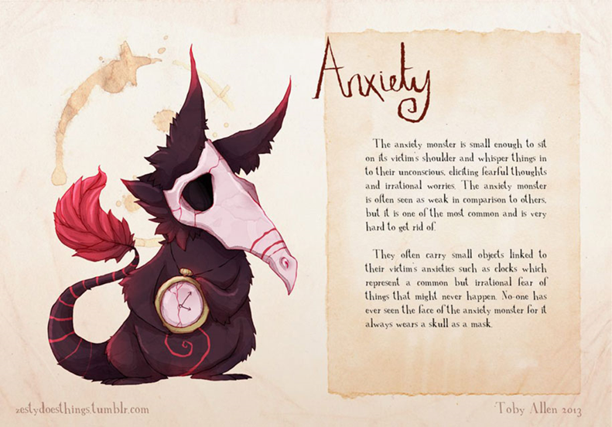

Figure 2: Allen, T. (2013), Anxiety.
Allen describes this series as ‘an ongoing personal project exploring mental health through character design’ (Allen, 2023b), which may then provide those who observe them with a deeper level of understanding. As seen in Figure 2, his work has strong links to the themes of the essay and will provide a strong case study into designing anthropomorphised characters for children around difficult themes like depression or PTSD. ‘The one thing that can unify what different children bring to a given book is that they may identify with an animal that has human attributes’ (Markowsky, 1975). Therefore, the essay will further explore the importance of designs like Allen’s Real Monsters project when it comes to identifiable character design for children’s books covering such themes.

Comfort
Described as ‘the easing or alleviation of a person's feelings of grief or distress’ (Oxford Languages, 2023), the concept of comfort is one that is highly personal and flexible to any given individual. Each person may feel a varied sense of comfort from different things, of which many can be captured and expressed through the means of illustration. Any given illustration may ‘connect instantaneously with [the] emotion, memory [or] experience’ (Hall, 2011) of a person, which could be utilised to trigger a feeling of comfort in some cases. When tackling difficult themes of mental health in children, such as depression or anxiety, the role that illustration plays could be argued as imperative. A child’s picture book that explicitly addresses upsetting topics may encourage an important discussion between parent and child (Spitz, 2000, p.9), which may then help provide support in order to deal with the issue and comfort the child in need. ‘Young children learn better from books that present information in a simple format’ (Kümmerling-Meibauer et al., 2015, p.42). Therefore, the fluidity and flexibility of illustration, as a medium, makes it an ideal method of communication for complex themes like mental health.
In particular, the proposed essay will delve into the use of anthropomorphic characters to communicate these themes to children within picture books. Two illustrated books will be deconstructed and analysed to provide further research into the ways in which this has been accomplished effectively. The first of which will be How Big Are Your Worries Little Bear? (2017) written by Jayneen Sanders and illustrated by Stephanie Fizer Coleman for children aged three to nine.
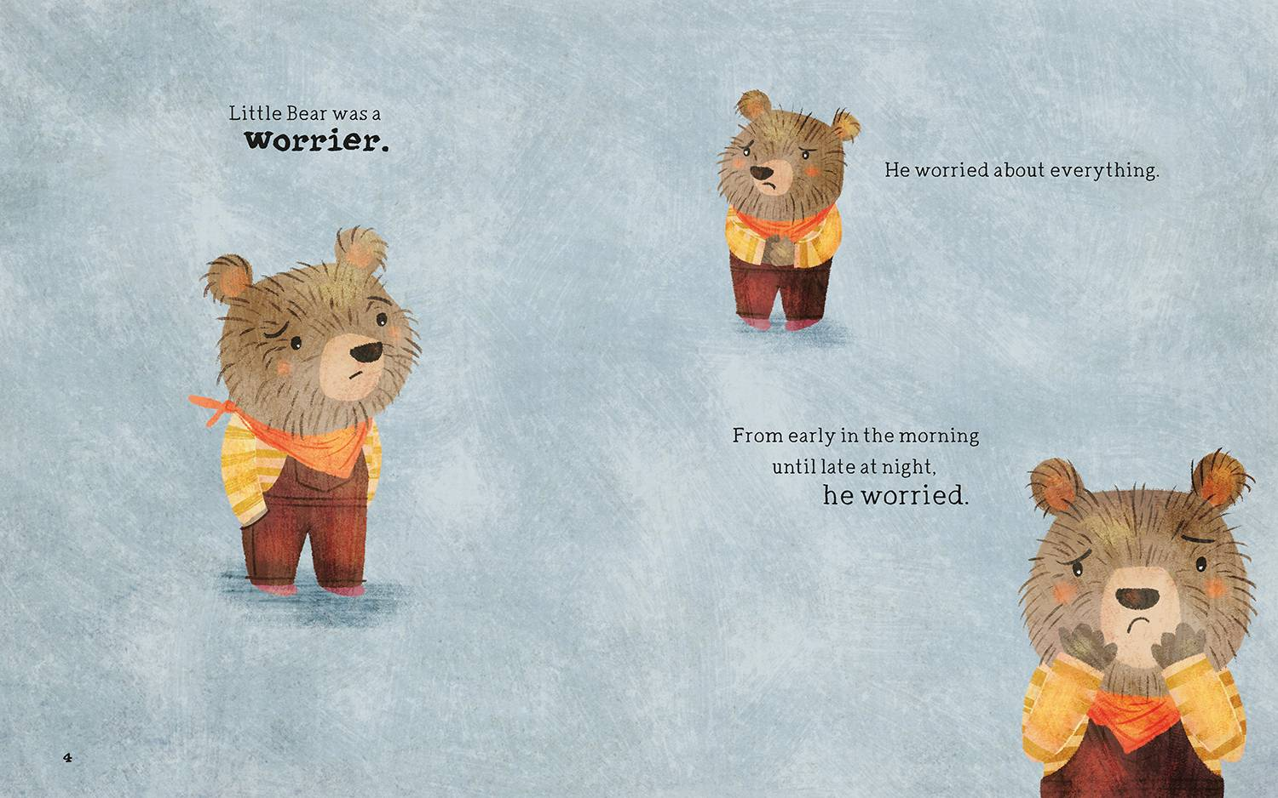

Figure 3: Sanders, J and Coleman, S. F., (2017), Little Bear was a Worrier.
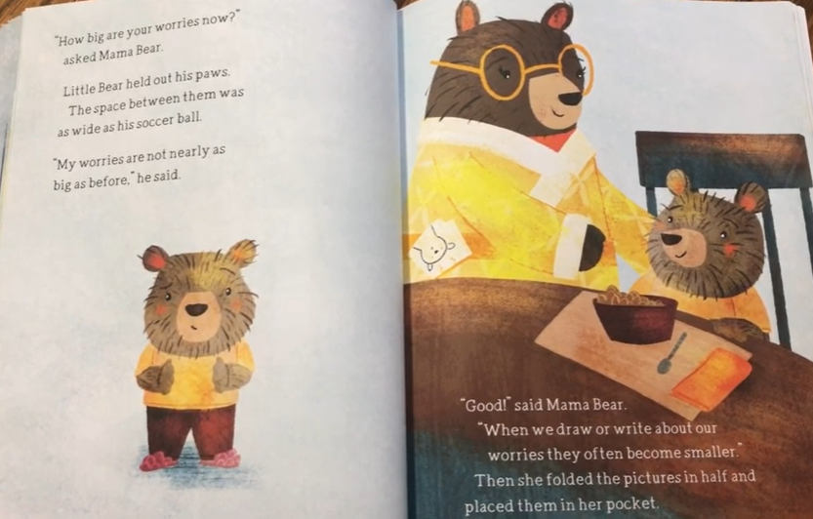

Figure 4: Sanders, J and Coleman, S. F., cited in HealthyCHILD (2017).
Using a small, anthropomorphised bear character by the name of Little Bear, this book aims ‘to help children overcome anxiety and manage anxious thoughts’ (E2EPublishing, 2014). Throughout the book, the reader is introduced to the character as a ‘worrier’ (as seen in figure 3) and all of the things that he may worry about during any given day. The fact that the bear is small in size and wearing what seems to be children’s clothing demonstrates that this character was meant to be appealing and identifiable for those of a younger audience. He stands, talks, dresses and behaves just like a normal child may and has a softer, rounder design that would likely comfort any child struggling with anxiety. The power held by illustration to ‘tie moments in a viewer’s personal history to the present’ (Zeegan, 2009b, p.18) may cause a child reader to identify with the anxious traits of the character. They, too, may worry about many things during their day to day lives and not fully understand the term ‘anxiety’ yet. Therefore, seeing this animal character, that is just as small and vulnerable as them (Tucker, 1990, p.100), feeling the same feelings may comfort the child and assure them that that they are not alone and that their feelings are valid.
Next, a book called The Kissing Hand (1993) by Audrey Penn, as illustrated by Ruth E. Harper and Nancy M. Leak, will be analysed. Centred around a racoon kit and his mother, this book tackles the theme of separation anxiety for children.
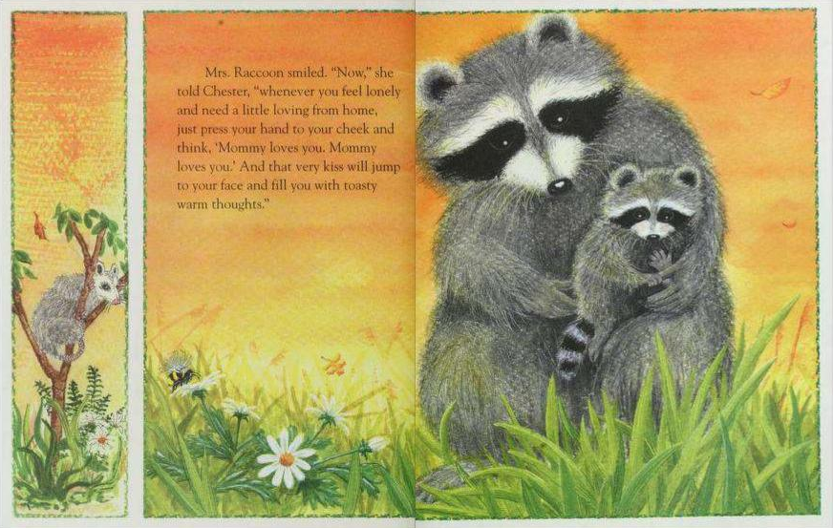

Figure 5: Penn, A., Harper, R. E. and Leak, N. M., (1993) The Kissing Hand.
The narrative follows a young racoon named Chester that struggles with separation anxiety from his mother, who then comforts him with a kiss on his paw and helps to relieve his worries of going to school in the woods. Unlike How Big Are Your Worries Little Bear? (2017) this book approaches the general theme of anxiety by using characters that are less anthropomorphised. The characters are designed like real racoons and the only elements of anthropomorphism present are the speech and emotion, as opposed to Little Bear who is bipedal and designed more similarly to a human child. The fact that the design of Chester is more animalistic strips the complexities of contextual elements such as race, age or class that may limit how one may identify with the character. The main focus remains on the anxiety of Chester, so that all the child may see is someone small and scared like them (Gravett, 2020), which will likely offer them comfort.
Overall, both How Big Are Your Worries Little Bear? (2017) and The Kissing Hand (1993) tackle the themes of anxiety within children in very similar, yet different ways. However, they both utilise anthropomorphic animals to offer identifiability and comfort to their child readers who may be struggling with the same problems. The illustrators have designed these books with the same visual softness, in order to reflect the sensitivity of the narrative contexts (Nodelman, 1988, p.78) they have encapsulated. Both books present the themes in appealing and reassuring ways for children and stand as key examples of anthropomorphism’s effectiveness within illustration. A further analysis and comparison will be carried out within the proposed essay to accompany my practice.

Conclusion
The key question I have arrived at is: Why use anthropomorphised characters in children’s books to tackle difficult themes of mental health? My practice for this project will consist of writing and illustrating my own children’s picture book themed around various mental health topics (primarily anxiety). The narrative will feature animal characters that have been designed to reflect and embody conditions and disorders like anxiety and depression, as inspired by the work of Toby Allen’s Real Monsters project. The practice will strongly relate to my theory by featuring anthropomorphised characters, who have been purposely designed and placed within a narrative for children to identify with and be comforted by. Taking inspiration from How Big Are Your Worries Little Bear? (2017) and The Kissing Hand (1993), the project will communicate the themes sensitively and rely heavily on the effective anthropomorphism of my characters.

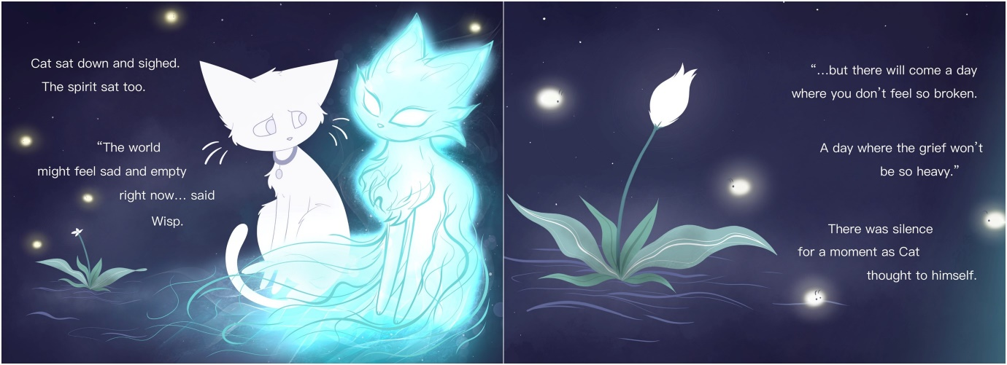

.”

Figure 6: Richards-Tang, K. (2023), There will come a day.
Due to the fact that anxiety was a challenge that I faced as a child, I feel personally connected to this project and compelled to produce an outcome that will capture it effectively. Similarly, my second year narrative project was a children’s book with anthropomorphised characters themed around grief (fig 6), which reflected my ongoing experiences and struggles at the time. The process of making the book comforted me in the ways that I hope my third-year project will for children. ‘In making [art] you lay bare a truth you perhaps never anticipated’ (Bayles, cited in Wix and Pierre, 2015, p.282), so my contemporary accounts may also help to inform this project in a similar way.

Bibliography
Allen, T. (2023). ZestyDoesThings Illustration. [online] ZestyDoesThings Illustration. Available at: https://www.zestydoesthings.com/realmonsters [Accessed 23 Apr. 2023].

Barlow, M.R., Cromer, L.D., Caron, H.P. and Freyd, J.J. (2012). Comparison of Normative and Diagnosed Dissociation on Attachment to Companion Animals and Stuffed animals. Psychological Trauma: Theory, Research, Practice, and Policy, [online] 4(5), pp.501–506. doi:https://doi.org/10.1037/a0028134.

Berger, J. (2009). Why Look at Animals? London: Penguin Books, p.20.

Brazell, D. and Davies, J. (2014). Understanding Illustration. London: Bloomsbury Academic, p.4.

Brubaker, R. and Cooper, F. (2000). Beyond ‘Identity’. Theory and Society, [online] 29(1), pp.1–47. doi:https://www.jstor.org/stable/3108478.

Dogra, N., Parkin, A., Warner-Gale, F. and Frake, C. (2008). A Multidisciplinary Handbook of Child and Adolescent Mental Health for front-line Professionals. [online] London: Jessica Kingsley Publishers, p.273. Available at: https://www.google.co.uk/books/edition/A_Multidisciplinary_Handbook_of_Child_an/YTIz78iWyq8C?hl=en&gbpv=1&dq=mental+health+and+children+taboo&pg=PA273&printsec=frontcover [Accessed 22 Apr. 2023].

Duffy, B. (2006). Supporting Creativity and Imagination in the Early Years. 1st ed. [online] Maidenhead: Open University Press, p.17. Available at: https://www.google.co.uk/books/edition/Supporting_Creativity_And_Imagination_In/ll1Rc5eyKpcC?hl=en&gbpv=1 [Accessed 23 Apr. 2023].

E2EPublishing (2014). How Big Are Your Worries Little Bear? [online] Educate2Empower Publishing. Available at: https://e2epublishing.info/hbay [Accessed 25 Apr. 2023].

Frisella, E. (2017). Anthropomorphism. [online] LitCharts. Available at: https://www.litcharts.com/literary-devices-and-terms/anthropomorphism#:~:text=Anthropomorphism%20is%20the%20attribution%20of%20human%20characteristics%2C%20emotions%2C [Accessed 27 Mar. 2023].

Gravett, E. (2020). Emily Gravett on How Animal Characters Can Help Children Build Empathy. [online] www.panmacmillan.com. Available at: https://www.panmacmillan.com/blogs/books-for-children/emily-gravett-on-animals-in-picture-books [Accessed 22 Mar. 2023].

Hall, A. (2011). Illustration. [online] London: Laurence King. Available at: https://www.google.co.uk/books/edition/Illustration/f_UgEAAAQBAJ?hl=en&gbpv=1 [Accessed 24 Apr. 2023].

Hutchby, I. and Moran-Ellis, J. (2001). Children, Technology, and Culture: The Impacts of Technologies in Children’s Everyday Lives. [online] United Kingdom: Routledge/Falmer, p.136. Available at: https://www.google.co.uk/books/edition/Children_Technology_and_Culture/NOfSHdweFLsC?hl=en&gbpv=1 [Accessed 21 Mar. 2023].

Kümmerling-Meibauer, B., Meibauer, J., Nachtigäller, K. and Rohlfing, K.J. (2015). Learning from Picturebooks. United Kingdom: Taylor & Francis, p.42.

Male, A. (2017). Illustration : a Theoretical and Contextual Perspective. [online] United Kingdom: Bloomsbury Publishing, p.9. Available at: https://www.google.co.uk/books/edition/Illustration/9wu8DQAAQBAJ?hl=en&gbpv=1 [Accessed 22 Apr. 2023].

Markowsky, J.K. (1975). Why Anthropomorphism in Children’s Literature? Elementary English, [online] 52(4), pp.460–461. doi:https://www.jstor.org/stable/41592646.

Mitchell, R.W., Thompson, N.S. and Miles, H.L. (1997). Anthropomorphism, Anecdotes and Animals. [online] Albany: State University of New York Press, p.5. Available at: https://books.google.co.uk/books?id=1kWZt3de0loC&printsec=frontcover#v=onepage&q&f=false [Accessed 21 Mar. 2023].

Nodelman, P. (1988). Words about Pictures : The Narrative Art of children’s Picture Books. [online] University of Georgia Press, p.78. Available at: https://books.google.co.uk/books?hl=en&lr=&id=IdCwtcCmN9oC&oi=fnd&pg=PP1&dq=character+design+for+children+picture+books&ots=hJGF8ZtG5c&sig=D_MsiFyWdeiLmBFWRL-Ac5X4aqw&redir_esc=y#v=onepage&q=character%20design%20for%20children%20picture%20books&f=false [Accessed 25 Apr. 2023].

Oxford Languages (2023). Comfort. [online] Bing. Available at: https://www.bing.com/search?q=comfort&qs=n&form=QBRE&sp=-1&ghc=1&lq=0&pq=comfort&sc=10-7&sk=&cvid=A3A4E38266C24A9F957EA9EA8683168F&ghsh=0&ghacc=0&ghpl= [Accessed 24 Apr. 2023].

Parkinson, C. (2019). Animals, Anthropomorphism and Mediated Encounters. United Kingdom: Taylor & Francis, p.79.

Pichot, T. and Coulter, M. (2011). Animal-Assisted Brief Therapy: a Solution-Focused Approach. [online] Google Books, Taylor & Francis, p.159. Available at: https://www.google.co.uk/books/edition/Animal_Assisted_Brief_Therapy/_MoGbwOwsZkC?hl=en&gbpv=1&dq=animals+in+childrens+books+comfort&pg=PA159&printsec=frontcover [Accessed 21 Mar. 2023].

Podberscek, A.L., Paul, E.S. and Serpell, J. (2005). Companion Animals and Us: Exploring the Relationships Between People and Pets. [online] Cambridge: Cambridge University Press, p.238. Available at: https://www.google.co.uk/books/edition/Companion_Animals_and_Us/tSs2yV_F4n0C?hl=en&gbpv=1&dq=attachment+theory+pets&printsec=frontcover [Accessed 22 Apr. 2023].

Reis, J. (2022). Advanced Design. [online] Switzerland: Springer Nature, p.168. Available at: https://www.google.co.uk/books/edition/Advanced_Design/inxrEAAAQBAJ?hl=en&gbpv=1&dq=familiarity+bias&pg=PA168&printsec=frontcover [Accessed 23 Apr. 2023].

Salisbury, M. and Styles, M. (2012). Children’s Picturebooks : The Art of Visual Storytelling. [online] United Kingdom: Laurence King Publishing. Available at: https://www.google.co.uk/books/edition/Children_s_Picturebooks/AvUgEAAAQBAJ?hl=en&gbpv=1 [Accessed 23 Apr. 2023].

Sani, F. and Bennett, M. (2004). The Development of the Social Self. [online] United Kingdom: Taylor & Francis, p.34. Available at: https://www.google.co.uk/books/edition/The_Development_of_the_Social_Self/vrp5AgAAQBAJ?hl=en&gbpv=1 [Accessed 23 Apr. 2023].

Selly, P.B. (2014). Connecting Animals and Children in Early Childhood. [online] St. Paul, Minnesota: Redleaf Press, p.8. Available at: https://www.google.co.uk/books/edition/Connecting_Animals_and_Children_in_Early/-TXoCAAAQBAJ?hl=en&gbpv=1&dq=why+children+are+drawn+to+animals&printsec=frontcover [Accessed 25 Apr. 2023].

Spitz, E.H. (2000). Inside Picture Books. New Haven ; London: Yale University Press, p.9.

Tucker, N. (1990). The Child and the Book : A Psychological and Literary Exploration. [online] Cambridge: Cambridge University Press, p.100. Available at: https://www.google.co.uk/books/edition/The_Child_and_the_Book/vig4AAAAIAAJ?hl=en&gbpv=1 [Accessed 25 Apr. 2023].

Wells, P. (2008). The Animated Bestiary : Animals, Cartoons, and Culture. [online] New Brunswick, N.J.: Rutgers University Press, pp.28, 99. Available at: https://www-jstor-org.ezproxy.uwtsd.ac.uk/stable/j.ctt5hj80j.5?searchText=&searchUri=&ab_segments=&searchKey=&refreqid=fastly-default%3A157663f94162487327321eaae174b1c5&seq=3 [Accessed 21 Mar. 2023].

Wigan, M. (2015). Thinking Visually for Illustrators. United Kingdom: Bloomsbury Publishing, p.12.

Wilson, B.J. (2008). Media and Children’s Aggression, Fear, and Altruism. The Future of Children, [online] 18(1), pp.87–118. doi:https://doi.org/10.1353/foc.0.0005.

Wimpenny, J. (2021). Aesop’s Animals. [online] United Kingdom: Bloomsbury Publishing, p.10. Available at: https://www.google.co.uk/books/edition/Aesop_s_Animals/_LQ8EAAAQBAJ?hl=en&gbpv=1&dq=anthropomorphism+aesop&printsec=frontcover [Accessed 22 Apr. 2023].

Wix, L. and D La Pierre, S. (2015). Book Review: Studies in Art Education. Available at: https://www-tandfonline-com.ezproxy.uwtsd.ac.uk/doi/pdf/10.1080/00393541.1998.11650031?needAccess=true [Accessed 25 Apr. 2023].

Zeegen, L. (2009). What is Illustration? [online] Switzerland: Rockport Publishers, pp.18, 24. Available at: https://www.google.co.uk/books/edition/What_is_Illustration/JfcYzi5M1rUC?hl=en&gbpv=1 [Accessed 21 Mar. 2023].

List of Figures:
Figure 1: Shepard, E.H. (1926). Pooh’s Party. [Graphite Pencil] WordPress. Available at: https://cdnhistorybits.wordpress.com/2014/11/27/canadian-icon-turns-100/ [Accessed 22 Apr. 2023].

Figure 2: Allen, T. (2013). Anxiety. ZestyDoesThings Illustration. Available at: https://www.zestydoesthings.com/realmonsters [Accessed 23 Apr. 2023].

Figure 3: Sanders, J. and Coleman, S.F. (2017). Little Bear Was a Worrier. Early Learning Shop. Available at: https://www.earlylearningshop.my/educate-to-empower/how-big-are-your-worries-little-bear [Accessed 25 Apr. 2023].

Figure 4: Sanders, J., Coleman, S.F. and HealthyCHILD (2017). How Big Are Your Worries Little bear? [Video Image] YouTube. Available at: https://www.youtube.com/watch?v=cttmPxZN5Aw.

Figure 5: Penn, A., Harper, R.E. and Leak, N.M. (1993). The Kissing Hand. Internet Archive. Available at: https://archive.org/details/TheKissingHand/page/n9/mode/2up [Accessed 25 Apr. 2023].

Figure 6: Richards-Tang, K. (2023). There will come a day. [Digital Artwork].

