UWTSD
WISA


Engineering Management & Management, Innovation and Sustainability
ACHA5012 & ACHA5007

Callum Francis-Beck
2312005
23/11/25

Table of Contents
1 Introduction 2
2 Roles and Responsibilities 2
3 Tasks and Timings 2
4 Personal Tasks 3
5 Milestones 3
6 Concerns 4
7 Full Plan 4

Introduction
For this assignment, my team and I have been tasked with designing and implementing active aerodynamics in the form of a moving rear wing for a vehicle of our choice. Using the university’s resources, we must design and manufacture the rear wing, then integrate electronics to turn it into an active air brake for track applications. To achieve this, we will use Simulink to interpret existing vehicle data and determine when and how the active wing should operate.

Roles and Responsibilities
Team leader/project management: Callum FB
A team leader must be efficient at problem-solving and capable of addressing potential conflicts before they impact the project. Their role involves overseeing all areas of the project to ensure that tasks are progressing as planned, while also acting as the primary point of contact whenever team members encounter difficulties or require guidance. In addition to managing people, the team leader must monitor budgeting, allocate team roles effectively, and track timelines to ensure the project remains on schedule.
According to the Belbin model, an effective project manager may draw on several different team roles, as there is no single profile that perfectly fits every situation. For example, the Team Worker role contributes strong interpersonal skills and helps maintain harmony within the group, while the Co-ordinator facilitates decision-making and ensures that each member's strengths are used effectively. The Plant provides creative ideas and innovative solutions, whereas the Monitor Evaluator offers objective judgement and analytical thinking. The Shaper drives progress and keeps the team focused under pressure, and the Implementer translates plans into practical actions. Together, these roles demonstrate that effective project management relies on a blend of attributes rather than one fixed style, allowing a leader to adapt to the evolving needs of the project. (Belbin, 1993)
Research: Mikel
A researcher must have a keen eye for identifying relevant information from reliable and credible sources. They need to communicate closely with the project manager to understand exactly what information is required at each stage of the project. Once gathered, the researcher must present their findings in a clear format that all team members can understand, while still retaining any necessary technical detail. In addition to gathering information, they must thoroughly fact-check all research to ensure accuracy and consistency. Finally, the researcher must deliver their findings in a timely manner so that other team members can progress with their tasks without delay.
Prototype design and CAD: Callum FB
A prototype designer must have strong creativity and solid problem-solving skills, as the design process often involves a significant amount of trial and error. It can be time-consuming, especially when issues such as spacing, fitting, or mechanical interference arise, which may require multiple design iterations. According to Belbin’s model, the role that best suits a prototype designer is the Plant, as this role emphasises creativity, imagination, free thinking, and effective problem-solving—qualities essential for developing and refining prototypes. (Belbin, 1993)

Control systems: Callum FB and Callum C
The people responsible for designing the control systems should have a solid understanding of basic wiring and component functionality. They also need to work closely with the prototype designer, as the control systems must be considered during the design stage. In addition, they require strong observation skills to identify the necessary data inputs for the system. According to Belbin’s model, control system engineers typically draw on two of the nine roles: the Plant, for creativity and effective problem-solving, and the Implementer, for their practical approach and efficiency in carrying out tasks. (Belbin, 1993)
Algorithm Selection: Group
Selecting the algorithm will primarily be the responsibility of the control system engineers; however, it is important for the rest of the team to understand how the chosen algorithm works. The algorithm acts as the “brain” of the project, controlling the rear wing in response to specific inputs, such as braking, and ensuring that the system functions correctly within the overall design.
Vehicle simulation: Oscar
To simulate the vehicle, the person responsible for this task must collaborate closely with the rest of the team, particularly the designer and the control systems engineers. Accurate simulation requires knowledge of the rear wing’s drag coefficient as well as the range of angles the wing will achieve, so effective communication between these roles is essential.

Final Spec: Group
To agree on the final specification as a team, we must combine our ideas to create a prototype that meets all required functions. The rear wing must ultimately act as an air brake while being strong and efficient enough to withstand the aerodynamic pressures it will encounter. Each team member should present their individual contributions to ensure that all tasks are complete and that no further adjustments are necessary.

3 Tasks and Timings

Project management – The project management section should run through the entirety of the project, as it’s a job of constant overseeing. The project manager needs to overlook all active projects to ensure the tasks are complete on time and are completed to a high standard. The role of this job doesn’t have an end until the completion date of the whole project.
Researching – Researching is the initial task before anyone can really start work. This task has been allocated six days to be completed, which should be enough time to gather all necessary information for the design team to create the initial designs for the project.
Designing – The design team has been allocated ten days to complete the initial and final designs, as well as have a fully built model based on the research carried out beforehand. This is one of the longest tasks, as CAD is a time-consuming process.
Control systems – The control system segment can begin before the final design has been created, as most of the components of the electrical systems are already known and the designer should have implemented them first. This task could take a bit longer than the allocated ten days due to trial and error.
Algorithm – Algorithm is incorporated at the same time as control systems, since both go hand in hand and the same team members are involved in deciding on both. The other team members will be informed of the selection and will be shown how it all works.
Vehicle simulation – This section has been given four days to complete, as it is not seen as an intensive task. The simulations are quick to run and easy to modify. The person conducting the vehicle simulations will have to work closely with the designer and the control systems team, as their specifications will be important in the simulator.
Final specification – The final specification should be completed relatively quickly. Ideally, at this point in the project, all sections should have their tasks finished; if not, the project manager will have to step in to help resolve any remaining issues. Three days have been allocated to finish all tasks and prepare the project for presentation.

Personal Tasks
As a group manager, my personal tasks integrate with everyone else’s, I need to keep track of everyone’s projects and make sure they are done on time and to the best of each person’s ability, I also need to delegate tasks to people I see fit to complete them, as well as being there to support team members in need. This task will be continuously done over the entire project duration as I am always overlooking the project and keeping track of the team’s progress through occasional team meetings.
As well as being the group manager I have also been tasked with the design and CAD section of the project, this involves me designing the entire physical rear wing as well as the mounting structure and housing for the electronics that will allow the rear wing to function as intended, this involves a lot of communication with the researcher for the project as I need to know what wing profile they have selected and I need to communicate with the control system person as the choice of electronics are crucial to the final design of the rear wing.

Bill of materials
Materials used for this project mainly consist of using programs and computer software with the exception of 3D printing material in the form of PLA, and the use of the electronic equipment such as servo motors, Arduinos and wiring.
PLA for 3D printing the model is around £12-15 per reel; for this project, I used a total of 37.04 metres of materials to create and test multiple models before achieving the end result. This length equates to the use of approximately ten percent of a reel, costing £1.20-1.50 to create a scaled model.
CAD software, such as SolidWorks, is free to use with the University’s licencing but if a personal software license were to be purchased, it would cost approximately £2,200 per year. Having access to the university’s licence really helps to keep costs more budget friendly.
The electronics are reasonably priced with a standard Arduino costing around £16-£25, a 9G servo motor costs around £6, a bread board to house all the wiring and components will cost somewhere between £5 for just the bread board and £11 to include all the wiring and other components needed, finally to run the Arduino MATLAB would be needed which is also free using university licencing but would normally cost £714 for the full library of addons as well as the base MATLAB program, but they do offer a student package which could cost a discounted £41.
Overall, for the entire project kept at a scale model it would cost only £48 providing all university software is used, if not it would cost £2,962 which is a heavy price to pay for a scale model project.

Milestones

The first milestone would be the first meeting with the team and choosing roles,
these will be very Important for the project, since each role has different strengths and weaknesses, keeping these in mind to create the most efficient team possible as well as choosing a good group leader who is able to bring the team together and keep them on track through the entire project.
Creating the first model in CAD based on the research will be the next major step as this allows some of the other members to continue their work with no restrictions. Using the CAD model the team could then start the simulation work and the control electronics.
3D Printing the prototype model is an important step after designing and running simulations as this now provides a physical item for the team to work with. The electronic control systems can be installed and tested.
Having a wing that can perform simple movements like rising from 0 – 180 degrees is crucial to the project overall as this is the fundamentals for the overall project.
Getting the wing to work with simulation data is an essential milestone as this is what the entire project is based upon, creating an active rear wing that reacts to braking.
The final milestone will be making sure that everything is presentation ready. Any adjustments to the rear wing need to be complete along with any improvements to the way it reacts. It must be professional and straight forward so that the audience can understand what is going on.

Concerns
One of the main concerns of being a group manager is ultimately time keeping, making sure mine and everyone else’s tasks are being complete on time or at least as close as possible to the deadlines set, doing this requires some good communication and team work to keep everyone on track. Another concern is keeping all team members happy and motivated to complete tasks to a high standard and again on time, holding regular team meetings should keep the project flowing as we can all help each other with any areas of concern.
As for areas of concern for my Design role, it is mostly due to my own ability to use CAD and turning CAD models to something physical. CAD is a highly skilled job as you need to have a keen eye for detail, making one small measurement mistake can cause the entire model to not work as intended. To avoid these issues, I can measure and double check the required measurements more than once before creating the final model.

Full Plan
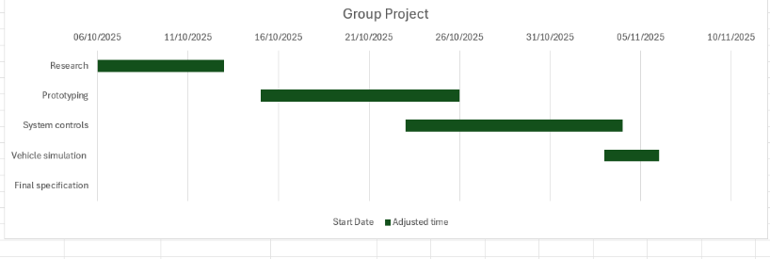

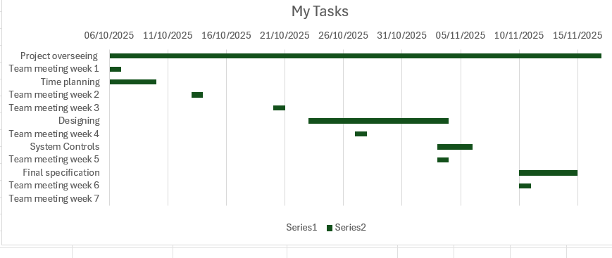

References

Belbin, M. (1993) The Nine Belbin Team Roles [online] Available at: https://www.belbin.com/about/belbin-team-roles [accessed 14th November 2025]

