

A Review: The under-reporting of sexual offences to Police

…………………………………………………….

Katie TOSH
Student ID: 1815290
BSc (Hons) Professional Policing Practice
March, 2023

Word Count:

Acknowledgements
I would like to thank my colleagues for their input in my dissertation, and the many research participants who have given their time to provide detailed and considerate responses.
I would also like to thank my supervisor Jane Davies for her thorough reviews of my dissertation throughout its completion. I will be ever grateful for her assistance throughout this process.

Declarations

- Declaration - This work has not previously been accepted in substance for any degree and is not being concurrently submitted in candidature for any degree.
Signed: Date: 06.03.2023

- Statement 1 - This dissertation is being submitted in partial fulfilment of the requirements for the degree of BSc.
Signed: Date: 06.03.2023

- Statement 2 - This dissertation is the result of my own independent work/investigation, except where otherwise stated. Other sources are acknowledged by footnotes giving explicit references. A bibliography is appended.
Signed: Date: 06.03.2023

- Statement 3 - I hereby give consent for my dissertation, if accepted, to be available for photocopying and for interlibrary loan, and for the title and summary to be made available to outside organisations.
Signed Date: 06.03.2023

- Statement 4 - I hereby give consent for my dissertation, if accepted, to be available on the university’s IT system to those who have consent to use the system.
Signed: Date: 06.03.2023

Abstract
The aim of this research project was to understand why women often do not report sexual offences or rapes to Police, given that only approximately one in every six victims report incidents to Police, and to further make recommendations on how women can be encouraged to report such incidents when they occur.
Research was undertaken through the medium of both surveys with the public and interviews with members of Gwent Police in response to the above aims, with answers such as victims fearing being blamed or judged, the lack of evidence available, fear of the court process etcetera being provided in response to the first aim. In response to the second aim above, recommendations on the investigation process were suggested to ensure evidence was not being lost, and that investigations were being dealt with promptly and effectively.
This primary research was substantiated by several items of literature which are considered in Chapter 2 of the dissertation, and provide an overarching reflection of the public opinion on the matter.
The objectives, as documented in Chapter 1 of the dissertation are met throughout the research, with recommendations such as further training for first responders, and further resourcing units such as CID or Public Protection Units being made by research participants and the supporting literature.

Table of Contents

Abstract ……………………………………………………………………………………. 4

Chapter 1: Introduction …………………………………………………………………. 7
  - Background …………………………………………………………………………... 7
  - Objectives ……………………………………………………………………............. 7

Chapter 2: Literature Review ………………………………………………………….. 9
  - Introduction …………………………………………………………………............. 9
  - The varying reporting rates of sexual offences across England and Wales 9
  - Victims’ reasons not to report sexual offences to Police ………………….. 10
    - Victim Precipitation Theory ………………………………………………….. 10
    - The support available to victims of sexual offences ……………………. 12
  - The attrition rates in sexual offence cases across England and Wales … 14
  - Conclusion and areas for further study ………………………………………. 16

Chapter 3: Methodology ………………………………………………………………. 17
  - Introduction …………………………………………………………………………. 17
  - Research Strategy ………………………………………………………………….. 17
  - Data Collection and Analysis ……………………………………………………. 18
  - Limitations and Potential Problems ……………………………………………. 19

Chapter 4: Research Analysis ………………………………………………………. 20
4.1 Introduction ………………………………………………………………………… 20
4.2 Analysis of Surveys ………………………………………………………………. 20
4.3 Analysis of Interviews ……………………………………………………………. 23

Chapter 5: Research Findings ………………………………………………………. 25
5.1 Theme 1 ………………………………………………………………………….….. 25
5.2 Theme 2 ………………………………………………………………………….….. 25
5.3 Theme 3 ………………………………………………………………………….….. 26

Chapter 6: Conclusion ………………………………………………………………… 27

Chapter 7: Limitations and Recommendations …………………………………… 29
7.1 Limitations …………………………………………………………………………... 29
7.2 Recommendations ……………………………………………………………….... 29

Bibliography …………………………………………………………………………….. 31

Appendices …………………………………………………………………………….... 36
Appendix A – Survey Responses ………………………………………………….... 36
Appendix B – Interview Transcript of Respondent 1 …………………………….. 52
Appendix C – Interview Notes of Respondent 2 ………………………………….. 60
Appendix D – Ethics Review …………………………………………………………. 65

Chapter 1: Introduction
  - Background
The topic of the under-reporting of sexual offences to Police is widely discussed by the public as a result of the astounding statistics that only approximately one in six female victims report incidents to Police (Office of National Statistics, 2021). Syal and Topping (2022) also bring this topic to the forefront of public attention as they shed light on the failure by organisations within the Criminal Justice System to deal with these incidents effectively in achieving successful prosecutions.
John (2023), on the other hand, states in her article that a young female victim of sexual abuse from her father wanted to encourage women to report incidents to Police, as it reduced her feelings of loneliness and gave her a voice. The above opposing views highlight the controversial nature of the chosen topic, thus emphasising the importance of an exploration into the under-reporting of sexual offences to Police.
A recent report by Baroness Casey (2023) described the data on sexual offences (reports and prosecutions) in the Met Police as a “grim read”, and further states that the data is similar across the country. Several failures of the Metropolitan Police Service are described within the report, where issues such as lack of specialist training, the inexperience of officers are explained. Further to this, approximately 30% of the attrition rates are explained by victim’s not supporting the prosecution. These are all factors within the lack of success in sexual offence and rape prosecutions, and the reason why so many women do not report these incidents to Police.

  - Objectives
The following objectives will be considered throughout the dissertation, by reviewing literature and completing primary research by way of surveys completed with members of the public and interviews completed with members of Gwent Police. The objectives will support the overall aim, which is to better the statistics mentioned above, by encouraging women to report incidents of a sexual nature to Police.
- To analyse the recorded statistics of sexual offences in England and Wales compared to the number of sexual offences reported to Police
- To gain an understanding of what prevents women from reporting sexual offences to Police through the completion of primary research
- To make recommendations on how women can be encouraged to report sexual offences to Police.

Chapter 2: Literature Review

2.1 Introduction

This aim of this literature review is to consider and critically evaluate the reasons behind the under-reporting of sexual offences to Police by women in England and Wales. This research will cover all types of sexual offences, from low-level sexual assaults to serious sexual offences such as rape.

The literature will be reviewed by theme/theory rather than chronologically, in order to cover the relevant areas in the most efficient way and identify the need for further research within the topic (Charlesworth, 2022).

2.2 The varying reporting rates of sexual offences across England and Wales

The Crime Survey for England and Wales shows 773,000 persons between the age of 16 and 74 to have become victims of sexual offences (including attempts) in the year ending in 2020 (Office of National Statistics, 2021). Out of these victims, 618,000 were women. The most recent figure of reporting rates compared to the actual believed number of offences tripled over the recent years, however dropped by 0.7% to 162,936 in the year ending in 2020. This suggests that approximately 600,000 victims did not report sexual offences to Police that year.

The figures highlight a discrepancy between the number of sexual offences that are occurring, compared to the number being reported, which aligns with the Rape Crisis (2022) view that “the vast majority of rapes and sexual assaults never get reported to Police”.

2.3 Victims reasons not to report sexual offences to Police

The specific reasons behind the under-reporting of sexual offences to Police include but are not limited to the fear of being disbelieved, fear of retribution, feelings of shame, fear of being blamed, and a lack of confidence in the Police and legal system (Taylor and Gassner, 2009). A theory focusing on victimology will be considered among other more general victim perspectives – that being the Victim Precipitation Theory (Harper, 2022).

John Scott, in his book ‘A Dictionary of Sociology’ (2014, pg 680) defines Victimology as “The study of victims of crime, including such aspects as patterns of offence, place of incident, characteristics of and relationship between victim and offender, and the like.”.

Throughout the research completed, one of the most common reasons behind the under-reporting of sexual offences that has come to light, is the victim feeling they are somehow involved or to blame for the incident (Parti and Robinson, 2021). Given this, it seems appropriate to review certain theories of Victimology, which study the victim of the crime and the role they play in the offence that takes place.

2.3.1 Victim Precipitation Theory
One of the many reasons behind the under-reporting of sexual offences to Police may be the victim’s fear of being blamed for the incident taking place (Harvey et al, 2014) The Victim Precipitation Theory explores the idea that “victims contribute to the criminal events that harm them, either through victim facilitation or through victim provocation” (Lasky, 2019).
Hans von Hentig (1940), described it as such: “The human victim in many instances seems to lead the evil-doers actively into temptation”.

Despite von Hentig (1940) being a leading thinker of his time, the world view has perhaps since moved on, and it would appear almost dissident to suggest that victims are to blame for being raped. This journal entry was written over 80 years ago, when society was far more misogynistic, and had far less sympathy for women than nowadays (Holland and Holland, 2018).

However, it is understandable that many victims may feel blamed for the incidents, given the way some have been treated by Police when reporting incidents. For example, BBC News shared an article in October 2022 relaying the story a teenage girl who reported a sexual assault to South Wales Police, and was told by an officer “Okay, that top is quite low-cut” (Williams, 2022).

The article title immediately draws the reader’s attention to the Police fault in blaming the victim, however upon reading the article, the writer explains how the Police in fact stated first that the victim’s clothing had no bearing on the matter. This victim later withdrew her complaint as she did not feel she had the required support for a female in her situation (Williams, 2022). News articles are often written in such a way that the title will draw the reader in, however the article itself does not directly reflect what the title suggests. The article itself focuses largely on the lack of support available to victims of sexual offences, rather than any victim blaming done by Police.

Menachem Amir (1967) provides a similar view to von Hentig in his journal entry “Victim Precipitated Forcible Rape”, stating that victim precipitation may refer to the “behaviour of the victim being interpretated by the offender as a direct invitation for sexual relations or as a sign that she will be available for sexual contact if he will persist in demanding it” (Amir, 1967).

As the article is 55 years old, this view will also likely be quite an outdated one, and potentially one that would offend the majority of women. However, it appears important to note that Amir is not blaming the victim’s behaviour, but attempting to gain an understanding of the offender’s thought process. Within the same article, he stated that precipitation is not as obvious or ‘clear-cut’ as seduction or provocation, but could be considered “undue, unwise or rash haste” where the victim does not have enough time to consider their behaviour or body-language, but is merely reacting to what is in front of them. This article is relevant to the chosen research topic, as it provides perspective on victims being partially to blame for the incidents.

This links well with the ‘Just World Theory’, which suggests that “individuals need to believe that people get what they deserve” (Lucas et al, 2007). If, as the theory argues, many people believe this, then a victim of a sexual offence may believe this of themselves, or believe that others have this view of them; that view being that the victim somehow deserved what happened to them due to being a generally ‘bad’ person (Landström et al., 2015). This fear of judgement from others; Police and pubic included, may deter victims from reporting incidents to Police.

There is room for further research here, in order to better relate this research to the overall research topic. Primary research can be done to understand the general public view on victim precipitation, and whether ideas such as the above may prevent women from reporting sexual offences to Police.

2.3.2 The support available to victims of sexual offences

The psychological effects of sexual offences, especially serious ones such as rape, are so momentous that for a victim to report the incident, they must be willing to “incur real and unique costs” (Allen, 2007). Allen describes the consequences of reporting rape incidents to Police, stating that victims will “lose their anonymity, risk retribution by the offender and stigmatization by people they know, and often must participate in an arduous, sometimes openly hostile, legal process” (Allen, 2007).

This article was written after research undertaken within the USA, but it shows the consequences to victims of offences such as these are unlikely to differ that drastically from country to country.

Despite the benefits of a victim reporting a sexual offence to Police (a criminal prosecution), a victim would require a lot of support to make such a report, especially given the above listed consequences/psychological effects. The victim support website offers insight into what support is available to victims of sexual offences, and the process of reporting incidents to Police or other organisations (Victim Support, 2022). Victim Support explains how they’re support can continue for years if required, and does not have to apply only to victims of recent assaults/rapes.

The website itself is extremely informative and is up-to-date. The website suggests that both the Police and organisations such as the Police or General Practitioners provide efficient services. However, a review by London’s independent victims’ commissioner completed in December 2021, states that Police are inadvertently discouraging victim’s from pursuing a complaint by managing their expectations of the legal process and court outcome (London City Hall, 2021). Claire Waxman, the victim’s commissioner, stated that rape myths (the idea of a traditional rape occurring in the middle of the night, by a stranger, in a public place) and stereotypes are deeply entrenched in our criminal justice system, and the victims are becoming the focus of the investigations rather than the offenders. Waxman used the example of obtaining the victim’s phone for digital evidence, rather than the offender’s.

This review, from 2019, was based on 450 rape allegations across London, and was completed alongside consultation from ISVAs (Independent Sexual Violence Advocates), who work to support victims following a sexual offence. According to the report, the involved ISVAs reported issues with victims not trusting Police, especially when dealing with digital evidence such as their phones.

The research is thorough, and makes sensible recommendations on how to better the victim service available, including offering support from ISVAs at a much earlier stage, whilst also offering free and independent legal advice surrounding the victim’s privacy (for example, whether or not to provide their phone as evidence).

The research, however, appears to focus largely on issues with the Police and the CPS, rather than any issues with the support available. In fact, throughout all of the research completed, only small explanations of the support available could be discovered, and the literature was lacking evaluations of the current support or any recommendations on how this could be enhanced. Given this, further primary research can be completed, both through surveys with the general public, and interviews with those working in the CJS, to evaluate the role of ISVA’s and the public knowledge of the support available.

2.4 The attrition rates in sexual offence cases across England and Wales

A common reason the under-reporting of sexual offences to Police is believing they will not achieve a successful prosecution from it, thus making the reporting process an emotionally distressing process with no benefit (Harvey et al, 2014).

It is important, then, to consider why so many sexual offenders are not being prosecuted, despite victims reporting incidents. According to an article on ‘Independent UK’, only 6% of all crimes in England and Wales have a charge outcome, with 1.3% of all reported rapes being charged, let alone ending in a successful prosecution (Dearden, 2022). These statistics are at a record low according to this article. However, the effects of Coronavirus may yet be evident, as courts work to keep up with the files being sent to the Crown Prosecution Service (CPS) from the Police. Despite only some of the article being accessible to the general public, it was clear that it did not account for the reasons behind these attrition rates, such as victims withdrawing their complaints (Hohl and Stanko, 2015).

Attrition is where “cases drop out of the criminal justice system (CJS) at one of a number of potential points of exit from that system” (Lea et all, 2003). The exit points mentioned are generally thought to be during Police involvement, whilst the case is sitting with the CPS, and in Court.

Many of the reasons behind these attrition rates include, but are not limited to victim withdrawal, partnership/resource issues, evidentiary issues etc. (George and Ferguson, 2021). This research report, completed by credible authors working for the Home Office and Ministry of Justice, details strained relationships between the CPS and the Police, causing time-consuming investigations and low-quality file submissions. The authors also document how in 2017, the number of reports made to Police for RASSO increased, however the number of convictions decreased. This does not promote confidence for victims in the future wishing to report their incidents to Police.

The report is extremely relevant to this research topic as it is quite recent, refers to England and Wales (which is the same scope that this research will cover), and it provides a robust review of the role of the Criminal Justice System throughout a sexual offence case. However, this report does not aim to understand the under-reporting of sexual offences, nor does it make recommendations on how to improve the prosecution rates. The report is effective in identifying the issues in the CJS, those including insufficient training, victim support, police resources, IT system limitations etc. and is successful in making recommendations for further research (victims’ perspective of the CJS, analysis of rape case files etc.). However, the report fails to make recommendations on how to reduce the attrition levels. Through the completion of this research project, recommendations should be identified on how to reduce attrition levels, which should in turn affect change in the reporting levels of sexual offences.

A further article published by BBC supports the above theory that strained relationships between the CPS and Police may be causing some rape cases to fall through. The article is titled “Police and CPS in rape case blame game” and refers to reviews completed by Police and CPS Watchdogs, whereby ‘finger-pointing’ between the organisations was referred to (Jackson, 2021).

The article includes multiple quotations from the CPS, taken from the official HMIC CPS report (HMICFRS, 2021), and also links the report within it, allowing readers to confirm any details documented. The article goes to further prove the requirement for a change in the report-to-court process, that being the moment the victim reports the incident, to the offender appearing in court for that offence. It is successful in identifying and prioritising multiple reasons for the process to fail, but again does not make any recommendations on how to resolve the issue. The author documents a statistic, stating that 57% of cases fall through due to victim withdrawal, thus cementing the above argument into the requirement of better support for victims of sexual offences.

2.5 Conclusion and areas for further study

From the literature that has been evaluated during this study, and other literature that has not been specifically mentioned, it appears that the most common reasons for the under-reporting of sexual offences to Police are the victim fearing being blamed for the incident, and the victim not believing they will achieve a successful prosecution in court. Given these factors, further literature relating to the Criminal Justice System has been reviewed, and several issues have been identified, such as the lack of appropriate victim care, strained relationships between the Police and the CPS, lack of sufficient evidence, and victim withdrawal.

However, the research already available fails to effectively resolve any of these issues, which is where further research is required. Further qualitative research may be required through interviews with those working within the CJS (Perhaps with Police, CPS, and ISVA’s (Independent Sexual Violence Advocates)), in order to make appropriate recommendations on how to better the investigation process, and in turn, the conviction rates for sexual offences.

Chapter 3: Methodology
3.1 Introduction
Throughout my literature review, certain areas were identified where the research was somewhat limited, such as weaknesses in the investigative process for dealing with sexual offences. Were this process more effective, the conviction rates for sexual offences may be higher, and women would feel more able to report sexual offences to Police. Another area which perhaps requires further research is more generalised, and relates to the public feelings towards the reporting of sexual offences and why perhaps women refrain from reporting them.
This primary research should respond to the two following objectives:
- To gain an understanding of what prevents women from reporting sexual offences to Police
- To make recommendations on how women can be encouraged to report sexual offences to Police.
The first of the above two objectives may have already been considered within the literature review, however, further recent studies may be beneficial in informing the research. The primary research completed here will also “make the material highly tailored to the needs of the primary researcher” (Walker, 2022).

3.2 Research Strategy
The research strategy will include a survey completed with members of public, and qualitative interviews completed with experts within the Criminal Justice System who deal with sexual offences.
The survey will be posted on social media for as many members of public to complete as possible, with the aim of approximately 20 participants. The purpose of the survey will be to obtain up-to-date responses from members of the public relating to why women don’t report sexual offences to Police, and possible experiences some may have had when reporting to Police. No personal details of participants will be asked, and participants will be reminded not to share any confidential information so as not to cause any ethical issues. The surveys will be completed by a varied group due to being posted on a social media page, therefore will be seen by persons of varied ages, genders, life experiences etc. It will also be set to share, meaning participants will be able to share it on their profiles in order to reach a wider audience. This method has been chosen as it is a fast and effective way of getting answers from a large group of people, without having to spend time talking to each individual participant. Research suggests that surveys can be conducted “at low cost and in a short period of time” (Nayak and Nayaran, 2019).
The interviews will be completed with approximately four members of the CJS that are involved in sexual offence investigations. These will likely be Police Constables and Detectives, however, experts such as ISVA’s (Independent Sexual Violence Advisors) and Crown Prosecution Service (CPS) prosecutors will also be asked to participate in order to shed light on the issues within the investigation/support/prosecution process. The research will target several different roles in within the CJS in order to most effectively identify the issues within the process, as opposed to hearing just one perspective (For example the Police) which may lay the blame on another member (for example the prosecution). This research method has been chosen as it will provide in depth answers to the question of issues relating to sexual offence investigations. Despite the interview questions being written prior to the interviews taking place, they will also be fairly flexible, in order to allow for further questions to be asked which relate to answers provided. The interview process allows for questions to be changed and developed in a dynamic way based on the answer provided in order for a full and detailed response from the participants. Another benefit it it’s capability in obtaining “a broader understanding of how and why certain things happen, and what are the opinions of people involved” (Jain, 2021).

3.3 Data Collection and Analysis
As discussed above, the data will be collected through the completion of online surveys and interviews with members of the CJS. The surveys will provide largely numerical (quantitative) data based on statistics and questions formats such as “To what extent do you agree with this statement” with an option of 1 (strongly disagree) to 5 (strongly agree). Each question will be documented within a graph or table to visually represent the answers. The research will likely be presented using Google Data, which assists in creating relevant graphs, charts and tables, which can then be inserted into the data analysis chapter of the dissertation.
The interviews with gather qualitative data based on answers provided. They will be gathered within tables, where the answers will be discussed by theme, such as the reporting process for sexual offences, the evidential requirements, the support available to victims etc. The tables will provide each interviewee’s views regarding each theme, in order to clearly and concisely understand the issues and recommendations on how to resolve the issues.

3.4 Limitations and Potential Problems
The research may face several issues throughout the collection stage based on the participants availability and time constraints. With regards to the surveys, there may not be enough willing participants responding to the survey on social media. To overcome this, the survey will be available for the longest amount of time possible, and will be reshared regularly. It was also be available for others to share on their page, and will be emailed to my work colleagues to increase the number of participants. Another issues relating to the survey may be that only certain groups of people (e.g. age, social class, gender, jobs) may answer the survey, due to the friends/followers available on social media. It is hopeful that the above solutions may also resolve this potential problem, as it would be beneficial for the survey to be completed by as wide a variety of people as possible.
With regards to the interviews, the aim is to complete interviews with several members of the CJS, such as Police, ISVA’s, CPS prosecutors etc. However, it may be that the ISVA’s and prosecutors refuse to become involved, thus limiting the research solely to Police. The time constraints on completing these interviews may also be an issue, as the research (surveys and interviews) and the analysis must be complete within approximately one month. The interviews will have to be completed as soon as possible to be able to analyse them in time. The interviewees will also be reminded not to discuss any cases in depth or provide any details that might make the victim/offender/investigation identifiable.

Chapter 4: Research Analysis
4.1 Introduction
The aim of the primary research was to fulfil the following objectives through the completion of surveys and interviews:
- To gain an understanding of what prevents women from reporting sexual offences to Police
- To make recommendations on how women can be encouraged to report sexual offences to Police.
The survey response target according to the methodology chapter was approximately 20 participants, however due to responses through social media there have been 73 participants, which ensures for a far more detailed and fair response, as the 73 respondents are more likely to represent the general population compared to 20 respondents. The survey response allowed the first objective to be fulfilled as will be documented below.
Following the surveys, two interviews were completed, one with a male response officer, and one with a female detective. The responses from these interviews fulfilled the second objective as the respondents were able to suggest recommendations to improve the investigation process, thus improving the prosecution rates. This should in turn encourage sexual offence victims to report incidents when they occur.

4.2 Analysis of Surveys
To open the survey, participants were asked the below question. Parti and Robinson (2021) document in their journal that the fear of being blamed is the most likely reason preventing victims from reporting sexual offences to Police, whereas the primary research below documents that this is the fourth most likely reason, with 21 of the responses choosing this option. In fact, participants responded that the fear of not being believed might be far more likely to prevent a person from reporting an incident to Police. The London City Hall review by Clare Waxman also discusses the emphasis placed on victims and their account compared to suspects, which supports the concept that victims are not being believed in the first instance (London City Hall, 2021), which reflects the below survey answers.

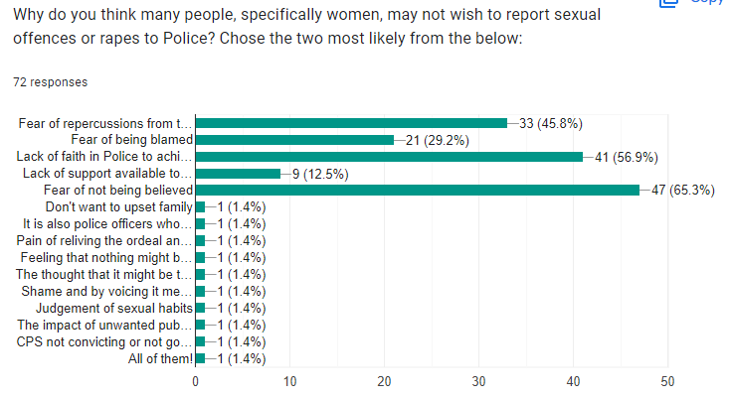

When asked what consequences victims face when reporting sexual offences or rapes, the respondents were able to provide individual answers (see Appendix A, Q4). Many respondents stated that the court process, the length of the investigation, the lack of evidence leading to no prosecutions, the possibility of offender retaliation, and the responsibility on the victim to share and re-live difficult experiences might impact their likelihood to report these things to Police (See below table for relevant figures). This reflects W. David Allen’s article on the under-reporting of rape, where he describes the legal process as arduous and openly hostile (Allen, 2007). Harvey et al (2014) also state a reason for the under-reporting of rapes in many cases is due to a lack of successful prosecutions, which is again evidences in the primary research responses noted above.
Consequences of reporting sexual offences | Number of responses
Court process | 16
Length of the investigation | 7
Lack of evidence | 9
Victim trauma from re-living experience | 17
Retaliation from offender | 13

Following this, respondents were asked about their knowledge of the support available to victims, and the impact this might have on their likelihood to report incidents to Police (see Appendix A, Q6 and Q7). Thirty-six of the sixty-six respondents reported that they had extremely limited knowledge regarding this, with nine respondents stating that they knew of websites such as ‘RapeCrisis.org’ and ‘Women’s Aid’, whilst two respondents who stated they had experience as victims stated they received no support, two others stated they were fully supported. When asked what impact this would have on their likelihood to report however, 55.6% of respondents stated the support available would have no bearing on their likelihood to report incidents to Police, whilst 38.9% of respondents stated that he level of support had no bearing on whether they would report an incident to Police or not. (see below image).
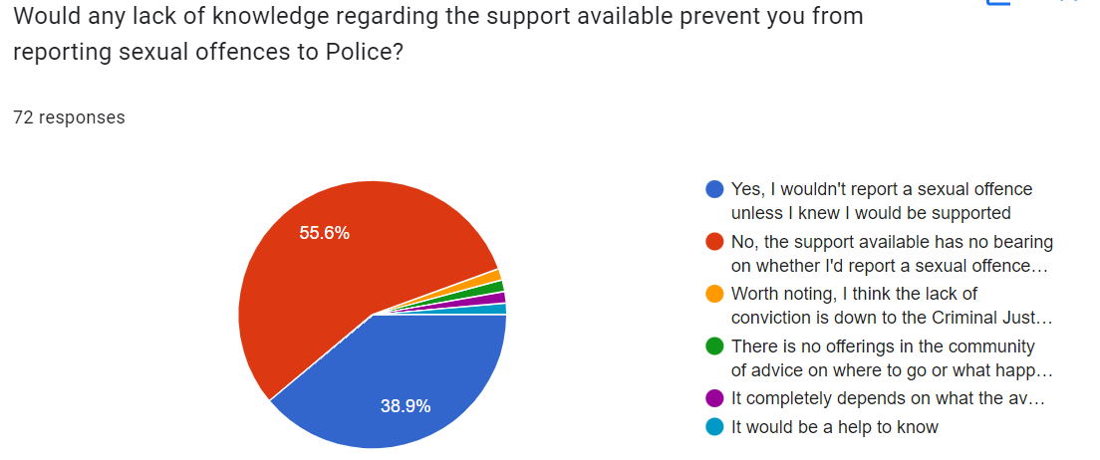
The Victim Support website (Victim Support, 2022) describes much of the support available to sexual offence victims, showing that there is in fact plenty of support available. However, throughout the research completed in the literature review, there was little to no reflection on the availability of support’s impact on victims. Thus, this primary research has been completed, which documents an even divide. However, perhaps further awareness of victim support may encourage victims to report incidents, given that almost half of the respondents stating that they would require evident support in order to report incidents.

4.3 Analysis of Interviews
Given that both the primary and secondary research indicated that the lack of successful prosecutions deters victims from reporting sexual offences and rapes to Police, two officers (one response officer and one detective) were interviewed to gain an understanding of why this is occurring and how it can be prevented.
When asked what the major issues within the investigation process were (see Appendix B and C, Q2), both interviewees provided answers such as victim withdrawal due to the length of the investigation or intimidation by the offender or court process. The government review by George and Ferguson (2021) aligns with this, by stating that victim withdrawal, evidentiary issues and partnership/resourcing issues are the main reasons behind the attrition rates. Respondent 1 (the response officer) also stated that communication issues with the CPS make the process increasingly difficult due to the lack of direct contact (see Appendix B, Q12). This correlates with an article released by Jackson (2021) where finger-pointing between the Police and CPS was discussed. From a Police perspective, it appears that the lack of communication from the CPS makes the investigation process unnecessarily difficult, and the blame is laid on the CPS. On the other hand, respondent 2 (detective) stated that some CPS lawyers are extremely helpful and provide contact details in order to facilitate better communication (see Appendix C, Q9). Respondent 2 did, however, state that this made the whole investigation process far easier, as the CPS can be approached regularly for advise and investigation direction.
Both respondents commented on the lack of resources to respond to and carry the investigations (see Appendix B, Q6 and Q10 and Appendix C, Q8), stating that despite officers not intentionally neglecting cases, they may spread themselves so thin that not all cases can be prioritised. Respondent 2 stated that she was carrying 14 cases over 31 occurrences at the time of the interview, and it was difficult to progress each one as often as she would like. This again relates to the above research by George and Ferguson, where it was stated that lack of resourcing plays a large part in the high attrition rates in RASSO cases. Lovell (2022) also reported that operational demand played a part as a large barrier to rape investigations.
The respondents were asked several questions on potential improvements that could be made throughout the investigation and prosecution process, and the responses were varied. Respondent 1 suggested the training of further SOLOs (Sexual Offence Liaison Officers), and taking response police officers out of the equation when it comes to dealing with sexual offences, whereas Respondent 2 suggested providing response officers with more training to be able to deal with sexual offences adequately in the first instance (see Appendix B, Q2 and Q6, and Appendix C, Q4, Q9 and Q10). Further to this, Respondent 2 suggested that further resources on CID/Rape Investigation Teams to carry out the investigations more efficiently and in effect, spread the burden would assist in resolving cases more quickly, thus reducing the likelihood of victim withdrawal.

Chapter 5: Research Findings

Following the completion of the above analysis of the quantitative surveys and qualitative interviews, several themes have been identified which closely relate to the literature review. This chapter will consider each of these themes based on both the primary and secondary research, and will then look to make recommendations on how to resolve the issue being discussed, that being the under-reporting of sexual offences and rapes to Police.

5.1 Theme 1
The first theme refers directly to the research question; why women do not report sexual offences or rapes to Police. The surveys suggest that women often do not report RASSO incidents to Police due to fear of not being believed, and a lack of faith in a successful prosecution. Other common answers included the fear of being blamed, and the fear of repercussions from the offender. The research also suggests that victims are concerned about the trauma of re-living the experience and going through the court process. When women do decide to report RASSO incidents to Police, a reason behind the lack of prosecutions is due to victim withdrawal, potentially as a result of the above fears. Further research was then completed into the reason behind the lack of successful prosecutions.

5.2 Theme 2
This brings us to the second theme, which is the high attrition rates in RASSO cases. The secondary research available suggests that victim withdrawal, resourcing issues, the lack of communication between agencies within the Criminal Justice System (for example between the Police and the CPS), and evidential issues play a large part in the reason behind the lack of successful prosecutions. Interview respondents within the primary research considered the lack of resourcing, especially within specialist groups such as Rape Investigation Teams and CID, which result in high workloads, low morale, and extended investigation lengths, all of which reduce the likelihood in successful prosecutions. Further research found that the lack of proper training for non-specialist officers resulted in small mistakes being made early on in the investigations (for example by first responders) which culminated in the loss of essential evidence such as forensic evidence that might allow for a prosecution.

5.3 Theme 3
The third theme identified considers recommendations on how to encourage female victims to report RASSO incidents. Given the first theme largely evidences a lack of successful prosecutions as the reason discouraging women from reporting RASSO incidents, and the second theme identifying reasons behind this, it seems common sensical that to resolve the initial issue, the investigation process must improve in order to reduce the attrition rates.
Research suggests that the training of further SOLOs (Sexual Offence Liaison Officers) would benefit the process by providing appropriately trained officers at the first response stage, which reduces the likelihood of mistakes when obtaining evidence such as forensics (samples, swabs, clothing etc.). Other suggestions included providing response officers with suitable training in the first place to ensure these mistakes are not being made, and that victims are given the best service possible from the beginning. Other suggestions were to increase the resources on specialist teams in order to share the workload out, thus reducing the length of investigations as officers have more time to complete them. Some research also proposed the increase of communication between the CPS and the Police, in order for the prosecution to better advise the Police on their investigations.

Chapter 6: Conclusion
The previous chapters have considered the literature already available on the topic of the under-reporting of RASSO incidents by female victims, the methodology of the primary research, the analysis of that research (having been completed through the use of surveys and interviews), and the findings as a result of that research. These chapters will have fulfilled the objectives noted at the beginning of the research project in the following way;

Objective 1: To analyse the recorded statistics of sexual offences in England and Wales compared to the number of sexual offences reported to Police.
This objective was fulfilled within the literature review chapter, where statistics from the Office of National Statistics review in 2021 were documented, which highlighted that only approximately one in every six female victims of RASSO incidents reported the incident. The review analysed the statistics by considering how the statistics have changed in recent years and identifying the issue of the lack of statistic in the last two years.

Objective 2: To gain an understanding of what prevents women from reporting sexual offences to Police through the completion of primary research.
The majority of the research paper has acted as an achievement of this objective, as seen within the literature review and surveys completed as part of the primary research. The researcher has gained an in-depth understanding through obtaining over 70 responses to the survey, where a sample group reflecting the general public have provided detailed and thought-provoking responses. The findings also summarise this within Theme 1, where the two most common responses are the lack of faith in Police to achieve a successful prosecution, and the fear of not being believed.

Objective 3: To make recommendations on how women can be encouraged to report sexual offences to Police.
This objective is completed through the review of literature around the attrition rates of RASSO investigations, where victim withdrawal and lack of evidence of the offence are two of the many reasons explained. Further to this, the interviews completed with two Police officers (one detective and one response officer) propose recommendations on how to reduce these attrition rates, in order to increase prosecution rates, thereby encouraging women to report rapes and sexual offences to Police. The recommendations proposed include more SOLO trained officers, further training for response officers, and more resources on specialist teams such as rape investigation teams.
Despite these three objectives being fulfilled, there is further research that can yet be completed around areas such as victim support, the attitude of Police when dealing with victims to ensure they feel respected and are not being blamed, and around the investigations into RASSO cases. These will be further explored within the below chapters relating to the research limitations and recommendations.

Chapter 7: Limitations and Recommendations

7.1 Limitation
Throughout the completion of the primary research, several limitations were faced. One issue faced during the completion of the surveys which I am now acutely aware of is the lack of questions regarding the respondents themselves, such as age, gender, ethnicity etcetera, which should have substantiated that the responses were provided by a sample that reflect the general population (Fink, 2003). This would’ve also clarified where certain people types such as the above might have had certain experiences or views.
When completing the secondary research, it was evident that despite authors clarifying the issues with the process, there was a distinct lack of recommendations for improvement, therefore many of the recommendations within Theme 3 of the research findings do not necessarily link with any other literature already reviewed.
An obvious limitation was the number of interviews completed. Due to time constraints, only two interviews could be completed. Were more interviews to be completed with mor experiences officers, a more accurate policing view might be obtained, where more recommendations for improvements on the investigation process might also be available.

7.2 Recommendations
Based on the above limitations, further primary research should be completed to include questions based on gender/ethnicity/age etcetera in order to obtain a more specific public view, and consider patterns where certain aged or gendered persons might share certain views.
Further research should also be completed around the recommendations of the chosen topic, i.e. how to encourage women to report sexual offences to Police. This research should be both primary (through further CJS interviews) and secondary (further literature-based interviews). Were the researcher to complete further interviews with Police, and other members within the CJS such as ISVAs (Independent Sexual Abuse Advocates) or CPS prosecutors, further recommendations could be obtained in order to respond to Objective 3 more effectively.

Bibliography
Allen, W.David. (2007). The Reporting and Underreporting of Rape. Southern Economic Journal, [online] 73(3), pp.623–641. Available at: https://www-jstor-org.ezproxy.uwtsd.ac.uk/stable/20111915?seq=2#metadata_info_tab_contents [Accessed 28 Oct. 2022].

Amir, M. (1967). Victim Precipitated Forcible Rape. The Journal of Criminal Law, Criminology, and Police Science, 58(4), p.493. doi:10.2307/1141908.
Casey, B. (2023) Analytical report - evidence to support baroness casey of Blackstock’s ..., Baroness Casey Review. Metropolitan Police . Available at: https://www.met.police.uk/SysSiteAssets/media/downloads/met/about-us/baroness-casey-review/baroness-casey-review-interim-report-on-misconduct.pdf (Accessed: March 23, 2023).
Charlesworth (2022) How to structure and write a thematic literature review. Available at: How to write a Thematic Literature Review? | CW Authors Accessed: 26 October 2022

HMICFRS (n.d.). A joint thematic inspection of the police and Crown Prosecution Service’s response to rape - Phase one: From report to police or CPS decision to take no further action. [online] His Majesty’s Inspectorate Constabulary Fire and Rescue Service. Available at: https://www.justiceinspectorates.gov.uk/hmicfrs/publications/a-joint-thematic-inspection-of-the-police-and-crown-prosecution-services-response-to-rape/.

Dearden, L. (2022). Only 6% of all crimes result in charge, as rape prosecutions hit record low. [online] The Independent. Available at: https://www.independent.co.uk/news/uk/crime/rape-prosecutions-charges-england-wales-b2001818.html.
Fink, A. (2003) in How to sample in surveys. Thousand Oaks: Sage, pp. 1–2.
George, R. and Ferguson, S. (2021). Review into the Criminal Justice System response to adult rape and serious sexual offences across England and Wales. [online] HM Government. Available at: https://assets.publishing.service.gov.uk/government/uploads/system/uploads/attachment_data/file/994817/rape-review-research-report.pdf.
Harper, L (2022). The Four Theories of Victimisation. Available at: The Four Theories of Victimization - Soapboxie Accessed: 26 October 2022

Harvey, S., Hayton, L., Beard, N. and Holly, J., 2014. Not worth reporting: Women's experience of alcohol, drugs and sexual violence. London: AVA
‌Hohl, K., & Stanko, E. A. (2015). Complaints of rape and the criminal justice system: Fresh evidence on the attrition problem in England and Wales. European Journal of Criminology, 12(3), pg. 328.
Holland, J. and Holland, J. (2018). A brief history of misogyny : the world’s oldest prejudice. London: Robinson, An Imprint Of Little, Brown Book Group.

Jackson, M (2021) Police and CPS in rape case blame game Available at: Police and CPS in rape case blame game - report - BBC News Accessed: 26 October 2022
Jain, N. (2021) “Survey versus interviews: Comparing data collection tools for exploratory research,” The Qualitative Report, 26(2), pp. 541–554. Available at: https://doi.org/10.46743/2160-3715/2021.4492. Fink, A. (2003) in How to sample in surveys. Thousand Oaks: Sage, pp. 1–2.
John, L. (2023) 'My biological father sexually abused me every night for six months', WalesOnline. Wales Online . Available at: https://www.walesonline.co.uk/news/wales-news/i-happy-little-girl-biological-26320702 (Accessed: March 6, 2023).
Landström, S., Strömwall, L.A. and Alfredsson, H. (2015) “Blame attributions in sexual crimes: Effects of belief in a just world and victim behaviour,” Nordic Psychology, 68(1), pp. 2–11. Available at: https://doi.org/10.1080/19012276.2015.1026921.
Lasky, N.V. (2019) “Victim precipitation theory,” The Encyclopedia of Women and Crime, pp. 1–2. Available at: https://doi.org/10.1002/9781118929803.ewac0517.
Lea, S.J., Lanvers, U., and Shaw, S., 2003. Attrition in rape cases: developing a profile and identifying relevant factors. British Journal of Criminology, 43 (3), 583–599.
‌London City Hall. (2021). Review of rape cases reveals victims discouraged from pursuing justice. [online] Available at: https://www.london.gov.uk/press-releases/mayoral/review-of-rape-cases-reveals-victims-discouraged [Accessed 21 Apr. 2022].
Lovell, C. (2022) Barriers to improving rape investigations, College of Policing. Available at: https://www.college.police.uk/article/barriers-improving-rape-investigations (Accessed: February 22, 2023).
Lucas, T. et al. (2007) “Development and initial validation of a procedural and distributive just world measure,” Personality and Individual Differences, 43(1), pp. 71–82. Available at: https://doi.org/10.1016/j.paid.2006.11.008.
Nayak, M. and Narayan , K.A. (2019) “Strengths and Weaknesses of Online Surveys” Journal of Humanities and Social Sciences , 24 (5), pp. 31–38.
Office of National Statistics (2021). Sexual offences in England and Wales overview - Office for National Statistics. [online] Available at: <https://www.ons.gov.uk/peoplepopulationandcommunity/crimeandjustice/bulletins/sexualoffencesinenglandandwalesoverview/march2020> [Accessed 6 October 2022].

‌Parti, K. and Robinson, R., 2021. What Hinders Victims from Reporting Sexual Violence: A Qualitative Study with Police Officers, Prosecutors, and Judges in Hungary. International Journal for Crime, Justice and Social Democracy, [online] 10(2), pp.159-160. Available at: <http://file:///C:/Users/406671/Downloads/1851-Article%20Text-7992-1-10-20210831%20(1).pdf> [Accessed 7 October 2022].
Rape Crisis.org (2022) Rape reports hit record high. Rape Crisis England & Wales. Available at: https://rapecrisis.org.uk/news/rape-reports-hit-record-high/ (Accessed: February 16, 2023).
Scott, J. (2014). A dictionary of sociology. 4th ed. [online] Oxford, United Kingdom: Oxford University Press, pg 680. Available at: https://www.oxfordreference.com/view/10.1093/acref/9780199683581.001.0001/acref-9780199683581-e-2530.
Syal, R. and Topping, A. (2022) Rape victims 'systematically failed' in England and Wales, report finds, The Guardian. Guardian News and Media. Available at: https://www.theguardian.com/society/2022/feb/25/victims-systematically-failed-in-england-and-wales-report-finds (Accessed: March 6, 2023).
Taylor, S.C. and Gassner, L. (2009) “Stemming the flow: Challenges for policing adult sexual assault with regard to attrition rates and under‐reporting of sexual offences,” Police Practice and Research, 11(3), pp. 240–255. Available at: https://doi.org/10.1080/15614260902830153.
Victim Support (2022). Rape and sexual assault. [online] Victim Support. Available at: https://www.victimsupport.org.uk/crime-info/types-crime/rape-and-sexual-assault/.

Von Hentig, H. (1940). Remarks on the Interaction of Perpetrator and Victim. Journal of Criminal Law and Criminology (1931-1951), 31(3), p.303. doi:10.2307/1137415.
Walker, J. (2022) Advantages of Primary Research, Research Prospect. Available at: https://www.researchprospect.com/advantages-of-primary-research/ (Accessed: December 14, 2022).
Williams, M (2022) Sex assault: South Wales Police officer said my top was low-cut – teenager. Available at: Sex assault: South Wales Police officer said my top was low-cut – teenager - BBC News Accessed: 26 October 2022

Appendices

Appendix A: Survey Responses
Q1.
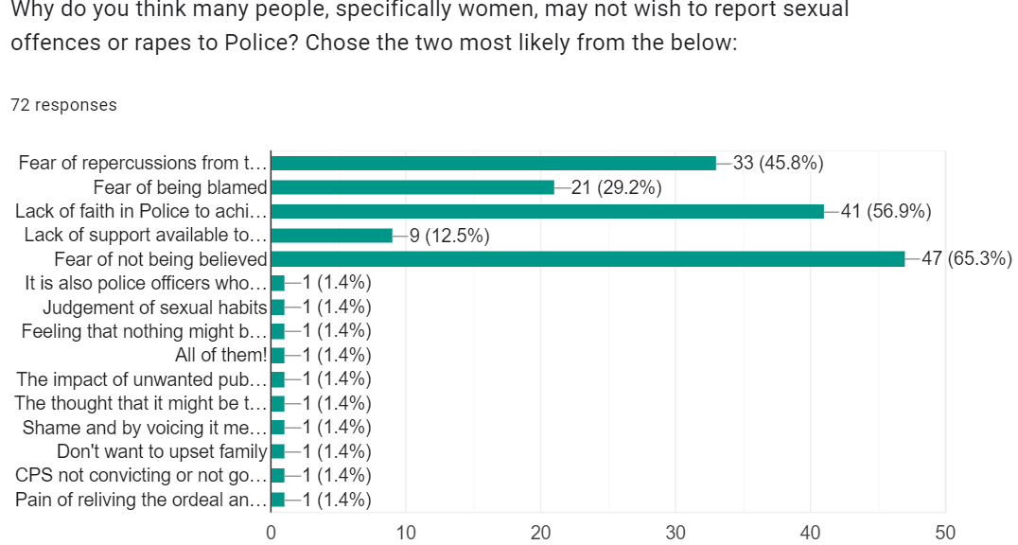

Q2.
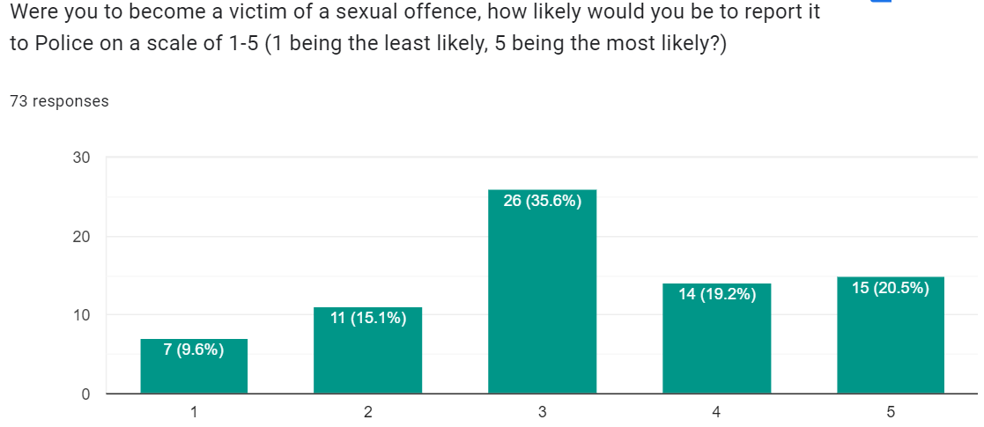

Q3.
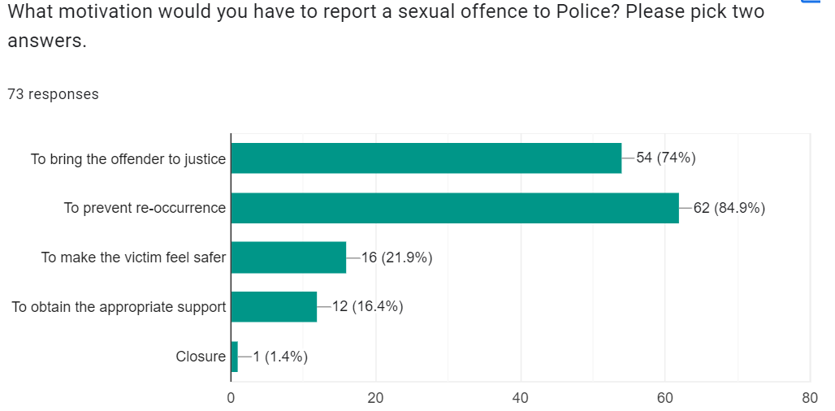

Q4. What consequences would you consider being an issue were you to report a sexual offence to Police?
- Lack of interest shown by the police
- Time from reporting to Police to any court date
- Knowing there’s an unlikely chance the offender will be prosecuted
- Not having enough evidence then getting the stigma of being “that girl”
- Further physical or sexual assault. Harm to family members.
- Embarrassment
- Lack of victim support until prosecution
- The process of being cross examined straight after one’s body has been forced upon
- Stress of hassle, expense, having to relive the experience
- Judgement
- Police officer not showing any empathy
- Violence from offender
- That justice would not be served, poor sentencing
- Not being believed by the cps and charge issued
- Anger from the perpetrator, not being believed, nothing being done about it, the person not being caught and dealt with and the risk of them doing it again to someone
- Being doubted would be one issue I think many women experience.
- Not being believed and then suffering mental health. Repercussions from the perpetrator
- Not being believed
- Don't know
- Possible retaliation from the offender or their family/friends
- Having to stand up in court and have my testimony torn apart
- The case being made front page news with the victim’s name broadcast widely.
- Not being taken seriously, especially for sexual assault that isn’t rape
- Further endangerment with perpetrator and backlash from perpetrators family / friends.
- Women tend to be labelled as overly sensitive and playing the victim, making things difficult for them in the workplace, and even among family and friends. Male police officers are probably more likely to have lower standards as to what they would consider a sexual offence. A victim of rape and other sexual assaults probably would rather forget the whole thing as soon as possible. Reporting it to the police might be the last thing they want to do, as it would draw out the experience and they'd be forced to relive the pain, and maybe without proper mental support.
- Going to court
- How long an investigation takes.
- Invasive and humiliating questioning
- Being labelled as someone who has been raped.
- Repercussions from perpetrator
- Breakdown of relationship, shame to the victim/victim's family, impact on victim's day-to-day life on having to relive the sexual offence while going through due process.
- The manner in which these cases are dealt with leaves no room for emotion. Victims are expected to be clear and precise, to know all the answers and to be able to repeat themselves to many different people. It’s uncomfortable.
- Community persecution, labelled as a liar , lack of evidence.
- Fear in all the ways
- Lack of evidence for a prosecution
- Not being taken seriously
- Public knowledge. Repercussions if offended not brought to justice. Impact of process on own health.
- The system is massively flawed, with video evidence, a written apology from the offender, medical reports, and mountains of police reports bailed for 21 months that’s it didn't even go to court, the video wasn't allowed to be used because I hadn't wanted the offender I was about to tape him raping me because it was my husband a whole new level of rules apply. It's a joke. He only list contact of the children after trying to kill my son by strangling him he was 2 years old. And again police didn't pursue a conviction I had to pay for it through court and a solicitor. Shame on you.
- Explicit rape, the police won’t bother with any less
- Trauma of an investigation and possible trial without a successful outcome.
- Proving the incident happened
- Being listened to, Police taking time to search for offender.
- Everyone knowing what happened, victim being blamed, ashamed, family and friends involved, people treating you differently
- The offender finding out
- Being harassed by offender trying to twist the words of victim
- My family and friends finding out about the assault, my attacker not being appropriately punished, especially if there's lack of evidence or in cases of coercion, lack of police support
- The belief it would be a long drawn-out process that would be invasive to my privacy or that I would not be believed by family/friends or officers.
- Lack of evidence, if I was drunk
- Lack of evidence of the offence
- Not being believed, bring judged forever then
- Not being believed or victim blaming
- Having to explain the offence many times with strangers.
- The court process
- Being investigated by Professional Standards if I was not believed
- Stigma
- Being blamed.
- Reliving trauma
- The offended getting away with it to hurt again
- Amount of time to be seen by an officer
- Privacy (need to protect family), what evidence victim would have to give (physical evidence? could be as bad as offence itself).
- Repercussions from the offender, the choice to be anonymous, feeling ashamed

Q5.
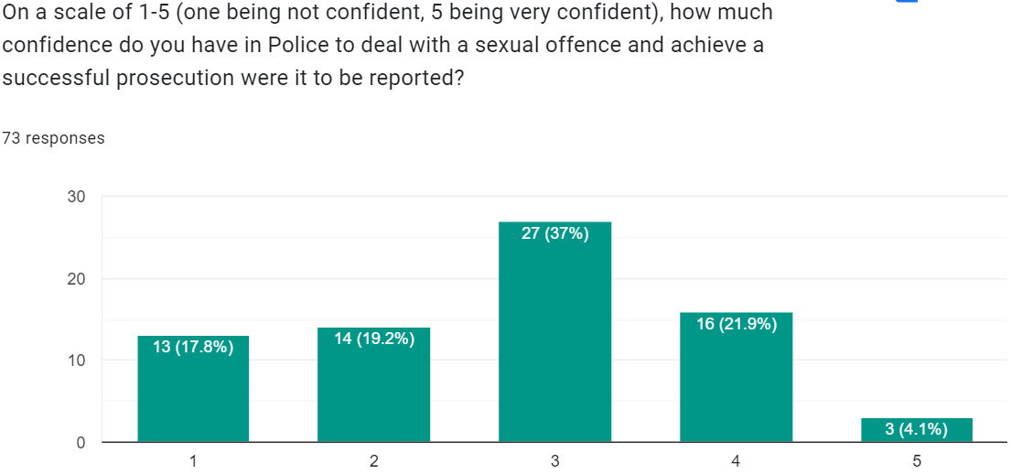

Q6. What is your knowledge of the support available for victims of sexual offences?
- None/very little x17
- Very little knowledge. I suspect that if a victim were to report a sexual assault and accepted a relevant court case, there would be some kind of restraining order to prevent the victim and the accused from seeing each other? But I was under the impression that was less to do with protection for the victim and more to do with not tampering with evidence/skewing the case. Generally, my admittedly uneducated assumption is that there is very little support, and the support that exists is not particularly accommodating. To be honest, from the little I know, I believe that the law, as it currently is, cannot successfully deal with cases of SA. The law is an organic thing, defined by and created for men and has changed very little since the integration of professional women into the justice system and the rise of women’s rights. However, women fight back in a manner distinct from the way men fight. Men have set the system up so that we do not ever interrogate the law’s own assumptions, instead we persist on interrogating the victims. But in cases of sexual assault, where it is extremely rare that there are any witnesses other than the accused and the survivor, and no lawful proof of sexual acts being without consent, the law turns into a farce. A sport to catch someone out on a misremembered hand placement that happened 700 days ago, because that’s often how long it takes a SA case to go to court. So yes, I imagine there is an *attempt* at support for SA survivors, especially with the integration of female or AFAB individuals into the police force. However, the justice system is faulty and due to it’s outdated and patriarchal nature, doesn’t support a modern society where we see SA and women’s rights as a necessity. Thus, making support for survivors of SA a losing game from the start.
- It can be obtained via New Pathways, Connect Gwent, Witness Care, via GP
- I have a good knowledge and am aware of the support offered to victims
- I do not know the correct support available.
- There’s lots of rape charities who can support victims available
- Mixed
- Pathways charity who offer therapy to go time of rape and sexual abuse
- Currently I don't know what official support there is
- Counselling
- Aware of services such as women's aid but would not feel comfortable using them
- Sign posting to counselling is often provided
- Very good
- Limited knowledge, potentially they can offer therapy-based support regardless of outcome
- Not much knowledge. Think there is initial sexual health clinic support but unsure what after
- I hold quite a fair amount of knowledge.
- 100% knowledge I work in domestic violence
- Good
- Gov.uk website provides links to support and contacts
- Complete, having worked closely with many police forces.
- Very little, just report to police and hope they get back to you
- Victim support officers and charities to talk to. Not sure what actual support other than counselling can be given.
- I know there is a liaison victim support
- I work as a Chaplain at a university so I am aware of support for student victims through safeguarding and report services. Other than that I wouldn't know much other than to contact the police, or an outside organisation e.g. a local charity that supports sexual abuse victims.
- Onyx booklets and referrals
- As a victim I received zero support
- I’d guess some counselling/therapy-based referrals would be available to any victim that came forward but I am not sure.
- I understand there are support groups but I’ve not experienced this for myself
- There is lots of support but the real need is prosecuting offenders
- Good knowledge!!! Personal Experience
- I am aware of New Pathways. If multi agency works well victims can have a good support network however this is reliant on all agencies involved communicating and working alongside each other.
- Rape crisis and other charities
- Rape Crisis Wales, Welsh Women's Aid, Stay Alive app
- Not a great deal although I would like to think a counselling service would be available to deal with the feelings and emotions of reliving the experience.
- I don't know but I do honour that they provide it.
- Limited knowledge of what support is available. It is not publicised enough
- I have little knowledge above victim support , special measures and presumably a referral to a specialist charity
- I know there is a lot of support and would access by looking online
- SOLO officer, charities
- I have very good knowledge.
- I’ve received counselling and rape victim support.

Q7.
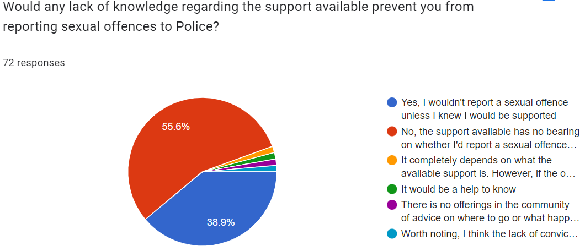

Q8. Do you believe the support available for victims of sexual offences might encourage a person to report a sexual offence to Police? Why?
- Yes
- It depends on what the support is, but again, we need to know about it before we’re assaulted not after.
- Yes, because a person might need to talk to someone that is neutral/unknown by the individual about the trauma they have endured
- Yes, as victims go through anxiety and distress having to re-live the trauma, any support to alleviate that would greatly help
- Dependant on family dynamic etc, some people may prefer to have support from family instead of agencies
- Yes, because they may feel like they have safety and understanding after reporting it. And bringing the offender to justice.
- Not sure
- Yes, as they will know that they will be helped if they report the sexual offence. Feeling safer and not alone.
- Maybe, it might make a victim feel safer when reporting an incident
- There is not enough support
- Yes. To make a victim feel safer and more at ease.
- Yes, because it helps to know you don't have to be alone.
- Yes, they’d know what to expect and how the reporting of the offence would help
- Rape crisis Wales
- With the right guidance from them potentially it could help support them to report it
- Yes, if a victim has confidence in the authorities then it will encourage them to report
- Unsure as it is a charge victim's look for and being believed from the outset is a main priority
- No, because despite any support given the outcome never seems to provide enough justice for the victim
- Potentially. So they know it’s not completely pointless to report it. But they may be able to get the same support without reporting the offence to the police, so they may just not bother to avoid the whole ordeal
- No. The support the police offer has no influence on reporting the crime. The only influence is the position the victim is In and whether they hold the courage. The most important time within the crime is the first 24 hours and I don’t feel the police can attend the the victims therefore leaving it to the victim to decide and report.
- Yes I do, there are lots of agencies out there who can now support victims of crime
- yes, if support is highlighted it would more likely to be used
- No clue
- Yes, I believe people would feel more inclined to report offences knowing that they have easy access to various support systems
- If I was confident of being believed then it would help me to report it
- No
- No because I don’t believe there’s enough support
- Yes. If victims knew exactly what support entails and how they can be protected they may be inclined to come forward.
- I believe it would encourage people to come forward and report an assault if they knew they'd receive proper support. Without support, they're forced to relive the experience alone, and this would certainly take a toll on a person.
- Yes, as it would affect mental health
- Yes because they won’t feel as alone through such a long and gruelling process.
- Increased confidence in system
- Yes I would, if there is good support, you feel like it’s a safe place to help you get back into social life.
- It will give a person more faith that the agencies that the police refer to them are best placed to support the victim
- Yes, it would help to know what support was available so the risks of seeking help could be minimised.
- Varies on the victim. Police support is one thing but if they are in a vulnerable situation with no other support it can be difficult to trust the police
- Yes to give more confidence to other victims who haven’t come forward
- Possibly but other concerns may outway the support
- Reporting it with no support or safety after would be much scarier and lonelier.
- Yes. If the right support is in place and the person who has been assaulted feels they can go forward with support and help then this would encourage a lot more people to come forward.
- No not hugely as support is to deal with the impact of the crime and police to deal with punishment
- Don’t know
- There nothing
- If they felt safe enough they'd say something
- Yes, however all cases differ therefore it’s dependent on the circumstances.
- Possibly
- Potentially - something that made aid support being found
- Yes, it helps to have someone talk through the process. It can feel isolating doing it on your own.
- No because when a sexual offence has happened the victim feels dirty and ashamed and not overly ready to open up and receive such support. Because even tho the victim wasn't to blame , there is still an element in the victims thoughts that she must be to blame . It can sometimes be years before a person is ready to report the crime.
- For some people yes, if they feel that they will be given guidance on how to overcome their trauma and also their understanding of the legal aspects
- If a person reporting a sexual offence understood that there was support available especially regarding life long anonymity in the press then I believe a person would be more likely to report a sexual offence to the police.
- Yes, they wouldn't feel so alone.
- Yes, they would know there was someone there to talk them through the process and help them back to as normal a life as possible
- No not in its own
- Yes, knowing they are not alone and being safeguarded and supported
- Yes, potentially to help them process and move on from the offence.
- Yes as the victim may be isolated from family / friends and may not have their own support network
- I don't think so, there is sufficient information re support services and self referral available on the internet
- Yes support could not only help them survive the trauma of the offence but also the ordeal of reporting it and the associated physical examinations following such an offence
- Yes, this would show more empathy from the police and that they were prepared to take the matter seriously
- Possibly, if they know they will be helped
- No - if someone doesn’t want to report support available will not persuade them to
- Yes, I think if there was support throughout the whole process involved from reporting, through giving evidence, going to court, person going to prison and then being released would make all the difference. If the victim is just forgotten after sentencing (or not), then what is the point…
- No, why should it. The victim should report it either way.
- Maybe
- If after showing evidence and bring believed became a norm, then I do believe it would encourage people to report it. I have seen too many cases where even after proof is given where the person committing the crime gets away with it. Just being believed is support, and if this support was given, it would definitely encourage more victims to come forward

Q9.
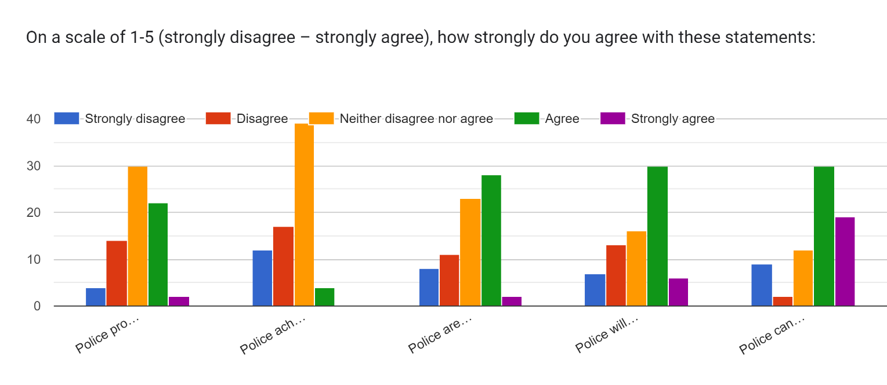
Statement 1 - Police provide an effective service when dealing with sexual offences
Statement 2 - Police achieve successful prosecutions for sexual offences
Statement 3 - Police are able to help sexual offence victims receive the support they need
Statement 4 - Police will not judge victims of sexual offences based on the incident
Statement 5 - Police can be trusted to keep all information confidential that needs to be to kept as such

Q10. Any other thoughts/comments…
- No
- I am commenting from a position of no experience, other than what I've heard on the news and from some people sharing experiences on podcasts.
- The whole process is a problem. I don’t know where my local police station is. They never answer 101. If something happened I do not know the process involved. Would be worried about repercussions, particularly with social media. Trust the police but not the justice system. What happens when they are let out?…
- The system is not working for the victims and it needs to change not just for victims but people falsely accused. There is no faith and police themselves are being found out for this behaviour people who join who wish to help should understand why people do not have this faith and then fix it. Not easy to fix but crimes of this nature are high and in our schools our police and our community. This system is not able to deal with it fairly
- Sadly, the system is more concerned with giving time to those who are dealers than those who sexually abuse or hurt others. To get justice you need evidence, and this usually isn’t possible and even when it is provided, it doesn’t guarantee a good outcome for the victim. Even if they get time, it’s usually minimal and the victim is left with scarring memories and the knowledge that the perpetrator will be free to offend again shortly.
- Wish there was more support about this in general and that we were told about it more often. A lot of people have no idea what they can do after sexual assault and are unaware of who they should go to and what can be done about it. If support was more frequently discussed, I think people may be more likely to try to get it or even report incidents
- Unable to agree or disagree as I don't know the system to comment on it or individual officers who may do their job well or the contrary
- As I have no personal recent knowledge of victim support - I have based my answers on what I hope is the case
- Rape is extremely complex and it’s difficult to answer these questions without further context. For me if I was raped and the offender was a stranger, I would be more likely to report this as I am aware the likelihood of prosecution is much higher, if the perpetrator was an intimate partner, I may report this but I would not support prosecution due to the evidential difficulties this would bring to the case, however, I would still seek support regardless of reporting to police.
- I’ve had a stalking case whereby there was CCTV evidence, witness evidence, confessions from my stalker. And the CPS dropped the case on the grounds that he said he was sorry. And the stalking continues. I’ve lost most of my faith in the justice system.
- I think a lot of the above really depends on the individual officer you go to. One could be extremely empathetic and understanding while the next could be dismissive/insensitive (male or female). This alone is enough to completely change someone’s experience with the police after a traumatic event.
- The problem is not fully on the police but rather on the laws around consent. They make it practically impossible for a victim to win a case.
- Police get a lot of the blame or case failing, whereas it should be the CPS
- The public are aware of the impact that the CPS has at deciding if a case progresses or not, and the number of times that they decline all types of cases. Victims do not wish to take the risk of reporting, for this to be dropped or fail at any point along the way.
- It's not the police that make the choice on prosecutions, it’s the CPS. The above statement as such needs to be amended.
- sorry for treating this as my own dissertation rather than yours
- Even when the crime has occurred, still there is an element even a minority of judgement in police and having to go through video statements and other statements sometimes repeating yourself it makes you feel like you’re not believed and in somewhat the suspect and not the victim. It takes a lot for a woman to open up about what happened to her and when it comes to historic sexual offences, you almost lose hope that the offender will in fact be prosecuted. Especially when mental abuse has occurred because in an abusive relationship your still expected to pretend that you love the offender, in fear of what he would do to you if you didn't make it look like a "happy marriage". And this can go against the victim and therefore the offender can in fact get away with what they have done and in the end the victim feels betrayed by police and the offender is free to do this once again. All because of the manipulation of the offender , and the woman carrying around with her forever what he has done to her, and he basically walks around with his head held high and now to feel untouchable.
- I was the victim of sexual abuse as a child, the answer was found not guilty , we were forced to move. Due to community persecution, I received no support. Years later I was raped and didn't report as a direct result of the experience. I still have trauma and PTSD from the cross examination in court.
- If you've never experienced sexual assault, it can be very difficult to be empathetic and put yourself in someone's shoes. It's very easy to find excuses and reasons not to believe someone, especially a woman. In a world primarily run by men, misogynistic ways of thinking have been ingrained in us all, and this is something we need to change.
- Thankfully I’ve never had to deal with this personally but cases that I have heard about have not given me confidence

Appendix B: Interview Transcript of Respondent 1
Explain the sexual assault/rape investigation process.
From the start – a call comes in after someone reports it, and then usually response officers will go and then take a first account, complete the golden hour enquiries, secure any forensics, obviously safeguard the victim, identify the offender, prepare a handover package for reactive CID or the rape team, then the rape team takeover.

What are the major issues in this process?
The fact that we wear so many hats as response officer. One minute you can be going to a fight on the town and the next you could be going to a rape call, and you’ve got to be in the right mindset to comfort the victim, you’ve got to know what to do with the forensic kits, the availability of said forensic kits which are just few and far between. There is a process where SOLO’s attend, but it just seems to be that every time you ask for a SOLO, there’s no SOLO available, so what is the point of having this process in place if you’re not going to use it. The investigation is handed from person to person to person, so that response officer goes, takes the first account, then hands it on to a SOLO, and that SOLO hands it on to a CID officer. It would be nice if there was a unified response, in other forces CID respond straight off the bat and attend in the first instance.
Essentially, we don’t need a first account from them because their report (999/101/third party report) is their first account. I don’t see why we go, complete an ONYX booklet which is exactly what is said in the initial report just then to pass it on to CID – get CID there in the first place, and if they feel they need a more detailed first account then they can do that.

Do you think we as response don’t go to them often enough and aren’t trained effectively enough to be able to deal with it straight off the bat?
It’s strange, because they try to send female officers to a female rape call, and male rape calls are extremely rare, and on the odd occasion where male officers do have to attend a female rape call (for example, if a female has said she’d be more comfortable speaking with a male officer), males are so uncomfortable in that situation, and they don’t deal with it often enough, that it impact the way they deal with it. It would knock my confidence if I went to a call and I knew that the victim wanted to speak to a female officer. I’d be uncomfortable and they’d be uncomfortable. If there was a dedicated team who deal with it every day, they would know how to deal with those situations better, how to support and answer the questions. Victims ask us questions that we’re not going to know the answers to because it’s stuff CID deal with. So we either answer as best as we can, which won’t always be the right information, or you just have to say sorry that we can’t answer, and it looks bad.

Do you think that if CID/RIT were first responders to rapes, that victims would feel ore inclined to report things, or if they were to report things more inclined to continue with the process and feel encouraged and supported..?
Yes, because I think that having a response officer turning up at your address is not the correct response to someone reporting something as intimate as that. It requires a delicate approach, and that delicate approach is likely going to be a female plain clothes officer sitting down, having a cup of tea with them perhaps, has a chat with them and goes through the process from start to finish, remains with them, rather than two burly men turning up in uniform, taking a first account and saying “SOMEONE FROM CID WILL BE IN CONTACT”, then passing it on to someone from CID, who then completes the rest.
Victims who have reported rapes more than once are not going to have faith from how it was dealt with the first time, or have friends who have previously reported rapes. The word goes around that the process is a mess, and that most outcomes for rape investigations are not positive for the victims, and so people do lose faith in us.

What is your view of the Police initial response to a sexual offence? Do response officers understand their role, or have enough training to fulfil this role as required?
The Police response is a bit of a firefighting situation, where the response relies upon whatever can be scrambled together at the time. For example, a rape comes in and it goes down the pecking order to deal – SOLO, CID, Experiences officer, any female officer, anyone else who’s free. It’s a poor service. The response is often rubbish.
Response officers know to go and take an ONYX booklet, obtain facts (What happened? Where? Who by Etc.) and think that is where their role ends. When it comes to rape kits, most on shift would not know how to use them or would have done more than a couple throughout their whole careers. They would not be confident doing it by themselves, and it may just be a case of muddling through. We would not know what to do with the same certainty that CID would have. It’s important things like seizing the tissue once they’ve been to the toilet, where you may only have five seconds before it’s too late and they’ve thrown it in the toilet. Officers need to know this, and CID will not exactly what to do as they deal with it all the time. If CID dealt with it from the offset, the process would be smoother, there would be less hands touching everything which means the information would probably be better, we’d get more from the first account and initial golden hour enquiries. When they do their CID attachments, officers will see how CID deal with it, and on the off-chance that they have to deal with one themselves they can pick it up. Nobody ever shows anyone how to deal with rapes, no one tutors someone through the rape process.

Would an increase in SOLOs benefit the process?
I can’t remember the last time I saw someone who was SOLO trained. They either need an uplift in SOLO’s so that there’s one or two working every shift across the East/West, or they need to make all CID officers SOLOs, and CID can attend rapes as first responders/SOLO’s. There’s always going to be someone from CID or the rape team working. They made all CID ABE trained and it would be beneficial to do the same with SOLO training.
What are your views on the support available to sexual offence victims and the impact that has on their likelihood to retract their support of the prosecution?
I don’t really know what support there is out there as we don’t deal with that a lot, but I’d imagine there is support out there but it’s just going to be mainstream support. For example, if the rape has effected the victim’s mental health, then we’d refer them to mainstream mental health support services, as we would to DV support agencies . I don’t know if we as response officers would offer a bespoke rape support package.

If we knew more about that support (ISVA’s, RapeCrisis.org) and were able to push that further to our victims, do you think that that would encourage them in not retracting etc..?
Because we don’t deal with that sort of that thing, CID/SOLOs have much more to do with it. If it’s anything like IDVA’s, they are so stretched, that I wouldn’t want to promise a victim an ISVA for that person to not live up to their expectation. I don’t want to say “SOMEONE WILL BE IN CONTACT TO SUPPORT YOU.” When A; they may not, and B; they may just ring and say there’s nothing they can do, or ring several weeks later. I don’t know enough about how ISVA’s are contacted or arranged. If it worked the same as IDVA’s – they make our lives harder, but I think that is good for the victim because they feel that the ISVA is listening to them and they are being listened to. They act as a channel, which isn’t good for Police, but I don’t know enough about it to say that is how it works.

What evidential difficulties are faced throughout the investigation process?
It’s an intimate offence, so there’s only ever usually going to be forensic evidence or the victim’s own evidence and account. There’s complexities around victim support if the victim doesn’t feel comfortable with the CJS or doesn’t feel confident in the Police then there evidence is lost, therefore we have nothing to go on. If they’re unwilling to give forensic samples or give consent to go to the SARC, then we literally have nothing. If we do go to the SARC but the defence of consent is raised then really the forensic evidence is not worth while, unless there is glaring medical evidence to the contrary such as injuries. The forensic evidence goes a bit when they’re not denying having sex, just the consent part. Consent is basically one word against the other unless they’ve texted someone bragging, there’s never going to be any external evidence. There just isn’t enough to prosecute – it’s just unfortunate.
Most rapes aren’t like stranger rapes where there’s more to go on – where you have DNA evidence if the sex part has been denied, CCTV of wherever they’ve met, dating profiles etc. Intimate DV relationships are more difficult .

Does an individual officer’s workload have any bearing on how successful the investigation may be?
Not from a response point of view, as we would treat a report of a rape like we would any priority, and would then pass it on, so that doesn’t touch our workload really. But I can imagine if it’s anything like our other jobs for CID, imagine having 28 rapes on your workload. It’s going to be overwhelming, not only that but it’s 28 files to the CPS, 28 victims, potentially 28 MG21’s. That’s 28 of the most complex cases and also the most evidentially challenging cases. Not only the workload but that officer’s morale if all 28 of those cases come back NFA and they have to tell these victims. That will put a massive burden on the officer thinking they’ve done a rubbish job. They may be sat there thinking “THE LAST 28 WERE NFA’D. WHY SHOULD I DO THE NEXT 28?”.
I don’t think anyone would intentionally neglect a case, but consciously you’re going to give up giving 100%. You’re not going to give everything you can to investigate an offence, because you know that the likelihood is that it will be NFA’d.

Do you think potentially then, there could be evidential opportunities missed, or deadlines missed, or evidential mistakes made, for example putting forensic evidence in the fridge instead of the freezer etc?
In the moment when taking forensic samples etc. But maybe after those initial enquiries are done, the case become protracted. It’s almost like you park that until the date comes up where it needs to be reviewed every month. The cases lose focus and momentum, and they’re still dealing with reactive cases.
When they park the cases and it becomes a part of their normal workload. CCTV is a common issue where it goes within 28 days. Which may look like a long time on paper but really isn’t when dealing with other things.

How does communication between different agencies within the CJS affect the investigation/prosecution process?
We only ask advice once the investigation is done. We used to ring up CPS and speak to them. But now with the CM01 process, it’s a really difficult process. We don’t know until the end of the investigation and file. Social Services can help if you’ve got children in arranging meetings but other that we don’t have much involvement.

What recommendations can you suggest to improve the investigation process when it comes to sexual offences/rapes?
- If CID were all SOLO trained they could all be first responders. Chances are you’d have 5/6 SOLO trained officers over the West and East, which means you’ve got more flexibility. One less hat for response officers to wear. Makes the response more consistent and uniform across the board. It would speed it up as CID officers know exactly what to do. We have to ask for help or point-to-point people which just slows things down. Even if the job is passed from CID to CID officer, it’s just consistency – they know how each other work and have the same level of qualifications.
- With rapes and it’s a live rape, if you’ve got two or three to the victim, you might need five for the suspect if he’s violent. So if response don’t touch the victim, we can just deal with the suspect and help with enquiries. Have them dealt with by the same person from the start.

What recommendations can you suggest to improve the prosecution process and communication throughout the CJS?
Unless it’s a red case, we don’t ever speak with a CPS lawyer. It would be nice if we could call up a CPS advice line, to say “THIS IS WHAT I’VE GOT, GIVE ME A DIRECTION TO GO IN. E.G. BURGLARY, DAMAGE ETC. ” Although this would likely be abused. Communication between Police and the CPS – we’ve got a rocky relationship, and that rocky relationship is not going to help to prosecution of rape suspects. We’re supposed to be on the same side, but if Police do not get on with the CPS, how on earth are we going to achieve the end goal of putting someone in front of the court – it’s nigh on impossible.

Victim withdrawal. Why does it happen? What can we do to stop it from happening?
They’ve got the right to withdraw. But they expect to much of us and then they withdraw, and then they expect us to just drop it. The process isn’t explained well enough from the start, and I think that is boiled down to the fact that response officers just go in, manage they’re way through it. If CID went in first, they could be honest and say: “LISTEN, THIS IS WHAT WE’RE LOOKING AT. WE MIGHT STRUGGLE TO GET A PROSECUTION. WE CAN TRY, BUT YOU NEED TO UNDERSTAND THAT IN SUPPORTING A COMPLAINT YOU WILL STICK WITH IT.” The system fails victims, and when they withdraw, we then have to ignore their wishes and go ahead with it anyway and try to get CPS advice. I think to them that is mind-blowing, because they think you’re doing nothing, then they withdraw and all of a sudden it looks like you’re doing everything. It’s mad, and the system isn’t built for victim’s to withdraw. The system is built where in an ideal world, every victim would support every prosecution. I understand why victims withdraw because if nothing is done on it for a couple of months because it’s sat with CID or CPS and then they withdraw, that makes all the work pointless, and CPS will still come back and say you need to do X, Y, and Z to go victimless (Evidence-led) – the system is broken and it doesn’t work that way.

Recommendations:
- CID attending as first response
- Plain clothes officer with calm response to sit down with cup of tea and go through everything with them
- First response goes down the pecking order – SOLO, RIT, CID, Experienced response, whoever’s available
- All CID officers as solos?

Appendix C – Interview with Respondent 2

Explain the sexual assault/rape investigation process?
- Report to Police
- First visit - SOLO or response
- Onyx in live RASSO case, WIB in historic RASSO case
- Forensics if live case
- Arrest/VA (Voluntary attendance interview)
- Golden Hour CCTV/ H2H - TRACE IDENTIFY ELIMINATE
- Scene/incident location
- Swabs
- ABE (achieving best evidence interview) - a process as you have to build a rapport with them first, they need to be ready to talk about the incident
- Third party material – E.g medical evidence, Social services etc.
- Witnesses
- Subject bail process
- Annex C – request to external agencies such as Social Services for information on victim/suspect etc.
- XRY exam (phone examination for discussion of offence or contact between victim and offender)
- Digital media investigations
- Clothing – seized from suspect following arrest for forensic examination to be completed
- Safeguarding / help and needs – multi agency meetings
- EIA – Early investigative advice from CPS
- Case File
- Upgrade files for Crown Court following charge
- PTPH - Pre-trial preparation hearing between court and Police – discuss the trial before it even happens (good to get contact details and speak with people) – CPS and Police have much more communication in RASSO cases
- First hearing
- Barrister conference - in person or on teams with prosecution to discuss case, iron out fine details, they may request further evidence/disclosure/ensuring nothing else left before trial, usually occurs a month before trial
- Defence case statement - subject will be able to provide full account in statement with their defence, it is Police duty to follow up enquiries as a result of their account
- Special measures – the victim may be entitled to special measures, and Police must apply to the court for them on an MG02 document
- Further disclosure / undermining material – disclosure is a continuous process within RASSO cases
- Research into victim/suspect/witness on PNC and PND
- Trial
- Sentencing

What are the major issues in this process?
- Victim disengagement – become intimidated, scared, afraid of offender, worried about court process, back off as they think it’s too much for them
- Rape victims process if based on victim’s credibility – if victim has previous for theft it is a dishonesty offence so may not go in victim’s favour. Defence will play on this dishonesty in court.
- Consent – two people in a room (one word against the other), if the offender calls it consensual sex any forensics goes out the window
- Historic reports – no more forensics
- Defence will pick holes in the victim – defence will play on victim continuing to live their lives after for sake of family etc. and will say that they’re out having fun
- The length of the investigation makes it difficult for victims to stay involved
- Threshold of going to court – so much evidence is required
- Difficulty with convictions – the three questions at the end of the trial
- Lack of resources
- Lack of inter-agency support, e.g requesting material from other agencies such as SS, paramedics
- Mistakes made by response officers – lack of training. Non-experienced people are going not knowing how to take swabs, package it correctly, asking too many questions or not getting enough information, forensics is intimidating. Less experiences officers don’t make executive decisions such as locking down scene. Lower experienced officers sometimes know what they’re doing and others muddle their way through without asking for advice.

What is your view of the police initial response to a sexual assault? Do response officers understand their role, or have enough training to fulfil this role as required?
- No – It’s something that should have experience dealing with it.
- Officers are low in service and experience
- Front line officers are not trained – WIB or Onyx, what to ask etc.
- Front line officers can be intimidated by the process
- Swabs taking completed incorrectly or packaged/stored incorrectly
- Lack of forethought of forensics – e.g. locking down a house due to not requesting advice from CID/RIT

Would an increase in SOLO’s benefit the process?
- Yes, definitely
- More supportive of victim
- Less pressure on officers
- Things done right first time
- Forensics completed correctly
- Second best if SOLO not available - Officers trained in dealing with sexual offences with WIB and how to deal with sensitively

What are your views on the support available to sexual offence victims and the impact that has on their likelihood to retract their support of the prosecution?
- ISVA
- New Pathways
- Womens Aid
- Social Services can provide support
- We can refer, however, there is not much support within the Police as first point of contact
- ABE officer – process afterwards regarding available support

What is your view of the role of the ISVA role regarding support provided to sexual offence victims?
- Advocate for the victim
- Point of contact between victim and police
- Supportive
- Often the victim may feel more confident saying something to their ISVA or asking them a question to be passed to Police, rather than going directly to that officer
- Not enough of them

What evidential difficulties are faced throughout the investigation process?
- Victim disengagement
- Credibility – history of dishonestly
- Consent
- Sexual offences are usually only two people involved- one word against other
- Lack of forensic opportunities
- Defence pick holes at victim
- Intimidation
- Length of time it takes
- The threshold to get to court
- Difficulty in conviction
- Getting things done urgently
- Lack of resources
- Lack of cooperation from other agencies e.g. Social Services
- Lack of cooperation from witnesses

Does an individual officer’s workload have any bearing on how successful the investigation will be?
- It shouldn’t but it does
- Length of time of investigation is elongated due to demand
- Threat/Risk/Harm of some incidents may put other investigations on the backburner - not taking precedence
- Not enough staff carrying more crimes than we should spreading ourselves thin
- Less of a thorough investigation
- Amount of work means prioritising live incidents over own workload

How does communication between different agencies within the CJS affect the investigation/ pros process?
- Dedicated RASSO CPS unit
- Dependant on lawyer
- If contact details are provided makes it a lot easier

What recommendations can you suggest to improve the investigation process when it comes to sexual offences/rapes?
- Resources
- More solo’s

What suggestion to improve the pros process and communication through the CJS?
- Providing direct contact details for CPS prosecutor
- Telephone CPS to be in touch
- Talking about cases as they progress rather than at the final point only

Appendix D – Ethics Form
APPLICATION FOR ETHICAL APPROVAL

In order for research to result in benefit and minimise risk of harm, it must be conducted ethically. A researcher may not be covered by the University’s insurance if ethical approval has not been obtained prior to commencement.

The University follows the OECD Frascati manual definition of research activity: “creative work undertaken on a systematic basis in order to increase the stock of knowledge, including knowledge of man, culture and society, and the use of this stock of knowledge to devise new applications”. As such this covers activities undertaken by members of staff, postgraduate research students, and both taught postgraduate and undergraduate students working on dissertations/projects.

The individual undertaking the research activity is known as the “principal researcher”.

Ethical approval is not required for routine audits, performance reviews, quality assurance studies, testing within normal educational requirements, and literary or artistic criticism.

Please read the notes for guidance before completing ALL sections of the form.

This form must be completed and approved prior to undertaking any research activity. Please see Checklist for details of process for different categories of application.

Delete the Guidance Notes at the end of the form BEFORE submitting your application

SECTION A: About You (Principal Researcher)
Full Name: |  | Katie TOSH
Tick all boxes which apply: |  | Member of staff: | ☐ | Honorary research fellow: | ☐
Undergraduate Student | ☒ | Taught Postgraduate Student | ☐ | Postgraduate Research Student | ☐

Institute/Academic Discipline/Centre: | School of business or other
Campus: | Swansea
E-mail address: | 1815290@student.uwtsd.ac.uk
Contact Telephone Number: | 07526208555
For students:
Student Number: | 1815290
Programme of Study: | Professional Policing Practice
Director of Studies/Supervisor: | Jane THOMAS

SECTION B: Approval for Research Activity
Has the research activity received approval in principle?  (please check the Guidance Notes as to the appropriate approval process for different levels of research by different categories of individual) |  | YES | ☒ | NO | ☐
 |  |  |  | Date
If Yes, please indicate source of approval (and date where known): Approval in principle must be obtained from the relevant source prior to seeking ethical approval | Research Degrees Committee |  | ☐
 | Institute Research Committee |  | ☐
 | Other: Approval from dissertation supervisor |  | ☒

SECTION C: Internal and External Ethical Guidance Materials
Please list the core ethical guidance documents that have been referred to during the completion of this form (including any discipline-specific codes of research ethics, and also any specific ethical guidance relating to the proposed methodology). Please tick to confirm that your research proposal adheres to these codes and guidelines.
UWTSD Research Ethics & Integrity Code of Practice | ☒
UWTSD Research Data Management Policy | ☒
 | ☐

SECTION D: External Collaborative Research Activity
Does the research activity involve collaborators outside of the University? |  | YES | ☐ | NO | ☒
If Yes, please provide the name of the external organisation and name and contact details for the main contact person and confirmation this person has consented to their personal data being shared.as part of this collaboration.
Institution | N/A
Contact person name | N/A
Contact person e-mail address | N/A
Has this individual consented to sharing their details on this form? |  | YES | ☐ | NO |  |  | ☐
Are you in receipt of a KESS scholarship? |  | YES | ☐ | NO |  |  | ☒
Is your research externally funded |  | YES | ☐ | NO |  |  | ☒
Are you specifically employed to undertake this research in either a paid or voluntary capacity? | Voluntary | YES | ☐ | NO |  | ☒
 | Employed | YES | ☐ | NO |  | ☒
Is the research being undertaken within an existing UWTSD Athrofa Professional Learning Partnership (APLP) | If YES then the permission question below does not need to be answered. | YES | ☐ | NO |  |  | ☒
Permission to undertake the research has been provided by the partner organisation | (If YES attach copy)  If NO the application cannot continue | YES | ☐ | NO |  |  | ☐

Where research activity is carried out in collaboration with an external organisation
Does this organisation have its own ethics approval system? | YES | ☐ | NO | ☐
If Yes, please attach a copy of any final approval (or interim approval) from the organisation

SECTION E: Details of Research Activity
Indicative title: | A review: The under-reporting of sexual offences to Police in England and Wales
Proposed start date: | 15/08/2022 | Proposed end date: | 27/03/2023
Introduction to the Research (maximum 300 words)
Ensure that you write for a Non-Specialist Audience when outlining your response to the three points below:
- Purpose of Research Activity
- Proposed Research Question
- Aims of Research Activity
- Objectives of Research Activity
Demonstrate, briefly, how Existing Research has informed the proposed activity and explain
- What the research activity will add to the body of knowledge
- How it addresses an area of importance.
Purpose of Research Activity
This research addresses the case of the under-reporting of sexual offences to Police by women in particular, looking at offences ranging from low level sexual assaults to rapes. The methods of surveys and interviews will only cover areas relevant to the under-reporting of sexual offences and encouraging women to report these types of offences.
Research Question

Q1. What prevents women from reporting sexual offences to Police?
Q2. How can women be encouraged to report sexual offences to Police?

Aims of Research Activity
The research aims to understand why so many women do not report sexual offences to Police, and make recommendations on how women can be encouraged to report these offences to Police.
Objectives of Research Activity

- To complete an extent literature review into the under-reporting of sexual offences by women in England and Wales
- To analyse the recorded statistics of sexual offences in England and Wales compared to the level of sexual offences reported to Police
- To gain an understanding of what prevents women from reporting sexual offences to Police
- To make recommendations on how women can be encouraged to report sexual offences to Police

Proposed methods (maximum 600 words)
Provide a brief summary of all the methods that may be used in the research activity, making it clear what specific techniques may be used. If methods other than those listed in this section are deemed appropriate later, additional ethical approval for those methods will be needed.
In this research the methods selected as most appropriate are to conduct a survey, which will be published on social media and sent to family/friends to complete, and to conduct interviews with several members of Gwent Police.
The survey will ask open questions around the reporting of sexual offences to Police and why they perhaps do not match the number of actual sexual offences that occur. I will also ask what people think might encourage women to report these offences to Police. This survey will be conducted with willing participants and will be completely anonymous.
The interviews will likely be conducted with a detective from CID, perhaps a sergeant from PPU (Pubic Protection Unit), an experienced response officer, and an student constable. The levels of experience may provide a wider variety of answers. The interviews will be audio recorded and a consent form will be completed prior to its start.

Location of research activity
Identify all locations where research activity will take place.
The surveys and interviews will be created on my work laptop from home. The surveys will then be posted on social media, where members of public will complete it from wherever is convenient for them. The interviews will likely occur in a Gwent police station, potentially Tredegar Police Station, as both CID and Response are based from there. If this is not possible, I will complete the interviews over Teams from my home address.

Research activity outside of the UK
If research activity will take place overseas, you are responsible for ensuring that local ethical considerations are complied with and that the relevant permissions are sought. Specify any local guidelines (e.g. from local professional associations/learned societies/universities) that exist and whether these involve any ethical stipulations beyond those usual in the UK (provide details of any licenses or permissions required). Also specify whether there are any specific ethical issues raised by the local context in which the research activity is taking place, for example, particular cultural and/or legal sensitivities or vulnerabilities of participants.
None of my research should occur outside of the UK.

Use of documentation not in the public domain: Are any documents NOT publicly available? | NO | ☒
 | YES | ☐
If Yes, please provide details here of how you will gain access to specific documentation that is not in the public domain and that this is in accordance with prevailing data protection law of the country in question and England and Wales.

N/A

SECTION F: Scope of Research Activity
Will the research activity include: | YES |  | NO
Use of a questionnaire or similar research instrument? | ☒ |  | ☐
Use of interviews? | ☒ |  | ☐
Use of diaries? | ☐ |  | ☒
Participant observation with their knowledge? | ☐ |  | ☒
Participant observation without their knowledge? | ☐ |  | ☒
Use of video or audio recording? | ☒ |  | ☐
Access to personal or confidential information without the participants’ specific consent? | ☐ |  | ☒
Administration of any questions, test stimuli, presentation that may be experienced as physically, mentally or emotionally harmful / offensive? | ☐ |  | ☒
Performance of any acts which may cause embarrassment or affect self-esteem? | ☐ |  | ☒
Investigation of participants involved in illegal activities? | ☐ |  | ☒
Use of procedures that involve deception? | ☐ |  | ☒
Administration of any substance, agent or placebo? | ☐ |  | ☒
Working with live vertebrate animals? | ☐ |  | ☒
Other primary data collection methods, please explain in this box  For example, ‘focus groups’. Please indicate the type of data collection method(s) in this box and tick the accompany box. | ☐ |  | ☒
Details of any other primary data collection method:

N/A

SECTION G: Intended Participants
Who are the intended participants: | YES |  | NO
Students or staff at the University? | ☐ |  | ☒
Adults (over the age of 18 and competent to give consent)? | ☒ |  | ☐
Vulnerable adults? | ☐ |  | ☒
Children and Young People under the age of 18? (Consent from Parent, Carer or Guardian will be required) | ☐ |  | ☒
Prisoners? | ☐ |  | ☒
Young offenders? | ☐ |  | ☒
Those who could be considered to have a particularly dependent relationship with the investigator or a gatekeeper? | ☐ |  | ☒
People engaged in illegal activities? | ☐ |  | ☒
Others (please identify specifically any group who may be unable to give consent) please indicate here and tick the appropriate box. | ☐ |  | ☐
Other – please indicate here: N/A

Participant numbers and source
Provide an estimate of the expected number of participants. How will you identify participants and how will they be recruited?
How many participants are expected? | Surveys: As many as possible via social media – minimum of 20 if possible  Interviews: 3/4
Who will the participants be? | Surveys: Willing adults over the age of 18 who will remain anonymous  Interviews: Qualitative interviews will be conducted with experts within the law enforcement industry, whom will likely be a Detective from CID/PPU, a Sergeant from CID/PPU, an experienced response officer, and a student officer (preferably within their 12 weeks tutorship or just out). These will have different levels of experience therefore potentially different outlooks on the issues discussed.
How will you identify the participants? | Surveys: The survey will be posted on social media for adults to complete anonymously, and the link will also be set to share with other members of public in order to gain the most reach/answered surveys.  Interviews: I will email the relevant persons within Gwent Police who fit the above criteria requesting to record an interview based on this research subject.

Information for participants: | YES | NO | N/A
Will you describe the main research procedures to participants in advance, so that they are informed about what to expect? | ☒ | ☐ | ☐
Will you tell participants that their participation is voluntary? | ☒ | ☐ | ☐
Will you obtain written consent for participation? | ☒ | ☐ | ☐
Will you explain to participants that refusal to participate in the research will not affect their treatment or education (if relevant)? | ☐ | ☐ | ☒
If the research is observational, will you ask participants for their consent to being observed? | ☐ | ☐ | ☒
Will you tell participants that they may withdraw from the research at any time and for any reason? | ☒ | ☐ | ☐
With questionnaires, will you give participants the option of omitting questions they do not want to answer? | ☒ | ☐ | ☐
Will you tell participants that their data will be treated with full confidentiality and that, if published, it will not be identifiable as theirs? | ☒ | ☐ | ☐
Will you debrief participants at the end of their participation, in a way appropriate to the type of research undertaken? | ☒ | ☐ | ☐
If NO to any of above questions, please give an explanation
N/A

Information for participants: | YES | NO | N/A
Will participants be paid? | ☐ | ☒ | ☐
Is specialist electrical or other equipment to be used with participants? | ☒ | ☐ | ☐
Are there any financial or other interests to the investigator or University arising from this study? | ☐ | ☐ | ☐
Will the research activity involve deliberately misleading participants in any way, or the partial or full concealment of the specific study aims? | ☐ | ☒ | ☐
If YES to any question, please provide full details
Audio recording equipment will be used for the interviews.

SECTION H: Anticipated Risks

Outline any anticipated risks that may adversely affect any of the participants, the researchers and/or the University, and the steps that will be taken to address them.

If you have completed a full risk assessment (for example as required by a laboratory, or external research collaborator) you may append that to this form.
Full risk assessment completed and appended? |  | Yes | ☐
 |  | No | ☒
Risks to participants
For example: emotional distress, financial disclosure, physical harm, transfer of personal data, sensitive organisational information
Risk to Participant:  I have referred to Flinder’s Ethical Framework (1992) for the three main areas of study:  Stage 1: The Recruitment: Risk of emotional distress when completing the survey due to its topic, especially if any participants have experienced anything of this nature in the past.  Stage 2: The fieldwork: Participants may feel like they should give a certain answer, despite it not being how they feel. This may be specific to interviews where staff may not want to specify fault in force policy.  Stage 3: Reporting: Participants may be concerned about the confidentiality of their personal data and any sensitive organisational information, such as examples of sexual offence investigations potentially mentioned during interviews. | How will you mitigate the Risk to Participant  1.Participants will be aware that they are free to withdraw from the interviews/surveys at any time. This will be explained prior to the interviews/surveys start and provided in paper form.  2. Participants will be encouraged to state how they actually feel, and will be reassured that their answer will remain anonymous.  3. Participants will be reminded not to share any personal information that is not theirs, such as names/address of persons involved in sexual offence investigations (the investigation may have a bearing on why sexual offences are often not reported). Assurances will be provided that any personal data will not be shared, and GDPR will be complied with.
If research activity may include sensitive, embarrassing or upsetting topics (e.g. sexual activity, drug use) or issues likely to disclose information requiring further action (e.g. criminal activity), give details of the procedures to deal with these issues, including any support/advice (e.g. helpline numbers) to be offered to participants. Note that where applicable, consent procedures should make it clear that if something potentially or actually illegal is discovered in the course of a project, it may need to be disclosed to the proper authorities
Due to the sensitive nature of the topic (sexual offences), participants may make disclosures during the surveys, and possibly the interviews too, although this is less likely. The surveys will be anonymous therefore I will not be able to report any disclosures of sexual offences were they to occur. I will provide information of support/advice from agencies such as Women’s Aid/Ty Cyfannol on the initial information page.
Risks to investigator
For example: personal safety, physical harm, emotional distress, risk of accusation of harm/impropriety, conflict of interest
Risk to Investigator:  - Risk of personal safety during face-to-face interviews.  - Risk of emotional distress/involvement when completing the research. | How will you mitigate the Risk to Investigator:  - Consider completing interviews over teams meeting or terminating interview if at risk. The interviews are being completed with fellow colleagues therefore I should not be at risk.  - Ensure I am objective whilst completing primary research. I have support through family/friends should I need to talk about anything at all distressing. I will continue to bear in mind data protection throughout should this issue be raised.
University/institutional risks
For example: adverse publicity, financial loss, data protection
Risk to University:  A detrimental effect on the university’s reputation. | How will you mitigate the Risk to University:  I will consider my attitude/ethical outlook throughout my research and order my conduct accordingly.

Disclosure and Barring Service
If the research activity involves children or vulnerable adults, a Disclosure and Barring Service (DBS) certificate must be obtained before any contact with such participants. | YES | NO | N/A
Does your research require you to hold a current DBS Certificate? | ☐ | ☒ | ☐

SECTION I: Feedback, Consent and Confidentiality
Feedback
What de-briefing and feedback will be provided to participants, how will this be done and when?
Prior to completing the survey/interviews, an information page will be present, providing participants with an explanation of what the answers provided will be used for. I will also explain how the personal data of the participants will remain confidential. The information page will contain my university email address, stating that should any participant want feedback regarding the outcome of my research, they may email me at a later date. This should provide a date on when the research will be completed. I will endeavour to remain transparent with all participants throughout the process.

Informed consent
Describe the arrangements to inform potential participants, before providing consent, of what is involved in participating. Describe the arrangements for participants to provide full consent before data collection begins. If gaining consent in this way is inappropriate, explain how consent will be obtained and recorded in accordance with prevailing data protection legislation.
The research methods will only be completed following approval from the ethics committee. An information page will be present prior to the surveys, and will be provided to the participants of the interviews, stating what the surveys/interviews will involve and how the information obtained will be used. It will be explained to the participants that they do not have to answer all questions, and that they may withdraw from the research at any time. A consent page will be present following this, (on the survey and in person/via email for the interviews). Participants will provide consent for their answers to be used for the research purpose.

Confidentiality / Anonymity
Set out how anonymity of participants and confidentiality will be ensured in any outputs. If anonymity is not being offered, explain why this is the case.
No personal data will be shared with any person other than the researcher. The surveys will be completed anonymously therefore neither the researcher nor any other persons (other than the participant his/herself) will be able to identify them. If any answers within the survey identify the participant, those answers will not be included in the analysis of the research. I will not compile diversity date such as age, gender, ethnicity etc. when completing the research so as not to identify any participant. During the interviews, I will differentiate between them using job titles and length of experience, rather than any other information which may identify the participant.

SECTION J: Data Protection and Storage
In completing this section refer to the University’s Research Data Management Policy and the extensive resources on the University’s Research Data Management web pages (http://uwtsd.ac.uk/library/research-data-management/).
Does the research activity involve personal data (as defined by the General Data Protection Regulation 2016 “GDPR” and the Data Protection Act 2018 “DPA”)? | YES | NO
“Personal data” means any information relating to an identified or identifiable natural person (‘data subject’). An identifiable natural person is one who can be identified, directly or indirectly, in particular by reference to an identifier such as a name, an identification number, location data, an online identifier or to one or more factors specific to the physical, physiological, genetic, mental, economic, cultural or social identity of that natural person. | X | ☐
If YES, provide a description of the data and explain why this data needs to be collected:
Personal data collections such as age, gender, ethnicity, location (e.g. England, Wales, Scotland, Ireland, Northern Ireland) will be taken into account when completing the research analysis following the surveys. These factors should not provide sufficient information to identify a person.
Does it involve special category data (as defined by the GDPR)? | YES | NO
“Special category data” means sensitive personal data consisting of information as to the data subjects’ –  (a) racial or ethnic origin,  (b) political opinions,  (c ) religious beliefs or other beliefs of a similar nature,  (d) membership of a trade union (within the meaning of the Trade Union and Labour Relations (Consolidation) Act 1992),  (e) physical or mental health or condition,  (f) sexual life,  (g) genetics,  (h) biometric data (as used for ID purposes), | X | ☐
If YES, provide a description of the special category data and explain why this data needs to be collected:
Questions will be asked surrounding the topics of racial/ethnic origin and sexual life, as these topics may affect the answers provided during the survey e.g. people from BAME backgrounds may share certain experiences/views which are not held by non-BAME background persons. Despite not wanting to create a distinction, it may already be in place, and the outcome may dictate the recommendations to come.
Will the research activity involve storing personal data and/or special category data on one of the following: | YES | NO
Manual files (i.e. in paper form)? | ☐ | ☒
University computers? | ☐ | ☒
Private company computers? | ☐ | ☒
Home or other personal computers? | ☒ | ☐
Laptop computers/ CDs/ Portable disk-drives/ memory sticks? | ☒ | ☐
“Cloud” storage or websites? | ☐ | ☒
Other – specify: | ☐ | ☒
For all stored data, explain the measures in place to ensure the security of the data collected, data confidentiality, including details of password protection, encryption, anonymisation and pseudonymisation:
- The stored data will be held on an encrypted work laptop where only the researcher will have access. This laptop is password protected with a ‘BitLocker’ code and a normal password, which only the researcher knows.
- The data may be shared with the dissertation supervisor when conducting the research, and will be sent via e-mail to her university email, to which only she has access. This is also password protected.
- Neither the researcher nor the dissertation supervisor will have access to any names/personal details that could identify the participant on the survey. Should any person identify themselves during the survey, the details will be kept anonymous on the research paper.
All Data Storage
Will the research activity involve any of the following activities: | YES | NO
Electronic transfer of data in any form? | ☒ | ☐
Sharing of data with others at the University? | ☐ | ☒
Sharing of data with other organisations? | ☐ | ☒
Export of data outside the European Union or importing of data from outside the UK? | ☐ | ☒
Use of personal addresses, postcodes, faxes, emails or telephone numbers? | ☐ | ☒
Publication of data that might allow identification of individuals? | ☐ | ☒
Use of data management system? | ☒ | ☐
Data archiving? | ☒ | ☐
If YES to any question, please provide full details, explaining how this will be conducted in accordance with the GDPR and DPA (and/or any international equivalent):
- Data will be shared between myself and my supervisor alone, as there is no reason for it to be shared further. Both my laptop and my supervisor’s computer will be password protected with only our knowledge of the passwords.
- The data stored on the relevant data management system will only be held for as long as it is required according to the GDPR, which will likely be until the conclusion of the research project, and will then be deleted.
- Were any data trasfers to be completed using a shared link, this will be a secure link only (using ‘https://’ rather than ‘http://’).

List all who will have access to the data generated by the research activity:
Myself
List who will have control of, and act as custodian(s) for, data generated by the research activity:
Myself
Give details of data storage arrangements, including security measures in place to protect the data, where data will be stored, how long for, and in what form. Will data be archived – if so how and if not why not.
- All devices used during this research will be password protected and will have anti-virus protection. The data will be stored on an encrypted work laptop, to which only the researcher will have access.
- Any files specifically linking personal data (such as interview transcripts) will be password protected, and no data files will be titled with the participants name. When transcribed, interview transcripts will have any identifiable personal date redacted.
- No data will be stored in paper format. If any paper copies were to exist, they would be stored under lock and key, with only the researcher having access to it, and would be shredded upon completion of the research.
- The data will be stored until the completion of the research paper, including any resubmissions if required. Following this, the date (not including the final paper) will be deleted from every device.
Please indicate if your data will be stored in the UWTSD Research Data Repository (see https://researchdata.uwtsd.ac.uk/ ). If so please explain. (Most relevant to academic staff)
I do not believe that the date will be stored in this way at this time.
Confirm that you have read the UWTSD guidance on data management (see https://www.uwtsd.ac.uk/library/research-data-management/) | YES | ☒
 | NO | ☐
Confirm that you are aware that you need to keep all data until after your research has completed or the end of your funding | YES | ☒
 | NO | ☐

SECTION K: Declaration
The information which I have provided is correct and complete to the best of my knowledge. I have attempted to identify any risks and issues related to the research activity and acknowledge my obligations and the rights of the participants.

In submitting this application I hereby confirm that I undertake to ensure that the above named research activity will meet the University’s Research Ethics and Integrity Code of Practice which is published on the website: https://www.uwtsd.ac.uk/research/research-ethics/
Signature of applicant: |  | Date: 29.08.2022

For STUDENT Submissions:
Director of Studies/Supervisor: |  | Date:
Signature: |  | Date:

For STAFF Submissions:
Academic Director/ Assistant Dean: |  | Date:
Signature: |  | Date:

☒ | I have read the guidance notes supplied before completing the form.
☒ | I have completed ALL RELEVANT sections of the form in full.
☒ | I confirm that the research activity has received approval in principle
☐ | I have attached a copy of final/interim approval from external organisation (where appropriate)
☐ | I have attached a full risk assessment (and have NOT completed Section H of this form) (where appropriate) ONLY TICK IF YOU HAVE ATTACHED A FULL RISK ASSESSMENT
☒ | I understand that it is my responsibility to ensure that the above named research activity will meet the University’s Research Ethics and Integrity Code of Practice.
☒ | I understand that before commencing data collection all documents aimed at respondents (including information sheets, consent forms, questionnaires, interview schedules etc.) must be confirmed by the DoS/Supervisor, module tutor or Academic Director.
☒ | I have deleted the guidance notes before submitting the PG2 for consideration

