

Enterprise and Entrepreneurship
LCLM4006
Task 1: Individual Written Business Plan.

Executive Summary
Atom Treasury is launching in the UK, which offers an MVP for calculations of expenses and undertaking its own budget fixing for effective expense management. This is going to follow a matrix model so that decisions are made faster, and then client-based demands are addressed. This remains a sole trading company, and profits will be high. Private equity and debt capital are the major sources of fundraising. The company will focus on targeting the young age group customers from the lower to middle-income group. There will be a focus on the MVP tool application in the business, and managing the financial transactions of the employees. Low prices will be followed by the attraction of potential customers in business.
Table of contents
Introduction 4
Business Idea 4
Product/ Service Description 4
Management Structure 4
Legal Format 4
PESTLE Analysis 5
Marketing Strategies 6
STP 6
Marketing Mix 7
Funding Strategies 9
Sources 9
Expenses 9
Conclusion 9
References 10

Atom Treasury calculates MVP's own budget fixing for expense management.

Introduction
This essay suggests the launching of a company, namely Atom Treasury, which provides financial management services. In this essay, a proper service description, its management structure and legal format are highlighted. The opportunities and challenges associated with opening this new business within the UK have been discussed using a PESTLE framework. The marketing strategies of this brand have been discussed within this analysis. The funding strategies and the sources for Atom Treasury are being highlighted in this study.

Business Idea

Product/ Service Description
Atom Treasury is a new business launching its operations across the UK. The main focus of this new business is to offer budget fixing services so that people can undertake effective expense management. This specific organisation is trying to focus on the young adults who have quick spending habits, and their budget fixation can be successfully attributed. The minimum viability of the product is also calculated by this company, so that the budget is analysed through real-time monitoring and finance-based decisions are made to help the customers with poor budget fixation methods.

Management Structure
Atom Treasury is going to follow a matrix or hybrid management structure through which department-specific teams are made, and functional divisions can be made from it. This specific model can create small departments so that client-specific requirements are offered by this company and then budget planning fixation is undertaken with higher precision. This is going to improve the internal communication, and a client-based approach can be integrated to ensure time-relevant decisions are fostered for Atom Treasury. The employees can have enough information regarding their duties, and time-specific solutions can be offered to the customers effectively (Heitasari et al. 2024).

Legal Format
This is a sole proprietor company that is likely to handle all the legal obligations alone, and liabilities would be based on its practices. This ensures faster decision-making and that delivering effective services will be possible to the target audiences. The legal handling is easier for a sole trading company, but it might have to bear losses and threats solely leading to more liabilities (Marjanski, 2022).

PESTLE Analysis
Pestle summarises socio-cultural industry activities and restates many legal commodities experiences, sharing. This highlights ecological potentialities and considers technical tactics and service economic criteria as well. This hypes sustainable work commissioning and reflects production legal actions towards management analytics and circumstantial flexibility (Capobianco et al. 2021).
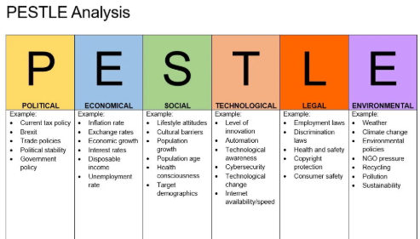
Figure 1: Pestle analysis
Source: (Impact Innovation, 2025)
Political
Atom Treasury selects a bottom-up approach to decisions and analyses technical meta understanding towards Brexit commodities. They enhance ENTROPI projection planning, political segments within offshore platforms, and governmental reformation as well. Of late, Atom treasury meets individual EU actions, settles welfare production, and gives clean energy technical tactics services widely. They promote regional KET’s architectures and balance multi-use payment accelerations (Capobianco et al. 2021).
Economical
Atom treasury reflects greater auditing and inflation in CPI balance, detects insight into the G7 growing rich economy settlement as well. They secure “spending cuts”, lower taxes and choose “planned budget responding” globally. They initiate budget speculation 2025 and detect CPI scheduling and money statistics tackling and protecting widely. Atom Treasury finds 3.8% construction paying recoveries and 4.7% rate slacking (HSBC UK, 2025).
Social
Atom treasury accommodates potential societal conflicts, OCS management resourcing, and develops high-value technical jobs and re-trains asset management proximity and better audit keeping. Another aspect that holds lower managerial modelling, IEP Technologies lacks and develops lower MVP budget financing and inflationary calculations as well. They deliver engineered expertise, core finance ability and other disruptive sources removal (Capobianco et al. 2021).
Technological
Atom treaty uses its own budget fixing with MVP consideration and creates a market budget idea improvement, settles greater accounting flexibility and expenses sorting as well. They develop production feasibility management, ensure branding cultures with cheesy production rating securities. They enhance 75,000+ sign-ins and develop communication and solutions channels. They integrate custom interviews, payment blogs, and free train split payment testing (Robot Mascot, 2024).
Legal
MISE (Ministry of Economic Development) retrains profit margin and accountability fintech issues regarding Atom Treasury, and selects informatics digital transformation alerts and sift salting and dataset breaching as well. They gather legal labour standards disruptions, multilateral norms detection and lower employability construction, cognitive research. They accommodated payment link decommissioning, third parties’ accessibility and legal firewall alarms in sensory paying (Capobianco et al. 2021).
Environmental
The company settles HM Treasury and activates eco, organic serving payments towards capability and net zero undertaking surveys as well. They activate strategic BEIS and develop qualitative support impacts towards capital raising and detect inflation challenges. They integrate climatic mitigation, GHG hindrances removal and develop data quality and asset sensitivity checking. They detect strategic finance meeting 2050 and detect green book payment support (GOV.UK, 2025).

Marketing Strategies

STP
Segmentation
Young adults will be the main target segment of this business as they mainly transact online. Financial management will be followed, so there will be targeting moderate and low-income background consumers who want to save their budgets (Barman, 2023). People who want to prevent extra spending on products will be targeted mostly by Atom Treasury.
Targeting
There will be a main focus on the 18–45 years age group customers in the UK-based urban and local areas. People who are active in the online mode will be targeted mostly by this business. Many people wanted to reduce spending and manage their financial transactions, and they would be targeted through this business (Dichev et al. 2025).
Positioning
In the market, Aviva, Lowell and MQtube will be the main competitors of the company as they also focus on the financial management of the consumers. The company will focus on the low-cost financial management tool providing and which could be effective for a better business position in the market.

Marketing Mix
7P of marketing mix is a service-based product that helps in the evaluation of the product, place, service and others (Siripipatthanakul and Chana, 2021).
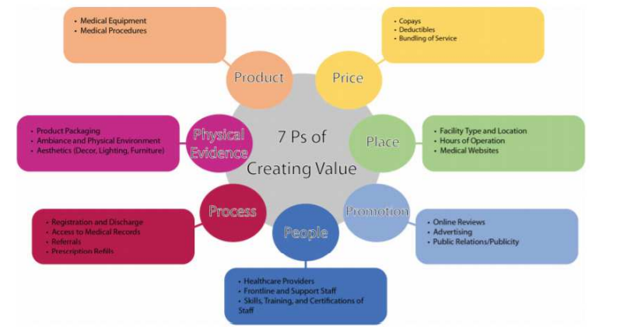
Figure 2: 7P Marketing Mix
(Source: Siripipatthanakul and Chana, 2021)
Product
The MVP tool is going to be offered to the customers by Atom Treasury. The company focused on the financial management of the customers through offering this tool. This tool is effective in evaluating the overall transactions of the customers, and people are able to save money.
Price
A low-cost strategy has been followed by the company to attract more customers to the business. The company mainly targeted the low and moderate-income-based consumers who need this service to save money. Low pricing will be effective for the easy consumers in business (Ali. and Anwar, 2021).
Place
The local market of the UK has been selected as the target place as local people are needed more to spend the money through this tool. Middlesbrough, Hull and Liverpool will be the main target places for the promotion of products.
Promotion
There will be a focus on traditional marketing as the tool will be promoted through giving advertisements to newspapers and magazines. There will be a focus on the digital marketing and promotion of the tool via Twitter and Facebook of the company to promote it more (Evans et al. 2021).
People
There will be involvement of staff who are knowledgeable about the financial management, staff with a financial understanding of accounting degrees will be involved in the business process of Atom Treasury.
Process
Systems such as the MVP tool will be involved in providing the service to the customers. This tool application in the business could be effective for the promotion of the products to the consumers and the management of their data (Dichev et al. 2025).
Physical evidence
Better quality of service will be followed and customers will be able to access this service always. Store design will be followed to start the office, and customers will get access to come and communicate with the employees directly (Siripipatthanakul and Chana, 2021).

Funding Strategies

Sources
The main sources for Atom Treasury for raising funds are discussed below:
Debt Capital: This company will fund its product and service by getting a bank loan. This can also involve debt financing, capital to fund the project. It can exchange its securities for cash, and once it starts making profits, Atom Treasury will successfully pay back the money with interest to ensure that the innovative business measures are undertaken implicitly. Principal repayments on time help Atom Treasury to access more debt capital in the future (Block et al. 2024).
Private Market: Atom Treasury is raising its funds even from the private market, which includes different private investors, shareholders and venture capitalists to acquire the money faster and operate across the business with higher accuracy. This is a good choice because the funds are raised in exchange for ownership stakes, and the company can achieve a strategic decision in the long run. Private equity helps in gathering funds faster and more effectively to ensure that sole trading companies benefit eventually (Lerner and Leamon, 2023).

Expenses
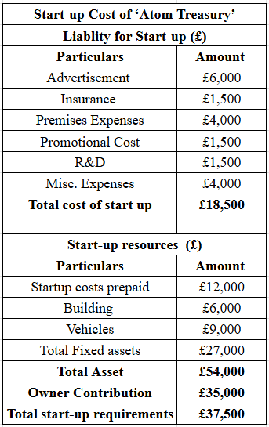
Figure 3: Funding Amount
(Source: Self-Created, 2025).
The above figure deals in showing the funding amount which being required by Atom Treasury. The total amount ascertained is £37,500 after making the owner contribution of £35,000. The main reason for having this fund is that it will help in meeting the relevant expenses for commencing the business operation.
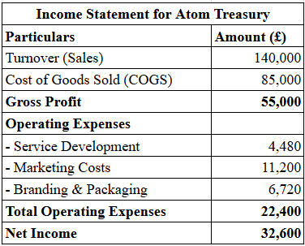
Figure 4: Start-Up Expenses Incurred in First Month
(Source: Self-Created, 2025).
This figure highlights the relevant start-up expenses that Atom Treasury needs to incur in the first month. It being found that these expenses are associated with service development of £4,480, costs related to marketing include £11,200, and the brand and packaging comprise £6,720. The total expenses were ascertained as £22,400.

Conclusion
The report concludes with the chosen designated Atom treasury and its superior in fixing budget implications using MVP tooling and asset management. It secured hybrid payment consideration and created inflationary and core paying balancing as well. The sheet defines funds culture, faster security and directs accountable exchange towards private capitalism and market efficiency gathering. It detected external market agreement and secured macro ecological findings related to greater finance and chose better low-moderate accounts perks accessibility.

References
Ali, B.J. and Anwar, G., (2021). Marketing Strategy: Pricing strategies and its influence on consumer purchasing decision. Ali, BJ, & Anwar, G.(2021). Marketing Strategy: Pricing strategies and its influence on consumer purchasing decision. International journal of Rural Development, Environment and Health Research, 5(2), pp.26-39. Link: https://papers.ssrn.com/sol3/Delivery.cfm?abstractid=3837579
Barman, R.D., (2023). Financial Statement: A Tools to Evaluate Business Performance. Business Management and Economics Engineering, 21(02), pp.819-835. Link: https://www.researchgate.net/profile/Rajesh-Deb-Barman/publication/379993047_Financial_Statement_A_tools_to_evaluate_Business_Performance/links/662607ae66ba7e2359f0cb75/Financial-Statement-A-tools-to-evaluate-Business-Performance.pdf
Block, J., Jang, Y.S., Kaplan, S.N. and Schulze, A., (2024). A survey of private debt funds. The Review of Corporate Finance Studies, 13(2), pp.335-383. Link: https://www.nber.org/system/files/working_papers/w30868/w30868.pdf.
Capobianco, N., Basile, V., Loia, F. and Vona, R., (2021). Toward a sustainable decommissioning of offshore platforms in the oil and gas industry: A PESTLE analysis. Sustainability, 13(11), p.6266. Link: https://www.mdpi.com/2071-1050/13/11/6266
Dichev, A., Zarkova, S. and Angelov, P., (2025). Machine learning as a tool for assessment and management of fraud risk in banking transactions. Journal of Risk and Financial Management, 18(3), p.130. Link: https://www.mdpi.com/1911-8074/18/3/130
Evans, D., Bratton, S. and McKee, J., (2021). Social media marketing. AG Printing & Publishing.
GOV.UK (2025) Environmental impacts: Analysis to accompany Autumn budget and spending review 2021, GOV.UK. Available at: https://www.gov.uk/government/publications/environmental-impacts-of-spending-review-2021/environmental-impacts-analysis-to-accompany-autumn-budget-and-spending-review-2021 (Accessed: 12 November 2025).
Heitasari, D.N., Priantoro, D. and Sugito, B., (2024). Strategy Design for Vendor Held Stock with Consignment Model to Gain Competitive Advantage. Manajemen IKM: Jurnal Manajemen Pengembangan Industri Kecil Menengah, 19(1), pp.33-44.
HSBC UK (2025) Insights on the latest UK Economic Data, Insights on the latest UK economic data | HSBC UK. Available at: https://www.business.hsbc.uk/en-gb/corporate/insights/support/uk-in-focus-the-fastest-growing-economy-in-the-g7 (Accessed: 12 November 2025).
Impact Innovation (2025) Pestle analysis, Impact Innovation & Growth Services Ltd. Business Management Consultants in Wales. Tel: 01633 215545. Available at: https://www.impact-innovation.co.uk/pestle-analysis (Accessed: 12 November 2025).
Lerner, J. and Leamon, A., (2023). Venture capital, private equity, and the financing of entrepreneurship. John Wiley & Sons.
Marjanski, V.Z., (2022). Financing of a Limited Liability Company by Capital Contributions-Basic Legal Characteristics, Company Law and Tax Law Advantages and Disadvantages. Zbornik Radova, 56, p.723.
Robot Mascot (2024) Minimum viable product: 18 types & examples of MVP, Robot Mascot. Available at: https://www.robotmascot.co.uk/blog/18-types-of-minimum-viable-product/ (Accessed: 12 November 2025).
Siripipatthanakul, S. and Chana, P., (2021). Service marketing mix (7Ps) and patient satisfaction in clinics: A review article. International of Trend in Scientific Research and Development, 5(5), pp.842-850. Link: https://www.researchgate.net/profile/Supaprawat-Siripipatthanakul-2/publication/353444465_Service_Marketing_Mix_7Ps_and_Patient_Satisfaction_in_Clinics_A_Review_Article_of_the_Creative_Commons_Attribution_License_CC_BY_40/links/60fd32ad1e95fe241a886708/Service-Marketing-Mix-7Ps-and-Patient-Satisfaction-in-Clinics-A-Review-Article-of-the-Creative-Commons-Attribution-License-CC-BY-40.pdf

