ECEY 5005
2305703
Words 4195

Part 1

Woodland Habitat

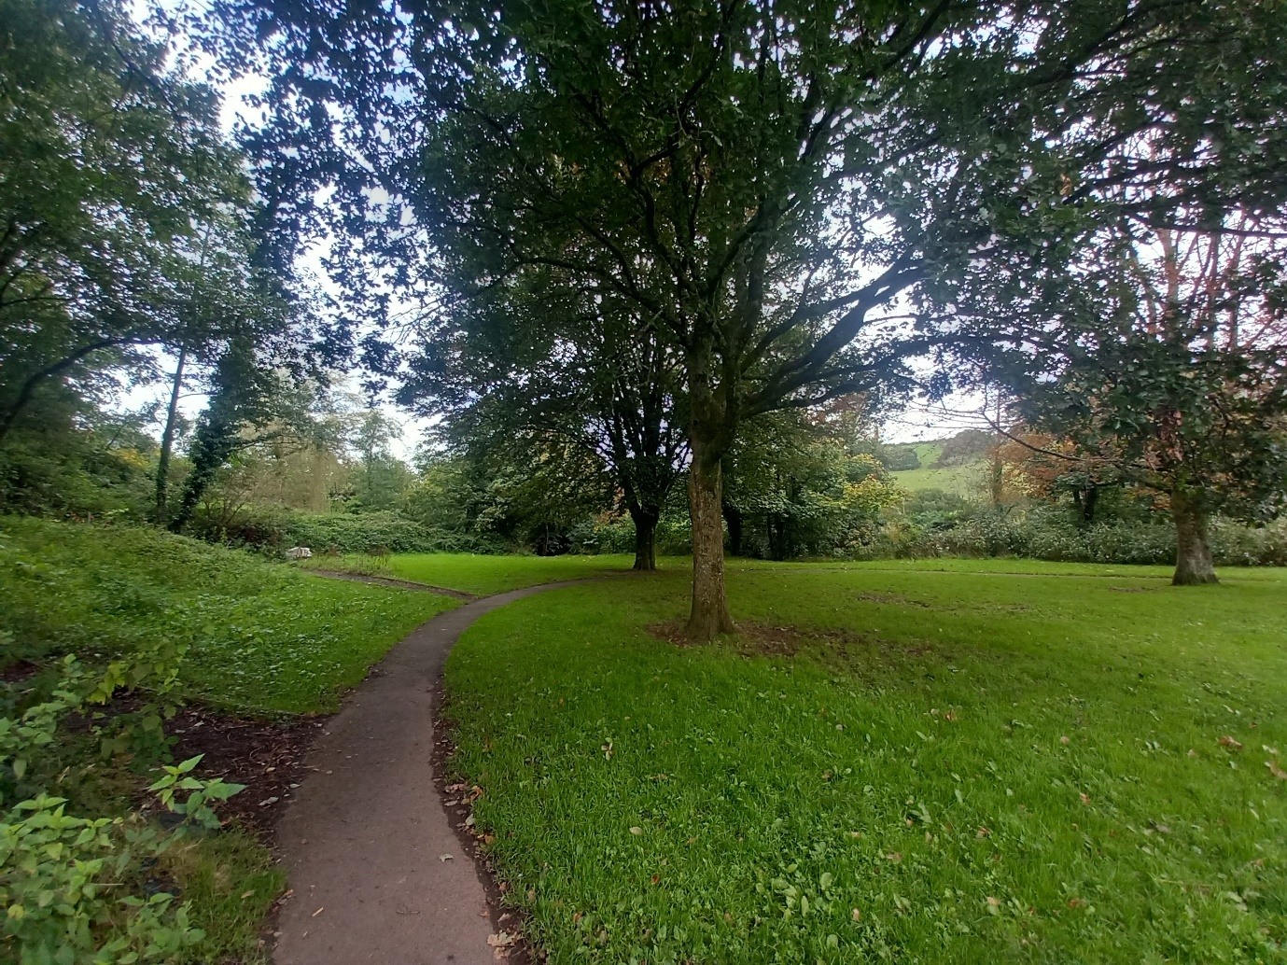
(Source: Roberts, 2024)

Part 2
Nature Journal

I recently led a group of six-year-olds, in an engaging and educative activity, in a woodland area. We planned to construct bug hotels out of recycled and natural materials, as part of our outdoor learning project, incorporating mathematics and science, and aiming to improve children’s knowledge and raise awareness, that even though insects live in their natural habitat in woodland areas, insects still require secure places to escape or hide from predators, seek shelter from weather conditions, and protect their young. Therefore, bug hotels can help to increase insect populations and enhance a balanced ecosystem. We had constructed the mini beast hotels utilising recycled materials, the previous day in class. Every student brought materials from home, such as cardboard and empty milk cartons, to create environmentally friendly, insect habitats.
Whilst creating the bug hotels, we explored how recycling can preserve the environment and provide insects with a place to live. By cutting, assembling and arranging the materials, this aided in the development of gross motor skills, therefore, promoting the growth of physical coordination, as well as environmental awareness, which demonstrates a key link to Progression step 1, of Science and Technology: Design, thinking and engineering (Welsh Government, 2020). | 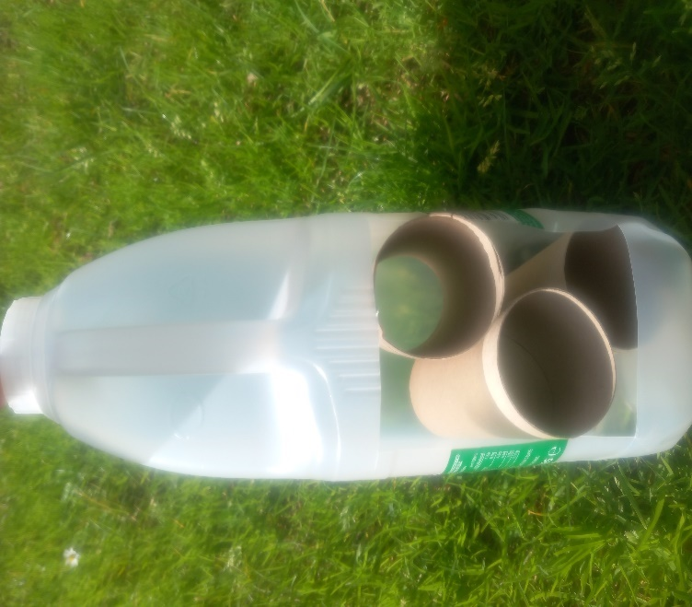  (Source: Roberts, 2024)
The children's eyes were widened with excitement as we made our way to the woodland, on a crisp autumn day. When we arrived, I gathered the children in a circle and explained the assignment. "Today, we are going to finish creating, our unique bug hotels, using natural materials!" I said.

"What could bugs possibly need in a hotel?" Child A instantly raised her hand and declared, “Bugs need sticks to crawl on.” Child B added, “They need leaves to hide under.” I encouraged further replies by asking, “What else do you think bugs might need in a hotel?” “What about food?” Child C raised his hand and stated, “Yes, bugs need plants and flowers to eat!” This method of cognitive discussion was an excellent means of encouraging the children, to apply their prior knowledge of nature and to think critically. Each child’s responses demonstrated that they were aware of the requirements and habitats of insects.
The children then got into pairs and were given a box each, to explore the woodland area and collect any natural materials that they thought might be suitable for their bug hotels. The children were enthusiastic and curious and quickly identified interesting items, such as moss, pinecones, sticks, and leaves. | 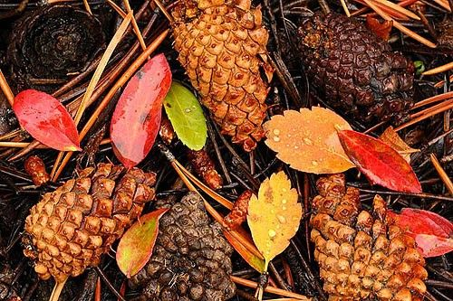
(Source: Pearre, n.d.)
As we walked and explored, the children were excited to show their peers and myself, the various materials they had found and asked questions such as, “Why are there different coloured leaves?” and “How do trees grow big and strong?” As a result of their discoveries and curiosity, it led to a discussion about the life cycle of a tree and why leaves change colour in Autumn.
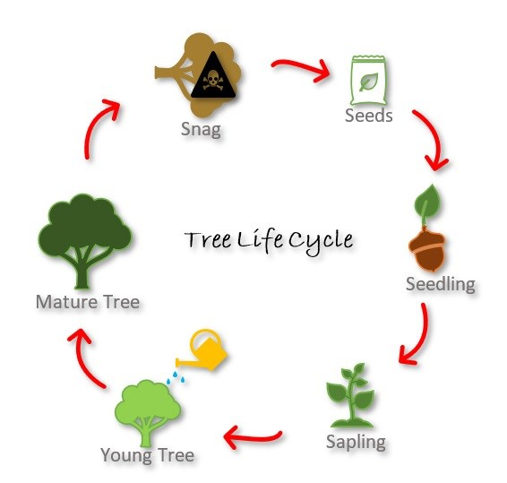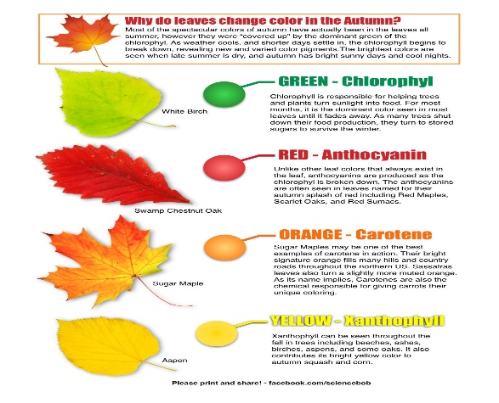
(Source: Savannah, 2022) (Source: Science Experiments For Kids, n.d.)

This demonstrates a key link to Progression step 1, of Science and Technology: Being curious and searching for answers (Welsh Government, 2020). I encouraged metacognitive discussion and sustained shared thinking, by asking the children, “Why do you think leaves change to such beautiful colours?” and “Why do you think these leaves have fallen off the tree?” encouraging each child to think critically, about how they perceive the workings of nature.
While exploring, the children collaborated to balance and walk through the wooded area, as they maneuvered across uneven paths and tree stumps, which offered opportunities to develop vestibular and proprioception skills. I observed how they interacted and shared their findings with each other. Once each child had spent enough time collecting natural materials, I gathered the children in a circle and asked, “Why do you think the materials that you’ve collected, will be helpful to insects?” Child A raised her hand and declared, “They’re cosy and the bugs can hide in them, to keep safe!” “Yes, that is correct, they offer the insects shelter” I said. What have you noticed about twigs?” Child D raised his hand and stated, “Twigs are strong and won’t snap easily.” I said “Brilliant! Each material provides something unique for insects.” This demonstrated a key link to Progression step 2, of Science and Technology: Being curious and searching for answers (Welsh Government, 2020).
The children then worked in groups, to utilise the materials, to build sections of their bug hotels. As I observed one group stacking twigs, I asked the group, “What shapes do you think these materials are?” They noticed immediately that the stones had more asymmetrical shapes than the twigs, which were primarily circular. We also discussed how long the materials were. "Is this twig longer than your arm or shorter?" I asked, as we made comparisons between items, introducing the idea of measurement in a fun, practical way. | 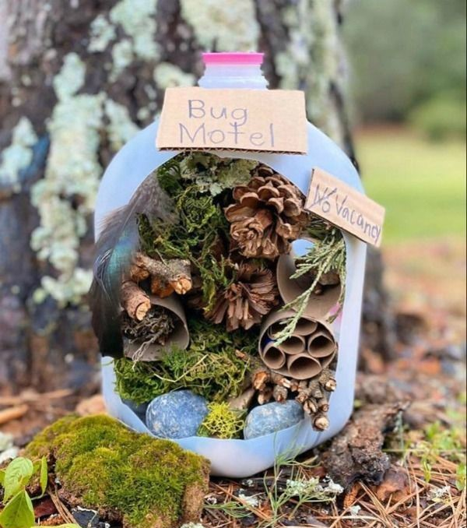  (Source: Red Ted Art, n.d.)

This demonstrated a key link, to Progression step 1, of Mathematics and Numeracy: Geometry (Welsh Government, 2020). I utilised this as a teaching opportunity, citing Gibson's Affordance Theory, which claims that an object's characteristics, encourage particular behaviours (Morris, 2023).
Once the children had finished constructing their bug hotels, they then worked in pairs again, to explore the area, to find minibeasts, taking with them a box, a lollipop stick for the bugs to crawl onto, a pencil and a notebook, to tally the amount of certain minibeasts found and record data. This demonstrated a key link, to Progression step 1, of Mathematics and Numeracy: Statistics (Welsh Government, 2020).
As the children turned over pieces of bark and stones, they counted the number of bugs they saw, which included, spiders, vibrant caterpillars and woodlouse and recorded their findings. Child E asked, “Do bugs grow older, like us?” This led to a discussion about the life cycles of insects and the transformation, from caterpillar to butterfly. | 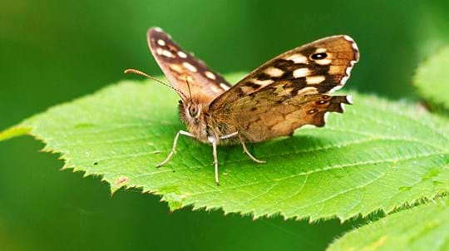  (Source: Wesley, 2023)

Utilising this as an opportunity for diagnostic assessment, I observed what the children already knew about minibeasts and identified the areas, where I could expand their knowledge. Child B stated, “Insects have six legs!” which led to Child A asking, “What about a spider?” So, I replied, “I know, why don’t you count them and see?” Child A looked at a spider in his box excitedly and counted the spider’s legs. “Eight!” he declared. In addition to encouraging their interest in nature, this practical experience developed their capacity for observation, counting, and logical information organisation. During the activity, I observed how the children communicated with each other and made notes for formative assessment. While several children were natural leaders, others were more interested in the specifics of constructing. I made use of these observations to organise activities in the future that would accommodate various requirements and teaching methods.

I ended the session, by gathering the children around the completed bug hotels and asking, “What do you think you will see in the bug hotels, the next time we visit them?” Child C raised his hand and stated, “Lots of minibeasts!” Child E quickly added, “A caterpillar that’s turned into a beautiful butterfly!”  “Wow!” I replied, “I am so excited to see if you are correct!” This helped lay the groundwork for continued curiosity and discovery, encouraging the children to be enthusiastic for our future visit. | 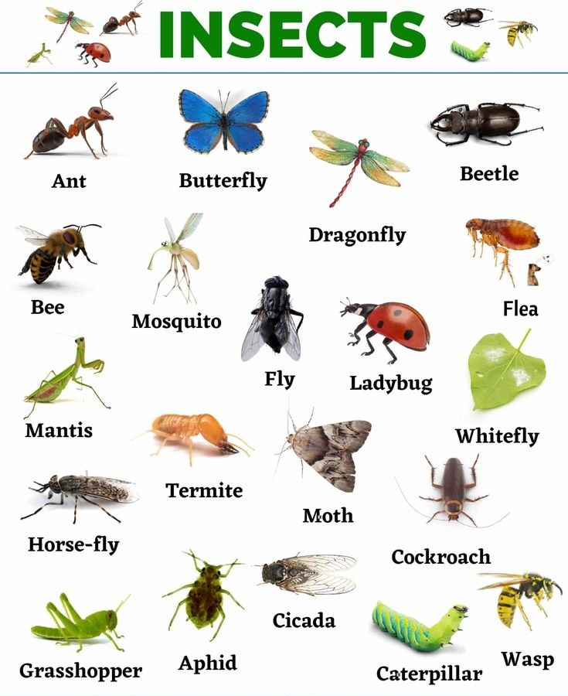  (Source: My English Tutors, n.d.)

Part 3

RISK BENEFIT ASSESSMENT

Location / Activity: | Woodland habitat | Date: | 10/09/2024
Assessor: | Christie Roberts | Review date: | 10/05/2025

The boxes in the table below will expand as you type into them; pre-entered text is simply for illustration. You should delete irrelevant items and replace with text relevant to your circumstances.
Your overall risk rating – Low, medium or high – is based on your judgement about whether the BENEFITS of the activity or opportunity outweigh the RISKS.

Experience exploring outdoor space in photograph | How will young people BENEFIT from this activity? | Hazards and associated risks | Who is at risk? | PRECAUTIONS in place to reduce the risk of injury | Overall risk after precautions  RATING: L/M/H
Children exploring an open area | 4Fosters exploration, curiosity and discovery  4Encourages creativity and imaginative play  4Active children, which encourages a healthy lifestyle 4Enhances gross motor skills and coordination | 4Children wondering off  4Encountering strangers  4Animal faeces 4Allergies to insects  4Slips, trips and falls  4Cuts and grazes  4Bumps and collisions with other children or trees | Children and adults | 4Ensure correct staff ratio  4Alfresco learning to carry out a sweep of the area  4Reiterating golden rules beforehand and procedures for strangers, no touching and setting of boundaries  4Play a fun insect game to discover the risks of certain minibeasts  4Ensure that a first aid trained member of staff is attending and take a first aid kit | L
Uneven ground | 4Improves cognitive development and balance  4Builds core strength  4Promotes awareness of slopes and gradients 4Knowledge of forces and energy  4Enhances proprioception skills | 4Slips, trips and falls  4Twisted ankles 4Cuts, bruises and other injuries  4Animal faeces  4Bumps or collisions with other children or trees | Children and adults | 4Ensuring that appropriate footwear and clothing is worn  4Encourage children to walk slowly at first 4Play a fun balance game or assault course game beforehand  4Carry out a safety check of the area  4Ensure that a first aid trained member of staff is attending and take a first aid kit | L
Low-level branches | 4Encourages imaginative play 4Enhances awareness of surroundings  4Develops resilience and physical strength  4Encourages a connection with nature  4Knowledge of trees, life cycles and seasons | 4Cuts and scratches  4Splinters  4Eye injuries  4Bumps or collisions  4Falls if children swing/hang on broken branches | Children and adults | 4Discuss risks and safety beforehand  4Carry out a safety check of the area  4Tie any harmful low-level branches back, in key areas  4Ensure correct staff ratio and supervise children playing by trees  4Ensure that a first aid trained member of staff is attending and take a first aid kit | L
Irritable plants | 4Knowledge and understanding of plants, life cycles, and safety  4Develops self-awareness 4Assessing dangers and managing own risks | 4Allergies to plants  4Ingesting berries, mushrooms, or unknown plants  4Stings, cuts, or scratches | Children and adults | 4Educating children beforehand on various species of plants and safety  4Reiterating golden rules and procedures, no touching or eating plants  4Play a fun game, or watch a fun educational video beforehand  4Carry out a safety check of the area  4Remove stinging plants in key areas. | L
Collecting materials and insects | 4Knowledge and understanding of the properties of materials  4Promotes schemas  4Knowledge of insects, life cycles and habitats  4Encourages discovery, curiosity and investigation  4Develops numeracy, tallying and the recording of data  4Develops gross motor skills | 4Cuts or splinters 4Trapped fingers 4Stings, bites, or skin irritation  4Ingesting toxins 4Infection from urine or faeces | Children and adults | 4Set expectations beforehand on how to utilise materials properly  4Educate children to check items for sharp edges  4Reiterate golden rules, not to put items in mouths and to wash hands  4Ensure a first aid trained member is present and take a first aid kit  4Play a fun discovery game beforehand | L
Litter | 4Learning about the concept of environmental responsibility and recycling  4Developing awareness of nature preservation  4A sense of achievement and creating a positive change  4Assessing dangers | 4Cuts and scratches  4Contact with faeces, urine, or vomit  4Insect bites or stings  4Dehydration | Children and adults | 4Take litter pickers and a rubbish bag with bag hoop  4Carry out a safety check of the area to ensure there are no harmful rubbish items  4Ensure that appropriate footwear and clothing/ gloves are worn  4Discuss golden rules and setting of boundaries  4Play a fun hazard game beforehand  4Ensure children bring water bottles  4Discuss personal hygiene, washing hands | L

Part 4

The objective of this assignment is to critically examine and explore, the value of assessing the methods, in which adults support science and mathematics, in outdoor educational environments. This assignment will also analyse, how adult involvement affects the development of a child's curiosity, critical thinking, and problem-solving abilities, in addition to the difficulties encountered, such as limited resources, risks, and maintaining curriculum coherence, in outdoor environments. Do the posed challenges, outweigh the benefits of outdoor learning?
Heathfield Knoll School (2024) suggests that outdoor learning is essential, to promote holistic development, which encompasses emotional, social, physical, and cognitive growth. Children who engage with nature, learn to analyse critically and problem solve, as they explore and engage with their surroundings (Lewis, 2023), and by utilising a hands-on approach, learning becomes more meaningful and experiential (Heathfield Knoll School, 2024). Furthermore, Moha (2024) suggests that in terms of behaviour, outdoor learning promotes self-reliance, adaptability, and collaboration, and in their natural environments, children frequently encounter novel challenges that promote flexibility and self-assurance, in addition to curiosity and creativity being fostered by the freedom to explore and are necessary for lifelong learning. However, Griffin, R. (2019) claims that in STEM education, professionals tend to focus on the individual fields of study, more than the fact that they are aimed to function as a coherent whole, and by integrating these areas with outdoor research, not only do children engage in active learning through practical experiences, utilising open-ended resources that combine multiple STEM elements, children are also preparing for the intricate and interrelated world they live in.
The Welsh Government (2022) points out that the four key purposes of the Wales 2022 Curriculum, are as follows: Aspirational, Competent Learners: Equipping students with the skills necessary for both academic success and future careers and preparing each child to learn throughout their lives. Resourceful, Innovative Contributors: fostering creativity and problem-solving skills, enabling students to fully participate in society and the workforce (Dauncey, 2021). Virtuous, Knowledgeable Citizens: Fostering responsible individuals, who are aware of their own cultural

identity, treat others with respect, and participate in global issues (Herr, 2023). Healthy, Self-Assured Participants: Encouraging children's mental and physical health, empowering them to live happy, purposeful lives, and developing resilience in the face of adversity (Nsead, 2024). Recent studies have indicated that nature-specific outdoor education, has demonstrable advantages for academic performance, social and emotional growth, and overall well-being, therefore, it ought to be a fundamental component of every child's educational journey (Mann, et al. 2022 and Becker, et al. 2017).
According to McLennan (2017), in addition to asking open-ended questions, which enables adults to assist children in thinking critically and investigating a variety of scientific ideas, encouraging children to use their imaginations, allows individuals to explore scientific concepts through play, such as den building, which stimulates imagination and creativity and develops problem-solving abilities, in addition to fostering collaboration and communication (Wesley, 2019). Furthermore, Sargent (2020) suggests that providing access to natural items such as seeds, stones, sticks, and leaves, allows children to investigate and classify them, and these resources can also be utilised, to develop early math skills in a practical way, by teaching concepts such as identifying patterns, categorizing, measuring, counting and contrasting. Similarly, Beloglovsky and Daly (2016) suggest that loose parts promote observation and investigation in science, as children can utilise natural art or building structures, to investigate ideas like symmetry, balance, and gravity, and since loose parts are designed to be freely manipulated, children can exercise creativity, critical thinking, and adaptability, while testing theories and exploring scientific concepts.
According to Early Education (2021), in early childhood study, the provision of natural items was supported by Friedrich Froebel, who emphasised the value of play, nature, and outdoor learning, as he believed they were crucial for a child's overall development, therefore, his method of teaching science and mathematics through outdoor learning, is based on practical, hands-on exercises that enable children to investigate the quantity, shapes, and patterns that nature provides. However, Josephidou and Kemp (2022) argue that safety concerns, frequently cause individuals to substitute naturally occurring elements, for artificial turf, or commercially manufactured materials, therefore outdoor learning may be limited.

Despite these findings, Short (2023) suggests that irrespective of urban limitations, teachers can encourage students to discover their surroundings, by guiding them on insect hunts or observations of inanimate objects like rocks or soil, and by modelling the value of inquiry and discovery, such activities enable students to respect nature in their immediate surroundings. Therefore, investigating school grounds, provides a feasible resolution (Short, 2023).
Furthermore, Gill (2016) points out that although responsible adults, such as teachers or facilitators, are required by law to take precautions to ensure that risks are kept to a reasonable level, they are not required to eliminate or minimise risks. An equally important aspect, is that the emphasis is on striking a balance between outdoor education's advantages and safety, acknowledging that certain risks are unavoidable and even advantageous to the learning process (Gill, 2016). Knight (2022) states that when children encounter reasonable risks, including tree climbing or navigating uneven surfaces, each child learns to think critically and evaluate dangers, which enhances their assurance and self-recognition, in addition to challenging their physical limits and encouraging their creative abilities, enabling children to reach their full potential.
Waite (2019) alleges that according to the Reggio Emilia method of early childhood development, a child is capable, self-assured, able to guide their own learning, and should be given the freedom to explore their surroundings and express themselves in a variety of ways, which emphasizes that children have rights, in addition to needs. The founder, Loris Malaguzzi, captured this in The Hundred Languages of Children (Seeds & Sprouts, 2019), a concept that encourages creativity, team cohesion, and respect for each child's uniqueness and potential (Mitchiner, et al. 2018).
Article 31 of the United Nations Convention on the Rights of the Child (UNCRC) guarantees children the right to play, relaxation, and participation in cultural and artistic endeavours, and highlights the importance of providing children with the opportunity, to express themselves freely and engage in leisure activities (Unicef, 2017). Additionally, The Equality Act of 2010, safeguards all individuals, including children, by addressing traits including age, gender, ethnic origin, religion, and disability, among others, and ensures that each child in education, receives equal

treatment and opportunities, promoting a secure, positive environment, where everyone is valued (Welsh Government, 2023a).
According to the Welsh Government (2020), the primary objective of the Welsh science and math curricula, is not only to assist learners to become analytical, critical thinkers, and problem solvers, but to promote numeracy across disciplines, by emphasizing the application of mathematical concepts to real-life situations, in addition to developing students' curiosity, scientific literacy, and awareness of their surroundings. Grimmer and Geens (2022) point out that children with ADHD, frequently contend with sensory factors, such as sound, lighting, space, or colours, which can be overwhelming and distracting, and may impair their focus, cognitive function, and comfort level. Therefore, Harding (2022) suggests that outdoor learning eliminates many of the overstimulation stressors, present in conventional indoor environments, and can be extremely beneficial for children with ADHD, as the natural world balances the stimulation of the senses, promoting curiosity, enhancing focus, and developing cognitive skills, without excessive stimuli. Furthermore, Woods (2017) suggests that outdoor learning can be child-led, since outdoor settings allow for flexibility and unplanned exploration, which enables each child to pursue their innate curiosity and allow their interests to guide the learning process, unlike traditional indoor learning, which is frequently structured around predetermined themes.
Van Dijk-Wesselius et al. (2020) claim that teachers' ability to fully integrate outdoor learning into their lessons, is frequently challenged by barriers, which include: inexperience and feelings of inadequacy in leadership of outdoor activities, transportation issues, exam and curriculum pressures, in addition to a lack of resources. Furthermore, NHS Federation (2024) allege that financial barriers to outdoor learning, are magnified by a lack of funding and the current crisis in the cost of living, especially for children from low-income families, as they are susceptible to income poverty, therefore, access to outdoor education is often restricted for underprivileged children, due to transportation, resources, and entrance fee charges, resulting in missed opportunities that foster holistic development and well-being.

The Children’s Commissioner for Wales (2024) claims that recent studies determine that in Wales, child poverty is a significant problem, and based on the most recent data, approximately 200,000 children, or 30% of the total, live in poverty in Wales, which is greater than the 27% UK average, and is caused by several factors, such as high living expenses, unemployment, and low salaries. NASUWT (2024) states that an equally important aspect, is that longstanding complexities have developed, from the COVID-19 pandemic's severe effects on students' conduct, psychological well-being, and academic achievement, which has resulted in families and educators, facing a shortage of funds, due to the cost-of-living crisis, forcing them to deal with increasing behavioural issues, mental health concerns, and cognitive limitations, without a correlating increase in funding, or access to educational materials.
To tackle child poverty, Swansea Council (2024) claim that underprivileged families with children under four, can receive crucial early support from the Wales Flying Start programme, such as free, high-quality childcare, support from health services, to facilitate growth and well-being, while parenting programmes provide direction and assistance, with speech and language. The Welsh Government have also implemented additional initiatives, such as free school lunches, to ensure that children are able to eat a healthy diet, the Council Tax Reduction Scheme, to reduce council tax liability, in addition to The Discretionary Assistance Fund, which additionally provides immediate financial assistance for necessities (Welsh Government, 2023b).
According to Learning through Landscapes (2024), schools could enhance their outdoor learning spaces, with £500 worth of specially selected outdoor equipment, in addition to an outdoor learning, training programme for staff members, by applying for the Learning through Landscapes, local school grants programme. Moreover, Daniels and Schroth (2020) suggest that children can interact with their environment and gain knowledge from natural materials like twigs, leaves, and stones, when engaging in outdoor learning, fostering a deeper relationship with the natural world and supporting environmentally responsible experiential learning, in a cost-effective strategy.

Recycling materials encourages environmental awareness in students (NDNA, 2021), while providing a hands-on learning experience, therefore, by upcycling materials such as paper, plastic, and cardboard, children can participate in imaginative exercises, that enhance their critical thinking and problem-solving capabilities (Jukes, 2023). SDN Children’s Services (2024) claims that utilising recycled materials for outdoor learning, eliminates the requirement to purchase new supplies, ensuring a method that is beneficial, for both the environment and the educational budget, concurrently.
Oliver (2024) suggests that utilising natural elements and recycled materials, enables parents to foster their children's curiosity, develop gross motor skills and promote educational experiences at home, in addition to learning about the environment, and the value of recycling and an eco-friendly lifestyle. However, Child in the City (2019) argues that the growing dependence of children on electronic devices, for both education and entertainment, presents challenges for home-based outdoor learning, as children are less likely to participate in outdoor activities, when distracted by devices such as gaming consoles, tablets, and mobile phones, therefore, setting boundaries for device utilisation, while promoting outdoor play, can be challenging for parents, particularly if their children utilise their gadgets for academic purposes. Mayo Clinic Health System (2023) suggests that parents could allocate areas at home, where phones are not permitted, to reduce the utilisation of devices and encourage outdoor learning, as well as implementing daily screen time limits and regular breaks from studying, to explore the outdoors.
Early Years Alliance (2019) maintains that to support each child's educational journey and development, both at school and at home, practitioners and parents must collaborate, as parents offer crucial insights into their child's individual needs, conduct, and preferences, and professionals offer expertise, planned activities, and customised educational methods.
To conclude, based on the analysis disclosed, the disputes presented, indicate that despite the fact outdoor learning can present certain challenges and limitations, the advantages significantly exceed the risks, and substantially aid in a child's overall development. In outdoor environments, acceptable risks encourage creativity, problem-solving, and resilience, which are all vital life skills. In terms of academics,

outdoor learning enhances retention and engagement levels, which enables instruction to be increasingly dynamic and significant. Furthermore, engaging in outdoor activities, offers inclusive opportunities that facilitate children of all abilities to flourish in a stimulating, natural setting, and to develop students who are capable and well-rounded, educators can provide engaging experiences that enhance students' academic development, emotional stability, and physical health, by taking calculated risks.
The second key point to highlight, is that to enhance outdoor learning, staff training and additional education are crucial. Teaching professionals the benefits of integrating outdoor environments into their lessons, can improve academic achievements and student participation. Professionals can promote interdisciplinary learning and design lessons that are more dynamic and meaningful, by combining subjects in outdoor spaces. Furthermore, training can assist educators, in finding affordable methods, to incorporate outdoor learning experiences into the curriculum, guaranteeing inclusivity and sustainability for each child.
As a final point, supporting children's holistic development, requires collaboration between parents and professionals. Together, a consistent, nurturing environment can be established, that fosters the child's development on all levels, physical, emotional, and cognitive. Additionally, encouraging outdoor learning at home, ensures that each child continues their educational journey, strives to be an environmental ambassador and strengthens the bond between a child and nature, fostering independence, creativity, and exploration.

Reference List

Becker, C., Lauterbach, G., Spengler, S., Dettweiler, U. and Mess, F. (2017) ‘Effects of Regular Classes in Outdoor Education Settings: A Systematic Review on Students’ Learning, Social and Health Dimensions’, Internation journal of environmental research and public health, 14(5), p. 485. Available at: https://doi.org/10.3390%2Fijerph14050485 (Accessed: 03 September 2024).
Beloglovsky, M. and Daly, L. (2016) Loose Parts 2: Inspiring Play with Infants and Toddlers. Minnesota: Redleaf Press.
Child in the City (2019) The impact of media use and screen time on children. Available at: https://www.childinthecity.org/2019/04/02/the-impact-of-media-use-and-screen-time-on-children/?gdpr=deny (Accessed: 07 September 2024).
Children’s Commissioner for Wales (2024) Child Poverty. Available at: https://www.childcomwales.org.uk/our-work/policy-positions/child-poverty/ (Accessed: 06 September 2024).
Daniels, J. and Schroth, S.T. (eds) (2020) Building STEM Skills Through Environmental Education. USA: IGI Global.
Dauncey, M. (2021) Donaldson Review: The ‘purposes’ and content of a Curriculum for Wales. Available at: https://research.senedd.wales/research-articles/donaldson-review-the-purposes-and-content-of-a-curriculum-for-wales/ (Accessed: 06 September 2024).
Early Education (2021) Friedrich Froebel. Available at: https://early-education.org.uk/friedrich-froebel/ (Accessed: 04 September 2024).
Early Years Alliance (2019) Involving parents in their children’s learning. Available at: https://www.eyalliance.org.uk/involving-parents-their-children%E2%80%99s-learning (Accessed: 08 September 2024).
Gill, T. (2016) Balancing Risks and Benefits in Outdoor Learning and Play. Available at: https://outdoorclassroomday.org.uk/wp-content/uploads/sites/2/2016/06/160606_PROJECTDIRT_ECD_BOOK7_A4-1.pdf (Accessed: 04 September 2024).
Griffin, R. (2019) ‘Three outdoor activities to encourage STEM learning through play’, 23 May. Available at: https://iowaccrr.org/blog/2019/5/23/CCRR_Blog/Three_Outdoor_Activities_to_Encourage_STEM_Learning_Through_Play/ar/2314/ (Accessed: 03 September 2024).
Grimmer, T. and Geens, W. (2022) Nurturing Self-Regulation in Early Childhood. London: Taylor & Francis.

Harding, N. (2022) ‘My Forest School Journey’, Forest School Association, 7 July. Available at: https://forestschoolassociation.org/my-forest-school-journey/ (Accessed: 05 September 2024).
Heathfield Knoll School (2024) Outdoor environment and social skills: Expanding learning beyond the classroom. Available at: https://www.hkschool.org.uk/outdoor-environment-and-social-skills-expanding-learning-beyond-the-classroom/ (Accessed: 03 September 2024).
Herr, O. (2023) Education: How CREST can help schools achieve the four purposes of the new Curriculum Wales. Available at: https://www.britishscienceassociation.org/blog/how-crest-can-help-schools-achieve-the-four-purposes-of-the-new-curriculum-for-wales (Accessed: 06 September 2024).
Josephidou, J. and Kemp, N. (2022) ‘A life in and with nature?’ Developing Nature Engaging and Nature Enhancing Pedagogies for Babies and Toddlers, 9(2), pp. 5-22. Available at: https://repository.canterbury.ac.uk/download/75300310b2ac26eb463ce628c56f5bea0828c467e766f2511eb0f6a1d52d63bf/291516/A4_A%20life%20in%20and%20with%20nature_approved.pdf (Accessed: 04 September 2024).
Jukes, S. (2023) Learning to Confront Ecological Precarity. Switzerland: Springer.
Knight, S. (2022) ‘Risk: A Forest School Perspective’ Early Education’, 23 March. Available at: https://early-education.org.uk/risk-a-forest-school-perspective/ (Accessed: 08 September 2024).
Learning through Landscapes (2024) Local School Nature Grants. Available at: https://ltl.org.uk/projects/local-school-nature-grants/ (Accessed: 06 September 2024).
Lewis, A. (2023) Why outdoor education is an essential part of every childhood. Available at: https://www.field-studies-council.org/2023/06/12/why-outdoor-education-is-an-essential-part-of-every-childhood/ (Accessed: 03 September 2024).
Mann, J., Gray, T., Truong, S., Brymer, E., Passy, R., Ho, S., Sahlberg, P., Ward, K., Bentsen, P., Curry, C. and Cowper, R. (2022) ‘Getting Out of the Classroom and Into Nature: A Systematic Review of Nature-Specific Outdoor Learning on School Children’s Learning and Development’, Frontiers in public health, (May) article 877058. Available at: https://doi.org/10.3389%2Ffpubh.2022.877058 (Accessed: 03 September 2024).
Mayo Clinic Health System (2023) 6 tips to reduce children’s screen time. Available at: https://www.mayoclinichealthsystem.org/hometown-health/speaking-of-health/6-tips-to-reduce-childrens-screen-time (Accessed: 07 September 2024).
McLennan, D. P. (2017) ‘Math Learning-and a Touch of Science-in the Outdoor World’, April/May. Available at: https://www.naeyc.org/resources/pubs/tyc/apr2017/math-learning-outdoors (Accessed: 03 September 2024).

Mitchiner, J., Batamula, C. and Kite, B.J. (2018) ‘Hundred Languages of Deaf Children: Exploring the Reggio Emilia Approach in Deaf Education’, American annals of the deaf, 163(3), pp. 294-327. Available at: https://doi.org/10.1353/aad.2018.0021 (Accessed: 05 September 2024).
Moha, T. (2024) The Balanced Growth: Nurturing Resilient Children Through Therapy & Natural Development. Canada: Fouzia Benbelkhir.
Morris, P. (2023) ‘Unravelling Affordance Theory and its Relevance in Marketing’ Paul Morris, 24 October. Available at: https://www.paulmorris.org.uk/unravelling-affordance-theory-and-its-relevance-in-marketing/ (Accessed: 18 September 2024).
My English Tutors (n.d.) Insects: List of 20+ Names of Insects in English. Available at: https://www.pinterest.com/pin/332633122488535436/ (Accessed: 19 September 2024).
NASUWT (2024) School funding levels insufficient to meet increased challenges. Available at: https://www.nasuwt.org.uk/article-listing/school-funding-levels-insufficient-challenges.html (Accessed: 06 September 2024).
NDNA (2021) 10 top tips for developing your use of the outdoors within the Foundation Phase on a budget. Available at: https://ndna.org.uk/wp-content/uploads/2022/07/FACT292-English-10-top-tips-for-developing-your-use-of-the-outdoors-Foundation-Phase.pdf (Accessed: 06 September 2024).
NHS Federation (2024) Welsh NHS Confederation response to the Children, Young People and Education Committee consultation on the Residential Outdoor Education (Wales) Bill. Available at: https://www.nhsconfed.org/publications/welsh-nhs-confederation-response-children-young-people-and-education-committee (Accessed: 06 September 2024).
Nsead (2024) A new Curriculum for Wales. Available at: https://www.nsead.org/resources/curriculum/planning-the-curriculum/the-national-curriculum-for-wales/ (Accessed: 06 September 2024).
Oliver, J. (2024) ‘How to encourage outdoor learning and environmental awareness in preschool kids’ The Oliver’s Madhouse, 14 June. Available at: https://theoliversmadhouse.co.uk/how-to-encourage-outdoor-learning-and-environmental-awareness-in-preschool-kids/ (Accessed: 07 September 2024).
Pearre, D. (n.d.) Autumn Pinecones. Available at: https://www.pinterest.com/pin/436989970065514280/ (Accessed: 17 September 2024).
Red Ted Art (n.d.) Simple Bug Hotel for Kids. Available at: https://www.pinterest.com/pin/200410252159416803/ (Accessed: 18 September 2024).
Roberts, C.M. (2024) Bug Hotel. [Photograph].
Roberts, C.M. (2024) Woodland Habitat. [Photograph].

Sargent, M. (2020) Developing Early Maths Skills Outdoors. Luton: Andrews UK Ltd.
Savannah, K. (2022) Life Cycles of Trees. Available at: https://www.nps.gov/choh/learn/kidsyouth/activity-4-life-cycle-of-trees.htm (Accessed: 17 September 2024).
Science Experiments For Kids (n.d.) Plant Respiration Experiment. Available at: https://www.pinterest.com/pin/why-do-leaves-change-color-in-the-autumn-from-science-bobs-blog--248260998189438277/ (Accessed: 17 September 2024).
Sdn Children’s Services (2024) Imaginative uses for recycled materials to inspire play. Available at: https://www.sdn.org.au/village-of-learning/parenting-article-imaginative-uses-for-recycled-materials-to-inspire-play/ (Accessed: 06 September 2024).
Seeds & Sprouts (2019) The Hundred Languages of Children. Available at: https://www.seedssproutsacademy.org/the-hundred-languages-of-children (Accessed: 06 September 2024).
Short, L. (2023) ‘Learning About Nature in the City’, A programme of Population Connection’, 23 August. Available at: https://populationeducation.org/learning-about-nature-in-the-city/ (Accessed: 05 September 2024).
Swansea Council (2024) Flying Start. Available at: https://www.swansea.gov.uk/article/2977/Flying-Start (Accessed: 06 September 2024).
Unicef (2017) Our Rights. Available at: https://www.unicef.org.uk/wp-content/uploads/2017/09/Our-rights_UNCRC.pdf (Accessed: 05 September 2024).
Van Dijk-Wesselius, J.E., Van Den Berg, A.E., Maas, J. and Hovinga, D. (2020) ‘Green Schoolyards as Outdoor Learning Environments: Barriers and Solutions as Experienced by Primary School Teachers’, Frontiers in psychology, 10, pp. 2919. Available at: https://doi.org/10.3389%2Ffpsyg.2019.02919 (Accessed: 06 September 2024).
Waite, S. (ed.) (2019) Outdoor Learning Research: Insight into forms and functions. Oxon: Routledge.
Welsh Government (2020) Curriculum for Wales. Available at: https://hwb.gov.wales/curriculum-for-wales (Accessed: 18 September 2024).
Welsh Government (2022) The new Curriculum for Wales: An easy read guide for young people. Available at: https://hwb.gov.wales/api/storage/e4dcdb2e-f87f-4f00-b110-488289cc02ca/220209-easy-read.pdf (Accessed: 03 September 2024).
Welsh Government (2023a) The Equality Act 2010: the Public Sector Equality Duty. Available at: https://www.gov.wales/public-sector-equality-duty-html (Accessed: 05 September 2024).
Welsh Government (2023b) Child Poverty Strategy for Wales. Available at: https://www.ldw.org.uk/wp-content/uploads/2023/07/Easy-Read-Welsh-Government-Child-Poverty-Strategy-for-Wales.pdf (Accessed: 06 September 2024).

Wesley, D. (2019) ‘How to build a den: outdoor activity for kids’, The Woodland Trust, 22 October. Available at: https://www.woodlandtrust.org.uk/blog/2019/10/how-to-build-a-den/ (Accessed: 05 September 2024).
Wesley, D. (2023) ‘Minibeast Hunt – Top Tips For Finding Bugs’ Woodland Trust, 26 May. Available at: https://www.woodlandtrust.org.uk/blog/2023/05/minibeast-hunt/ (Accessed: 18 September 2024).
Woods, A. (ed.) (2017) Child-Initiated Play and Learning. 2nd edn. London: Routledge.

