A REPORT FOCUSING ON:
THE CONSTRUCTION DETAILING OF A TWO STOREY DETACHED DOMESTIC BUILDING WITH A LOFT ROOM.

FELIX HOARE
STUDENT NUMBER: 1908089

SUBMISSION DATE: 28/04/20
LECTURER: JUAN FERRIZ – PAPI
MODULE: FUNDAMENTALS OF CONSTRUCTION TECHNOLOGY

Table of Contents Page Number

1.0 Executive Summary 3

2.0 Terms of reference 3

3.0 Procedure 3

4.0 The Ground Floor 4

5.0 The First Floor 5

6.0 Lintels 6
6.1 Sills 6

7.0 Eaves 6
7.1 Roof Covering 7

8.0 Main Roof Structure 7
8.1 Roof at Front and Side of Property 8
9.0 Conclusion 8
10.0 Appendices 9
11.0 References 24

- Executive Summary
This report is broken up into five sections, each give practical solutions in line with set guide lines for the constructions details of five different elements to the design set out in the assignment brief. Each of the five sections are supported by drawings set out in the appendices.

- Terms of reference

  - The principal focus are:
    - Solving the construction detail to the ground floor
    - Solving the construction detail to the first floor
    - Solving the construction detail to the openings
    - Solving the construction details for the roof covering
    - Solving the construction details for the main roof

- Procedure
3.1 All material that has been used for this assignment has been gathered during lecture time and through secondary sources that have been listed in the references.

- The Ground Floor
The ground floor is detailed to be a suspended timber design, this is an effective method of floor construction as it is easy to construct whilst cost effective. The design is made up of a number of key structural elements, the outer wall will be made using a standard brick running bond design. Between the outer and inner wall will be a cavity which will be insulated. The inner wall as seen in appendix 3 will be a crucial element to the structure as this will be the load bearing wall and will be made from concrete blocks. This will form the structure to the suspended floor. There are a number of methods that can be used to form the joists, for this project the most suitable solution is to hang the joists from the internal wall. The benefit of this method is that over time if any of the joists need replacing it can be done so easily.
Each joist should hung using typical joist hangers as seen in appendix 4 labelled point 3 complying with BS 6178 part 1 or BS EN 845-1 and must be of suitable type for the strength of blockwork being used, the joists should also be cut accurately to length and must not be loaded until at least three courses have been built over the hanger flange and the mortar has set (How to get it right: Supporting joists on external walls | LABC, 2020).
In order to calculate the number and size of the joists needed, using the BS 8103-3 span table timber class C16 for lightweight partitions, we are able to calculate the number of joists that will be required based on the width of the room and the span between the joists. Due to the dead load being no more than 0.25, the spacing between each joist will be 400mm. For the ground floor lounge, based on the length of the room and the width between the joists (8.430m / 400mm) there will be approximately 20 joists required. As for the size of the joists, through using span table C16, all joists in the kitchen / Dining lounger area will be: 38 x 220 while the hall / study and utility will be: 38 x 145 as illustrated in appendix 1 by the colour of the joist. This method has been applied throughout the entire ground floor and each room’s number of joists calculated in appendix 1.
The joists should then be supported by Herringbone strutting as labelled in appendix 4. This bracing is used to help prevent any lateral bending or deformation. Depending on the clear span, it will vary the amount of strutting needed. For example in this project, the ground floor lounge, utility room and dining / kitchen area will all require one strutting at mid joist span. Where there is a partition wall, there should be an additional joist placed underneath for extra support.
As the floor is not supporting any great deals of loads, honeycombed sleeper walls are used throughout the design as show in appendix 3, they are positioned throughout the design to support the joists. These sleeper walls along with the external and internal walls have weeper ventilation holes incorporated into the design which feed air into the chamber between the ground and the floor joist to ventilate the building and help prevent issues such as moisture coming from the ground.
In order to employ further damp resistant measures, a damp proof coating will be located in the main wall and the sleeper wall. In addition, the earth will be covered by a small concrete slab which will be at ground level in order to prevent a build-up of water as shown in appendix 3.
With regards to insulation, this will be made of polystyrene because it is rigid and can be supported by itself. It will be located in-between joists, secured in place by small rigid batons as seen in appendix 5 labelled point 2. A problem with this however is that the insulation is not continuous and as a result is not as efficient.
On top of the joists the floorboards will be placed which will be a tongue and groove soft wood flooring. The benefits of this style of flooring is that it is easy to install and can be held together with an invisible screw. Issues that tend to arise with this style of flooring is that they can become loose and start to squeak. One way to prevent this is to add a foam layer underneath which will reduce noise and other slight movements.

- The First Floor
Constructing the first floor will consist of a number of the same key factors included in constructing the ground floor. The upper floors should be designed to provide sufficient support and transmit the loads safely to the supporting structure. The outer wall will continue with the running brick bond design. Again, there will also be a cavity gap between the outer wall and the inner wall to which will be insulated.
The inner wall will be made using blocks and will be load bearing to which the joists will be hung from using joist hanger supports as shown in appendix 4 and 5. Again, these joist hangers should meet with requirements of BS EN 845 – 1.
Similarly to the ground floor, the number of joists will remain the same as the width between the joists will remain at 400mm throughout the majority of the first floor. The only difference however is that where there are partition walls on the first floor, for example separating bedroom 2 and 3, this may cause a variation in the dead load weight which may require a greater strength joist. As the span of the joists will remain the same on the first floor, for the purpose of convenience and cost, the same two cross sections will be used for the first floor and the ground floor as shown in appendix 1. If there is a greater strength required due to this partition, an additional joist may be added underneath the partition for additional support.
Given the size of the joists in bedroom 1, 2 and 3, they will require strutting mid joist in order to prevent any lateral bending or deformation as they are greater than 2.5m in length. As shown in appendix 1 labelled ‘strutting 1 and 2 ‘. Appendix 4 gives a clear side profile of how the herringbone strutting will be fitted.
The Insulation will be acoustic as shown in appendix 4, alternatively to the ground floor, insulation is not essential according to the building regulations for first floor joists. Whilst the flooring will remain the same as the ground floor, tongue and groove will be placed on top of the joists, straps will be rebated into the top of the joists to allow the boards to lay flat as shown in appendix 4. This method is easy to apply and will be held together with screws.

6.0 Lintels
The lintel is a beam used to support the above wall by taking the loads and transferring it to the side walls. As this design requires soldier courses over all openings, the most suitable lintel to use is a standard steel cavity lintel as shown in appendix 6, the solider course finish is where the bricks are placed to stand on end and this style of lintel is the most appropriate for creating a decorative finish.
There are guidelines laid out in the BS 5977-1:1981 which indicate how the masonry about the lintel should be built, specifically looking at loads for lintels. With regards to the quality of the steel it must be in line with BS EN 10346:2015. Installing this style of lintel is quick and straight forward. They are also considerably light weight in comparison to alternatives such as stone which will help for the load bearing on the inner and outer wall. It is important to note that the end bearing of the steel should be of 150mm as shown in appendix 7.
Prior to being installed, mortar should be spread evenly across both inner and outer walls to which the lintel is then placed on top. The lintel should be left to cure before any work commences around the lintel, temporary propping can be used in order to speed up construction.
When installed, caution should be taken to ensure it is done correctly as thermal bridging can occur through gaps as a result of being fitted incorrectly which would ultimately result in heat loss from the house (Steel Lintels - Installation Guide - Keystone Lintels, 2020).
As shown in appendix 6 the NHBC suggest a damp proof course or cavity tray should be installed over all openings in the external cavity wall. (Steel Lintels - Installation Guide - Keystone Lintels, 2020) This is put in place on top of the lintel as this is a common area for moisture to seep on and cause damp.
When applying point loads, this should not be done directly onto the lintel flanges, to prevent this the lintels should have a masonry 150mm high between the flange and the application level of any form of loading and also the external flange must protrude beyond the external door frame and it’s suggested that a sealant component is used between the underside of the lintel flange and the frame. (Steel Lintels - Installation Guide - Keystone Lintels, 2020)

6.1 Sills
When constructing a sill there are a number of functional considerations that need to be made including its purpose, its function to prevent moisture, how it will transfer loads from above and also an aesthetic purpose.
The sills to the house will be constructed as shown in appendix 8, this detail illustrates a masonry window sill condition. The primary focus of a sill is to divert water away from the building, in order to achieve this the top surface should slope downward at 15 degrees from horizontal and also should protrude a minimum of 1 inch beyond the face of the wall. (Gobrick , 2020)
In theory, if a cavity or air space is interrupted, in this instance when fitting a sill, a system of flashing and weeps should be provided in order to prevent any moisture penetrating the wall or the sill and is located across the span of the cavity. It is important that the flashing continues through the brick to the exterior face of the wall to which it should be then turned down to form a drip (Gobrick , 2020) whilst the opposite side extends to the first head joint of the jamb and should be turned up as an extra measure to prevent moister penetration The drip edge guards against moisture re-entry acting as a further protection measure as seen in appendix 8.
There is also an element of structural stability that needs to be taken into consideration as it needs to be ensured that the applied loads can be adequately transferred to other elements in the structure or resisted. One way of guaranteeing structural stability is ensuring connection to the structure is solid.
The sill will also have to fulfil an aesthetic consideration, as it provides a decorative purpose to the window and also the design of the property.
When the jams are fitted, these as illustrated in appendix 8 will be fitted with jamb liners in order to improve air tightness.

7.0 Eaves
For this project, they style of eave will be a closed eave with a soffit. As illustrated in appendix 9, it is located at the end of the rafter, the rafter tail will be placed at the end to which the soffit will be attached on a 90 degree angle. The soffit serves a functional purpose of providing ventilation through the loft room, it also conceals the rafter beans which makes it seem more pleasing on the eye. The fascia board will then be placed along the end of the rafters which primary function is to protect the roof and interior of the home from weather and ultimately moisture through sealing up its entrance. Not only do they have the practical purpose but they do also play an aesthetic role as they can create a smooth finish along the roofs rough edge (Fascia design, 2020). To finally complete the eave, as labelled in appendix 9, the gutter will hang from the fascia, the purpose of the gutter is to remove any excess water, leaves or dirt that can accumulate.

7.1 Roof Covering
Roof covering – The project specification is for a warm roof, this Is a roof that will make the entire structure of the building warm in an attempt to avoid any cold bridging (Kingspan, 2020). It is considered to be the most efficient in heat retention and therefore cost effective. Appendix 10 illustrates how this roof will be constructed.
As the design requires a warm roof, this means that insulation should be located on top of the rafters as appose to being located between or underneath. The difference between a warm roof and cold roof is that on the warm roof the insulation is continuous, this has many benefits over the traditional ‘cold roof’, in essence it is a breathable roof construction which allows moisture to escape, ultimately then preventing problems associated with damp.
However, as appose to a ‘cold roof’, the structural loads on a pitched warm roof do not perform the same way and different consideration must be taken. On a cold roof the weight of the roof covering is supported by a rafter, on a warm roof this is not the case. The weight is taken by the battens which are located on top of the insulation which is a non – structural element. Therefore, the counter batten becomes an element of the composite rafter above the insulation and plays an essential role as a structural element to which the tile batten can be fixed (What is a warm roof? | Helifix, 2020). It is on top of the tile batten to which the single natural slate covering will be fixed.
In accordance to the specification, the roof is on a 40 degree angle, when constructing the roof tiles factors such as rain fall must be taken into consideration to determine the head lap. Given the heavy rainfall in the location of the build this indicates that the head lap should be 80mm.
As you can see in appendix 10, breathable membrane layer is installed which is used to reduce moisture into the walls, roof and floor. This is an important element to the warm roof to prevent damaging levels of condensation occurring in the fabric of the building which in turn cause potential problems such as decay in timber, corrosion in metals and frost damage in masonry (Back to Earth, 2020). It is required in the building regulations and is an essential part of the roof construction located on top of the insulation to act as an extra layer of protection In accordance with ‘Approved document L building regulations 2006’.

8.0 The Main Roof Structure
The main roof structure is detailed in the plan to be pitched at 40 degrees with a free space in the loft, giving the span required is 6.83m, this will mean that a queen post truss is the most suitable option. This is illustrated in appendix 11. This option is preferred rather than a king post truss due to the fact that a king post truss requires load bearing wall in the middle and will occupy the space required to be left free for the loft.
All structural designs must be in line with ‘Approved document A’s guidelines, as for this design there will be two trusses positioned throughout the middle of the house, whilst the load bearing wall on each side of the house will act as blind walls so will not need a truss. Both trusses location are identified on appendix 2. As seen in appendix 11, it gives a clear overview of how the queen’s truss will look. The purlins will be used to cover the span between the trusses to which the rafters will then be placed over.
In regards to the wall support, there will be a wall plate positioned on top of the internal load bearing wall which will perform as a platform for the truss to fix too as shown in appendix 11. The restrain strap should be turned down the cavity by at least 100mm and be tight against the internal wall for extra support. This is in accordance with BS EN 1996-2:2006 and Building Regulation requirements (How to ensure lateral support to walls when constructing floors and roofs, 2020).

8.1 Roof at front and side of property
As for the roof at the front of the property that is protruding out and the side of the property used as the utility room, the roof structure can be solved using a pitched design due to the fact that the span of this roof does not exceed 4.5m. As the roof is greater than 3.5m, this would mean using a ‘collar roof’ design is most suitable. If the for example design were to be a ‘couple roof design’ this will introduce problems as there would be horizontal loads on the walls which has a potential to cause issues. To prevent this, a collar tie is needed as shown in appendix 12 which will absorb the horizontal efforts. This will leave then just vertical loads and ensure that performance is much better. This is a simple design and can be easily constructed, all elements of this design are set out in appendix 12.

9.0 Conclusion
This report has detailed and illustrated how to construct five major components of a house, presenting logical and practical solutions for each element. Each solution is specifically designed to tailor the description set out in the assignment brief addressing each issue with the best possible solution whilst keeping in line with the British Standards and Building regulations.

Appendices

Appendix 1 – Illustration of the ground floor joists

Utility joists - 2.565m = 14 Joists Joist length in Lounge - 3.915m = 20 Joists
Strutting 1
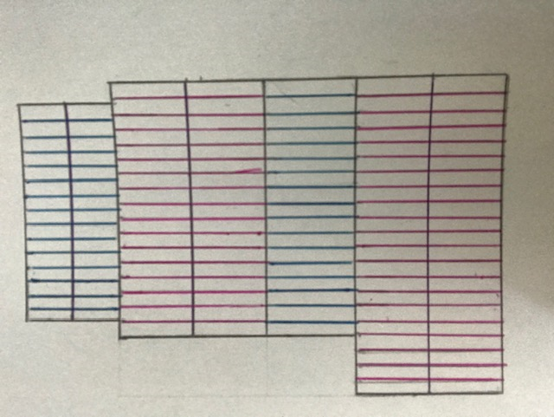
Strutting 2

Hall / Study joists - 2.4m = 16 Joists

Sleeper wall 2

Strutting 3

Scale = 1:100 Sleeper Wall 1
Size of Joists Joists in Dining area / Kitchen = 3.915m = 16 Joists
Pink joists = 38 x 220
Blue Joists = 38 x 145

Appendix 2
Main Roof Truss

Blind wall – No Truss needed Truss 1 will be located here
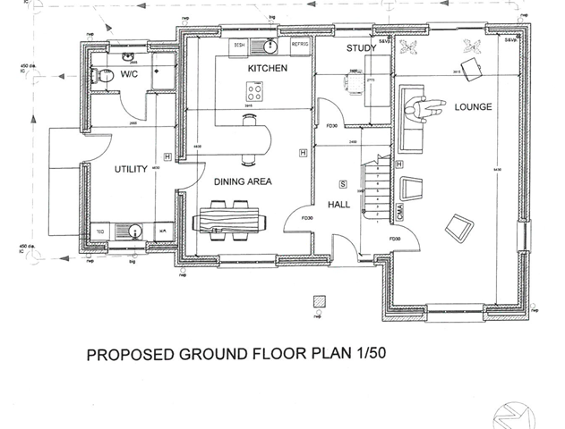

Blind wall – No Truss needed

Truss 2 will be located here

Appendix 3 – Suspended timber floor
2 3
5 6 7 4

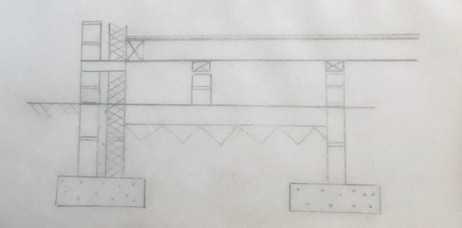

8
1 9 10

1 - Concrete Base 7 – Floor Boards
2 - Outer wall 8 – 150mm Ventilation Gaps
3 – Inner wall 9 – Honeycomb sleeper walls
4 – DPC 10 – Strip Foundation
5 –Joist hangers
6 – Joists

(Image sketched from the different types of suspended wooden flooring construction, 2020)

Appendix 4 – First floor suspended floor
7
3 4
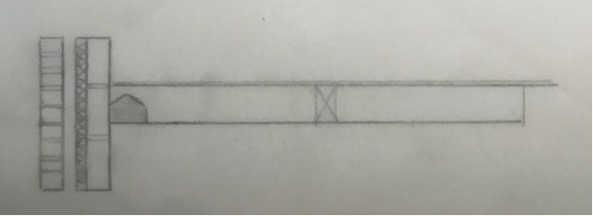

2 5 6
1

1 – Outer brick wall
2 – Insulation
3 – Inner block load bearing wall
4 – Joist Hanger
5 – Herringbone strutting
6 – Joist
7 – Flooring

Appendix 5 – Metal Herringbone Strut

1 2 3

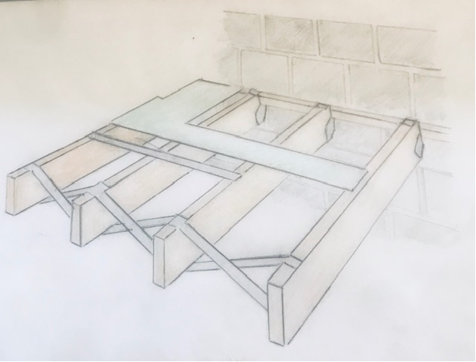

4
5

1 – Floor Boards
2 – Joist Hanger supports
3 – Joist hangers
4 – Joists
5 - Herringbone strutting

(Image sketched from: Herringbone Strut 400mm Centres Galvanised Joist Braces - Box of 50, 2020)

Appendix 6 – Insulation

1
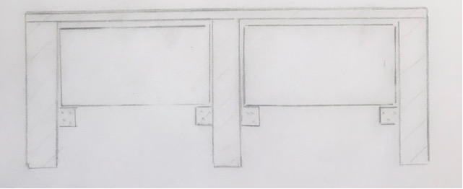
2

4 3

- Floor boards
- Insulation
- Battens
- Joists

Appendix 7 – Lintels

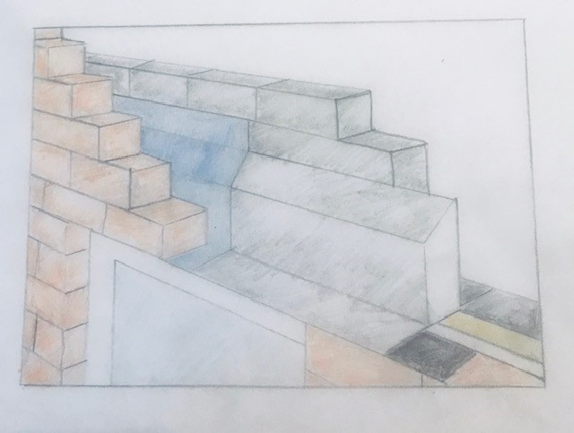
2 3 1

4 6
5
- Inner Wall
- Outer wall
- DPC
- Window
- Steel cavity lintel
- Insulation

(Image sketched from Steel Lintels - Installation Guide - Keystone Lintels, 2020)

Appendix 8 – End Bearing

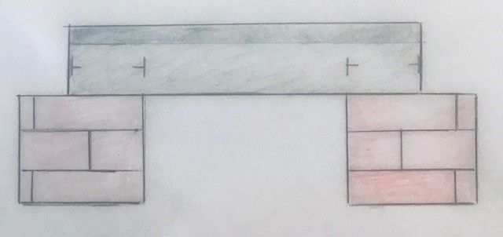

150 mm 150mm

Appendix 9 – Sills 1 7 2
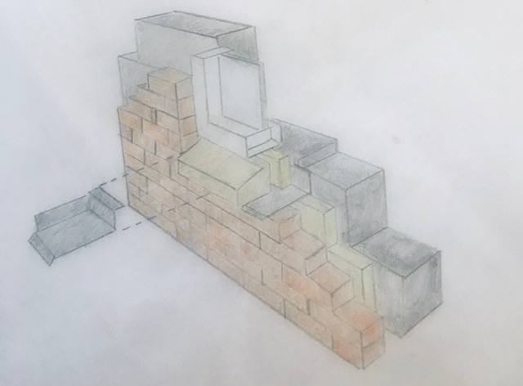

4 5
3 6

1 – Inner wall
2 – Flashing
3 – Outer wall
4 – Masonry Sill
5 – Drip
6 – Insulation
7 – Jamb
(Image sketched from International Masonry Institute, 2020)

Appendix 10 – Closed Eave
1 2 3
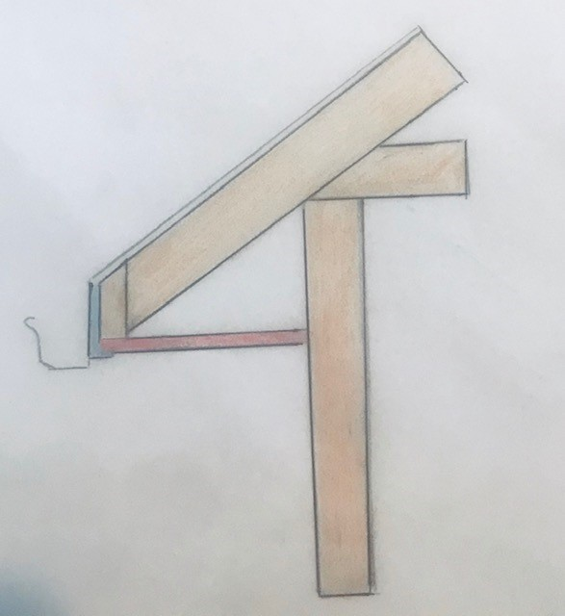

4 5

1 – Fascia
2 – Sub Fascia
3 – Rafter
4 – Gutter
5 - Soffit

Appendix 11 – Warm Roof Covering

3 2 1 4
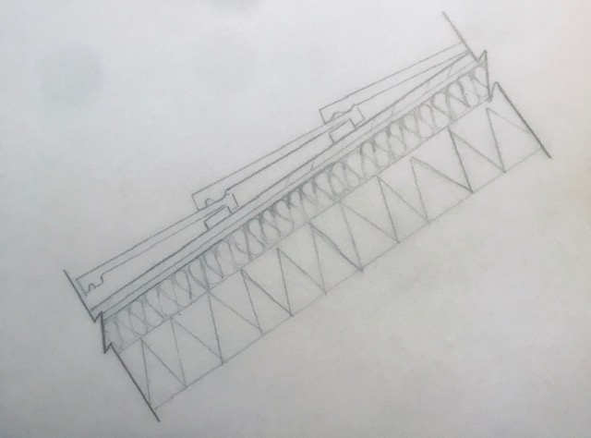

5 6

1 – Roof Tiles 80mm overlap
2 - Counter Batten
3 – Tile Batten
4 – Breathable membrane layer
5 – Insulation
6 – Rafter
(Image sketched from: What is a warm roof? | Helifix, 2020)

Appendix 12 – Queen Post Truss

2 5 3 6
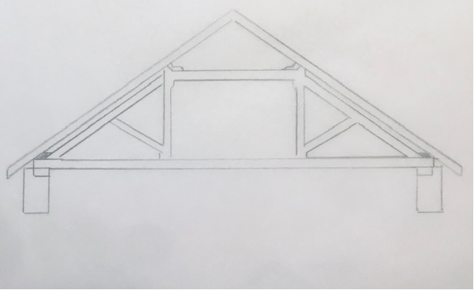

4
1

1 – Tie Beam
2 – Purlin
3 – Queen Post
4 – Strut
5 – Rafter
6 – Wall Plate
(Image sketched from Queen Post Truss, 2020)

Appendix 13 – Collar Pitched Roof
5 4

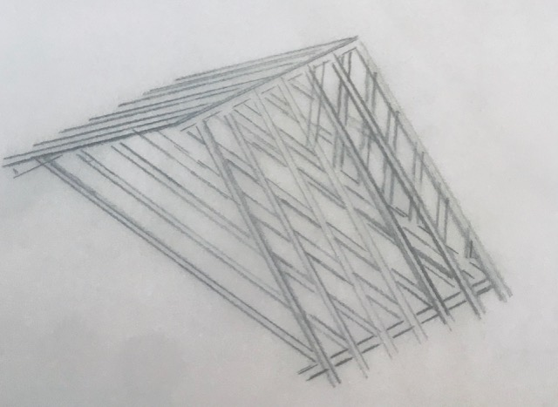

1 3 2

1 – The Member
2 – Batons
3 – Wall Plate
4 – Ridge piece
5 – Rafter
(Image sketched from Roof Framing Suggestions, Canadian guidelines, 2020)

11.0 References
Angie's List | Join for FREE to see 10 Million Verified Reviews. 2020. What Is A Fascia?. [online] Available at: <https://www.angieslist.com/articles/what-fascia.htm> [Accessed 23 April 2020].
Back to Earth. 2020. What Is A Vapour Control Layer (VCL)? | Back To Earth. [online] Available at: <https://www.backtoearth.co.uk/what-is-a-vapour-control-layer-vcl/> [Accessed 23 April 2020].
Builderbill-diy-help.com. 2020. Queen Post Truss. [online] Available at: <http://www.builderbill-diy-help.com/queen-post-truss.html> [Accessed 28 April 2020].
Btlpropertyltd.co.uk. 2020. Concrete Vs Timber Floors. [online] Available at: <https://www.btlpropertyltd.co.uk/blog/build/concrete-vs-timber-floors/> [Accessed 21 April 2020].
Gobrick.com. 2020. [online] Available at: <http://www.gobrick.com/docs/default-source/read-research-documents/technicalnotes/36-brick-masonry-details-sills-and-soffits.pdf?sfvrsn=0> [Accessed 24 April 2020].
Helifix.co.uk. 2020. What Is A Warm Roof? | Helifix. [online] Available at: <https://www.helifix.co.uk/blog/warm-roof> [Accessed 23 April 2020].
International Masonry Institute. 2020. 01.030.0402: Window Sill Detail - Anchored Brick Veneer, CMU Backing | International Masonry Institute. [online] Available at: <https://imiweb.org/01-030-0402-window-sill-anchored-brick-veneer/> [Accessed 28 April 2020].
Inspectapedia.com. 2020. Roof Framing Suggestions, Canadian Guidelines. [online] Available at: <https://inspectapedia.com/structure/Roof_Framing_Specifications_Canada.php> [Accessed 28 April 2020].
Keystone Lintels. 2020. Steel Lintels - Installation Guide - Keystone Lintels. [online] Available at: <https://keystonelintels.com/technical-support/steel-lintels-installation-guide/> [Accessed 24 April 2020].
Kingspan | Great Britain. 2020. What Is The Difference Between A Warm Pitched Roof And A Cold Pitched Roof?. [online] Available at: <https://www.kingspan.com/gb/en-gb/products/insulation/kingspan-insight/articles-and-advice/what-is-the-difference-between-a-warm-pitched-roof> [Accessed 23 April 2020].
Labc.co.uk. 2020. How To Get It Right: Supporting Joists On External Walls | LABC. [online] Available at: <https://www.labc.co.uk/news/how-get-it-right-supporting-joists-external-walls> [Accessed 21 April 2020].
LABC Warranty. 2020. How To Ensure Lateral Support To Walls When Constructing Floors And Roofs. [online] Available at: <https://www.labcwarranty.co.uk/blog/how-to-ensure-lateral-support-to-walls-when-constructing-floors-and-roofs/> [Accessed 23 April 2020].

Lizhiniv.com. 2020. Herringbone Strut 400Mm Centres Galvanised Joist Braces - Box Of 50. [online] Available at: <https://www.lizhiniv.com/index.php?main_page=product_info&products_id=240962> [Accessed 28 April 2020].
Practicaldiy.com. 2020. The Different Types Of Suspended Wooden Flooring Construction. [online] Available at: <https://www.practicaldiy.com/general-building/flooring/suspended-timber-flooring.php> [Accessed 28 April 2020].
Rightsurvey.co.uk. 2020. [online] Available at: <https://www.rightsurvey.co.uk/wp-content/uploads/2018/07/Easi_Span-tables.pdf> [Accessed 22 April 2020].

