Worksheet One
James Andrew David Beard
Student University of Wales Trinity St David
Swansea, Wales
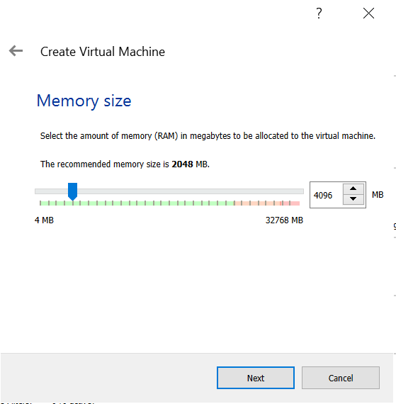
1901671@student.uwtsd.ac.uk

- Practical Tasks
- Initial Set up
The first step in completing worksheet one was to successfully set up each of the virtual devices, much of the authors input was the same for each device, all had 4GB of ram to allow the device to run at a good pace while not consuming too many resources. A screenshot showing one of the machines being allocated its ram can be seen in fig. 1. Next came the process of creating the virtual hard disk for the machines. Firstly, they all had a virtual disk image created to act as the hard drive for the devices. Next, all devices were set up as dynamically allocated so that they could use more memory if required, however, this should not be a problem as the server devices have 25GB of storage on them and the client devices have 20GB of storage. A screenshot showing server one being allocated its file location and hard disk size can be seen in fig two.

Fig. 1 Ram Allocation.
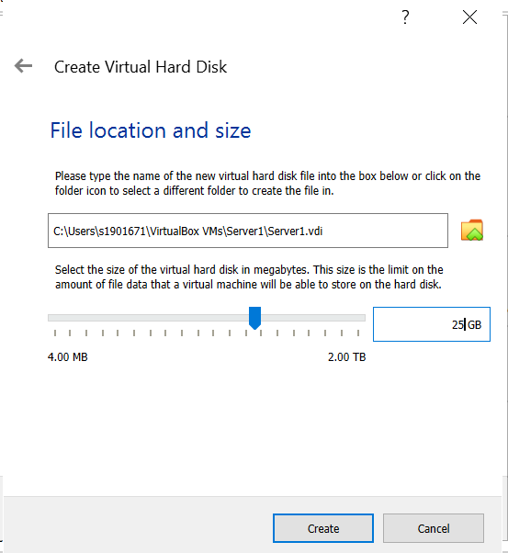
Fig. 2 Hard Disk Set Up.

The second process in the initial set up of machines was to make the initial changes to ensure that the virtual device ran as smoothly as possible. This was achieved by enabling PAE/NX in the processer tab, this was enabled to help the CPU and the device to run at optimal efficiency. A screenshot showing this being done on one of the machines can be seen in fig. 3. Next the virtual machine was given 128MB of video memory, this will hopefully optimise the GUI to run smoothly while completing tasks. Figure 4 shows a screenshot of the video setting set up.
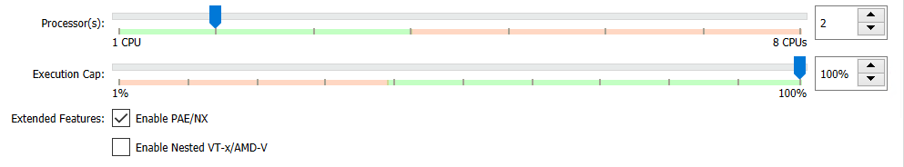
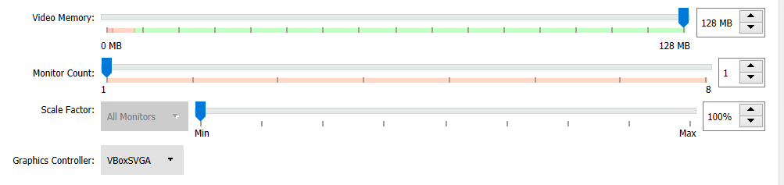
Fig. 3 Processor & PAE/NX Set Up.

Fig. 4 Graphics Settings Set Up.

- Server Set-Up
After setting up the server machines, the author started them up and began the initial set up and installation of windows on the device. First, he selected the correct startup disk, for the servers this was the windows server 2019 updated edition, this was chosen as it was the best and most up to date edition of Windows server. A screenshot of this selection can be seen in fig. 5.

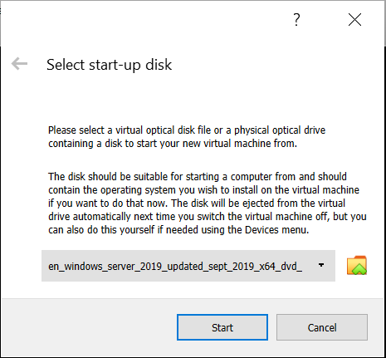

Fig. 5 Server Start-up disk Selection.

Next, the author had to select the correct time and currency format. The author selected English (United Kingdom) as the author was from the UK and would be using the machines in the UK. The author then chose the keyboard or input method which again was the United Kingdom as this is where the machines are being used. The final setting was language, this was left as the default setting of English (United States) as that was the only option available. Proof of these choices can be seen in fig. 6.

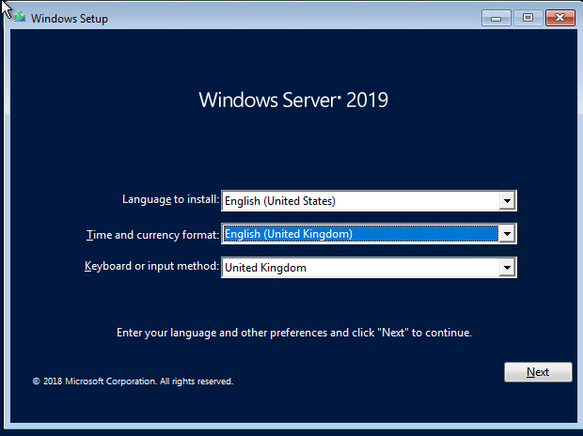
Fig. 6 Window Server Preferences.

Next, the author had to choose the operating system he wanted to install for his servers, he selected the windows server 2019 datacentre (desktop Experience). He chose the desktop experience as this choice uses a GUI to make it easier to navigate and use than the plain datacentre in which the user would have to navigate a command line. This being the user's first time working on a server he felt it was a better choice for him.

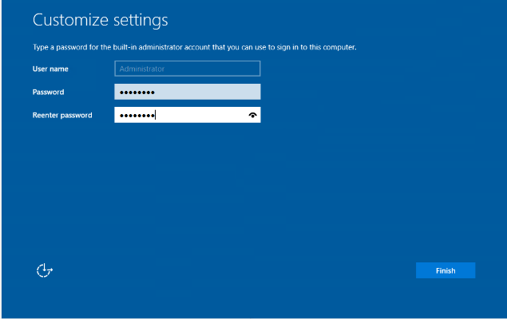
After this the Windows operating system began to install with the settings that the author had specified, this download was successful and without any problems or errors. The final step for the server’s initialisation was to set up the administrator account so that the user could log in to the server and begin to explore it. The author stuck with the original name given to him and created his password, which was accepted. A screenshot of this account creation can be seen in fig. 7.
Fig. 7 Administrator Account Creation

- Client Set-Up.
The first step the author took in setting up Windows on the client machines was to select the correct start-up disk, on the client systems this was the Windows 10 consumer edition disk, this was selected as Windows 10 is Windows most up to date operating system and Windows is the operating system that is being used in these tasks.

Next, the author had to choose the operating system he wanted to install, for this he chose windows 10 Education edition as can be seen in Fig. 8. This edition can be added to domains to allow the accounts with administrator rights on the server machine to have greater control of the client devices. This means that clients can be added to groups and be granted or denied permissions based on the groups they are in or individually set up.

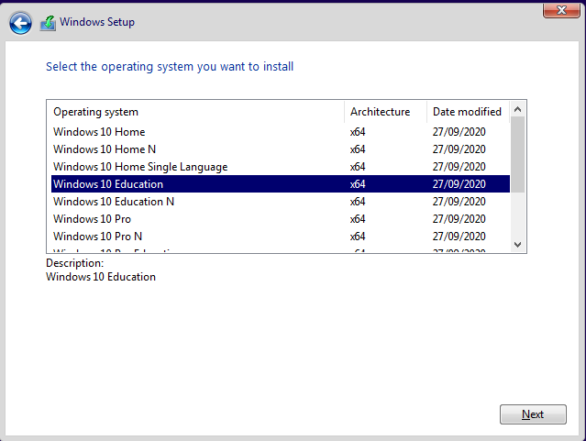
Fig. 8 Windows OS Selection

The final steps of setting up the client machines for the author was to set the account name and the password for the account. Next, the author had to select the region/country in which the device was being used, the author chose the UK for the reasons specified before, next the author was prompted for the correct keyboard layout, again he chose the United Kingdom option. Then the author had to select three security questions that he would answer if he forgot his password and needed to regain access to his account, as well as an added security measure to prevent unauthorised changes.

- Network Configurations
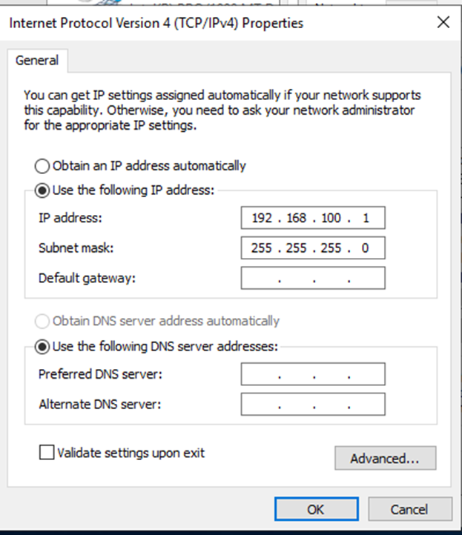
With the virtual machines switched off, the author went to the network tab of the virtual machine’s settings and changed the name of the virtual switch on the adapter of client one to “PrivateNet1”. On client two it was set to “PrivateNet2”. The servers however have two adapters enabled. On the first adapter of both servers, the virtual switch was named “PublicNet”. This network will be used by the servers to allow them to communicate with each other. The virtual switch on adapter two of server one was named “PrivateNet1”. This network will allow communication between Client one and server one. on Server two’s second adapter the virtual switch was changed to "PrivateNet2", this network allows server two and client two to communicate. Fig. 9 shows the network adapters with the names described above on server one.
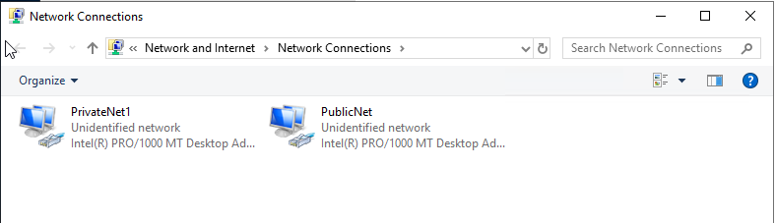
Fig. 9 Server One’s Adapters and Names.

After this, the author loaded up each virtual machine in turn, then went to the network configurations and set up the correct static IPV4 address on each device in relation to that network as instructed in the worksheet's physical topology. "Client1" was given the IP address of 192.168.100.2, the first three octets, 192.168.100 is referred to as the network portion, in this case, it is the subnet of "Privatenet1", and the value of these octets will not change as the subnet mask inputted by the author for this network was "255.255.255.0 or simply /24. This means only the last 8 bits or the last octet of the address can change, the final octet in this IP address is the host portion and is unique to the device. This is the same for all three of the networks they are all class c networks, they all have /24 subnet and they all have a unique host portion however the third octet of "Publicnet" is "1" and "Privatenet2" the third octet is "101".
Fig. 10 IPv4 Addressing Properties

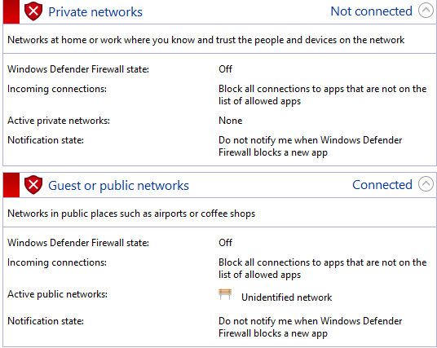
- Firewall Configurations
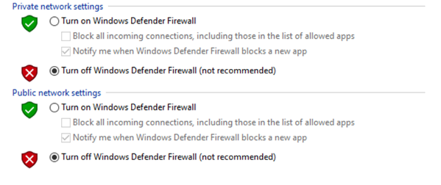
The next objective for the author was to turn off the firewalls to ensure that the author could test network connectivity by performing a simple ping test between the device of each network. The following steps were performed on both the server devices and the client devices. First, the author went to the search bar in his toolbar and searched for the firewall. He then clicked on check firewall status, then the author navigated to the “Turn Windows Defender Firewall on or off". The author then clicked the option to turn off the "Windows defender firewall" on the private network settings and he then clicked the same option to turn the firewall off on the public network settings section. Proof of this step can be seen in Fig. 11 and proof that the firewall is successfully off on one of the devices can be seen in Fig. 12.
Fig. 11 Firewall Settings Being Switched Off

Fig. 12 Proof Firewall is Off.

- Ping/ Network Testing
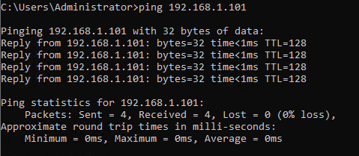
Now that the firewalls and the IP address were set up on all devices, it was time for the author to ensure that he had successfully achieved network connectivity. As mentioned above this was achieved using ping in the devices command prompt, to test the connectivity between the devices on each of the three networks. As can be seen in Fig. 13, Fig. 14, and Fig. 15. each of the three networks were able to correctly communicate as expected.
Fig. 13 “PublicNet” Ping
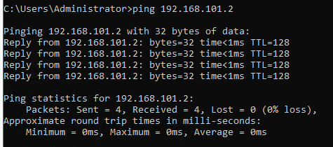
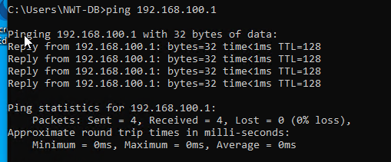
Fig. 14 “PrivateNet1” Ping
Fig. 15 “PrivateNet2” Ping

- Observation Tasks

- The main differences between Type 1 and Type 2 Hypervisors.
Type 1 hypervisor is classified as hardware virtualisations whereas type 2 is classified as operating system virtualization [1]. Type 1 hypervisor runs directly on the client's device with the virtual machines running directly on the device, type 2 hypervisors Runs on the operating system [1].
Some of the advantages of type one hypervisors over type two is that type one has much better scalability potential to type two hypervisors this is due to type two’s reliance on the operating system [1]. Type two is also considered to be less secure than type one, this is due to any problems in the main operating system also influences the whole system including the hypervisor [1]. The speed of type one is also considered to be much greater than type two, once again because of system dependency [1]. The final advantage of type one over type two is that type one is believed to hav34e a better performance than type 0ne due to it not having a middle layer and the fact type two has extra overhead reducing type two's performance [1]. A disadvantage of type one is that it requires separate management to control the different machines and handle the host hardware [1].
An advantage of type two hypervisor is it much simpler installation and setup process dues to already having an operating system [2]. Another advantage is that it allows easy and fast access to different OS alongside the main one, making it great for productivity and allowing a user to use the best features of multiple OS [1]. The biggest disadvantage of type two is it needs to access and consume the physical device's resources leading to the issues discussed previously paragraph in comparison to type one [1]. A list of vendors that uses type one hypervisors or type two hypervisors can be found in appendix one.

- The significance of the subnet mask in IPv4 addressing?
Devices must be aware of which part of the subnet is the network portion, the part that will not change and is the same on each device on the network and the host portion, the part that is unique to every device on the network [1]. This is achieved by a 32-bit subnet mask that is made up of ones and zeros [1]. The ones must always be at the start of the subnet mask and next to each other. The last one in the subnet is where the network portion ends and the first zero is where the host portion begins. Most commonly the subnet will be displayed as a dotted-decimal value [1]. An example of how this is achieved and the process of determining the network and host portions can be seen below.
Fig.16 Subnet Mask example

- The use of cloud computing including its benefits and drawbacks.
According to Karim and Soomro cloud computing is one of the biggest and most vital expansions in the IT industry of the last decade [1] as of the book's release in 2020. Cloud computing has allowed users to access and update their documents and work anywhere in the world and at any time of the day or week if they have an internet connection. Cloud computing works off a service subscription whereby a user or company pays for a service such as software or storage from the provider without the need for physical hardware [1]. A list of vendors that offer cloud computing and cloud services can be found in appendix two.
- Advantages
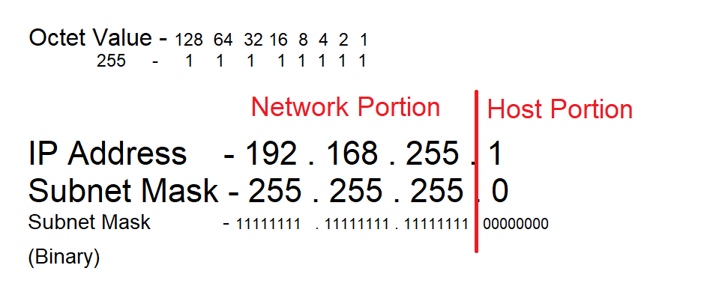
- Cost-effective- Cloud system can allow an organization to use various software, online storage, and other online services without the need for physical copies, this allows for the prices of these services to be lower than they would be if the organization was to buy a physical copy of a piece of software or if they were to buy physical storage [2]. As cloud services are often subscription-based, they do not have to worry about paying for the maintenance and upgrading of storage or having to buy a new copy of the software when the old one is outdated [2].

- Flexibility- Cloud computing can also give the organization far more flexibility in running its infrastructure. The Administrator and company can rent and subscribe to a software or service when it is required and then stop the service when it is no longer required, allowing the company to better deal with real-world events [2]. For example, an online retailer in the UK may require more resources at Christmas when traffic to the site is higher than it will need in January. Another example is if a company or user needed to use specific software to complete a task but was unlikely to need it again, they can subscribe and pay for a month's access to the software or application, instead of having to having to buy it outright and wasting memory.

- Simplicity - Software from the cloud can be easier to set up and less demanding than physical copies of the software, the cloud-based application is easier to maintain for administrators as access to it only requires a web browser [2]. Most of the heavy work is completed by the service provider leaving the administrators to get on with other tasks [2]. The layout of cloud storage is also much simpler as all the physical storage devices are offsite meaning that the company's IT department does not worry about where they are going to house the device as once again it is not their concern [2].

- Scalability- As briefly touched on in flexibility the ability to add more resources when needed can also be expanded into the company's scalability. Scalability being one of the most important aspects for network engineers to consider when designing a network, with cloud storage the engineers do not have to worry about running out of physical space in their building as they are using the service providers hardware to store their data which will be offsite [2]. They do not need to go out and spend a fortune on new hardware as again they are renting the providers hardware [2]. This can be a massive advantage for smaller and newer businesses growth as they are not limited to their building size and an extent, they do not require huge financial resources to expands as they would if they wanted to physical buy software and hardware.

- Disadvantages
- Internet connection- To access cloud services the user and or company must have an internet connection [2]. On the surface, this may seem a rare occurrence for the interment to go down, but it is still a concern that if a connection cannot be made then the user has no access to their data, software, and applications on the cloud. Another issue interlined with connection problems is if the internet connection is poor and slow. This is not likely to be a massive problem for downloads with today's connections, at worst it may take a little longer than hoped to download software or files from the cloud [2]. A slightly bigger concern is poor connection could lead to latency problems when the company tries to use a certain service to complete work and finds it to be poor and non-responsive, damaging the productiveness of the company and its staff.

- Damage/Loss- If The cloud is the only place that a company or user stores their data then it could be lost or damaged if something happens to the service providers storage [2] such as physical damage to the devices, malware infects the system and corrupts everything. This unlikely to happen with the extensive security measures that are in place at these cloud companies, but it would be recommended to consider an appropriate backup plan to ensure data is lost.

- Security concerns- Though security is likely to be a high priority for the service provider there is always the risk that hackers and malicious software could breach the system and gain unauthorised access to the information on the cloud [3]. This could mean that the company's information is stolen or accessed unauthorised, with which the criminals could blackmail or hold the company to ransom to gain their information back. The criminals could just as likely steal copies of the information and sell it on to other criminals for financial gain.

- Terminologies and Comparison between Windows and Linux.
Firewall – This is a security program, that prevents certain information transporting between untrusted networks (WAN) and the trusted network (LAN) [4]. A firewall can either run as a separate entity/device, a piece of software on the device or as a different network the supports a group of devices [4].

PAE- Physical Address Extension is a processor feature that allows x86 processors to access 4GB or more of memory [4]. The PAE mode must be running on the processor if the processor wishes to enable e NX mode as without it the processor will not be able to use the NX feature [4].

NX- “No-Execute is a processor feature that allows memory pages to be marked as non-executable” [4]. This feature helps the CPU to guard the system form malicious activity and software by preventing malicious code from being placed inaccessible areas of memory [4].

Ping – the abbreviation of Packet internet grouper, is a utility used to
Test connection between two devices [4]. It does this by sending out a set of packets to the desired IP address or domain name asking for that devices to send a reply to these packets to confirm the connection as well as testing how long it takes to reach them and for them to reply [4]. This command works for both Windows and Linux operating systems and does the same function on both.

Windows Server manager- Windows server manager is a management console on a Windows server that helps administrators and IT staff to manage Windows-based servers from their desktops [7], this can be both locally or remotely without the need for physical access to the servers or without enabling Remote Desktop protocol [7]. An advantages comparison between windows server and Linux can be found in appendix three.
- Appendix One - Hypervisors
- Type One:
- Citrix XenServer [3]
- VMware vSpher ESX/ ESXi [3]
- Microsoft Hyper-V [3]
- KVM – Kernal-Based Virtual Machine [3]
- Oracle VM [3]

- Type Two:
- Sun’s VirtualBox [3]
- Oracle VM VirtualBox [3]
- VMware Workstation Pro/VMware Fusion [3]
- Windows Virtual PC [3]
- Parallels Desktop [3]

- Appendix Two - Cloud Vendors
  - phoenixNAP [12]
- Amazon Web Services [12]
- Microsoft Azure [12]
- Google Cloud Platform [12]
- VMware [12]
- IBM Cloud [12]
- Verizon Cloud [12]
- Dropbox [12]
- Egnyte [12]

- Appendix Three- Windows server vs Linux

- Advantages of Linux
- Open source: Linux is open-source software and an IT infrastructure platform; this means that Linux's source code is available to coders to update and change the software allowing for them to edit features or fixes bugs and faults when required [11].

- Free to Use: Due to Linux being open-source it is generally free to use and install whereas with windows the user/ company must pay for the licencing of using window’s programs [11]. The only exception to this is if the user needs technical support regarding installing the software or maintain it [11].

- Easy accessibility with other open-source software: Linux allows for easy and fast compatibility with other open-source software and provides a quick interface with faultless adoption of the program [11]. This ability also extends to allowing Linux to also run windows programs if they have the correct licencing [11].

- Uses few resources: Linux servers are considered to run leaner and with fewer resources than windows. Linux also allows for alterations to be made to the servers and the software without the need of rebooting the system something that is not considered possible on windows [11].

- Advantages of Windows
- Works well with other windows programs: All windows applications will work with windows server as soon as it is set up, it also makes the most sense that if all other programs being used are windows and the user is used to windows it makes sense to use it [11].

- Database backend (Microsoft SQL version) easier to use: Windows will run a database backend based on Microsoft SQL much easier than Linux will, for Linux to run it you need to instal windows emulator and buy a copy of windows and database software tom use it [11].

- Complete solution: windows server is a complete solution that is easy and fast for the user to set up. Windows servers are great for remote desktop access with GUI without the need for command-line programming, Linux however does require command-line programming [11].

- Easy to use: As mentioned before windows server does require the use of command line-programming make it much easier to use and configure than using Linux to configure the server [11].

- Works with scripting frameworks: Windows server can work with scripting frameworks such as ASP whereas this is not possible with a Linux operating system [11]. Active server page (ASP) is a web page that has small, embedded programs (scripts) on them [11], this means that any scripts or webpages that a user makes with these programs will not work on Linux [11].

- References

[1] | K. Taylor, "Type 1 vs Type 2 Hypervisors," hitechnectar, [Online]. Available: https://www.hitechnectar.com/blogs/hypervisor-type-1-vs-type-2/#:~:text=The%20native%20hypervisors%20are%20a,efficiency%2C%20performance%2C%20and%20speed. [Accessed 20 02 2021].
[2] | IBM Cloud Education, "Hypervisors," IBM, 08 05 2019. [Online]. Available: https://www.ibm.com/cloud/learn/hypervisors. [Accessed 20 02 2021].
[3] | T. Lammle, "Easy Subnetting," in Routing and Switching Complete Study Guide, Indianapolis, Wiley, 2016, pp. 190,191.
[4] | S. Karim and T. R. Soomro, "What Is Cloud Computing?," in Cloud Computing Applications and Techniques for E-Commerce, Hershey, IGI Global, 2020, pp. 1,2.
[5] | P. Abdalla and A. Varol, "Advantages to Disadvantages of Cloud Computing for Small-Sized Business," in 7th International Symposium on Digital Forensics and Security (ISDFS), Barcelos, 2019.
[6] | A. Constantinides, "Advantages and disadvantages of cloud computing," IBS.
[7] | M. Whitman and H. Mattord, "Security Technology: Firewalls and VPNs," in Principles of Information Security, Boston, Cengage Learning, 2011, p. 250.
[8] | Microsoft, "PAE/NX/SSE2 Support Requirement Guide for Windows 8," Microsoft, 17 02 2017. [Online]. Available: https://docs.microsoft.com/en-us/windows-hardware/manufacture/desktop/paenxsse2-support-requirement-guide-for-windows-8. [Accessed 22 02 2021].
[9] | D. Ince, "Packet Internet Groper," in A Dictionary of the Internet, Oxford, Oxford University Press, 2019.
[10] | Microsoft, "Server Manager," Microsoft, 16 10 2017. [Online]. Available: https://docs.microsoft.com/en-us/windows-server/administration/server-manager/server-manager#:~:text=Server%20Manager%20is%20a%20management,rdP)%20connections%20to%20each%20server.. [Accessed 22 02 2021].
[11] | S. Simic, "What Is A Hypervisor? Types Of Hypervisors 1 & 2," PhoenixNAP, 24 01 2019. [Online]. Available: https://phoenixnap.com/kb/what-is-hypervisor-type-1-2. [Accessed 20 02 2021].
[12] | softwaretestinghelp, "15 Top Cloud Computing Service Provider Companies," softwaretestinghelp, 18 02 2021. [Online]. Available: https://www.softwaretestinghelp.com/cloud-computing-service-providers/. [Accessed 22 02 2021].
[13] | B. Dobran, "Windows Server vs Linux: The Ultimate Comparison," PhoenixNAP, 05 07 2018. [Online]. Available: https://phoenixnap.com/blog/linux-vs-microsoft-windows-servers. [Accessed 25 02 2021].

