i) On the Hagiographical and Historiographical Materials Relating to Saint William of Norwich.
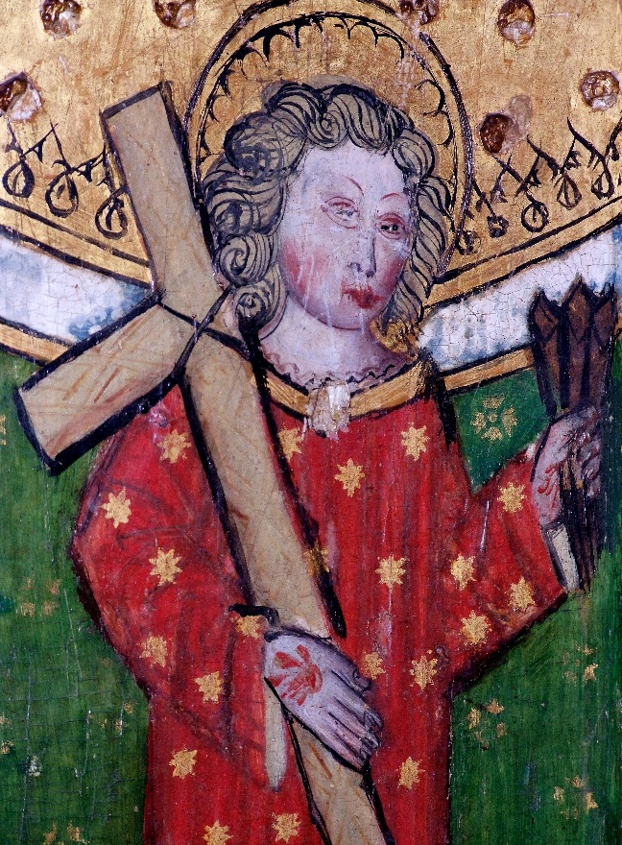
The story of William of Norwich, as told by Thomas of Monmouth is one of the first instances of Blood Libel in history. Because of this, and because it can tell us a fair amount about the history of the Jew in Medieval Europe during the eleventh century, it has been an invaluable piece of work.
The Life and Miracles of St. William of Norwich (Henceforth called Life) written by Thomas of Monmouth from 1149 to 1173 gives an in-depth account of William’s life in Norwich and the miracles that occurred after William’s death as a result of his intercession. It also presents a very detailed look at the population of Norwich and the surrounding areas. From the miracles that are present in the book, we can begin to see the kinds of people that St. William helped, and who joined his cult. However, one cannot ignore the fact that the books tell a particularly bleak and sometimes horrendous tale of the hatred and persecution of the Jewish people during the twelfth century. Thomas puts forth his beliefs, which in turn may say something about the Christian population’s beliefs too. Namely that a popular belief in the Christian faith was that the Jews were responsible for the death of Jesus. Whether this has been conceived out of hatred for the Jewish population, a perceived twisting of the stories and tales of the bible or fear, perhaps, that the Jews would do unto the Christians as they did to Christ. Regarding the question ‘why did certain members of the Christian Faith hate the Jews?’, it is impossible to come to some sort of conclusion just by examining the one book written by one monk.
Figure 1 - William of Norwich, rood screen from the church of St. Peter and St. Paul, Eye, Suffolk
Life focuses not only on William’s life before his murder and becoming a saint, but it also focuses on the miracles that William performed. Being such an important local saint to Norwich, William’s miracles tended to focus on that area of England. However, we find that as William’s cult grows and as more and more people get to know about him, either through word of mouth or through William appearing to them in dreams, his area of influence begins to grow too. Eventually, William is not just performing miracles in Norwich and at his tomb, but he is also called upon to calm a raging storm. The miracles in the book sometimes result in the person asking for the miracle having to go to Thomas. Once with the asker, Thomas would produce some relic of William and heal the person. It can, perhaps rather cynically, be assumed that Thomas asked for donations in return for the relic cure, although this is purely speculation.
While Life is certainly the most important hagiographical material that we have available to us today, there are also a number of paintings that should be examined. For example, figure 1 which shows William holding a cross and three nails. His hand has been pierced by a nail which reflects the story that Thomas presents. The nails become William’s motif and are present in most other pictures of the child. They represent the torture and murder that he underwent at the hands of the Jews and serve as a very visual reminder of the horrors that they put him through. He is carrying a cross as well, which is identical to Christ carrying his cross, and a representation of his suffering.
Paintings like this one and Figures 2 and 3, while not essential for understanding the story, certainly are of use. They give us an idea of what this story meant to the people of their respective time periods. The hatred and persecution present in Thomas’ work did not fade; blood libels would continue for centuries after both Thomas and William passed away.
It is a given that this story and collection of books has been instrumental in many historiographical works surrounding the topic. There are a number of articles written and published that examine the tale and question certain parts of it through a number of schools of thought.
Gillian Bennett, examines the story of William of Norwich through the eyes of a folklorist. She remarks that “Thomas himself was not above trying to change the meaning of events and rewrite history. In fact, his account is often a blatant attempt to do just that.” Her expertise as a folklorist allows Bennett to be critical of the story and to remind us that just as in folklore, people can change the events to suit their purpose and their work. This is most certainly the case of William of Norwich, as Bennett writes that Thomas came to the area in 1146, two years after William was murdered. Bennett goes on to examine whether this case was truly the first instance of blood libel in the middle ages and does so in a very convincing manner.
Another article that is of great relevance is written by Heather Blurton. In her article she examines the way in which Christian liturgy is applied throughout Thomas’ work. Blurton shows how the life of William draws upon many “hagiographical tropes that link the life of the saint to the life of Christ” and demonstrates how it relies on liturgical language to authenticate the story that Thomas is trying to tell. Blurton raises a good point here, as without the language used by the church and the liturgy, Thomas’ story might not have been as readily accepted by the people. The acts performed by William, if he were to be made a saint, have to be similar to those that Jesus performed, otherwise he would have just been considered an ordinary child.
Although the only hagiographical materials we have available to us are Life and paintings, they can tell us a lot about not only William and Thomas’ story, but also of the people that surrounded them both, and who were members of St. William’s cult.

ii) On a dumb boy recovering his speech and the miracles of Saint William of Norwich.
In the chapter “Concerning a dumb boy brought to the sepulchre by a vision and how he recovered his power of speech.” Thomas of Monmouth recalls a story in which a couple received a vision to visit St. William, and to present their son who Thomas describes as “dumb”. They bring the child to the sepulchre, where the family pray together, present St. William with a candle held by the child and have the boy kiss the sepulchre. Upon kissing the sepulchre, the boy begins to speak in his mother tongue, asking if they could go home. The sight of the miracle brings all those who witnessed it to tears. I chose to examine this miracle, firstly because the parents are noted as leading “very honest lives, though poor.” Secondly, because he heals a child. Both of these factors demonstrate how kind and caring St. William was. Through this one miracle, and indeed countless others that come after this miracle, St. William is always presented as a kind saint, who is not vengeful.
Of course, we know that William’s life was one of great kindness, as he gave alms to the poor, broke men out of shackles and many other feats of great kindness. One should consider though that these stories were most likely greatly exaggerated and were an attempt to get him canonised as a saint, and an aim to hit the charitable works a saint should accomplish. Regardless, the life of William of Norwich would have been an inspiration to many. This could also have been another reason that children were so regularly brought to the shrine of St. William; so that they might be taught the values of being a good Christian and that they too should live their life as William did.
Throughout The life and miracles of St. William of Norwich, Thomas names thirty children that William healed, and we can assume that there were many more that aren’t named, but who are placed in such chapters as “Of a multitude of sick persons cured” (Book seven, chapter viii. Although the presentation of sick children to a Saint for healing is not special to St. William, it is significant because he is a particularly important child saint. I believe that the young age of St. William encouraged people to visit his shrine because he would be more sympathetic to children.
Due to the presence of death in the middle ages, particularly surrounding children, when it wasn’t uncommon for children to move on before their time, it is easy to imagine that the average medieval person did not care for their children, and that people had multiple children as security to ensure that both their name and their possessions would be passed on. Thomas’ work presents an account that greatly goes against this thought. Throughout the book, we are served multiple cases of incredibly caring parents who would do anything for their child. People would visit St. William from great distances, which would have cost a fair amount of money. People would present William with candles, which again would have cost money. There seems to be no lack of parental care throughout the work.
In the middle ages, a person was deemed dumb if they could not speak. This could be for a number of reasons, either selective mutism, a learning disability, or a multitude of other reasons. There was a mixture of attitudes to disabilities in the middle ages, of course, it was not ideal. A common thought was that the disability was forced upon the person as a punishment for sin. Another belief was that having a disability meant that you were closer to God because you were “suffering purgatory on earth rather than after death and would get to heaven sooner.” There were often stories that involved ‘dumb’ children, including the daughter of King Henry III, Katherine, who died in 1257. She was born dumb, being unable to talk, which may have been attributed to a mental disorder that she had from birth. Although she was considered ‘dumb’ and kept in a separate house from Henry’s other children, it is reported that Henry and his wife Eleanor were “overcome with grief at the death of their three-year-old daughter.” I mention this case, only as a reminder that medieval parents were indeed caring, and loved their children, even those who were ailed with mental health problems. St. William clearly loves these children as well, as he was blessed with the ability to help them recover from their ailments.
Throughout the books, we can see St. William grow in strength. While his initial miracles occur at either the site where his body was dumped in the forest or the grave where he was buried. However, as more and more miracles occur, his body is translated into more impressive sites, for his second translation, he is moved into the chapter house, which would have been considered a great honour. Here his powers begin to grow, and his influence grows beyond the border of Norwich. In the above miracle, the parents were originally from the city, however, we later see people coming from Ormesby, a village twenty miles from Norwich. As he is translated into the altar for holy martyrs, we begin to see people coming from London and even further afield. This shows both the power of St. William, and also the influence of his cult. As more and more people began to believe in St. William, more and more people visited his shrine, and thus his cult grew.
One must always remember to think critically when reading miracle stories and remember that they were intended to make more people aware of the saint and to encourage people to worship the saint. That’s not to say that the stories aren’t without value. Thomas’ work is an invaluable source regarding the miracles that it displays. It gives the reader insight into the people that were in the cult of St. William, and by extension, the people of the middle ages.

iii) On the artwork of Saint William of Norwich and the beliefs of Thomas of Monmouth.
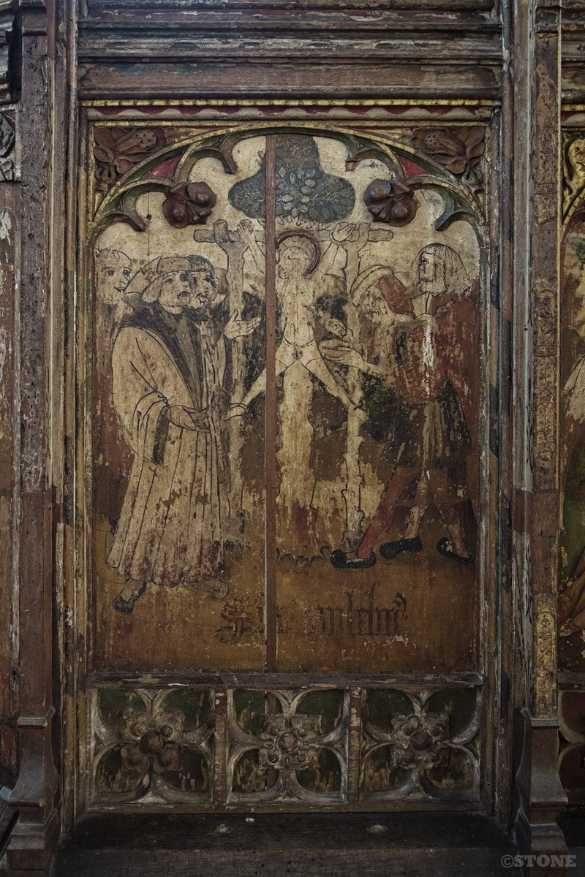
While there are not many visual sources available for William, the ones we do have available to us today are incredibly important. This rood screen painting (figure 2), painted in the 15th century by an unknown artist, depicts William being crucified and tortured by the Jews. Although this painting was completed in the fifteenth century, it shows that there was an understanding, at the very least, or Thomas of Monmouth’s work, if a slightly skewed understanding. There are many similarities between the painting and Thomas’ work. Thomas writes: “For the report goes that there was there instead of a cross a post set up between two other posts, and a bean stretched across the midmost post.” And “The right hand and foot had been tightly bound and fastened with cords, but the left hand and foot were pierced with two nails.” The picture does indeed depict this, although the exact state of bound and nailed limbs is slightly different. Given the time difference between the two sources though, this is forgivable. The time difference is noteworthy though, because it could be assumed that the Jews might have crucified William in the same way that Jesus was, on the cross. However, the artist stayed true to Thomas’ depiction.
Figure 2 - The Crucifixion of William by Unknown. A rood screen in Holy Trinity Church, Loddon, Norfolk
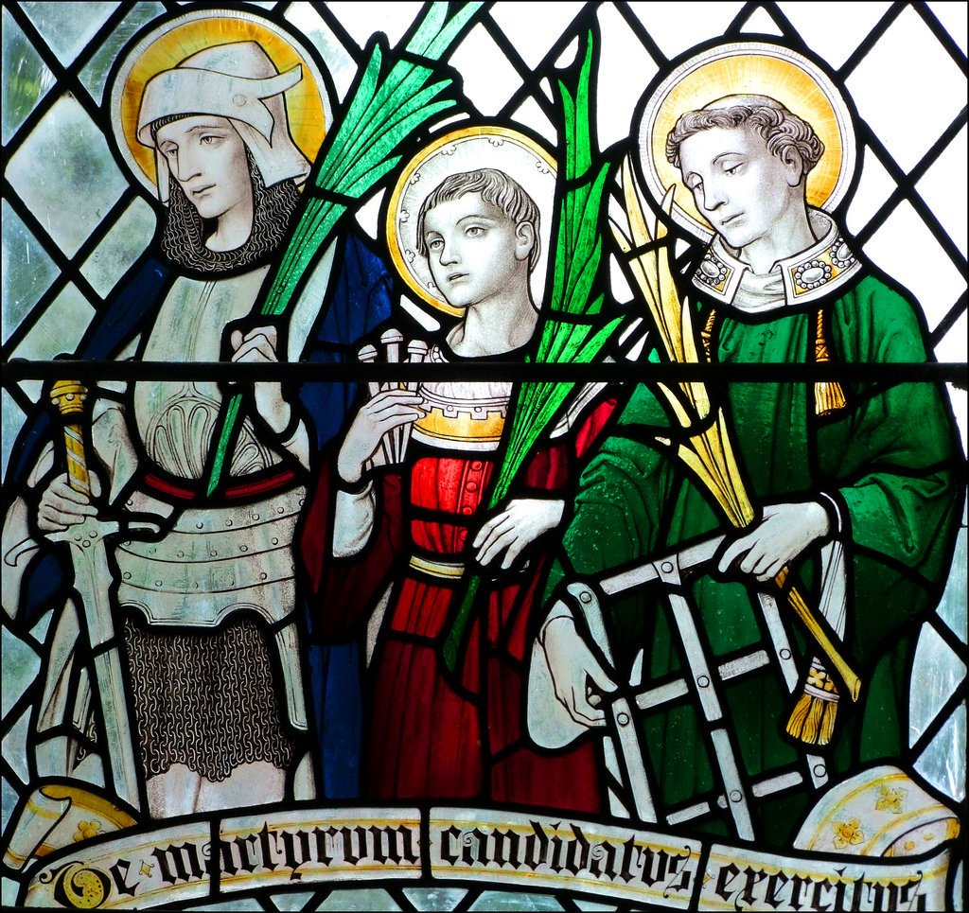
In the painting, the men surrounding William, the Jews, are pictured in complete bliss and elation at the fact that they have been able to murder this innocent child. One can be seen piercing William’s side with a knife, which both calls back to the spear that pierced Jesus’ side on the cross, and the belief that Jews would use the blood in their meals at Passover, which is when this account occurred. Behind William, we can see the top of a tree, which is a representation of the forest in which William’s body was found. In the middle of the picture sits William, tied to the cross with a fire lit beneath him. This is a depiction of the tortures that the Jews made William endure. All depictions of William show him as being quite an angelic child, who is often carrying three nails (See Figure 3.) The three nails were the ones that were driven into the top of William’s head. In this stained glass, William is pictured between St. Alban and St. Lawrence, who were both early martyr saints. William could also be called a martyr saint, as he died because of his religious beliefs. This modern image shows us that the story of William remains and that the aspects of his death have not been forgotten; and for one very important reason.
Figure 3 - A Stained Glass image of St. William pictured between St. Alban and St. Lawrence, by FC Eden, 1925, St. Andrew's Church, Marks Tey, Essex
The story of the murder of William is one of the first cases of Blood Libel: the false accusation of Jews kidnapping and murdering children so that their blood might be used in certain rituals and food. This belief first occurred in Egypt in the first century but didn’t resurface until the murder of William in 1144. In the medieval period, this thought could have stemmed from the bible verse “All the people answered, ‘His blood is on us, and on our children!’” This belief must have been widely held, as when the Jews murdered William, the whole community was driven out of the city.
It would be no stretch of the imagination to think that Thomas held these beliefs too, as his work is full of anti-Semitic messages. Throughout the book, he refers to the Jewish people as “our enemies”, and is often highly stereotypically racist as shown in chapter iii of book one: “For they esteemed him to be especially fit for their work, either because they had learnt that he was guileless and skilful, or because attracted to him by their avarice they thought they could bargain with him for a lower price.” This quote shows that Thomas had horrible feelings towards the Jews. Therefore, it can be thought that the story of William of Norwich, being written in 1149, just a few years after his death could perhaps have been written as an attempt to convince more of the population of his thoughts and feelings towards the Jews. Gillian Bennett puts forth the idea that Thomas wanted to gain money from the saint and rewrote the story to fit with his feelings. She suggests “If Thomas could persuade people that this is what had actually happened, … a stream of pilgrims would want to visit his shrine and … Thomas himself would gain income and prestige as the saint’s sacristan.” To some extent, I believe that Bennett is correct, that Thomas did alter the events and to make it seem like a community of Jews was to blame for the child’s murder, rather than just one individual, which seems more likely.
There is an argument to be made that Thomas stood to make a not-so-small amount of money from Life. Indeed, William’s shrine brought in lots of money throughout the twelfth and thirteenth centuries. In 1277, the shrine brought in £21 3s. 4d. This is an enormous amount of money. We can assume then that at the time, Thomas and the shrine were making a fair amount of money. However, it should not be overlooked that Life was most likely intended as an anti-Semitic work, either to push Thomas’ belief on to the reader, or the belief of someone higher up in the church. An editor of the book, Doctor Jessop of Norwich suggests that “our monkish author belongs to the class of those who are ‘deceivers and being deceived.’” With this quote, it is not difficult to believe that Thomas could have been convinced to hate the Jews by someone who taught him, perhaps in the monastery, or a family member. This is not to defend Thomas or his beliefs, but merely to put forth a suggestion of where his ideas began.

iv) On the arguments for sanctification and the importance of child saints.
Before William was even born, he was destined to become a saint. His mother, Elviva, was given a dream. In that dream, she came upon a fish at her feet. She took the fish into her bosom and nurtured it until it grew until she could no longer carry it, at which point the fish grew wings and flew into Heaven, where the gates opened for it. This dream represents a few things. Of course, her fish represents her unborn child, William. She chose to take the fish into her bosom, this demonstrates her unconditional love for the child. The fish grew until she could no longer hold it any more. I have interpreted this as being about the size of a child, perhaps a little bigger, so to me, this represents the young age at which William was prophesied to go to heaven. William becoming a saint is here represented as the fish flying directly into heaven, and not having to go through purgatory. Such an important dream must have been reserved for an important child. For the city of Norwich, William was certainly an important figure.
One should call into question whether William becoming a saint was a result of the prophecy, or whether the prophecy made William a saint. Was William truly demonstrating such saintly actions, or were his actions witnessed and the label of holiness placed on them? In answer to this, Patricia writes that “The vast majority of child saints would not be considered saints by the standards applied to adults.” This suggests that there is perhaps more emphasis placed on the few good deeds performed by William in Life, than there ought to be, because of his age and the need for sanctification.
In order to be considered a saint, even a non-canonised saint, one must first live a life of holiness and purity. To lead a life of holiness involves implementing the seven works of mercy into your life. These are seven ‘jobs’ that a Christian must perform without hesitation. As Reverend John Wesley writes: “both repentance, rightly understood, and the practice of all good works, - works of piety, as well as works of mercy … are in some sense, necessary to sanctification.” These works of mercy are particularly important, and is, I believe, the first instance where we can see the label of sainthood being placed on William’s actions. The works of mercy are as follows: Feed the hungry, Give drink to the thirsty, shelter the homeless, visit the sick, visit the prisoners, bury the dead and give alms to the poor. Thomas suggests that throughout his infancy and childhood, William not only understands the works of mercy but adopts and performs them too. There is one incident when William was a child that demonstrates this. Wenstan makes a feast and entertains his fellow men. A man who is undergoing penance, shackled with iron, comes to the feast and begs the people for alms. The family gladly feed him, but William walks to the man and examines his shackles which suddenly shatter, and the man is freed. It is likely that if this event did occur exactly as Thomas describes, that there was some weak link within the shackles, and they simply fell off without William’s intercession. However, this is the first case of William performing such a kind act for the man.
Thomas then goes on to describe William’s childhood, in which at the age of seven, he became “so devoted to abstinence that, though his elder brothers did not fast, he himself fasted on three days of the week.” And observes the vigils of the saints that celebrated devout fasting. It is odd that a child should be content with going days on nothing but bread and water and saving “whatever he could save from his own portion of food … to bestow upon the poor.” However, this demonstrates William’s prophesied sanctity. He was such a holy child, that he would have already been well known by the community, especially if he is giving food and alms to the poor and living his life in such piety.
Thomas mentions that William became devoted to abstinence at the age of seven. This is a reoccurring theme throughout saints’ lives, and the number appears throughout the world. This could be for a number of reasons, but primarily I believe that it is both the number of works of mercy, which are so ingrained in people of the Christian faith’s lives and is also the number of days in which God created the world. I believe that Thomas included such an important aspect of William’s childhood, that he underwent such devotion to abstinence at the age of seven, due to the importance and prominence of the number.
Another aspect that works with the prophecy is that he was born on the “day of the Purification of the Blessed Virgin Mary, that is on Candlemas.” Of course, this is a very special day, where both the presentation of Jesus at Temple and the purification of Mary are celebrated. Mary is considered one of the most important figures in the Christian faith, and so this day is very important to those who celebrate it. While Jesus was presented into the Jewish faith, it is still an important moment in his life and is therefore celebrated by Christians. William being born on this day mimics the presentation, only William is being presented into the world. It can be argued that being born on the same day as Mary was purified could mean that William had a special bond with Mary, one which enhanced both his families and William’s faiths.
In book one of Life, Thomas mentions that William chose to move to Norwich: “So leaving the country, by the drawing of a divine attraction he betook himself to [Norwich] and lodged with a very famous master of that craft.” From this, we can assume that his parents lived outside Norwich in the countryside, which gives more provenance to the fact that he became a local saint for Norwich. William chose to move to the city, meaning that for the people of the city, Norwich was special. It had been chosen by someone who would become a saint. This also helps to fulfil the prophecy of his death, because had he not moved to the city, there is the chance, no matter how slight, that he would not have met the Jewish people. Being so skilled, and at such a young age, according to Thomas, attracted the Jews to him. Whether because they saw an opportunity to save some pennies and scam the child, or because of divine providence.
There are a number of other saints who were children. They were held in very high regard in the medieval period. This could be for a multitude of reasons. As previously discussed, children were so very loved, and one way of protecting them is to call upon saints that are like their children. Perhaps someone so young would want to help protect those who have lots of potential in their life, and for it not to be wasted. Michael Goodich suggests that the “deaths [of child saints] reflect the typical bogeyman of the medieval mind.” With this quote, Goodich is suggesting that people worshipped child saints in the hopes that whatever death befell the saint will not happen to their own child. In the case of William of Norwich, perhaps people were praying to him in order to prevent the Jews from murdering their own son or daughter. Patricia Wasyliw notes that “Among the child saints discussed in [Patricia’s] work, violent deaths vastly outnumber death by natural causes.” This could mean that the violent nature of their deaths is related to how much sympathy the child gets from the public, and therefore how much they are celebrated and subsequently become a saint.
Unfortunately, William of Norwich was never formally canonised. The pope concluded that there was not enough documentation and proof that what Thomas writes in Life actually happened. However, this did not, and should not prevent someone from celebrating William. The miracles that he performed and the hope that he brought to so many people is worth celebrating alone. Although I have examined the life and miracles of Saint William in a highly cynical manner throughout this essay, I really believe that William was of great importance not only to the people of Norwich but to the ‘tourism’ industry of the city too. The impact that he had as part of the community, and after life becoming an icon for the community to collectively celebrate and revere is nothing to be ignored. William helped many people throughout both his life and after he died. Ignoring Thomas’ personal views that are so obviously scattered throughout Life, his work and efforts to collect stories of William’s intercession and the miracles that arose as a result of that; the work that he put into making sure that William was canonised, regardless of if it actually occurred or not was remarkable, and presents one of the most thorough and well put together accounts that we have available to us today.

Bibliography
Bennett, Gillian, "Towards A Revaluation Of The Legend Of “Saint” William Of Norwich And Its Place In The Blood Libel Legend", Folklore, 116 (2005), 119-139 <https://doi.org/10.1080/00155870500140156>
Blurton, Heather, "The Language Of The Liturgy In The Life And Miracles Of William Of Norwich", Speculum, 90 (2015), 1053-1075 <https://doi.org/10.1017/s0038713415001682>
Coss, Peter R, and Simon D Lloyd, Thirteenth Century England IV (Boydell P., 1992), pp. 57-72
“Disability In The Medieval Period 1050-1485 | Historic England", Historicengland.Org.Uk, 2019 <https://historicengland.org.uk/research/inclusive-heritage/disability-history/1050-1485/> [Accessed 8 April 2019]
Domnitch, Larry, "Passover And Blood Libels | My Jewish Learning", My Jewish Learning <https://www.myjewishlearning.com/article/blood-libels/> [Accessed 9 April 2019]
Eden, F C, St Alban, St William Of Norwich And St Lawrence (Marks Tey, Essex: St. Andrew's Church, 1925)
Harris, Stephen J, and Byron Lee Grigsby, Misconceptions About The Middle Ages(New York: Routledge, 2009), pp. 230-235
Marcus, Jacob Rader, The Jew In The Medieval World (New York: Atheneum, 1983), p. 121
of Monmouth, Thomas, Montague Rhodes James, and Augustus Jessopp, The Life And Miracles Of St. William Of Norwich (Cambridge: Cambridge University Press, 1896)
"St. William Of Norwich - Saints & Angels - Catholic Online", Catholic Online<https://www.catholic.org/saints/saint.php?saint_id=2136> [Accessed 14 April 2019]
Wasyliw, Patricia Healy, Martyrdom, Murder, And Magic (New York, N.Y.: Lang, 2008)
Wesley, John, The Works Of The Rev. John Wesley, A.M (London: James Nichols, 1840)
“What Does 'Blood Libel' Mean?", BBC News, 2011 <https://www.bbc.co.uk/news/world-us-canada-12176503> [Accessed 9 April 2019]

Thomas of Monmouth, Montague Rhodes James and Augustus Jessopp, The Life And Miracles Of St. William Of Norwich (Cambridge: Cambridge University Press, 1896).
Thomas of Monmouth, p. 178.
Ibid, p. 174.
Anonymous Rood Screen Painting Of William Of Norwich From The Fifteenth Century, 2009 <http://farm2.static.flickr.com/1236/528606469_c28149289e_b.jpg> [Accessed 11 April 2019].
Figures 2 and 3 are examined in more detail below.
Gillian Bennett, "Towards A Revaluation Of The Legend Of “Saint” William Of Norwich And Its Place In The Blood Libel Legend", Folklore, 116.2 (2005), 119-139 <https://doi.org/10.1080/00155870500140156>.
Bennett, p. 128
Bennett, p. 128.
Heather Blurton, "The Language Of The Liturgy In The Life And Miracles Of William Of Norwich", Speculum, 90.4 (2015), 1053-1075 <https://doi.org/10.1017/s0038713415001682>.
Thomas of Monmouth, p. 149.
Thomas doesn’t mention these people by name because they suffer the same illnesses that have already been mentioned or are too numerous to mention individually.
"Disability In The Medieval Period 1050-1485 | Historic England", Historicengland.Org.Uk, 2019 <https://historicengland.org.uk/research/inclusive-heritage/disability-history/1050-1485/> [Accessed 8 April 2019].
For more information about the children of King Henry III, I recommend Margret Howell’s article The Children of King Henry III and Eleanor of Provence in Thirteenth Century England IV.
Stephen J Harris and Byron Lee Grigsby, Misconceptions About The Middle Ages (New York: Routledge, 2009), pp. 230-235.
Thomas of Monmouth, p. LXXVI.
Ibid, pp. 21-22.,
Ibid, p. 22.
F C Eden, St Alban, St William Of Norwich And St Lawrence (Marks Tey, Essex: St. Andrew's Church, 1925).
"What Does 'Blood Libel' Mean?", BBC News, 2011 <https://www.bbc.co.uk/news/world-us-canada-12176503> [Accessed 9 April 2019].
Larry Domnitch, "Passover And Blood Libels | My Jewish Learning", My Jewish Learning <https://www.myjewishlearning.com/article/blood-libels/> [Accessed 9 April 2019].
Matthew 27:25
Thomas of Monmouth, p. 17.
Gillian Bennett, "Towards A Revaluation Of The Legend Of “Saint” William Of Norwich And Its Place In The Blood Libel Legend", Folklore, 116.2 (2005), 120 <https://doi.org/10.1080/00155870500140156>
Bennett argues that the murder of William should not be considered Blood Libel and presents some very convincing arguments in Towards a Revaluation of the Legend of the “Saint” William of Norwich and it’s Place in the Blood Libel Legend in Folklore.
Patricia Healy Wasyliw, Martyrdom, Murder, And Magic (New York, N.Y.: Lang, 2008), p. 124.
Jacob Rader Marcus, The Jew In The Medieval World (New York: Atheneum, 1983), p. 121.
Thomas of Monmouth, p. 11.
Wasyliw, p. 11.
John Wesley, The Works Of The Rev. John Wesley, A.M (London: James Nichols, 1840), p. 46.
Thomas of Monmouth, p. 13.
Ibid, p. 14.
Ibid, p. 12.
Wasyliw, p. 8
Ibid.
"St. William Of Norwich - Saints & Angels - Catholic Online", Catholic Online<https://www.catholic.org/saints/saint.php?saint_id=2136> [Accessed 14 April 2019].

