Element 2: Portfolio of Evidence and the Live Event
Introduction

This element of the independent project focuses on the planning and execution of the ITT Future You Event at Swansea Arena. This career-focused event helps facilitate networking between students and industry professionals, providing students with the opportunity to engage with professionals about their career paths while allowing industry leaders to identify potential employees (University of Wales Trinity Saint David) [hereafter UWTSD] (2025).
As part of the event, my peers from UWTSD and I were responsible for inspiring young people to pursue careers in the expanding travel, tourism, and events industry and also for promoting the Travel, Tourism, and Events courses at UWTSD. We achieved this by showcasing the accomplishments of industry leaders and highlighting the success of students who have embarked on the courses.
Our team of six was tasked with organising and managing this year’s event, overseeing all logistical aspects. Each team member had specific responsibilities, including inviting students and guests, creating a presentation featuring UWTSD experiences, and conducting interviews with industry leaders to promote the sector. Regular meetings were held to ensure coordination and alignment among the team.
My specific responsibilities included recording interviews with industry leaders, creating videos for social media promotion, inviting companies to set up stalls at the event, curating a travel-themed playlist to enhance the event atmosphere, and managing all recordings on the day of the event.

Planning Phase: Team Roles and Responsibilities
Team Communication and Updates, 17th October 2024
We created a WhatsApp group to schedule meetings and provide regular updates on our progress. This platform allowed us to share feedback, coordinate tasks, and make necessary adjustments to our work efficiently.

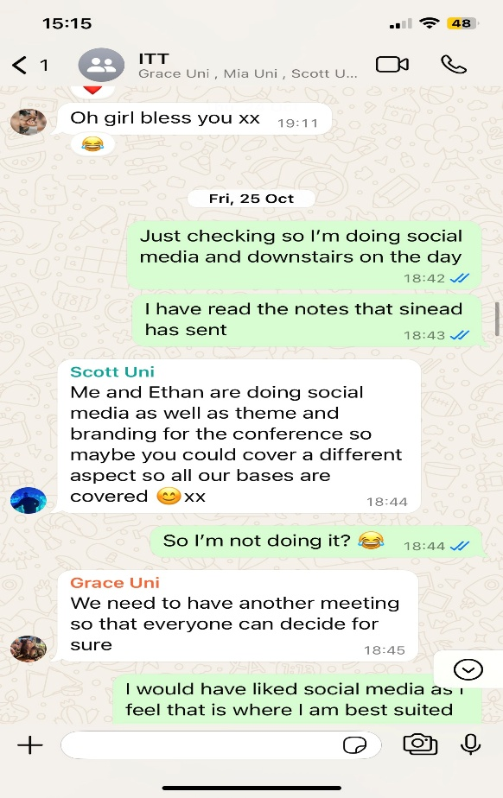
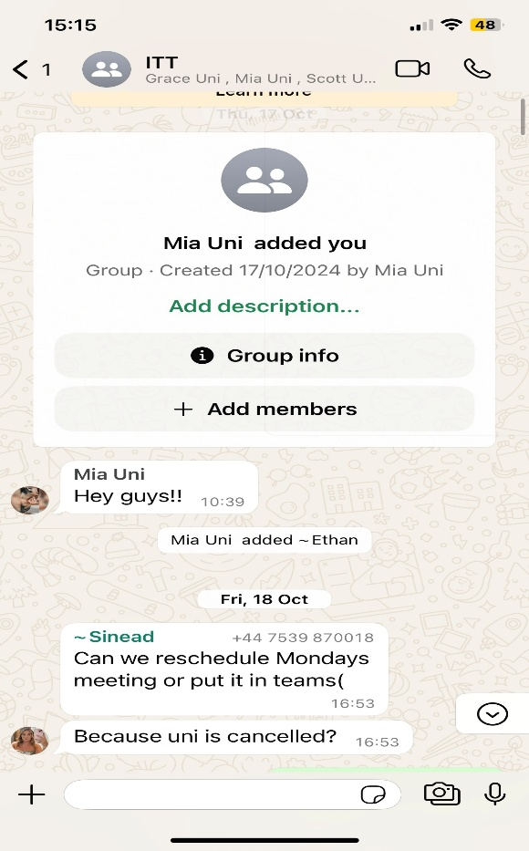

First In-person Meeting: 23rd October 2024
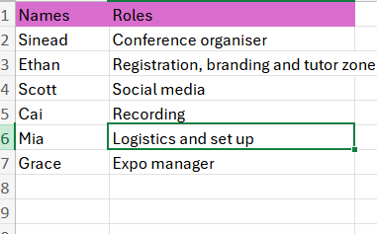
Before we began organising the event, we assigned roles to ensure smooth execution. Initially, I was responsible for ticketing and registration, a role I had previous experience in, having created digital tickets for Medal Monday, a sports-themed event for students.
The rest of the team had distinct roles:
- Ethan, Sinead, and Scott were responsible for managing the conference area and presenting on stage.
  - Sinead, as the conference organiser, served as the primary contact for attendees.
  - Ethan handled registration, branding, and the tutor zone, ensuring that schools and colleges were properly registered before arrival. He also developed the event’s branding, which featured the tagline "Wales to the World".
  - Scott was in charge of social media, creating promotional content to generate excitement and encourage attendance.
- Mia and Grace managed the event logistics. Mia, the logistics coordinator, ensured that the exhibition area was properly set up and that all stands were correctly assigned. Grace, the exhibitions manager, assisted Mia in overseeing the stands and the overall exhibition setup.

I had expressed my interest in overseeing social media, as I had relevant experience in managing content and creating videos. However, because I was unable to attend the first meeting due to prior commitments, I later understood that Scott and Ethan had already been picked this role. Instead, I was given a role in ticketing and registration, which I did not feel comfortable with. This was disappointing, as I believed my skills in social media and content creation could have been better utilized. Missing the initial meeting left me with fewer opportunities to contribute in ways that aligned with my strengths.

Change of Role: 25th October 2024
I discovered that ticketing had already been set up by the course lecturer. As a result, my role changed to content creation, which involved conducting interviews with industry leaders and previous students and producing marketing videos.
Second In-person Meeting: 13th November 2024
During our second meeting, we gathered at the immersive studio to film short promotional videos. Each team member recorded a 15-second clip explaining their role, the event details, and why attendees should join. These videos were then uploaded to the ITT Future You Instagram account to generate interest and engagement for the event.
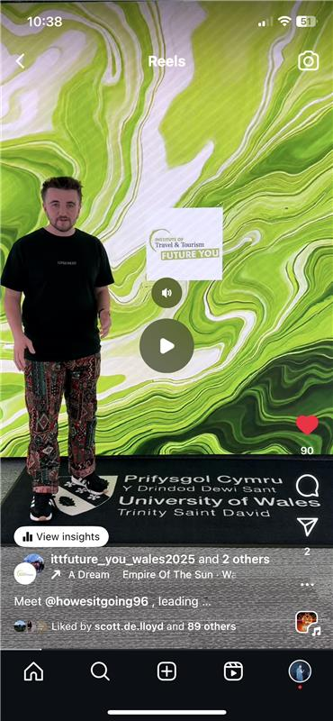

My Role

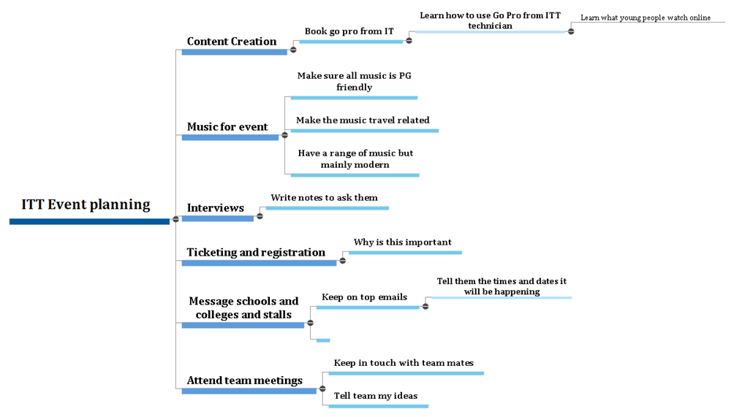
Content Creation – Prior experience
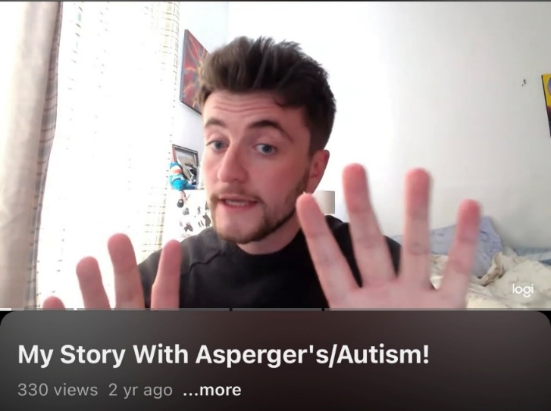
Taking on the role of content creator for the event felt like a natural fit, as it aligned well with my background and personal interests. I have over 15 years of experience in creating and editing video content, which began with recording webcam reviews of technology and films, to my experiences with having Asperger’s, which I then uploaded to YouTube. Over time, this hobby evolved into a refined skill set in digital media production, allowing me to develop skills in various aspects of filmmaking, editing, and audience engagement. Expand on this how has the previous work I have done helped making videos.

Initial Ideas
As part of my initial plan, I began by brainstorming ideas for engaging and dynamic video content. The aim of the video was to promote and showcase the event so that we could use it as a marketing approach for attracting potential students to a future within the travel and tourism industry.
My initial thoughts were to create videos that were fun, visually appealing, and attention-grabbing. To achieve this, I focused on incorporating: upbeat and positive music to enhance the mood; short, fast-paced clips to maintain audience attention and quick transitions, and varied camera angles to keep the visuals dynamic and engaging.
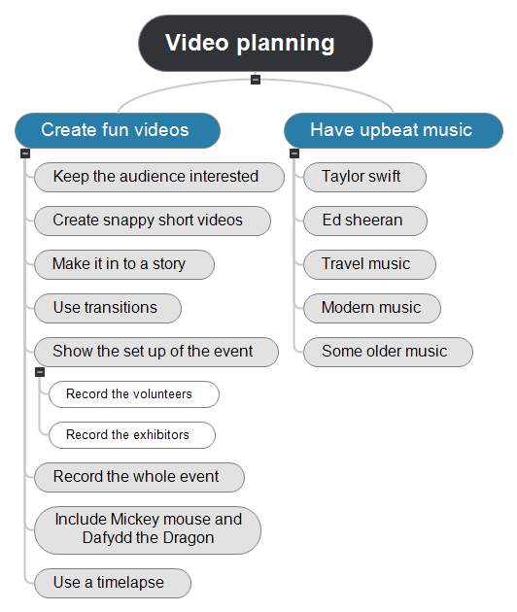
In terms of the content, or storytelling, I wanted to ensure it effectively captured the atmosphere, excitement, and key moments. My initial vision included clips of the event location, behind-the-scenes footage of the team and volunteers, and the arrival of guests. I thought to highlight dynamic shots of attendees from different angles to create an immersive viewing experience. Additionally, I planned to film walkthrough footage of the event space, capturing attendees visiting different stalls and engaging with exhibitors. To showcase the conference itself, I wanted to incorporate a timelapse of guests taking their seats, as well as full recordings of key presentations.

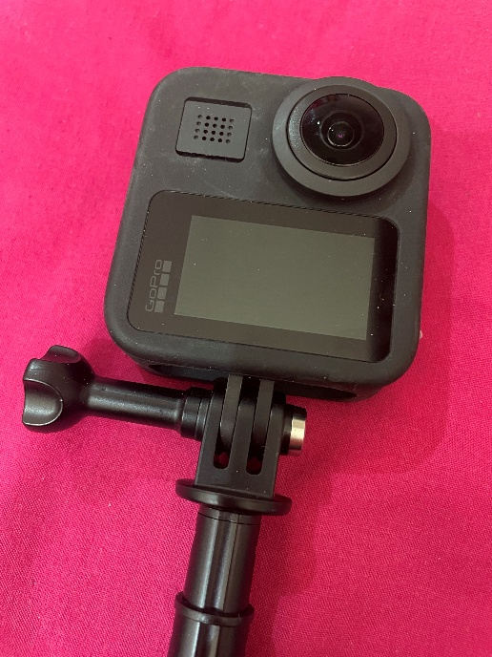
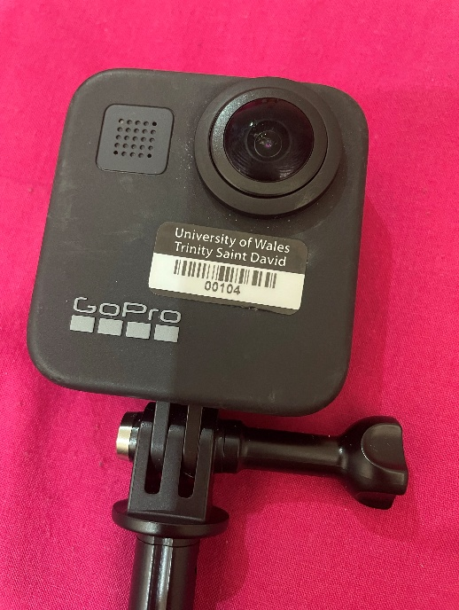

Equipment
I used a GoPro camera for filming and was given a brief tutorial on how to operate it. To familiarise myself with its settings and capabilities, I experimented with different modes and features and created a mock video to practice before the actual event.
To ensure that the content I created for the event was engaging and effective, I developed a clear marketing strategy. I adopted a value-based marketing approach, which focuses on enhancing the perceived value of a product or service to maximize customer satisfaction. In this case, the goal was to encourage students to pursue travel and tourism courses at UWTSD. This strategy involves identifying opportunities to improve engagement and enhance the overall customer experience (Battisti et al., 2020).
To implement this approach, I created short videos of the team members introducing themselves and explaining their roles in the event. This approach humanised the brand, making the audience feel more connected to the team behind the event. Research shows that when customers see the faces behind a brand, they are more likely to trust and engage with it (Rau, 2022). Additionally, in the video I showed the behind-the-scenes look at the event, which helped to foster a sense of inclusion and deepening the connection with our audience. As a result, this strategy encouraged participation and sharing, enabling viewers feel more involved in the event's journey (Miller and Sweeney, 2023).

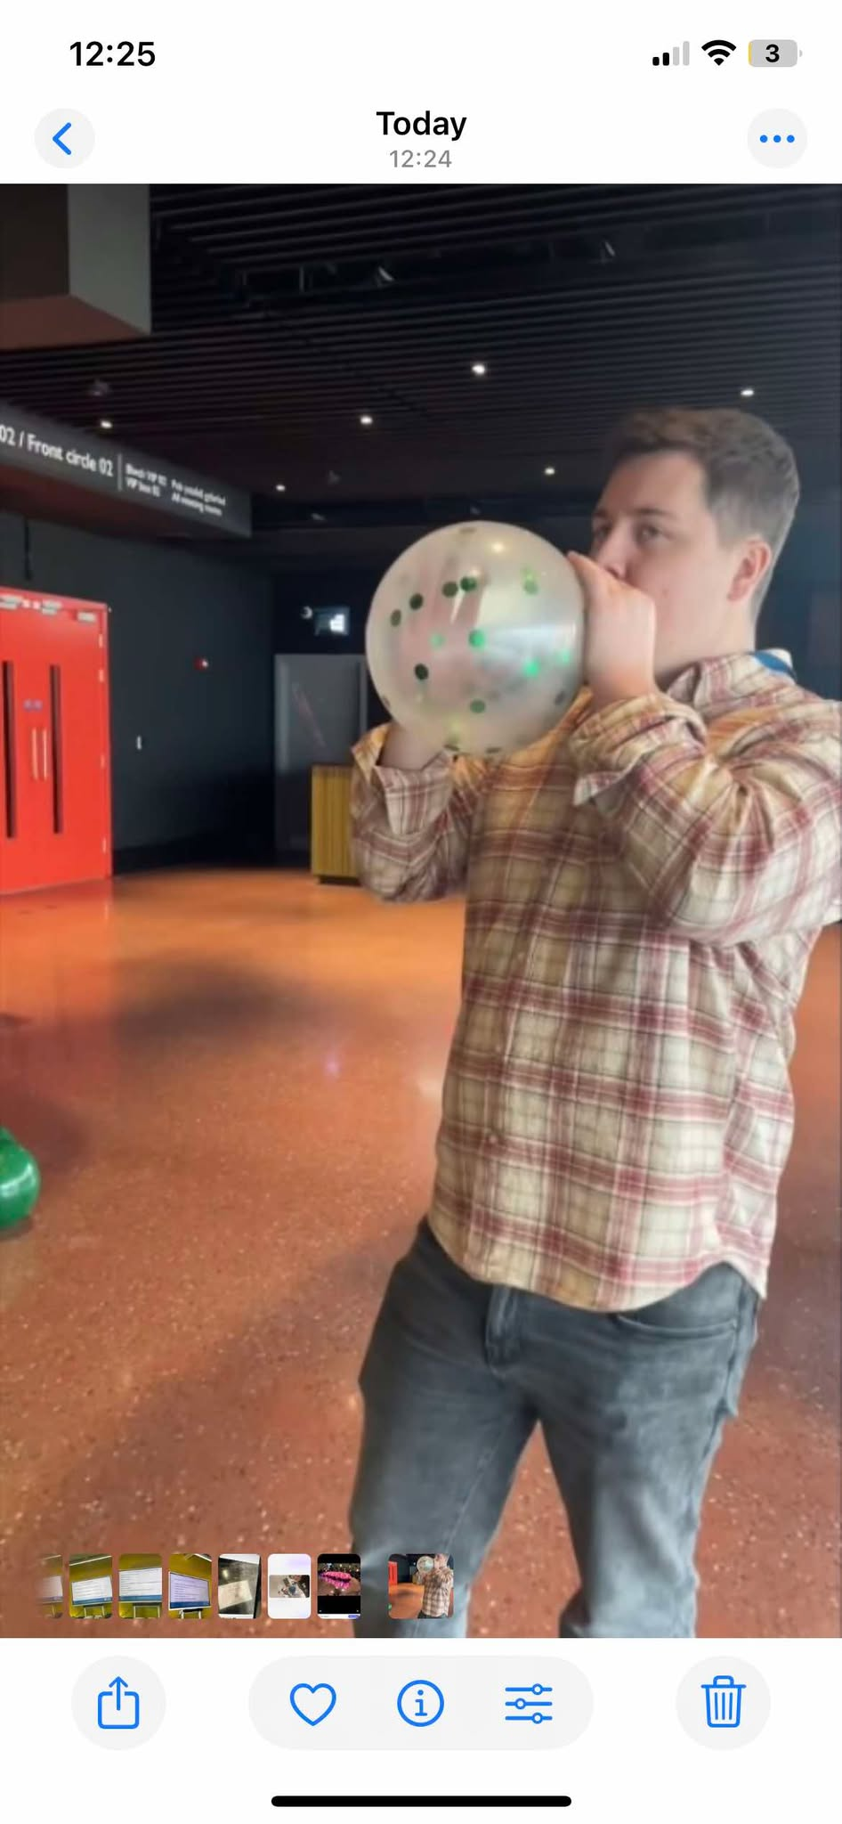

Promotion and Engagement
We were fortunate to be sponsored by Great Western Railway (GWR) which provides research opportunities for students. They were celebrating 200 years of train travel, having this sponsor meant that we could go to Tenby using the railway, free of charge. As an additional role, I was asked by my lecturer to create a video of the trip to Tenby, as a way of attracting more people to use the railway and enhance the appeal for a career in travel and tourism. This would later be uploaded on the ITT Future You Instagram page.
To enhance the event’s appeal, I focused on creating engaging and dynamic content that aligned with the event's train travel theme. The video not only highlighted the real-world experiences offered by the industry but also made the content more relatable and immersive. The video featured a representative from GWR who discussed the importance of having a train station in Tenby and the accessibility the train service provides. I also wanted to incorporate storytelling techniques. I filmed people arriving at the train station, followed them throughout the day, and captured key events as they unfolded. A story-driven video is an effective way to engage an audience during an event. Research shows that stories evoke stronger emotional responses and are more likely to influence people’s attitudes than straightforward factual content (Fitzgerald and McSweeney, 2022). Moreover, this emotional connection increases audience retention and fosters positive perceptions. Therefore, the aim was to create a video with a narrative structure to help viewers follow and retain the content, making it more memorable (Green and Brock, 2021).
Editing
When editing the video, I used CapCut, a popular video editing app, to compile and structure the short clips I had recorded. My goal was to create a cohesive narrative, ensuring that each clip followed a logical sequence to tell a story. Selecting the right background music was particularly time-consuming, as I had to synchronize it with the transitions between video clips to enhance the overall impact.
To maintain audience attention and excitement, I kept the clips short and dynamic. Research suggests that bite-sized content is more effective in helping viewers focus and retain key messages. Studies indicate that audiences are more likely to engage with short, well-structured video segments, making the information more memorable (Keller et al., 2022). Additionally, Sundar et al. (2021) highlight that brief clips prevent viewers from feeling overwhelmed. With limited attention spans, particularly on digital platforms like social media, breaking content into shorter segments increases engagement and ensures the audience remains interested throughout.

Visitor Engagement
As a team, we wanted to find ways to make the event more interactive and engaging rather than simply having the audience watch videos for extended periods during the conference. One of our ideas was to create a quiz that guests could participate in using their phones, which I took lead on. Initially, we planned to use Kahoot, but I encountered technical difficulties, it would not allow me to share the quiz with others. Instead, I opted for Microsoft Forms, a free and user-friendly platform. Once I created the quiz, which consisted of eight questions, I shared it with the team.
Given the travel theme, I decided to base the questions on their interest in the travel and tourism industry, initially starting with their travel preferences. Some of the key questions I included was, “are you interested in tourism and events”, “do you go on holiday in the UK or Wales”, or “how much do you spend when going on holiday”.

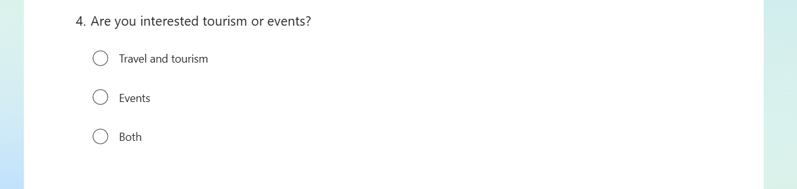

Disagreements and Challenges
Unfortunately, I faced resistance from some team members regarding the quiz. A few individuals were unhappy that I had used Microsoft Forms instead of Kahoot, and their criticism felt dismissive and abrupt. When I explained the technical challenges, I faced with Kahoot, rather than discussing possible solutions, they insisted that I remove the quiz entirely. Additionally, they proceeded to create a replacement without including me in the process, adding only a few short questions to the presentation. While I would have welcomed constructive feedback, the way the situation was handled made me feel undervalued and excluded. Research suggests that diverse perspectives enhance teamwork, bringing fresh ideas and innovative solutions to event planning. Encouraging inclusivity fosters a more engaging and well-rounded experience for all participants (Paulus and Dzindolet, 2008).
Day Before the Event
The day before the event was dedicated to final preparations, which primarily involved transporting equipment, such as banners, tables, and cloths, to the arena and setting up the auditorium. This space was designated for industry leaders to set up their stalls, allowing students to engage in discussions and learn about various services.
Our team met at 10 a.m. at the SA1 campus to review our individual responsibilities for the day. Along with Grace and Mia, I worked on creating a short video presentation for the conference. This video introduced our roles, outlined what students could expect from the event, and encouraged them to approach us if they had any questions.
Once all necessary equipment was collected from the Dylan Thomas Centre, we transported it to the arena and began setting up. This included arranging and numbering tables to ensure industry leaders could easily locate their designated spots. I also took the opportunity to record behind-the-scenes footage, capturing moments such as assembling goody bags, inflating balloons, and decorating stalls with banners.
Additionally, we prioritized health and safety measures throughout the setup process. This included using proper lifting techniques, such as bending the knees when carrying heavy items, and ensuring the area remained free of clutter or potential hazards.
Day of the Event
On the day of the event, we arrived at Swansea Arena by 8:00am to finalise preparations. The night before, I had ensured that my GoPro was fully charged to avoid any interruptions while recording.
Upon arrival at the arena, I assisted with final preparations, including packing goodie bags, setting up banners, and arranging the final balloons. As these tasks were being completed, I began recording with the GoPro to capture the atmosphere just before attendees arrived.
Guest Arrival and Registration
To document the arrival process, I positioned myself at the front of the arena to film guests as they entered. This involved capturing their check-in process, where they signed up and received a goodie bag filled with travel and tourism flyers, booklets, and sweets. In addition to filming, I also assisted in handing out the goodie bags and used my experience in guest engagement to ensure attendees knew where to go. Effective event management and guest services play a crucial role in enhancing attendee experience and satisfaction (Getz, 2012).
Auditorium and Stall Recording
After covering the arrival process, I moved to the auditorium to film the various stalls, interacting with vendors while doing so. My goal was to capture the full scope of the event and create a cohesive video that would tell a complete story of the day. Capturing event highlights through video documentation is an important tool for post-event evaluation and marketing (Bowdin, et al., 2011).
Conference Recording and Challenges
At 11:00am, I went up to the conference area before the guests arrived to record their entrance. I used the GoPro’s time-lapse feature to capture attendees taking their seats. However, after reviewing the footage post-event, I realized that the time-lapse feature only captured the initial hundred guests and did not record the full entry process as intended. To compensate, I later fast-forwarded the regular video footage to create a similar effect.
Once the conference began, I was responsible for recording the entire two-hour session. I successfully recorded the first 45 minutes before the GoPro battery died. To continue filming, I switched to my phone while quickly retrieving the GoPro charger from the staff room. Unfortunately, upon returning, I discovered that the charging cable was too short to allow recording while charging. As a result, I had to wait until the GoPro was sufficiently charged before resuming filming. Proper planning, including backup equipment and contingency strategies, is essential for successful event media coverage (Silvers, 2012).
Post-Conference and Event Wrap-Up
Following the conference, I returned to the auditorium to capture additional footage, including the stalls and a live musician performing on stage. However, some attendees had already left by this time, meaning they missed the musical performance and the remaining stalls. Music and entertainment are key components of event engagement, as they contribute to the overall attendee experience and create a lasting impression (Shone and Parry, 2013). If they conference was shorter, I feel like people would have stayed longer and seen the live musician on stage as I feel some of them lost interest after the conference. I also would have suggested having the musician on in the morning to hype the audience up ready to go in the conference. Once the event concluded, I assisted with cleanup, including removing tables and collecting any leftover goodie bags.
Conclusion of the day
Despite facing some technical challenges with the GoPro, I was able to adapt and continue recording, ensuring that the key moments of the event were captured. The footage gathered throughout the day will be instrumental in creating a comprehensive video that reflects the event’s success. Moving forward, I will consider bringing extra batteries and longer charging cables to prevent similar issues in future recordings. Effective event management requires adaptability and problem-solving skills, which are crucial for handling unexpected challenges (Goldblatt, 2011).
Final Production
After the event, my role was to edit and upload the video to Instagram and TikTok. I was excited to begin the editing process, as I enjoy it; however, I faced unexpected challenges due to my lack of experience with GoPro footage.
One major issue was connecting the GoPro to my laptop, it failed to recognize the device each time I tried. As an alternative, I attempted to transfer the files to my phone, which occasionally worked. However, the large file sizes made it difficult to transfer multiple videos at once. I spent a significant amount of time researching online for solutions and eventually decided to use an SD card adapter to transfer the footage. Unfortunately, my laptop still failed to detect the SD card.
With limited options, I reached out to the UWTSD IT department, but since it was a Friday, I did not receive a response until Monday. In the end, I had to delete multiple apps from my phone to free up enough storage space for the videos. While this workaround was successful, it took three days to resolve the issue, causing me to miss the peak excitement surrounding the event. If I were to do this again, I would consult a professional beforehand to troubleshoot potential technical issues. This would have saved valuable time and allowed me to publish the video while the event was still generating buzz.

Editing the final video
For the final editing process, I used CapCut, one of the most popular mobile editing apps. I wanted the video to feel like a story rather than just a collection of clips, so I carefully arranged the footage to create a clear narrative that captured the essence of the event. My goal was to make the video not only visually appealing but also engaging and easy to follow.
The final edit was just over a minute long. I kept it short because I wanted it to be impactful—something that would hold viewers' attention from start to finish. To achieve this, I made sure each clip served a purpose and contributed to the overall flow of the video.
One of the key editing choices I made was speeding up certain sections of the video. For example, I condensed footage of the exhibitor’s area into a single, fast-paced clip. This allowed me to showcase the entire floor in a short span, making it visually engaging without lingering too long on any one section. I used a similar effect for the guest arrivals, making it look as though people were quickly filling up the venue. This helped create a sense of excitement and movement, adding energy to the final product.
Initially, these fast-paced sections weren’t included in my first few edits because I was working with limited files. However, after some troubleshooting, I managed to download the larger video files onto my phone. This allowed me to incorporate more comprehensive footage, making the final edit more polished and complete.
Once I was satisfied with the final version, I uploaded it to both my Instagram and TikTok accounts. The response was really encouraging—on Instagram, the video received over 20 likes, while on TikTok, it performed even better, racking up an impressive 2,000 views. Seeing that level of engagement was rewarding, as it showed that people enjoyed the content and found it worth watching.
Overall, I’m happy with how the video turned out. The editing process taught me a lot about storytelling through video, using pacing and transitions effectively, and working around technical challenges. Moving forward, I’d like to continue refining my editing skills and experimenting with different styles to make my content even more engaging.

Conclusion
The ITT Future You Event at Swansea Arena was an invaluable learning experience, allowing me to apply my skills in content creation, teamwork, and event management. From planning to execution, I played a key role in promoting the event through video production, social media engagement, and visitor interaction. Despite technical challenges with recording and editing and having disagreements with a few of my team mates I manged to not let this affect me by adapting effectively to ensure high-quality results that captured the event’s essence.
A key takeaway was the importance of flexibility and resilience in event planning. Facing last-minute role changes and technical difficulties reinforced the need for preparation and adaptability. Working within a team provided valuable insight into collaboration, emphasizing clear communication for a smooth workflow.
This event also refined my video production and marketing skills, as I applied strategic storytelling techniques to engage audiences. The positive reception of my content on social media demonstrated the impact of visually compelling, well-structured promotional materials.
I also needed to consider that I should have explored further GDPR as a was the videographer which is a law that protects the rights of individuals whose personal data is processed. It came into effect on January 1, 2021.
Overall, my involvement in the ITT Future You Event has strengthened my professional competencies and deepened my appreciation for the travel, tourism, and events industry. This experience has motivated me to further develop my skills in digital media and event promotion, ensuring I am well-equipped for future opportunities in the field.

References

Anderson, M., Johnson, P. and Taylor, L. (2023) 'The Impact of Interactive Quizzes on Audience Engagement in Live Events'. International Journal of Event Management, 12(3), pp. 91-105.
Bowdin, G. A. J., Allen, J., O'Toole, W., Harris, R and McDonnell, I. (2011). Events Management. Great Britain: Elsevier Ltd.
Brown, A., & Smith, J. (2022) 'Enhancing Learning Retention Through Interactive Content: The Role of Quizzes in Event Engagement'. Journal of Educational Technology, 21(2), pp. 130-144.
Edmondson, A.C. and Lei, Z. (2014). ‘Psychological safety: The history, renaissance, and future of an interpersonal construct’, Annual Review of Organizational Psychology and Organizational Behavior, 1, pp.23–43.
Fitzgerald, R., and McSweeney, T. (2022) 'The Power of Storytelling in Video Marketing: Emotional Engagement and Brand Loyalty'. Journal of Digital Marketing, 9(3), pp. 45-59.
Frazier, M.L., Fainshmidt, S., Klinger, R.L., Pezeshkan, A. and Vracheva, V (2017). ‘Psychological safety: A meta-analytic review and extension’, Personnel Psychology, 70(1), pp.113–165.
Getz, D. (2012). Event Studies: Theory, Research and Policy for Planned Events. Abingdon, Oxon: Routledge.
Goldblatt, J. (2011). Special Events: A New Generation and the Next Frontier. Wiley.
Green, M and Brock, T. (2021) 'Narrative Persuasion and the Effectiveness of Story-Based Videos in Marketing Campaigns'. Media Psychology Review, 18(2), pp. 211-227.
Keller, M., Rowe, B and Davis, K. (2022) 'Maximizing Audience Engagement with Short-Form Video Content'. Journal of Interactive Marketing, 34(1), pp. 56-71.
Miller, T and Sweeney, D. (2023) 'Engagement Strategies for Event Promotion: The Role of Video Content in Social Media Marketing'. International Journal of Marketing, 32(4), pp. 142-159.
Morgeson, F.P., DeRue, D.S. and Karam, E.P. (2010). ’Leadership in teams: A functional approach to understanding leadership structures and processes’, Journal of Management, 36(1), pp.5–39.
Page, S. J. (2019). Tourism Management. Abingdon, Oxon: Routledge.
Paulus, P. B. and Dzindolet, M. T. (2008) ‘Social influence, creativity and innovation’, Social Influence, 3(4), pp. 228–247.
Rau, F. (2022) 'The Impact of Authentic Brand Representation on Consumer Trust: A Study of Instagram Content'. Journal of Digital Marketing, 8(2), pp. 47-59.
Reiter, M., Cupka, O. and Miklosik, A. (2021). Search Engine Optimization of Video Content. ResearchGate. Available at: https://www.researchgate.net/publication/356604345
Shone, A., & Parry, B. (2013). Successful Event Management: A Practical Handbook. Cengage Learning.
Silvers, J. R. (2012). Risk Management for Meetings and Events. Routledge.
Sunarso, B. and Mustafa, F. (2023). ‘Analysing the Role of Visual Content in Increasing Attraction and Conversion in MSME Digital Marketing’, Journal of Contemporary Administration and Management (ADMAN), 1(3), pp.193–200. doi:https://doi.org/10.61100/adman.v1i3.79.
Sundar, S. S., Lim, S. S., & Brown, W. J. (2021) 'How Short Clips Enhance Audience Attention and Retention: The Effect of Duration on Viewer Engagement'. Media Psychology Review, 27(4), pp. 99-113.
UWTSD (2025) ITT Future You – Wales to the World: Student & Industry Careers Event. Available at: https://www.uwtsd.ac.uk/events/itt-future-you-wales-world-student-industry-careers-event (Accessed: 3 February 2025)
Zeng F. ( 2021’)Analysis on the application of custom segmentation.’ Proceedings of the 6th International Conference on Financial Innovation and Economic Development (ICFIED), 129. University of Wisconsin – Madison. Available at: 10.2991/aebmr.k.210319.023

