Systems thinking applied to the Testing and Evaluation of the Rocket Rake
Quinn Dunbar (2217666)

Contents
Table of Figures 2
1. Introduction 3
2. Determining requirements 3
3. Functions and QFD 1 5
4. System composition and experimental design 7
5. Conclusion 9
References 10

Table of Figures
Figure 1 - Pairwise comparison of the requirements for the Rocket Rake 5
Figure 2 - QFD1 for the functions and requirements for the Rocket Rake 6
Figure 3 - Importance ranking for the functions of the Rocket Rake 7
Figure 4 - A simplified Taguchi Matrix for the destructor warhead in the Rocket Rake 8
Figure 5 - A simplified P-diagram for the delivered destructor in the Rocket Rake 9

Introduction
Designing a product to meet a customer brief involves more than just turning the brief into a product. Rarely do customers consider all the requirements needed to achieve their desired goal, or any negative interactions that may occur between subsystems required to achieve different parts of their goal. Systems engineering steps in to remedy this, by providing tools that can be used to expand on the customer brief and provide insights to whatever level of detail required by the manufacturer [1]. This pertains not just to the design of the product but also to the steps involved in the designing process itself, and every step after that to ensure as many problems are identified and solved before anything is physically built, saving both time and money for the manufacturer and the customer, whilst also increasing the probability of producing a successful product. This report covers the systems engineering approach and tools used in the development of a test and evaluation schedule for the Rocket Rake - a novel mine clearing device.

Determining requirements
The first and most important step in systems thinking is the derivation of functional requirements from the customer brief [2]. These functions transform the customer brief into a series of actionable, measurable and achievable statements that will serve as the foundation of the product. This can also include so-called non-functional requirements, numerical performance values either provided by the customer directly or derived in order to meet a goal listed in the brief [3]. For this exercise the customer brief was as follows:
  - The design scenario is that we have a column of supplies (Medical) traversing desert terrain. The approved route will come across a mined area.
  - The mined area is within a steep walled pass. Go-around is difficult, if not impossible. A persistent ground to air MANPAD threat makes helicopter use too risky. As we need to open up the route for civilian medical transport for subsequent convoys the road route is much preferred.
  - Time on the operation is critical. The emphasis is on a rapid move in, clear the objects and move on.
  - The indigenous population do not have easy access to helicopter transport. The mission is the get the convoy. (Nothing heavier than a Land Rovers or ubiquitous Toyota trucks) carrying their delicate cargo through the mined area and leave the area clear for subsequent transport.
  - I will present several mine clearing options as a functional guide. The grand Panjandrum, the progression from Conger to Viper to Python, flails, and rollers.
  - Unfortunately, the use of Python is banned because there is a perceived vulnerability against bullet / fragment attack and also that misfires or capture would afford the opportunity of furnishing any hostiles with explosive resources.
  - There is also an issue with transporting heavy vehicles to the location. There’s a driveshaft/gearbox issue with the low loaders required to bring heavy vehicles forward. Someone forgot to fit the gaiters that keep the dust out. Most of the fleet is awaiting spare parts or have been reserved for combat missions rather than humanitarian exercises.
  - The teams are required to design a portable (Land Rover or Hi-Lux) mine detection, clearing and marking system to ensure safe passage for this and future convoys
The brief does not contain all of the functions required to achieve the set goals and can be summarised as: The customer requires a device capable of clearing a minefield containing both anti-personnel and anti-tank mines in an air-denied area. The system can only be transported by light vehicle and excessive use of explosives poses an unacceptable risk.” This summary also does not contain the requirements so further derivation is required, from the brief the following requirements were derived:
- The system shall defeat the mine threat in a minimal timescale.
- The system shall not be vulnerable to MANPADs.
- The system shall not produce UXO.
- The system shall defeat every mine in the desired area.
- The system shall be insensitive to bullet, fragmentation attack.
- The system shall mark the area cleared of mines.
- The system shall not render the road impassable by its use
- The system shall always detect buried mines within a horizontal distance of 30cm.
- The system shall always detect buried mines up to a depth of 15cm.
- The system shall be suitable for use with mines up to 15 Kg NEQ.
- The system shall be suitable for use with mines fuzed with pressure, tripwire, tilt-switch and remote triggers.
- The system shall operate reliably for the full duration of minefield clearance tasks without unplanned loss of function.
- The system must not harm or kill any persons.
- The system should conform to OME Safety Regulations
- The system shall be transportable by light vehicle.
- The system shall be suitable for use in sandy desert environments (AECTP-230 zones A1, B2, C1)
Whist the setting of requirements is necessary for the design of a product, they are also the foundation of the testing and evaluation piece, as these are the parameters that the system must be tested against, and hence determine the type of testing to be carried out. A pairwise comparison of the requirements can be carried out to rank the requirements allowing for a clear hierarchy of which functions are most important to the accomplishment of the customer brief [4]. The pairwise for the derived requirements is shown in Fig. 1.
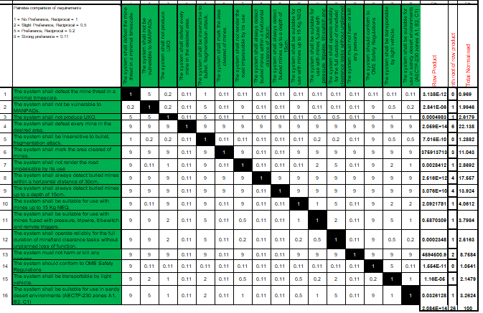
Figure 1 - Pairwise comparison of the requirements for the Rocket Rake

Functions and QFD 1
From the functional requirements, the fundamental functions the product needs to perform can be derived and these are then used to compartmentalise the design process to prevent scope-creep, where unnecessary capabilities are incorporated into the product resulting in a bloated product that is more difficult and expensive to develop. The following functions were determined for this product:
- Transport system to minefield
- Deploy the system
- Detect Mines
- Defeat Mines
- Confirm Clearance
- Mark Cleared Area
- Undeploy [sic] System
All of these functions can be met in differing ways but that does not make them independent from one another, as the subsystems making up the overall product can be designed to perform one or more of these functions. As such it is useful to rank the importance of each function in achieving the functional requirements, and this is performed using Quality Function Deployment 1, a matrix that allows for the ranking of how important each function is to the accomplishment of that requirement, weighted by the pairwise results, as shown in Fig. 2 [5].
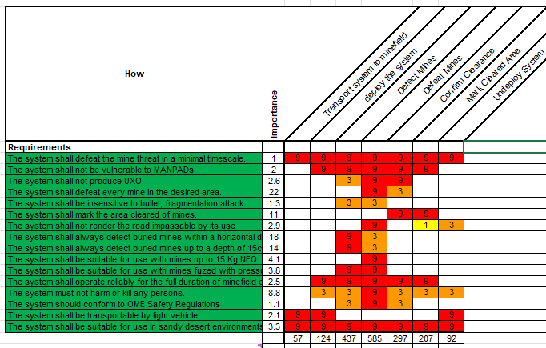
Figure 2 - QFD1 for the functions and requirements for the Rocket Rake

Whilst the ranking of functions is clearly important to the design phase of a product, it also guides the testing schedule, as the most important functions are the ones that require the most extensive testing to ensure they perform the requirements, in the same way as ranking the requirements determines the most important outputs from the testing. The requirements determine the output the testing must provide and the functions determine how the system should be tested. The rankings for this system are given in Fig. 3.
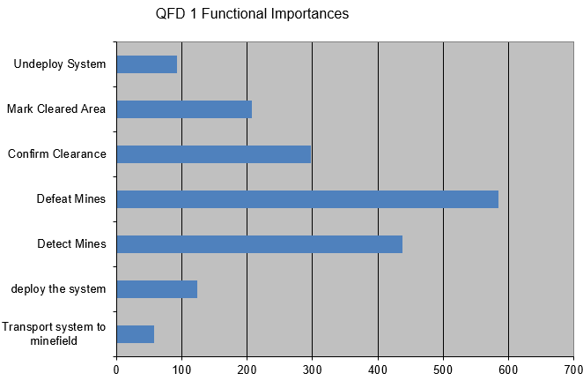
Figure 3 - Importance ranking for the functions of the Rocket Rake

System composition and experimental design
The product is a system that is designed to produce the output specified in the customer brief. In the case of the Rocket Rake, this output can be tested against the International Mine Action IMAS 09.50/01/2009 “Machines” testing schedule [6]. However, this is a test for the final product and elaving the testing of the system until its final stage would allow for many unexpected issues to arise.
Observing the system as a whole, it is natural to break it down into subsystems, those that perform a particular function or sub-function or that are manufactured together. It is possible to follow this process all the way down to the most basic component of the system. This is the approach that needs to be applied when composing the testing schedule, with each component and subsystem being tested to show that it can achieve its designed function before being integrated into the subsystem above it.
However, at each progressive subsystem level, there is an accumulation of acceptable tolerances that produce an acceptable output within the required bounds. Although it is possible that a lower-level subsystem can produce the required function, when integrated with other subsystems it may result in a higher-level subsystem failing to function as required. This could be due to emergent behaviours, where subsystems interact with each other unexpectedly, either resulting in an unforeseen behaviour that is detrimental to performance or a combinational effect of tolerances resulting in an out-of-spec output. The complexity of a system can quickly result in an extremely large combination of factors that need co-testing to determine what effect they may have on the overall function of a subsystem.
Tackling this large array of combinations would result in an unfeasibly long and expensive testing schedule that would likely provide far more data than was useful. One method of tackling this is the Taguchi Method of experimental design [7]. This methodology takes complex multi-variable systems and reduces their complexity in order to facilitate simpler experimental design whilst also providing valuable results. This is achieved through reducing each variable to two dimensions, a high and low value as determined by the acceptable tolerances for each component, a third intermediate value can also be included, though this increase the number of required experiments so is best used only if an interaction is expected. These are then used to compose n + 1 experiments, where n is the number of variables under test, with random combinations of high and low values across each variable in each experiment. In these variables are a number of dud “interaction” variables that are randomly assigned high and low values, from these it can be determined if there are any interactions, as with the random distribution, there should be no difference in output between the high and low values beyond the margin of error of the measurement. If a measurable difference does occur, this implies an interaction and allows for development of a further, more targeted series of experiments to isolate and eliminate the issue, without the excessive burden of further experiments between variables that do not interact. A simplified Taguchi matrix is shown in Fig. 4.

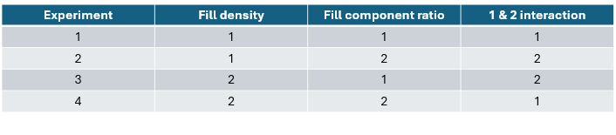
Figure 4 - A simplified Taguchi Matrix for the destructor warhead in the Rocket Rake
Compartmentalised testing of subsystems also allows for the early detection of unexpected noise factors, and the simplification of isolating and preventing the causes of these noises. A noise factor is an external or internal stimuli that negatively affects the output of a process, and control factors are put in place to prevent this. During the design phase, it is possible to use a Parameter diagram (P-diagram) to list all possible noises, and this allows the design team to consider and implement the necessary control factors [8]. However, this is limited to the noise factors the design team are aware of or can imagine. This can lead to control measures that are unnecessary if that noise does not occur as expected, or to noises that are missed and require additional control factors to be added to the design, A testing schedule can be designed to test for both of these case, and the P-diagram can be updated and returned to the designers to allow for the subsystem to be redesigned or simplified as necessary. By performing tests at every subsystem level these noises can be identified early and hence save time and money in both prototype production and testing time. A simplified P-diagram is shown in Fig. 5.
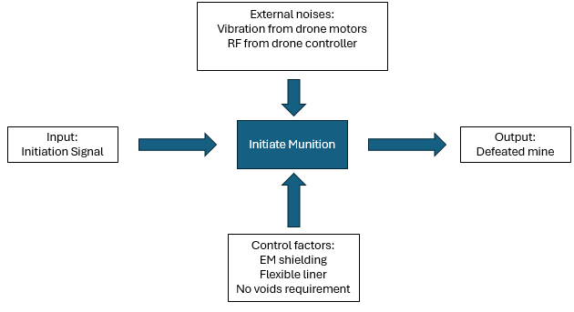
Figure 5 - A simplified P-diagram for the delivered destructor in the Rocket Rake

Conclusion
Systems engineering is a series of powerful tools that can be utilised to limit wastage in the design and production of a new product. As applied here, it can be sued to show the viability of a system without even a formal design, never mind the production of a prototype. When applied to the testing and evaluation role, it can be used to focus the testing primarily on the aspects of a system that are most important to the delivery of the goals defined in the customer brief. It allows for efficient test planning and limiting the number, and hence expense, of tests to determine the product’s functionality. It is also important to note that the concept of systems thinking applies to more than just the design and testing of a product and can be used in any task that relies on multiple processes. The examples included here are based on those used by BAE Systems and hence are tailored to a manufacturer’s mindset, but many other bodies use similar variation of systems thinking, such as NASA, and it should be considered a general purpose tool that can be applied to any problem as necessary.

References

[1] | D. Holley, Writer, ACDA5021: Systems Engineering. [Performance]. UWTSD, 2026.
[2] | A. Baletti and P. Litva, “Integrating customer requirements into product designs,” Journal of Product Innovation Management, vol. 12, no. 1, pp. 3-15, 1995.
[3] | Nourhansaeed, “Functional VS Non-Functional Requirements in system design,” Medium, 3 Novemner 2024. [Online]. Available: https://medium.com/@nourhansaeed707/functional-vs-non-functional-requirements-in-system-design-6b1b1a3785da. [Accessed 8 May 2026].
[4] | E. Kulcsár, I. Gyurika and T. Csiszér, “Increasing the Reliability of FMEA Evaluation by Modifying Rating Scales and Applying Pairwise Comparison Method,” IOP Conference Series: Materials Science and Engineering, 2021.
[5] | S. Burge, “A Functional Approach to Quality Function,” Systems Engineering Company, 2007.
[6] | International Mine Action, “IMAS 09.50/01/2009 “Machines”,” United Nations, New York, 2009.
[7] | J. Antony, D. Perry, C. Wang and M. Kumar, “An application of Taguchi method of experimental design for new product design and development process,” Assembly Automation , vol. 26, no. 1, pp. 18-24, 2006.
[8] | M. BARSALOU, K. WILCYNSKA and P. SARAIVA, “Using a Parameter Diagram as a DoE Planning Tool,” Management and Production Engineering Review, vol. 14, no. 4, pp. 3-9, 2023.

