
Applied Leadership and Management Outreach
Module Assignment Submission

Student Name: | Samantha Paton
Student Number: | 2318459
Module No: | BMSK4014
Module Title: | Problem Solving and Decision Making

Statement of Confirmation of Authenticity
By the act of making this submission, the student declares that this is the work of the student named above. The work has not, in whole or in part, been knowingly presented elsewhere for assessment, or where assessment has been built on a previous assessment, this has been identified. Where materials have been used from other sources it has been properly acknowledged. If this statement is untrue, the student acknowledges that an assessment offence has been committed.
Attention is drawn to the plagiarism and unfair practice policies of UWTSD.

Table of Contents
Define a complex problem in the workplace, including its scope and impact 3
Analyse information on the identified problem, to help inform the decision making process 3
Propose a range of alternative solutions to the problem 7
Using a decision making technique, evaluate a range of solutions to identify the most appropriate option 8
Cost Benefit Analysis 9
Develop a detailed plan for implementing the solution 11
Communicate the plan to relevant stakeholders 13
Assess appropriate monitoring and review techniques to ensure successful implementation of solution 13
References 14

Define a complex problem in the workplace, including its scope and impact

The complex problem at my wellness studio, situated on a busy road in swansea is that local customers are not aware the business is in the vicinity. 90 percent of our customers come from a booking appointment app Booksy. Lack of local clientele is leading to a loss of revenue by hours not being filled at the studio.
This is a strategic problem as it could have significant consequences for the business long term. If we do not also gain clientele locally the impact could mean the business falling into financial difficulty and failing. If for some reason we no longer have the Booksy app the business would have no revenue. For the business to grow we must raise brand awareness locally and solve this problem.
As we are now a well established business it is time to solve this problem.
Clients who have come locally comment that they have passed the studio many times, however have been unaware that we are there. They are also unsure of what treatments we offer at Tigerlily Holistic Therapies.
My customer satisfaction and rating is five stars on my Booksy app and clients come from all over, however I have had certain days recently with no clients booking in, I need to tackle this problem and gain clients locally.
The telephone number to the studio is on the lower shop windows, however local residents park in front of the window blocking the visual impact of the window sihn.

Analyse information on the identified problem, to help inform the decision making process

By using different methods to describe and analyse the problem Maund et al (2017), we can then go on to solve the problem.
Myself and a work colleague used the brainstorming model Proctor (2005) to find a range of creative ideas and solutions to the business problem. I work alone, however I sometimes find it useful to collaborate with fellow beauticians and wellness therapists when solving business problems.
During the brainstorming session we threw wild ideas out freely without judgement whether or not they were practical or feasible did not matter as they could generate other ideas to build upon.
My perspective to my colleagues was very different. We found ourselves being silly and creative. There was no wrong idea, I would not have had this flexibility if I did not collaborate and brainstormed alone to explore ways to solve this business problem. By the end of the brainstorming session we had a wide range of solutions to the problem to explore.
We used a mindmap to record all our brainstorming ideas. Mind maps provide a visual structure for organising thoughts and information, making it easier to see relationships and patterns between different concepts.

Below is the mind map diagram we produced from myself and my colleagues brainstorming session to explore ways of solving the problem of lack of local clientele
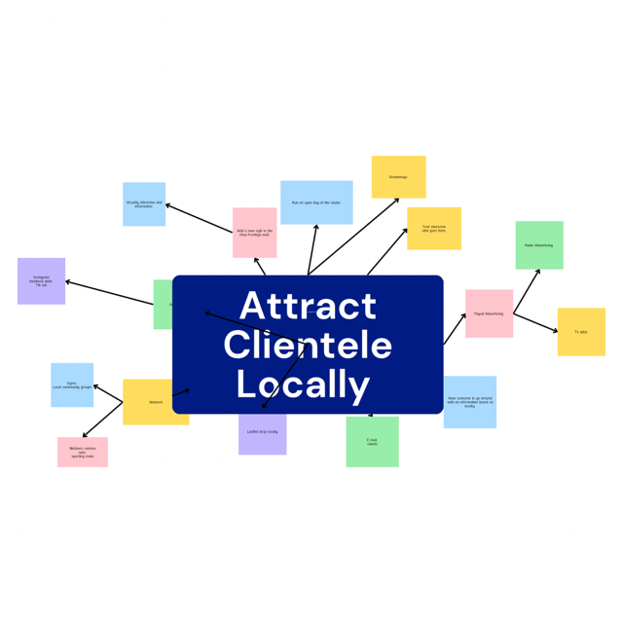
During our brainstorming session our ideas were not flowing so freely, we also used a reverse brainstorming technique. Instead of how we could increase clientelle locally, we used how we could decrease the amount of clientele locally. The reverse form of thinking got us back on track thinking again about the original problem solving.
We could then narrow down a list of definitely to be considered ideas to solve the problem, the ideas that were a definite no, ideas that were wild but may be worth looking at. We also had a healthy list of ideas that could possibly solve the problem.

By using the 5 Whys tool developed by Sakichi Toyoda we can identify the root cause of the business problem, Revolution (2024) and potentially find solutions to the problem. By doing this we aim to improve the businesses visibility and attract more clientele locally.
By using the following questions to describe the business problem along with who is experiencing the problem it can give us a better understanding of the problem and its root causes.

1 WHO is experiencing the problem?
TIGERLILLY Holistic Therapies business is experiencing the problem. It has come to our attention that the sign outside the shop is not effective and locals are unaware of the business location.

2 WHAT are the impacts / effects / Symptoms - errors / defects or something you expected didn't happen?

When chatting with clients and asking where they have come from they never say locally. Clients have also remarked that they have passed and live locally but were unaware that we were even in the area. The impact is that 80% of our clients are from our online booking system.

3 WHEN does the problem occur or when did it start happening?
Clientele has always been widespread, which is great as a business to reach a wider audience, however as an established business it is now time to tackle the problem locally.

4 WHERE does the problem occur?
The problem occurs at the business based on a main busy road. Local residents' cars block the sign on the lower windows making it invisible to passers by and potentially new clientele.

5 Why did the error happen?
The problem occurred due to the sign being ineffective to locals and passers by. The sign is low and needs to be higher up on the wall. This will then give us a chance of attracting more clientele locally.

Cause and effect techniques such as Ishikawa (1968) fishbone analysis can be used to identify possible causes to the problem we are experiencing. This diagram helped us focus on causes of the problem by breaking it down into different sections which ultimately all have an effect on the problem itself. This was extremely useful in getting to the cause of the problem.

Ishikawa Fishbone Diagram to show the cause and effect of the problem at TIGERLILLY Holistic Therapies.
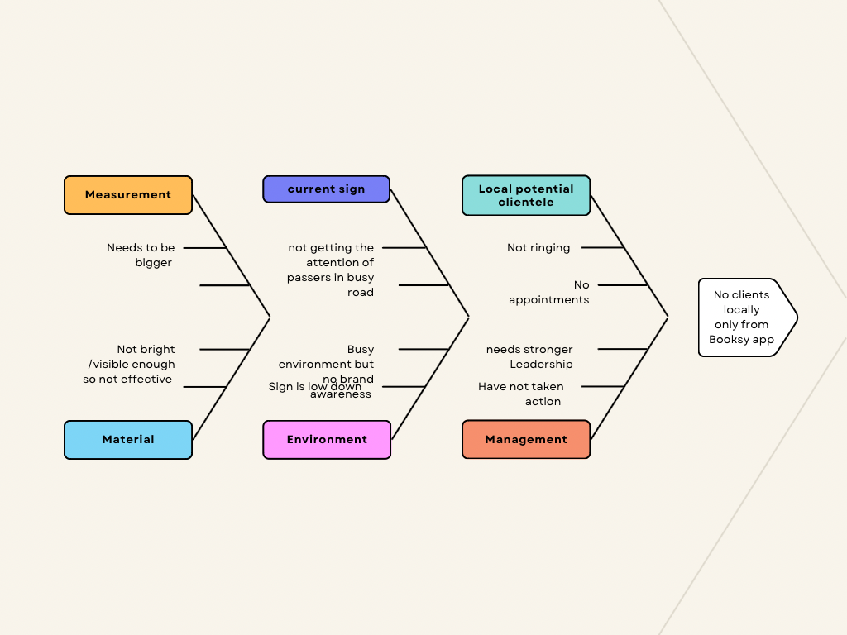

Propose a range of alternative solutions to the problem

By using the brainstorming model Proctor (2005) to find a range of creative ideas and solutions to the business problem myself and my colleague came up with many wild, and effective ideas to consider :

Paid advertising - local radio and and tv adds
Networking - gyms, local community groups
Have someone go around with a notice board with info on
Leaflet drop locally
Add a new visually attractive sign to shop frontage
Email potential clientelle

Using a decision making technique, evaluate a range of solutions to identify the most appropriate option
Grid analysis Pugh (1981) is a useful quantitative decision making tool to use when making a decision. It is very effective when you have a number of good alternatives and many different factors to take into account when a decision is needed, especially in the workplace. MindTools (2024).

Factors | Cost | Potential Impact On Gaining Clients Locally | Easy to  Implement | Look | Total
Weights | 2 | 5 | 3 | 5
Leaflet Drop Locally | 2 4 | 2 10 | 4 12 | 4 20 | 12 46
Advertising on Shop Wall | 5 10 | 5 25 | 1 3 | 5 25 | 16 62
Email Campaign | 0 0 | 2 10 | 5 15 | 2 10 | 9 35
By implementing the grid analysis it is possible to make an informed decision on where to allocate our businesses marketing resources effectively to reach clientele locally.
By evaluating each form of marketing based on cost, the impact it will have locally, and the ease of implementing the marketing strategy, we decided to go with the purchase of the sign.
Based on the results from the grid analysis the advertising campaign from wall signs appears to be the most effective form of marketing for the wellness business to target clients locally. It has a higher cost than the other forms of marketing campaigns, it will also need to be designed, made and installed professionally. Despite these factors the sign will have years of impact, will be seen by passer by on the busy road day and night and can inform passers by exactly what is offered at the studio.
Additionally the leaflet drop is another form of marketing that we will look into in the future as it is relatively straightforward to implement and is cost effective, however we will have to gain permission by the local council to deliver leaflets.
Emailing is also another viable option, however they have a moderate reach within the local community, and will be read once and deleted. There is no initial cost, however the potential return could be quite high to start and then fizzle out.

Cost Benefit Analysis
Now that we have identified the solution and the potential project to solve the problem, we can evaluate whether the benefits outweigh the costs of the sign. We have gone for the more costly solution rather than the cheaper option of a leaflet drop or an email campaign. Sometimes cutting corners durning marketing a business by using a cheaper method is not always the right way Beckmann (2005).

Below is a table to show the relevant costs over a three year basis for the sign to the shop frontage informing clients locally and motorists of the treatments at the studio. The sign will also be of impact by directing clientele to our location. The sign will include the telephone number and opening hours. Overall the large eye-catching sign will have a great impact on the business by being visually seen by the local community and passing trade.

Purchase of a shop sign.
 | Year 1 | Year 2 | Year 3 | Cosy (£) Total
Purchase Of The  Sign | £1000 | £0 | £0 | £1000
Net Cost Of Purchase | £1000 |  |  | £1000
Maintenance Of The Sign | £120 | £120 | £120 | £360
Total Costs | £1200 | £12 | £120 | £1360
 |  |  |  | Total Cost

From this table I can see instantly that this option, although relatively expensive compared to the other options over a longer time, will be more effective to the business.
Below is a table to show the benefits that we will gain at the business over a three year period.

List Of The Benefits
Benefits | Year 1 | Year 2 | Year 3 | Total
Earnings Made By Purchasing The sign | 12 Hours Filled Per Week At £40 Per Hour | 12 Hours Filled Per Week At £40 Per Hour | 12 Hours Filled Per Week At £40 Per Hour | £5,760 annually
Total Benefits
£5,760
Total Costs £5,760
______ = 4 . 2 : 1
Ratio £1,360
Benefit to cost ratio shows the return on investment. 5.60 pence for every pound spent

Develop a detailed plan for implementing the solution

By using a Gnatt chart to identify the key tasks involved in implementing the sign to solve the problem of lack of clientele locally at the business, we can visually represent the project's timeline. We can then allocate resources effectively, track success and progress of the solution. We can also help to identify any delays that may occur. We can keep the chart updated to ensure the project is on schedule and stays on track. Ultimately the sign needs to be fitted within a month as the problem has already been ongoing for a year with bookings not being taken locally.

Below is a gantt chart with the relevant steps from start to finish including monitoring afterwards how the project is going.

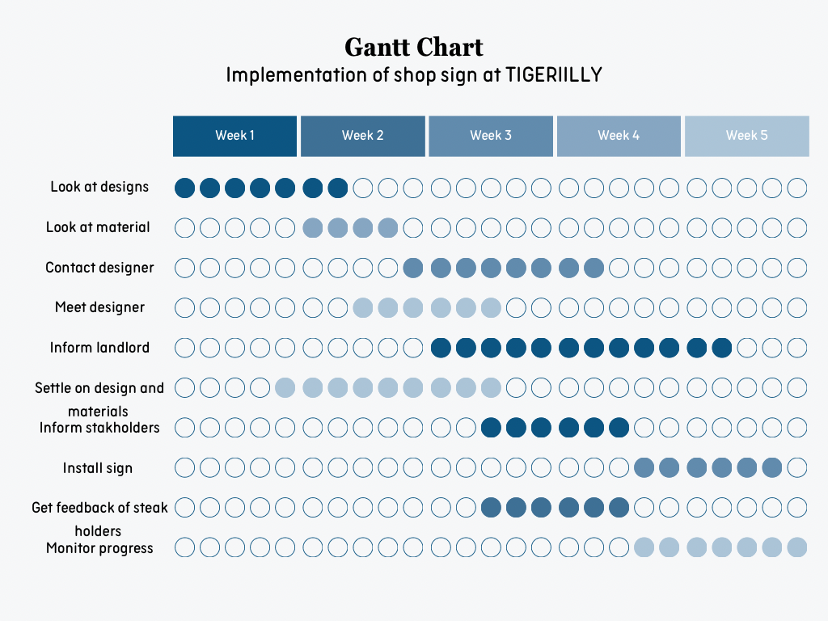

From the gantt chart I can visually see that I should have informed the landlord earlier just in case there were any issues with the sign being installed on the shop frontage.
If I had gone forward with my plans and this had become a problem I would have wasted a lot of time and maybe revenue. Planning correctly is crucial when putting a project into plan. ScienceDirect (2018).
Covey (1989) says by scheduling time to achieve goals, checking in on yourself and by staying proactively organised anything is achievable in all areas of your life.

Communicate the plan to relevant stakeholders
There are no shareholders in the business as I am a sole trader, however there are many stakeholders such as family and friends who will need to be informed about the project. By using the Influence - Interest Matrix, Mitchell et al. (1997), we can prioritise the stakeholders engagement needs and how often we will keep them updated on the progress of the project. Some stakeholders I will regularly update others I will inform from time to time depending on their level of interests.
I will ask permission from the landlord to put up extra signage, this should not be a problem however it is better to get permission for insurance purposes. I will send a formal email letting them know about the project, I shall inform them of timelines and keep them updated if necessary.
I will also discuss the plans and get clients' views on the proposed project. I will not need to keep them informed on project plans, and timelines. Their opinions will have a great influence on the decision making process as I value their opinions. They have invested in me as a therapist regularly to take care of their wellness and relaxation needs.

Assess appropriate monitoring and review techniques to ensure successful implementation of solution

By monitoring the project effectively, we can ensure the project stays on track.
We need to keep track of the project's milestones, such as are designers of the project delivering on time, and are we set to meet the next milestones of fitting and revealing the new sign. Have there been any delays and if so what caused these delays.
Is the project staying within budget, and keeping track of all expenditures. It is important to keep track of any unexpected costs that may occur, if so where will this money come from.
Are all team members aware of their roles, what tasks are theirs and deadlines. Are there any resource constraints that may be affecting their performance?
Have any risks been identified? Maybe new risks have arisen. What strategies would we use to sort or eliminate the risks and are they effective.
We would also monitor any feedback from stakeholders and respond accordingly.
Throughout the project we should always check we are utilising our resources, are there any areas where resources are being wasted or unnecessarily used.
By continuously checking in on the gantt chart we can have a clear visual representation of the project's timeline, we can check our progress and ensure the project stays aligned with the goals set.
If this project and the designers failed, we would have recordings of areas that went good and bad. This would also ensure we did not make the same mistake twice. For future projects we may decide not to use the designer as they did not deliver on the deadline for example.
Maybe it was our fault and we did not communicate effectively with designers, and other project managers. By providing a gantt chart to them also can serve as a straightforward communication tool to ensure everyone is on the same track.
It is essential going forward that effective monitoring of local clientele to the business is monitored.
Monitoring the effectiveness of the new sign for the wellness business is crucial to ensure that it is attracting potential clients locally and contributing to the overall success of the business.
We can monitor the foot traffic around the location to see if there is an increase in people stopping by or entering the wellness studio. This can be done by tracking the number of enquiries or appointments made by telephone.
We can then compare this to the time period before the sign was installed. We can do this using a flow chart to visually be effective.
We can also conduct informal surveys verbally with clients to determine how they heard about the business.
By monitoring the strategy, our business can assess the effectiveness of the sign and make informed decisions about future marketing strategies to attract and retain clients.

References

Andrew Maund, Michaela Schriek and Paul K Twinkler, 2017. Certificate in Higher Education: Skills for the Workplace Student Yearbook. SAGE Publications Ltd.
Beckmann and Suzanne Le Quesne, (2005). The Essential Guide to Holistic & Complementary Therapy. Page 434. Ashford Colour Press.
Covey, Steven, R. 1989. The 7 Habits of Highly Effective People. Simon & Schuster UK Ltd.
Ishikawa, Kaora (1968). Guide To Quality Control. Tokyo: JUSE.
MindTools, (2024). Decision Matrix Analysis. Mindtools.com. Accessed from Google August 17th 2024.
Mitchel, R.K., Agle, B. R., and Wood, D.J., (1997). ‘Toward a Theory of Stakeholder Identification and Salience: Defining the Principle of Who and What Really Counts.’ Academy of ManagementReview 22(4)
Proctor, T. (2005). essentials of Marketing Research., 4th edition, financial Times/Prentice Hall
Pugh, S. (1981). Concept Selection: A Method That Works. In : Hubka, V. (ed.), ‘Review of Design Methodology’. Proceedings International.
Revolution-Learning & Development. The 5 Whys Problem Solving Technique. revolutionlearning.co.uk. Accessed from Google 22 of August 2024.
ScienceDirect (2018). Gantt Chart. sciencedirect.com. Accessed from Google August 27 2024.

