
International Meetings Management for the Hotel Industry
MIHAI ALEXANDRU CRISAN
2217500

TUTOR NAME
Chris Wilkin



I acknowledge the use of Grammarly (https://www.grammarly.com/) on January 2024 to check my work using the prompt(s): 1. Please check the following text for readability, grammar and syntax. I confirm that I have not presented any AI-generated text as my own work. I confirm I have copies of my drafts, notes, and other resources I used before, and after the use of AI tools which I may be asked to provide in evidence.

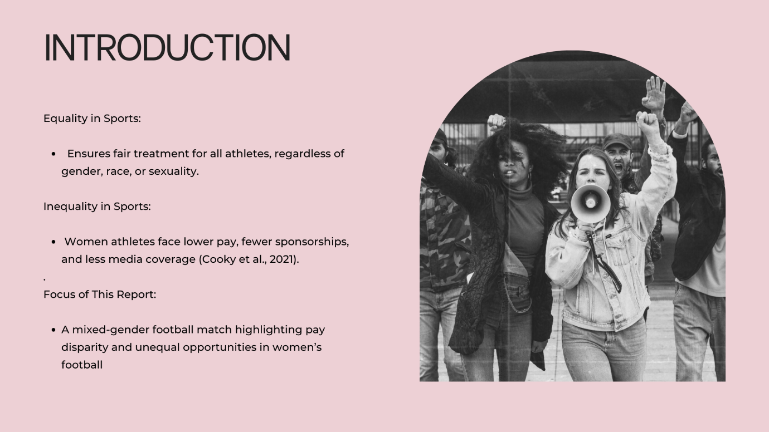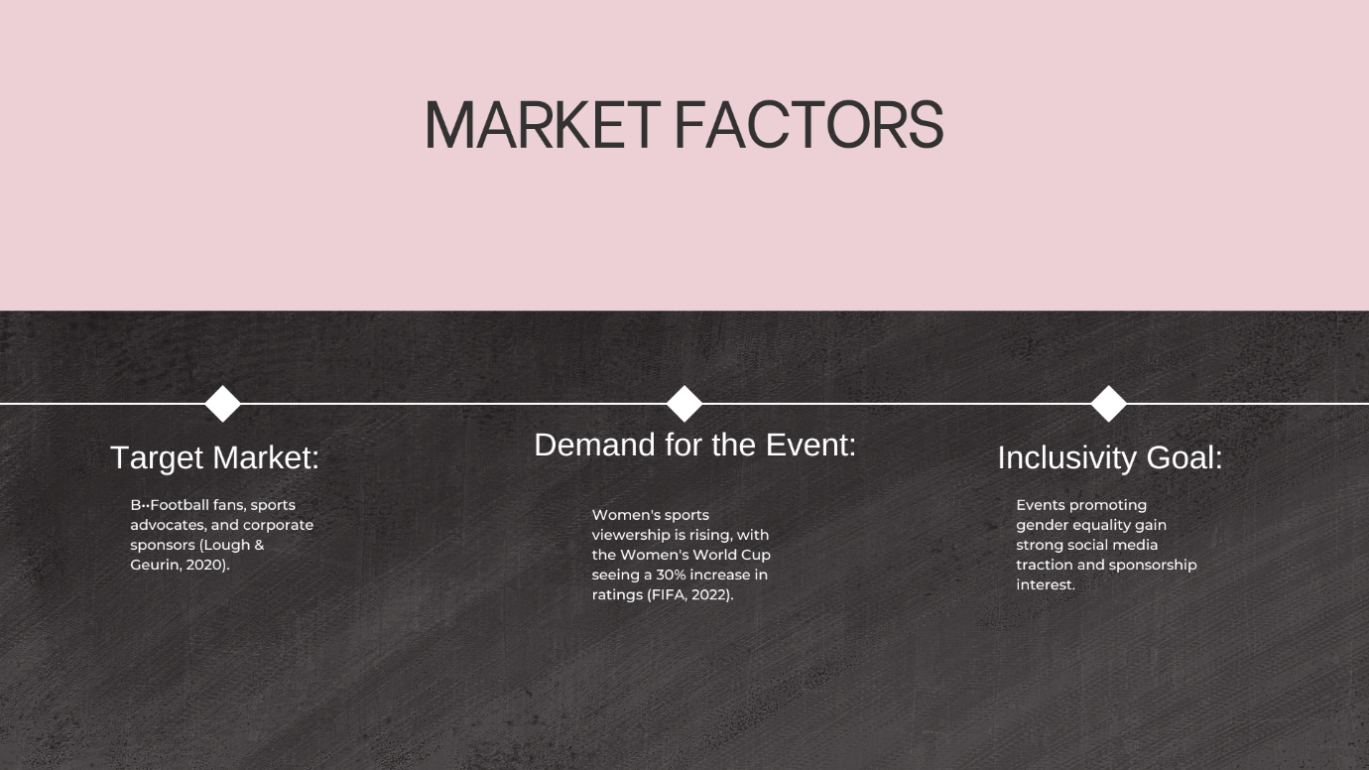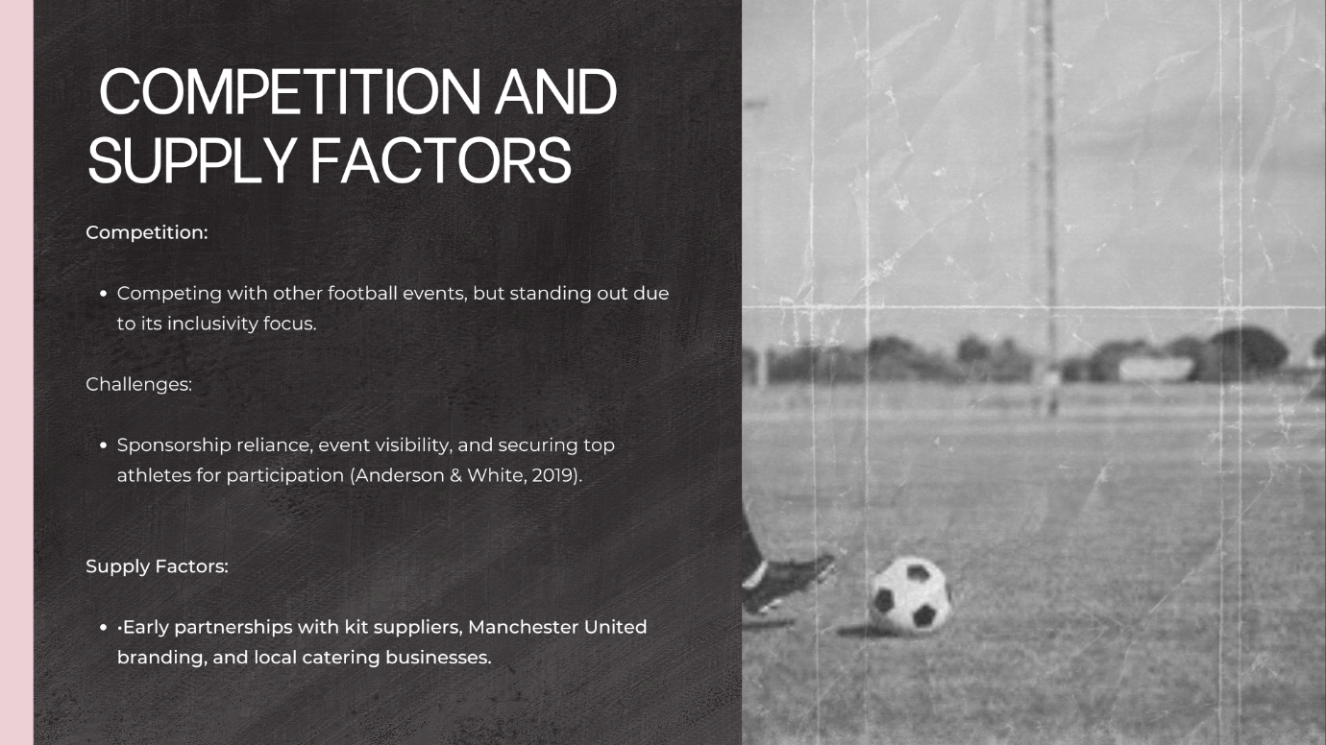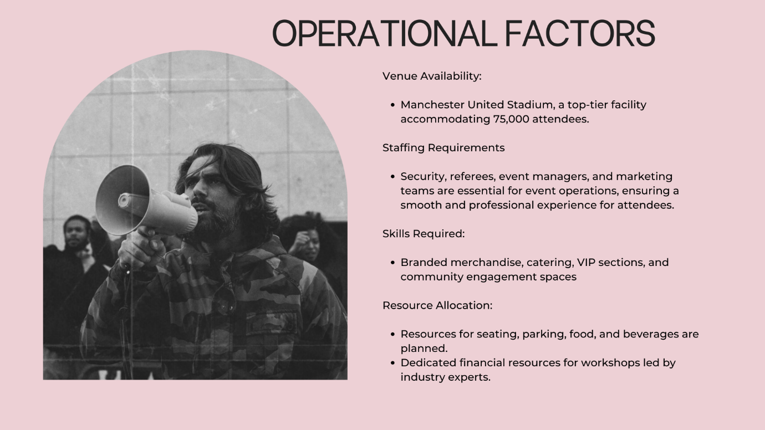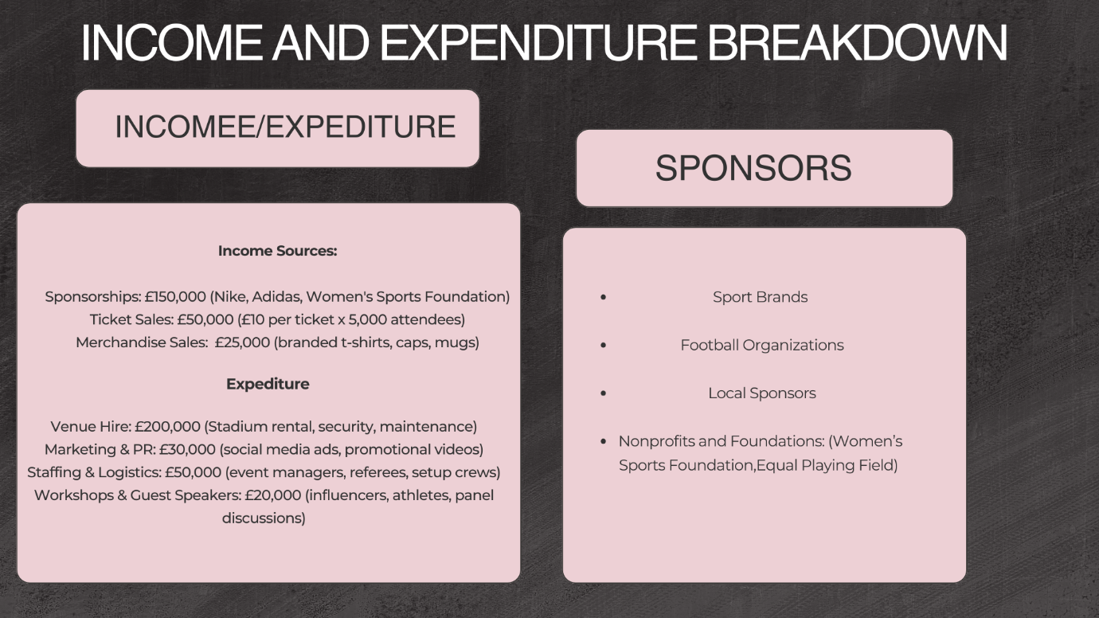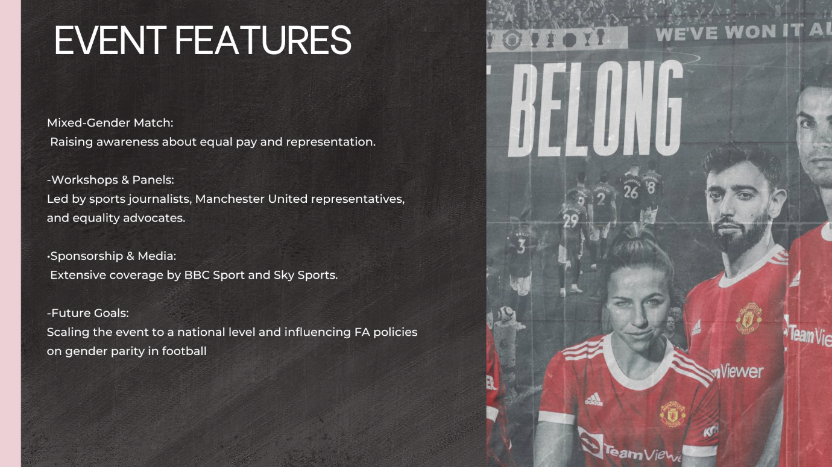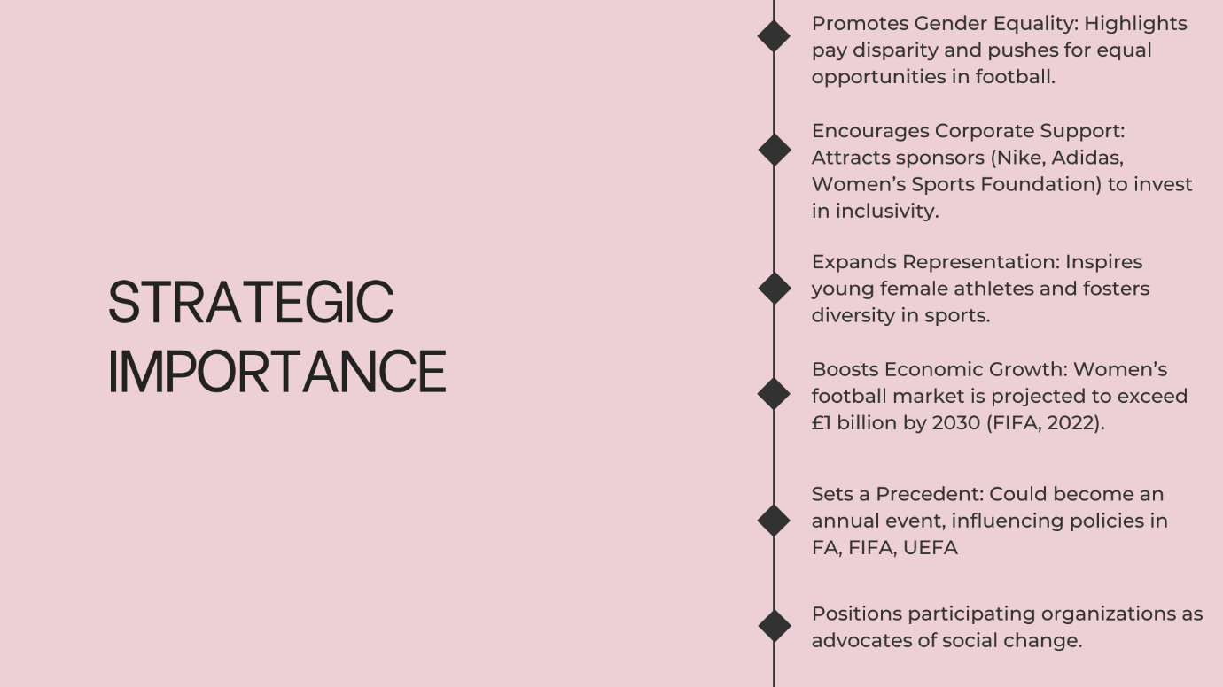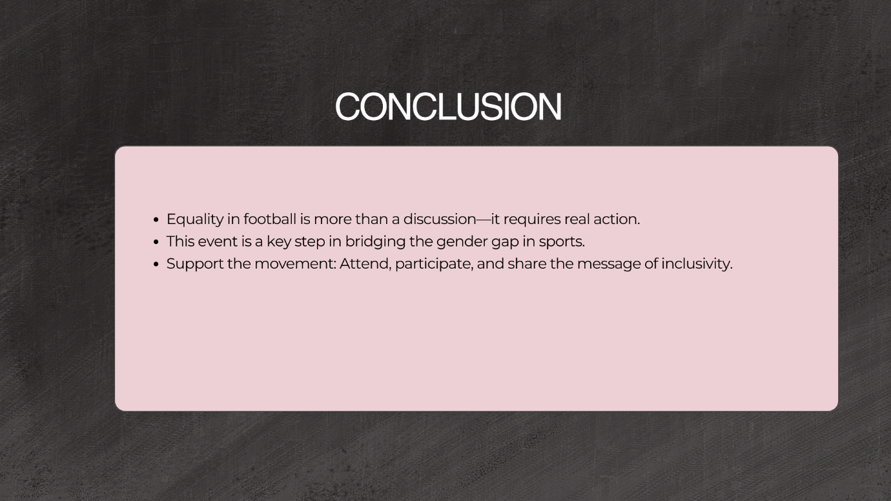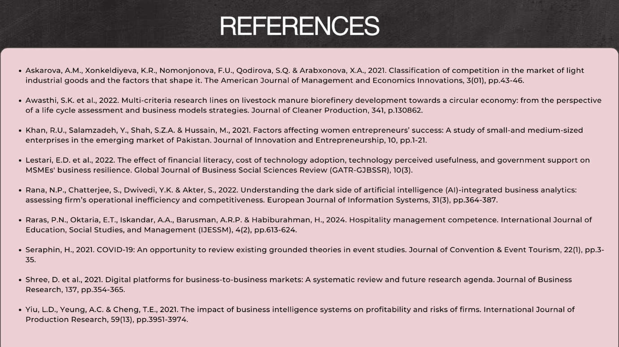

References:

- Allen, J., O'Toole, W., Harris, R. and McDonnell, I., 2022. Festival and special event management. 6th ed. London: Routledge.
- Askarova, A.M., Xonkeldiyeva, K.R., Nomonjonova, F.U., Qodirova, S.Q. and Arabxonova, X.A., 2021. Classification of competition in the market of light industrial goods and the factors that shape it. The American Journal of Management and Economics Innovations, 3(1), pp.43-46.
- Awasthi, S.K., et al., 2022. Multi-criteria research lines on livestock manure biorefinery development towards a circular economy: From the perspective of a life cycle assessment and business models strategies. Journal of Cleaner Production, 341, p.130862.
- Getz, D. and Page, S.J., 2020. Event studies: Theory, research and policy for planned events. 4th ed. London: Routledge.
- Hoye, R., Nicholson, M. and Houlihan, B., 2022. Sport and policy: Issues and analysis. 2nd ed. London: Routledge.
- Kaplanidou, K. and Gibson, H.J., 2020. Perceptions of legacy and its impact on sport event participation: A longitudinal analysis. Journal of Sport Management, 34(5), pp.437-450.
- Khan, R.U., Salamzadeh, Y., Shah, S.Z.A. and Hussain, M., 2021. Factors affecting women entrepreneurs’ success: A study of small and medium-sized enterprises in the emerging market of Pakistan. Journal of Innovation and Entrepreneurship, 10, pp.1-21.
- Lestari, E.D., et al., 2022. The effect of financial literacy, cost of technology adoption, technology perceived usefulness, and government support on MSMEs' business resilience. Global Journal of Business Social Sciences Review (GATR-GJBSSR), 10(3).
- Mallen, C. and Adams, L., 2017. Sport, recreation and tourism event management: Theoretical and practical dimensions. London: Routledge.
- Nicholson, M., Kerr, A. and Sherwood, M., 2021. Sport and the media: Managing the nexus. 2nd ed. London: Routledge.
- Parent, M.M. and Chappelet, J.L., 2017. The (official) political and economic environment of sport event organizations. London: Routledge.
- Rana, N.P., Chatterjee, S., Dwivedi, Y.K. and Akter, S., 2022. Understanding the dark side of artificial intelligence (AI)-integrated business analytics: Assessing firm’s operational inefficiency and competitiveness. European Journal of Information Systems, 31(3), pp.364-387.
- Raras, P.N., Oktaria, E.T., Iskandar, A.A., Barusman, A.R.P. and Habiburahman, H., 2024. Hospitality management competence. International Journal of Education, Social Studies, and Management (IJESSM), 4(2), pp.613-624.
- Seraphin, H., 2021. COVID-19: An opportunity to review existing grounded theories in event studies. Journal of Convention & Event Tourism, 22(1), pp.3-35.
- Shree, D., et al., 2021. Digital platforms for business-to-business markets: A systematic review and future research agenda. Journal of Business Research, 137, pp.354-365.
- Smith, A.C.T. and Stewart, B., 2020. Sports management: A strategic approach. London: Routledge.
- Taks, M., Misener, L. and Chalip, L., 2019. Sport events and gender equity: The influence of mixed-gender competitions on participation trends. Sport Management Review, 22(2), pp.261-276.
- Taylor, T. and Toohey, K., 2019. Mega sporting events, gender equity, and legacy: Female participation in sports post-event. Event Management, 23(4), pp.377-392.
- Yiu, L.D., Yeung, A.C. and Cheng, T.E., 2021. The impact of business intelligence systems on profitability and risks of firms. International Journal of Production Research, 59(13), pp.3951-3974.

