1708878
VIV COLLIS
Photojournalism & Documentary Photography

ADAD5001 RESEARCH PRACTICES

DISSERTATION PROPOSAL
2415 words

This week a boat retrieved from the bottom of the Mediterranean Sea where almost 300 bodies had been trapped inside was put on display, at the Venice Bienniale by the artist Christoph Buchel. Nearly 700 people died on this boat, when it sunk off the coast of Italy, carrying migrants from Libya, all hoping for a different future. Unsurprisingly this activist event has caused much controversy being described by one commentator as ‘a coffin’.
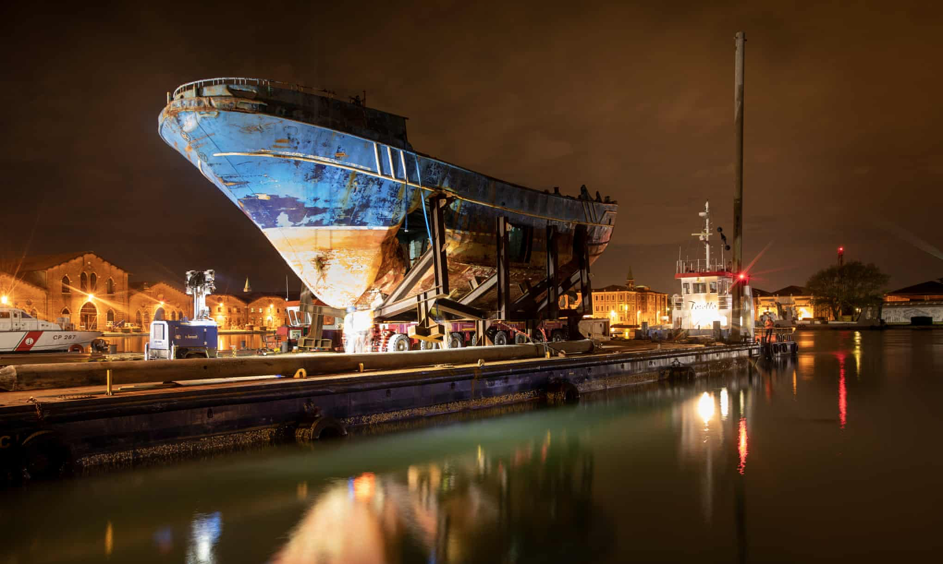

Figure: 1

Photograph: David Levene/The Observer

This is the intersection of migration, representation and narrative played out as a meta-narrative on the world stage. ‘The spectacle’. Raising the boat cost €9.5M. There is little here to help us understand the narratives of those who died and how the political is intertwined with the personal.
These areas will be explored looking at the political, historical, theoretical and artistic responses to migration, narrative and representation of people.

Migration

Migration is not a new phenomenon. Evidence of human migration goes back 1.75 million years to Homo erectus leaving Africa to Eurasia. Diaspora has effected widespread human populations for a variety of reasons such as famine, flooding and other natural disasters, employment and industrialisation. Migration increased during the Western World and Far East industrialisation, displacement after two World Wars, during Imperialism and reaching new heights in what is now considered a globalised economy. At the heart of all these latter events lies political and economic activity.

Documentary Photography has depicted the plight of migration from it’s early inception especially in America, producing classics such as ‘The Migrant Mother’ by Dorothea Lange in 1936 and ‘Boat of no Smiles’ by Eddie Adams in 1977.

The migration of people has been categorised into metanarratives such as Asylum Seekers and Economic Migrants, this reinforces the stories that are being told. There is a hierarchy of migration. “Political and media frames have adopted a binary representation of refugees that focus on the ‘legitimacy’ or ‘illegality’ of asylum seekers” (Cooper et al., 2017, p.78)

Politics plays on fears, using images and media representation as we see in Trumps America, of people invading our borders, stealing our jobs, using up our services, such as the NHS in Britain, changing our laws and the list goes on. This also serves to frame thinking and language such as “boat people” and serves to “dehumanise refugees and asylum seekers”. (Cooper et al., 2017)

The artist JR is a photographer who “exhibits freely in the streets of the world, catching the attention of people who are not typical museum visitors” (JR, 2008). Here he has asked us to look at archival images of Ellis Island immigration, alongside current images of Syrian refugees from Zaartari camp. The size and scale of these images is challenging us not to ignore the plight of migrating people in the past and today, making an historical and geographical connection to the proximity of what happened at Ellis Island.
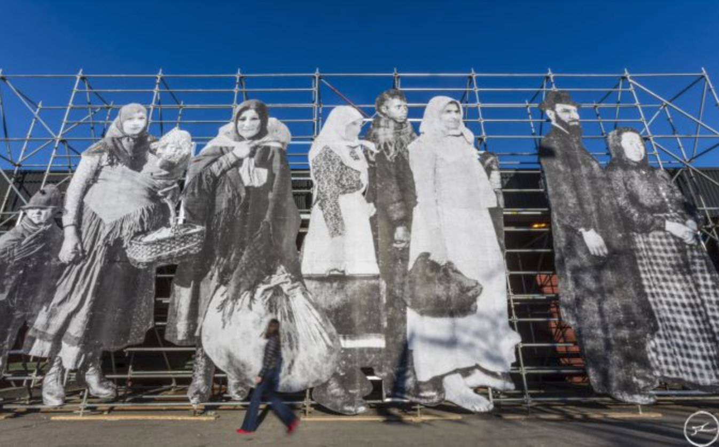

Figure 2

JR’s “So Close” on display at The Armory Show in New York.

JR connects with communities to produce his work and includes supporting narrative at his exhibitions e.g. Momentum, Paris 2018.
The general public tends to rely on news media for information about asylum seekers; in turn, the media’s framing of these issues, by selecting events, opinions, facts, images and information, shapes audience responses, encouraging ‘particular interpretations or understanding of issues’ and reflecting, increasing and influencing prejudicial attitudes (Cooper et al., 2017, p.79)

JR is selecting images that “shape audiences responses” but he is challenging and eliciting different responses and narratives. “He is one of the rare artists to combine artistic innovation with political engagement,” Deitch wrote in an email to Artnet News . However we tend to see the headline narrative and little of the biographical stories of the people in his work.

The economic, social, cultural and political contributions of migrants are rarely told through their eyes and their biographies. How are migrants represented and by whom?

Representation

Representation through photography is explored through the semiotics of “signifiers” and “symbols” that interact with individuals cultural understanding and reading of the image. Barthes (Barthes, 2000) discusses the relationship between reality, the lens and the image in Camera Lucida. How we interpret photographic images is culturally nuanced and dependent on the receiver’s personal and cultural position, which will impact on their interpretation of signifiers and symbols.

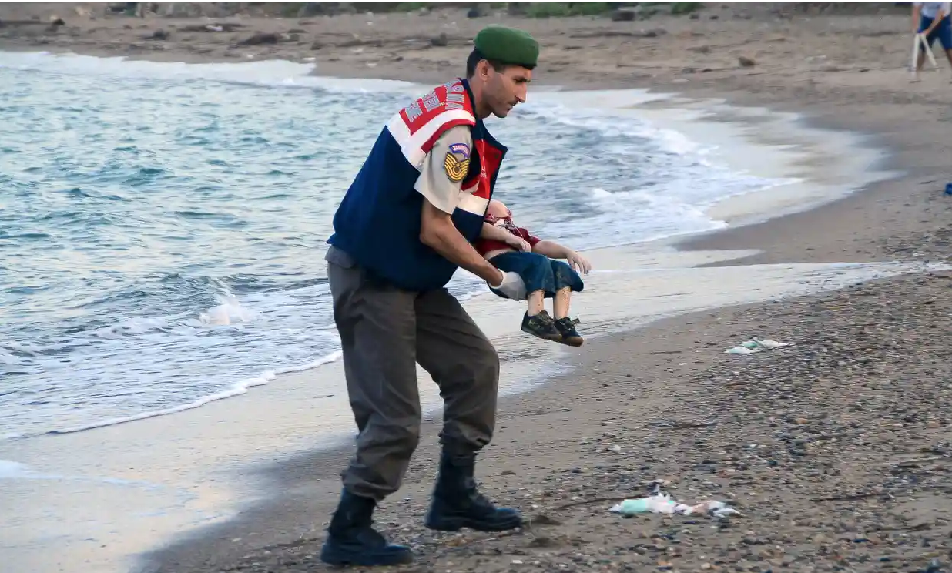
Representation of migration within media has tended to focus upon themes of threat and despair. This representation often plays out the Karpman ( 2014) Drama Triangle of Victim, Persecutor, Saviour. With such representations migrants are often depicted as oppressors (persecutors - e.g. stealing our jobs), passive (victims - drowned at sea). Media monitoring demonstrated these discourses by highlighting that a third of news stories identified migrants of all kinds as perpetrators and less than a third as victims/survivors. A British Press report “found that the top three modifiers in British newspapers regarding immigration between 2006 and 2016 were mass, net, and illegal.” (Pierigh and Spreicher, 2017)

Figure 3

These are enhanced by images that go viral. Here the young boy was given a name but we find out little about his biography, just some basic facts. The media article had a warning at the beginning for readers that they may find it distressing.

Research suggests “The media has a ‘privileged’ social–cultural position, able to legitimise particular truths and shape public attitudes.” (Cooper et al., 2017)

Exploring the earlier proposition of a hierarchy of migration, legitimate or illegal, this image depicts illegal migration of Syrians by boat to the Greek Island of Kos. The image however flips the elicited representation from oppressor to victim and clearly sets out to show the Turkish Army as ‘saviour’. Who decides which images the media favours, where does the focus lie?
The young boy depicted had been displaced through war in Syria. Other forms of migration will elicit different responses for example natural disaster versus economic migration. This again underlines
The general public tends to rely on news media for information about asylum seekers; in turn, the media’s framing of these issues, by selecting events, opinions, facts, images and information, shapes audience responses, encouraging ‘particular interpretations or understanding of issues’ and reflecting, increasing and influencing prejudicial attitudes (Cooper et al., 2017)

Publicised research from 201-2017 states that “The US undocumented population from Mexico fell by almost 400,000 in 2017” (Warren, R. 2019) and that most undocumented Mexicans arrive in America via airplane and then stay on, although only having temporary visa’s. Despite this research there is still in the mindset of many Americans and others, that Mexican illegal migration to America needs to be stopped by building a border wall. Trump has played this out politically to his advantage. American people become the ‘victims’, Mexicans the ‘persecutors’ and Trump the ‘saviour’. Research suggests this narrative is statistically supported.

Research also identifies that women and particular groups are missing from reporting on migration, echoing both gender and race politics.
“Certain groups of people are even more invisible. Women and some other groups of people are disproportionately absent from the news on refugees and migrants. Of the 21% of articles that mentioned a refugee or migrant, only in about one-quarter (27%) was that person a woman.” (Brown et al, 2017, p.5)
The research goes further to highlight the under-represented groups in media reporting on migration: “Afghans represent the second-largest group of asylum applicants in the EU, yet they were only the fourth most represented group in the news sample.” (Brown et al., 2017, p.5).

The European Federation of Journalists also cite problems with under-representation of women, particular migrant groups, the covering asylum seekers in news reports and the omission of news on economic migrants. The article cites that “the terms ‘migrants’ and ‘immigrants’ are closely associated with the media frame of economic threat.” (Eberl et al., 2018).

As Tagg suggests “The image is therefore to be seen as a composite of signs, more to be compared with a complex sentence than a single word.” (Tagg, 1988, p.187)

Narrative

I will discuss narrative in two main forms, metanarrative, the grand story and overarching discourse alongside narrative(s) the telling of event(s) in relation to migration and how images impact on these stories.

As we have seen there are overriding discourses about Mexicans in America and it is interesting to note that in the UK there is little to no mention of Eastern Europeans in media articles. So how are these reports defined and who controls and tells the story? We have seen that the way in which the story is told can define the overarching narrative and research suggests that the narrative is not that of the migrant themselves.” Refugees were given limited opportunities to speak of their experiences and suffering. Most often they were spoken about and represented in images as silent actors and victims.” (Brown et al., 2017, p.13)

Exploring the work of the Magnum Photographer Kent Klich whose book, El Niño, reflected a 10-year study documenting the street children of Mexico. Klich would stay for 2-3 months at a time and get to know the young people and the community well, gaining trust. “Klich’s photos are meant to provoke debate and change, in addition to being a source of empowerment and representation for those who are not normally represented” (Nair 2012, 97, p.104).

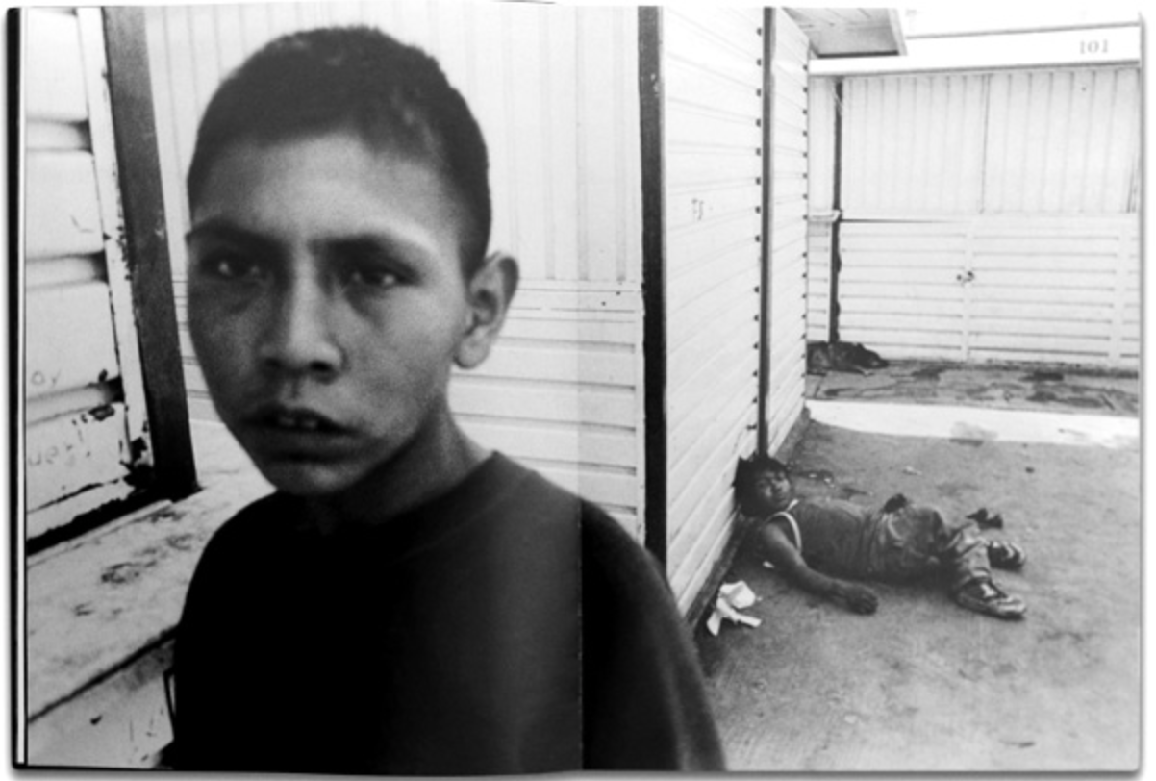

Figure 4

El Niño

Klich wanted to explore the complexity of the situation and in his Youtube interview he has his own take on the power of photography

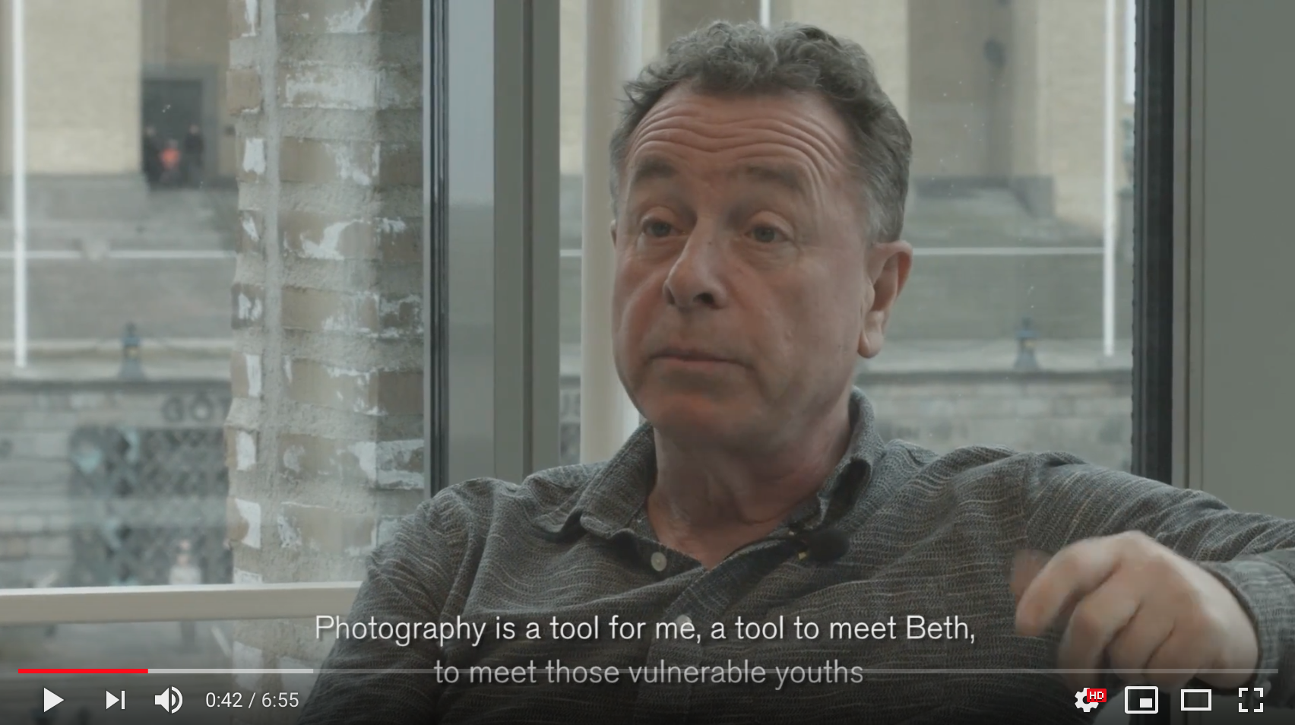

Figure 5

“Photography is a tool for me, to meet Beth, to meet those vulnerable youths.”
((50) On Photography with Kent Klich - YouTube, no date)

Klich reflects on his role as a documentary photographer in Gaza when he is asked the question by a Palestinian ‘Does he think that life in Gaza is really like that?’ This challenges him to consider how people are represented and what ‘stories’ he could legitimately tell.
“Because newspapers must always be filled, a new reportage has to come out. It never stays with us to become like a dialogue.” ((50) On Photography with Kent Klich - YouTube, no date)
Klich sort to initiate dialogue with his El Niño book, seeking to publish it in Mexico and America. David Bohm sought to explore dialogue and how it can support understanding. Bohm in his article, “Dialogue a Proposal”, gives a guide on how to conduct dialogue and asks that one suspends dis-belief and judgement and seeks to suggest we consider what effect our own cultural metanarratives have, in order to explore understanding, learn and change.

Klich’s work proposes other ways of documenting by listening and engaging with stories as opposed to objectifying whilst passing through. This changes the emphasis. Research suggests that this does not always happen in the media.
The function and role of migrants in the news speaks to broader trends of marginalisation: in the majority of cases migrants and refugees are subjects of the stories; they are present as experts in a very small number of articles. This general trend contributes to the overarching narrative that does not seek to see the person behind the label applied to them, and has designated migrants and refugees as victims and people incapable of helping themselves. (Brown et al, 2017, p.38)

Research Proposal

My research has lead me to consider how often news articles and images talking about migration fail to respect the individual by not identifying them nor listening to them or including their voice in them. In the article by Brown et al. (2017) the research shows that from their analysis these details were omitted in 45% of articles and only 40% these articles quoted refugees in their own words. There are many examples where documentary photographers have sort more inclusive and interactive attempts to engage with individuals and their biographies. Research shows that this is more frequently happening at a local level in news and media despite the metanarritive which is predominantly negative. Brown et al. conclude that we all need to
Work together to change the narrative in Europe from “crisis” to “opportunity”, from “faceless floods” to individual people each with their own story, hopes and capacities.” (Brown et al., 2017, p.10)

The proposal question I would like to explore further is:

How can visual images and visual reporting on the issues of migration ensure it includes the narratives and biographies of individuals and support a change in the migration metanarrative prevailing in Europe?

Bibliography

(50) On Photography with Kent Klich - YouTube (no date). Available at: https://www.youtube.com/watch?v=EMyZ13u26dA (Accessed: 16 May 2019).
Barthes, R. (2000) Camera Lucida: Reflections on Photography. London: Vintage. doi: 10.1007/978-1-137-08886-4_6.
Brown, S., Green, E., Moritz, T., Reimann, R. P. and Speicher, S. (2017) Changing the Narrative: Media Representation of Refugees and Migrants in Europe Project Steering Committee.
Cooper, S., Olejniczak, E., Lenette, C. and Smedley, C. (2017) ‘Media coverage of refugees and asylum seekers in regional Australia: A critical discourse analysis’, Media International Australia, 162(1), pp. 78–89. doi: 10.1177/1329878X16667832.
Eberl, J.-M., Meltzer, C. E., Heidenreich, T., Herrero, B., Theorin, N., Lind, F., Berganza, R., Boomgaarden, H. G., Schemer, C. and Strömbäck, J. (2018) ‘The European media discourse on immigration and its effects: a literature review’, Annals of the International Communication Association, 42(3), pp. 207–223. doi: 10.1080/23808985.2018.1497452.
Gardner, N. (2018) ‘Mediating Marginality Through Photography: Kent Klich’s El niño: Children of the Streets, Mexico City’, Photography and Culture, 11(3), pp. 277–295. doi: 10.1080/17514517.2018.1465650.
JR (2008) JR - Artist, JR - Art. Available at: https://www.jr-art.net/ (Accessed: 16 May 2019).
Karpman, S. (2014) A Game Free Life. Self Pubblished.
Pierigh, F. and Spreicher, S. (2017) CHANGING THE NARRATIVE: MEDIA REPRESENTATION OF REFUGEES AND MIGRANTS IN EUROPE. Available at: www.ticktock-design.co.uk (Accessed: 16 May 2019).
Tagg, J. (1988) The burden of representation : essays on photographies and histories. Macmillan Education.
Warren, R. (2019) ‘US Undocumented Population Continued to Fall from 2016 to 2017 and Visa Overstays Significantly Exceeded Illegal Crossings for the Seventh Consecutive Year’, Journal on Migration and Human Security. SAGE PublicationsSage CA: Los Angeles, CA, 7(1), pp. 19–22. doi: 10.1177/2331502419830339.

List of Illustrations

Figure: 1 Photograph: David Levene/The Observer. https://www.theguardian.com/world/2019/may/12/venice-biennale-migrant-tragedy-art-makes-me-uneasy

Figure: 2 JR “So Close” https://www.jr-art.net/news/jr-at-the-armory-show-2018

Figure: 3 https://www.theguardian.com/world/2015/sep/02/shocking-image-of-drowned-syrian-boy-shows-tragic-plight-of-refugees. A Turkish police officer carries a young boy who drowned in a failed attempt to sail to the Greek island of Kos. Photograph: Reuters

Figure: 4 http://www.kentklich.com/case.php?case_id=21&sort=12

Figure: 5. (50) On Photography with Kent Klich - YouTube (no date). Available at: https://www.youtube.com/watch?v=EMyZ13u26dA (Accessed: 16 May 2019).

