Assessment 1

Blogging to communicate

Name student : Patricia Constandache
Student id : 2020640
Marketing Fundamentals

Table of Contents
1. Introduction 3
2. Series of blog posts 3
3. Conclusion 10
Reference list 11

1. Introduction
Kotler and Keller, in the fifteenth edition of ‘Marketing Management’ book, have focused on the value of marketing communication by mentioning them as the means through which the firms make necessary attempts to share relevant information with the customers, persuade them directly or indirectly and remind or encourage them regarding the products, services or the brands they sell (Kotler et al., 2016). Thus, in improving brand recognition, sales volume, and profitability, marketing communication plays a key role. In modern times, blogging has been considered an easy platform to converse and interact with customers, increase brands’ visibility, promote products, services, and other facilities, and thereby, help in fostering a trusted relationship with potential buyers. Therefore, here, a series of blog posts will have been developed for Tesco under this project, which aims at improving the sales volume of the company that has dropped during the Covid-19 pandemic. As this project focuses on driving revenue for the company, it will consider generating awareness among the customers regarding the company offerings, limited period deals, new products, and service launches as well as the new management practices of Tesco.

2. Series of blog posts
Tesco offers a half-price deal for the last toys and gifts this Christmas
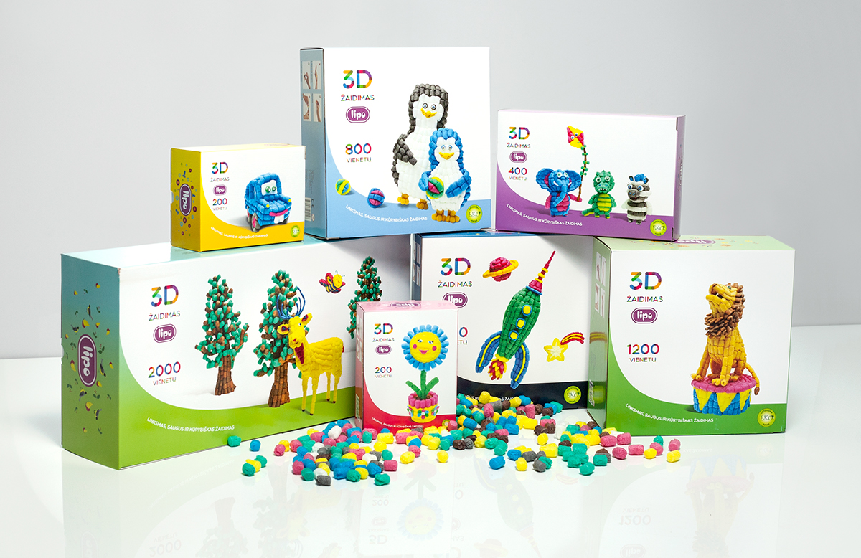
Tesco knows well the importance of Christmas gifts to everyone. To make this Christmas special, Tesco is going to offer its customers half-price deals for the last toys and gifts. Every parent, friend, family member, or close relative goes on a hunt to purchase favourite gift items for their near-and-dear ones during this time and considers making strict bargaining with the shopkeepers. Tesco wishes to offer its customers some relief this year by bringing an extensive range of gift items at half prices than usual.
Though it is a limited-period sale, Tesco will not compromise with quality. To gain the loyalty of customers and to retain them for longer, it is essential to offer them a unique shopping experience with greater quality (Kotler and Armstrong, 2018). Tesco is well-aware of this fact and this is why when it comes to gifting children, Tesco considers the top toy brands like Nerf, Barbie, Paw Petrol, LEGO, Harry Potter, Roblox, and many more (tescoplc, 2021). Also, for gift items, Tesco is going to offer an attractive opportunity for the customers to give customized gifts to their special persons. It is undeniably a great effort to make the gifts more unique and different from others. Say, for instance, cards with customized pictures, songs or other memories, chocolates with special notes, 3D printed merchandise, and so on.
Christmas is just ten days left and we know what a great hurry remains for purchasing the best gifts. Also, a strong confusion prevails for choosing the right gift. Tesco here also decided to ease the pressure on customers by enabling a chatbot facility in the mobile application. Customers after visiting the application can use the chatbot to gather relevant suggestions regarding the gift options, facilities, and their availabilities. This will definitely help in finding the most appropriate Christmas gift and that too at half-price.
The sale will start from 13th December and end on 26th December till stocks last. Hurry, select and grab favourite gifts as fast as possible.

Roasting potato is the new product that can be found on Tesco’s shelves

By considering human labour and environmental benefits, Tesco is going to launch a new product called British roasting potato in the UK market that is very new, unique, and high in quality. Along with its capability to reduce the time of cooking, the new variety has been grown sustainably for the last six years and Tesco has started sourcing them through fair trade. As the demand for local and ethical sourcing is growing massively, the sustainability and reputation of businesses strongly depend on this area (Kim et al. 2018).
Keeping in mind this factor, Tesco selected this product that consumes less water and zero fertilizer to grow which are undeniably important for saving natural resources and protecting environmental and societal well-being. Apart from this, the new roasting potato of Tesco is also unique for reducing cooking time at least by 25% and thus, save energy for both humans and nature (tescoplc, 2021).
Tesco knows well that the demand for roasting potato reaches the zenith during this Christmas time. More than 500 percent of sales of roasting potatoes increases during this Christmas season compared to other weeks of the year (Byrne and Farrell, 2021). To fulfil the high surge of demands, Tesco will launch the same product but with higher quality. Compared to the other European varieties of roasting potatoes available in the UK market, the potatoes that Tesco is going to offer are fluffier, crispier at the outside, rich and light in inside texture, and will come with an attractive and bright golden-yellow shade.
Usually known as Nemo this is a natural hybrid potato that takes less roasting time and is able to offer a unique roasting experience to Tesco customers. It will be available as Tesco Finest Roasting Potatoes at all online and supermarket stores. Primarily, it will be offered as 3-kilo packs which later will be available in a variety of sizes and prices (tescoplc, 2021).
Plastic reduction is the prime aim of Tesco initiated by the 4R strategy
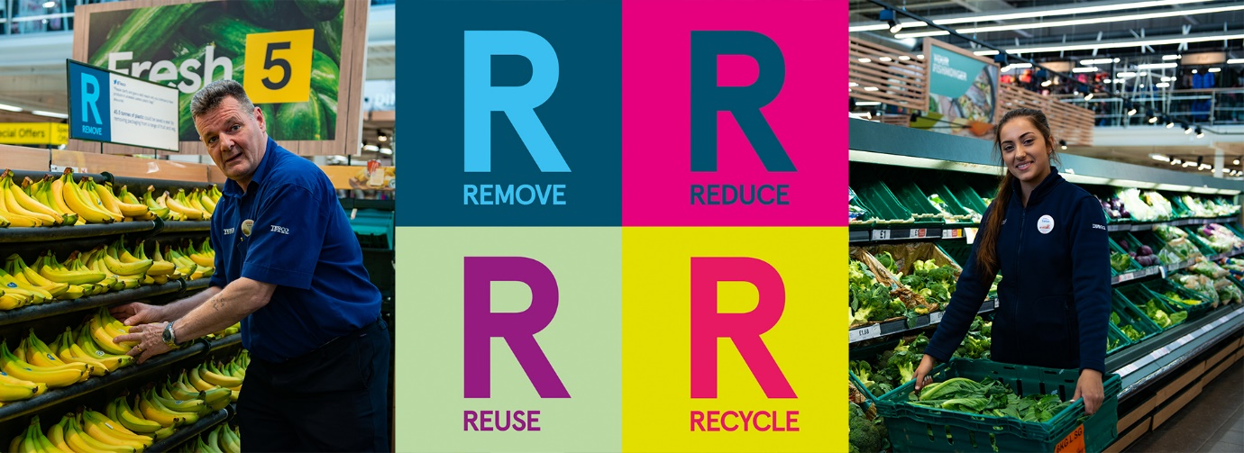
In the current business phenomenon, sustainability is the main corporate concern and here, fulfilling social responsibilities is one of the most crucial areas for every modern organisation (Tilt, 2016). Tesco keeps no stone unturned to achieve sustainability by taking utmost care of the people and the planet, the two most valuable parts of this business. Now Tesco will be a ‘plastic-free’ supermarket chain completely which is not only a unique initiative but also important for the health and well-being of the environment and society.
With the growth of the supermarket industry, the usage of plastic has grown to a significant extent and the rate of pollution has also risen parallelly (Mortimer, 2017). Tesco has adopted a 4R strategy in its packaging plan that includes four strategic elements, Remove, Reduce, Reuse and Recycle, aiming at eliminating plastic as far as possible (White, 2020). This initiative will start by modifying the packaging of its own Tesco products and later, Tesco will ensure recyclable packaging for other branded products too available at Tesco stores.
To celebrate this Christmas sustainably, Tesco has announced to package Christmas gifts, lifts, cards, etc. in recyclable cardboard packaging (White, 2020). Also, the company will reduce the usage of glitters for packaging as well as single-use items like crackers, gift bags, wrapping paper, cards, etc. to make the entire process more recyclable and sustainable.
The study of Arı and Yılmaz (2017), shows that customers are more conscious to use environment-friendly products and they are highly willing to eliminate the products that are made of or packaged with harmful plastics. It is necessary to remember Tesco has already improved its packaging process for over 1600 products through which it becomes able to remove billions of plastics (tescoplc, 2021). It is undeniably an achievement for Tesco that shows how far the company is committed to the well-being of the customers, community, and the environment.
Tesco has made a partnership with Gorillas to offer ultra-fast deliveries to customers
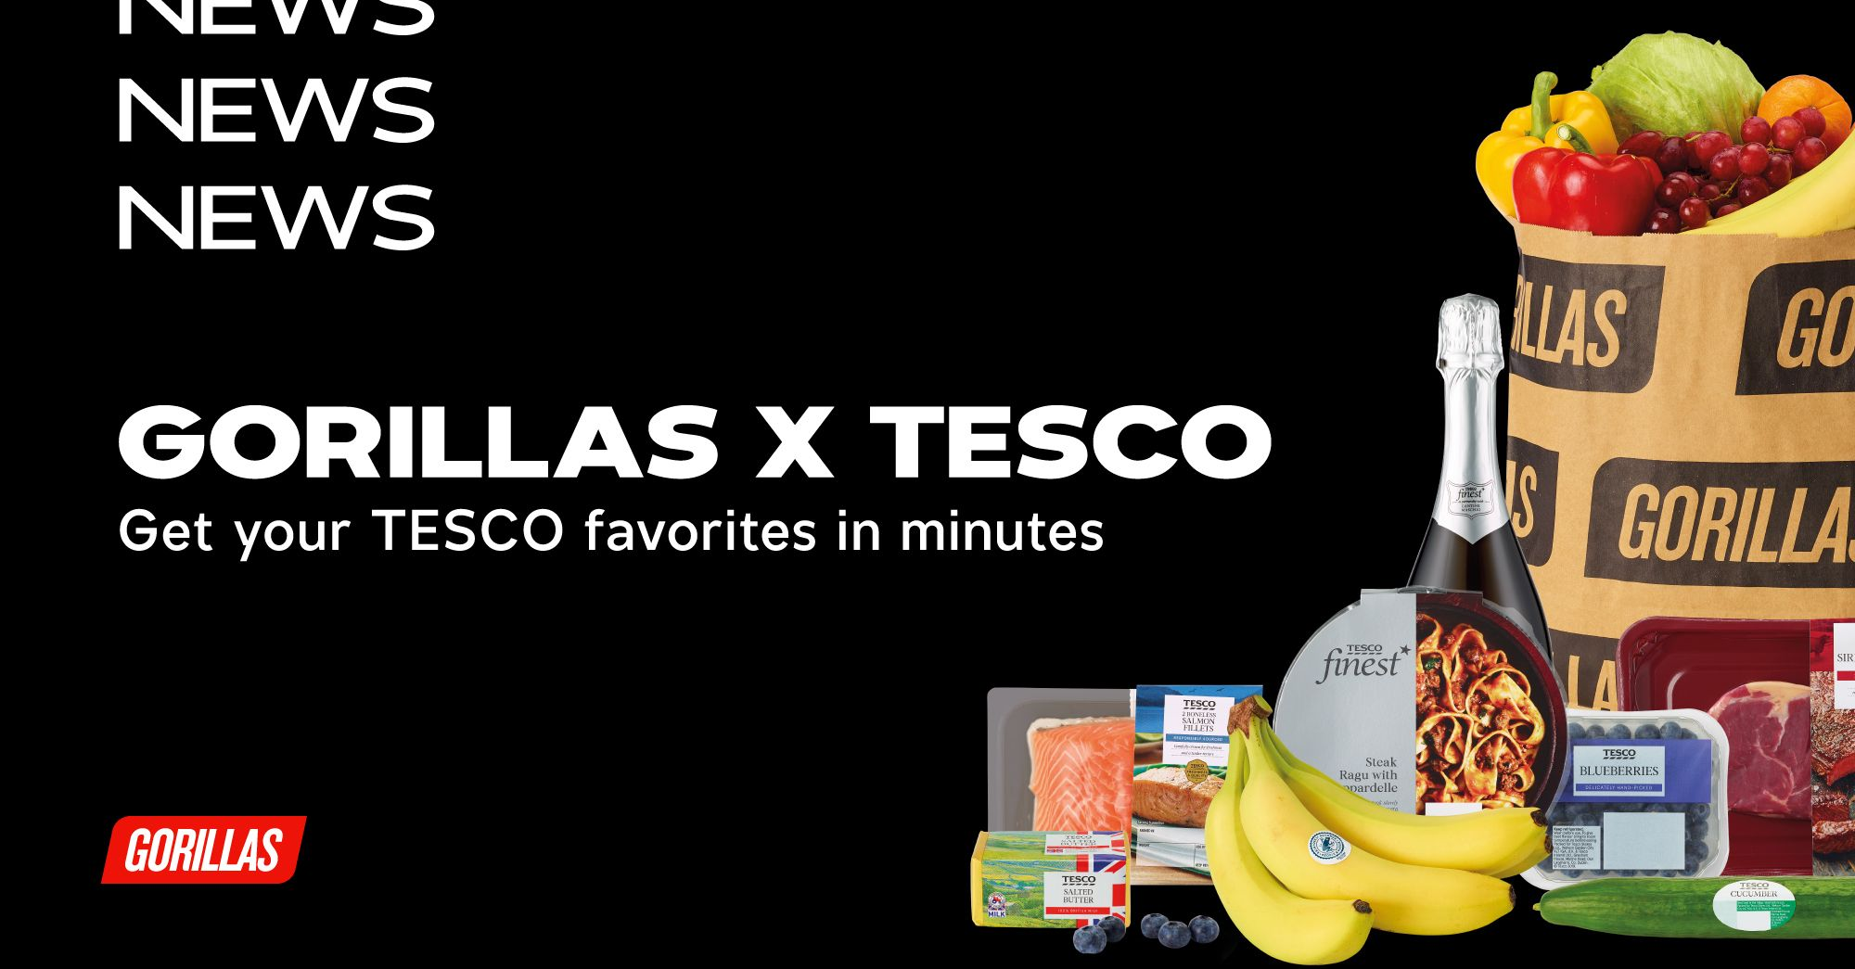
The demand for groceries is growing and the competition in the supermarket industry is rising by leaps and bounds to acquire major market share and customer base (Thomassen et al., 2017). Tesco, since the beginning, remains a pioneer in this industry of the UK by offering customers quality, variety, and innovation altogether. Now Tesco has taken another initiative to satisfy customers the most and offer them a superior shopping experience that they can never have with other supermarkets.
Tesco now aims at delivering its customers their desirable items within ten minutes of ordering and to fulfil this goal, a partnership has been made with Gorillas that is widely recognized as a super-fast delivery brand. Customers can purchase Tesco products through Gorilla’s app which will be immediately delivered to the customers at the desired locations. Now customers can just order and go for pre-heating the oven and Tesco by partnering with Gorillas will pick up, pack, and deliver the items at the given areas (tescoplc, 2021).
Tesco understands the importance of having the facilities of superfast delivery especially when the forgotten items are last minutes needs or of intense emergencies. This partnership will enable Tesco customers to satisfy such needs and the company ensures that customers can have a fantastic experience after shopping with Tesco.
Tesco is for all! We’re making the stores a happy place for all customers
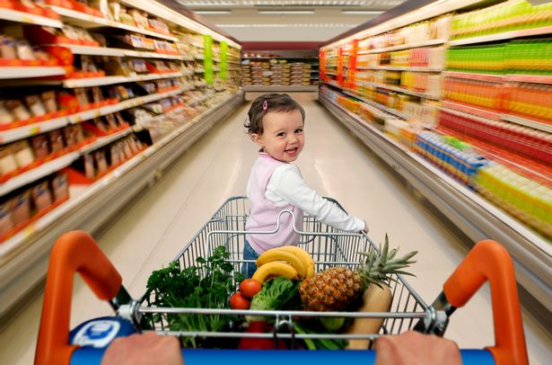
20% of the total UK population or 1 out of 5 people in the UK hold any kind of disability (Wafa et al., 2020). Tesco welcomes everyone. Still, the company understands that the stores are public places with loud sounds, music, lights, noises, etc. which can be disturbing and stressful as well for some customers especially people with Autism or other critical disabilities. Apart from having any disabilities, regular people also have the wish to have a calm place to make necessary purchase decisions and shop.
Every individual see, perceive, feel and experience the world in a different way (Krems et al., 2017). Tesco after having a huge customer base that consists of different generations, genders, and kinds of customers, understands well their preferences. Say, for instance, the elderly customers, or mothers with newborns, individuals with mental stress, etc. a calm environment is highly desirable.
To offer the easiest and most convenient shopping experiences at Tesco stores to all customers, the company will offer quiet hours on Wednesday and Saturday from 9 am to 10 am. All the lights and music of the stores will be dimmed during that time and the checkout noises will also be reduced as far as possible to create a calm ambiance for the customers and offer them a unique and enjoyable shopping experience with Tesco (tescoplc, 2021).
The new Checkout-free stores of Tesco ‘GetGo’ is on the go
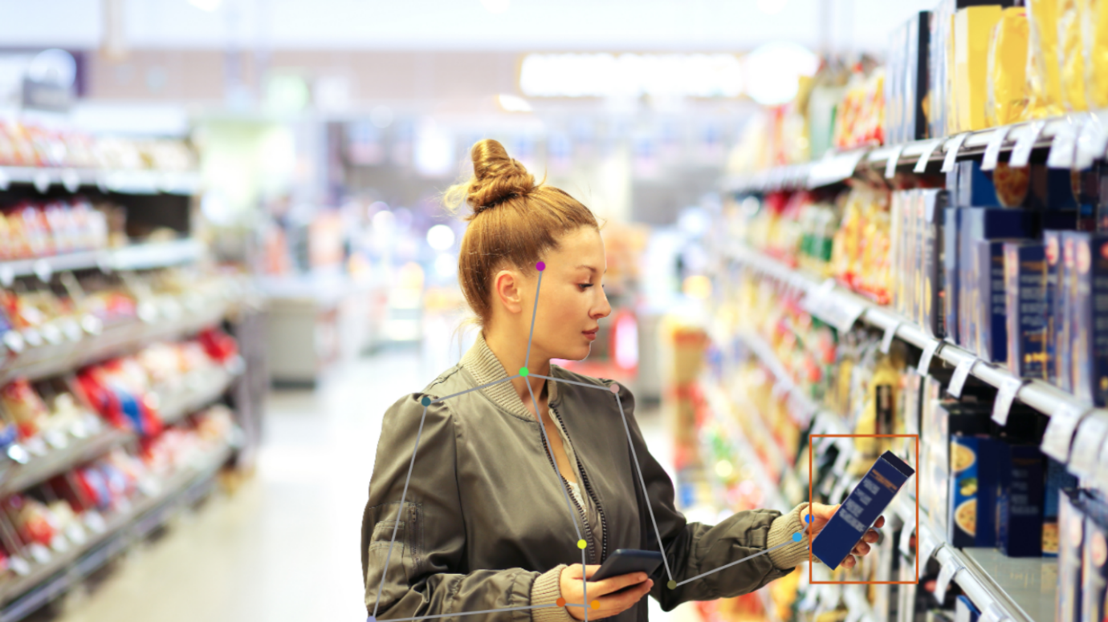
In central London, Tesco has opened its first checkout-free store to give customers a unique opportunity to purchase Tesco products and pay without checkout or even by scanning (tescoplc, 2021). Though it is in the trial phase, Tesco aims at offering the same products to its customers with a more innovative and seamless experience of supermarket shopping.
Technology goes on to be advanced and reshaping contemporary business practices in the supermarket industry. It has become a need of the hour for the retailers to make extensive usage of advanced technologies, generate innovation, attract and retain customers as well as keep a stronghold on the competitive industry position (Wadhawan and Seth, 2016). By becoming greatly aware of these facts and offering customers new shopping experiences, Tesco has launched this unique facility in the store with the adoption of leading-edge technologies. Customers now can simply log in to Tesco’s mobile application to check-in, collect products they need to purchase, and checkout. By using weight-sensors and cameras Tesco will identify the picked-up products and charge customers for those items through the app (tescoplc, 2021).
By partnering with Trigo, Tesco has launched a fully automated store. However, in the age-restricted sections, customers’ ID proofs will be verified manually to ensure all the legal and ethical protocols of operating a business (tescoplc, 2021). Here, Tesco highlights how it fulfils legal as well as customers’ requirements. Thus, the new Tesco ‘GetGo’ stores will create an exciting experience among the customers and help them save their time especially when they will be in an utmost hurry.

3. Conclusion
Thus, a series of blog posts has been prepared for Tesco by highlighting all the new offerings and practices that the organisation has considered as its key strategic movements. Therefore, posting these blogs over the company’s official websites as well as social media pages will help generate awareness among customers and by opening comment sections under these blogs, Tesco can communicate with customers efficiently. Therefore, these blogs will fulfil the project aim of boosting sales volume and revenue of the company and also benefit in maintaining a strategic relationship with its huge customer base for longer.

Reference list
Arı, E. and Yılmaz, V., 2017. Consumer attitudes on the use of plastic and cloth bags. Environment, Development and Sustainability, 19(4), pp.1219-1234.
Byrne, S. and Farrell, K., 2021. An investigation into the food related traditions associated with the Christmas period in Rural Ireland. Folk Life, 59(2), pp.123-140.
Kim, S., Colicchia, C. and Menachof, D., 2018. Ethical sourcing: An analysis of the literature and implications for future research. Journal of Business Ethics, 152(4), pp.1033-1052.
Kotler, P. and Armstrong, G.M., 2018. Marketing Mix: Selected Chapters From: Principles of Marketing, Philip Kotler and Gary Armstrong. Pearson.
Kotler, P., Keller, K.L., Manceau, D. and Dubois, B., 2016. Marketing Management, 15e édition. New Jersy: Pearson Education.
Krems, J.A., Kenrick, D.T. and Neel, R., 2017. Individual perceptions of self-actualization: What functional motives are linked to fulfilling one’s full potential?. Personality and Social Psychology Bulletin, 43(9), pp.1337-1352.
Mortimer, G., 2017. Getting rid of plastic bags: a windfall for supermarkets but it won't do much for the environment. The Conversation.
Tesco PLC. 2021. Tesco is partnering with Gorillas to pilot ultra-fast delivery for customers. [online] Available at: <https://www.tescoplc.com/news/2021/tesco-is-partnering-with-gorillas-to-pilot-ultra-fast-delivery-for-customers/> [Accessed 14 December 2021].
Tesco PLC. 2021. Tesco opens new checkout-free store, ‘GetGo’. [online] Available at: <https://www.tescoplc.com/news/2021/tesco-opens-new-checkout-free-store-getgo/> [Accessed 14 December 2021].
Tesco PLC. 2021. Tesco to launch last toy sale of the year in time for Christmas. [online] Available at: <https://www.tescoplc.com/news/2021/last-tesco-toy-sale-before-christmas/> [Accessed 14 December 2021].
Tesco PLC. 2021. Tesco to launch last toy sale of the year in time for Christmas. [online] Available at: <https://www.tescoplc.com/news/2021/last-tesco-toy-sale-before-christmas/> [Accessed 14 December 2021].
Tesco PLC. 2021. Tesco’s plastic packaging reduction programme is on a roll. [online] Available at: <https://www.tescoplc.com/news/2021/tesco-s-plastic-packaging-reduction-programme-is-on-a-roll/> [Accessed 14 December 2021].
Tesco PLC. 2021. We’re launching Quiet Hour permanently in stores to support customers. [online] Available at: <https://www.tescoplc.com/news/2021/we-re-launching-quiet-hour-permanently-in-stores-to-support-customers/> [Accessed 14 December 2021].
Thomassen, Ø., Smith, H., Seiler, S. and Schiraldi, P., 2017. Multi-category competition and market power: a model of supermarket pricing. American Economic Review, 107(8), pp.2308-51.
Tilt, C.A., 2016. Corporate social responsibility research: the importance of context. International journal of corporate social responsibility, 1(1), pp.1-9.
Wadhawan, N. and Seth, A., 2016. Technology Revolutionizing Retail Practices in Digital Era. International Journal of Recent Research Aspects, 2(1), pp.60-62.
Wafa, H.A., Wolfe, C.D., Emmett, E., Roth, G.A., Johnson, C.O. and Wang, Y., 2020. Burden of stroke in Europe: thirty-year projections of incidence, prevalence, deaths, and disability-adjusted life years. Stroke, 51(8), pp.2418-2427.
White, R., 2020. Tesco to remove '20 million pieces' of plastic - letsrecycle.com. [online] letsrecycle.com. Available at: <https://www.letsrecycle.com/news/tesco-to-remove-20-million-pieces-of-plastic/> [Accessed 14 December 2021].

